

DRAFT RECOMMENDATION FOR SPACE
DATA SYSTEM STANDARDS

Time Critical Onboard Network Services (TCONS)

CCSDS xxx.x-R-0.2

DRAFT RED BOOK

September 2004



AUTHORITY

 | Issue: | Draft Red Book, Issue 0.2
 | Date: | September 2004
 | Location: | N/A

(WHEN THIS RECOMMENDATION IS FINALIZED, IT WILL CONTAIN THE FOLLOWING STATEMENT OF AUTHORITY :)

This document has been approved for publication by the Management Council of the Consultative Committee for Space Data Systems (CCSDS) and reflects the consensus of technical panel experts from CCSDS Member Agencies. The procedure for review and authorization of CCSDS Reports is detailed in reference [2].

This document is published and maintained by:
CCSDS Secretariat
Program Integration Division (Code MT)
National Aeronautics and Space Administration
Washington, DC 20546 USA
STATEMENT OF INTENT
The Consultative Committee for Space Data Systems (CCSDS) is an organization officially established by the management of member space Agencies. The Committee meets periodically to address data systems problems that are common to all participants, and to formulate sound technical solutions to these problems. Inasmuch as participation in the CCSDS is completely voluntary, the results of Committee actions are termed Recommendations and are not considered binding on any Agency.
This Recommendation is issued by, and represents the consensus of, the CCSDS Plenary body. Agency endorsement of this Recommendation is entirely voluntary. Endorsement, however, indicates the following understandings:
- Whenever an Agency establishes a CCSDS-related standard, this standard will be in accord with the relevant Recommendation. Establishing such a standard does not preclude other provisions which an Agency may develop.
- Whenever an Agency establishes a CCSDS-related standard, the Agency will provide other CCSDS member Agencies with the following information:
  - The standard itself.
  - The anticipated date of initial operational capability.
  - The anticipated duration of operational service.
- Specific service arrangements are made via memoranda of agreement. Neither this Recommendation nor any ensuing standard is a substitute for a memorandum of agreement.

No later than five years from its date of issuance, this Recommendation will be reviewed by the CCSDS to determine whether it should: (1) remain in effect without change; (2) be changed to reflect the impact of new technologies, new requirements, or new directions; or, (3) be retired or cancelled.
In those instances when a new version of a Recommendation is issued, existing CCSDS-related Agency standards and implementations are not negated or deemed to be non-CCSDS compatible. It is the responsibility of each Agency to determine when such standards or implementations are to be modified. Each Agency is, however, strongly encouraged to direct planning for its new standards and implementations towards the later version of the Recommendation.

FOREWORD
(WHEN THIS RECOMMENDATION IS FINALIZED, IT WILL CONTAIN THE
FOLLOWING FOREWORD)

This document is a technical Recommendation for use in developing flight and ground systems for space missions and has been prepared by the Consultative Committee for Space Data Systems (CCSDS). The Time Critical Onboard Networking Services (TCONS) described herein is intended for missions that are cross-supported between Agencies of the CCSDS, in the framework of the Spacecraft Onboard Interface Services (SOIS) CCSDS area.
This Recommendation specifies a service interface and underlying protocols to be used by space missions to transfer space application data over an onboard network. TCONS services and protocols are employed at the Transport and Network layers (OSI model) of an onboard communication protocols stack, for transferring information across a spacecraft onboard network comprising one or more sub-networks where the sub-networks may be of different types. The specified services may be implemented in a number of different ways but will support interoperability for time critical onboard applications. The Time Critical Onboard Network Services (TCONS) will provide services exclusively to the Time Critical Onboard Applications (TCOA) layer above and/or to user applications. It will exclusively use services of the Onboard Bus and LAN (OBL) layer below.

Through the process of normal evolution, it is expected that expansion, deletion, or modification to this Report may occur. This Report is therefore subject to CCSDS document management and change control procedures, which are defined in reference [3]. Current versions of CCSDS documents are maintained at the CCSDS Web site:
http://www.ccsds.org/
Questions relating to the contents or status of this report should be addressed to the CCSDS Secretariat at the address on page i.
At time of publication, the active Member and Observer Agencies of the CCSDS were

Member Agencies

- Agenzia Spaziale Italiana (ASI)/Italy.
- British National Space Centre (BNSC)/United Kingdom.
- Canadian Space Agency (CSA)/Canada.
- Centre National d’Etudes Spatiales (CNES)/France.
- Deutsches Zentrum für Luft- und Raumfahrt e.V. (DLR)/Germany.
- European Space Agency (ESA)/Europe.
- Instituto Nacional de Pesquisas Espaciais (INPE)/Brazil.
- National Aeronautics and Space Administration (NASA)/USA.
- National Space Development Agency of Japan (NASDA)/Japan.
- Russian Space Agency (RSA)/Russian Federation.

Observer Agencies

- Austrian Space Agency (ASA)/Austria.
- Central Research Institute of Machine Building (TsNIIMash)/Russian Federation.
- Centro Tecnico Aeroespacial (CTA)/Brazil.
- Chinese Academy of Space Technology (CAST)/China.
- Commonwealth Scientific and Industrial Research Organization (CSIRO)/Australia.
- Communications Research Centre (CRC)/Canada.
- Communications Research Laboratory (CRL)/Japan.
- Danish Space Research Institute (DSRI)/Denmark.
- European Organization for the Exploitation of Meteorological Satellites (EUMETSAT)/Europe.
- European Telecommunications Satellite Organization (EUTELSAT)/Europe.
- Federal Service of Scientific, Technical & Cultural Affairs (FSST&CA)/Belgium.
- Hellenic National Space Committee (HNSC)/Greece.
- Indian Space Research Organization (ISRO)/India.
- Institute of Space and Astronautical Science (ISAS)/Japan.
- Institute of Space Research (IKI)/Russian Federation.
- KFKI Research Institute for Particle & Nuclear Physics (KFKI)/Hungary.
- MIKOMTEK: CSIR (CSIR)/Republic of South Africa.
- Korea Aerospace Research Institute (KARI)/Korea.
- Ministry of Communications (MOC)/Israel.
- National Oceanic & Atmospheric Administration (NOAA)/USA.
- National Space Program Office (NSPO)/Taipei.
- Swedish Space Corporation (SSC)/Sweden.
- United States Geological Survey (USGS)/USA.
PREFACE
This document is a draft CCSDS Recommendation. Its Red Book status indicates that the CCSDS believes the document to be technically mature and has released it for formal review by appropriate technical organizations. As such, its technical contents are not stable, and several iterations of it may occur in response to comments received during the review process.

Implementers are cautioned not to fabricate any final equipment in accordance with this document’s technical content. SO WHAT IS THE DOCUMENT FOR!! (SMP)
DOCUMENT CONTROL

Document | Title | Date | Status
CCSDS  xxx.x-RD-0.1 | Time Critical Onboard Networking Services (TCONS) | April 2004 | GSFC update
CCSDS  xxx.x-RD-0.2 | Time Critical Onboard Networking Services (TCONS) | Sept 2004 | Dundee update  (Current draft)

CONTENTS
Section Page
1 INTRODUCTION 1-9
1.1 purpose and scope of this document 1-9
1.2 APPLICABILITY 1-10
1.3 RATIONALE 1-10
1.4 DOCUMENT STRUCTURE 1-10
1.5 Conventions and Definitions 1-10
1.5.1 Bit Numbering Convention and Nomenclature 1-10
1.5.2 DEFINITIONS 1-11
1.6 how this document fits into the SOIS documentation Tree 1-13
1.6.1 DOCUMENT NOMENCLATURE 1-13
1.7 REFERENCES 1-13
2 general concepts and assumptions 2-15
2.1 Overview 2-15
2.1.1 TCONS ARCHITECTURE 2-15
2.1.2 TCONS SERVICES 2-15
2.2 Assumptions 2-15
3 TCONS transport layer 3-16
3.1 Overview 3-16
3.2 Prioritized, best-Effort, Data Delivery Service 3-17
3.2.1 best-Effort Service Overview 3-17
3.2.2 Best-Effort Service Primitives 3-19
3.2.3 Best-Effort Service Protocol 3-21
3.2.4 Best-Effort Service Protocol Data Units 3-22
3.2.5 Best-Effort Service API 3-24
3.2.6 Best-Effort Service Management Parameters 3-27
3.3 Prioritized, Guaranteed, Data Delivery Service 3-29
3.3.1 Guaranteed Service Overview 3-29
3.3.2 Guaranteed Service Primitives 3-30
3.3.3 Guaranteed Service Protocol 3-35
3.3.4 Guaranteed Service Protocol Data Units 3-47
3.3.5 Guaranteed Service API 3-53
3.3.6 Guaranteed Service Management Parameters 3-59
3.4 Scheduled, Data Delivery Service 3-61
3.4.1 Scheduled Service Overview 3-61
3.4.2 Scheduled Service Primitives 3-61
3.4.3 Scheduled Service Protocol 3-61
3.4.4 Scheduled Service Protocol Data Units 3-61
3.4.5 Scheduled Service API 3-61
3.4.6 Scheduled Service Management Parameters 3-62
3.5 Services required from Layer Below 3-62
3.6 Interfaces to System Management 3-62
4 TCONS network layer 4-63
4.1 Overview 4-63
4.2 Network Datagram Delivery Service 4-63
4.2.1 Network Datagram Service Overview 4-63
4.2.2 Network Datagram Service Primitives 4-64
4.2.3 Network Datagram Service Protocol 4-65
4.2.4 Network Datagram Service Protocol Data Units 4-66
4.2.5 Network Datagram Service API 4-67
4.2.6 Network Datagram Service Management Parameters 4-69
4.2.7 QoS Fields 4-70
4.3 Sub-Network Dependent convergence sublayer 4-72
4.3.1 Convergence Service Overview 4-72
4.3.2 Convergence Service Primitives 4-72
4.3.3 Convergence Service Protocol 4-74
4.3.4 Convergence Protocol Data Units 4-75
4.3.5 Convergence Service API 4-75
4.3.6 Convergence Service Management Parameters 4-77
5 THings TO BE CONSIDERED 5-78
5.1.1 Schedule table 5-78
5.1.2 Scheduled Delivery 5-78
ACRONYMS AND ABBREVIATIONS 1

AN SDL MODEL OF TCONS 2

Table of Figures
Figure 1-1: Bit Numbering Convention 1-11
Figure 3-1 Best-Effort Transactions - Normal Operation 3-21
Figure 3-2 Best-Effort Transactions - Blocking Send Request 3-22
Figure 3-3 Best-Effort Transactions - No Receive Request 3-22
Figure 3-4 Best-Effort Protocol Data Unit 3-23
Figure 3-5 Open Sequence 3-35
Figure 3-6 Opening of Multiple Connections 3-37
Figure 3-7 Both Ends Opening at Same Time 3-38
Figure 3-8 Failure to Open a Connection 3-39
Figure 3-9 Nominal Send and Receive 3-40
Figure 3-10 Rejected Send and Receive 3-41
Figure 3-11 Send Retry Due To Lost Data 3-41
Figure 3-12 Send Retry Due To Lost ACK 3-42
Figure 3-13 Use of NACK to Hasten Retry 3-43
Figure 3-14 Failed Connection 3-44
Figure 3-15 Sending to a Closed Connection 3-45
Figure 3-16 Closing a Connection 3-46
Figure 3-17 Close When Destination Already Closed 3-47
Figure 3-18 Guaranteed Service PDU Format 3-47
Figure 3-19 Open PDU Format 3-49
Figure 3-20 Accept PDU Format 3-49
Figure 3-21 Established PDU Format 3-50
Figure 3-22 Close PDU Format 3-50
Figure 3-23 Data PDU Format 3-51
Figure 3-24 ACK PDU Format 3-52
Figure 3-25 NACK PDU Format 3-53
Figure 4-1 Network Protocol 4-65
Figure 4-2 Routing a Datagram 4-66
Figure 4-3 Datagram Error 4-66
Figure 4-4 Network Protocol Data Unit Format 4-66
Figure 4-5 Convergence Service Protocol 4-74

Table
Error! No table of figures entries found.Error! No table of figures entries found.

INTRODUCTION
The Time Critical Onboard Network Services (TCONS) recommendation specifies a service interface offering Transport and Network layer functionality to Time Critical Onboard Applications (TCOA) and /or user applications, enabling space missions to efficiently transfer space application data of various types in the form of variable length, delimited, octet aligned data units across an onboard network between two end systems residing on the same sub-network (intra-networking) or on different sub-networks (inter-networking).
This technology allows a range of Application layer protocols and processes to be implemented over a well-defined standard set of service profiles regardless of the characteristics of the existing underlying sub-networks.
The scope of TCONS covers the end-to-end transfer of space data or messages across an onboard data communications network which may comprise one or more different forms of sub-network. The end-points are processors, memory units, sensors, telemetry and telecommand units and related onboard equipment that require the services of an onboard communication network. More specifically the end-points may be processes running on these processors or other equipments.
The TCONS defines service interfaces and API definitions for priority driven asynchronous services and isochronous bounded latency delivery services. It also defines a management framework allowing the asynchronous and isochronous services to co-exist on one or more sub-networks.
The relationship of TCONS Layer to the other SOIS Layers is described in the SOIS Reference Model, which is documented in reference [1].

  - purpose and scope of this document
The purpose of this document is to define:
- Services and service interface provided by the TCONS layer to the above SOIS layer (TCOA) and/or user applications;
- Services and service interface expected from the underlying SOIS layer (OBL);
- Services and service interface to SOIS network management framework;
- Normative API definitions associated with each service interface;
- Protocols used with the TCONS layer to provide the required services;
- Protocol Data Units used to carry data and protocol control information.

APPLICABILITY
IF THIS IS STANDARD CCSDS BLURB THEN OK, OTHERWISE IT SHOULD Best-Effort RE-WRITTEN (SMP).
This Recommendation applies to the creation of Agency standards and to future data communications over space links between Consultative Committee for Space Data Systems (CCSDS) Agencies in cross-support situations. It includes comprehensive specification of the services and protocol for inter-agency cross support. It is neither a specification of, nor a design for, real systems that may be implemented for existing or future missions.
The Recommendation specified in this document is to be invoked through the normal standards programs of each CCSDS Agency and is applicable to those missions for which cross support based on capabilities described in this Recommendation is anticipated. Where mandatory capabilities are clearly indicated in sections of the Recommendation, they must be implemented when this document is used as a basis for cross support. Where options are allowed or implied, implementation of these options is subject to specific bilateral cross support agreements between the Agencies involved.

RATIONALE
The CCSDS believes it is important to document the rationale underlying the recommendations chosen, so that future evaluations of proposed changes or improvements will not lose sight of previous decisions.

DOCUMENT STRUCTURE

Conventions and Definitions

Bit Numbering Convention and Nomenclature
In this document, the following convention is used to identify each bit in an N-bit field. The first bit in the field to be transmitted (i.e., the most left-justified when drawing a figure) is defined to be ‘Bit 0’; the following bit is defined to be ‘Bit 1’, and so on up to ‘Bit N-1’. When the field is used to express a binary value (such as a counter), the Most Significant Bit (MSB) shall be the first transmitted bit of the field, i.e., ‘Bit 0’, as shown in figure 1-1.
YUK - I REALLY DISLIKE THIS WAY OF NUMBERING BITS. I PREFER THAT BIT0 IS ALWAYS THE LSB AND BIT N-1 THE MSB (SMP).
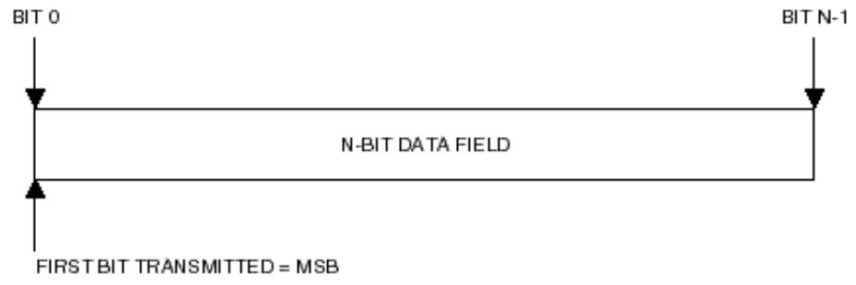
Figure 1-1: Bit Numbering Convention1
In accordance with modern data communications practice, spacecraft data fields are often grouped into 8-bit ‘words’ which conform to the above convention.
Throughout this Recommendation, such an eight-bit word is called an ‘octet’. The numbering for octets within a data structure starts with zero. By CCSDS convention, all ‘spare’ bits shall be permanently set to ‘0’.

DEFINITIONS
Within the context of this document the following definitions apply:

Definitions from the Open Systems Interconnection (OSI) Basic Reference Model
The TCONS interface is defined using the style established by the Open Systems Interconnection (OSI) Basic Reference Model [2]. This model provides a common framework for the development of standards in the field of systems interconnection.
The following terms, used in this Report, are adapted from definitions given in [3]:
Layer: a subdivision of the architecture, constituted by subsystems of the same rank WHAT DOES THIS MEAN – PREFERABLY IN PLAIN ENGLISH?? (SMP)
Protocol data unit (PDU): a unit of data specified in a protocol and consisting of protocol-control-information and possibly user data.
Service: a capability of a layer (service provider) together with the layers beneath it, which is provided to the service-users.
Service data unit (SDU): an amount of information whose identity is preserved when transferred between peer entities in a given layer and which is not interpreted by the supporting entities in that layer. I DON’T UNDERSTAND THIS (SMP)

Terms Defined in this Recommendation
For the purposes of this Recommendation, the following definitions also apply. Many other terms that pertain to specific items are defined in the appropriate sections.
Aperiodic: not periodic (see below).
Asynchronous: not synchronous (see below).
Delimited: having a known (and finite) length; applies to data in the context of data handling.
Periodic: of or pertaining to a sequence of events in which each event occurs at a fixed time interval (within specified tolerance) after the previous event in the sequence.
Space link: a communications link between a spacecraft and its associated ground system or between two spacecraft. A space link consists of one or more Physical Channels in one or both directions.
Synchronous: of or pertaining to a sequence of events occurring in a fixed time relationship (within specified tolerance) to another sequence of events. Note that ‘synchronous’ does not necessarily imply ‘periodic’ or ‘constant’ rate.
Octet: an 8-bit word.
Sub-Network Data Unit (SNDU): the unit of data to be transferred over the underlying sub-network, for example an IP datagram, or a CCSDS encapsulation packet. IS THIS NOT A PROTOCOL DATA UNIT? OR IS AN SNDU ONE TYPE OF PDU? (SMP)
Bounded Delivery – The time taken to deliver a packet has a maximum specified value which it should not exceed i.e. is bounded.
Scheduled Delivery – The time of delivery of a packet is specified by a delivery schedule.
Quality of Service – The level of service that is requested / provided.
Priority – A per-packet datum identifying the transmit precedence relative to other packets.
Reliability – A quality of service parameter indicating whether or not TCONS will attempt to acknowledge and possibly retry a transmit packet.
Channel – aqueue of transmit packets with a predefined maximum length. In an unscheduled network one channel exists for each TX priority supported. Packets or connections are prioritised within a channel as well. In a scheduled network channels are allocated slots in the Network Schedule table. Priority still exists within a channel and at least one channel consisting of left over bandwidth exists. NEEDS TO Best-Effort DEFINED IN A CLEARER WAY (SMP)

Network Schedule – a synchronized, fixed-length repeating interval, subdivided into Slots that dictate which Channels have media access at any moment.
Slot – In a Scheduled Delivery regime, a Slot represents the duration within the network bus cycle that a Channel has media access for transmitting packets.

Packet – Delimited octet aligned data unit.
SAP – Service Access Point. Identifies the Source endpoint system, Destination endpoint system and a Channel identifier.
Request
Indication
Response
Confirmation

how this document fits into the SOIS documentation Tree
The SOIS documentation tree has an overall document [1] that describes the concepts and rationale for Spacecraft Onboard Interfaces and Services (SOIS). Below this document are a set of documents that provide descriptions and requirements for each of the different areas within the scope of the SOIS work.
SOIS is composed by the following Layers:
- Time Critical Onboard Application Services (TCOA)
- Time Critical Onboard Network Services (TCONS)
- Onboard Bus and LAN Services (OBL)
This CCSDS document provides the recommendations for the SOIS TCONS Layer, used for end-to-end transportation of information across data busses and networks onboard a spacecraft.

DOCUMENT NOMENCLATURE
The following conventions apply throughout this Recommendation:
- a) The words ‘shall’ and ‘must’ imply a binding and verifiable specification;
- b) The word ‘should’ implies an optional, but desirable, specification;
- c) The word ‘may’ implies an optional specification;
- d) The words ‘is’, ‘are’, and ‘will’ imply statements of fact.

REFERENCES
The following documents contain provisions which, through reference in this text, constitute provisions of this Recommendation. At the time of publication, the editions indicated were valid. All documents are subject to revision, and users of this Recommendation are encouraged to investigate the possibility of applying the most recent editions of the documents indicated below. The CCSDS Secretariat maintains a register of currently valid CCSDS Recommendations.
[1] Spacecraft Onboard Interfaces Concepts and Rationale Green Book, CCSDS, CCSDS-830.0-G-0.4, Green Book, Issue TBD, Washington D.C., CCSDS, September 2003
[2] Information Technology.Open Systems Interconnection.Basic Reference Model: The Basic Model. International Standard, ISO/IEC 7498-1. 2nd ed. Geneva: ISO, 1994.
[3] Information Technology.Open Systems Interconnection.Basic Reference Model.Conventions for the Definition of OSI Services. International Standard, ISO/IEC 10731:1994. Geneva: ISO, 1994.
[4] Procedures Manual for the Consultative Committee for Space Data Systems. CCSDS A00.0-Y-7. Yellow Book. Issue 7. Washington, D.C.: CCSDS, November 1996.
[5] CCSDS File Delivery Protocol (CFDP). Recommendation for Space Data System Standards, CCSDS 727.0-1. Draft Blue Book. Washington, D.C.: CCSDS, December 2001.
NOTE . Informative references are listed in annex B.
SHOULD [2] and [3] be informative references – as they are just being used to help define some terms, with the terms being specified in this document? (SMP)

general concepts and assumptions
In this section an overview of the general concepts of the TCONS is provided. The assumptions that have been made are also listed.

Overview

TCONS ARCHITECTURE

TCONS SERVICES

Assumptions

TCONS transport layer
In this section the TCONS Transport Layer is defined.
First an overview of the Transport Layer is given in section 3.1. The three services provided by TCONS are then described in sections 3.2, 3.3 and 3.4. Each of these three sections contains sub-sections providing:
- an overview of the service,
- a definition of the service primitives,
- a description of the protocols used to implement the service,
- a description of the protocol data units used to carry data and protocol control information,
- an example of an API that provides access to the service, and
- a description of the service management parameters.

Overview
The SOIS Transport layer transfers packets of information from one end-point to another end-point using the SOIS Network layer services to move segments of the information across the onboard network.
There are three levels of service provided by TCONS:
- A Prioritized, Best-Effort, Data Delivery Service (Best-Effort Service), which makes a single attempt to deliver data to a destination. Arrival of data at the destination is not signalled to the source i.e. the safe arrival of a packet of data is not acknowledged. Individual packets of data being sent cannot be larger than the MTU. A priority level can be assigned to each packet of data being sent. Packets with higher priority are sent before those with lower priority. If the destination is not ready to receive the data it will be discarded.
- A Prioritized, Guaranteed, Data Delivery Service (Guaranteed Service), which makes repeated attempts to deliver the data to its destination. The arrival of data at the destination is signalled (acknowledged) to the source. If a packet does not arrive at the intended destination it will not be acknowledged, a timer in the source will detect that no acknowledgement has been sent and the source will then resend the packet. This is repeated until either the packet eventually gets through successfully to the destination, or until, after several attempts, it is decided that it is not possible to reach the destination in which case an error is reported. Packets of data being sent can be larger than the MTU. In this case TCONS will segment the large packet into smaller segments of data which are each equal in length or smaller than the MTU. The segments are then sent by the Network level service. The Transport layer keeps track of each of the segments sent, received and acknowledged, and will resend any that are not received correctly. A priority level can be assigned to each packet being sent. Segments of packets with higher priority are sent before those with lower priority. Flow control is provided so that data is not lost just because the destination is not ready to receive them.
- A Scheduled Data Delivery Service (Scheduled Service), which transfers data across the network according to a predefined schedule. The available communications bandwidth is separated by time division multiplexing, into a number of time slots. The time slots are each given a number (identifier) and repeat cyclically after a period of time known as the epoch. Time slots are then allocated for communication between particular source/destination pairs. When a time slot arrives which has been allocated to a source/destination pair the source can send a packet to the paired destination. No other source is allowed to send at this time. A source can send to one of several possible destinations in any particular time slot.
It is not necessary for an onboard network to implement all of these services. Normally scheduled services would be used for deterministic data delivery requirements, e.g. AOCS sub systems, and the Best-Effort and Guaranteed data delivery services would be used for payload data.
A time-slotted sub-network may implement Best-Effort and Guaranteed services in spare (unallocated or unused) time slots but this is an implementation consideration.

Prioritized, best-Effort, Data Delivery Service
In this section, the best-effort service is defined. First an overview of this service is provided, and then the service primitives, protocols and protocol data units for the service are described. An example API is then given implementing the service primitives. Finally the service management parameters are introduced.

best-Effort Service Overview
The Prioritized, Best-Effort, Data Delivery service can send data from one End System to another End System, where an End System is a system using the TCONS services e.g. an application running on a processor which has the TCONS services installed. The Best-Effort service does not have to establish a connection between End Systems before sending data. Since no connection is made, the service offered cannot guarantee delivery of information to a destination End System. The service provided is on a best effort basis, hence its name. Data that goes missing or is corrupted during its transfer across the network will be lost and the source End System will not be informed that the data has been lost.
The maximum amount of data that can be sent in one packet is limited to the MTU. This is the maximum amount of data that can be passed in one go to the Best-Effort service. The MTU is the maximum transmission unit which is a network wide parameter that sets the maximum size of a datagram (network PDU). The scheduled service may have a different MTU, the scheduled MTU (SMTU), than the Best-Effort and Guaranteed services.
Packets of data that are sent can arrive at the destination in a different order to that in which they were sent: the packet sequence may not be maintained across the network.
An End System that wishes to receive data has to register (bind) with the Best-Effort service so that the End System can provide receive buffers for the information to be placed in. This approach is used in TCONS to enhance the performance of the receiving process.
The Best-Effort service supports priority. When a packet is passed to TCONS for sending it can be assigned a priority level. High priority packets are sent and forwarded before lower priority ones.
The TCONS Best-Effort service is similar to UDP except that TCONS supports packet priority.
The Best-Effort service has the following features:
- No need to set up a connection before sending and receiving data
- Send a packet
- Receive a packet
- Maximum packet size is MTU
- Priority packet support
- Delivery is not guaranteed
- If a receiver is not ready or does not have buffer space the packet is thrown away
- No order preservation
- Statistics maintained about errors and undelivered data.
To receive data from the Best-Effort service an application must first register with the service, providing one or more buffers in which to put data. When an application registers a receive buffer it can register to receive any Best-Effort datagrams that arrive on the port or to receive Best-Effort datagrams that arrive on the port from a specific source service access point (SAP). A service access point is the interface between an End System (application) and the TCONS service. A source SAP comprises the source address and source port. A destination SAP similarly comprises the destination address and destination port.
The Best-Effort service listens for incoming Best-Effort datagrams. When a datagram comes in it is checked against the list of registered buffers on the port and put in the first buffer for which it destined, i.e. which has the corresponding source SAP ID. Multiple buffers can be registered for a source SAP in which case the first one registered is used first. So, the list is actually a list of buffer queues, one queue per source SAP for which a Receive has been registered.
The following sequence of events happens when a Best-Effort datagram arrives at a destination:
- Best-Effort datagram arrives at destination address
- The Best-Effort datagram is directed to the destination port defined in the Best-Effort datagram header
- If there are no buffers registered for the destination port then the Best-Effort datagram is dropped
- If there is one buffer queue for all source SAPs sending to the port then the Best-Effort datagram is put in the first buffer of the queue and this buffer is returned to the application by calling the corresponding call-back routine.
- If there are separate buffer queues for each source SAP and if there is a buffer queue that corresponds to the source SAP of the Best-Effort datagram then the datagram is put in the first buffer of the queue and that buffer is returned to the application by calling the appropriate call-back routine.
- If there is no buffer queue for the source SAP then the Best-Effort datagram is dropped.
There is no queuing at the receiver other than that provided by the user application(s).

Best-Effort Service Primitives
In this section the service primitives for the Prioritized, Best-Effort Data Delivery service are presented.
There are four primitives used by this service:
- Send Request which requests to send a packet of data,
- Send Confirmation which indicates that the packet has been accepted for sending,
- Send Fail which indicates that TCONS has failed to send the packet,
- Receive Request which registers an application for receiving packets,
- Receive Indication which indicates that a packet has been received, and
- Receive Fail which indicates that there was a problem receiving a packet.

Send Request
Name: T_BE_SendData.request
Parameters: <Dest SAP> <Src SAP> <Data> <Priority>
- Dest SAP is the Destination Service Access Point.
- Src SAP is the source Service Access Point.
- Data is the data to be sent from the Source to the Destination Service Access Point.
- Priority is the priority which is given to the sending and forwarding of this packet. The priority values used refer to a global (network wide) priority classification.
The SendData.request primitive requests the Best-Effort service to send a datagram from a particular port (source port) on the local processor (source address) to a destination address and destination port. The datagram is assigned a priority level which determines the urgency with which it will be sent and forwarded through the onboard network.

Send Confirmation
Name: T_BE_SendConf.indication
- Parameters: none
The SendConf.indication primitive indicates that a request send has been completed.

Send Fail
Name: T_BE_SendFail.indication
- Parameters: none
The SendFail.indication primitive indicates that a request send has been rejected.

Receive Request
Name: T_BE_ReceiveData.request
Parameters: <Dest SAP> <Src SAP> <Buffer>
- Dest SAP List is the list of Destination Service Access Points that data is to be accepted from. The Destination Address must be the destination address of the current node otherwise the receive request will be rejected.
- Src SAP List is the source Service Access Point that data is to be accepted from.
- Buffer is the memory space, owned by the End System, where received data will be placed.
The ReceiveData.request primitive registers a buffer for receiving data. The port that data is to be received on is specified (destination port). The source address and port (source SAP) may also be specified. If a source SAP is specified then data will be put into the registered buffer only from the specified source SAP. If no source SAP is specified then any data that arrives at the specified destination port, which does not have a buffer registered for its source SAP, will be put in the registered buffer, i.e. when no source SAP is specified it acts as a catch-all or “otherwise”.

Receive Indication
Name: T_BE_ReceiveData.indication
Parameters: <Dest SAP> <Src SAP> <Data>
- Dest SAP is the Destination Service Access Point where the data has been received.
- Src SAP is the source Service Access Point that sent the data.
- Data is the data received at the Destination Service Access Point that was sent from the Source Service Access Point.
The ReceiveData.indication primitive indicates that data from the specified source SAP has arrived at the destination port and has been placed in a registered buffer.

Receive Fail
Name: T_BE_ReceiveFail.indication
- Parameters: none
The ReceiveFail.indication primitive indicates that there was an error receiving a packet.

Best-Effort Service Protocol
In this section the protocols used by the Best-Effort service are described with the aim of sequence diagrams.
The Best-Effort service protocol is illustrated in Figure 3-2.
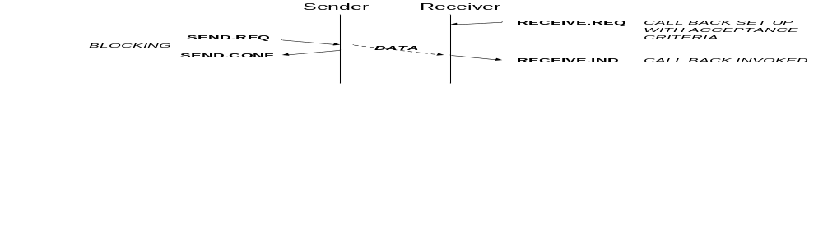
Figure 3-2 Best-Effort Transactions - Normal Operation
To receive data using the Best-Effort service the process that wishes to receive data must first register with TCONS the source SAP or set of source SAPs from which it would like to receive data. This is done using the Receive.Req primitive that also provides a buffer for the received data and a call-back for the process that is to handle the received data.
The sender sends a packet of data using the Send.Req primitive. Acceptance of the send request is indicated by the Send.Conf primitive. Send.Req blocks until the data packet has been accepted for sending. Note that this does not necessarily mean that it has been sent, but it does mean that the buffer provided with the data to be sent is no longer needed by TCONS and may be reused or freed by the user application.
When the data arrives at the destination node, its source and destination SAPs are checked against the acceptance criteria for each registered receive request. The data from the packet is placed in the receive buffer from the corresponding receive request and its call-back process invoked.
The receive request may also be blocking as illustrated in Figure 3-3.
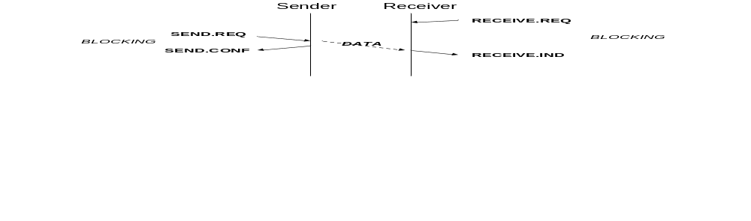
Figure 3-3 Best-Effort Transactions - Blocking Send Request
If the received packet does not fit the acceptance criteria of any of the registered receive requests, then the packet is dropped, as illustrated in Figure 3-4. Statistics of dropped packets are maintained.

Figure 3-4 Best-Effort Transactions - No Receive Request
If the sent packet is lost, for any reason, or corrupted during transfer across the network then it will not be passed to the receiving process and the sending application will not know that the packet failed to arrive.

Best-Effort Service Protocol Data Units
In this section the Protocol Data Units used by the Best-Effort service are described.
Figure 3-5 shows the structure of the Best-Effort Protocol Data Unit (PDU).
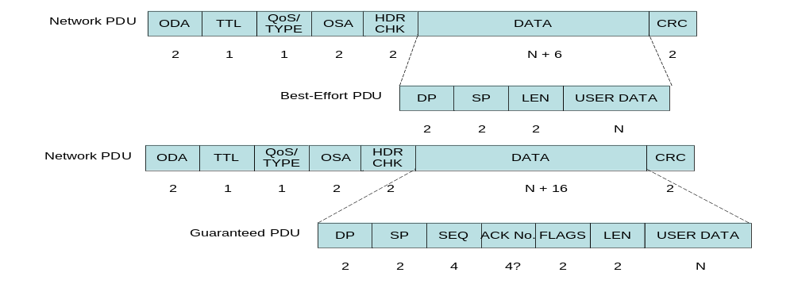
Figure 3-5 Best-Effort Protocol Data Unit
- ODA is the Onboard Destination Address, which is the address of the node for which the PDU is intended,
- TTL is a Time To Live counter, which is decremented at each TCONS router device -if the count reaches zero the entire PDU is dropped,
- QoS is the Quality of Service for the PDU, which for the Best-Effort PDU is the priority of the PDU,
- TYPE is the type of service being carried – Best-Effort, Guaranteed or Scheduled,
- OSA is the Onboard Source Address, which is the address of the node from which the PDU originated,
- HDR CHK is the Network layer PDU header checksum,
- DP is the Destination Port at the destination node, which is the port on the destination node that the receiving application has to be registered with in order to get the data from the PDU,
- SP is the Source Port at the source node, which is the port on the source which is attached to the application that originated the data in the PDU,
- LEN is the length of the data field,
- User Data is the user data, or higher-layer protocol data unit, that is being sent in the PDU, and
- CRC is a cyclic redundancy check code used to confirm that the PDU has no errors – this CRC covers the entire network PDU including the network header.
ODA and DP together make up the Destination Service Access Point (SAP).
OSA and SP together form the Source Service Access Point (SAP).
The order of the elements in the Best-Effort PDU is arranged to ease the appropriate forwarding and processing of the PDU. The first thing that an intermediate node needs to know is the destination address for the PDU. If it does not match the address of the intermediate node then the PDU has to be forwarded. If it is being forwarded then the priority with which it should be forwarded is needed. Only when the PDU arrives at its intended destination are the Destination Port, Source Address and Source Port information needed to determine where to put the PDU and which process it is to be passed to.

Best-Effort Service API
In this section the API for the Best-Effort service is described covering each of the service primitives.

Send Request / Send Confirmation
Abstract definition:
T_BE_SendData.request <Dest SAP> <Src SAP> <Data> <Priority>
T_BE_SendConf.indication
T_BE_SendFail.indication

API Prototype:
Int T_BE_SendData(SAP_Type dest_SAP,
SAP_Type src_SAP,
void * data,
size_t length,
uint8_t priority,
struct timeval*,
void *(*CB_Routine) (void *, size_t, return_t))

- SAP_Type dest_SAP is the destination SAP (port number) that the calling process wishes to receive data from.
- SAP_Type src_SAP is the source SAP (port number) through which the calling process wishes to send the data.
- void *data is a pointer to a buffer passed by the calling process, which contains the data to be sent.
- size_t length is the amount of data to be sent. The amount of data to be sent must be less than or equal to the MTU.
- uint8_t priority is the priority level with which the data must be sent.
- struct timeval* is a timeout interval for which TCONS will wait for the data to be sent. If the data has not been sent and TCONS has not finished with the data buffer by the time the timeout interval has passed, then TCONS will abandon the attempt to send the data and will return the data buffer back to the calling application.
- *(*CB_Routine) is a pointer to the call-back routine to be invoked when TCONS has finished with the passed data buffer.
- (void *, size_t, status) are the parameters of the call-back routine where:
  - void * is a parameter which points to the data buffer,
  - size_t is a parameter giving the size of the buffer, and
  - return_t is a parameter indicating whether the data has been sent (see return codes, below).
The CB_Routine, which is defined by the application, is called by TCONS when TCONS has finished with the passed data. This indicates that the data buffer is again available for use (or freeing) by the application. Arguments of the CB_Routine are the pointer to the buffer and its length. A NULL value for a CB_Routine will cause the T_BE_SendData.request to block, only returning once the buffer is freed or the timeout has expired.
Return codes:
0: If a call-back routine has been provided then a return code of 0 means that TCONS has accepted the function call and is in the process of arranging for the sending of the data. The data buffer will remain in use by TCONS until the specified call-back routine has been called. If a Null call-back routine has been provided then a return code of 0 means that TCONS accepted the passed data for transmission and the buffer is no longer needed by TCONS.
-1: an error occurred

Receive Request / Receive Indication
Abstract definition:
T_BE_ReceiveData.request <Dest SAP> <Src SAP> <Data>
T_BE_ReceiveData.indication <Dest SAP> <Src SAP> <Data>
T_BE_ReceiveFail.indication
API Prototype:
There are two types of receive request: one that registers a call-back to respond to a packet being received on a port and the other that waits for a packet to be received. The API prototypes for these two functions are described below:

void T_BE_ReceiveData_ev(SAP_Type dest_SAP,
void * data,
size_t length,
void *(*CB_Routine) (void *, size_t, SAP_Type *src_SAP))

- SAP_Type dest_SAP is the destination SAP (port number) that the calling process wishes to receive data from.
- *data is a pointer to a buffer passed by the calling process, into which data arriving at the port is to be placed. The buffer must be large enough to hold the data field of a packet as large as the MTU.
- length is the amount of data received and placed into the buffer.
- *(*CB_Routine) is a pointer to the call-back routine to be invoked when a PDU arrives at the port specified in the receive request (dest_SAP).
- (void *, size_t, SAP_Type *src_SAP) are the parameters of the call-back routine where:
  - void * is a pointer to the data buffer,
  - size_t is the amount of data in the buffer, and
  - SAP_Type *src_SAP is the source SAP that sent the data.
T_BE_ReceiveData_ev (TCONS Best-Effort Receive Data Event) function registers a call-back routine which will be called by TCONS when the passed buffer is filled with data. The call-back routine is given the number of bytes that were actually received, as well as an indication of the buffer that was filled. dest_SAP can have multiple receive requests registered to it, so that it is possible to register multiple buffers with that port. The buffers will be used in the order that they are registered. Multiple receive requests to the same port should normally all refer to the same call-back routine.

Int T_BE_ReceiveData_po(SAP_Type dest_SAP,
void * data,
size_t length,
struct timeval* timeout)

- SAP_Type dest_SAP is the destination SAP (port number) that the calling process wishes to receive data from.
- *data is a pointer to a buffer passed by the calling process, into which data arriving at the port is to be placed. The buffer must be large enough to hold the data field of a packet as large as the MTU.
- length is the amount of data received and placed into the buffer.
- struct timeval* timeout is the interval for which TCONS will wait for the data to be received. If the data has not been received by the time the timeout interval has passed, then TCONS will abandon the attempt to receive data and will return the registered data buffer back to the calling application.

T_BE_ReceiveData_po (TCONS Best-Effort Receive Data Poll) function waits for a packet to be received, returning when the buffer pointed to by *data has been filled with the packet.
If the timeval parameter is passed as NULL, the routine will wait forever. If timeval has a value, it will do the following:
Timeval = 0 - return immediately
n – time to wait
Return codes:
-2: Error caused by timeout occurring which indicates that no packet was received within the specified timeout interval.
-1: Error in parameter passed to the routine.
0: Not used
>0: Packet has been received and the return code gives the number of bytes in the packet.

Best-Effort Service Management Parameters
In this section the management parameters for the Prioritized, Best-Effort Data Delivery service are introduced.
Parameters:
- Maximum Transmission Unit (MTU): network wide maximum size of network PDU which applies to the Best-Effort and Guaranteed services.
- Receive queue size: the number of PDUs that can be stored in the receive queue as reported by TCONS. If the receive queue is full TCONS will either drop the new packet or replace the oldest packet in the queue by the newly arrived packet. Higher priority packets have priority over lower priority ones, so that a more recent low priority packet is replaced before an older higher priority packet. Note that TCONS implementations do not have to provide a receive queue.
- Transmit queue size: the number of PDUs that can be stored in the transmit queue as reported by TCONS. If the transmit queue is full TCONS will reject further send requests. The transmit queue length may be zero, in which case TCONS transmits data directly from the data buffer passed down by the user application. Note that TCONS implementations do not have to provide a transmit queue.
- Default send timeout interval
- Default receive timeout interval
Status and Statistics:
- Number of dropped packets: The number of dropped PDUs is recorded. There is no need to indicate an error every time a PDU is dropped since in the Best-Effort service TCONS can do nothing about it. The statistics about data loss are useful for understanding and managing any errors that occur on the network.
- Number and types of errors: Statistics on any errors that are detected and where possible the cause of those errors are recorded by TCONS. The statistics are useful for understanding and managing any errors that occur on the network.

Prioritized, Guaranteed, Data Delivery Service
In this section, the guaranteed service is defined. First an overview of this service is provided, and then the service primitives, protocols and protocol data units for the service are described. An example API is then given implementing the service primitives. Finally the service management parameters are introduced.

Guaranteed Service Overview
The Prioritized, Guaranteed, Data Delivery service sends data from one End System to another End System and ensures that the data arrives intact and in the same order in which it was sent. It also ensures that no data is lost due to receive buffers not being available.
When a packet is sent a timeout timer is started at the source. When a packet arrives at its destination its safe receipt is acknowledged. The acknowledgement will arrive at the source of the original packet telling the source that the packet arrived safely at its destination. If no acknowledge is received before the source timeout timer expires then the source assumes that the packet did not arrive safely and it resends the packet. When this resent packet arrives at the destination it can be passed up to the application. If the original packet had actually arrived safely and it was the acknowledgement that went missing, then the resent packet is a duplicate of an already received packet and is discarded. The duplicate packet is acknowledged so that the source knows that one of the packets reached the receiver.
The point of this detailed explanation at this stage is to illustrate that both the source and the destination have to keep information (state) about the packets and acknowledgements sent and received. Since each end holds state information concerning the other end, there is a connection between the two ends. Hence a guaranteed service implies a connection between the source and destination and so to provide guaranteed data delivery the Guaranteed service first sets up a connection between the two end points i.e. it sets up and initiates the state machines at the two SAPs that form the two ends of the connection.
The maximum amount of data that can be sent in one packet is limited to the MTU. The Guaranteed service can send units of data of an arbitrary size by splitting it up into a series of smaller packets of size less than or equal to the MTU. This process is known as segmentation. At the destination TCONS reconstructs the original arbitrary sized data unit from the received segments.
Note that the MTU is required to ensure that different sources of data get fair access to the transmission medium, by multiplexing traffic on a packet (Network PDU) by packet basis. When a large data unit is being sent, other sources can get a look in after each segment of the large data unit has been sent.
The Guaranteed service ensures that packets of data that are sent at one priority level arrive at the destination port in the same order in which they were sent. High priority packets will arrive before lower priority packets, so overall packet order is not necessarily maintained, but within any specific priority level the packet order is consistent.
Once a connection has been established between two End Systems, using the open protocol, either or both End Systems can send data to the other end. The connection is bi-directional. To receive data an End System must first register a buffer with the Guaranteed service. When data arrives it is placed in this user application buffer. Multiple buffers may be registered with a connection allowing the application to receive several packets when they arrive.
The Guaranteed service supports priority. When a packet is passed to TCONS for sending it can be assigned a priority level. High priority packets are sent and forwarded before lower priority ones. Best-Effort and Guaranteed packets are treated the same by the network layer, so a high priority Best-Effort packet is sent and forwarded before a lower priority Guaranteed packet, and vice versa.
The TCONS Guaranteed service is similar to TCP except that TCONS supports packet priority and other enhancements have been made to make the Guaranteed service more suitable than TCP for onboard networking.
The Guaranteed service has the following features:
- Connection-oriented
- Open a connection
- Send data
- Receive data
- Close a connection
- Large data sent in segment
- Maximum segment size is MTU
- Priority data delivery support
- Delivery ensured through retry mechanism
- Flow control to prevent receive buffer overflow
- Order preservation within each priority level
- Statistics maintained about errors and undelivered data.
When a connection is made it is between a source SAP (source address and port) and a destination SAP (destination address and port). A ConnectionID is created by TCONS to refer to a specific connection. A ConnectionID is a mapping of a pair of source and destination SAPs into a single reference identifier.

Guaranteed Service Primitives
In this section the service primitives for the Prioritized, Guaranteed, Data Delivery service are presented.
There are fourteen primitives used by this service:
- Listen Request, which listens for an incoming connection request,
- Open Connection Request, which opens a connection between two end points,
- Open Connection Confirmation, which confirms that a request for a connection has been accepted and a connection established,
- Established Indication, which indicates that an accepted request to open a connection has been completed and the connection has been established,
- Open Connection Failure Indication, which indicates that an open has failed,
- Send Request which requests to send a packet of data across a connection,
- Send Confirmation, which confirms that a Send Request has completed successfully,
- Send Fail, which indicates that a Send Request has failed,
- Receive Request which registers a buffer for receiving data into,
- Receive Indication which indicates that a packet has been received on a connection, and placed in a registered buffer provided by a previous Receive Request,
- Receive Fail Indication which indicates that a receive request has failed,
- Close Connection Request, which closes a connection at both end points.
- Close Connection Confirmation
- Close Connection Indication

Listen
Name: T_G_LISTEN.REQUEST
Parameters: <Dest SAP> <Src SAP>
- Dest SAP is the Destination Service Access Point.
- Src SAP is the source Service Access Point.
In order for an End System to accept a connection it must be listening for incoming open requests. The Listen.Request primitive requests to receive on a specific port from a specific source SAP, on a specific port from any source SAP, or on any port.
End Systems (applications) that want to receive connections first invoke the listen primitive, specifying the port (destination SAP) that they want to listen on and the source SAP that they want to receive a connection request from. If the destination SAP is Null then TCONS will listen on any port. If the destination SAP is specified and the source SAP is Null then TCONS will listen on the specified port for incoming calls from any source SAP. Multiple listens may be invoked by one or more applications. If more than one application is registered then any incoming open requests are allocated first based on Listens with both source SAP and destination SAP fully specified, then on those with destination SAP (port) specified and finally a Listen which specifies no destination SAP or source SAP. Only one Listen is allowed with the same parameters e.g. it is not possible to have two applications registered to listen for calls on the same port for the same source SAP. Listen_On_Any_Port is an “otherwise” after the registered list of Listen_On_Port, which in turn are “otherwise” after the list of individual listens on source SAP.

Open Connection
Name: T_G_Open.Request
Parameters: <Dest SAP> <Src SAP> <QoS>
- Dest SAP is the Destination Service Access Point.
- Src SAP is the source Service Access Point.
- QoS is the required quality of service of the connection.
The Open.Request primitive opens a connection between two End Systems. Either end can request to open the connection, but the other end must accept the open request in order for the connection to be established. The source and destination SAPs are provided with the open primitive specifying the connection to be made. Quality of service parameters may also be provided when opening a connection (TBC). Note that priority information is not provided with the open but with the send primitive.

Open Confirmation
Name: T_G_OpenConf.Indication
Parameters: <ConnectionID>
- ConnectionID is a local identifier for the specific connection that has been established. It is used by the application to refer to the connection. If this is Null then the connection is not confirmed.
The Open Confirmation primitive is used to indicate to the application which requested to open a connection that the connection has been established.

Established Indication
Name: T_G_OpenEstablished.Indication
Parameters: <ConnectionID>
- ConnectionID is a local identifier for the specific connection that has been established. It is used by the application to refer to the connection. If this is Null then the connection is not established.
The Established Indication is passed to the application at the far end of a connection (i.e. the other end to that which requested to open the connection) to indicate that the connection has been established.

Open Failure
Name: T_G_OpenFailure.Indication
Parameters: None
The Open Failure indication indicates that a connection request has failed.

Send Request
Name: T_G_SendData.request
Parameters: <connectionID> <Data> <Priority>
- ConnectionID is an identifier that refers to a connection formed using the open primitive. The connectionID is effectively a shorthand for the source and destination Service Access Points that are joined by the connection.
- Data is the data to be sent across the connection from the Source to the Destination Service Access Points.
- Priority is the priority which is given to the sending and forwarding of the data. The priority values used refer to a global (network wide) priority classification.
The Send Request primitive is used by an application to send data over an established connection.

Send Confirmation
Name: T_G_SendConf.request
Parameters: <Flag>
- Flag indicates whether the Send has been confirmed or not confirmed.
Send Confirmation is passed to the application that made a Send Request to indicate that the data has been sent and received successfully at the intended destination.

Receive Request
Name: T_G_ReceiveData.request
Parameters: <connectionID> <Buffer>
- ConnectionID is an identifier that refers to a connection formed using the open primitive.
- Buffer is the memory space, owned by the End System, where received data will be placed.
Receive Request registers a buffer in to which data received over a specific established connection is to be placed.

Receive Indication
Name: T_G_ReceiveData.indication
Parameter : <connectionID> <Data>
- ConnectionID is an identifier that refers to a connection formed using the open primitive. The connectionID is effectively a shorthand for the source and destination Service Access Points that are joined by the connection.
- Data is the data received through the connection at the Destination Service Access Point.
Receive Indication is passed to an application that registered a buffer to receive data (Receive Request) to indicate that data has been received and place in the buffer.

Send Failure Indication
Name: T_G_SendFail.Indication
Parameters: <connectionID>
- ConnectionID is an identifier that refers to a connection formed using the open primitive.
Send Fail indicates that a Send Request has failed. This may be because the connectionID is no longer valid (connection has been closed) or because receipt of the data was not acknowledged by the destination, possibly after several retries.

Receive Failure Indication
Name: T_G_ReceiveFail.Indication
Parameters: <connectionID>
- ConnectionID is an identifier that refers to a connection formed using the open primitive.
Receive Fail indicates that a Receive Request has failed. This may be because the connectionID is no longer valid (connection has been closed) so the Receive Request could not be registered, or because no data was received correctly across the specified connection within the timeout interval given in the Receive Request.

Close Request
Name: T_G_Close.Request
Parameters: <connectionID>
- ConnectionID is an identifier that refers to a connection formed using an open primitive and which identifies the specific connection that is to be closed.
Close Request is used by an application to close a connection.

Close Confirmation
Name: T_G_Close.Request
Parameters: <connectionID>
- ConnectionID is an identifier that refers to a connection formed using an open primitive and which identifies the specific connection that is to be closed.
Close Confirmation indicates to the application that requested to close a connection that the connection has been closed.

Close Indication
Name: T_G_Close.Request
Parameters: <connectionID>
- ConnectionID is an identifier that refers to a connection formed using an open primitive and which identifies the specific connection that is to be closed.
Close Indication indicates that the other end of a connection has closed the connection.

Guaranteed Service Protocol
In this section the protocols used by the Prioritized, Guaranteed, Data Delivery service are described with the aid of sequence diagrams.

Open
The Open protocol used to establish a connection is described in this section. To establish a connection the events shown in the sequence diagram of Figure 3-6 have to take place.

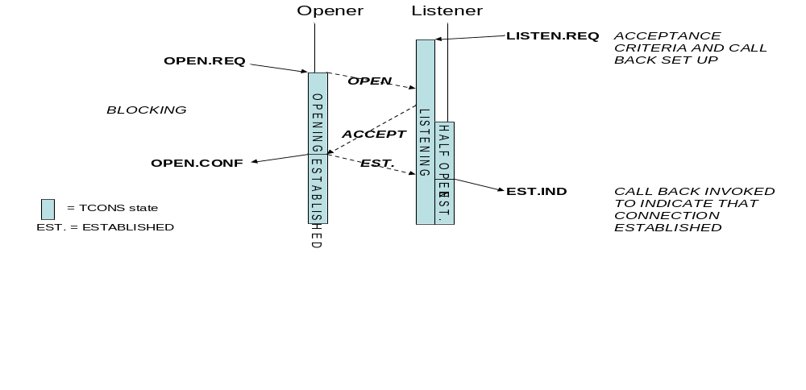
Figure 3-6 Open Sequence
- LISTEN.REQ registers the acceptance criteria (destination port number and source SAP) for accepting an incoming call and sets up a call-back to the process that wants the connection.
- OPEN.REQ requests to make connection. The OPEN.REQ blocks until the OPEN.CONF or a call-back can be registered. At the Opening end a state machine for the connection is created and put in the Opening state.
- When the OPEN PDU reaches the Listener the connection parameters sent with the OPEN are checked against all the acceptance criteria registered by with the various Listen requests.
- Assuming that the incoming OPEN is acceptable, TCONS will then send the ACCEPT PDU to the Opening end of the emerging connection. A state machine for the connection is created at the Listener end and put into the Half Open state.
- When the ACCEPT PDU reaches the Opening end it causes the Opening application to be unblocked, or the call-back to be invoked, and an EST PDU to be sent back to the Listener end. The state machine moves to the Established state.
- When the EST PDU reaches the Listener end the connection is established. The state machine moves to the Established state.
- TCONS only accepts send and receive requests when the connection is established i.e. when the connection state machine within TCONS is in the Established state.

shows what happens when multiple connections are to be established. Separate state machines are created for each connection at each end.
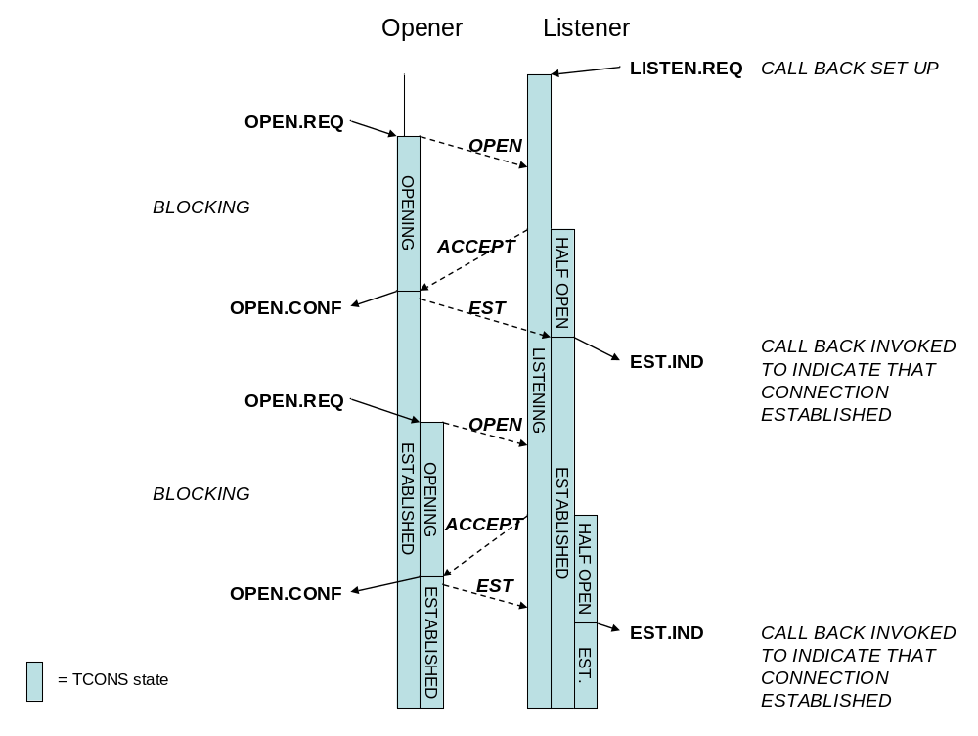
Figure 3-7 Opening of Multiple Connections

It is possible for both ends of a potential connection to be listening for the connection and to request to open the connection at the same time. This situation is illustrated in Figure 3-8.

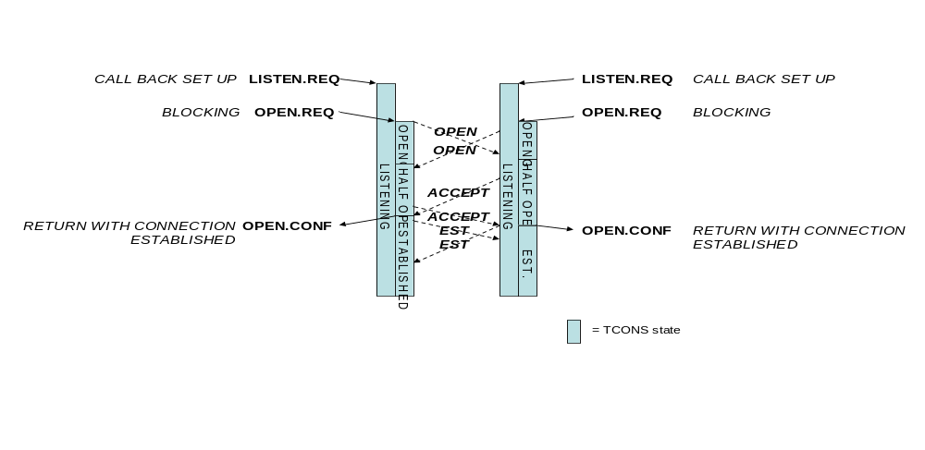
Figure 3-8 Both Ends Opening at Same Time
- Both ends of the potential connection register to listen for an incoming open request.
- The local application requests to open a connection. A connection state machine is created and initialised to the Opening state. An OPEN PDU is then sent to the other end.
- Shortly afterward an OPEN PDU arrives from the other end.
- The parameters of the OPEN PDU are compared to the list of expected connections and the Open accepted. The connection state machine is moved to the Half Open state and an ACCEPT PDU is sent to the other end.
- An ACCEPT PDU arrives from the other end. The connection state machine is moved to the Established state and an EST PDU is sent to the other end of the connection.
- The call-back function registered with the Open request is invoked to tell the application that the connection has been established.
- The connection is now in the Established state so can be used for data transfer.
- An EST PDU arrives from the far end of the connection. Since the connection is already in the Established state the EST PDU is effectively ignored.
The main thing to note in this situation is that the two ends do not have to wait for the EST PDUs to complete the connection.
Figure 3-9 shows what happens if an attempt to open a connection fails because of a communications failure.

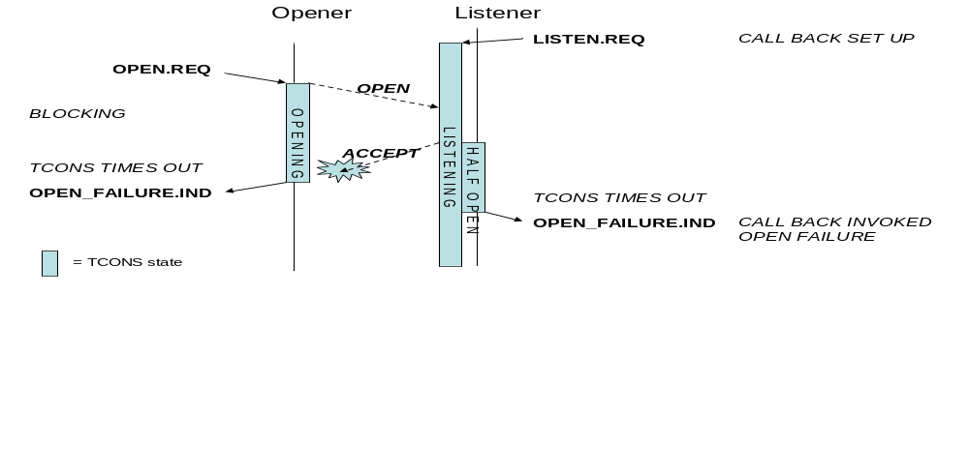
Figure 3-9 Failure to Open a Connection
- LISTEN.REQ sets up the connection acceptance criteria and call-back to the application.
- OPEN.REQ requests to make connection. An OPEN PDU is sent to the Listener end.
- When the OPEN PDU reaches the Listener end it is accepted and a connection state machine created and set to the Half Open state.
- An ACCEPT PDU is sent to the Opening end. This gets lost or corrupted on the way.
- Since the ACCEPT PDU has been lost or corrupted it does not arrive at the Opener end. A timeout timer set during the Open request will expire and cause an Open Failure indication to be made to the application that requested the Open. At this point the connection state machine is destroyed.
- At the Listener end a timeout set when the ACCEPT PDU was sent will expire because no EST PDU is received. An Open Failure indication is then made to the listening application at that end and the connection state machine is destroyed.

Data Transfer
Once a connection has been established then data transfer can take place between the two End Systems connected by the connection.
The normal transfer of data is illustrated by the sequence diagram of Figure 3-10.
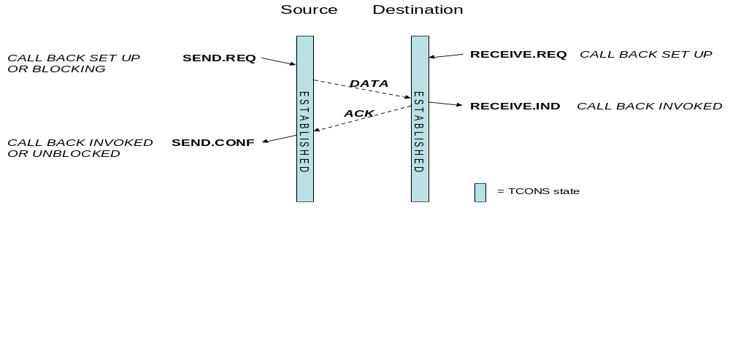
Figure 3-10 Nominal Send and Receive

- RECEIVE.REQ sets up buffer for incoming data and associated call-back for a particular connection.
- SEND.REQ sends data to the destination across the connection. This can be a blocking send or one with a call-back.
- Data arrives at destination through the connection, is put in the receive buffer and the receive call-back routine is invoked.
- When the call-back routine returns, an ACK is sent back to the source via the connection.
- The ACK arrives at the source the send is confirmed either by returning from the call or calling the registered call-back routine.
If the connection has not been established then send or receive requests are rejected as illustrated in Figure 3-11.
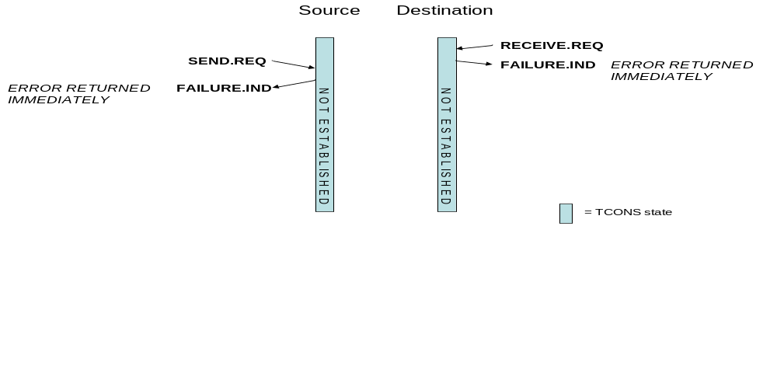
Figure 3-11 Rejected Send and Receive
- TCONS rejects RECEIVE.REQ because connection not established. Call-back not registered by TCONS because of error.
- TCONS rejects SEND.REQ because connection not established. Call-back not registered by TCONS because of error.

Figure 3-12 shows what happens when a data packet is lost.
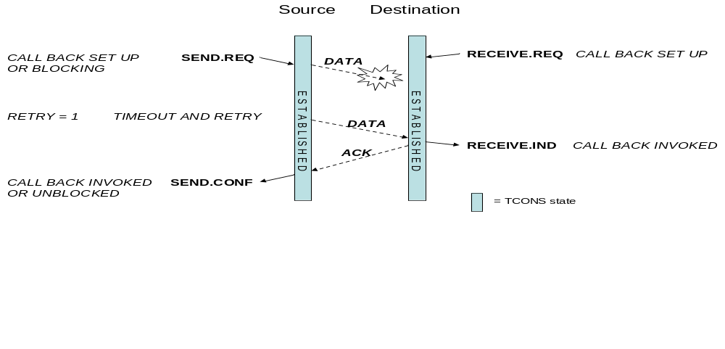
Figure 3-12 Send Retry Due To Lost Data
- RECEIVE.REQ prepares TCONS to receive data i.e. gives it a buffer. TCONS sets up call-back to indicate when data received.
- SEND.REQ sends data. TCONS sets up call-back and also starts timeout timer.
- Data gets lost, is not received by Destination, so no ACK is set back to the Source.
- No ACK received by Source so it times out and retries, sending the data once again. The timeout timer is restarted.
- This time the data does get through. The data arrives at destination, is put in the receive buffer and the receive call-back routine is invoked.
- When the call-back routine returns an ACK is sent back to the source.
- The ACK arrives at the source and the send is confirmed either by returning from the call or calling the registered call-back routine.
The retry has “guaranteed” that the data will be delivered successfully even though the original data packet was lost.
A similar situation arises, when an ACK is lost. This is shown in Figure 3-13.
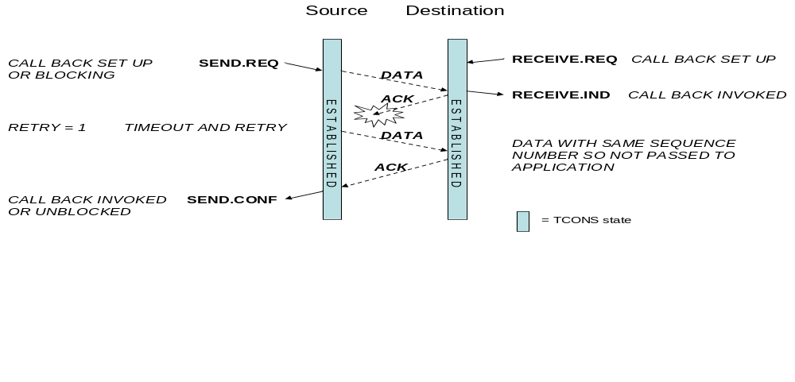
Figure 3-13 Send Retry Due To Lost ACK
- RECEIVE.REQ prepares TCONS to receive data i.e. gives it a buffer. TCONS sets up call-back to indicate when data received.
- SEND.REQ sends data. TCONS sets up call-back and also starts timeout timer.
- Data arrives at destination through the connection, is put in the receive buffer and the receive call-back routine is invoked.
- When the call-back routine returns an ACK is sent back to the source via the connection.
- The ACK gets lost.
- No ACK is received by Source so it times out and retries, sending the data once again. The timeout timer is restarted.
- The data arrives for a second time at destination. Since the data packet has the same sequence number as the previous data packet it is not put in a receive buffer and the receive call-back routine is not invoked. An ACK is, however, sent back to the source to indicate that the packet has been received.
- This time the ACK arrives safely at the source and the send is confirmed either by returning from the call or calling the registered call-back routine.
If the data arrives at the source but has been corrupted then TCONS uses a negative acknowledge (NACK) to indicate this to the source enabling the source to respond more quickly to the fault by resending the corrupted packet. This is illustrated in Figure 3-14.
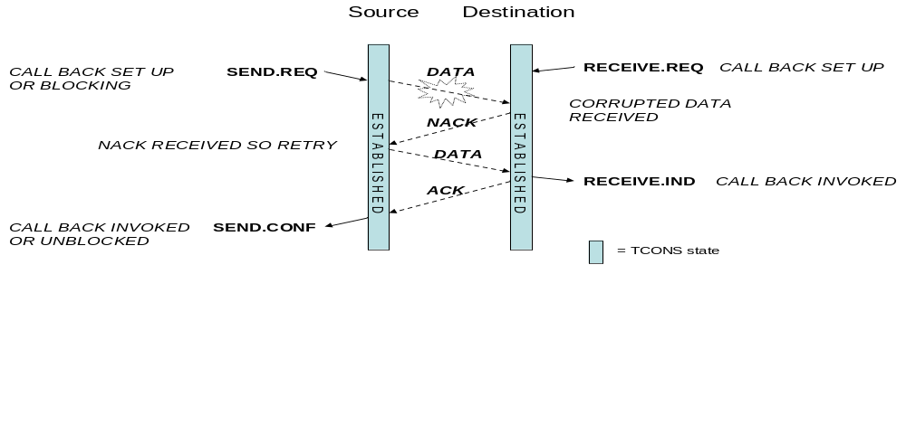
Figure 3-14 Use of NACK to Hasten Retry
- RECEIVE.REQ prepares TCONS to receive data i.e. gives it a buffer. TCONS sets up call-back to indicate when data received.
- SEND.REQ sends data. TCONS sets up call-back and also starts timeout timer.
- Data gets corrupted but is received by Destination.
- The Destination detects that the Data has been corrupted. If the Network PDU header checksum and Guaranteed PDU header checksum indicate that the headers are still valid then the information about the source SAP contained in the Data PDU is still valid. It is the data field that has been corrupted. In this case a NACK (negative Acknowledgement) can be sent back to the Source to speed up the resending of the packet.
- The NACK is received by Source so retries immediately, sending the data once again. The timeout timer is restarted.
- This time the data does get through safely. The data arrives at destination, is put in the receive buffer and the receive call-back routine is invoked.
- When the call-back routine returns an ACK is sent back to the source.
- The ACK arrives at the source and the send is confirmed either by returning from the call or calling the registered call-back routine.
The use of the NACK has allowed the source to resend the data quickly without having to wait for the send timeout to expire.

It is possible that a connection has completely failed in which case TCONS will retry several times, the number of retries depending on the value set in the connection management parameters. This is illustrated in Figure 3-15.
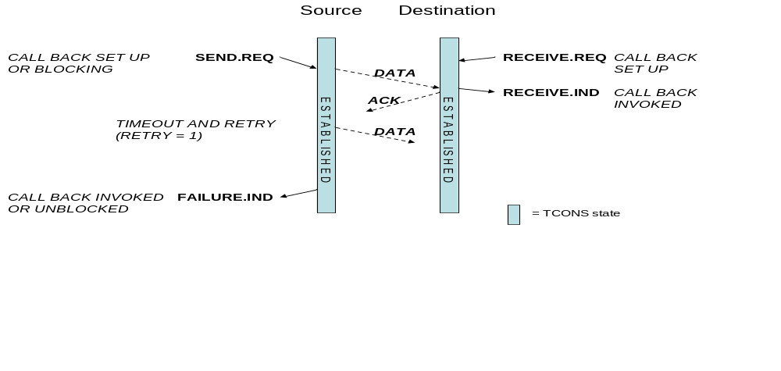
Figure 3-15 Failed Connection
- RECEIVE.REQ prepares TCONS to receive data i.e. gives it a buffer. TCONS sets up call-back to indicate when data received.
- SEND.REQ sends data. TCONS sets up call-back and also starts timeout timer.
- Data arrives at destination through the connection, is put in the receive buffer and the receive call-back routine is invoked.
- When the call-back routine returns an ACK is sent back to the source via the connection.
- The ACK gets lost.
- No ACK is received by Source so it times out and retries, sending the data once again. The timeout timer is restarted.
- Since the physical connection has broken the data does reach the Destination, so no ACK is sent back to the Source.
- No ACK received by Source so it times out and retries, sending the data once again.
- Eventually all the permitted retries will have been sent and the failure is indicated to the Source End System.
- The network manager application on the Source is also informed that a communications failure has occurred.
When a total failure of a connection happens the Network Manager, once informed of the failure may reconfigure the network to use a redundant bus or alternative route through the network.
Another situation that may possibly arise is shown in Figure 3-16. A source has an Established connection but at the Destination has no connection. In effect the connection is broken and the two ends of the connection do not agree on the state of the connection. In this case both ends of the connection are closed. If necessary a new connection can then be established.
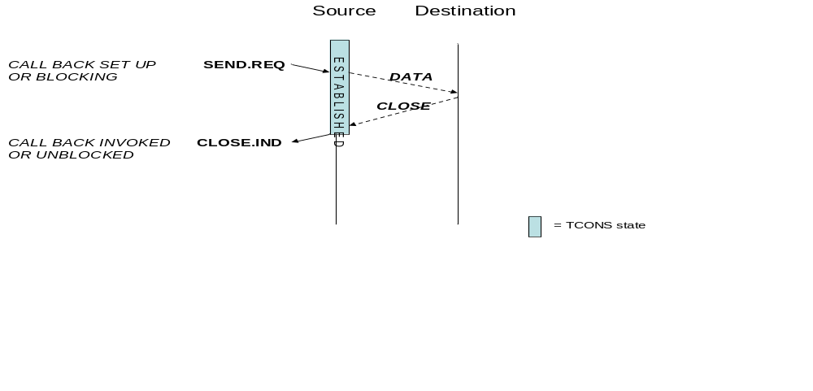
Figure 3-16 Sending to a Closed Connection
- SEND.REQ sends data. TCONS sets up call-back and also starts timeout timer.
- Data arrives at the destination through the connection, but the receiver has no knowledge of the connection so is not expecting data from this connection.
- The destination sends a Close PDU to the source of the original data packet.
- The Close PDU arrives at the source and terminates the connection.
- The Application that set up the connection is informed of the closure of the connection through the close indication invoked by a call to the call-back routine registered during the open of the connection.
Note: If there is a catch-all connection (i.e. receives on the port that the data arrives on regardless of the Source SAP of the data, or receive on any port from any Source SAP) then the data will be passed to that connection.

Close
The Close protocol used to terminate a connection is described in this section. The termination of a connection is shown in Figure 3-17.
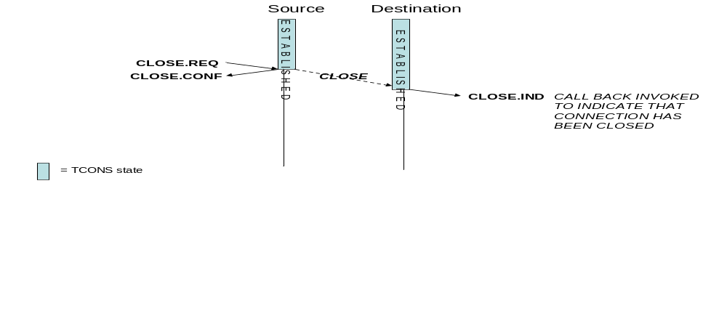
Figure 3-17 Closing a Connection
- The End System at the source address requests to close the connection (CLOSE.REQ).
- TCONS sends out a CLOSE PDU to the other end of the connection, deletes the connection state machine at the source and confirms to the End System that the connection has been closed (CLOSE.CONF).
- The CLOSE PDU arrives at the other end of the connection. TCONS deletes the connection state machine at the destination and indicates to the End System on the destination that was using the connection that the connection has been closed.

It is possible that, due to the loss of a CLOSE PDU, one end of a connection remains open while the other end is closed. In this case when a data PDU is sent from the open end of the connection to the closed end, the closed end will send a CLOSE PDU to the open end, finally closing the connection. This has been illustrated in Figure 3-16.
Another situation can arise when one end of a connection is open and the other end is closed. If the open end requests to close the connection then a CLOSE PDU will be sent to the closed end. When it arrives at an already closed connection the CLOSED PDU is ignored. The result is that the connection is now properly closed, see Figure 3-18.

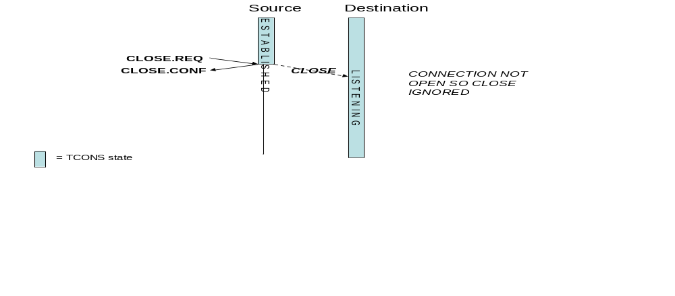
Figure 3-18 Close When Destination Already Closed

Guaranteed Service Protocol Data Units
In this section the Protocol Data Units used by the Prioritized, Guaranteed, Data Delivery service are described.

Generic PDU
The generic PDU format used by the Guaranteed service is illustrated in Figure 3-19. This diagram shows both the Network PDU and the generic Guaranteed Service PDU.
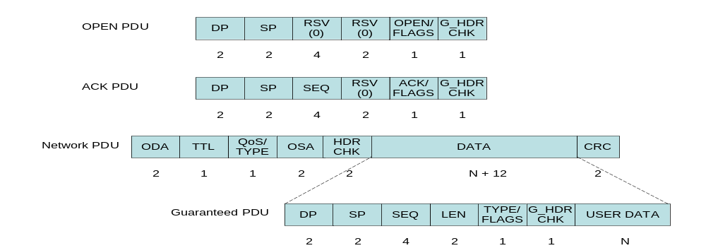
Figure 3-19 Guaranteed Service PDU Format
- ODA is the Onboard Destination Address, which is the address of the node for which the PDU is intended,
- TTL is a Time To Live counter, which is decremented at each TCONS router device -if the count reaches zero the entire PDU is dropped,
- QoS is the Quality of Service for the PDU, which for the Best-Effort PDU is the priority of the PDU,
- TYPE is the type of service being carried – Best-Effort, Guaranteed or Scheduled,
- OSA is the Onboard Source Address, which is the address of the node from which the PDU originated,
- HDR CHK is the Network layer PDU header checksum,
- DP is the Destination Port at the destination node, which is the port on the destination node that the receiving application has to be registered with in order to get the data from the PDU,
- SP is the Source Port at the source node, which is the port on the source which is attached to the application that originated the data in the PDU,
- SEQ is the sequence number of the packet,
- LEN is the length of the user data field in the packet. This is included to support transfer of the data into the user buffer (e.g. using DMA).
- TYPE/FLAGS contains the type of the Guaranteed PDU (Open, Accept, Established, Data , ACK, NACK, and Close) and, and other flags.
- G_HDR CHK is the Guaranteed service PDU header checksum,
- Data is the user data, or higher-layer protocol data unit, that is being sent in the PDU, and
- CRC is a cyclic redundancy check code used to confirm that the PDU has no errors – this CRC covers the entire network PDU including the network header.
ODA and DP together make up the Destination Service Access Point (SAP).
OSA and SP together form the Source Service Access Point (SAP).
The order of the elements in the Guaranteed Delivery PDU is arranged to ease the appropriate forwarding and processing of the PDU. The Network and Guaranteed PDU headers are both a multiple of four bytes easing implementation with 32-bit processing systems.

Open
The Open PDU is illustrated in Figure 3-20. The Sequence and Length fields of the generic Guaranteed Service PDU are currently not used in the Open PDU. These fields are both reserved and should be set to zero. The Data field is not used and is absent. The flags in the TYPE/FLAGS field are also reserved.
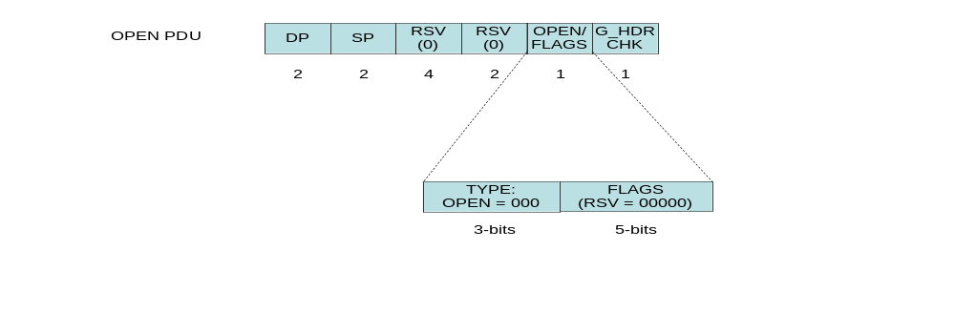
Figure 3-20 Open PDU Format

Accept
The Accept PDU is illustrated in Figure 3-21. As for the Open PDU the Sequence and Length fields are currently not used in the Accept PDU. These fields are both reserved and should be set to zero. The Data field is not used and is absent. The flags in the TYPE/FLAGS field are also reserved.

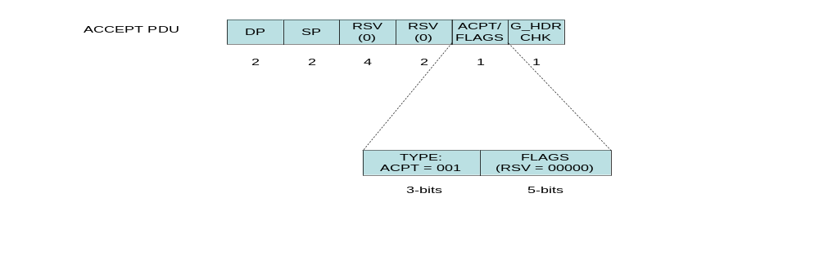
Figure 3-21 Accept PDU Format

Established
The Established PDU is illustrated in Figure 3-22. As for the Open PDU the Sequence and Length fields are currently not used in the Established PDU. These fields are both reserved and should be set to zero. The Data field is not used and is absent. The flags in the TYPE/FLAGS field are also reserved.

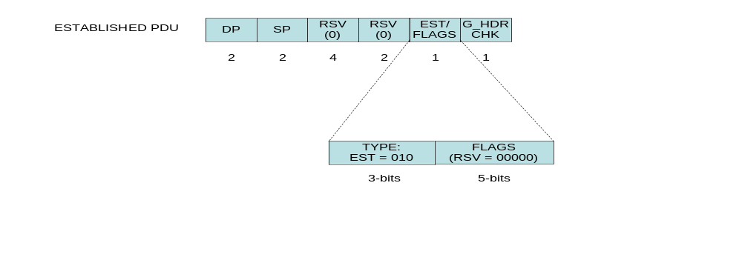
Figure 3-22 Established PDU Format

Close
The Close PDU is illustrated in Figure 3-23. As for the Open PDU the Sequence and Length fields are currently not used in the Close PDU. These fields are both reserved and should be set to zero. The Data field is not used and is absent. The flags in the TYPE/FLAGS field are also reserved.

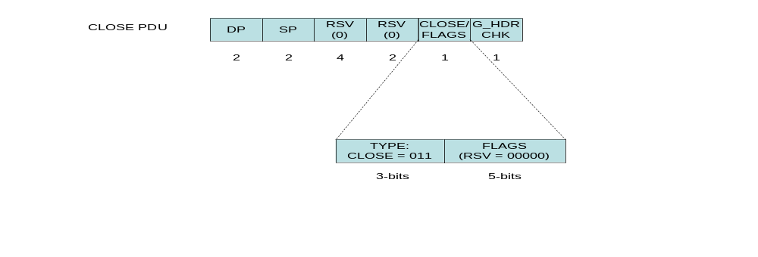
Figure 3-23 Close PDU Format

Data
Figure 3-24 shows the format of the Data PDU for the Guaranteed service. The User Data field is of variable length depending on the amount of data being sent.

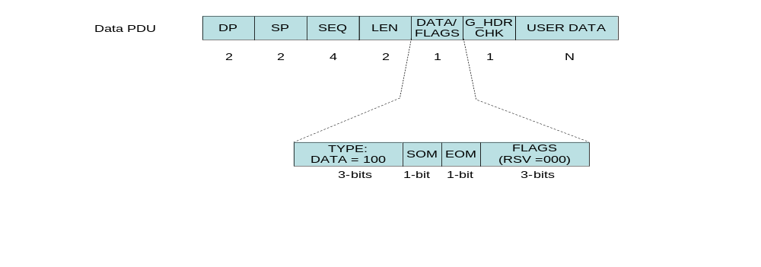
Figure 3-24 Data PDU Format
- SEQ is the sequence number of the Data PDU. When SEQ reaches its maximum value it rolls over to zero.
- LEN is the length of the User Data field of the Data PDU. All Data PDUs of a message are the length of the MTU with the exception of the last one.
- TYPE is set to 100 to indicate that this is a Data PDU
- SOM is the Start Of Message flag which is set when the Data PDU is the first Data PDU of a message.
- EOM is the End Of Message flag which is set when the Data PDU is the last Data PDU of a message. Both SOM and EOM may be set if the message has a total length which is less than the MTU.
- FLAGS are reserved flag bits and should all be set to zero.

ACK
The ACK PDU format is shown in Figure 3-25. The Sequence Number field (SEQ) hold the sequence number of the Data PDU being acknowledged. The Length field (LEN) holds the length of the Data PDU that is being acknowledged. There is no User Data field.
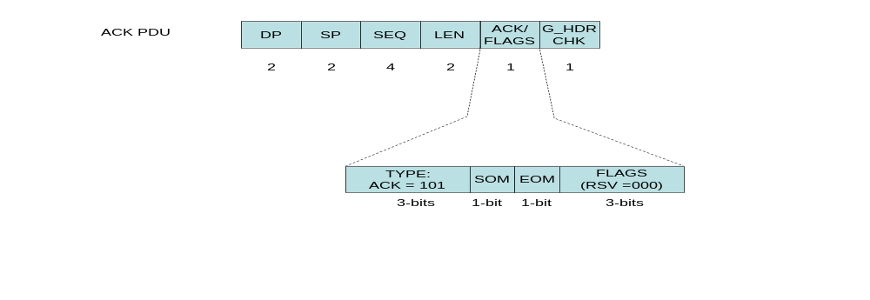
Figure 3-25 ACK PDU Format
- SEQ is the sequence number of the Data PDU that is being acknowledged.
- LEN is the length of the User Data field of the Data PDU that is being acknowledged.
- TYPE is set to 101 to indicate that this is an ACK PDU
- SOM is the Start Of Message flag of the Data PDU that is being acknowledged.
- EOM is the End Of Message flag of the Data PDU that is being acknowledged.
- FLAGS are reserved flag bits and should all be set to zero.

NACK
The NACK PDU format is shown in Figure 3-26. The Sequence Number field (SEQ) holds the sequence number of the Data PDU that was received with the data field and which is being NACKed. The Length field (LEN) holds the length of the Data PDU that is being NACKed. There is no User Data field.

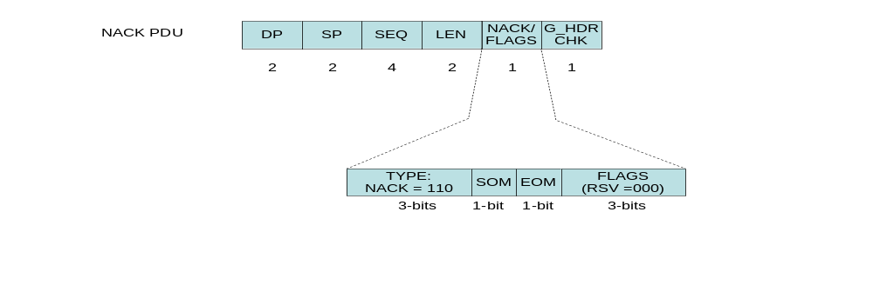
Figure 3-26 NACK PDU Format
- SEQ is the sequence number of the Data PDU that is being NACKed.
- LEN is the length of the User Data field of the Data PDU that is being NACKed.
- TYPE is set to 110 to indicate that this is a NACK PDU
- SOM is the Start Of Message flag of the Data PDU that is being NACKed.
- EOM is the End Of Message flag of the Data PDU that is being NACKed.
- FLAGS are reserved flag bits and should all be set to zero.

Guaranteed Service API
In this section the API for the Prioritized, Guaranteed, Data Delivery service is described covering each of the service primitives.

Listen
Abstract Definition:
T_GD_Listen.Request <DSAP> <SSAP>
T_GD_Established.Indication <connectionID>
T_GD_OpenFailure.Indication

Listen registers an application (End System) to receive and respond to incoming connection requests (Open PDUs). The application specifies what connection requests it will accept: any incoming requests on any port, any requests on a specific port, or requests from specific source SAPs on a specific port. An application may request to listen for more than one connection by calling the Listen function more than once. Two call-back routines are registered: one to be called when an acceptable connection request is received and the other to be called when there is an error, or the connection is closed.

API Prototype:
void T_GD_Listen ( SAP_Type dest_SAP, SAP_Type src_SAP,
void (*CB_establish) (connectionid_t connectionID,
SAP_Type src_SAP, SAP_Type dest_SAP,
int QOS),
void (*CB_error) (connectionid_t connectionID)
)

- SAP_Type dest_SAP is the destination SAP (port number) that the calling process wishes to listen for a connection from. The calling process sets this parameter to Null to receive data from any port. Only one process may be registered to Listen for connection requests from any port. Listen requests with fully specified source and destination SAPs take priority over the Listen with no destination port specified.
- SAP_Type src_SAP is the source SAP (port number) which the calling process wants to listen for a connection from. The calling process sets this parameter to Null if it wants to accept connection requests from any source SAP.
- *(*CB_establish) is a pointer to the call-back routine to be invoked when the requested connection has been established.
- (connectionid_t connectionID, SAP_Type src_SAP, SAP_Type dest_SAP, int QOS) are the parameters of the call-back routine where:
  - connectionid_t connectionID is the connection identifier that the process should use to reference the connection,
  - SAP_Type src_SAP is the source SAP of the connection,
  - SAP_Type dest_SAP is the destination SAP of the connection, and
  - int QoS is a quality of service parameter.
- void (*CB_error) (connectionid_t connectionID) is a pointer to a call-back routine to be invoked if there is an error when trying to send or receive data over a connection.
Return codes:
0: TCONS has accepted the listen request.
-1: An error occurred and TCONS is not able to fulfil the listen request.

Open Connection
Abstract definitions:
T_GD_Open.Request <SSAP> <DSAP> <QOS>
T_GD_OpenConf.Indication <connectionID>
T_GD_OpenFailure.Indication

API Prototype:
connectionid_t T_GD_Open(SAP_Type dest_SAP,
SAP_Type src_SAP,
struct timeval * Timeout,
int Num Retries,
int (*CB_openconf) (connectionid_t connectionID)
)
- SAP_Type dest_SAP is the destination SAP (address and port number) that the calling process wishes to open a connection with.
- SAP_Type src_SAP is the source SAP (port number) that the calling process wants to use to make the connection.
- struct timeval* timeout is a timeout interval for the connection. When data is sent through the connection TCONS will wait for receipt of the data to be acknowledged. If it is not acknowledged within the time interval specified in the timeout parameter, then the source will resend the data. The timeout is for each data send retry.
- int Num Retries is the number of times a packet will be resent when no acknowledgement of receipt is received.
- *(*CB_openconf) is a pointer to the call-back routine to be invoked when the requested connection has been established.
- (connectionid_t connectionID) is a parameter of the call-back routine where:
  - connectionid_t connectionID is the connection identifier that the process should use to reference the connection,
Return codes:
>= 0: The connectionID i.e. the connection identifier to be used by the calling application to refer to the process
-1: An error occurred and TCONS is not able to make the requested connection

Send
Abstract definition:
T_GD_SendData.request <connectionID> <Data> <Priority>
T_GD_SendConf.indication <connectionID>
T_GD_SendFail.indication <connectionID>

API Prototype:
int T_GD_SendData(connectionid_t connectionID,
void *data,
size_t length,
uint8_t priority,
struct timeval*,
void (*CB_Routine) (void *data, size_t length, int result) )

- connectionid_t connectionID is the connection to be used to send the data.
- * data is a pointer to the message to be sent.
- size_t length, is the number of data bytes in the message.
- uint8_t priority is the priority level with which the message must be sent.
- struct timeval* is a timeout interval for which TCONS will wait for the data to be sent. If the data has not been sent and TCONS has not finished with the message buffer by the time the timeout interval has passed, then TCONS will abandon the attempt to send the data and will return the message buffer back to the calling application.
- *(*CB_Routine) is a pointer to the call-back routine to be invoked when the message has been sent. If this is Null then the send will block, only returning once the transfer of the message is complete or the timeout has expired.
- (void *data, size_t length, int result) are parameters of the call-back routine:
  - *data is the pointer to the data message that was sent,
  - size_t length, is the number of data bytes in the message, and
  - int result indicates whether the message was transferred correctly.
Return codes:
0: The message was transferred successfully.
-1: An error occurred and TCONS was not able to transfer the data, even after several retries.

The send routine segments and sends messages, guaranteeing their safe arrival using receipt acknowledgements and a retry mechanism for segments of the message that did not arrive safely on the first attempt. Segments are reconstructed into messages at the receiving end, taking into account the fact that the segments may not arrive in the correct order.

Receive
Abstract definition:
T_GD_ReceiveData.request <connectionID> <Buffer>
T_GD_ReceiveData.indication <connectionID> <Data>
T_GD_ReceiveFail.indication <connectionID>

API Prototype:
void T_GD_ReceiveData_ev(connectionid_t connectionID,
void * data,
size_t length,
void (*CB_Routine) (connectionid_t connectionID,
void *data, size_t length, int result)
)
- connectionid_t connectionID is the connection over which data is to be received.
- * data is a pointer to the buffer into which received data is to be placed.
- size_t length, is the size of the buffer in bytes.
- *(*CB_Routine) is a pointer to the call-back routine to be invoked when a message is received on the specified connection.
- (connectionid_t connectionID, void *data, size_t length, int result) are parameters of the call-back routine:
  - connectionid_t connectionID is the connection on which data was received.
  - *data is the pointer to the buffer into which the received data was placed.
  - size_t length, is the number of data bytes received and put in the buffer, and
  - int result indicates whether the message was received correctly (0 = correctly received, -1 = failure reading data)
Return codes:
0: The Receive Request was accepted by TCONS.
-1: The Receive Request was not accepted by TCONS.

This routine registers a call-back routine which will be called by TCONS when the defined buffer is filled with data. The call-back routine is given the number of bytes that were actually received, as well as a pointer to the buffer that was filled. ConnectionID can have multiple buffers registered to it.

int T_GD_ReceiveData_po(connectionid_t connectionID,
void * data,
size_t length,
struct timeval* timeout)

- connectionid_t connectionID is the connection over which data is to be received.
- * data is a pointer to the buffer into which received data is to be placed.
- size_t length, is the size of the buffer in bytes.
- struct timeval* timeout is the interval for which TCONS will wait for the data to be received. If the data has not been received by the time the timeout interval has passed, then TCONS will abandon the attempt to receive data and will return the registered data buffer back to the calling application. If the timeval parameter is passed as NULL, the routine will wait forever.

Return codes:
>0: Data has been received. The return code gives the number of bytes received and placed in the buffer.
-1: Data not received before timeout.

Close
Abstract definitions:
T_GD_Close.Request <connectionID>
T_GD_CloseConf.Indication <connectionID>
T_GD_Close.Indication <connectionID>

API Prototype:
int T_GD_Close(connectionid_t ConnectionID)

- connectionid_t connectionID is the connection which is to be closed..

Return codes:
>0: The connection has been closed
-1: The connection was already closed

The close function closes the specified connection.

Guaranteed Service Management Parameters
In this section the management parameters for the Prioritized, Guaranteed Data Delivery service are introduced.
Parameters:
- Maximum Transmission Unit (MTU): network wide maximum size of network PDU which applies to the Best-Effort and Guaranteed services.
- Default send timeout interval
- Default receive timeout interval
- Default priority level
- Default number of retries
Status and Statistics:
- Number of messages that failed to reach their intended destination.
- Number of times retry mechanism invoked i.e. number of time segments of messages did not get through on first attempt.
- Number and types of errors: Statistics on any errors that are detected and where possible the cause of those errors are recorded by TCONS. The statistics are useful for understanding and managing any errors that occur on the network.

Scheduled, Data Delivery Service

Scheduled Service Overview

Scheduled Service Primitives

Open
<Dest Addr> <Dest Port> <Src Addr> <Src Port> : <Isoc. Channel ID>

Send
<Isoc. Channel ID> <Message>

Receive
<Isoc. Channel ID> <Buffer>

Close
<Isoc. Channel ID>

IOCTL
<Isoc. Channel> <data rate> : <data rate>

Scheduled Service Protocol

Scheduled Service Protocol Data Units

Scheduled Service API

Open
<Dest Addr> <Dest Port> <Src Addr> <Src Port> : <Isoc. Channel ID>

Send
<Isoc. Channel ID> <Message>

Receive
<Isoc. Channel ID> <Buffer>

Close
<Isoc. Channel ID>

IOCTL
<Isoc. Channel> <data rate> : <data rate>

Scheduled Service Management Parameters

Services required from Layer Below
The TCONS Transport Layer sits above the Network Layer and provides Transport Layer Protocol Data Units (Transport PDUs) to the Network Layer for transfer across the network. The Transport Layer requires the Network Layer to provide the following services:
- Transport PDU transmission
- Transport PDU reception

Interfaces to System Management
There is a Management Interface Base (MIB) provided for each service that the Transport layer provides which contains control and status information used to manage the various Transport Layer services. The content of these MIBs include quality of service (QoS) and fault detection, isolation and recovery (FDIR) information.

TCONS network layer

Overview
The SOIS Network layer transfers packets of information across an underlying onboard network comprising one or more sub-networks, offering both a connectionless and a connection-oriented network layer service.
It provides support to the Transport layer with an asynchronous datagram delivery service with no guarantee about delivery or the order of delivery and an isochronous datagram delivery service which ensures deterministic delivery (i.e. delivery with a certain amount of time).
The Network layer is responsible for:
- Routing Network PDUs (datagrams) towards their intended destination
- Multiplexing various network protocols across the underlying network
- Address translation from network logical address to physical address.
- QoS at the network level which include
  - Deterministic delivery of datagrams when required
  - Priority based forwarding of datagrams when required
- Fault management
The Sub-Network Dependent Convergence layer of TCONS is responsible for:
- Fragmentation and de-fragmentation of datagrams to suit a particular sub-network. Note that any fragmentation is to be contained with the sub-network that implements fragmentation i.e. fragmentation on entry to a sub-net is followed by de-fragmentation on exit from the sub-net.
These functions are part of the data-link functionality and hence are specified within the Onboard Bus and LAN service specification.

Network Datagram Delivery Service
In this section the Network Datagram Delivery service is described.

Network Datagram Service Overview
This Network Datagram Delivery service provides a prioritized, asynchronous datagram delivery service. This service may be used to transfer Best-Effort and Guaranteed Delivery PDUs across the onboard network.

Network Datagram Service Primitives
In this section the service primitives for the Network Datagram Delivery service are presented.
There are six primitives used by this service:
- Send Datagram Request which requests to send a datagram,
- Send Datagram Confirmation which indicates that the datagram has been sent,
- Receive Datagram Request which registers to receive datagrams,
- Receive Datagram Indication which indicates that a datagram has been received,
- Receive Datagram Response which provides a buffer in which the contents of the datagram is to be placed, and
- Receive Datagram which transfers the datagram into the buffer.

Send Datagram Request
Name: N_Send.request
Parameters: <Dest Address> <Data> <Priority>
Sends a transport layer PDU towards the specified destination.

Send Datagram Confirmation
Name: N_SendConf.indication
Parameters: <Flag>
Confirms that a transport layer PDU has been sent and that the buffer holding the datagram is no longer needed by the Network layer.

Receive Datagram Request
Name: N_ReceiveData.request
Parameters: none
Requests to receive datagrams from the Network layer. Only one Receive Datagram Request needs to be made for each protocol supported.

Receive Datagram Indication
Name: N_ReceiveData.indication
Parameters: <Dest Addr> <TTL> <QoS> <TYPE> <Src Addr> <Transport PDU Hdr>
Indicates that a datagram has been received and provides the header information.

Receive Datagram Response
Name: N_ReceiveData.response
Parameters: <Buffer>
Provides a buffer for the contents of the incoming datagram to be placed into.

Receive Datagram Confirm
Name: N_ReceiveData.confirm
Parameters: <Data>
Transfers the incoming datagram into the provided buffer.

Network Datagram Service Protocol
In this section the protocols used by the Network Datagram service are described with the aid of sequence diagrams.
The Network Datagram service protocol is illustrated in Figure 4-27.
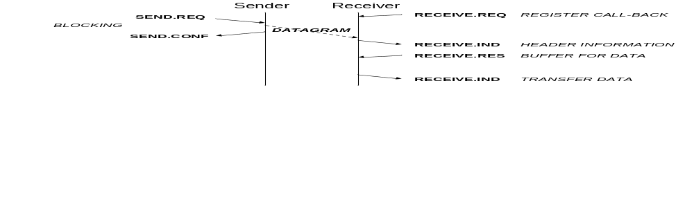
Figure 4-27 Network Protocol
The Transport layer at the receiver must first register a call-back function (interrupt service routing) with the Network service. It does this using the Receive request with a pointer to the call-back function as a parameter. One receive request must be made for each Transport layer protocol that is to be used.
To send a Network PDU (datagram) the sender uses Send Request. The Network layer will then send the datagram and give the send confirmation (SEND.CONF) as soon as the datagram has been transmitted. There is no acknowledgement at the Network level. When the datagram arrives at the receiver if this is the final destination of the datagram then a Receive indication is made to the appropriate Transport layer protocol as determined by the TYPE field in the datagram header. The Receive indication passes the Network and Transport PDU header information to the Transport layer so that the Transport layer can sort out which buffer the received data should be placed in. If there is an appropriate buffer (e.g. user application buffer registered with the Transport layer) then the Receive Response is made to the Network layer to pass it a pointer to this buffer. The Network layer then transfers the received data to the buffer.
If the datagram’s final destination is not the same as the receivers address then the Network layer will forward the datagram towards its final destination using information from a network routing table. This is illustrated in Figure 4-28.
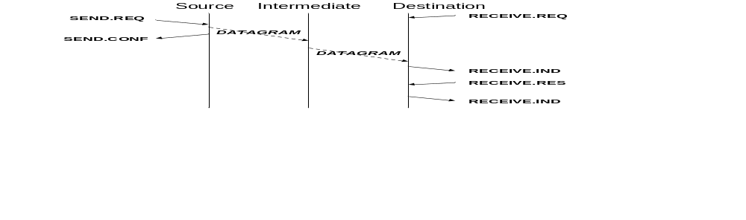
Figure 4-28 Routing a Datagram

If a datagram is lost or corrupted then there is no indication made to the receiver as shown in Figure 4-29.
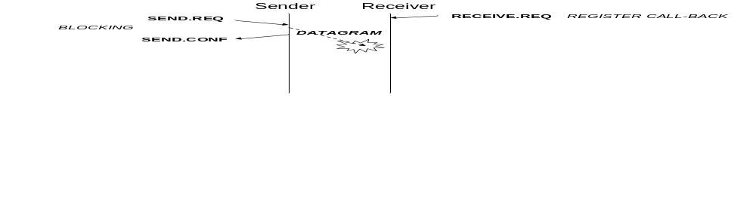
Figure 4-29 Datagram Error

Network Datagram Service Protocol Data Units
In this section the Protocol Data Units used by the Network service are described.
Figure 4-30 shows the structure of the Network Protocol Data Unit (PDU).
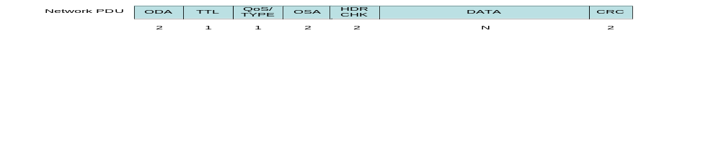
Figure 4-30 Network Protocol Data Unit Format

- ODA is the Onboard Destination Address, which is the address of the node for which the PDU is intended,
- TTL is a Time To Live counter, which is decremented at each TCONS router device -if the count reaches zero the entire PDU is dropped,
- QoS is the Quality of Service for the PDU, which for the Best-Effort PDU is the priority of the PDU,
- TYPE is the type of service being carried – Best-Effort, Guaranteed or Scheduled,
- OSA is the Onboard Source Address, which is the address of the node from which the PDU originated,
- HDR CHK is the Network layer PDU header checksum,
- User Data is the user data, or higher-layer protocol data unit, that is being sent in the PDU, and
- CRC is a cyclic redundancy check code used to confirm that the PDU has no errors – this CRC covers the entire network PDU including the network header.

Network Datagram Service API
In this section the API for the Network service is described covering each of the service primitives.

Send
Abstract definition:
N_Send.request <Dest Address> <Data> <Priority>
N_SendConf.indication <Flag>
API Prototype:
Int N_SendData(Addr_Type dest_Addr, Addr_Type src_Addr,
void * data,
size_t length,
uint8_t priority,
struct timeval*,
)

- Addr_Type dest_Addr is the destination address that the transport layer PDU is to be sent to.
- Addr _Type src_ Addr is the address of the source of the transport layer PDUs that are to be sent.
- void *data is a pointer to a buffer containing the transport layer PDU, which contains the data to be sent.
- size_t length is the amount of data to be sent. The amount of data to be sent must be less than or equal to the MTU.
- uint8_t priority is the priority level with which the transport layer PDU must be sent.
- struct timeval* is a timeout interval for which TCONS will wait for the transport layer PDU to be sent. If the data has not been sent and TCONS has not finished with the data buffer by the time the timeout interval has passed, then TCONS will abandon the attempt to send the data and will return the data buffer back to the Transport layer.

Return codes:
0: The datagram has been sent successfully.
-1: an error occurred and the Network layer was unable to send datagram.

Receive
Abstract definition:
N_ReceiveData.request
N_ReceiveData.indication <Dest Addr> <TTL> <QoS> <TYPE> <Src Addr> <Transport PDU Hdr>
N_ReceiveData.response <Buffer>
N_ReceiveData.confirm <Data>

API Prototype:
There are two functions related to network level datagram reception. One sets up a call-back (interrupt service routine) which is called whenever a datagram arrives at the receiver. Network and Transport Layer PDU header information is passed to the call-back routine when a datagram arrives and the call-back routine determines which buffer the data should be placed in. The second function is used to pass a pointer to the buffer to the Network layer so that the User data contents of datagram can be put in the buffer.

void N_ReceiveReq( void *(*CB_Routine) (Addr_Type, u8int_t, u8int_t, Addr_Type, void *)
- *(*CB_Routine) is a pointer to the call-back routine to be invoked when a datagram arrives at the receiver.
- (Addr_Type, u8int_t, u8int_t, Addr_Type, void *) are the parameters of the call-back routine where:
  - Addr_Type refers to the destination address in the Network PDU (datagram)
  - u8int_t refers to the time to live in the Network PDU
  - The second u8int_t refers to the priority and type information in the Network
  - The second Addr_Type refers to the address of the source of the Network PDU.
  - void * is a pointer to the Transport layer PDU information contained in the data field of the Network PDU.

void N_ReceiveResponse(void * data)
- *data is a pointer to a buffer passed by the calling process, into which data arriving at the port is to be placed. The buffer must be large enough to hold the data field of a packet as large as the MTU.

Return codes:
>0: Data has been placed in the buffer provided. The return code gives the number of bytes received and placed in the buffer.
-1: Error during transfer of data to buffer.

Network Datagram Service Management Parameters
In this section the management parameters for the Network service are introduced.
Parameters:
- Maximum Transmission Unit (MTU): network wide maximum size of network PDU which applies to the Best-Effort and Guaranteed services.
- Receive queue size: the number of PDUs that can be stored in the receive queue as reported by TCONS. If the receive queue is full TCONS will either drop the new packet or replace the oldest packet in the queue by the newly arrived packet. Higher priority packets have priority over lower priority ones, so that a more recent low priority packet is replaced before an older higher priority packet. Note that TCONS implementations do not have to provide a receive queue.
- Transmit queue size: the number of PDUs that can be stored in the transmit queue as reported by TCONS. If the transmit queue is full TCONS will reject further send requests. The transmit queue length may be zero, in which case TCONS transmits data directly from the data buffer passed down by the user application. Note that TCONS implementations do not have to provide a transmit queue.
- Routing table
- Address translation table for each type of sub-net
Status and Statistics:
- Number of dropped packets: The number of dropped PDUs is recorded. The statistics about data loss are useful for understanding and managing any errors that occur on the network.
- Number and types of errors: Statistics on any errors that are detected and where possible the cause of those errors are recorded by TCONS. The statistics are useful for understanding and managing any errors that occur on the network.

QoS Fields
There are four classes of QoS:
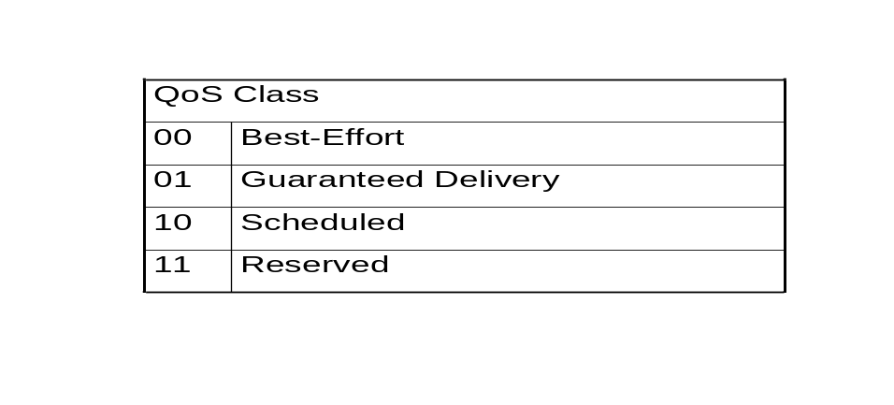
The QoS fields are as follows:
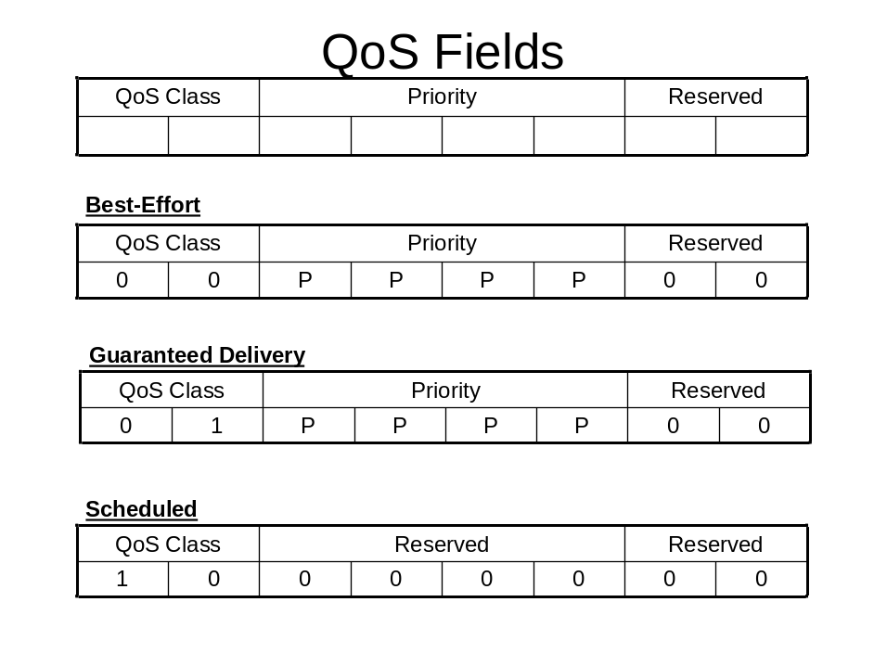
The QoS field is sent with the Network PDUs (datagrams). This avoids complicating the network routing tables with channel based QoS and means that the source, routers and destination can respond to the required QoS rapidly.
QoS parameters fall into two types:
- End-to-end QoS Parameters (Transport Layer QoS) e.g. time-out, number of retries, which are held at the end-points only. Routers do not need to know about these QoS parameters.
- QoS Parameters Needed by Routers (Network Layer QoS) e.g. priority, which are passed in packets and can be rapidly accessed and acted upon by each router.

Sub-Network Dependent convergence sublayer
In this section the sub-network dependent convergence layer is described.
NOTE: I WOULD LIKE TO RENAME THIS THE “GENERIC DATA-LINK LAYER”

Convergence Service Overview
The Sub-Network Dependent Convergence layer (Convergence layer) provides the functions of the network layer which are dependent upon the specific underlying bus/network, including: address translation from logical to physical address and fragmentation/de-fragmentation. The Convergence layer is concerned with communication across a single sub-network (bus/network/link).
The Sub-Network Dependent Convergence layer effectively provides a common interface to all the different buses or sub-networks that may be used within a SOIS network. It is sub-network, i.e. beneath the Network layer, and it is dependent on the sub-network, i.e. its implementation is entirely dependent on the particular sub-network. The layers above the Sub-Network Dependent Convergence layer are completely independent of the underlying bus/network/link.
The Convergence layer sends and receives Network PDUs over a specific bus/network (e.g. MILSTD1553 or SpaceWire). It translates the destination address from the Network PDU into a bus/network specific address that will forward the Network PDU towards its final destination. If necessary it also fragments the Network PDUs into a series of small fragments that can be sent sequentially over a bus that cannot handle the transfer of complete packets. For example, for MILSTD1553B data buses the Network PDU must be fragmented into a number of messages of up to 32 16-bit words. The fragments of the Network PDU are reassembled to form the Network PDU as they leave the Convergence layer. It is assumed that fragments sent across a bus will always arrive in the same order in which they were sent. SOIS does not support PDU fragmentation where bus cannot guarantee that the fragments will arrive in the same order as they were sent. Fragmentation in SOIS is different to fragmentation in IP in that the fragments are always reassembled into complete Network PDUs before they leave the Convergence layer. This means that fragmentation is invisible to the Network and Transport layer protocols. The Network and Transport layers can therefore assume that all buses/networks support datagrams of the MTU and that a single MTU applies for the entire network.
The rules for encapsulating the data onto the underlying sub-network are highly dependent on that underlying bus or link. For example, for operation over a SpaceWire network no fragmentation is necessary, while operation over CAN bus will require fragmentation into 8-octet frames. The interface to the Convergence service is sub-network independent and therefore represents a common interoperable interface.

Convergence Service Primitives
In this section the service primitives for the Convergence service are presented.
There are six primitives used by this service:
- Send Datagram Request which sends a datagram to a specified physical address,
- Send Confirmation which confirms that a datagram has been accepted for sending,
- Send Datagram Failure Indication which indicates that the sub-network was unable to send the datagram,
- Receive Datagram Request which registers a higher layer to receive data,
- Receive Datagram Indication which indicates that a datagram has been received, and
- Receive Fail Indication which indicates that there was an error receiving a datagram.
These primitives and their associated parameters are described in the following sections.

Send Datagram Request
Name: C_Send.request
Parameters: <Physical Address> <Network PDU>
Sends the Network PDU (datagram) towards the required physical destination, fragmenting the Network PDU if necessary

Send Datagram Confirm
Name: C_SendConf.indication
Parameters: none
Indicates that the datagram was sent successfully.

Send Datagram Failure
Name: C_SendFail.indication
Parameters: <Error>
Indicates that there was a problem sending a datagram. The Error parameter can be used to indicate the reason that the Network PDU could not be sent.

Receive Datagram Request
Name: C_ReceiveData.request
Parameters: <Call-back Routine>
Registers to receive data from the Convergence layer.

Receive Datagram Indication
Name: C_ReceiveData.indication
Parameters: <Network PDU>
Indicates that a datagram has been received and provides the received Network PDU to the Network layer, re-assembling the PDU from fragments if necessary.

Receive Datagram Response
Name: C_ReceiveData.Response
Parameters: <Buffer>
Reads Network and Transport layer PDU header information and provides a buffer into which the user data field of the Transport layer PDU can be placed.

Receive Datagram Confirm
Name: C_ReceiveConf.indication
Parameters: none
Confirms that a complete Network PDU was received without error.

Receive Datagram Failure
Name: C_ReceiveFail.indication
Parameters: <Error>
This indicates that there was a problem receiving a datagram. The Error parameter can be used to indicate the reason that the Network PDU could not be sent. For example a fragment may have been lost or corrupted resulting in an invalid CRC/Length for the PDU.

Convergence Service Protocol
In this section the protocols used by the Convergence service are described with the aid of sequence diagrams.
The Convergence service protocol is illustrated in Figure 4-31.
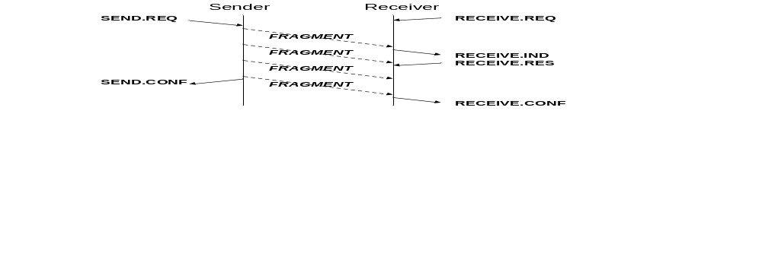
Figure 4-31 Convergence Service Protocol
The sender makes a send request to the Convergence service to send a Network PDU. If necessary the PDU is split into a number of small fragments, as determined by the underlying bus/network/link. These fragments are then transferred one at a time to the receiver, which may be the final destination or an intermediate node. The Receiver must register to receive data from the Convergence layer using Receive Request. Once this has been done then whenever the first fragment of a Network PDU arrives at the receiver the Network layer is notified using Receive Indication. The Network layer responds by reading the Transport and Network layer header information from the PDU and then passing a buffer pointer to the Convergence layer into which the rest of the PDU data is transferred. Once the complete PDU has been sent it is confirmed to the sender (SEND.CONF). Once all the fragments have been received, reassembled and passed to the Receiving Network layer the reception of the PDU is confirmed (RECEIVE.CONF). If there are any errors the send and receive confirmation are replaced by failure indications (SEND.FAIL and RECEIVE.FAIL).
The Convergence layer is responsible for re-assembling all the fragments of the Network PDU. Fragments are sent in order and arrive in the order in which they were sent. If a fragment goes missing, the entire Network PDU is lost.

Convergence Protocol Data Units
The Protocol Data Units used by the Convergence layer are dependent upon the particular bus/network/link that is being used.

Convergence Service API
In this section the API for the Network service is described covering each of the service primitives.

Send
Abstract definition:
C_Send.request <Physical Address> <Network PDU>
C_SendConf.indication
C_SendFail.indication <Error>

API Prototype:
Int N_SendData(PhyAddr_Type Phy_Addr,
void * data,
size_t length,
)

- PhyAddr_Type Phy_Addr is the physical address of the intermediate or final destination of the PDU on the local sub-network.
- void *data is a pointer to a buffer containing the Network layer PDU, which contains the data to be sent.
- size_t length is the amount of data to be sent. The amount of data to be sent must be less than or equal to the MTU.

Return codes:
0: The datagram has been sent successfully.
-1: an error occurred and the Convergence layer was unable to send datagram.

Receive
Abstract definition:
C_ReceiveData.request <Call-back Routine>
C_ReceiveData.indication <Network PDU>
C_ReceiveData.Response <Buffer>
C_ReceiveConf.indication

API Prototype:
There are three functions related to network level datagram reception. One sets up a call-back (interrupt service routine) which is called whenever a datagram arrives at the receiver. The second is used to read the Network and Transport Layer PDU header information a word (4 bytes) at a time from the receiver. The third function is used to transfer the user data field of the Transport layer PDU to a buffer provided by the user application (via the Transport an Network layer services).

void C_ReceiveReq( void *(*CB_Routine) )
- *(*CB_Routine) is a pointer to the call-back routine to be invoked when a datagram arrives at the receiver.

int C_ReceiveRead()
Returns the next received data word (4 bytes) of the datagram. The first time this is called it will return the first word of a datagram, then the second word and so on.

void C_ReceiveData( void *buffer )
- void * buffer is a pointer to the user buffer where the user data field of the PDU is to be transferred.
This starts transferring data from where the C_ReceiveRead finishes, i.e. the first word transferred is the one after the last one read by the C_ReceiveRead. The number of bytes transferred into the provided buffer is returned by the function.

In addition to these functions it may be necessary to have function for the following:
- Link Status Indication
- Link Control Request

Convergence Service Management Parameters
Convergence Service Management parameters include:
- Size of fragments

THings TO BE CONSIDERED
Timeout, Number of Retries, Retry on alternate bus, Simultaneous send on redundant bus

Schedule table
Thought was given by the group on which layer an isochronous schedule table should be in:
If the schedule table is in the dependent layer then the schedule table becomes specific to each bus. For a router between two or more sub-networks there is the need to have multiple scheduling tables one for each sub-network, giving rise to the possibility of conflict.
If the schedule table is in the independent layer it provides single scheduling table on each node covering several buses. For this reason it seems best to have the schedule table in the independent layer.
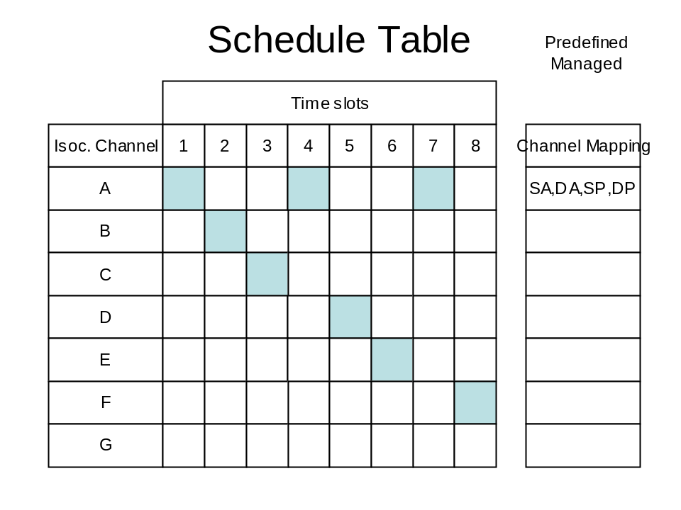
TBD

Scheduled Delivery
In the Scheduled Delivery service, the transfer of Service Data Units (SDUs) by a user is scheduled in the network schedule table. The network schedule table operates on a fixed period with a defined phasing to spacecraft time and the various software application schedules. Slots: Intervals of time/bandwidth are allocated within the schedule. One or more slots are assigned to a channel. The application requests specific channels for specific isochronous transfers.. Traffic not scheduled is aggregated into slots left over after the scheduled channels are allocated.

Such considerations may lead to the selection of specific classes or subsets of the TCONS (e.g., reliable or unreliable modes of data transmission).

ACRONYMS AND ABBREVIATIONS

ACK Positive Acknowledgment
ADU Application Data Unit
CCSDS Consultative Committee for Space Data Systems
CFDP CCSDS File Delivery Protocol
ES End System
ESOC European Space Operations Centre
ESTEC European Space Research and Technology Centre

FDIR Fault Detection Isolation and Recovery
FIFO First-In-First-Out

GUI Graphical User Interface
LSB Least Significant Bit

MIB Management Information Base
MSB Most Significant Bit
NACK Negative Acknowledgment

OSI Open Systems Interconnection
PDU Protocol Data Unit
QoS Quality of Service
SAP Service Access Point
TBS To Be Supplied
TC Telecommand
TCP Transmission Control Protocol
TM Telemetry
TPDU Transport Protocol Data Unit
UDP User Datagram Protocol
UT Unitdata Transfer

AN SDL MODEL OF TCONS
This Annex provides state diagrams of the Consultative Committee for Space Data Systems (CCSDS) TCONS using the ITU SDL graphical representation technique. These representations are intended as a pilot boat to navigate specifications for implementers.
GRAPhical symbol convention
This section describes a summary of graphical symbols used in following state diagrams. Detail information about symbols is described in the SDL recommendations.
 | Decision symbol
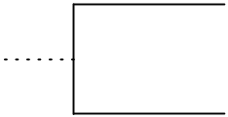 | Comment symbol
 | Input symbol
 | Output symbol(dotted: optional)
 | Procedure call symbol
 | Start symbol
 | State symbol
 | Task symbol
 | Stop symbol
 | Macro symbol

ITU Recommendation Z.100: Specification and Description Language SDL(Blue Book, Volume X.1 – X.5, 1988, ITU General Secretariat – Sales Section, Places des Nations, CH-1211 Geneva 20)

