**The CCSDS Proposed Draft Recommended Standard for   
Electronic Data Sheets.**

R. Melvin1 – Scisys Ltd

M. Perrotin2, A. Valverde3 – ESA  
F. Ahlendorf 4– Jena Optronik  
E. Durand5 – Airbus  
J. Cornforth6 - Thales

1SCISYS Ltd, (Clothier Road, Bristol, BS4 5SS, UK, [richard.melvin@scisys.co.uk](mailto:richard.melvin@scisys.co.uk)), 2Maxime.Perrotin@esa.int, 3Alberto.Valverde@esa.int, 4Jena Optronik, (Otto-Eppenstein-Straße 3, 07745 Jena, Germany, Falk.Ahlendorf@jena-optronik.de), [5emmanuel.e.durand@airbus.com](mailto:5emmanuel.e.durand@airbus.com), 6[john.cornforth@thalesaleniaspace.com](mailto:john.cornforth@thalesaleniaspace.com)

**Introduction:** Electronic Data Sheets (EDS) is a concept that has been proposed to allow the capture of the relevant information about a piece of equipment. This should capture the relevant aspects not just to enable an efficient exchange of information (easing its maintainability, enforcing consistency, etc.) but should also enable the development process to be partially automated.

The Consultative Committee for Space Data Standards (CCSDS) has been active on these topics and focusing on interoperability, both on-board and on the ground segments. The CCSDS Spacecraft Onboard Interface Services (SOIS) [1] working group is looking at the On-board communications architectures and how would it be possible to maximise reuse and minimise component integration efforts. SOIS Electronic Data Sheets (SEDS) [2] is the result of that effort; a proposed standard which allows specifying the data interfaces for a device or other onboard component in a standardised form.

**Concept**

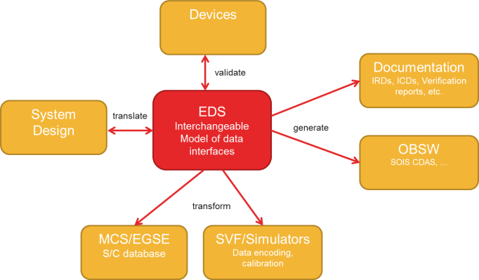  
The SEDS standard defines a data interchange format, designed to allow tools to talk to tools. It is scoped to the interchange of device or software component data between a vendor and an integrator. As such, it is able to avoid any complications posed by issues outside that scope.

It takes the form of an XML schema, derived from various pre-existing standards, that captures a model of those interfaces.

Given suitable tooling, this model can be used, directly or after appropriate transformation, in any or all of:

* system design
* device and system-level validation
* EGSE testing, LEOP and flight operations
* simulator and OBSW development and test.

**Outline of the Standard**



A SOIS datasheet contains device metadata plus multiple namespaces, which:

* define a variety of data types;
* declare interfaces referencing those types;
* contain components that specify a behavioural mapping between those interfaces.

In turn, components:

* are defined by a set of state machines;
* that control the execution of a set of activities.

The data types supported are:

* Single-valued scalars , which can be limited by ranges;
* Arrays;
* Containers;

**Usage within SOIS Architecture:** A SOIS datasheet for a device primarily consists of a pair of behavioral mappings between interfaces:

* Between the byte-stream interfaces of the subnetwork layer and the raw TM/TC interfaces of the access layer.
* Between that access layer and the calibrated TM/TC interfaces of the functional layer.

In the SOIS architecture, these mappings and interfaces have conventional names, as shown below.



Depending on the onboard software architecture in use, either or both of those abstract behavioral mappings may or may not correspond to actual processing done by the OBSW. In the case where they did, the result would look something like the diagram below.

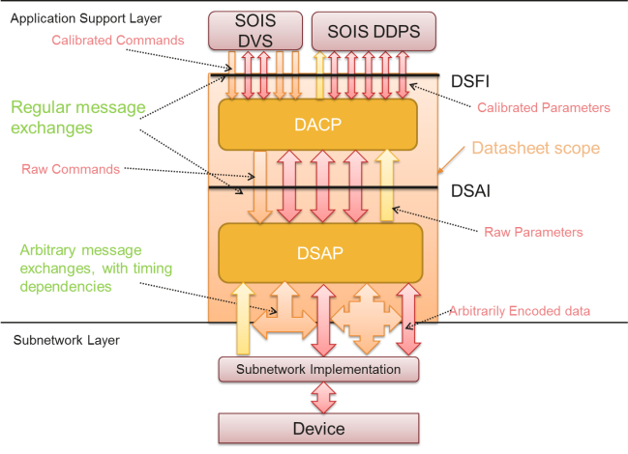

In it, all of the behavior defined in the datasheet is directly performed as part of the SOIS Application Support Layer, i.e. it corresponds to the device-specific parts of the implementation of the relevant SOIS services. This means that devices with arbitrarily-complex encoding, timing and behavioral rules can be encapsulated behind a set of simple, regular interfaces uniformly usable by any onboard application.

Note that even in the case where the onboard processing did not correspond so directly to the datasheet contents, the fact that a datasheet can be proven to contain all the information required to do that processing correctly should still be of considerable value.

**Reference Tooling:** TheSOIS EDS Reference Tooling has been developed to validate the standard, and promote its adoption. This is available under standard ESA licensing terms, as a simple command-line application, or embeddable java library. It supports:

* Documentation generation
* Datasheet authoring, including the import of pre-existing bulk data in the form of packet layouts, calibration curves, etc.
* Validation of datasheets according to the static completeness and correctness rules defined in the standard.
* Datasheet and/or device verification by consistency checking against a log of the device data from a particular test run
* A standard plugin mechanism for writing code generators for any particular context, language and environment.
* Export to ESA’s TASTE[4] system design tool.

**Interoperability** **Testing:** As SEDS is a tool interchange format, as it is critical to provide a means of verifiying the compability of a given tool with the standard. The main tool for such testing is the interoperability test data set, which is a set of artificial datasheets designed to provide a more comprehensive test-bed than any similar numbr of real datasheets.

In order to provide complete coverage of key combinations of schema features without exponential growth in the number of tests cases, the standard technique of all-pairs testing[3] is used. This involves generating test data according to a vector of factors in such a way that each possible pairing of factors is catered for by at least one test case.

It is supplemented by several datasheets created for real-devices, including:

* ESA NPAL Camera
* Thales MEMS Rate Sensor
* Jena Optronik Star Tracker

**Standardisation progress:** The Proposed Draft Recommended Standard[1] was sent out for Agency Review in mid-2015. All resulting RIDs have been processed and an updated draft produced , which is currently awaiting editorial re-review.

Two ESA study projects, Vericocos[5], and Deploying Plug and Play Avionics[6], are currently underway with goals including validation of the standards and further development of the reference tooling.

**References**:

[1] Spacecraft On-board Interface Services (SOIS)

<http://cwe.ccsds.org/sois>

[2] CCSDS 867.0-R-0: XML Specification for Electronic Data Sheets.

[3] <https://en.wikipedia.org/wiki/All-pairs_testing>

[4] <http://taste.tuxfamily.org/>

[5] ESA 4000113294/15/NL/FE

[6] ESA NC+IPL-PTE/LF/mo/1063.2014