CCSM Teleconference Notes, 10 December 2024

Attendees
E. Barkley, P. Crump, M. Gnat, W. Eddy, C. Haddow, H. Kelliher, M. Unal

Agenda (ass adjusted at the teleconference)
- General Announcements
- Action Items Check
- Fall 2024 meetings summary – any comments, inputs?
- CDE, SMURF. SPDF update check/status
- Resource check re Best Practices production
  - Also, can we get a good title for this – rather than “SM Lite”, “Baby SMURF”, etc (e.g., Best Practices, Issue 1: Minimal Implementation for Essential Interoperations)?
- Approach re updating to latest Eclipse/papyrus tooling
- FRI xml schema update
- Prototype exercise in constructing a configuration profile via UML model and FRM (E. Barkley)
- AOB
  - Frequency Band naming
  - Additional teleconferences given late spring meetings (CSSM 8 meeting invitation sent during the meeting)

Notes

General Announcements
- CDDS confirmed as official WG
- D. Fischer confirmed as new CESG Chair
- J. Lux confirmed as new SE AD
- M. Skarati confirmed as new MOIMS AD
- S. Singh very likely to be confirmed as new SOIS AD
- Spring 2025 meetings to be at APL (Laurel, Maryland, USA) starting June 9

Action Items Check
- 6 action item(s) closed
- 4 action item(s) postponed
- 0 new action item(s)
- 13 action items open
- See updated spreadsheet for details

Comments (if any) on Fall 2024 meeting summary
- No comments

---Remainder of the Meeting Transcript Summary---
(editorial note: Teleconference recording was turned on at this point during the teams meeting; subsequently, the transcript was summarized by ChatGPT. What follows is a summary of the main points with some very minor editing (indicated by “<eb>”) provide a couple of points that I think the summarization missed. There is also a transcript available, but due to the very low level nature of the conversation back-and-forth, this is not being posted to the minutes meeting. It is being distributed to those that attended the meeting. If you did not attend and would like to read the low-level detailed conversation please let E. Barkley know.)

The transcript outlines a detailed discussion on a variety of technical topics related to service management levels, functional resource models, configuration profiles, and XML schema definitions. Here is a summary:
Key Discussion Points:
- Service Management Level 0 (SML0):
  - Colin Haddow presented an update on the draft documentation for Service Management Level 0, which defines the simplest service configuration and assumptions.
  - Key points include simplified constraints, limited trajectory information, and minimal configuration requirements.
- Configuration Profiles:
  - The discussion emphasized defining templates and providing clear parameters for telemetry, ranging, and other services. Concerns about duplicate or conflicting parameter definitions were raised.
  - Examples were presented to ensure clarity and reduce potential errors in defining configuration profiles.
  - <eb> Also noted that the work is promising as it shows that configuration profiles can be constructed with current UML Model + FR approach
  - <eb> The presentation is in the meetings material for teleconferences for 2024: https://cwe.ccsds.org/css/docs/CSS-SM/Meeting%20Materials/2024/Telecons/241209-ConfigProfileAndFRM.pptx?d=w74eff59a9577427e99e48848b3c937cf
- Functional Resource Instance (FRI) XML Schema:
  - Updates were shared regarding schema generation, emphasizing the need for compatibility and ease of substitution for functional resource instances.
- Frequency Band Naming:
  - There was debate about aligning frequency band naming conventions in XML schemas with those in the CCSDS 320 document. Maintaining hyphens in names was considered important for readability.
- Best Practices and Standards Integration:
  - Concerns were expressed about referencing and updating multiple interrelated standards to ensure consistency and completeness.
- Negative Returns and Error Handling:
  - The team discussed how to handle cases where service requests cannot be fulfilled. Options such as introducing a “rejected” status in the service package were explored.
  - <eb> Addition of a rejected status in the SPDF is the approach that will be taken; note that this lines up with state machine (rejected state) developed by M. Gnat – image posted in meeting chat: 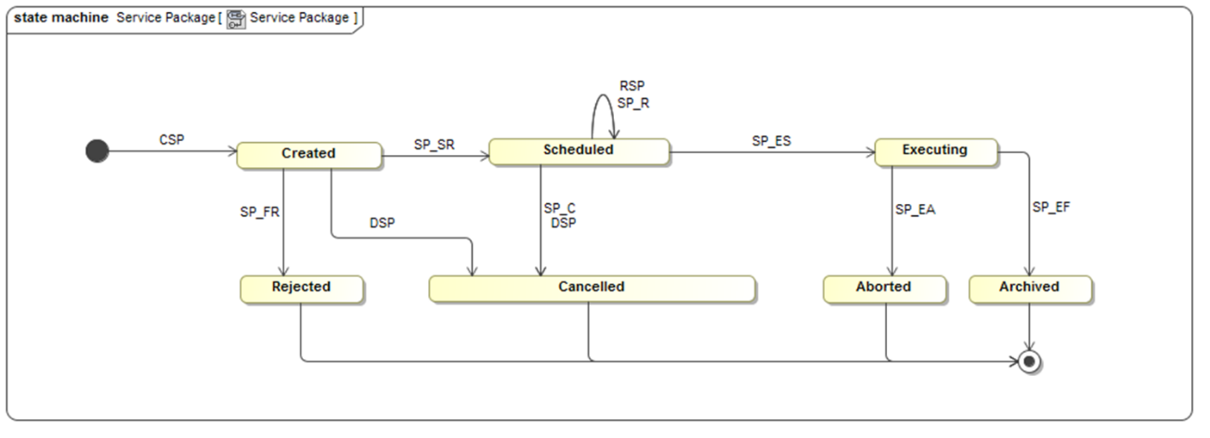

- Tooling Updates:
  - Uncertainty was noted regarding potential impacts of updates to the Eclipse tooling environment used for modeling and schema generation.
Action Items:
- Colin to continue refining the SML0 draft and provide examples for configuration profiles.
- Address schema issues with Holger to ensure compatibility and clarity in FRI handling.
- Finalize frequency band naming conventions in collaboration with the CCSDS 320 team.
- Investigate how negative returns are handled and consider documenting best practices for error handling in service management.
General Notes:
- Emphasis was placed on keeping solutions simple and manageable while addressing edge cases.
- The team highlighted the importance of pre-mission testing to resolve potential issues in configuration profiles.

Next Teleconference:
Our next teleconference is scheduled for January 14, 2025.

