CCSM Teleconference Notes, 04 April 2024

Attendees
E. Barkley, M. Gnat, H. Kelliher, T. Pham

Agenda (as modified during the teleconference) and notes

General Announcements
- Reminder to everyone to register if you plan to attend the Spring meetings, even if attendance is virtual
- Lunar Interoperability Forum will take place at the Executive Office Building of the White House (believe or not)
- CESG publication poll of a yellow book (which was a technote) about the “ICD” for the FRM model release to SANA is currently in progress
  - once the yellow book is formally published it means that the FRM Magenta book will appear in the list of CCSDS publications as the magenta book essentially implied a reference to the yellow book
- CSSM Developer’s developers confierence was held on March 26; expect to have some updated input from Goonhilly/UKSpace, and DSN/NASA
- Have a had couple of splinter session regarding FRM and usage in a managed service context
- Good response so far re request for participation in CDDS WG
- M. Gnat noted that at the IOAG meeting earlier today that a policy issued by the US Govrnment addressing development of Coordinated Lunar Time had been released (also confirmed by multiple news reports cited by meeting attendees)

Action Items Check
- 3 action item(s) closed
- 4 action items postponed
- 0 new action items
- 7 action items open
- See updated spreadsheet for details

- Spring Meetings Agenda/Area Calendar/planning
- Reviewed consolidated area level set of meetings
  - No adjustments or changes requested

Updated on FRM Splinter sessions (so far)
- E. Barkley provided a verbal summary
  - Appears that working with the FRM requires us to make use of (OID,FRIN) tuple to probably identify configuration parameters (OID = Object Identifier, FRIN = Functional Resource Instance Number)
  - C. Haddow noted that in the CDE we currently make use of the FRNickname for modResParm (to request modification of a particular configuration parameter for a particular tracking pass)
- M. Gnat walked through a draft of a technote he prepared (which in turn was part of an identified need as the FRM splinter session)
  - Agreed that the FRINs, being part of the configuration profile, which in turn is part of the service agreement can be assigned as part of the service agreement
    - it can be noted that the service user should be the responsible party for creating the functional resource identifiers but, as a data format definition, this cannot be made mandatory
    - Given that the modResParm is part of the CDE, addition of the FRIN should be accompaned by notes indicating assignment in the service agreement and suggested party
    - recommended roles for the parties involved can be examined and more directly indicated in the SMASH
  - Introduced the notion of a sub-FRIN to deal with multiple transfer servcies that are already in a particular services instance (e.g. differentiate among multiple RCF transfers for the telemetry service at Ka-Band vs multiple RCF transfer services for telemetry service at X-Band)
  - Technote to be uploaded to the CWE by M. Gnat

Configuration profile agency examples (and/or request for inputs)
  - Walked through the NASA/DSN configuration profile example
  - Noted that this generally seems to be in line with FRM
  - Noted that it may difficult for some agency to produce other similar XML formatted artefacts – an example of configuration information from an ICD is also good
  - A reminder to WG membership to provide agency configuration profile examples (if it okay to do so)

Update (if any) re XML instance example for SSF aliasing matching UML diagram from March 12 telecon
  - C. Hadow walked us throught an XML snippet (highlighted in blue)
(XML Snippet)
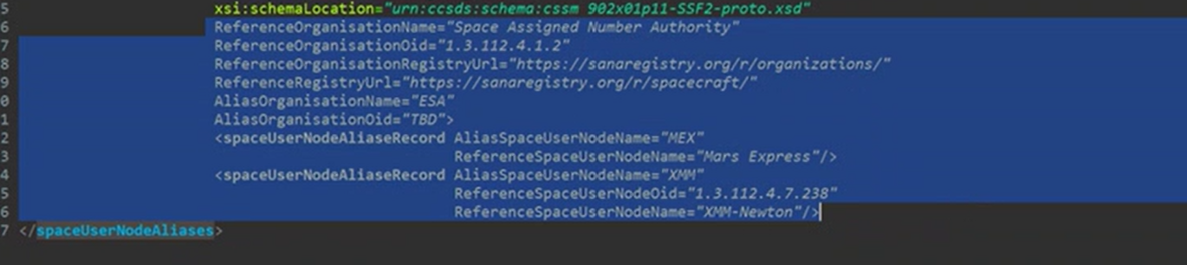
  - Agreed that the approach looks reasonable
  - also looked at the UML model to provide better background/context (see below)
  - Discussed the scoping – would this be applicable to SMURF/service requests for example
    - Agreed that this would be applicable to the SSF only
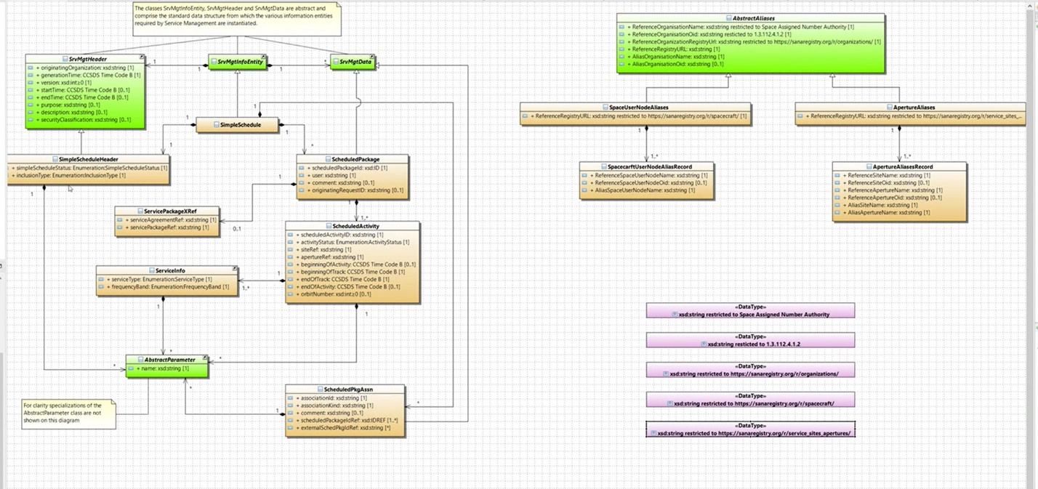

AOB
- Concept book outine/suggested updates
  - Walked through presentation on updates needed for the concept book (see below for presentation)
  - agreed with the suggested changes
  - will be examined further at the upcoming spring
  - general consensus is that the concept book simplified significantly and sharpen to be more to the point – rough estimate is that the document can likely be 50 pages shorter

Next Teleconference
Our next teleconference will be determined at the Spring 2024 meetings.

Annex A – files from teleconference
- XML SSF aliasing prototype example from C. Haddow
- Presentation form M. Gnat on updates to Concept Book

