CCSM Teleconference Notes, 08 August 2023
Revision A: corrected item 3 d) a. (version number for demonstrated need)

Attendees
E. Barkley, D. Bliss, W. Eddy, M. Gnat, C. Haddow, H. Kelliher

Agenda and notes

General Announcements
- SACP project creation poll was requested, have not seen formal CMC poll yet
- All of the SLE update books have been “adopted” by the CMC (final approval for publication)
- LunaNet developer’s forum meeting (November 14) is now listed as part of the fall meetings (see CCSDS.org - LunaNet Developers Forum)

Action Items Check
- 1 action item(s) closed
- 6 action items postponed
- 0 new action items
- 7 action items open
- See updated spreadsheet for details

XML Schema namespace
- We are already using a namespace (ccsds:schema:cssm:1.0.0)
- All released schemas have that name space
- If we change, we need to update everything in SANA
- Agreed to drop versioning in namespace – going with ccsds:schema:cssm
  - Agreed to add a version number if need is demonstrated in the future
- Agreed to go with “cssm” prefix for the namespace
- C. Haddow to revise the schemas and books as needed for updated namespace

Developer’s Forum
- Reviewed the latest plan (see image in appendix)
- Agreed to initiate first teleconference in late September
- Participates likely to attend so far are identified as being from
  - DLR
  - NASA/GSFC
  - NASA/JPL
  - UKSPACE
- E. Barkley to email H. Dreihahn re ESA participation

Github process/procedure
- Considerations re internal CCSDS procedures
  - E.g., CESG release – point to appropriate tag in GitHub
  - Discussed setting up repository landing pages that can re-direct to location
    - W. Eddy to send an example of landing page
  - Also we will check with T. Gannett re blessing for updating url without RID for release
    - C. Haddow to send an email to T. Gannett

Working Session: Papyrus
- Appears that application of style is a bit different
  - Project level with install of papyrus on top of EMF, by selection style sheet with RCP (pre-packaged version of papyrus)
- We were able to get a consistent style application between the RCP and EMF versions of papyrus
- C. Haddow pointed out some other tips
  - Association lines
    - Need to set the owner to be “Association” (not “Classifier”)
    - Need to set “Navigable” to “true”
  - Routing of lines
    - No default for rectilinear routing via stylesheet, but rectilinear can be set as the default for a class diagram vis PapyrusDiagramLine Style

AOB (None)
Our next teleconference is on Tuesday, August 29.

Appendix

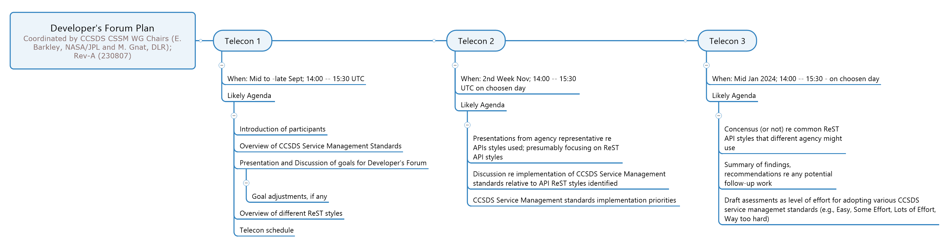
Figure 1 -- Developer's Forum, Latest Plan

