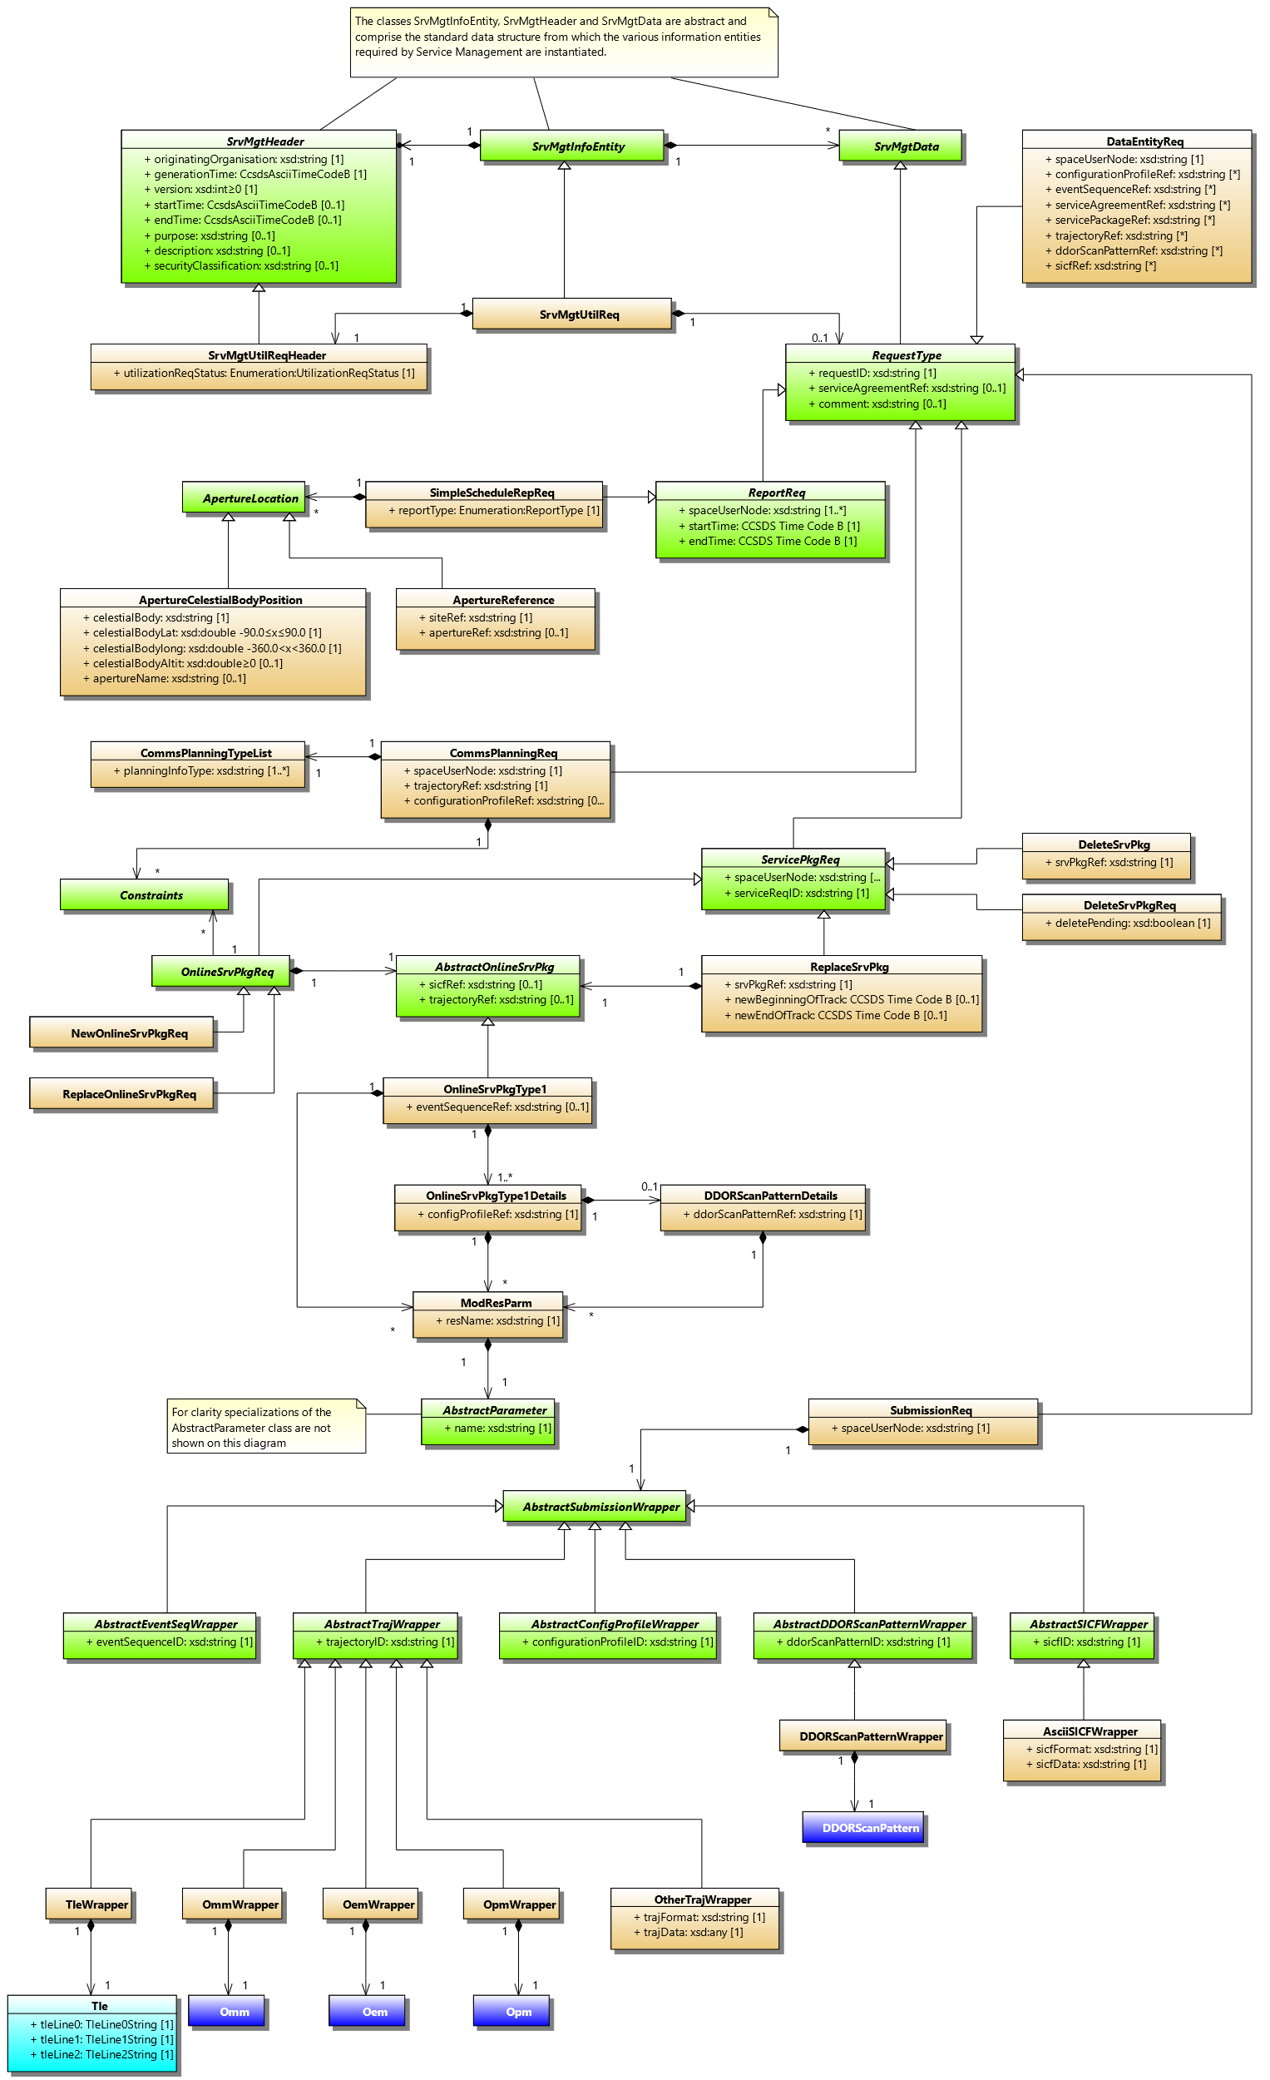

**SMURF UML Model from W0.09**

**SMURF UML Model Blue 1 Candidate (i.e. current version)**