CCSM Telecon/Webex, 07 February 2023

Attendees
H. Akasaka, E. Barbieri, E. Barkley, D. Bliss, A. Crowson, W. Eddy, M. Gnat, C. Haddow, H. Minori, Y. Kimura, M. Unal

Agenda (as adjusted at the teleconference) and notes

General Announcements
- K. Scott has retired/stepped down as WG chair for SIS-DTN
- CESG mid-term teleconference to be held February 21st
- SLS Coding & Synch WG have renamed CADU (Channel Access Data Unit) to be SMTF (Sync-Marked Transfer Frame)
  - Generally, SMTF is a better term
  - Causes a bit of involved work for CSS Area FRM
- H. Dreihahn has initiated a survey in the CSS Area for retiring the SLE API Magenta books

Final Check of RID Dispositions
- SMURF, RID 11, agreed to adjust the multiplicity of the srvPkgRef from [0..*] to [1] for the DeletSrvPkg class – ie., revise such that only one provider Id is present which is consistent with only user Id (“serviceReqID”) being present in the ServicePkgReq
- No other inputs re final RID dispositions
  - Dispositions now deemed to be completed, “official”

UML Class Diagrams + Eclipse
- C. Haddow reported that UML diagraming in Eclipse can not “natively” handle model naming changes (which MagicDraw/Cameo System Modeler can)
- C. Haddow indicated that the issue can be addressed via shell scripts which is developing

Action Items Check
- 1 action item closed
- 4 action items postponed
- 1 new action item
- 11 action items open
- Note: Not all actions checked due to actionee not present

Updated Book Publication Planning
- CDE-M2 – appears that it can be published this year
- SMURF – appears that it can be published this year pending prototype report evaluation
- SPDF -- insufficient prototyping at this time to confidently project publication this year

Developer’s Forum Follow-up
- no objections to goal statements noted
- reported that there has been either interest expressed or preliminary engagement for appropriate management at
  - DLR
  - JAXA (interest re goals 4, 5, 6)
  - NASA/DSN
  - NASA/NSN
  - UKSPACE
- ESA will check

GitHub Sandbox Repository + Schema naming (not addressed)
- See notes related to sandbox repository action item

AOB (None)
- UML modeling check re Event Sequence Abstract Class diagram
  - Reviewed draft UML class diagram for abstract event sequence (see last page)
  - Noted that stereotypes are not needed, not quite correct – can just be abstract classes
  - Noted that abstract sequence state does not need to have the TemporalPlacement class in a composition relationship as the stateStart and stateEnd data members are defined to be of this (TemporalPlacement) type
  - Multiplicity shown between SvcSequence and the forward|return|Additional services sequence states should be shiffted to be between abstract sequece and SvcSequenc

Next Telecon.
Our next regular telecon date is March 14.

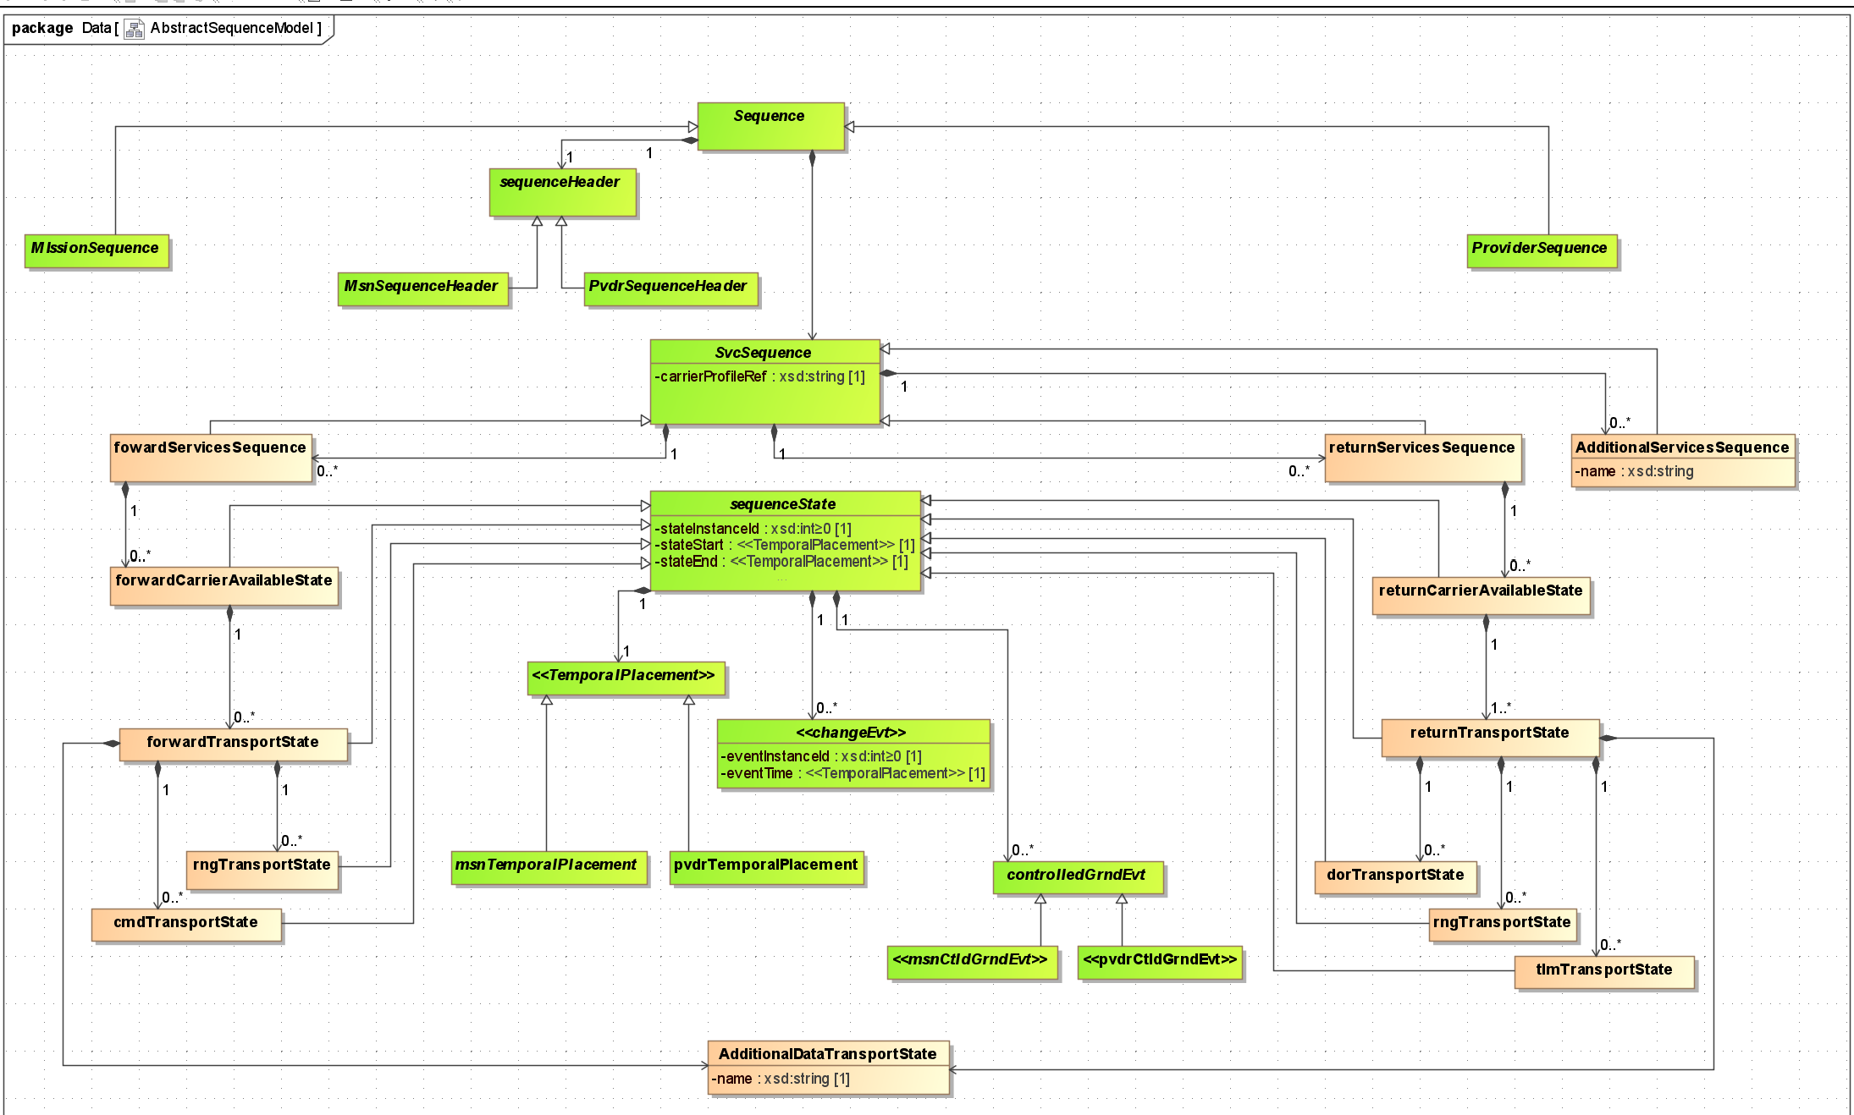
Figure 1 - Draft Abstract Event Sequence Diagram

