CCSM Telecon/Webex, 13 September 2022

Attendees
E. Barbieri, E. Barkley, D. Bliss, C. Ciocirlan, A. Crowson, W. Eddy, M.Gnat, H. Kelliher

Agenda and notes

General Announcements
- Meeting registration is now open – for Boot camp, just resgister for CSSM WG on Friday morning
- Draft CSTS Orange book completed AD review, request for updates sent out and subsequently processed; final AD check pending (prior to publication polling)
- SLE Referfence Model update has gone through AD review and will have some minor changes (prior to agency review)
- Resolution let for publicaton of MD-CSTS B-2
- CESG recently had a meeting on CCSDS terminology – CSS Area will be expected to produce some sort of listing of terms used

Action Items Check
- 1 action item(s) closed
- 0 action item(s) postponed to next telecon
- 1 action item(s) postponed to fall meetings
- 1 new action item(s) added
- 5 actions total currently open
- NOTE: Two actions are pending for the WG in general – service agreement parameters, and agency implementaiton plans; these are both due at the fall meetings
- See updated spreadsheet for details

Fall Meetings Planning
- Reviewed the room allocations/time slots available for the CSSM WG meetings
- Reviewed the list of topics to be covered at the fall meetings
- Noted that Friday morning is reserved to allow attending the boot camp session
- See figure 1 below for the CSSM WG meetings and list of topics for the meetings so far
- E. Barkley will post detailed agenda about two weeks prior to the start of the fall meetings
- Note that an area dinner is planned for Tuesday evening of the meetings week

Status of Books
- CDE M2, SMURF, and SPDF currently in CESG polling to go to agency review
- (Ed. note – all three books have been approved for going to CMC polling; some relatively minor editorial clean-up has been noted/request)

Preview/preparation re joint D-DOR/CSSM WG meeting
- Walked through presentation on proposed approach for coordination between D-DOR and CSSM WGs
- Noted that there are few corrections needed to the presentation
- Question of schema master raised – wil have to discuss with D-DOR WG
  - It may be that the D-DOR WG prefers to specificy on the basis of an instance document rather than XML Schema per se

Use of Eclipse Modeling Framework re UML diagrams follow up (if any)
- No follow-up at this time

Brief Update re EVSQ
- Draft EVSQ is being updated with the following approach:
  - An abstract sequence defintion is being developed
    - This will define the carrier and data transport states that govern all event sequences
    - This will also define extension points so that provision of services not in the common set of CCSDS member agency services (e.g., NASA/DSN beacon tone service) can be included/addressed via standardized extension mechansim
  - A mission sequence, as specialization of the abstract sequence will be defined
    - This will add the mission sequence specific data classes/parameters to the abstract sequence
  - A provider sequence, as specialization of the abstract sequence will be defined
    - This will add the provider sequence specific data class/parameters to the abstract sequence

AOB (none)

Next Telecon
Our next telecon date is October 4th.
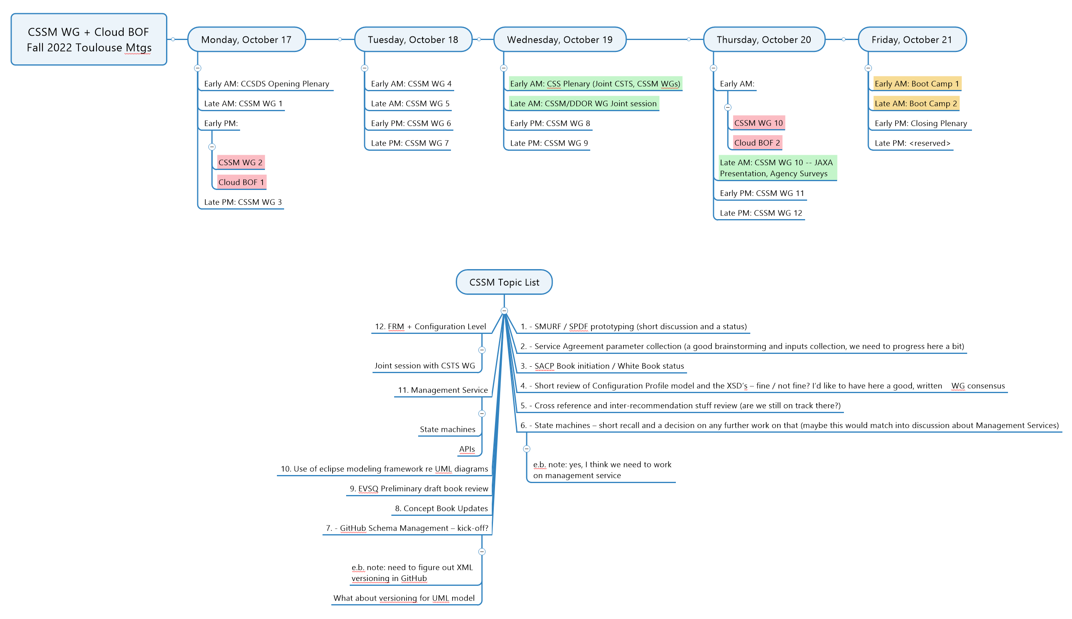
Figure 1: Fall Meetings Time Slots & Topics List

