CCSM Telecon/Webex, 19 July 2022

Attendees
E. Barbieri, E. Barkley, D. Bliss, C. Ciocirlan, A. Crowson, M. Gnat, H. Kelliher, M. Unal

Agenda and notes

General Announcements
- Agency review polling requested for SMURF, SPDF
- CSS Area Cloud Computing BOF, had its first meeting June 23
  - Next mtg to be on July 21
    - Concept paper outline
    - Survey of “Big 3” cloud provider native functionalities
    - Abstraction/summary of CSS data transfer standards (SLE, CSTS)

Action Items Check
- 0 action item(s) closed
- 2 action item(s) postponed to next telecon
- 0 action item(s) postponed to fall meetings
- 1 new action item(s) added
- 7 actions total currently open
- See updated spreadsheet for details

Status of Books
- CDE M2, SMURF, and SPDF are awating secreteriat processing to be submitted for polling to release for agency review

Service Agreement Parameters – Follow-up
- M. Gnat walked through the service agreement classificaitons that he has developed
- Classifications adjusted during the meeting
- A request/Action item to the WG: please fill in service agreement parameters, with regard to the classifications listed, for your particular TT+C service provider to the extent possible; input requested by early October

Referential framework diagram update - comments
- Reviewed the lastest diagram sent out by M. Gnat
- Noted that the “standing order” was not represented in the diagram (aka the request for the request)
- M. Gnat agreed to update the diagram further

XML Schema master
- Agreed that individual book captains or their delegates will be responsible for the XML schema pertinent to that book
- Agreed that there should be an overall “schema master” looking out for proper use of “foundational” schemas as well as consistency in schema style of construction (e.g., schemas to date favor use of attributes vs explicit elements), etc. is needed
- Discussed use of GitHub and agreed that individual schema contributors should be added as contributors (rather than use the CCSDS email distribution list set up CSS Area Git Hub repository admin)
  - Implies that contributors will have to have a github.com account (which is free)
- A. Crowson agreed to consider schema master duties – to be discussed further

AOB
- Follow up re NAV WG XML Schema versioning issues (from NAV WG presentation shared at last telecon)
  - A. Crowson noted that the main issue that comes acrss in the NAV WG presentation is filename vs versioning consideration
  - Agreed that some sort of use case write-up and/or presentation is needed to get at what is really desired re schema versioning; e.g.,
    - Visibility with regard to superceeded schemas (more about standards implementation)
    - Tracking inter-depedencies for such cases as CSSM XML Schema making use of NAV WG NDM XML Schemas (more about schema construction/standards development)
- IOAG Service Catalog 1 (SC1) updates
  - M. Gnat presented the proposal he made at the latest IOAG Service Catalog Working Group meeting
  - The main ascpect of the proposed revision of SC1 is shown below
  - Agreed that the proposed revision makes sense from a CSSM WG perspective
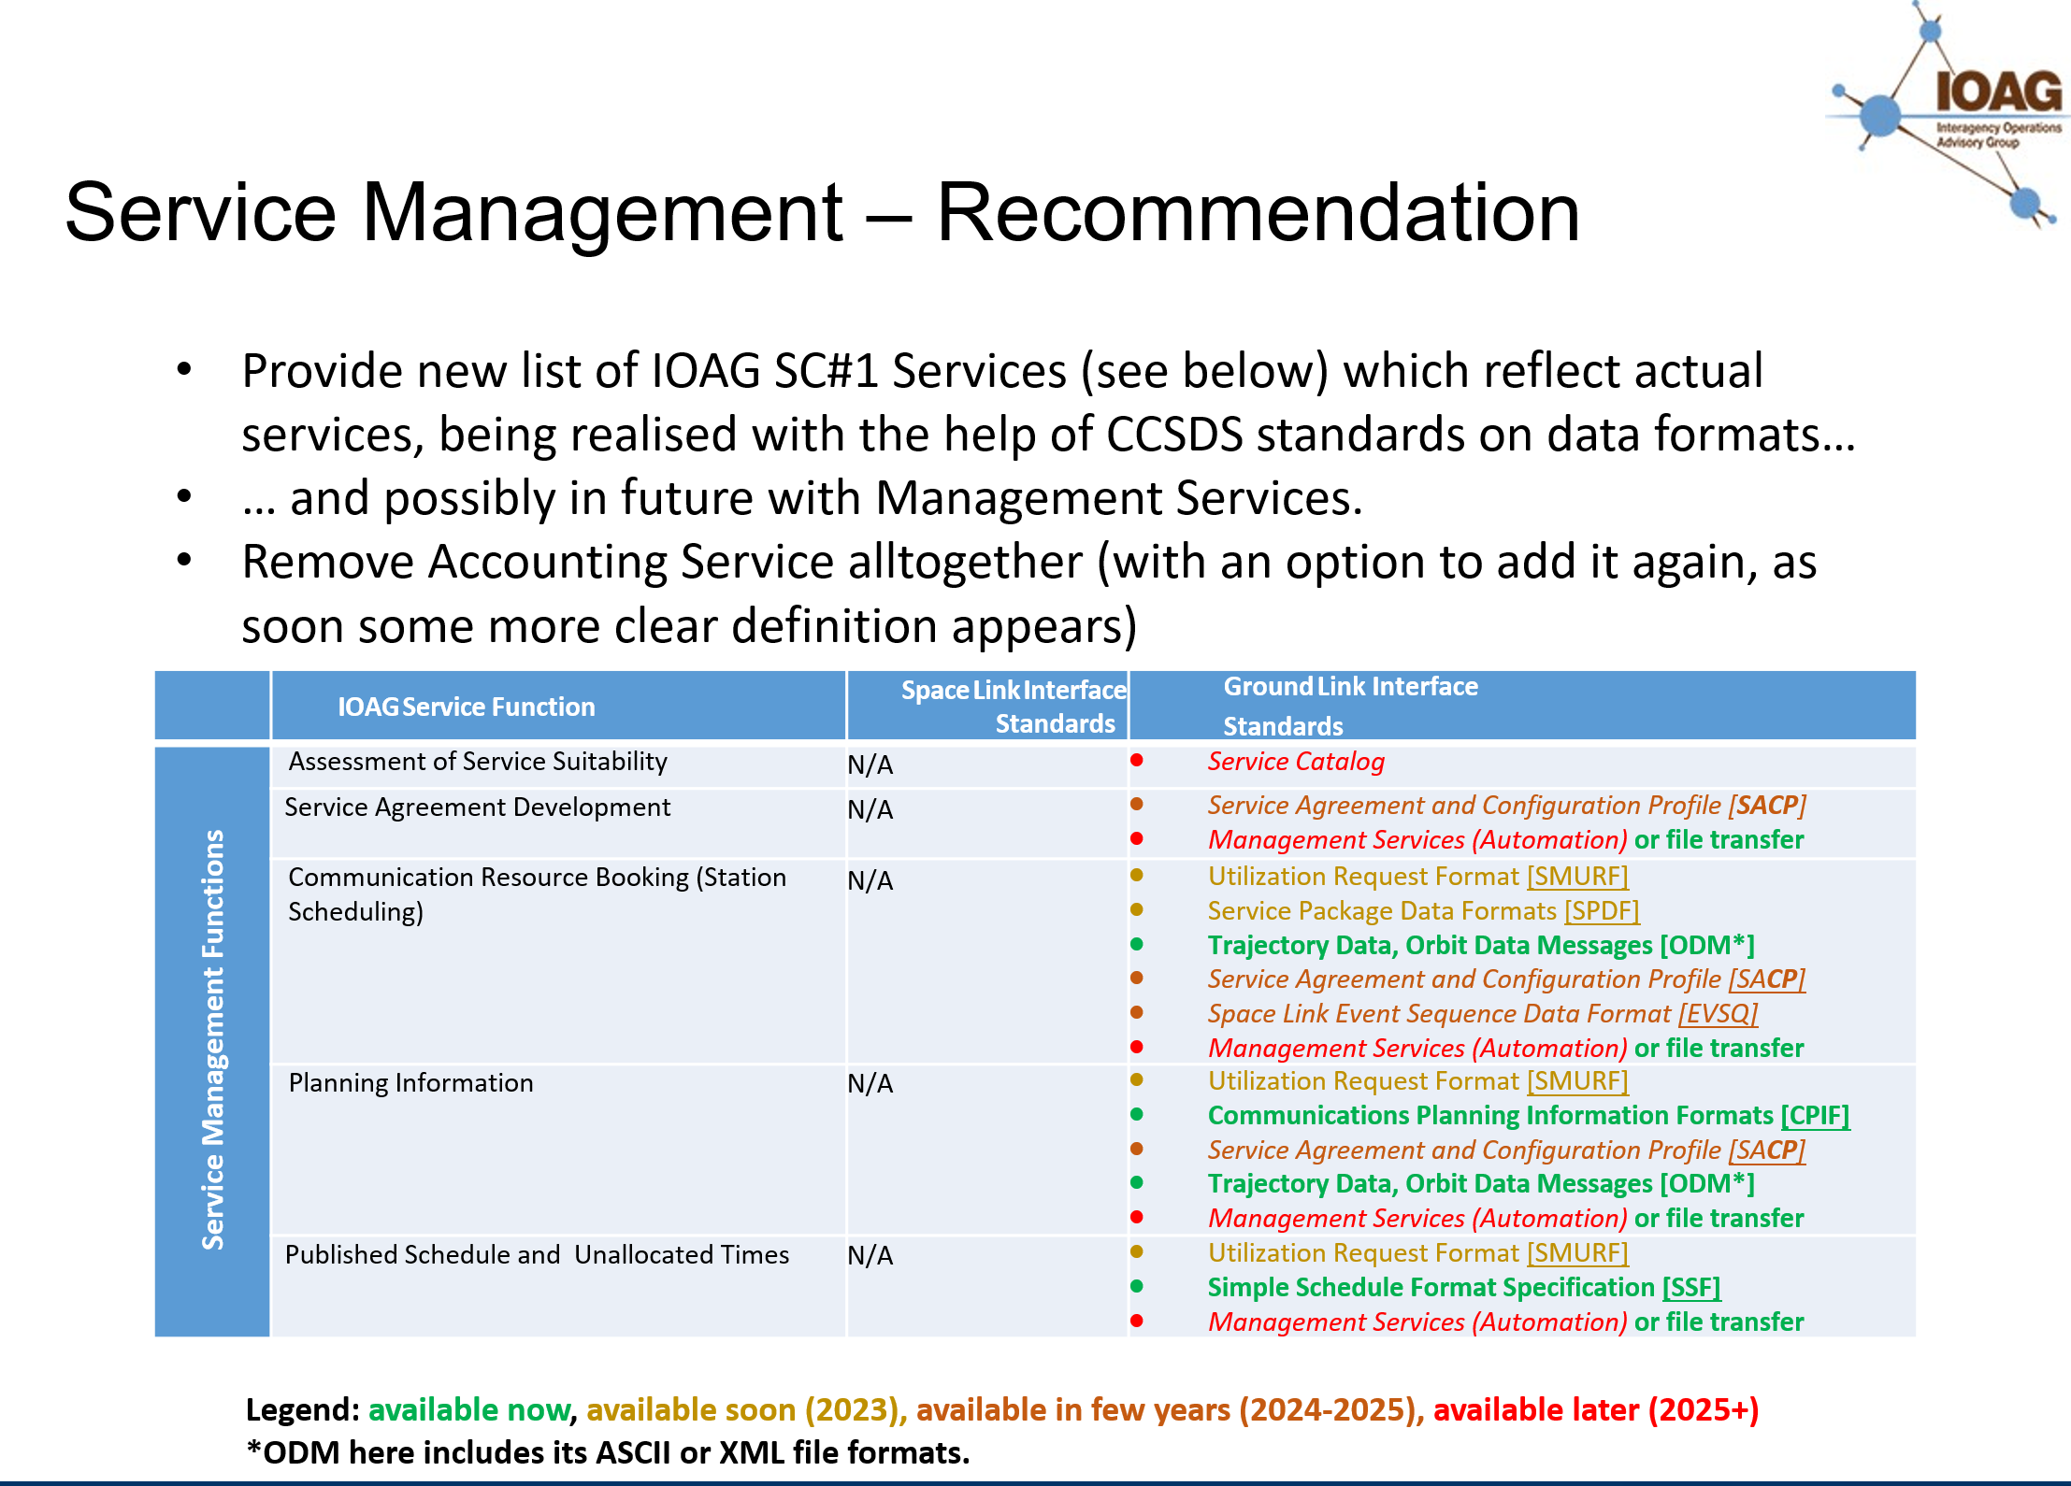

Next Telecon
Our next telecon scheduled date is August 9.

