# CCSM Telecon/Webex, 17 June 2020

# Attendees

E. Barkley, A. Crowson, C. Haddow, H. Dreihahn, H. Kelliher, J. Pietras, M. Gnat, T. Pham, W. Eddy, W. Hell

# Agenda

## General Announcements

1. CMC/CESG meeting currently in progress in virtual format; we may have to eventually have to address “ALACAMAD” -- a proposal for “all the links, all codings, all modulations, all directions” – which would likely have impact on the FRM, configuration profiles and potentially event sequences

## FRM & SACP

1. H. Dreihahn provided an overview of the FRM .xsd and highlighted the ability to filter parameters of FRs based on classification
   1. Note that this is based on each type definition having a “containing” type definition which can supply addition attributes in addition to the “pure” type definition
2. E. Barkley questioned whether additional filtering criteria can be added; answer yes
   1. Motivation is consideration that there may in fact be two-level of configuration data – service level and service implementation level
      1. An example to help illustrate this was discussion with regard to one-way, two-way, three-way tracking -- yes the ground station is configured for these different communication modes but the mission that is coordinating for interagency tracking station support does not supply this as a basic telecom parameters; rather these are execution time changes that the ground station configures for based on round-trip lighttime
   2. agreed that further discussion will be needed on what constitutes the “boundaries” for the different flavors of configuration profiles and most importantly what kind of information ends up in the configuration profile book
3. from the overall mechanism perspective, it was agreed that this approach is quite promising and appears to be a good basis for moving toward automated configuration profile schema generation
4. J. Pietras supplied an overview picture, shown immediately below
5. Subsequent discussion confirmed that this approach can support the “cookie cutters” i.e. well defined configuration profiles for which a mission/user has to do no more “thinking” as well as profile development where missions select “more specialized” aspects of the configuration profile by selecting the appropriate items from the various strata parameter sets
6. Tooling with respect FRM editing was briefly discussed and it was noted that ESA is in the process of making licenses available for the FRM tooling and the FRM code is already on github.

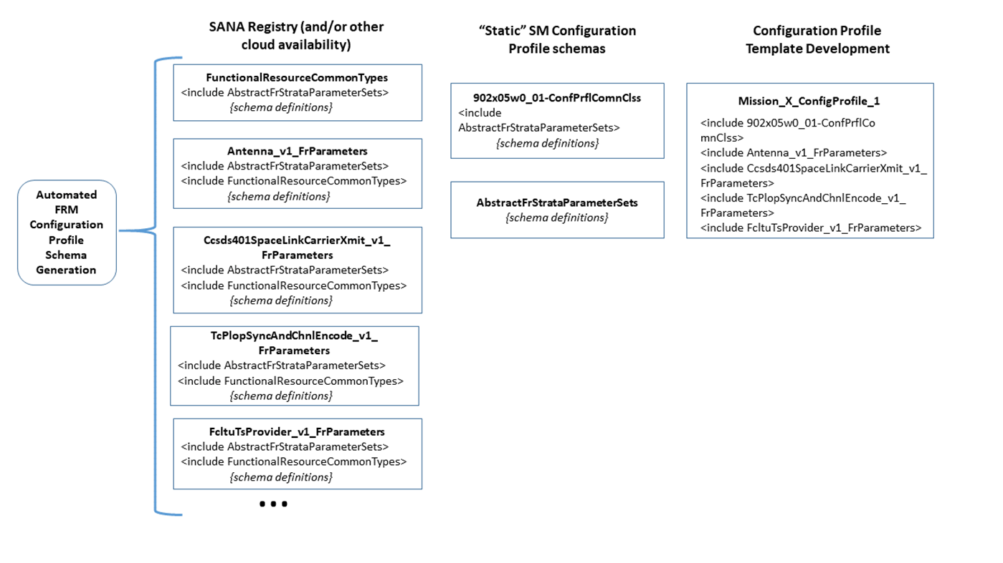

## Resolving Poll Conditions for AED and CDE

1. For CDE, agreed to remove the “schedule publisher” role from the CDE book and then proceed in discussions with SANA for adding just the user and provider roles.
   1. The SSF will be addressed via technical corrigendum to eliminate the “schedule publisher role
2. For the AED, the question of whether or not type should be mandatory is to be further pursued by C. Haddow taking up the condition with the SE AD

## TFGT Book Update – deferred

## CPIF Book update – deferred

## DDOR Interagency Coordination/Standardization

1. Reviewed, discussed email exchange between M. Unal and E. Barkley
2. M. Unal indicated that proposed scan pattern, based on DDOR MB, helps to eliminate ambiguity, errors
   1. E. Barkley agreed
3. Agreed to invite Jim Border, WG DDOR Chair to next telecon for review

## AOB

1. The NAV WG schema issue, form some year ago, has surfaced in the context of putting the navigation XML schema into the SMURF
   1. The issue essentially has to do with qualified versus unqualified namespaces with the latter causing issues for inclusion of the NAV schema into CSSM schemas in general (ambiguous data type definitions possible, etc.).

## Next telecon planning

1. a further check for TGFT and CPIF book updates
2. a joint session with DDOR chair and/or WG
3. poll condition resolutions for AED, CDE
4. SMURF prototype follow-up
5. CPIF prototype follow-up

# Next Telecon

Our next telecon will be on July 7th