CSSM Virtual Spring Meeting 2020 Summary

Agendas and Attendees
 | CSSM Spring Virtual-1 Telecon
 | Meeting Agenda
 | Monday, May 4, 2020
 | Start - PDT | Start - CET | Item
 | 7:30 AM | 4:30 PM | Intro, comments, webex gremlins, etc
 | 7:35 AM | 4:35 PM | TGFT RIDs
 | 8:00 AM | 5:00 PM | CPIF RIDs
 | 8:15 AM | 5:15 PM | SACP + FRM
 | 8:55 AM | 5:55 PM | Wrap-up plan for next telecon
 | 9:00 AM | 6:00 PM | Adjourn

E. Barkley, C. Ciocirlan, A. Crowson, M. Gnat, C. Haddow, H. Kelliher, J. Pietras, M. Unal

 | CSSM Spring Virtual-2 Telecon
 | Meeting Agenda
 | Tuesday, May 5, 2020
 | Start - PDT | Start - CET | Item
 | 7:30 AM | 4:30 PM | Intro, comments, webex gremlins, etc
 | 7:35 AM | 4:35 PM | CPIF RIDs
 | 8:00 AM | 5:00 PM | SMURF Book
 | 8:20 AM | 5:20 PM | SMURF Prototype Plans
 | 8:35 AM | 5:35 PM | CPIF Prototype Cloesout SCAP & FRM Follow-up
 | 8:55 AM | 5:55 PM | Wrap-up plan for next telecon
 | 9:00 AM | 6:00 PM | Adjourn

E. Barkley, A. Crowson, W. Eddy, M. Gnat, C. Haddow, A. Kalkhof, H. Kelliher, M. Unal

 | CSSM Spring Virtual-3 Telecon
 | Meeting Agenda
 | Thursday, May 7,2020
 | Start - PDT | Start - CET | Item
 | 7:30 AM | 4:30 PM | Intro, comments, webex gremlins, etc
 | 7:35 AM | 4:35 PM | Event Sequence - very preliminary stuff
 | 7:50 AM | 4:50 PM | Teleconference Schedule to Fall Meetings
 | 7:55 AM | 4:55 PM | Action Items Check
 | 8:05 AM | 5:05 PM | Work Plan to Fall Meetings
 | 8:20 AM | 5:20 PM | Closing comments, virtual meetings assessment
 | 8:25 AM | 5:25 PM | Adjourn

E. Barkley, C. Ciocirlan, A. Crowson, W. Eddy, H. Haddow, A. Kalkhof, H. Kelliher, M. Unal

TGFT RID Dispositions
- Dispositions agreed to for all RIDs
- Book updates as a result of RID dispositions discussed at the meeting
  - Agreed that fail-over specification is not part of TGFT service definition and is subject to negotiation/agreement by implementing parties
  - A package-level sensitivity meta-data item is to be added -- for implementing parties to agree to sensitivity level definitions and to provide specific indication
  - A general applicability statement of some sort will be provided to indicate the general intention for routine, not stupendously large, transfer of files
    - essentially an acknowledgment that the very large DDOR files are likely not a good candidate for TGFT usage
  - Some sort of statement with regards to practical size considerations will be added to the book based on prototyping results which were carried out with files up to 250 MB -- essentially this is the largest at which we can claim this has been tested successfully without engaging in further (currently unfunded) prototyping efforts
    - note that this could be changed if as part of early agency implementation some sort of specific size test were conducted
- Update plan calls for C. Haddow to send the agency review red book copy to J. Pietras for some minor editorial fixup and then for C. Haddow to conclude the updates

SACP vs FRM Discussion
- There was a general discussion on the configuration profile vs the functional resource model
- J. Pietras has provided a presentation (to be shared with the WG) as to a possible convergence approach
- Some agreement that operational implementations do not really need to know about the FRM “wiring” and that the FRM and configuration profile may in fact have somewhat different purposes
  - But also general agreement that FRM is necessary for the CSS Area in general
- Suggested that agency implementations be surveyed to look at practical considerations re construction of configuration profiles

CPIF RIDs
- All RIDs dispositioned
- Book updates as a result of RID dispositions
  - Note to clarify that there are interrelated terms (rtltEvent, rangeEvent, and rangeRateEvent) used in the CPIF but that this intentional (near earth community prefers range, deep space prefers round-trip light time)
  - AncillaryInfo will be added to the PlanningInfoHeader to allow for any particular modelling assumptions to be noted
  - In correct identification of “Schedule” will be changed to “Communication Planning Information Format” (note for Table 3-3)
- Working group membership present at the teleconference concurred with sending the final rid dispositions at the same time as they are posted for the working group in general – i.e., there is no need for any further subsequent review of the RIDs for either TGFT or CPIF

SMURF Book
- Agreed that an analysis of the enhanced constraints is now required (as a compliment/follow-up regard to the analysis that has already occurred for the basic constraints)
- If prototyping can be more or less concluded by November 2020 that should inform us sufficiently to have confidence in moving forward with red-1 agency review of SMURF at that time

SMURF Prototyping Plans
- M. Gnat presented the SMURF prototype test plan/schedule
- 42 test cases involved
- Plan calls for prototype testing to be wrapped up by the end of October 2020

SACP vs FRM Discussion II
- E. Barkley reported that he had surveyed the DSN implementation for configuring DSN equipment for providing telemetry, command, and ranging services
  - essentially all flat files of the form parameter: value
  - the only multiplicity instances found are with regard to telemetry parameters which are essentially indexed by symbol rate
    - It seems that by the time we get to configuring the equipment, multiplicity concerns/wiring have been addressed by mapping to specific receivers, transmitters
- Noted that the service management configuration profile may in fact have concerns that are not reflected in the functional resource model
  - for example, to keep carrier identifications sorted out between mission spacecraft and ground station providers, it may be useful to know which antenna(s) on the spacecraft is receiving the forward carrier and transmitting the return carrier
- E. Barkley clarified that it is not necessarily “flat” files but rather “flatter” files (there can still be some hierarchy) as a consideration for mapping from whatever CCSDS configuration standard emerges into real world operations
- Discussed the idea of using the various strata in the functional resource model to provide the basis for a configuration profile outline and sort through those parameters of the functional resource model that are applicable for the configuration profile
  - This can be considered as the first cut and would perhaps be a good first step to support further discussions
- noted that as a result of having looked into the DSN equipment configuration tables there may in fact be parameters missing from the functional resource model
  - W. Eddy also noted a similar concern for NASA SN/NEN
- a general approach of using the FRM to inform what needs to go into the configuration profile (rather than translate it directly), using the “leaf node” parameter names and data types was also discussed

Event Sequence
- E. Barkley presented a preliminary class diagram for the mission event sequence (see below)
- Key points from walking through the class diagram
  - This is the mission sequence only; provided sequence (envisioned as returned to the mission) will be a separate class diagram in the book
  - Details for various state change events are still to be worked/provided
  - A table with preliminary definition of rule expression for relative placement of events will be provided by the time of the next CSSM WG teleconference

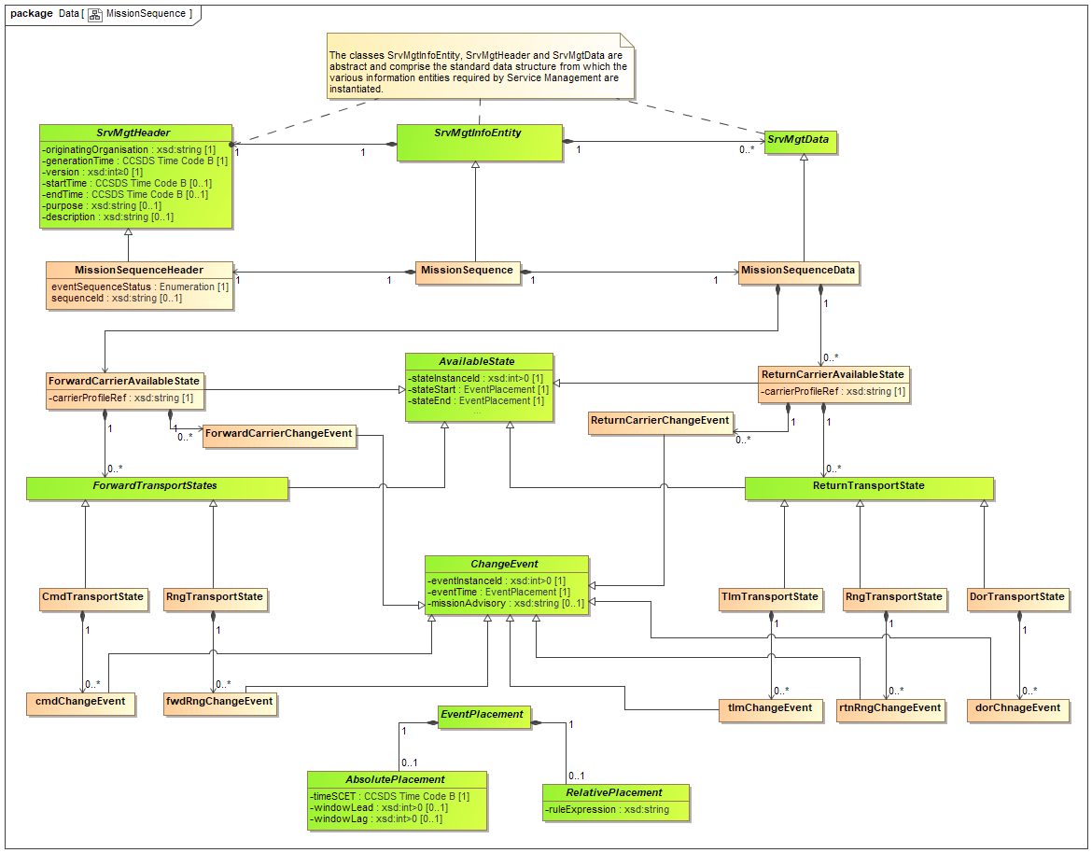
Figure 8-1 Preliminary Class Diagram for Mission Sequence

Work Plan
- Work plan to November 1, 2020 was developed. See diagrams in Annex A.

Virtual Meeting Assessment
- Meetings seemed to work reasonably well, but with some considerations
  - Webex was “cranky” for a couple of the session – particularly difficult were audio connection issues
  - Ability to meet virtually is facilitated by having had several face-to-face meetings in the past
    - it seems it would be quite difficult if it was the first meeting of a working group and/or for a new person just joining the working group

ANNEX A

