CSSM Mountain View/Spring Meeting 2019 Summary

Agenda
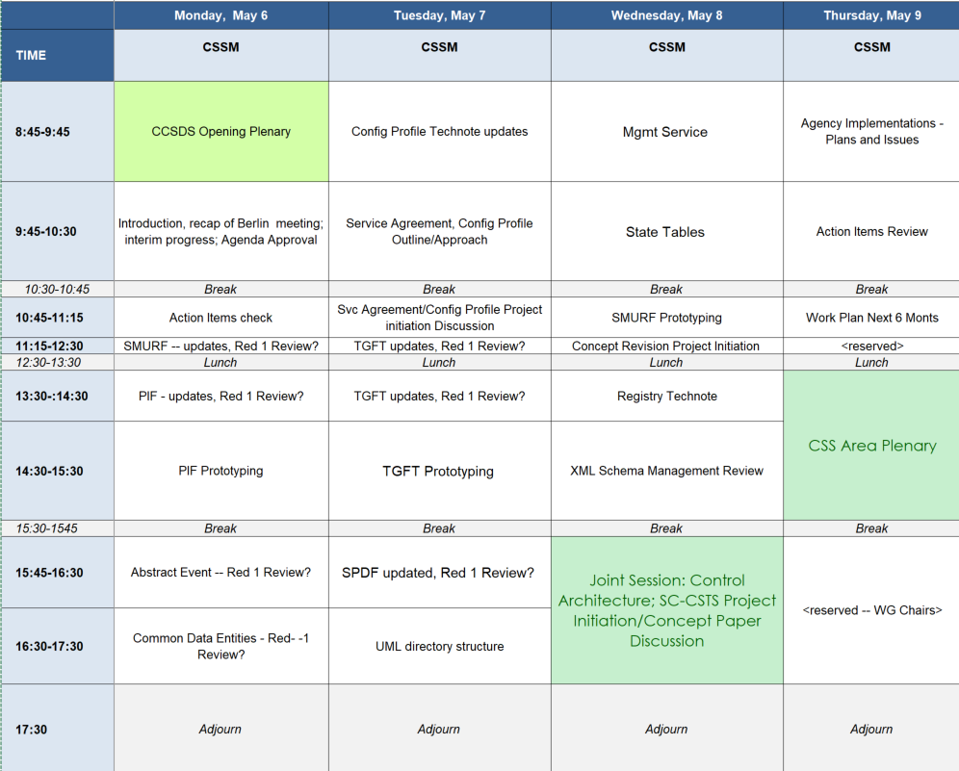
Note: The Control Architecture Joint Session was moved to the first item on Wednesday morning.

SMURF – updates
- ICS is currently the missing piece of the book
  - Agreed that this is to be included prior to submission for agency reviews
- Discussion re “FRParameter” name
  - in recognition that we cannot assume that the functional resource model is being used by implementations
  - agreed to go with “ModResParm” (Modified Resource Parameter) with “resName” (for resource name)
- The question of whether or not “chaining” of requests was really required came up.
  - W. Eddy checked in the answer is it is not required as
    - SGSS (next generation of NASA’s SN) is not implementing this
    - the current SN implementation has ceased using this capability
- Agreed to allow for set active scenario flag to accompany service package request
- Agreed to add a query for the scenario set, which will include a return flag for active scenario (in SPDF)
- Ed. Note: for those at the meetings you may recall that we discussed the active scenario at the end of the first day of the meetings; items 4 and 5 are captured here for ease of reading

PIF – updates
- Geocentric versus topocentric reference for the aperture
  - agreed that using (0, 0, 0) as the coordinates with no additional aperture reference effectively connotes a geocentric reference
    - book will be updated to go with this approach
- reviewed the new verbiage for “user” as observer and observed
  - deemed to be okay
  - noted that this may have to be re-examined in a true DTN use case (as will the notions of forward and return carrier)

PIF – Prototyping
- walked through the NASA/JPL produced PIF instance for test case 2
  - noted that there is an end CableWrap event but no start CableWrap event
- Noted that we need a new schema to accommodate the 0, 0, 0 coordinates with no additional aperture reference for representing geocentric based events

Abstract Event Definition Review
- Epoch list has been moved to SANA registry (per Berlin meetings)
- Discussed extendedParameter having extensions registred as part of the abstract event
  - Conclusion is that this can stay as a concrete class for the extended parameter
  - Also implied that timeParameter will be a concrete class
  - extendedParameter registry will be defined in the Abstract Event book, but the “using” books will be where additional attribute or attributes, if any, are defined
    - (Ed.: see the related notes on SANA Registry Technote)
- discussed whether a range definition should be included at the level of the abstract extended parameter
  - agreed that although this might show up in the common data entities definition it is mostly concerned for the SACP book and as such no abstract range definition will be introduced at this time for the Abstract Event book

Common Data Entities Review
- FRParameter to be renamed as per the SMURF updates/review (see above)

Configuration Profile Technote Update
- Walked through presentation on updated technote (see presentation in CWE, CSS-SM -> Meeting Materials -> 2019 -> Spring); some key items include
  - Discussion of static vs dynamic allocation of port numbers (for SLE & CSTS service instances)
    - Accommodation for both “SICF method” (SLE instance configuration file) and dynamic allocation method
  - Location of data stores (aperture vs centralized)
  - Updates in progress for accommodating USLP (Universal Space Link Protocol)
  - Addition of attribute to designate/restrict set FRs to just those are truly available for configuration by the service user
    - also in consideration with regard to leveraging SANA registry -- i.e. this could be the result of a filtered query on the functional resource model
  - versioning of data kept in the Sana registry
  - Noted that with CSTS SFW pink book, complex values for monitored data parameters are now allowed (in ASN.1 vs XML schema)

Service Agreement Configuration Profile Approach
- Walked through the presentation of the approach being considered (see presentation in CWE); some key items include:
  - leveraging parameter definitions in SANA -- no parameters in the blue book; just functional resource types being put together
    - Essentially allowing for an intermediate level of compliance whereby the functional resource types are used but the parameters could in fact be locally defined
  - agreed that further work with this approach should continue
- prototype resources attentively identified to be ESA and NASA;
  - prototyping start in the summer of 2020 was tentatively identified

TGFT
- Prototyping
  - Incorrect error returns -- Appears to be more a matter of getting test report correct rather than an issue with the specification
    - C. Haddow to take the lead in getting closure on the yellow book
- Book
  - Scrolled through the latest book
  - Some minor edits/tweaks noted, esp re XmlSpy call outs for diagrams (remove)
  - Agreed to remove schema listing -- in favor of schema file on SANA

Service Package Data Format
- Review of changes made since Fall 2018 mtgs
- Errata noted for SSF
- Dynamically assigned port numbers -- part of ModResParm
  - Agreed to add a note in an annex to make clear that things that were unassigned but assigned dynamically are included in the modified result parameter list
- Magic draw model needs to be updated
- ICS still need to be written
- Agreed to remove start and stop time in event sequence brief form
  - Just keep the reference

Joint Session w CSTS WG – Service Control Architecture, SC-CSTS Project Initiation Discussion
- Walked through presentation on service control architecture (see presentation in CWE)
- With regard to event sequences, discussed the idea of having a pre-planned “no-sequence” aspect which allows for SC-CSTS issues directives without consideration of turning event sequence execution off
- Agreed to work on a concept paper for SC-CSTS
  - Action to E. Barkley for concept paper outline prior to Fall 2019 meetings
- discussion involved in the functional resource model
  - agreed to having the functional resource model tool will be able to generate .xsd (XML schema) for complex parameter definitions
  - ESA representatives agreed to look into making the tool generally available for CCSDS (the functional resource model tool has been developed at ESA)

Management Service
- Reviewed draft requirements
  - Removed requirement re performance for being able to reply to query sometime after submission of request
  - Discussion of delete operation
    - In general SMURF is to have the different types of operations; limited to submission for non-service pkg data types
  - Security considerations; agreed to put most of security outside the scope of mgmt svc with exception of authentication credentials and encryption for data in transit
  - Versioning
    - Data entities vs management svc vs protocol (ie, we may need to consider how to keep track of separate sets of version numbers)

- AI to E. Barkley to provide material on the pros and cons of different REST URL/API styles

XML Schema Management Review
- Reviewed the Xml Schema file naming convention originally proposed by C. Haddow with proposed modification from E. Barkely
  - No issues/follow-up work identified

State Table Discussion
- Reviewed presentation (see presentation in CWE – for AI2017-0512-11)
- States for several information entities reviewed
  - Service Package State table -- modifications discussed and agreed to
    - Terminated state
    - Completed state
    - When Replace fails --> still in scheduled state (for original SP)
  - Service Package Request state machine
    - Noted that some of the transitions are really just comments on internal processing associated from the state
  - Configuration Profile
    - Agreed to put in a retired state
  - Event Sequence
    - Agreed to split this into mission sequence and provider sequence modeling
  - Trajectory
    - Question of replacing (same id) vs new trajectory
    - Agreed that replace trajectory is allowed

Registry Technote Working Session
- Note captured for update to template text and instructions in draft registry technote

SMURF Prototyping
- Noted that test plan may need updating
- Plan to begin this summer; hope to have completed by EOY 2019
  - May use REST calls – pseudo-management services

Agency Implementation Plans
- Presentations were provided by NASA/JPL/DSN,JAXA, ESA/ESOC
- Additionally verbal inputs were provided by CNES, and DLR
- In general there seems to be good interest among the CCSDS member agencies for implementing CCSDS service management standards
- See the presentations on the CWE

Action Items Update
- Multiple action items were administratively closed as they were deemed to have been effectively answered (for example, even though the exact directives to line up with regard to functional resources and event sequences were not identified, the types of directives were in fact identified for an event sequence to sufficiently answer the question as to how these items conceptually go together)
- See the updated action items spreadsheet on the CWE

Work Plan, next 6 months
- See diagrams below for work plan milestones/projected dates
- Seven teleconferences have been scheduled -- see calendar invites

