CCSM Telecon/Webex, 16 April 2019

Attendees
E. Barkley, A. Crowson, W. Eddy, M. Gnat, C. Haddow, H. Kelliher, H. Li, J. Pietras, T. Pham

Agenda

General Announcements
- FF-CSTS and CSTS SFW agency reviews have concluded; RIDs have been submitted

Action Items Check
- 3 AIs closed, 1 opened
- 15 total AIs open
- See updated spreadsheet

Spring Meetings Planning
- Reviewed the draft agenda
- Noted that it may be beneficial to have a discussion with regard to a vent sequencing on the agenda could tentatively be added to the Tuesday list of topics

Service Package Data Formats Check
- Noted that SSF (yes SSF) can allow for separate radiometric services vs Doppler extraction service to be scheduled at different times
  - Viewed as not being an issue; likely that these will never be expressed separately on real-world schedules, but okay to allow for them to staggered and/or non-contemporaneous
  - Agreed that we should start tracking potential future “RIDs” against published documents
    - Consensus is to set up an additional directory under the current CWE structuring for recording these types of considerations
    - E. Barkley to suggest revised CWE structuring
- Discussed on “unified” vs multiple UML diagrams for different
  - Concurred that as the brief versus detailed service package data formats represent distinct messages that multiple UML diagrams are warranted for clarity
- Noted a discrepancy between SSF frequency band enumeration values and those in the XML schema
  - A corrected XML schema will be posted [editorial note: this will also serve as a check on our XML schema conventions]

Configuration Profile Outline Discussion
- The spreadsheet identifying the functional resources versus the service provider types was discussed and noted that font size will be a practical consideration for this kind of table
- Noted that using functional resource sets could help to shrink the table
- M. Gnat presented some work in progress with regard to configuration profile and service agreement
  - See figures 1 and 2 below
  - the question was raised as to whether or not the configuration parameters could just simply be referenced from the SANA registry

PIF Prototyping & Book Check
- the proposed solution for the action item action item with regard to indicating the aperture reference as “earth-center” is accepted with the privy so that “earth-center” be replaced with the phrase “geocentric”
- Noted that the JPL prototype has moved into the second set of test cases

TGFT Prototyping & TGFT Book Check – not addressed

AOB
- Tooling environment diagram
  - the functional resource diagram with the environment for developing model and manipulating discussed -- see figure 3 below

Next Telecon
Our next teleconference will be determined at the spring 2019 meetings.

Figures

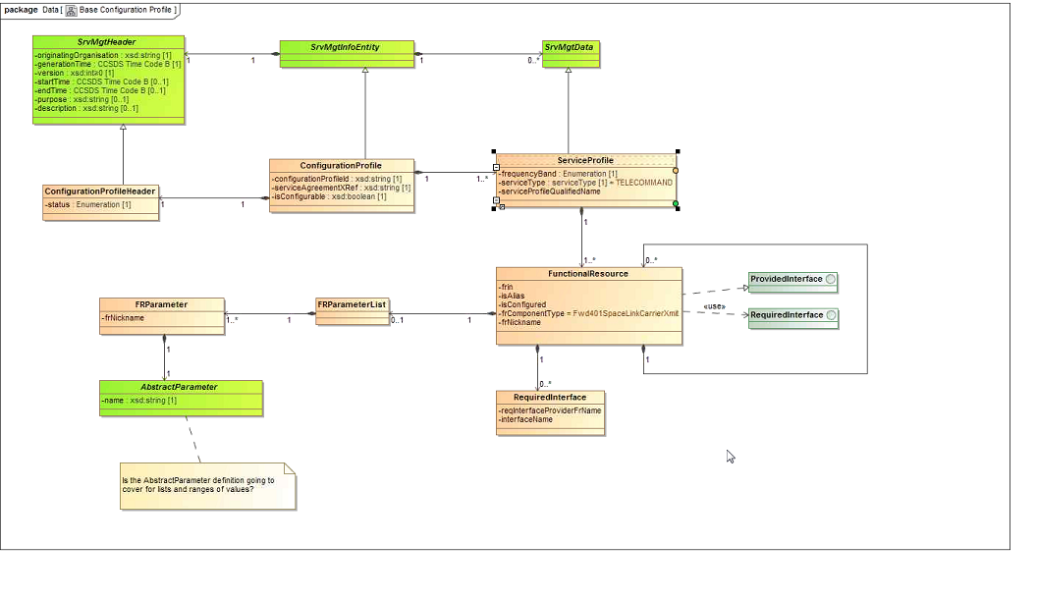
Figure 1: Configuration Profile -- Work in Progress

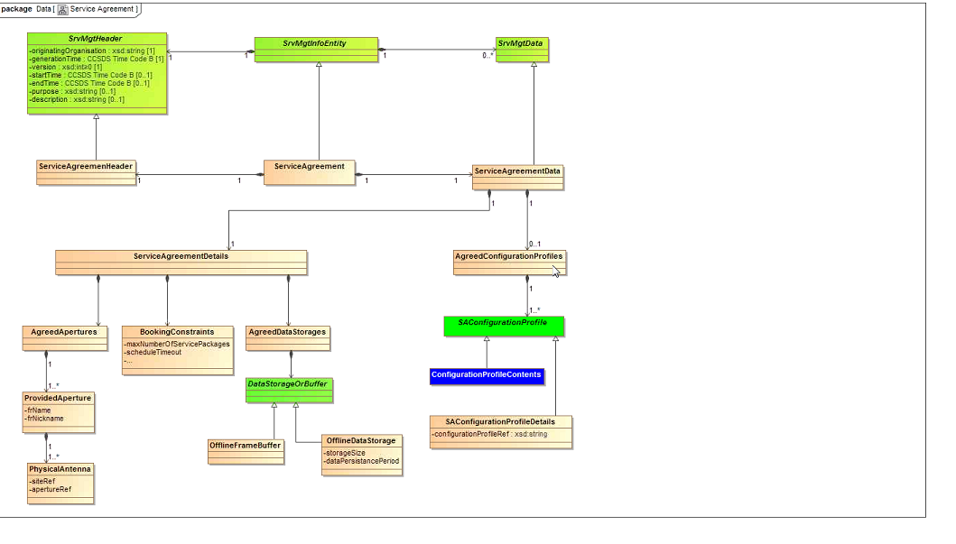
Figure 2: Service Agreement – Work in Progress

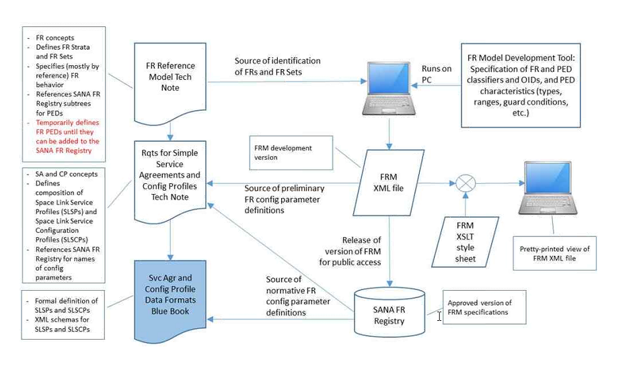
Figure 3 – Function Resources, Tooling Environment

