CCSM Telecon/Webex, 26 March 2019

Attendees
E. Barkley, A. Crowson, M. Gnat, C. Haddow,

Agenda

General Announcements
- Dr Stephen Townes (NASA/JPL) is the new CMC Chair

Action Items Check
- Several action items extended
- Two new action related to service agreement/configuration profile opened
- See spreadsheet for details

TGFT Prototyping & TGFT Book Check
- Not addressed

Service Package Data Formats Check
- Noted that magic draw models need to be coordinated between W. Eddy and C. Haddow
- Will likely reserve some working time at the spring meetings for this

PIF Prototyping & Book Check
- C. Haddow acknowledged receipt of verbiage to use for “user” parameter
- E. Barkley agreed to produce first cut for resolving AI 2019-0205-01 (occultation representation)
- A. Crowson acknowledged that latest preliminary exchange has been uploaded by NASA/JPL team
- discussed the potential use of missions other than those in the prototype plan and agreed that this could be allowed if identifying a trajectory formation in the prototype plan becomes too onerous with regard to satisfy the success criteria
  - further noted that this is not the preferred approach as presumably the missions in the prototype plan were chosen such that all parties can do some degree independently validate the information being exchanged

Service Agreement and Service Configuration Profile Data Formats Outline
- Discussed how to present outline – concern noted from E. Barkley as to how to present the configuration profile information in a “natural” fashion for operations/implementation engineering (leading/classifying the profile via the frame type does not seem the most “natural”)
  - H. Kelliher noted that it should also fit with how the service catalog is organized
  - An option for an index table was noted
  - Also an option for re-structuring the outline such that the frame type is moved to a sub-header was discussed
  - Action to E. Barkley to produce some suggested change re c) above
  - Action to M. Gnat to revise the outline for the Spring meetings

Spring Meetings Planning
- See diagram below for 1st cut agenda for Spring 2019 meetings

AOB (none)

Next Telecon
Our next teleconference is scheduled for April 16th 2019

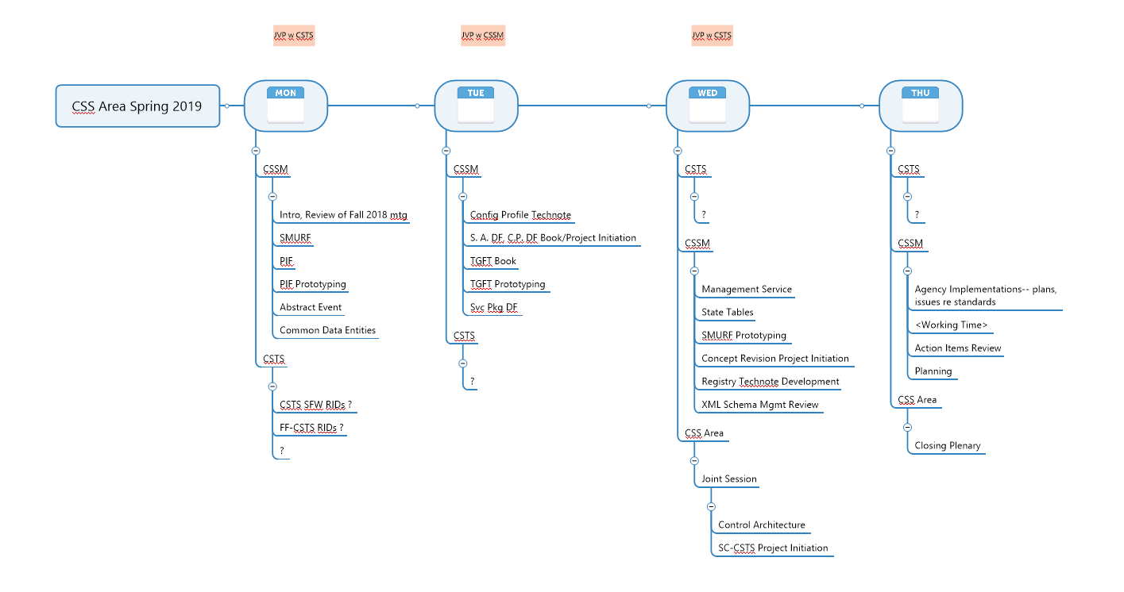
Figure 1 - Preliminary Agenda Spring 2019 Meetings

