CSSM Berlin/Fall Meeting 2018 Summary

# Agenda



# SMURF – WG 2nd Draft Review

1. Agreed to remove “additionalUser” from BasicApertureConstraint
2. Added Maximum Overlap (to compliment minimumOverlap)
3. Other comments discussed
4. AD review copy (for agency review) projected by late March 2019

# TGFT -- WG 2nd Draft Review, Prototyping Discussion

1. Agreed to revise front matter material to be more in line with CCSDS terse style
2. No inputs on XFDU packaging rules – deemed to be okay
3. AD review copy (for agency review)
4. Concluded that prototyping concerns have to do with sorting out the test plan
   1. This is to be done via separate telecon as neither CNSA or CNES representatives were in attendance

# Configuration Profile + Book Planning

1. Walked through presentation re latest configuration profile technote
2. Agreed that making configuration profile, to a large degree, a collection of configuration profiles implies that adding/deleting/modifying a configuration profile a modification to the service agreement
3. Agreed that the equivalent of the SICF (SLE Instance Configuration File, currently used by some member agencies) can be part of the configuration profile but pending a parameter service agreement they can also be dynamically included as part of the service package
4. Preliminary draft white book targeted for Oct 2019 (for Fall 2019 meetings)

# MBs: Abstract Event Definition, Common Data Entities

1. WG members who reviewed the books agreed that they are in good shape
2. Noted that Abstract Event needs a minor tweak to move epic definitions from enumerated list to a Sana maintained registry list
   1. this will be a new registry for Sana
3. noted that common entities needs to have PIF definition/dependency moved from SMURF
   1. Need to ensure that common data entities covers SSF, SMURF, and Service Package
4. AD review copies (for both books) projected by 1st week of December 2018

# PIF – Second WG draft review

1. The term “user” generated a fair amount discussion in the on-than-earth-celestial-body context
   1. Term is has its “traditional” meaning when considered strictly from the point of view of an earth based aperture and planning information with regard to rise/set for that particular aperture
      1. this is typically understood to be an aperture of the service provider
   2. in the off Earth celestial body context such as Mars coordination, the service provider is not necessarily a traditional TT&C provider
      1. in reality, it tends to be yet another organization between various spacecraft mission operations centers utilizing common infrastructure
      2. in this case the “user” is a spacecraft that serves as a relay for a landed asset on Mars
   3. Agreed that the definition of the term will be addressed in an update to the draft recommendation as being context dependent
2. agreed to add optional “altitude” parameter, with units of kilometers for the off Earth aperture location
   1. This allows the PIF to be used vis-à-vis current Mars relay coordination practice
3. Agreed to remove the operational phases discussion from the front matter of the book
   1. Not really in keeping with CCSDS terse style
4. AD review copy projected by 1st week of December 2018

# Service Package Data Format – 1st draft WG review

(note we agreed to call this SPDF or just “Service Package” rather than “Service Package Result”)

1. Walked through presentation of changes since Spring (2018) meetings
   1. All changes accepted
2. Agreed to remove what amounts to management service requirements re “rules” for stating start and stop time
   1. Agreed that as a data format the, values for start and stop time are set by the service provider; anything further is in the purview of the (eventual) management service recommendation
3. Similarly agreed that trajectory Id being updated or considered “continuous” is moot at the level of a data format – to be addressed at the level of management service
4. 2nd Draft for WG comment projected mid November 2018

# Discussion: FRM, CP, EVSQ, SMURF, SPDF fit

(note: this was essentially a cross-check function)

1. SPDF vs SMURF – “Modified parameters” vs “OID Parameters” (respectively)
   1. Agreed to make consistent in preference for “Modified parameters”
   2. To be accomplished via update to the Common Data Entities update
2. All references to “Service Package Result” to be scrubbed in favor of “Service Package”
3. SMURF vs PIF -- Optional altitude parameter to be added to both (request vs response)
4. Agreed to normalize all instances of <something>XRef to just <something>Ref
5. Agreed to normalize all instances of <something>IdRef to just <something>Ref
6. Scenarios and how they are carried in the data formats – agreed that
   1. An optional Scenario Set Id can be stated for one or more service packages (via SMURF)
      1. Scenario Set Id is echoed by the Service Package
   2. An optional flag is in the service request for service packages that indicates if the service package is to be the "prime scenario"
      1. Echoed in SPDF
   3. A subsequent request can change the "prime scenario" flag to another service package that is identified via the same scenario Id
      1. done via service package Id and scenario Id
   4. Can query for service packages that represent alternate scenarios by filtering for service packages with the same scenario Set Id

# Joint Session – Functional Resource Model Discussion

(Joint session for CSSM and CSTS WGs)

1. Agreed that the FRM is "firewalled" at the level of cross support (inter-agency) cross support
   1. Agency internal considerations can be “extended” from the inter-agency recognized Functional Resources – likely via an OID “index” reserved for this purpose
2. Walked through presentation on updates to FRM
   1. Biggest addition is for TDM Segment Generation (to support TD-CSTS)
   2. USLP accommodates via new set of FRs rather than adding several “switches” to existing FRs

# Joint Session – Control Architecture

(Joint session for CSSM and CSTS WGs)

1. Walked through presentation on functional resources vs event sequence states
   1. Outline of directives at level of FR and their alignment re state transitions for event sequences
   2. A preliminary diagram, developed by H. Dreihahn is shown below
      1. E. Barkley has an action to further develop this

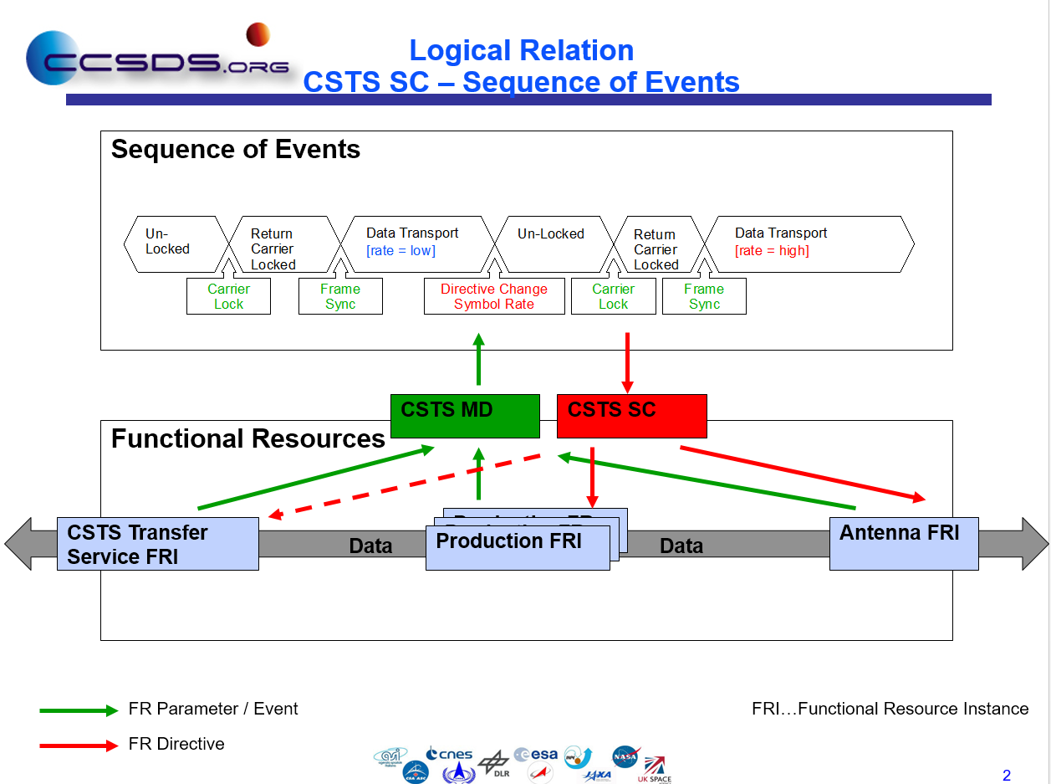

# PIF and SMURF Prototype Discussions/Planning

1. Briefly walked through draft SMURF test plan
   1. Side bar discussion developed re having sufficient meta-data in service management headers for tracking of requests vs responses
      1. Agreed to defer any additional meta data parameters re management service hooks pending further study re concept of management service and development of an appropriate model
         1. Goal is to keep data formats separated from management concerns to the extent possible
   2. Rough time frame of Spring 2019 identified for start of SMURF prototyping (DLR, ESA being the prototyping partners)
2. Updated the PIF planning timeline (see figure below)
   1. Basic gist is to have actualy prototyping complete by late March 2019, with documentation activities concluding by May 2019

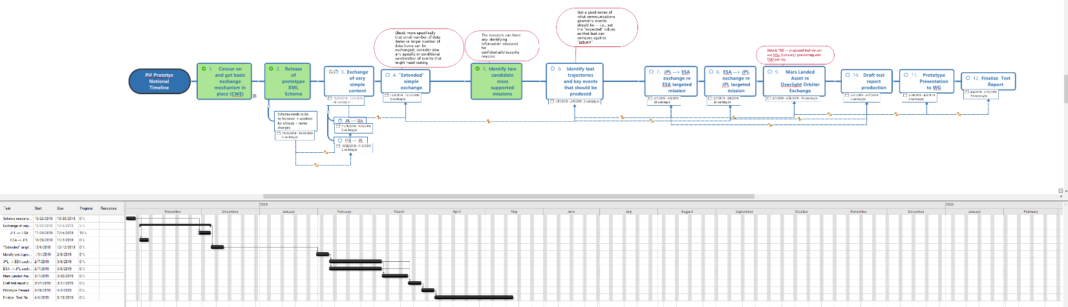

# State Machines Discussion

1. Walked through state machines presentation from M. Gnat
2. Agreed that service package can be modeled as having an “embryo” state such that the service package exists as soon as it is requested
   1. This allows transition to “alternate” vs “scheduled” states as needed
3. Agreed that state machines will eventually be part of management services

# UML + XML Schema Management

1. Agreed to go with current attributes oriented approach
2. Agreed that all service management schemas will be under the same namspace
   1. No conclusion re versioning of namespaces
   2. At minimum, we considered putting a version number in as an attribute of the schema
3. Deployment technique ./latest directory noted, but not the same as version control re namespace, etc.
4. Agreed to query SANA/SSG (SANA Steering Group) for what kind of CM technology may be available
   1. Can a GIT server be provided either in the CWE or at SANA?

# Management Service Discussion

1. Walked through BPMN diagram for overview context from management svc concept technote
2. Discussion of timeout vs automated systems vs humans in the loop
   1. Does this look like B-1 ?
   2. After some discussion a realization that use of REST allows for user to make multiple calls to see/check status -- may not really need to have hard time outs
3. Next steps
   1. consider REST APIs and see how that does or does not support the notion of mgmt service "envelop” (keeping information entity “payloads” separate from management service metadata entities)
   2. consider notifications for the next update of the concept
4. Targeted AMES/Mountain View mtgs (Spring 2019) for statement of high-level management services requirements

# Review Of Updated Information Entity Framework Diagram

1. Generally agreed that updated diagram in good shape
2. Minor clean-up noted
   1. E.g., remove “X” from “XRef” – just “Ref”, etc

# Registry Technote Development

1. Agreed that this is basically to be just a copy and paste type technote indicating the various bits and pieces that need to be tailored for the specific recommendation (i.e, paste “destination”)
   1. Essentially an editable template for the SANA considerations section

# Concept Book Update Planning

1. Walk through of M. Gnatt's comments from 2017
2. General agreement that functional resource material needs to be pared back significantly
   1. FRM technote, especially in consideration re a future MB, largely replaces this
3. E. Barkley to be the book boss for the updates
4. Survey of updates need to be provided at the Spring 2019 mtgs

# Inter-Recommendation Spread Sheet

1. Reviewed -- some minor updates need to be done

# Working Session – SPDF updates

1. Agreed that recommendations all present complete class diagram as the first UML diagram in the book
   1. In contrast to summarized UML class diagram in SPDF leading to complete UML diagram
2. Agreed that the FR nickname is assigned at service agreement time

# Working Session – Further Follow-Up Re AI 2018-0411-18

1. AI was in regards to supporting reference to carriers in case where they are all in separate profiles or all part of the same configuration profile
2. Diagram below shows the basic scheme developed

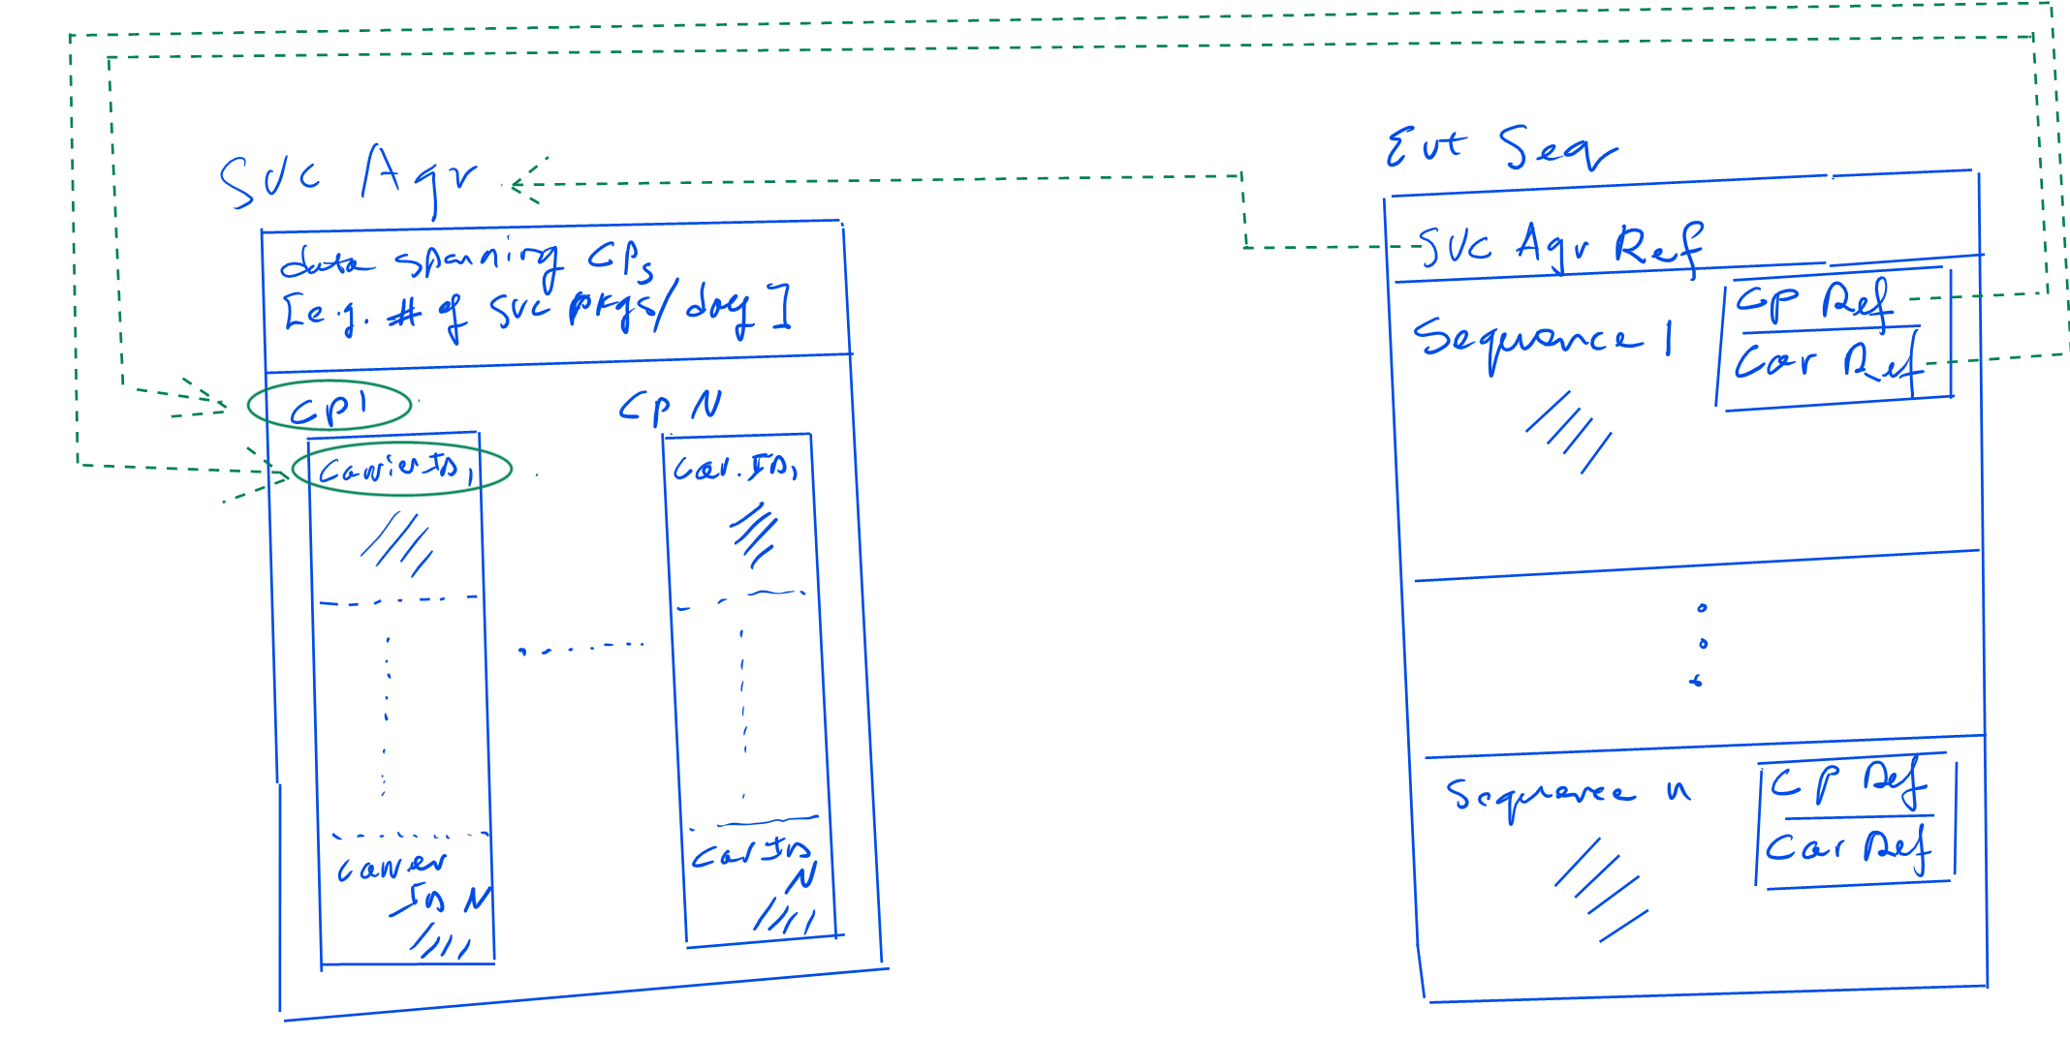

# Work Plan, next 6 months

1. See diagrams below for work plan milestones/projected dates

