CCSM Telecon/Webex, 28 August 2018

Attendees
E. Barkley, C. Ciocirlan, A. Crowson, C. Haddow, H. Kelliher, J. Pietras

Agenda

General Announcements
- Registration is open – if not already registered please do so ASAP
- In discussion with J. Border, have decided not to pursue joint session with DDOR WG at Berlin meetings

Action Item Status/Project status checks
- No actions closed, but also no new actions opened
- Currently 32 actions open
- Several due dates adjusted

TGFT Book and Prototype Status Updates
- Agreed that a more restrictive name (“manifest.xfdu”) is okay for the purposes of prototyping and does not impact validation of the draft recommendation (which allows *.xfdu)
- Discussed DDOR use case re up to 60 files being needed – i.e. ability to indicated a related set of files
  - Noted that draft TGFT recommendation allows for “sequenceInformation” to essentially indicate file 5 of 20
  - Agreed to add this to the TGFT prototype testing
    - Can be something relatively simple such as 3 related files
- C. Haddow indicated that 2nd draft to the TGFT whitebook will be made avaialbe to the WG for review in the very near/immediate future
- In general prototyping seems to be going well

Abstract Event + Common Entities WG Review/Comments
- No comments submitted by any member of the WG
- A reminder that the draft books are out for WG review; please provide comments as soon as possible

PIF updates and prototyping
- Walked through updated general test design section – no issues noted
- Noted that both ESA and NASA resources should be okay for prototyping to continue into November

Service Package Book Comments/1st WG draft review conclusion (not addrfessed)

Work Plan Check
- Several dates updated -- see figure below
- E. Barkley to update project defintions in CWE management framework as needed

AOB
- Berlin meetings planning
  - Identified joint session time for functional resource model review – see preliminary table for preliminary draft Berlin planning below

Next Telecon
Our next teleconference is scheduled for September 20th – note that this is a change from the originally planned Sept 25th date

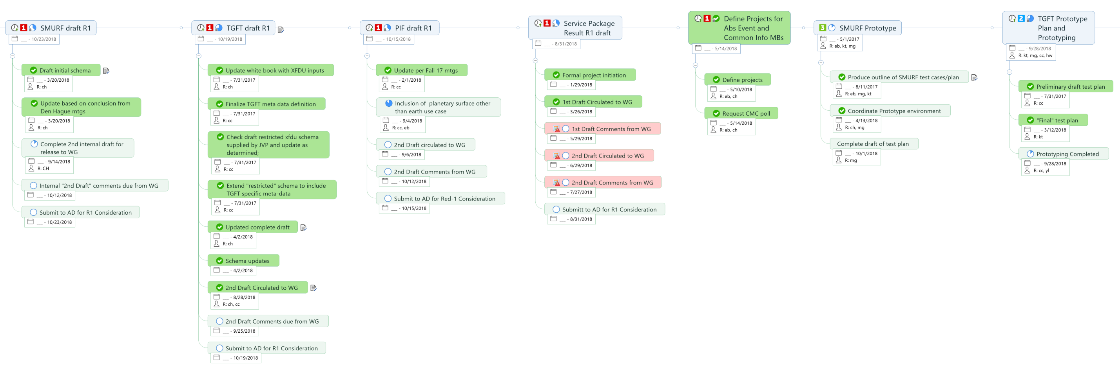
Figure 1 – (Partially) Updated Work Plan

