CCSM Telecon/Webex, 22 May 2018

Attendees
E. Barkley, A. Crowson, M. Gnat, J. Pietras

Agenda/Notes (as adjusted at the telecon)

General Announcements
- SSF is Blue! (10/11 agencies voted; all votes for “Adopt”)
  - DSN and ESTRACK have agreed to work/exchange some early, likely-to-be-the-real-values efforts for site and aperture registries population
    - E. Barkley has agreed to develop data prioritization spreadsheets for SANA + SSG
      - Agreed to review this at the next telecon
- CMC Spring 18 meetings held last week
  - No real issues for CSS Area came up
  - Registries in general getting a closer look by CMC
- Abstract Event and Common Data Entities projects drafted and submitted for CMC polling
- PIF, TGFT, and SMURF projects have been re-baselined in CWE framework re schedule

Action Item Status/Project status checks
- No objections to new format noted
- Actions for due by end of June were checked – a few closed
- Some need input from those not in attendance at today’s telecon
- *Reminder* to WG -- comments are due by the end of the month for draft Service Package

Service agreement discussion (follow up re approaches as outlined by M. Gnat at S18 mtgs)
- Explored approach a service agreement being a collection of configuration profiles
- Agreed that other data/information is still needed
  - E.g, Data store/retention policy/parameters, levels of services (number of service packages per unit time)
- Reviewed presentation provided by M. Gnat at S 18 meetings and also input from M. Gnat email of 08 May 2018 to refresh our understanding of the approach (see annex below)
- Discussed re-specification (ability for a service package request to state changed values to configuration profile for a given tracking pass)
  - in the absence of service agreement ranges, the proposed consideration is that the configuration profile itself can have optional metadata attached to those items in the configuration profile that allow for subsequent service package request time re-specification
  - J. Pietras agreed to attempt putting this into the soon-to-be-released update of the configuration profile technote

Service Package reviews/inputs (no inputs provided)

Work plan check (not addressed)

AOB
- Configuration profile – example
  - J. Pietras presented trial XML instance document
    - Agreed that this is going in the right direction
  - Noted that there is not yet a clear consensus as to what belongs in a configuration profile
    - E.g, inclusion of information/parameter that can indicate, among other things that an antenna is stowed was not universally accepted as configuration profile information
    - subsequently performed a bit of a compare and contrast exercise in terms of functional resource model derived configuration parameters versus those developed inside the DSN without direct reference to the functional resource model
    - this yielded some additional information that could perhaps be considered in the functional resource model and also indicated that the DSN configuration profile is almost exclusively focused on the space link itself
    - general conclusion is that further joint sessions are required for the CSS area in general in working out for the proper boundary for configuration profile
- OIDs, classifiers, and FRINS
  - J. Pietras noted that the classifier for functional resource could serve for the configuration profile rather than the OID
    - This should lead to more human readable configuration profile definitions
- Updated document/book diagram
  - M. Gnat presented two diagrams (see screen shot Annexes below)
  - Revised the arrows to be clear in terms of exits and entries
    - Updated diagram will be sent to the WG by M. Gnat
  - Agreed to include, as part of revisions needed for the concept book, and indication that the concept addresses the abstract event definition
    - this then renders the abstract event definition magenta book as being “under” the concept book as correct
      - there was general agreement that in fact the concept should address this in any case

Next Telecon
Our next teleconference is scheduled for June 12th.

Annexes

Email from M. Gnat re Configuration Profiles and Service Agreements

From: Marcin.Gnat@dlr.de <Marcin.Gnat@dlr.de>
Sent: Tuesday, May 8, 2018 5:04 AM
To: Barkley, Erik J (3970) <erik.j.barkley@jpl.nasa.gov>; john.pietras@gst.com
Cc: Colin.Haddow@esa.int
Subject: RE: Service Agreement questions

Hi,

Yes John, you have read correctly my concerns out of my presentation. The resolution (or something-kind-of-everybody-nodding-as-they-would-agree) was going into direction of having loose collection of FR values, and a list of CP’s which are included in the Service Agreement. This would as I said, simplify my book production, but on the other hand I would have exactly a problem you described (how I called that “some logic bringing FRs’ values to specific CP’s together”). And as I do not have any good idea for that (and the danger is great that description of such logic would explode the SA-chapter), maybe the opposite proposal (stick to Service Profiles or even complete Config Profiles) would be better. I can imagine also producing some nice chapter of how to specify predefined values or value ranges, which would be generic to all Service Profiles or Configuration Profiles.

This would mean Service Agreement chapter would include:
- Standard header stuff…
- Some more or less flat “thingy” with meta-information
- Mechanism how to include Service Profiles or Config Profiles into SA (extension mechanism in principle), including description how to extend parameters to allow ranges (this one may be tricky, but let’s see…).

We can discuss it further today.

Btw. I will join a bit later on (hopefully only 30minutes later, but can be it will be something between 30m and 1hour later (Ranges! You see!). I’m sorry for that, but else it won’t work better for me today.

Best Regards
Marcin

From: Barkley, Erik J (3970) [mailto:erik.j.barkley@jpl.nasa.gov]
Sent: Samstag, 5. Mai 2018 02:39
To: Gnat, Marcin; john.pietras@gst.com
Cc: Colin.Haddow@esa.int
Subject: RE: Service Agreement questions

All,

A brief initial reply…

Perhaps we can consider a service agreement to be made up of multiple configuration profiles. This would argue for just the addition of the metadata as indicated in Marcin's presentation. If there are new profiles that are required, then perhaps this is an update to the service agreement as well. It does strike me that although this is a simple approach maybe it is not simplistic? As I recall, Wolfgang advocated for fixing as much as possible at the level of service agreement and that the need for broad ranges of parameters in service agreements against which to then validate configuration profiles was not necessarily needed. Perhaps we can discuss this more at the upcoming teleconference.

Best regards,
-Erik

From: Marcin.Gnat@dlr.de <Marcin.Gnat@dlr.de>
Sent: Thursday, May 3, 2018 11:14 PM
To: john.pietras@gst.com
Cc: Barkley, Erik J (3970) <erik.j.barkley@jpl.nasa.gov>; Colin.Haddow@esa.int
Subject: RE: Service Agreement questions

Hi John,

Wow… Long E-Mail ;-). Anyway, I just wanted to say I got that, but won’t have time this week to answer anymore…
I’ll try next week, just before our telecon.

Marcin

From: John Pietras [mailto:john.pietras@gst.com]
Sent: Mittwoch, 2. Mai 2018 16:51
To: Gnat, Marcin
Cc: Erik.J.Barkley@jpl.nasa.gov; Colin.Haddow@esa.int
Subject: Service Agreement questions

Hi, Marcin.
For the next draft of the Simple Config Profile and Service Agreement Tech Note I need to address Service Agreement aspects a bit more. My question at this point is whether the Service Agreement-level parameters (e.g., ranges of permissible values, from which individual config profiles select one value) are set for all instances of an FR type for all config profiles, or whether there might be some sort of “subsetting” (e.g., some constraints that somehow apply for configurations when the receiver is operation at S-band, but a different set of constraints that apply when receiving at X-band)?

I’ve looked at the presentation that you made at the Spring Workshop and I think that you were asking a similar question on your second-to-last slide. Did you ever come to a resolution? (I didn’t find mention of this particular topic in Erik’s recap of the meeting). I would like to be able to reflect that approach in the Tech Note as well.

As you pointed out in your presentation, the simplest approach might be to just have a single list of allowed values for each FR configuration parameter, which applies to all configuration profiles purportedly conforming to that Service Agreement. That could lead to some combinations that are actually illegal – e.g., if a mission operates in multiple bands and at significantly different data rates, a configuration profile combining a low-rate carrier with frame length/coding combination that is only intended for use with high link carriers would nevertheless be validated against such a Service Agreement. HOWEVER, I think that this is primarily a concern if we are talking about (a) fully-automated validation of CPs against SAs and (b) no expectation of a “smart user”. If we take the approach that this initial round of SA/CP formats supports a simplified approach, we could reasonably assume that the CP validation won’t be fully automated (i.e., there will be some human QA), then this is a valid approach, at least for the initial roll-out.

For what it’s worth, over the years (yikes!) that I have been thinking about these kinds of things, I have thought about what I’ll call here (for lack of a better name) “Service Agreement Sets”. Briefly, a single Service Agreement could have multiple Service Agreement Sets. Each SA Set would just be a collection of FR types with the allowed parameter ranges valid for that set. The last time I thought along these lines was before the re-orientation of Config Profiles to Space Link Service Profiles, but I think that any given single-service configuration profile (that is, a CP that has only one Space Link Service Profile) could be constrained to be required to conform to a single SA Set. However, this assumption would not necessarily hold true for multi-service CPs – some additional “plumbing” would be necessary to have each SLSP in that CP be tied to a specific SA Set.

But enough rambling for now. What is your current thinking on this? Thanks.

Best regards,
John

Example of configuration profile work from NASA/JPL/DSN

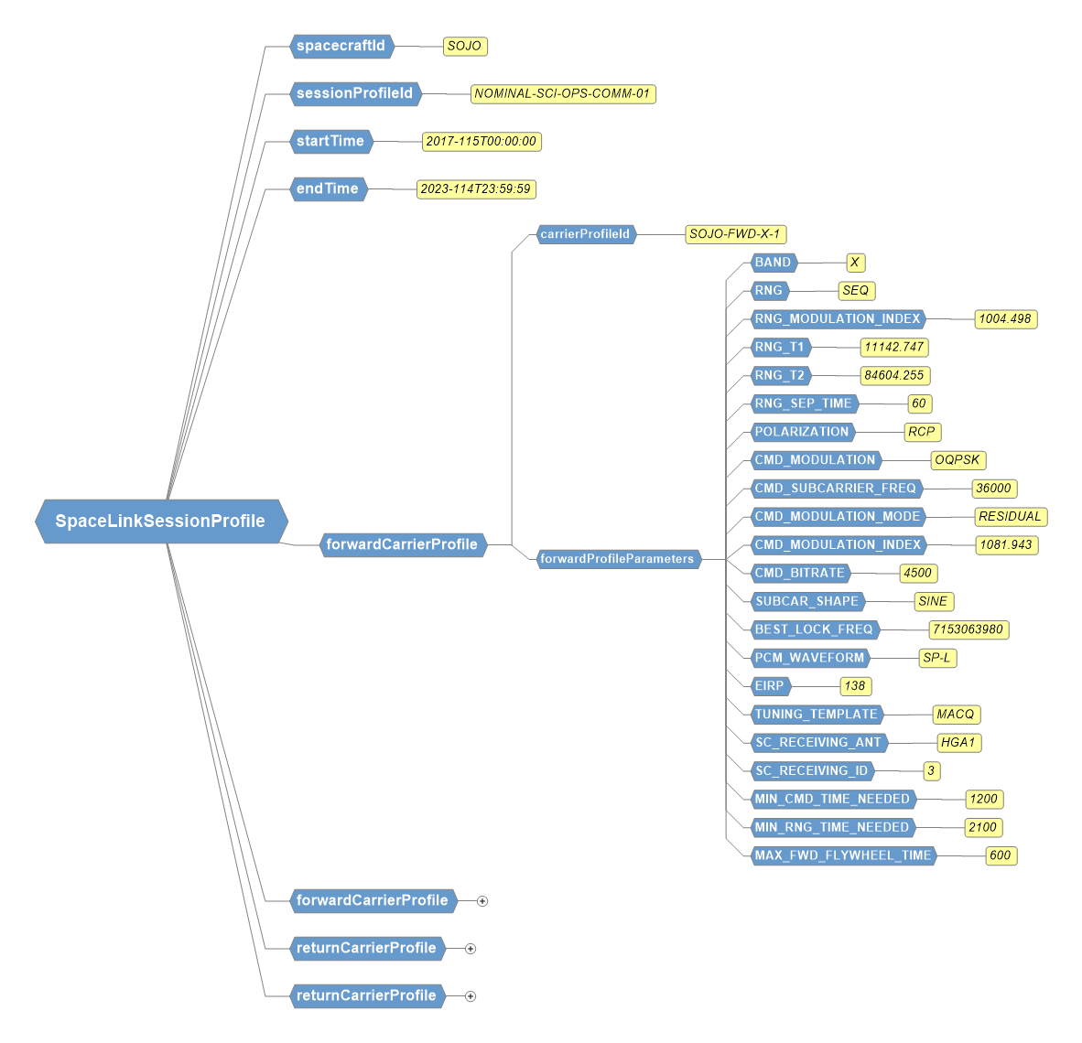

Compare and Contrast re Book Diagram connector arrows

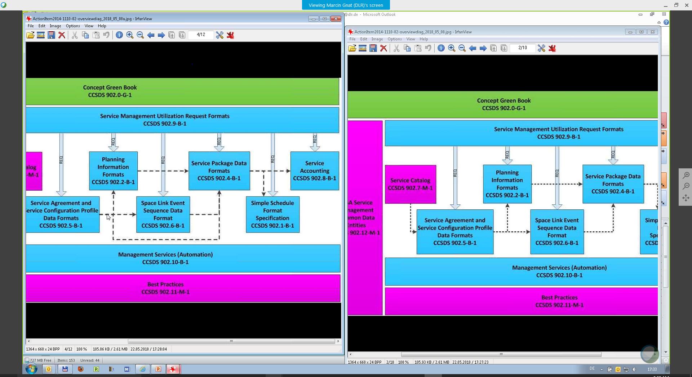
Diagram on left is basis for moving forward, but exits and entries will be cleaned up so as to remove visual confusion (e.g, Service Package does not “flow back” to Planning Information)

