CCSM Telecon/Webex, 08 May 2018

Attendees

Agenda/Notes (as adjusted at the teleconference)

General Announcements
- SSF approved with just one condition – frequency bands table – approach to resolve agreed upon and document currently being updated by CTE
  - Also minor schema update sent to SANA – and has already been posted
- Spring 19 meetings may be at or near NASA AMES facility – Silicon Valley area
- CMC S18 meeting will start this coming Monday

Action Item Status/Project status checks
- Action items updated – see latest spreadsheet
- Project status schedule updated – please see latest image below

TGFT Updates/Status
- Confirmed that the convention for file naming is to be <name>.<timestamp>.<ext>
- Discussed security considerations (i.e. section 3.3)
  - noted that multiple file types, per the draft recommendation, are destined for a single inbox/in tray
  - Use of the package type attribute (part of XFDU) was discussed as a possible mechanism for sorting out the different file types
    - noted that if the entire package is encrypted this may not be the best approach
    - also noted that is possible some implementations may in fact want the entire file name encrypted
  - Action to C. Haddow further study the security considerations and provide recommendation

Interim approach re registered items pending SANA updates
- noted that both ESTRACK and DSN are moving ahead with their implementations of SSF and this is at a faster pace than Sana sites and apertures registry updates
- C. Haddow has been designated as the point of contact by ESA to help provide the proper values for ESTRACK
- E. Barkley has contacted the DSN point of contact (T. Pham)
- For early SSF implementations that are moving faster than SANA registry updates we will work with point of contacts to use the best forecasted values rather than unregistered values

Functional Resources names (see email from J. Pietras, May 4th)
- Agreed to go with the proposed approach J. Pietras with regard to the functional resource Nick naming
- walked through preliminary analysis of changes required at the level of the SMURF to support respecification (of configuration profile parameters)
  - preliminary analysis indicates that it is not a significant change to allow for functional resource nicknames
- E. Barkley noted general desire for having “simple” configuration profiles -- to that end see figure 1 for a potential example in state to pursue
  - in general, agreed that the functional resource nickname approach should support this

Service agreement discussion (follow up re approaches as outlined by M. Gnat at S18 mtgs) (Not address)

PIF prototype test plan
- agreed that the use of the CWE for file exchange is to be used for prototyping exchanges

Any review inputs so far re Service Package
- No comments yet
- Review date deadline extended to 29 May 2018 – a request/reminder to please provide comments

AOB
- Agreed that use of reference to SANA registry (rather than copying information) is just fine for configuration technote.

Next Telecon
Our next teleconference is scheduled for May 22nd.

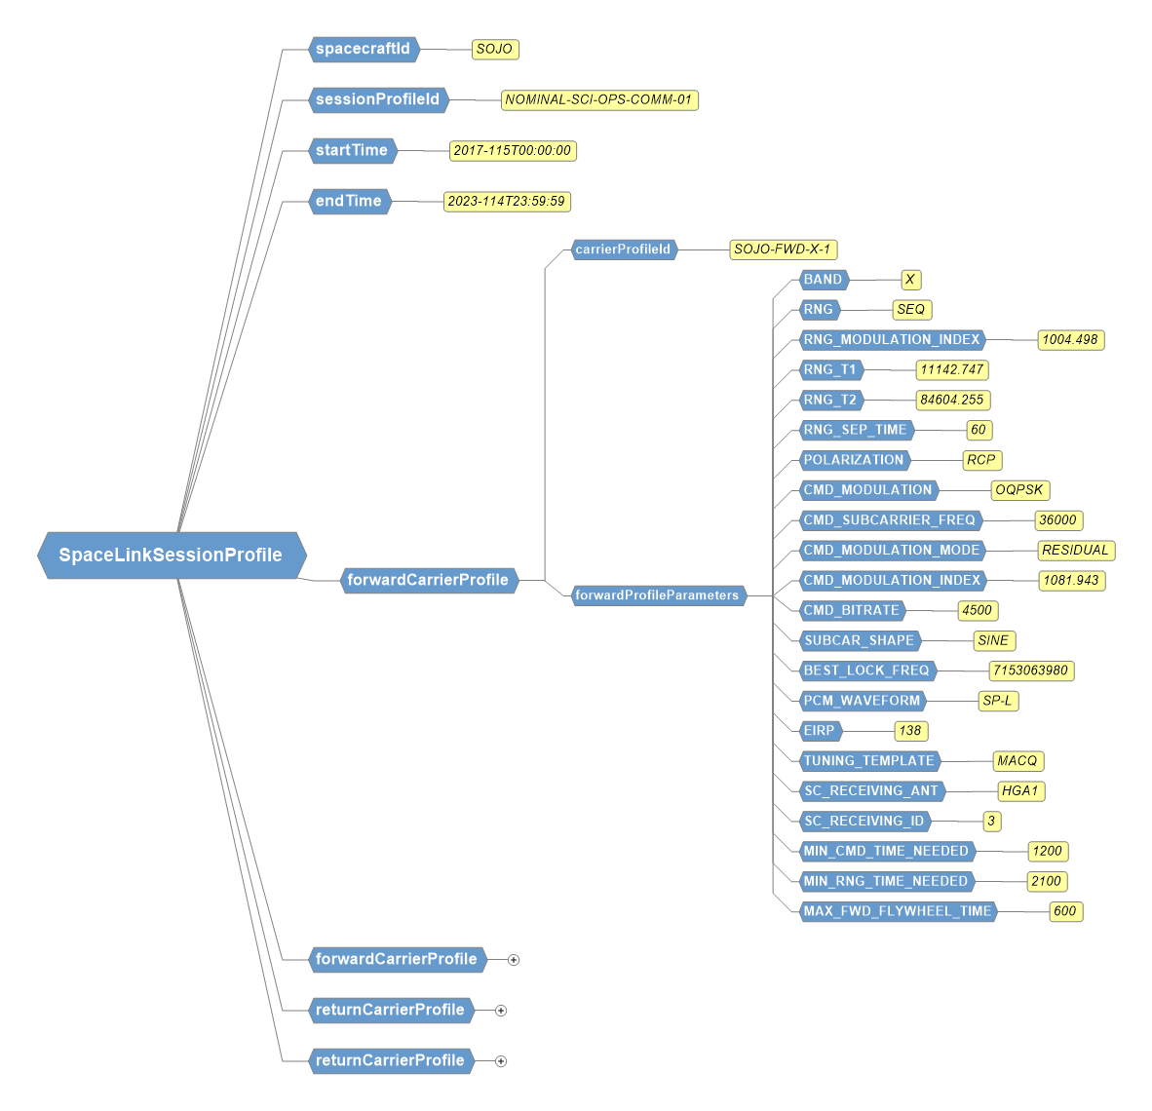
Sample of Configuration Profile Work from DSN

