CCSM Telecon/Webex, 20 March 2018

Attendees
E. Barkley, A. Crowson, W. Eddy, M. Gnat, C. Haddow, T. Pham

Agenda/Notes

General Announcements
- Registration now open
  - NIST Registration also required – no later than March 30th
    - Noted that registration confirmation emails have not been received – E. Barkley to follow up with CCSDS secretariat

Action Item Status -- not reviewed

Spring 2018 Planning
- Walked through preliminary draft of S 18 meetings agenda
- Re moving configuration profile tech note discussion (M. Gnat vs J. Pietras availability conflicts)
  - M. Gnatt suggested leaving as is – he will attempt to read the technote prior to the meetings
  - The configuration profile project initiation discussion (Wed afternoon) will be lengthened and/or moved to allow for discussion of ideas that M. Gnatt has re configuration profile book
- (Editorial note – anticipated that integrated will be circulated by the end of this week)

SMURF Updates
- C. Haddow briefly described the updtaes – resulting in changes agreed to at San Antonio and The Hague meetings.
- Time windows still not well understood
  - W. Eddy volunteered to supply more information on this

AOB (none)

Next Telecon
The teleconference schedule for April October 2018 will be determined at the Spring 2018 meetings.

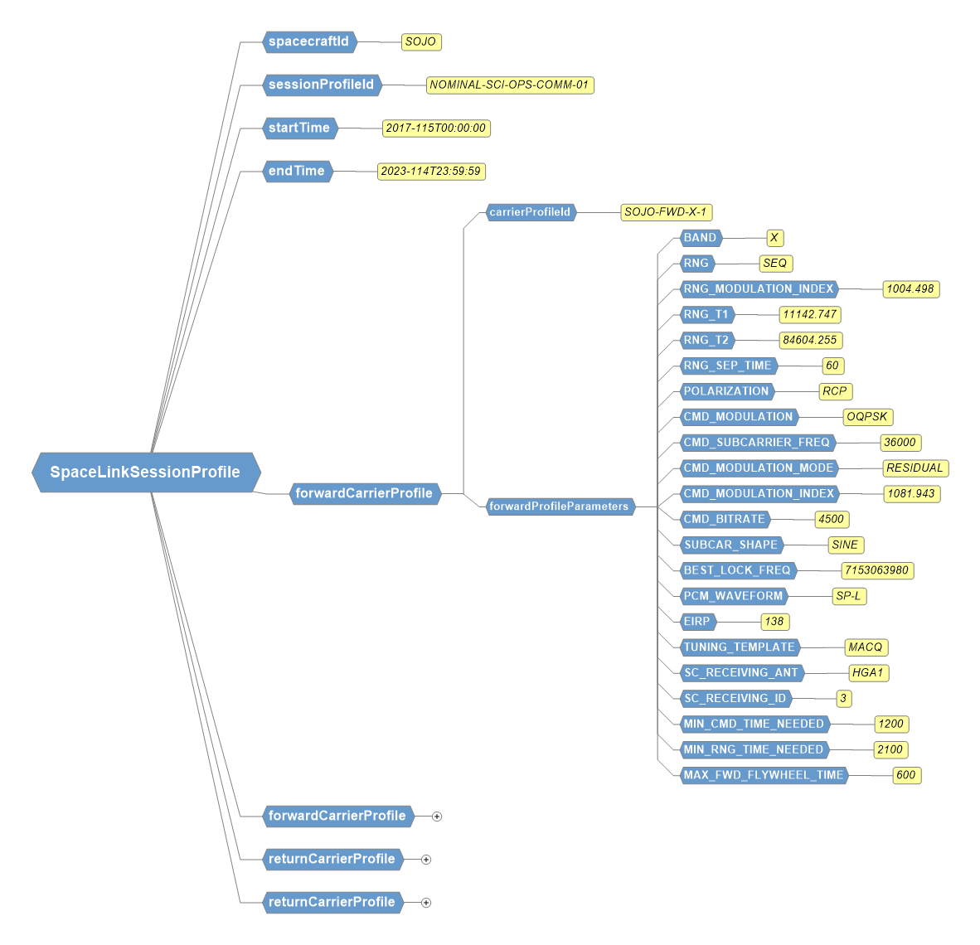
Sample of Configuration Profile Work from DSN

