CCSM Telecon/Webex, 27 February 2018

Attendees
E. Barkley, A. Crowson, W. Eddy, C. Haddow, H, Kelliher, J. Pietras, T. Pham, Y. Wang

Agenda/Notes

General Announcements
- Registration now open
  - NIST Registration also required – no later than March 30th
- Welcome to the new CSS DAD

Action Item Status
- Reviewed actions due prior to spring 18 meetings
  - Some due dates updated

TGFT Updates/Status – not addressed

General Work Plan Check
- Reviewed and added dates to general work plan – see diagram below
- Event sequence book needs work re planning dates

Configuration Profile Update
- Walked through configuration profile work being done in the DSN
  - Perhaps some parameters that may not be in FRM?
  - Question of can configuration profile work result in a fairly “flat” list of parameters along the lines of those shown? (see diagram below)
- Walked through some of the updates to the updated technote
  - Noted that an exercise of how services are scheduled/service packages produced/FRM/CSTS monitored data should be worked to ensure that different service configurations (e.g, single aperture vs multiple apertures) is properly accommodated
  - A consideration of naming vs FRIN was discussed in the past in the CSTS WG; we may want to revisit this from a more global perspective as noted immediately above.
  - It may be possible to consider “reserved” FRINs rather than having them be dynamic – this may help with standardized sets of configurations profiles

AOB
- Planning for S18 mtgs
  - Identified likely joint sessions to have
    - CSTS WG – control architecture, configuration profiles/FRINs
    - DDOR – both from service management and TGFT points of view
    - NAV WG – check re abstract event definition + new orbit events message project
    - DTN – exchange of information re standards that CSSM is producing that may be of use for DTN network management

Next Telecon
Our next teleconference is scheduled for March 20th. Agenda will include planning for Spring 18 mtgs

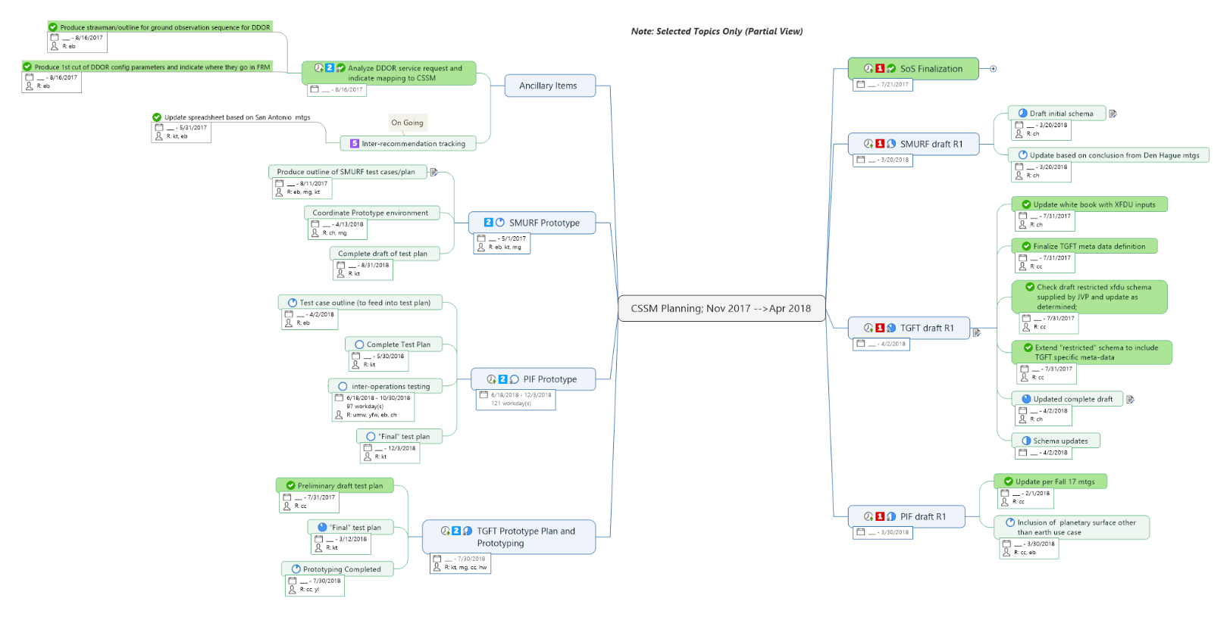
Partially Updated Work Plan

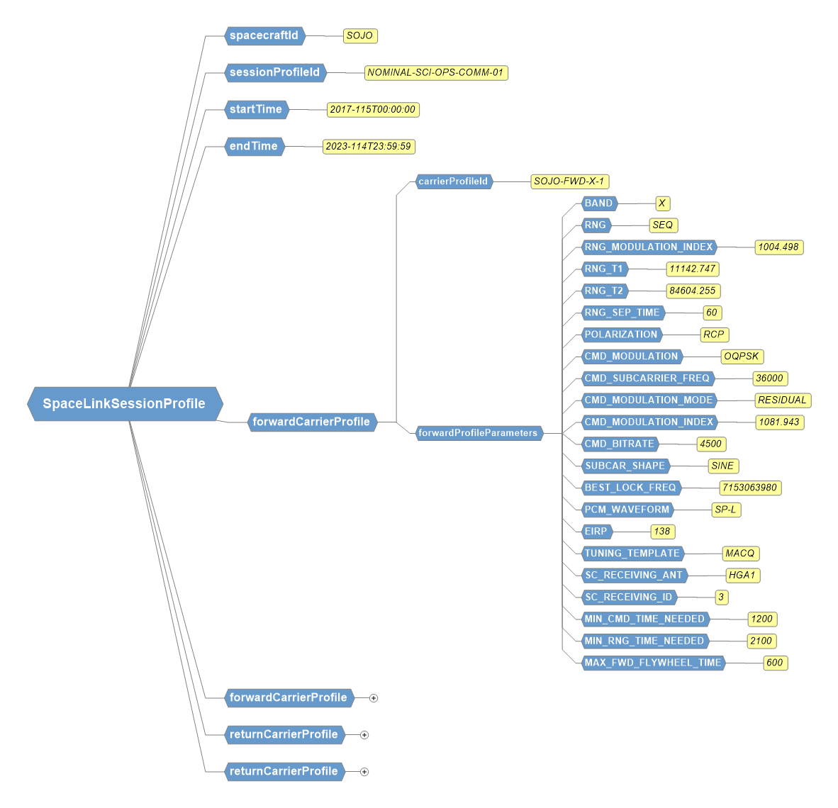
Sample of Configuration Profile Work from DSN

