CCSDS Engineering Steering Group (CESG)
Spring 2017 Meeting: Monday, 15th May 2017 SRI, San Antonio, Texas, USA
Attendees: MdG, BB, WT, PS, EB, SB, JW, GM, MM, GPC, NP
Absent: TdC, HT, XH, TG
CESG Discussion on SLS Area Issues from the past week  - CESG approves unanimously the nomination of Matt Cosby (UKSA) as SLS SLP WG deputy Chair. It should be noted that the CMC did not identify any other candidate upon request of the SLS AD/DAD (mail from 24th April 2017).  - CESG approves the reconfirmation of Lossless Data Compression CCSDS 121.0.B-2  CESG Discussion on SOIS Area Issues from the past week  - YB on EDS / MAL analysis has to be distributed to MOIMS for concurrence  CESG Discussion on SIS Area Issues from the past week  - MIA Charter to be updated including the new MIA BB for RTP  - MAL to BP binding: Joint discussion MOIMS/SOIS/SIS needed  CESG Discussion on CSS Area Issues from the past week  - As CSTS WG Chair (ESA) is stepping down at the end of 2017, ESA has already identified a new replacement. AD will consult in the next months the CMC for additional nominees. AD will also ask CNES to confirm if the Deputy Chair will continue with his task (i.e. he is soon retiring)  - FF-CSTS BB requires the definition of coding and modulation options in order to support the AOS uplink, e.g. a Magenta Book. CSS shall have in the final presentation the different options including number (or type) of books to be produced.  - Time format between Area template for report to CESG and CWE (European and American formats) have to be streamlined. A suggested solution is to use a totally unambiguous time format in the template of the form dd-mmm-yyyy eg. 12-Aug-2018.  CESG Discussion on MOIMS Area Issues from the past week  - Meeting duration / total assistance is missing from demographics  - CESG Chair to bring to the attention of the CMC that its direct to the DAI WG did not follow the normal CCSDS procedure  - MP&S WG discussed the SEA AD’s suggestion to split the approved BB in 2 volumes. WG unanimously agreed to comply with the approved Charter and Project Definition, which calls for a single BB. MOIMS AD and DAD concurred with the WG position and suggested not to re-open this matter that had been already discussed at length at the time of the BB project approval. During CESG discussion other CESG members (SIS AD, CSS AD, SOIS AD) also supported the SEA AD position, noting that the majority of CCSDS standards separate these topics into different books at different layers. The CESG Chair declared that there was no consensus and asked that a webex be organized (inviting all ADs / MP&S WG Chairs) prior to the next CMC meeting. Should no agreement be found or no webex organized, the matter will be escalated to CMC.  CESG Discussion on SEA Area Issues from the past week  - Both MOIMS and SOIS expressed appreciation for the work that the SAWG has done to clearly describe their architectures and expect to incorporate some of these materials in their own future updates  - New, re-engineered, SANA registries are nearly ready to be put into production. SEA / SSG proposal is to make any additional changes for alignment to new registry structures after this has occurred.  - IOAG Service Catalogue : Security is largely absent from this document  - DDOR RBs with minor edits proposed to be published due to non-substantial changes. (Books will be checked by CTE) | NP to ask Secretariat to only issue a CMC Poll  NP to contact Secretariat  NP to address the CMC  MM/BB/PS to organize a webex
Logistics for next meeting in St Petersburg, Russia
The CESG presentation to CMC will be held on Tuesday 13th June 2017 from 09:30 – 12:30 hrs (St Petersburg time)
i.e. 08:30 – 11:30 hrs CET
i.e, 02:30 – 05:30 hrs EST
i.e . 11:30 – 02:30 hrs PST
Recommendation for area sequence is as follows
SEA 09:30 – 10:00 hrs (23:30 – 24:00 hrs PST on June 12th)
CSS 10:00 – 10:30 hrs (00:00 – 00:30 hrs PST)
SIS 10:30 - 11:00 hrs (00:30 – 01:00 hrs PST)
MOIMS 11:00 – 11:30 hrs (10:00 – 10:30 hrs CET)
SLS 11:30 – 12:00 hrs (10:30 – 11:00 hrs CET)
SOIS 12:00 – 12:30 hrs (05:00 – 05:30 hrs EST)
The Area Presentations shall be uploaded in CWE at the latest by 1st June 2017 COB
CESG Chair will consolidate the whole presentation and deliver to CMC on 2nd June 2017 cob
CESG will request CMC for early comments on Thursday 8th June COB
Potential updates to presentation by 12th June 2017 COB
Updated IOAG Service Catalogue #1 and #2 + ICPA  Following SC#1 Services have no corresponding CCSDS Draft projects  CSS Area  - CORS- Off-line Radio Metric Service  - Once TGTF is available, CSS will analyse the need of the required Metadata  - DDORS - CSTS D-DOR Service  - Once TGTF is available, CSS will analyse the need of the required Metadata  - Forward CFDP File Service  - to be implemented when hard requirements exist  - Forward Packet File Service  - to be implemented when hard requirements exist  - Return CFDP File Service  - to be implemented when hard requirements exist  - to be implemented when hard requirements exist  - Return Packet File Service  - to be implemented when hard requirements exist  Following SC#2 Services have no corresponding Draft projects  - Time Services (Clock Correlation Procedures, Time Synchronisation , Time Transfer)  - SEA BoF to be resurrected with all Areas participating.  Note: SEA Time Services BoF was disbanded some years ago due to lack of resources  - ICPA will not be updated until IOAG delivers to CCSDS the new priorities  - ICPA will only include the SC#1 and SC#2 Core Services and those extended services supported by several Agencies  - SC#2 shall reference the 9 SM&C services in section 1.4 | PS to resurrect Time Services BoF
Technical Quality of CCSDS Documents + CESG Poll conditions
The following has been agreed (in alignment with current procedures):
- CESG SHALL ensure the Technical Quality and consistency of CCSDS Recommended Standards and Practices
- But CESG SHALL IDENTIFY AND ADDRESS ISSUES EARLY
The following requirements are agreed:
- AD / DAD shall thoroughly check the technical quality and format at the time of submission of its Area’s Book for Agency Review
- CESG shall check the technical quality at the time of submission for AR
- CESG (all ADs / DADs ) should raise PIDs and should raise RIDs during their Agency’s Review
- AD/DAD shall check the quality of the doc at the time of submission of its Area’s Book for Publication
- CESG shall check the quality of docs at the time of submission for Publication
But CESG SHALL minimize approval conditions at time of final book publication polls, to avoid wasting resources which are scarce.
If all steps have been carried out as said, at publication time there should be no issues of technical nature. We intend to avoid technical issues at this time in the book publication cycle.
CESG Poll Conditions
- Conditions can be negotiated and if it fails can be escalated to Area, CESG and CMC. CMC can finally decide if condition is accepted or rejected.
- Identification of PIDs (Poll Item Discrepancy) at least for showstopper conditions is required during all phases of the process
Proc & Org YB updates  Criteria for joining WGs  CESG has approved the following changes (text highlighted in red)  - From:  5.1.5.4 Official CCSDS E-mail Lists  The Secretariat shall maintain an e-mail list server and provide moderated announcement and discussion e-mail lists for all CCSDS organizational units, including WGs and BOFs. A Web interface shall be provided for access to list archives.  The e-mail lists maintained by the Secretariat shall be the official CCSDS e-mail lists and shall be used for all official CCSDS correspondence distributed via e-mail to CCSDS organizational units. The Secretariat monitors, filters, and virus-scans all e-mail sent to CCSDS e-mail lists to remove SPAM and messages that contain viruses.  - To:  5.1.5.4 Official CCSDS E-mail Lists  The Secretariat shall maintain an e-mail list server and provide moderated announcement and discussion e-mail lists for all CCSDS organizational units, including WGs and BOFs. A Web interface shall be provided for access to list archives.  The e-mail lists maintained by the Secretariat shall be the official CCSDS e-mail lists and shall be used for all official CCSDS correspondence distributed via e-mail to CCSDS organizational units. The Secretariat monitors, filters, and virus-scans all e-mail sent to CCSDS e-mail lists to remove SPAM and messages that contain viruses.  Access to the working email lists shall be limited to individuals who are members of the CCSDS Working Groups and who are approved participants in a Working Group (see 5.2.6.4 Participation) or CCSDS leadership. Working Groups may, at their discretion, request creation of "WG-info" mailing lists for outreach that is broadly open to the public, but these shall not be used for normal Working Group operation.  - And on pg 5-9, sec 5.2.6.4  From:  5.2.6.4 Participation  Working Group participation is generally limited to WG members; however, occasional participation by ad-hoc technical experts may take place. Working group members must be affiliated with member or observer agencies, or liaison or associate organizations. Any WG participant who does not meet these criteria must be endorsed by an authorized representative from a member or observer agency.  To:  5.2.6.4 Participation  Working Group participation is generally limited to WG members; however, occasional participation by ad-hoc technical experts may take place. Working group members must be affiliated with member or observer agencies, or liaison or associate organizations. Any WG participant who does not meet these criteria must be endorsed by an authorized representative from a member or observer agency.  Working Group participants must register with the CCSDS online Collaborative Work Environment (CWE) via the "Request Login" link (http://cwe.ccsds.org/ReqLogin.aspx).  Approved registration provides access to CWE private working group areas and is required for working group meeting attendance. CWE registrants must be approved by a member agency or the Secretariat.  CESG has also agreed the following:  - Every WG Chair :  - Shall have 1 WG Mailing list including only the WG members. It should be noted that the public access to these mailing lists archives raises a security issue.  - May have 1 extra optional “info” mailing list for outreach and general information.  - WG Chairs are currently checking the mailing list. Individuals not responding will be deleted from it.  - Once the lists are cleaned, the CESG Chair will request the Secretariat to check the mapping between consolidated WG mailing list and CWE login account lists in order to detect inconsistencies.  Liaisons  The CESG proposes the following changes:  2.3.1.4.3 CCSDS Liaisons  The CMC acts as representative of the interests of the CCSDS in formal liaison relationships with other organizations concerned with standards. Liaison organizations are those having their own developmental programs in the area of space data and information transfer systems and who wish to establish formal information sharing relations with CCSDS.  A special technical liaison exists between CCSDS and ISO/TC20/SC14, the ISO subcommittee for Space Systems and Operations. Since CCSDS functions as ISO TC20/SC13, it is a peer organization to ISO TC20/SC14. The two organizations will strive to ensure that their work in the standards world is not competitive, but rather is complementary and cooperative. More information on TC20/SC14, including their working group structure, is available at  http://isotc.iso.org/livelink/livelink?func=ll&objId=8791028&objAction=browse&sort=name.  CCSDS also has additional liaison relationships with other organizations. More information is available at http://public.ccsds.org/participation/liaisons.aspx.  More information is detailed in Section 4.1.4  4.1.4 LIAISON  Liaison organizations are those having developmental programs in the areas of space-related data and information systems.  Liaison status is open to standards-developing organizations operating in areas similar to those of the CCSDS. The purpose of creating a liaison is to ensure that their work in the standards world is not competitive, but rather is complementary and cooperative. This is achieved by reciprocal exchange of information regarding current and future standardization activities. Liaison organizations receive from the Secretariat all CCSDS documentation released for external dissemination; they are welcome to submit Review Item Dispositions (RIDs) on CCSDS review documents.  Liaison relationships should be bidirectional. The process of formal review and approval of a new Liaison shall include identification of a CCSDS Liaison point of contact (PoC) to act as official counterpart to the Liaison organization’s point of contact. Such Liaison PoC shall be nominated by the CESG and approved by the CMC. CCSDS Liaison PoC shall report interactions with their respective Liaison organizations semi-annually (i.e. Spring and Fall Technical meetings) to the CESG, for inclusion in the CESG report to the CMC. The CCSDS Liaison PoC shall include in its report any detected overlap and /or contradiction across both Organizations.  CCSDS Liaison PoC shall be cognizant of the standardization activities of the external organization. All liaison relationships and CCSDS liaison PoCs shall be reviewed by the CESG and authorized by the CMC every two years. The review shall include evaluation of the continued participation in CCSDS Liaison relationships, and, as necessary, result in authorization of renewal or replacement.  Liaisons can have two levels of participation,  Active: The CCSDS Liaisons actively participate in the working meetings of the other organization (e.g. IOAG)  Passive: The CCSDS Liaisons only observe / monitor remotely the activities of the other organization (e.g. CASCO, NARA)  4.2 MEMBERSHIP LISTS  The Secretariat shall maintain lists of Member Agencies, Observer Agencies, Liaison organizations PoCs , and Associate organizations. These lists are maintained on the CCSDS Web site.  The CESG has additionally agreed to include informational text on the CTE Document Queue priority handling:  CCSDS CTE will process the document queue according to the following priorities:  - BB for publication  - RB (BB) for Agency Review  - MB for publication  - RB (MB) for Agency Review  - GB for CESG / CMC review / publication  - YB for review or publication  It should be noted that the maximum duration for processing a GB cannot go over 2 technical meeting cycles and that CCSDS internal procedures YB may be given higher priority. | NP to ask Secretariat to perform a cross-check between cleaned WG lists and CWE account Lists  NP to send updated text to CTE
Existing CCSDS Liaisons
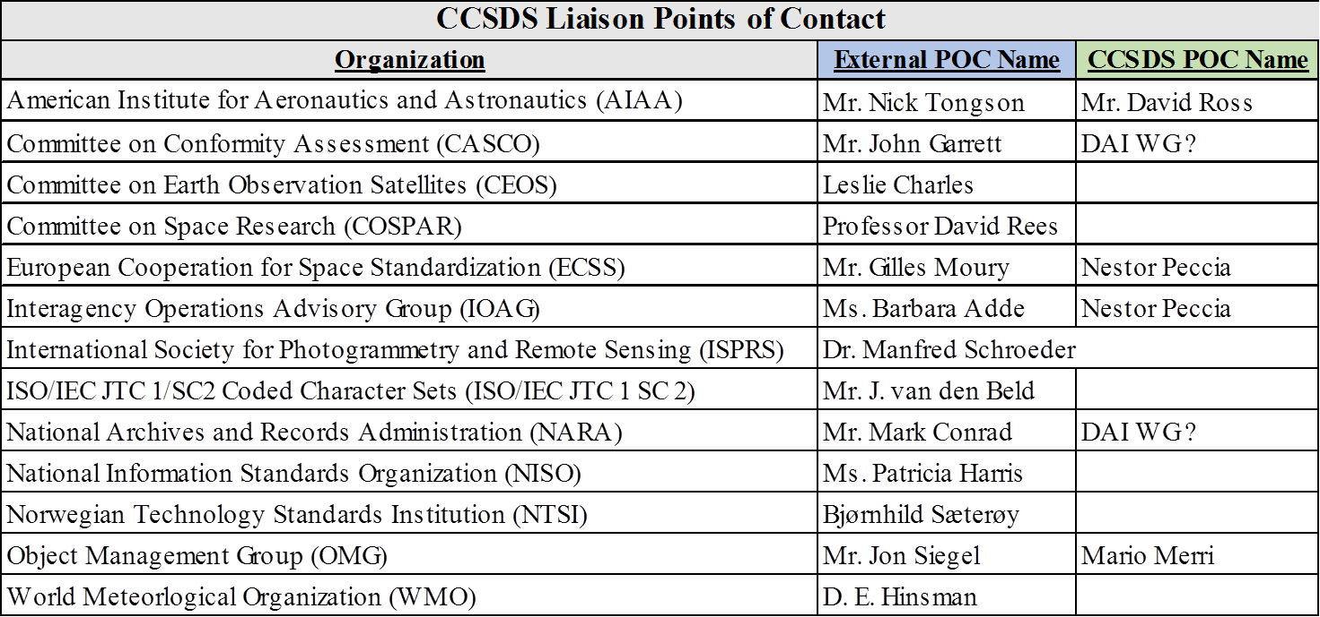
CESG will present this list to the CMC in order to discuss the following issues:
- Are all listed liaisons needed?
- Are there other organizations that deserve a liaison ?
- An “Active / Passive”column has to be added
CWE info on completed reviews / Agency RIDs  CESG suggests that the NASA system shall be extended to all Agency RIDs, which have to be inserted by a batch process and not one by one.  Wallace to check with James and the Secretariat if this is possible.  Another option is to wait until the new RID System is deployed, but this may be incompatible with the available Secretariat resources.  The Table below shows the IT Team 3 highest priority tasks  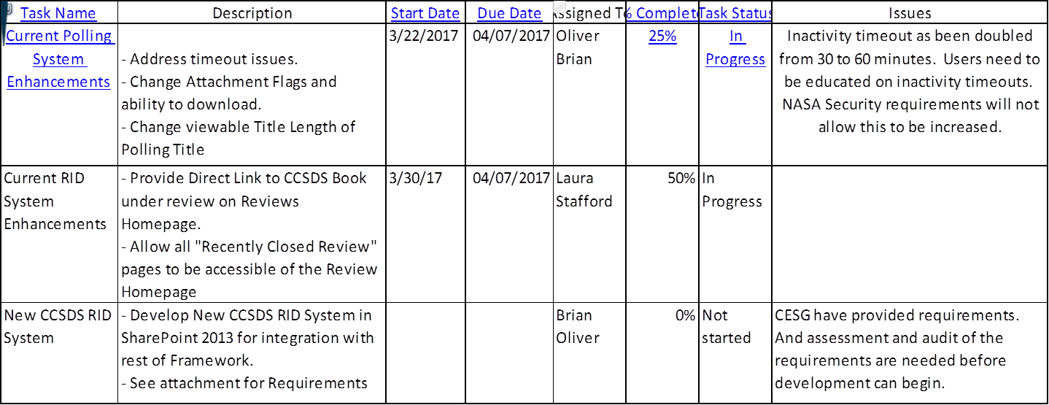 | WT to check with JA and the Secretariat
Update of Omnibus Specifications  SEA AD has shown that there are a number of CCSDS docs of various flavors that need to be brought up to date to ensure alignment with our evolving set of standards, but it will have some knock-on effects on our activities  - Cost involved in doing this,  - Keep them as stable as is practical, if now somewhat out of date and inconsistent, full set of standards.  - Some of the new specs have introduced features that should be retrofitted to older ones in order to keep the whole set aligned  - "Omnibus" type specs exist in more than one area and WG.  - Some of the new standards really need to evolve beyond where we started with TC, TM, and SPP, and that may involve accepting backward incompatible changes as well so as to not "hobble" the ones that are moving forward.  SEA AD has identified in a quick search (probably not a complete list) the following documents:  - CSS SCCS-ADD & ARD (of course, the COP issue and new standards like USLP & optical)  - CSS Cross Support Concept — Part 1: Space Link Extension (CSTS and deprecated specs)  - CSS Cross Support Reference Model—Part 1: Space Link Extension Services. (CSTS and deprecated specs)  - SLS OSCP (coding changes, USLP, & optical comm)  - SLS Coding Green Book  - SLS Telecommand Summary of Concept and Rationale (integrate AOS and USLP forward)  - SLS TM Channel Coding profiles (AOS & USLP, optical)  - SLS Mars Mission Protocol Profiles--Purpose and Rationale  - SIS SSI Architecture  - MOIMS Mission Operations Services Concept. Green Book  - MOIMS Mission Operations Reference Model  - MOIMS Navigation Data—Definitions and Conventions  - MOIMS Standard Formatted Data Units — Control Authority Data Structures (align with RMP)  - MOIMS OAIS & PAIS (align with RMP)  - SOIS Spacecraft Onboard Interface Services. Green Book (deal with the slew of silver standards)  - Unique Identification of CCSDS Objects and Services (I forgot this even existed, RMP alignment)  - And the MOIMS and SOIS Application & Support Layer architecture that is now in work.  The CESG has decided the following:  - BBs / MBs Updates will be carried out at each 5 yr review  - Action on Areas to check GB reconfirmation | All areas to check the GBs with reconfirmation date due
Document status & CTE Queue  The CESG Chair has produced a list of all documents with reconfirmation dates that are due or past due (i.e. 32 documents). ADs / DADs to review them and decide if the books shall be "silverized" or reconfirmed or a new project has to be created for the 5 year review.  The main issues on the CTE Queue are as follows:  - CCSDS 922.1-B-1, Cross Support Transfer Services—Monitored Data Service. BB for publication  BB was returned to Working Group due to additional editorial changes after CMC approval for publication. CTE is solving it.  - CCSDS 522.2-R-0, Mission Operations—Mission Data Product Distribution Services. RB for Agency review.  CTE assessment is that the book is not in very good status. CTE has to dedicate more resources than usual to bring it under compliance with our rules  - CCSDS 524.2-B-0, Mission Operations—Message Abstraction Layer Binding to TCP/IP Transport and Split Binary Encoding BB for Publication. Once check by CTE a CESG Poll will be initiated.  - CCSDS 524.3-R-0, Mission Operations—Message Abstraction Layer Binding to HTTP Transport and XML Encoding. BB for Agency review.  CESG conditions were raised during the poll and are being solved.  This is the only existing Poll with CESG conditions open. | ADs / DADs to check all Area docs with reconfirmation date due
DAI WG Report to CMC
CESG comments to the report are as follows:
- The current work is embryonic and demands a lot of consolidation and resources for completion.
- Report gives a good idea of their very ambitious planned future work. SEA SA WG assessed the DAI notional architecture and provided its recommendations, which will be included in updates to the draft WB of the already existing Draft Project (DAADD : Data Archive Architecture Description Document, MB), once approved by CMC.
- CESG endorses
  - Improvements to the scope and clarity of the draft WB
  - the importance of the early ISO participation during the CCSDS ARs
  - the participation of the digital preservation community
  - Parallel CCSDS and ISO reviews
- Last but not least, CESG Chair will bring to the attention of the CMC that its direct request to the DAI WG did not follow the normal CCSDS procedure
Logistics for F17 meeting
- 4 days Technical meeting (6th – 9th November 2017)
Maximum 15 rooms per day. Additional rooms (if needed) only available at ESTEC (40 Kms from The Hague)
Rooms can be used until 18:00 / 18:30 hrs
Marriott offered lunch at 25€ (it will be an issue because of high cost)
Several Restaurant/ Snack bars are close to the Marriott, but 1 hr lunch break may not be long enough
- CESG meeting will be at ESTEC on Friday 10th November 2017
- CESG / CMC Joint Meeting will be at ESOC on Monday 13th November 2017
- CMC will discuss at St Petersburg the logistics for the future meetings
- Logistics for CMC / IOAG Joint meeting on Wednesday 15th Nov 2017 are still to be agreed
OMG Liaison
- Liaison PoCs: Mario Merri (CCSDS), Steven MacLaird (OMG)
- OMG liaison attended the CCSDS meetings in San Antonio. First liaison meeting took place
  - General exchange of information
  - OMG would prefer informal liaison (no MoU)
- Next OMG Meeting will be in Brussels 05-09Jun17 (SDTF meets for 0.5 day on 08Jun). MM will try to attend the SDTF meeting (does liaison need to pay OMG registration?)
- Current active standard publication of the OMG Space Domain Task Force (see http://www.omg.org/space/):
XTCE (XML Telemetric and Command Exchange)
GEMS (Ground Equipment Monitoring Service)
SOLM (Satellites Operations Language Metamodel)
XUSP (XTCE Profile for US Government Satellites: aka GovSat)
- Current OMG SDTF priorities have been developed without consultation with the CCSDS via the Liaison PoC
- CCSDS liaison PoC needs CESG guidance on how to handle:
  - The potential overlaps
  - The renewed NASA/US interest in OMG: J. Afarin, P. Shames, D. Smith, M. Kearney
CESG has agreed that
- all official information has to be channeled via the CCSDS Liaison PoC (MM), in particular Work Plans, Long Term Strategy plan, resources, etc.
- MM will draft a OMG – CCSDS MoU to be reviewed by CESG and CMC
AOB
- Update of CCSDS Code of Conduct
CESG Chair asked the CESG members if the Code of Conduct has to be updated by adding a requirement
“ CCSDS members shall not plagiarize other standards documents without the owner permission”
AD / DADs’ opinion is that this is already covered by current copyright law.
- Secretariat new Help Desk Tools
The Secretariat has adopted a new help desk tool to better control the work done by SW support.
Ca. 60 tickets were raised in the first 10 days of May 2017.

