CCSM Telecon/Webex, 29 May 2017

Attendees
E. Barkley, C. Ciocirlan, J. Chamoun, A. Crowson, T. Pham, K. Tuttle

Agenda/Notes

General announcements
- FF-CSTS and AOS uplink
  - perceived lack of standards coverage re AOS uplink
- CSTS WG Chairs
  - agencies to be polled re future chair and deputy chair
- IOAG Catalog 1 Services
  - agreed (at CESG meeting) that DDOR and Radiometric files can be application of TGFT; various flavor of files into other protocols (e.g., file of packets for forward direction) pending input of hard requirement.
- Silver status for 910.11-B-1 and related concept book
  - Question of references from MD- and TD-CSTS recommendations; perhaps this can be changed to the current concept book; further check by E.B. pending

Action Items Review/Updates (Finalize from San Antonio)
- AIs without due date were assigned due date of 31-July-2017; this includes the following AIs: 2017-0508-03 Prepare a presentation on service package proposal (re: state machine) MG
2016-1017-5 Add PIF test case for space-based aperture JPC
2017-0512-36 Put comments in master copy of concept book MG

Request goes out to M. Gnat, and J. Chamoun to see if the dates are okay.

SOS Agency review inputs
- RIDS received by DLR (M. Gnat) as agreed at San Antonio meetings
- RIDS received from MSFC/NASA re “xsd:unsigned integer” vs “xsd:unsignedint” and “xsd:any” vs “xsd:anyType”

Planning Data – Structuring proposal
- Initial draft proposal to add optional structuring meta-data was reviewed. Further work/development to be pursued by E. Barkley. See picture below.
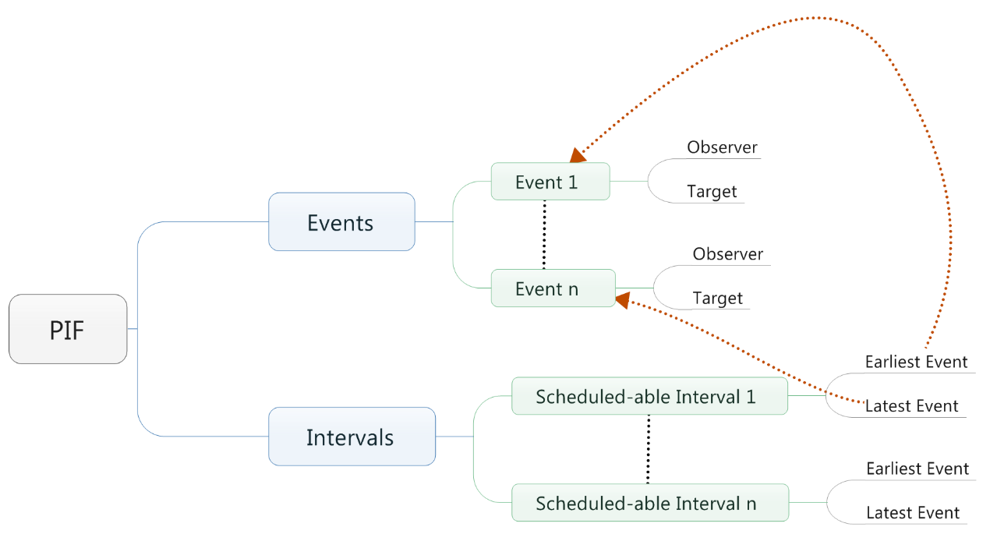

AOB – None.

Next Telecon
Our next telecon is scheduled for June 27th.

