CCSM Telecon/Webex, 28 February 2017

Attendees
E. Barkley, C. Ciocirlan, A. Crowson, M. Gnat, C. Haddow, H. Kelliher, J. Pietras, Y. Wang, L. Yurong,

Agenda/Notes

General announcements
- Schedule Book submitted to secretariat
- FRM teleconference held
- Draft OMG RFP

Action Items Review/Updates (not addressed at telecon)

Mid-term WG plan check
- Updated various completion status, verified and/or modified various completion dates
- Noted that TGFT prototype test plan will likely have a focus on construction/generation of XFDUs
  - C. Haddow noted that CNES, at one point had an XFDU library – further checking to be done
- Service Package book discussion
  - Noted that issue of configuration profiles still needs work – particularly re service specific (“individual”) profiles, aggregate profiles, and relation to event sequences (which involves multiple services)
  - J. Chamoun agreed to organize further discussion for the March 13th telecon.
- Please see revised diagram with updated dates and status below

Any comments on XFDU approach
- No comments provided
- J. Pietras will release the proposed approach today
- Discussed example in relation to delivery of radiometric data as TDM in XML format
  - Question of how much meta-data to bundle with TDM payload
    - URL to official schema and sub-schemas
    - Schemas themselves
    - Conclusion is that URL will be sufficient

PIF Prototype inter-operation timeline check/update
- Agreed that for ExoMars, TGO S/C can be used
- Action to E. Barkley to pick/propose one of the STEREO spacecraft

SMURF Test Plan status check
- Reviewed M. Gnat’s test plan outline presentation
  - Appears that there may be many test cases (~50 – 60)
  - Noted that test has to sufficiently cover SMURF features by rules of CCSDS
    - But some judgement can be appliled – e.g, a submission request test case is likely to be sufficiently verified by submitting trajectory data that a test case for submission of configuration profiles is not necessarily called for
  - Noted that the SMURF testing may be more akin to a test bed approach as various recommendations that require a request to be tested will likely emerge after the Smurf book has been written
  - also noted that this has a bearing on the test plan for the eventual management service

Service Catalog review inputs (assuming we have a quorum)
- agreed to walk through the comments at the March 13 teleconference

CWE re-structuring status (not addressed)

AOB
- March 20th telecon -- agreed to reschedule for March 13th.

Next Telecon
Our next teleconference is scheduled for March 13.

Updated work plan

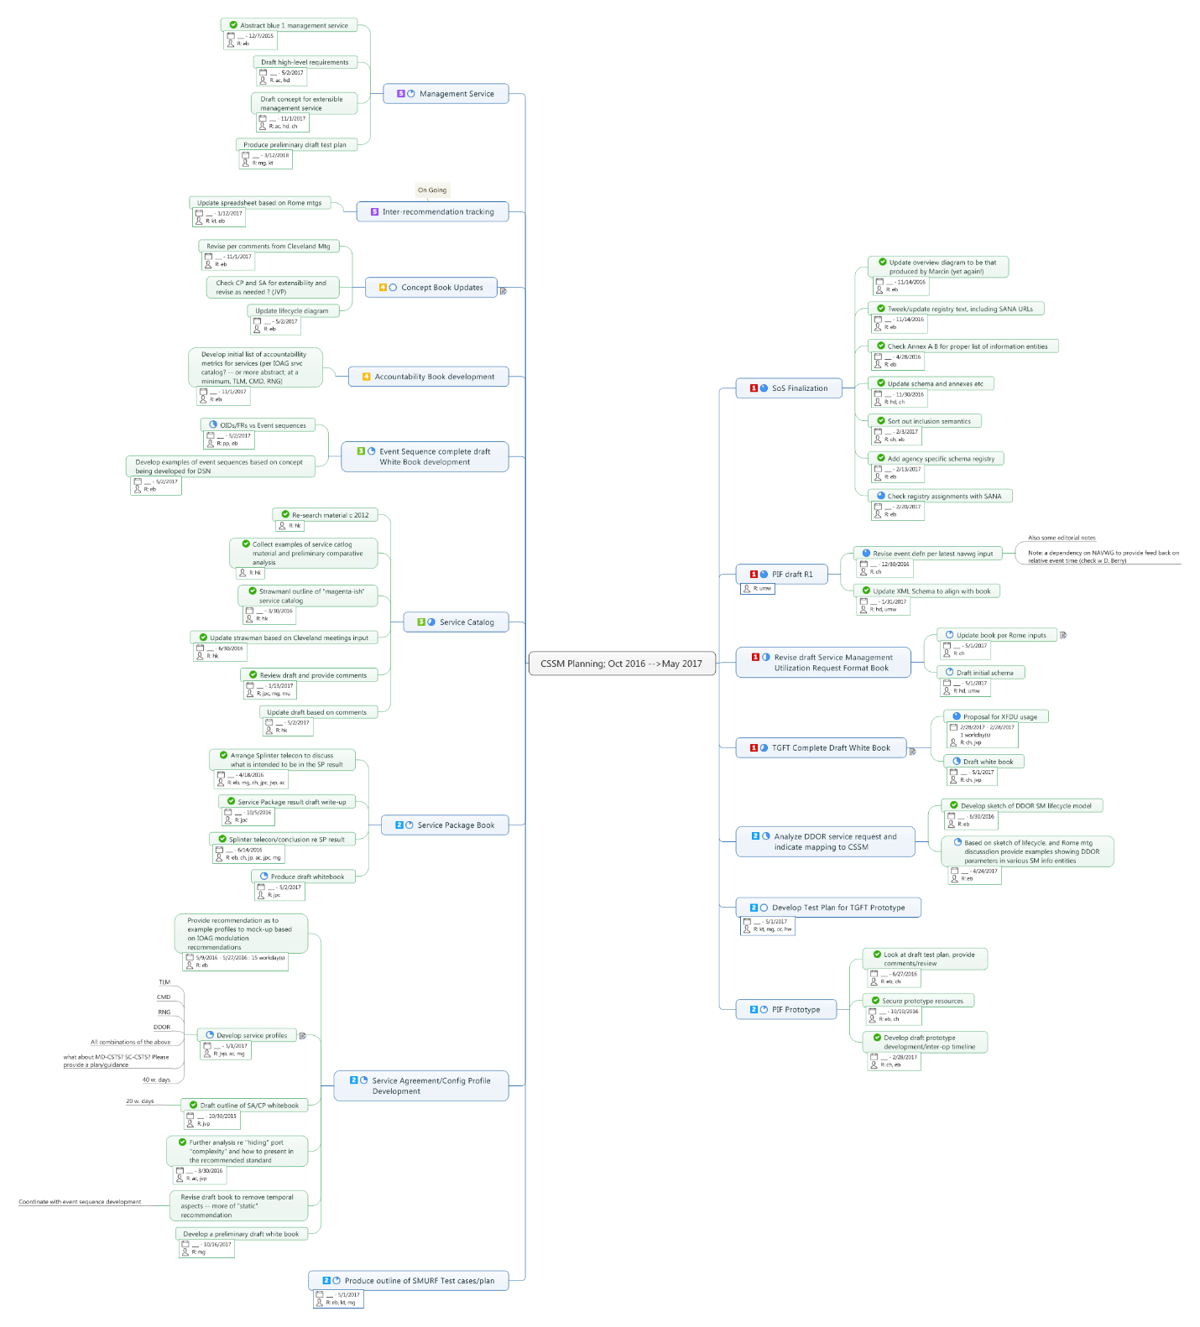
[end notes]

