CCSM Telecon/Webex, 09 Aug 2016

Attendees
E. Barkley, L. Cacciatore, A. Crowson, C. Haddow, H. Kelliher, K. Tuttle

Agenda (as adjusted at the Telecon)
- Information Entities list -- check on the list of information entities defined and their management in SANA
  - Looked at comparative charts – SANA already has a beta registry for the information entities defined in appendix B of the SOS book (see below)
  - Agreed to keep SANA registry as “flat” – ie., “sub-entities” such as component of the provisional plan that can be delivered on their own will be given listed as separate entities (e.g., communication geometry)
  - Meta-data can be supplied in the registry to indicate the “parent” information entity
    - Editorial note – Assigning OIDs which is what part of the RMP advocates might help with this
  - Agreed to work with organization as listed in the inter-recommendation tracking spreadsheet, but to factor in the different request types identified in the SMURF – action to E. Barkley
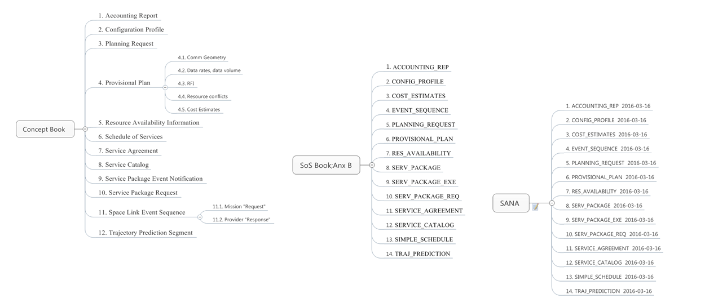
- Update re CCSDS Time Code B definition
  - E. Barkley has engaged CESG on a proposed update to make it clear that fractional seconds are not required
    - This has a bearing on the SOS book – use of Time Code B is desired, but fractional seconds for when a scheduled set of services begins/ends makes no sense
  - Appears that either a corrigendum and/or a pink sheet to be voted on will be forthcoming
- AOB – Service Package development – progress review
  - Reviewed latest inputs from J. Chamoun (see below)
  - In general, this is going the right direction based on the conceptual diagram from the splinter session
  - Discussion re list of services vs putting in the service data directly:
    - noted that the list of service might be more flexible overall rather than having to adjust the underlying structure as new services emerge
  - Some more work needs to be done with regard to connecting the scenarios to different set of services and alternate trajectories
    - For the “simple” service package the implied single scenario is in good shape
  - Noted that the notion of a configuration profile with a top-level “directory” of service level configurations (also indexed via carrier) would work well with the list of service approach
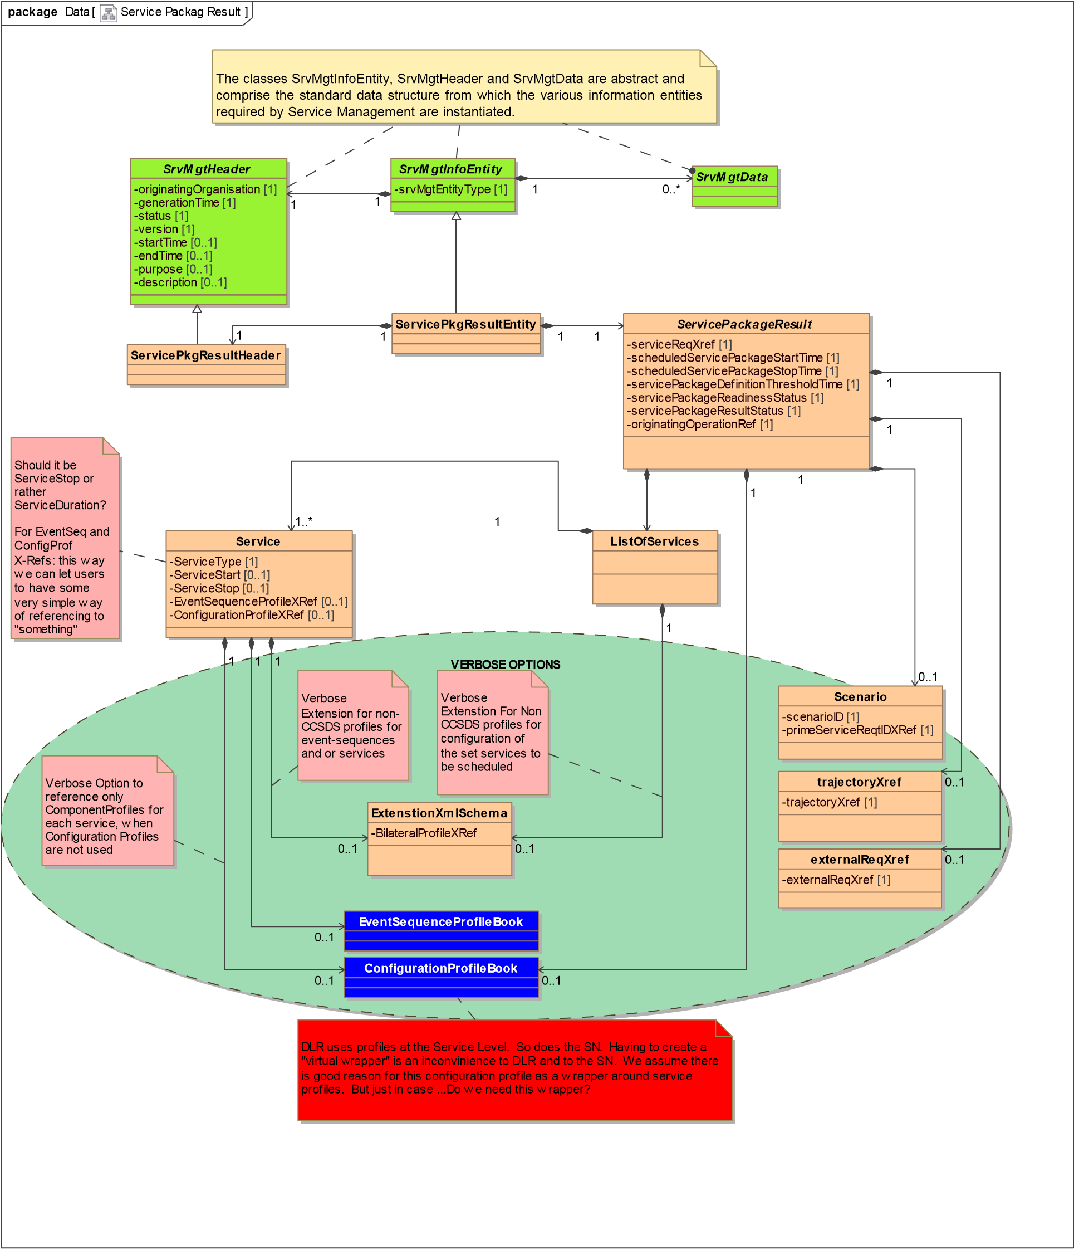
- Review of Planning Information Format XML Schema – comments from WG members
  - Relative to the version posted by U. Muller-Wilm, noted that the AOS type definition appear to be incorrectly assigned – A. Crowson to follow up with Uwe
  - Larger schema management issues starting to emerge
    - Noted that PIF Schema is using copy of the Time Code B definition
      - Ultimately want common schema in fixed location; not copied
      - Need to consider namespace assignments and document them, etc.
      - H. Dreihahn identified as potential new schema master
- Preliminary Rome meetings planning
  - Agreed to have a session on schema management – goal will be to produce a proposed approach for input XSG
  - Agreed to have a joint DDOR session on Thursday afternoon of meetings week
  - Agreed to have a small joint meeting re event definition (MOIMS + CSS areas)
- Action Items Status/Updates
  - Several action items delayed to either Rome or San Antonio (Spring ’17) meetings
  - Some actions still have “TBD” for actionee as a result of resource issues

Next Telecon
Our next telecon is scheduled for August 13th

[end notes]

