CCSM Telecon/Webex, 10 May 2016

Attendees
E. Barkley, J. Chamoun, C. Ciocirlan, A. Crowson, M. Gnat, C. Haddow, K. Tuttle

Agenda
- General updates/announcements
  - Noted that registry creation work on going in SANA; almost have complete set of URLs to proceed with SOS book
  - CMC surveyed projects with delays and requested inputs; no signficant changes re CSSM WG products as result of survey (ed. note – this will be reported to CMC as such)
- Cleveland Meetings Summary
  - No comments at telecon
- Action items status
  - Several action items checked and updated and/or consolidated vis a vis Cleveland work plan
    - Especially those relating to DDOR
  - See updated spreadsheet
- SOS and Registries update
  - Reviewed registry URL/status of registries
  - Agreed that updates to SOS book should include removal of complete list of information entites in preference to their expression in the Green Book
    - SANA registry (which is created by SOS book) will be where all of the information entities are kept
- Planning Book progress, incl XML Schema
  - Reviewed the Sun Alignment Angle defintion and agreed to go with Option A (see diagrams below)
  - Action to EB to update presentation with defintion and distribute presentation.
- AOB
  - IOAG service catalog re service management
    - Looked at management services defintions in draft updated IOAG service catalog 1
    - Action to EB to provide comments and circulate to WG for input
    - Comments to be reviewed at next telecon

Next Telecon
Our next telecon/webex is scheduled for 07 June 2016

Option A/Option B Sun Alignment Angle Diagrams

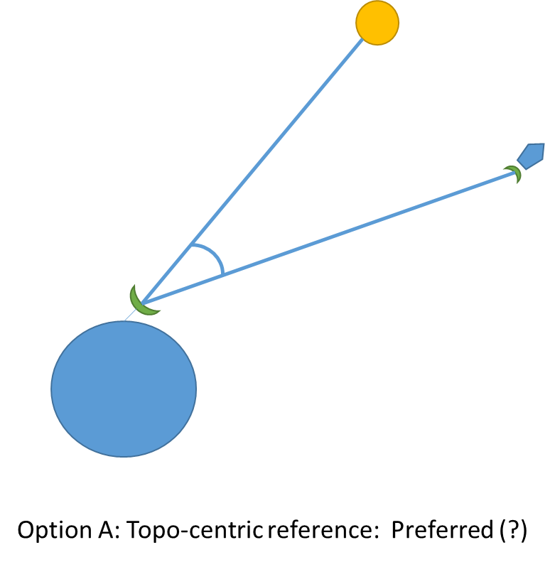

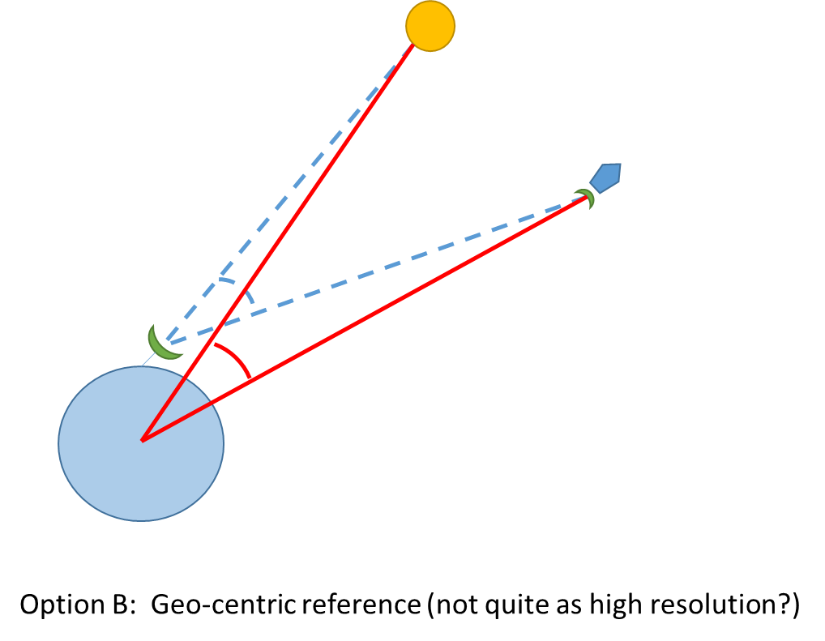
[end notes]

