
Draft Recommendation for
Space Data System Standards
Service Management Utilization Request Formats
Draft Recommended Standard
CCSDS 902.9-W-0.01
White Book
November 2015

AUTHORITY

 | Issue: | White Book, Draft 0.01
 | Date: | November 2015
 | Location: | Not Applicable
(WHEN THIS RECOMMENDED STANDARD IS FINALIZED, IT WILL CONTAIN THE FOLLOWING STATEMENT OF AUTHORITY:)
This document has been approved for publication by the Management Council of the Consultative Committee for Space Data Systems (CCSDS) and represents the consensus technical agreement of the participating CCSDS Member Agencies. The procedure for review and authorization of CCSDS documents is detailed in Organization and Processes for the Consultative Committee for Space Data Systems (CCSDS A02.1-Y-4), and the record of Agency participation in the authorization of this document can be obtained from the CCSDS Secretariat at the e-mail address below.

This document is published and maintained by:

CCSDS Secretariat
National Aeronautics and Space Administration
Washington, DC, USA
E-mail: secretariat@mailman.ccsds.org
STATEMENT OF INTENT
(WHEN THIS RECOMMENDED STANDARD IS FINALIZED, IT WILL CONTAIN THE FOLLOWING STATEMENT OF INTENT:)
The Consultative Committee for Space Data Systems (CCSDS) is an organization officially established by the management of its members. The Committee meets periodically to address data systems problems that are common to all participants, and to formulate sound technical solutions to these problems. Inasmuch as participation in the CCSDS is completely voluntary, the results of Committee actions are termed Recommended Standards and are not considered binding on any Agency.
This Recommended Standard is issued by, and represents the consensus of, the CCSDS members. Endorsement of this Recommendation is entirely voluntary. Endorsement, however, indicates the following understandings:
o Whenever a member establishes a CCSDS-related standard, this standard will be in accord with the relevant Recommended Standard. Establishing such a standard does not preclude other provisions which a member may develop.
o Whenever a member establishes a CCSDS-related standard, that member will provide other CCSDS members with the following information:
-- The standard itself.
-- The anticipated date of initial operational capability.
-- The anticipated duration of operational service.
o Specific service arrangements shall be made via memoranda of agreement. Neither this Recommended Standard nor any ensuing standard is a substitute for a memorandum of agreement.
No later than five years from its date of issuance, this Recommended Standard will be reviewed by the CCSDS to determine whether it should: (1) remain in effect without change; (2) be changed to reflect the impact of new technologies, new requirements, or new directions; or (3) be retired or canceled.
In those instances when a new version of a Recommended Standard is issued, existing CCSDS-related member standards and implementations are not negated or deemed to be non-CCSDS compatible. It is the responsibility of each member to determine when such standards or implementations are to be modified. Each member is, however, strongly encouraged to direct planning for its new standards and implementations towards the later version of the Recommended Standard.
FOREWORD
Through the process of normal evolution, it is expected that expansion, deletion, or modification of this document may occur. This Recommended Standard is therefore subject to CCSDS document management and change control procedures, which are defined in the Organization and Processes for the Consultative Committee for Space Data Systems (CCSDS A02.1-Y-4). Current versions of CCSDS documents are maintained at the CCSDS Web site:
http://www.ccsds.org/
Questions relating to the contents or status of this document should be sent to the CCSDS Secretariat at the e-mail address indicated on page i.
At time of publication, the active Member and Observer Agencies of the CCSDS were:
Member Agencies
- Agenzia Spaziale Italiana (ASI)/Italy.
- Canadian Space Agency (CSA)/Canada.
- Centre National d’Etudes Spatiales (CNES)/France.
- China National Space Administration (CNSA)/People’s Republic of China.
- Deutsches Zentrum für Luft- und Raumfahrt (DLR)/Germany.
- European Space Agency (ESA)/Europe.
- Federal Space Agency (FSA)/Russian Federation.
- Instituto Nacional de Pesquisas Espaciais (INPE)/Brazil.
- Japan Aerospace Exploration Agency (JAXA)/Japan.
- National Aeronautics and Space Administration (NASA)/USA.
- UK Space Agency/United Kingdom.
Observer Agencies
- Austrian Space Agency (ASA)/Austria.
- Belgian Federal Science Policy Office (BFSPO)/Belgium.
- Central Research Institute of Machine Building (TsNIIMash)/Russian Federation.
- China Satellite Launch and Tracking Control General, Beijing Institute of Tracking and Telecommunications Technology (CLTC/BITTT)/China.
- Chinese Academy of Sciences (CAS)/China.
- Chinese Academy of Space Technology (CAST)/China.
- Commonwealth Scientific and Industrial Research Organization (CSIRO)/Australia.
- Danish National Space Center (DNSC)/Denmark.
- Departamento de Ciência e Tecnologia Aeroespacial (DCTA)/Brazil.
- European Organization for the Exploitation of Meteorological Satellites (EUMETSAT)/Europe.
- European Telecommunications Satellite Organization (EUTELSAT)/Europe.
- Geo-Informatics and Space Technology Development Agency (GISTDA)/Thailand.
- Hellenic National Space Committee (HNSC)/Greece.
- Indian Space Research Organization (ISRO)/India.
- Institute of Space Research (IKI)/Russian Federation.
- KFKI Research Institute for Particle & Nuclear Physics (KFKI)/Hungary.
- Korea Aerospace Research Institute (KARI)/Korea.
- Ministry of Communications (MOC)/Israel.
- National Institute of Information and Communications Technology (NICT)/Japan.
- National Oceanic and Atmospheric Administration (NOAA)/USA.
- National Space Agency of the Republic of Kazakhstan (NSARK)/Kazakhstan.
- National Space Organization (NSPO)/Chinese Taipei.
- Naval Center for Space Technology (NCST)/USA.
- Scientific and Technological Research Council of Turkey (TUBITAK)/Turkey.
- South African National Space Agency (SANSA)/Republic of South Africa.
- Space and Upper Atmosphere Research Commission (SUPARCO)/Pakistan.
- Swedish Space Corporation (SSC)/Sweden.
- Swiss Space Office (SSO)/Switzerland.
- United States Geological Survey (USGS)/USA.
PREFACE
This document is a draft CCSDS Recommended Standard. Its ‘Red Book’ status indicates that the CCSDS believes the document to be technically mature and has released it for formal review by appropriate technical organizations. As such, its technical contents are not stable, and several iterations of it may occur in response to comments received during the review process.
Implementers are cautioned not to fabricate any final equipment in accordance with this document’s technical content.
Recipients of this draft are invited to submit, with their comments, notification of any relevant patent rights of which they are aware and to provide supporting documentation.

DOCUMENT CONTROL

Document | Title | Date | Status
CCSDS 902.2-W-0.00 | Planning and Service Request Specification, Draft Recommended Standard, Draft 0.00 | November 2015 | Initial draft for working group
CCSDS 902.9-W-0.01 | Service Management Utilization Request Formats, Draft Recommended Standard, Draft 0.01 | November 2015 | Update after discussions at Darmstadt meeting.

CONTENTS
Section Page
1 Introduction 1-11
1.1 PURPOSE AND SCOPE 1-11
1.2 APPLICABILITY 1-11
1.3 RATIONALE 1-11
1.4 DOCUMENT STRUCTURE 1-11
1.5 DEFINITIONS 1-11
1.6 NOMENCLATURE 1-11
1.7 CONVENTIONS—THE UNIFIED MODELING LANGUAGE 1-12
1.8 References 1-12
2 Overview 2-1
2.1 GENERAL 2-1
2.2 SIMPLE Planning Entity 2-1
2.3 MAPPING TO W3C XML SCHEMA 2-1
3 SERVICE MANAGEMENT UTILIZATION REQUEST FORMATS 3-1
3.1 GENERAL 3-1
3.2 Abstract Service Management Utilization Request Formats CONTENT/STRUCTURE 3-3
3.3 Service Management Utilization Request Formats Basic Constraints 3-23
3.4 Service Management Utilization Request Formats Enhanced Constraints 3-27
3.5 Submission Request 3-36
3.6 Basic Service Management Utilization Request Formats – Service Package - New Request 3-39
3.7 Basic Service Management Utilization Request Formats – Service Package - Update Request 3-42
3.8 Basic Service Management Utilization Request Formats – Planning Info Request 3-45
3.9 Service Management Utilization Request Formats – Service Package - Delete Request 3-47
3.10 Service Management Utilization Request Formats – Service Package – Select Alternate Request 3-49
3.11 Service Management Utilization Request Formats – Report Request 3-51
3.12 Service Management Utilization Request Formats – Information Request 3-52
3.13 Enhanced Service Management Utilization Request Formats – Service Package - New Request 3-54
3.14 Enhanced Service Management Utilization Request Formats – Service Package - Update Request 3-58
3.15 Enhanced Service Management Utilization Request Formats – Planning Info Request 3-62

ANNEX A Informative References (INFormative) 1
Figure
Figure 3-1: Abstract Service Management Utilization Request Formats Class Diagram 3-4
Figure 3-2: Service Management Utilization Request Formats Basic Constraints Class Diagram 3-23
Figure 3-3: Service Management Utilization Request Formats Enhanced Constraints Class Diagram 3-27
Figure 3-4: Service Management Utilization Request Formats - Submission Request Class Diagram 3-36
Figure 3-5: Basic Service Management Utilization Request Formats Service Package New Request Class Diagram 3-39
Figure 3-6: Basic Service Management Utilization Request Formats Service Package Update Request Class Diagram 3-42
Figure 3-7: Basic Service Management Utilization Request Formats Planning Info Request Class Diagram 3-45
Figure 3-8: Service Management Utilization Request Formats Service Package Delete Request Class Diagram 3-47
Figure 3-9: Service Management Utilization Request Formats Service Package Select Alternate Request Class Diagram 3-49
Figure 3-10: Service Management Utilization Request Formats Report Request Class Diagram 3-51
Figure 3-11: Service Management Utilization Request Formats Information Request Class Diagram 3-52
Figure 3-12: Enhanced Service Management Utilization Request Formats Service Package New Request Class Diagram 3-54
Figure 3-13: Enhanced Service Management Utilization Request Formats Service Package Update Request Class Diagram 3-58
Figure 3-14: Enhanced Service Management Utilization Request Formats Planning Info Request Class Diagram 3-62

Table
Table 3-1: Class SrvMgtUtilReq Parameters 3-5
Table 3-2: Class SrvMgtUtilReqHeader Parameters 3-5
Table 3-3: Class RequestType Parameters 3-6
Table 3-4: Class ServicePkgReq Parameters 3-7
Table 3-5: Class NewSrvPkg Parameters 3-8
Table 3-6: Class NewSrvPkg use of Class ServicePkgReq Parameters 3-8
Table 3-7: Class UpdateReq Parameters 3-8
Table 3-8: Class UpdateSrvPkg use of Class ServicePkgReq Parameters 3-9
Table 3-9: Class DeleteSrvPkg Parameters 3-9
Table 3-10: Class DeleteSrvPkg use of Class ServicePkgReq Parameters 3-9
Table 3-11: Class SelectAltSrvPkg Parameters 3-10
Table 3-12: Class SelectAltSrvPkg use of Class ServicePkgReq Parameters 3-10
Table 3-13: Class PlanningInfoReq Parameters 3-11
Table 3-14: Class reportReq Parameters 3-12
Table 3-15: Class InfoReq Parameters 3-13
Table 3-16: Class Scenario Parameters 3-14
Table 3-17: Class ServiceInfo Parameters 3-15
Table 3-18: Class ConfigurationProfileXRef Parameters 3-16
Table 3-19: Class ConfigProfileParameter Parameters 3-16
Table 3-20: Class EventSequenceXRef Parameters 3-17
Table 3-21: Class EventSeqParameter Parameters 3-17
Table 3-22: Class OIDParameter Parameters 3-18
Table 3-23: Class SubmissionReq Parameters 3-18
Table 3-24: Class TrajectoryDataSubmission Parameters 3-19
Table 3-25: Class CCSDSTrajectoryPrediction Parameters 3-20
Table 3-26: Class ConfigProfileSubmission Parameters 3-20
Table 3-27: Class EventSeqSubmission Parameters 3-21
Table 3-28: Class Constraints Parameters 3-21
Table 3-29: Class BasicStartTimeConstraint Parameters 3-24
Table 3-30: Class BasicDurationConstraint Parameters 3-25
Table 3-31: Class BasicHandoverConstraints Parameters 3-25
Table 3-32: Class BasicApertureConstraint Parameters 3-26
Table 3-33: Class StandingOrder Parameters 3-28
Table 3-34: Class PassIntervalConstraints Parameters 3-29
Table 3-35: Class PassDailyTimeConstraints Parameters 3-29
Table 3-36: Class PassRangeConstraints Parameters 3-31
Table 3-37: Class PassRelativeTimeConstraints Parameters 3-32
Table 3-38: Class EventParameter Parameters 3-35

Introduction

PURPOSE AND SCOPE

PURPOSE

SCOPE

APPLICABILITY

RATIONALE

General

USE CASES

DOCUMENT STRUCTURE
This document is organized as follows:

DEFINITIONS
For the purposes of this document, the following definitions apply:
- the word ‘agencies’ may also be construed as meaning ‘satellite operators’ or ‘satellite service providers’;
- the notation ‘n/a’ signifies ‘not applicable’.

NOMENCLATURE

Normative Text
The following conventions apply for the normative specifications in this Recommended Standard:
- the words ‘shall’ and ‘must’ imply a binding and verifiable specification;
- the word ‘should’ implies an optional, but desirable, specification;
- the word ‘may’ implies an optional specification;
- the words ‘is’, ‘are’, and ‘will’ imply statements of fact.
NOTE – These conventions do not imply constraints on diction in text that is clearly informative in nature.

Informative Text
In the normative sections of this document, informative text is set off from the normative specifications either in notes or under one of the following subsection headings:
- Overview;
- Background;
- Rationale;
- Discussion.

CONVENTIONS—THE UNIFIED MODELING LANGUAGE
The Unified Modeling Language (UML) diagrams used in the specification (including class diagrams, package diagrams, sequence diagrams, and activity diagrams) follow the notation, semantics, and conventions imposed by the Version 2.4.1 UML specification of the Object Management Group (OMG) (reference [4]). An overview of UML diagramming conventions can be found in Annex E of reference [1].
Within the document use is made only of class diagrams. A UML class diagram describes the structure of a message, its parts, and how those parts interrelate. A UML class, represented in the diagram as a box, represents a data set. Class diagram conventions include composition, generalization, multiplicity, and constraints. Enumeration notation is also used but only when it is involved in a composition constraint.

References
The following publications contain provisions which, through reference in this text, constitute provisions of this document. At the time of publication, the editions indicated were valid. All publications are subject to revision, and users of this document are encouraged to investigate the possibility of applying the most recent editions of the publications indicated below. The CCSDS Secretariat maintains a register of currently valid CCSDS publications.
[1] Space Communication Cross Support—Service Management—Service Specification. Issue 1. Recommendation for Space Data System Standards (Blue Book), CCSDS 910.11-B-1. Washington, D.C.: CCSDS, August 2009.
[2] “CCSDS-910.11-B-1_XML_schemas.” http://public.ccsds.org/publications/archive/CCSDS-910.11-B-1_XML_schemas.zip.
[3] Time Code Formats. Issue 4. Recommendation for Space Data System Standards (Blue Book), CCSDS 301.0-B-4. Washington, D.C.: CCSDS, November 2010.
[4] Unified Modeling Language (UML). Version 2.4.1. Needham, Massachusetts: Object Management Group, August 2011.
[5] Service Agreement and Service Configuration. Recommendation for Space Data System Standards (Blue Book), CCSDS 902.5-B-1. Blue Book. Issue 1. Washington, D.C.: CCSDS, xxxx 20xx.
[6] Simple Schedule Format. Recommendation for Space Data System Standards, CCSDS 902.1-B-1. Blue Book. Issue 1. Washington, D.C.: CCSDS, xxxx 20xx.
[7] Planning Data Formats. Recommendation for Space Data System Standards, CCSDS 902.2-B-1. Blue Book. Issue 1. Washington, D.C.: CCSDS, xxxx 20xx.

Overview

GENERAL

SIMPLE Planning Entity

MAPPING TO W3C XML SCHEMA
This Recommended Standard includes the specification of a mapping to World Wide Web Consortium (W3C) extensible Markup Language (XML) schema. The normative mapping of this Recommended Standard to XML W3C schemas is a virtual annex to this Recommended Standard and is contained in a stand-alone set of schema files (reference [2]).
NOTE – The XML schema has been elaborated on the basis of the mapping guidelines described in reference [A7].

SERVICE MANAGEMENT UTILIZATION REQUEST FORMATS

GENERAL
The Service Management Utilization Requests Formats forms the basis from which various types of requests required by Service Management are derived. These can be categorized into 5 types:
- Planning Information Request – permits the submission of a query that can request various types of planning information.
- Report Request– permits the submission of a request for a report to be returned. Currently two types of report are foreseen:
- Simple Schedule (see [6]– Simple Schedule Blue Book)
- Accounting Report (see TBD)
- Information Request – permits the submission of a request for one or more of the following types of information:
- Configuration Profile(s)
- Event Sequence(s)
- Service Agreement(s)
- Service Package(s)
- Trajectory(s)
The information that is being requested is specified by means of a cross reference to the identifier(s) of the data entity(ies) that was previously defined.
- Submission Request – permits the submission of data entities that are used as part of Service Management. Currently 3 types of submission request are foreseen:
- Trajectory Submission Request – enables the submission of a new trajectory prediction.
- Configuration Profile Submission Request – enables the submission of a new configuration profile.
- Event Sequence Submission Request – enables the submission of a new event sequence.
- Service Package Request– permits the submission of requests relating to service packages. The supported types of service package requests are:
- New Request – permits the submission of a new planning or service request.
- Update Request – permits the revision of a previously submitted request.
- Delete Request – permits the deletion of a previously submitted request.
- Select Alternate Service Package – permits the selection of a service package which was established via an alternative scenario.

Abstract Service Management Utilization Request Formats CONTENT/STRUCTURE

Overview
shows the UML Class diagram for the Abstract Service Management Utilization Request Formats.
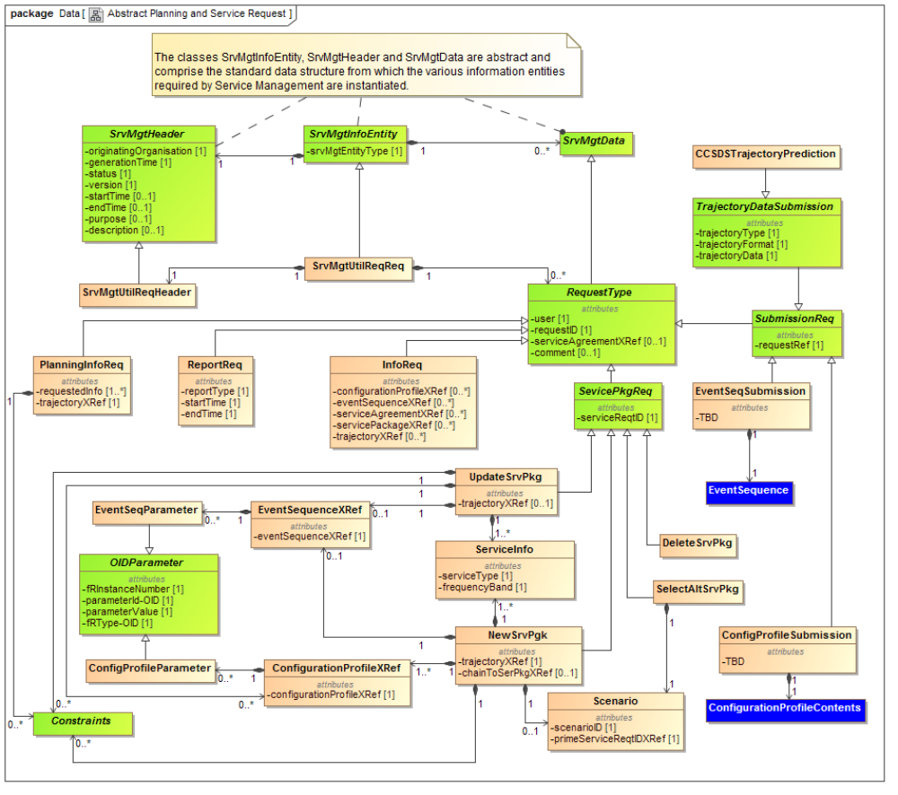
Figure 3-11: Abstract Service Management Utilization Request Formats Class Diagram
The attributes of each class are described further in the following subsections and tables.

CLASS SrvMgtUtilReq
      - The SrvMgtUtilReq class is mandatory and shall constitute the Planning And Service information entity.
NOTE – The SrvMgtUtilReq class is a specialization and of class SrvMgtInfoEntity described in Annex A of reference [6] and the generic description of the parameters is can be found there.
      - Table 3-1 specifies the use of the parameters in the SrvMgtInfoEntity in the scope of the Simple Service Request.
Table 3-1: Class SrvMgtUtilReq Parameters
Parameter | Description | Data Type | Data Units
srvMgtEntityType | See Annex A of reference [6]. | String1024—For the Service Management Utilization Request Formats request the only permitted value for this parameter is the string  - “UTILIZATION_REQ” | See Annex A of reference [6].

CLASS SrvMgtUtilReqHeader
      - The SrvMgtUtilReqHeader class is mandatory and shall constitute the ‘header’ of the Service Management Utilization Request Formats.
NOTE – The SrvMgtUtilReqHeader class is a specialization of class SrvMgtHeader described in Annex A of reference [6] and the generic description of the parameters is can be found there.
      - Table 3-2 specifies the use of the parameters in the SrvMgtHeader in the scope of the Service Management Utilization Request Formats.
Table 3-2: Class SrvMgtUtilReqHeader Parameters
The parameters for the SrvMgtUtilReqHeader class are as per Annex A of reference [6] except for the following:
Parameter | Description | Data Type | Data Units
status | See Annex A of reference [6]. | Enumeration – For the simple Service Management Utilization Request Formats the only permitted values are  - TEST  indicates that the request has been generated for test purposes only.  - PROVISIONAL  indicates that the request contained is provisional and may still be subject to change.  - OPERATIONAL  indicates that this is an operational request.  - OTHER  indicates that this request has been generated for other purposes. In this case the optional parameter purpose can be used to further specify the purpose of the request. | See Annex A of reference [6].

CLASS RequestType (Abstract)
      - The RequestType is an abstract class which is used to instantiate the various classes of request required by service management in the context of planning ansd scheduling requests.
NOTE – The RequestType class is a specialization and of class SrvMgtData described in Annex A of reference [6].
      - The RequestType class shall contain the parameters as specified in Table 3-3.
Table 3-3: Class RequestType Parameters
Parameter | Description | Data Type | Data Units
user | The user of the requested services. These must be spacecraft names as specified in SANA. | String64—Permitted values registered in SANA | n/a
requestID | A unique request ID assigned by the requestor. | String1024 | n/a
serviceAgreementXRef | Optional Parameter.  This can be used to specify a cross reference to the service agreement under which the requested services are to be provided. | String1024 | n/a
comment | Optional Parameter  May be used for the provision of ad hoc information. | String8096 | n/a

CLASS ServicePkgReq (Abstract)
      - The ServicePkgReq is an abstract class which is used to instantiate the various classes of request required by service management for manipulating service packages.
NOTE – The ServicePkgReq class is a specialization and of class RequestType described in section above.
      - The ServicePkgReq class shall contain the parameters as specified in Table 3-4.
Table 3-4: Class ServicePkgReq Parameters
The parameters for the ServicePkgReq class as are as per Table 3-3 with the addition of the following:
Parameter | Description | Data Type | Data Units
serviceReqID | Service request identifier. | String1024 | n/a
chainToSerPgkXRef | Optional parameter.  This parameter may be used to specify a cross reference to an existing service package to which this service package should be “chained”. | String 1024 | n/a

CLASS NewSrvPkg
      - The NewSrvPkg class is optional and may be used to submit a new service request.
NOTE – The NewSrvPkg class is a specialization of class ServicePkgReq described in 3.2.5 and the generic description of the parameters is given in that subsection.
      - The NewSrvPkg class, in addition to the parameters in the abstract RequestType class described in 3.2.5 shall contain a reference to the appropriate Trajectory data. This parameters is as specified in Table 3-5.
Table 3-5: Class NewSrvPkg Parameters
The parameters for the NewSrvPkg class as are as per Table 3-3 and Table 3-4 with the addition of the following:
Parameter | Description | Data Type |  | Data Units
trajectoryXRef | This is used to specify a reference to the trajectory data that is applicable to the user (i.e. spacecraft) for the requested services. | String1024 | n/a
Table 3-6: Class NewSrvPkg use of Class ServicePkgReq Parameters
In the context of the NewSrvPkg class the usage of the following ServicePkgReq parameters (as described in Table 3-4) should be noted:
Parameter | Description | Data Type | Data Units
serviceReqID | In the context of the NewSrvPkg class this parameter must be an identifier that has not previously been used. | String1024 | n/a

CLASS UpdateSrvPkg
      - The UpdateSrvPkg class is optional and may be used to update a new service request.
NOTE – The UpdateSrvPkg class is a specialization of class RequestType described in 3.2.5 and the generic description of the parameters is given in that subsection.
      - The UpdateSrvPkg class, in addition to the parameters in the abstract RequestType class described in 3.2.5 shall contain a reference to the appropriate Trajectory data. This parameter is as specified in Table 3-7.
Table 3-7: Class UpdateReq Parameters
The parameters for the UpdateSrvPkg class as are as per Table 3-3 and Table 3-4 with the addition of the following:
Parameter | Description | Data Type |  | Data Units
trajectoryXRef | This is used to specify a reference to the trajectory data that is applicable to the user (i.e. spacecraft) for the requested services. | String1024 | n/a
Table 3-8: Class UpdateSrvPkg use of Class ServicePkgReq Parameters
In the context of the UpdateSrvPkg class the usage of the following ServicePkgReq parameters (as described in Table 3-4) should be noted:
Parameter | Description | Data Type | Data Units
serviceReqID | In the context of the UpdateSrvPkg class this parameter must refer to the identifier of the previously submitted request that is to be updated. | String1024 | n/a

CLASS DeleteSrvPkg
      - The DeleteSrvPkg class is optional and may be used to delete a previously submitted service request.
NOTE – The DeleteReq class is a specialization of class RequestType described in 3.2.5 and the generic description of the parameters is given in that subsection.
Table 3-9: Class DeleteSrvPkg Parameters
The parameters for the DeleteSrvPkg class are as per Table 3-3 and Table 3-4 with the addition of the following:
Parameter | Description | Data Type | Data Units
Not applicable.
Table 3-10: Class DeleteSrvPkg use of Class ServicePkgReq Parameters
In the context of the DeleteSrvPkg class the usage of the following ServicePkgReq parameters (as described in Table 3-4) should be noted:
Parameter | Description | Data Type | Data Units
serviceReqID | In the context of the DeleteSrvPkg class this parameter must refer to the identifier of the previously submitted request that is to be deleted. | String1024 | n/a

CLASS SelectAltSrvPkg
      - The SelectAltSrvPkg class is optional and may be used to select an alternative scenario service request that has previously been submitted.
NOTE – The SelectAltSrvPkg class is a specialization of class RequestType described in 3.2.5 and the generic description of the parameters is given in that subsection.
Table 3-11: Class SelectAltSrvPkg Parameters
The parameters for the SelectAltSrvPkg class are as per Table 3-3 and Table 3-4 with the addition of the following:
Parameter | Description | Data Type | Data Units
Not applicable.
Table 3-12: Class SelectAltSrvPkg use of Class ServicePkgReq Parameters
In the context of the SelectAltSrvPkg class the usage of the following ServicePkgReq parameters (as described in Table 3-4) should be noted:
Parameter | Description | Data Type | Data Units
serviceReqID | In the context of the SelectAltSrvPkg class this parameter must refer to the identifier of the previously submitted request that is to be used as the alternate scenario. | String1024 | n/a

CLASS PlanningInfoReq
      - The PlanningInfoReq class is optional and may be used to submit a query that can request various type of planning information.
NOTE – The PlanningInfoReq class is a specialization of class RequestType described in 3.2.4 and the generic description of the parameters is given in that subsection.
      - The PlanningInfoReq class, in addition to the parameters in the abstract RequestType class described in 3.2.4 shall contain the list of the requestedInfo. This parameter is as specified in Table 3-13.
Table 3-13: Class PlanningInfoReq Parameters
The parameters for the PlanningInfoReq class as are as per Table 3-3 with the addition of the following:
Parameter | Description | Data Type | Data Units
requestedInfo | This specifies the type of information that is being requested and can be one or more of the information types specified in the next column. | Enumeration  - COMMS  Predicted communications geometry events (see reference [7])  - DATARATE  Sustainable data rates & volume estimate events (see reference [7])  - RFI  Predicted radio frequency interference events (see reference [7])  - CONFLICTS  Predicted resource conflict events (see reference [7])  - COSTS  Cost estimates (see reference [7])  - OTHER  Any event not falling into the above categories (see reference [7]) | n/a

CLASS ReportReq
      - The ReportReq class is optional and may be used to submit a request for report.
NOTE – The ReportReq class is a specialization of class RequestType described in 3.2.4 and the generic description of the parameters is given in that subsection.
      - The ReportReq class, in addition to the parameters in the abstract RequestType class described in 3.2.4 shall contain the reportType required along with the required start and end times. These parameters are as specified in Table 3-14.
      - Currently two basic types of report are foreseen:
- Simple Schedule as described in Ref. [6]
- Accounting reports as described in TBD.
      - In the returned Simple Schedule the following should be noted;
- Service Packages that start before the startTime but end after the startTime will be included in the schedule information.
- Service Packages that start before the endTime but end after the endTime will be included in the schedule information.
Table 3-14: Class reportReq Parameters
The parameters for the reportReq class as are as per Table 3-3 with the addition of the following:
Parameter | Description | Data Type | Data Units
reportType | This is used to specify the type of report required. | Enumeration  - SIM_SCH_SPECIFIC  results in a Simple Schedule (see Ref. [6]) containing only information directly related to the requesting user  - SIM_SCH_COMPLETE  results in a Simple Schedule (see Ref. [6]) containing a complete schedule of all station/aperture allocations insofar as this is permitted by the agencies policies.  - SIM_SCH_FREE  results in a Simple Schedule (see Ref. [6]) containing a schedule of all aperture free times insofar as this is permitted by the agencies policies.  - ACCOUNTING results in an accounting report containing TBD data. | n/a
startTime | The start time to be used for the requested report. | CCSDS ASCII Time Code B (reference [3]) | UTC
endTime | The end time to be used for the requested report. | CCSDS ASCII Time Code B (reference [3]) | UTC

CLASS InfoReq
      - The InfoReq class is optional and may be used to submit a request for information about one or more of the following:
- Configuration Profile(s)
- Event Sequence(s)
- Service Agreement(s)
- Service Package(s)
- Trajectory(ies)
NOTE – The InfoReq class is a specialization of class RequestType described in 3.2.4 and the generic description of the parameters is given in that subsection.
      - The InfoReq class, in addition to the parameters in the abstract RequestType class described in 3.2.4 shall contain one or more of the parameters specified in Table 3-15.
Table 3-15: Class InfoReq Parameters
The parameters for the InfoReq class as are as per Table 3-3 with the addition of the following:
NOTE: At least one parameter must be specified.
Parameter | Description | Data Type | Data Units
configurationProfileXRef | Optional Parameter.  This is used to specify a reference or references to the configuration profile(s) that the user wants the information for. | Array of String1024  The format of the configuration cross-reference is defined in reference [5] | n/a
eventSequenceXRef | Optional Parameter.  This is used to specify a reference or references to the event sequence(s) that the user wants the information for. | Array of String1024 | n/a
serviceAgreementXRef | Optional Parameter.  This is used to specify a reference or references to the service agreement(s) that the user wants the information for. | Array of String1024 | n/a
servicePackageXRef | Optional Parameter.  This is used to specify a reference or references to the service package(s) that the user wants the information for. | Array of String1024 | n/a
trajectoryXRef | Optional Parameter.  This is used to specify a reference or references to the trajectory(ies) that the user wants the information for. | Array of String1024 | n/a

CLASS Scenario
      - The Scenario class is optional and is required only if it is necessary to specify multiple requests covering the same time period so that non-nominal cases can be handled.
      - The Scenario class shall contain the identification of the scenario and cross reference to the prime request shall include parameters specified in Table 3-16.
Table 3-16: Class Scenario Parameters
Parameter | Description | Data Type | Data Units
scenarioID | This is defined by the request submitter and must uniquely define the scenario | String1024 | n/a
primeRequestIDXRef | Identifies the request that contains the request that applies to the nominal case. In the case of the nominal request itself this value must be the same as the requestID of the nominal request | String1024 | n/a

CLASS ServiceInfo
      - The ServiceInfo class shall be used to provide information about the type of operations to be carried out during a pass.
      - The ServiceInfo class shall use the parameters specified in Table 3-17 to specify the type of service and frequency band to be used.
      - There shall be one or more instances of the ServiceInfo class for each instance of the Servcies class.
Table 3-17: Class ServiceInfo Parameters
Parameter | Description | Data Type | Data Units
serviceType | The type of service that will be carried out during an activity.  It should be noted that:  - APA-AZ/EL indicates Antenna Pointing Angles, Azimuth/Elevation  - APA-X/Y indicates Antenna Pointing Angles, X/Y  - VLBI indicates Very-Long-Baseline Interferometry. | Enumeration:  - APA-AZ/EL  - APA-X/Y  - DELTADOR  - DOPPLER  - OFFLINE-TM-RECORDING  - OFFLINE-TM-PROVISION  - RF-ONLY  - RANGING  - RESERVED  - TBD  - TELECOMMAND  - TELEMETRY  - TEST  - UNUSED  - VLBI | n/a
frequencyBand | The frequency band that will be used by the service. If the frequency band is not relevant the value N/A (not applicable) shall be used. (See annex See Annex H of reference [6]. for a definition of the frequencies each band refers to.) | Enumeration:  - VHF  - UHF  - C-BAND  - KA-BAND  - KU-BAND  - L-BAND  - S-BAND  - V-BAND  - X-BAND  - OPTICAL  - N/A  - ALL | n/a

CLASS ConfigurationProfileXRef
      - The ConfigurationProfileXRef class shall provide a cross-reference to an existing configuration profile.
      - The ConfigurationProfileXRef class shall use the parameters specified in Table 3-18 to provide the cross-reference to the existing configuration profile.
Table 3-18: Class ConfigurationProfileXRef Parameters
Parameter | Description | Data Type | Data Units
configurationProfileXRef | The cross- reference to an existing configuration profile. | String1024 | n/a

CLASS ConfigProfileParameter.
      - The ConfigProfileParameter class is optional and may be used to specify the values for the configuration parameters that apply to the service being requested. It is possible to use the ConfigProfileParameter class to specify values that override those specified in a ConfigurationProfileXRef class.
NOTE – The ConfigProfileParameter class is a specialization of class OIDParameter described in below and the generic description of the parameters can be found there.
      - There shall be zero or more instances of the ConfigProfileParameter class for each instance of the ConfigurationProfileXRef class.
      - In the context of service management it is expected that the details of which parameters of a particular Configuration Profile that are permitted to be updated will be contained in the Service Agreement (see reference [5]).
      - The ConfigProfileParameter class shall use the parameters specified in Table 3-19.
Table 3-19: Class ConfigProfileParameter Parameters
The parameters for the ConfigProfileParameter class are as per Table 3-22.

CLASS EventSequenceXRef
      - The EventSequenceXRef class shall provide a cross-reference to an existing event sequence.
      - The EventSequenceXRef class shall use the parameters specified in Table 3-20 to provide the cross-reference to the existing event sequence.
Table 3-20: Class EventSequenceXRef Parameters
Parameter | Description | Data Type | Data Units
eventSequenceXRef | The cross- reference to an existing event sequence. | String1024 | n/a

CLASS EventSeqParameter.
      - The EventSeqParameter class is optional and may be used to specify the values for the parameters that are to be used to update values in an event sequence. It is possible to use the EventSeqParameter class to specify values that override those specified in an EventSequenceXRef class.
NOTE – The EventSeqParameter class is a specialization of class OIDParameter described in below and the generic description of the parameters can be found there.
      - There shall be zero or more instances of the EventSeqParameter class for each instance of the EventSequenceXRef class.
      - In the context of service management it is expected that the details of which parameters of a particular Event Sequence that are permitted to be updated will be contained in the Service Agreement (see reference [5]). (TBD)
      - The EventSeqParameter class shall use the parameters specified in Table 3-21.
Table 3-21: Class EventSeqParameter Parameters
The parameters for the EventSeqParameter class as are as per Table 3-22.

CLASS OIDParameter (Abstract)
      - The OIDParameter is an abstract class which is used to instantiate the various classes of parameter required to update values which are identified by object identifiers
      - The OIDParameter class shall contain the parameters as specified in Table 3-22.
Table 3-22: Class OIDParameter Parameters
Parameter | Description | Data Type | Data Units
frInstanceNumber | The functional resource instance number | As defined in reference [5]. | n/a
parameterId-OID | The Object Identifier of the parameter ID | As defined in reference [5]. | As required by the additional parameter
parameterValue | The value for the parameter | As defined in reference [5]. | As required by the additional parameter
frType-OID | The Object Identifier specifying the function resource type (i.e. what type the parameter value is) | As defined in reference [5]. | As required by the additional parameter

CLASS SubmissionReq (Abstract)
      - The SubmissionReq is an abstract class which is used to instantiate the various classes of request required by service management for manipulating submitting new information entities, i.e. trajectory predictions, configuration profiles and event sequences.
NOTE – The SubmissionReq class is a specialization and of class RequestType described in section above.
      - The SubmissionReq class shall contain the parameters as specified in Table 3-23.
Table 3-23: Class SubmissionReq Parameters
The parameters for the SubmissionReq class as are as per Table 3-3 with the addition of the following:
Parameter | Description | Data Type | Data Units
requestRef | This is the reference by which the information entity can later be cross-referenced by. It is the responsibility of the submitted that this reference is unique within the scope of their service agreement. | String1024 | n/a

CLASS TrajectoryDataSubmission (Abstract)
      - The TrajectoryDataSubmission is an abstract class which is used to instantiate the classes required by service management to submit trajectory prediction data.
NOTE – The TrajectoryDataSubmission class is a specialization and of class RequestType described in section above.
      - The TrajectoryDataSubmission class shall contain the parameters as specified in Table 3-24.
Table 3-24: Class TrajectoryDataSubmission Parameters
The parameters for the TrajectoryDataSubmission class as are as per Table 3-23 with the addition of the following:
Parameter | Description | Data Type | Data Units
trajectoryType | This specifies the type of the Orbit Data Message used to specify the trajectory information. | String16 | n/a
trajectoryFormat | This specifies the format of the Orbit Data Message used to specify the trajectory information. | String16 | n/a
trajectoryData | This is used to hold the required trajectory data. | TBD | n/a

CLASS CCSDSTrajectoryPrediction
      - The CCSDSTrajectoryPrediction class is optional.
NOTE – The CCSDSTrajectoryPrediction class is a specialization of class TrajectoryDataSubmission described in above and the generic description of the parameters can be found there.
      - Table 3-25 specifies the use of the parameters in the CCSDSTrajectoryPrediction .
Table 3-25: Class CCSDSTrajectoryPrediction Parameters
The parameters for the CCSDSTrajectoryPrediction class are as per Table 3-24 except for the following:
Parameter | Description | Data Type | Data Units
trajectoryType | This specifies the type of the Orbit Data Message used to specify the trajectory information. | String16 – permitted values stored in SANA  - OPM – CCSDS Orbit Parameter Message, See Refs. YYY and ZZZ  - OMM – CCSDS Orbit Mean-Elements Message , See Refs YYY and ZZZ  - OEM – CCSDS Orbit Ephemeris Message, See Refs YYY and ZZZ  - OHM – CCSDS Orbit Ephemeris Message, See Refs YYY and ZZZ | n/a
trajectoryFormat | This specifies the format of the Orbit Data Message used to specify the trajectory information. | String16 – permitted values stored in SANA  - TEXT – text format of CCSDS Orbit Data Message, See Ref. YYY.  - XML – XML format of CCSDS CCSDS Orbit Data Message, See Ref. ZZZ | n/a

CLASS ConfigProfileSubmission
      - The ConfigProfileSubmission class is optional.
NOTE – The ConfigProfileSubmission class is a specialization of class SubmissionReq described in above and the generic description of the parameters can be found there.
      - Table 3-26 specifies the use of the parameters in the ConfigProfileSubmission.
Table 3-26: Class ConfigProfileSubmission Parameters
The parameters for the ConfigProfileSubmission class are as per Table 3-24 with the addition of the following:
Parameter | Description | Data Type | Data Units
TBD | TBD | TBD | TBD

CLASS ConfigurationProfileContents
      - The ConfigurationProfileContents class shall be used when it is required to submit a complete configuration profile.
      - The ConfigurationProfileContents class is specified in reference [5].

CLASS EventSeqSubmission
      - The EventSeqSubmission class is optional.
NOTE – The EventSeqSubmission class is a specialization of class SubmissionReq described in above and the generic description of the parameters can be found there.
      - Table 3-27 specifies the use of the parameters in the EventSeqSubmission.
Table 3-27: Class EventSeqSubmission Parameters
The parameters for the EventSeqSubmission class are as per Table 3-24 with the addition of the following:
Parameter | Description | Data Type | Data Units
TBD | TBD | TBD | TBD

CLASS EventSequence
      - The EventSequence class shall when it is required to submit a complete event sequence.
      - The EventSequence class is specified in reference TBD [Event Sequence Book].

CLASS Constraints (Abstract)
      - The Constraints class is abstract and is used to instantiate the various constraint classes that apply to the Service Management Utilization Request Formats.
Table 3-28: Class Constraints Parameters
Parameter | Description | Data Type | Data Units
N/A | N/A | N/A | N/A

Service Management Utilization Request Formats Basic Constraints

Overview
Figure 3-2 shows the UML Class diagram for the Service Management Utilization Request Formats Basic Constraints.
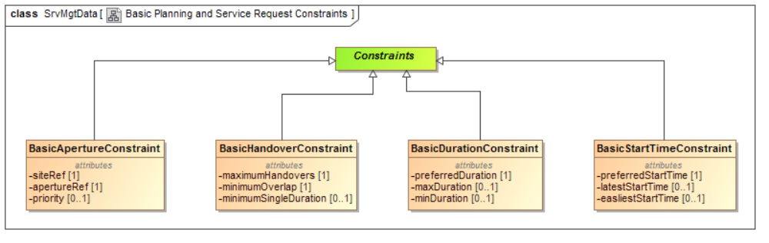
Figure 3-2: Service Management Utilization Request Formats Basic Constraints Class Diagram
The attributes of each class are described further in the following subsections and tables.

CLASS Constraints (Abstract)
See section 3.2.17 for the definition of this class.

CLASS BasicStartTimeConstraint
      - The BasicStartTimeConstraint class is optional and may be used to specify the preferred start time of a pass along with the acceptable earliest and/or latest start times.
      - The parameters of the BasicStartTimeConstraint class are specified in Table 3-29.
      - There shall be zero or one instances of the BasicStartTimeConstraint class for each instance of the TimingConstraints class. If no BasicStartTimeConstraint class is specified it is assumed that any start time is acceptable.
Table 3-29: Class BasicStartTimeConstraint Parameters
Parameter | Description | Data Type | Data Units
PreferredStartTime | Used to specify (in UTC) the preferred time at which a pass starts. | CCSDS ASCII Time Code B (reference [3]) | UTC
earliestStartTime | Optional parameter.  Used to specify (in UTC) the earliest time at which a pass can start. | CCSDS ASCII Time Code B (reference [3]) | UTC
latestStartTime | Optional parameter.  Used to specify (in UTC) the latest time at which a pass can start.  NOTE: If both earliestStartTime and latestStartTime are specified then latestStartTime ≥ earliestStartTime | CCSDS ASCII Time Code B (reference [3]) | UTC

CLASS BasicDurationConstraint
      - The BasicDurationConstraint class is optional and may be used to specify the preferred duration of a pass along with the acceptable minimum and/or maximum duration.
      - The parameters of the BasicDurationConstraint class are specified in Table 3-30.
      - There shall be zero or one instances of the BasicDurationConstraint class for each instance of the TimingConstraints class. If no BasicDurationConstraint class is specified it is assumed that any duration is acceptable.
Table 3-30: Class BasicDurationConstraint Parameters
Parameter | Description | Data Type | Data Units
minimumDuration | Optional parameter.  This is used to specify the minimum duration required for a pass. | Integer ≥ 0  Default value if omitted is 0 | Seconds
maximumDuration | Optional parameter.  This is used to specify the maximum duration required for a pass.  NOTE: If both minimumDuration and maximumDuration  are specified then maximumDuration ≥ minimumDuration | Integer ≥ 0  Default value if omitted is ∞ | Seconds

CLASS BasicHandoverConstraint
      - The BasicHandoverConstraints class is optional and if not specified for a request it is assumed that a station handover is not permitted,
      - The BasicHandoverConstraints class shall contain the details of the constraints applying to station handovers shall include parameters specified in Table 3-31.
      - There shall be zero or one instances of the BasicHandoverConstraint class for each instance of the ApertureConstraints class.
Table 3-31: Class BasicHandoverConstraints Parameters
Parameter | Description | Data Type | Data Units
maximumHandovers | The maximum number of station handovers that are permitted during the requested tracking time. | Integer >0 | n/a
mimimumOverlap | Used to specify the minimum overlap between stations during a handover.  NOTE: if this is negative then there will be a gap in the coverage provided. | Integer | Secs
minimunSingleDuration | Optional Parameter.  This can be used to specify the acceptable minimum duration of contact on any one of the apertures used during the pass. | Integer>0 | Secs

CLASS BasicApertureConstraint
      - The BasicApertureConstraint class is optional and can be used to specify the aperture with it is desired that the service is provided.
      - The parameters of the BasicApertureConstraint class are specified in Table 3-32.
      - There shall be zero or more instances of the BasicApertureConstraint class for each instance of the ApertureConstraints class. If no BasicApertureConstraint class is specified it is assumed that any aperture specified in the service agreement can be used.
Table 3-32: Class BasicApertureConstraint Parameters
Parameter | Description | Data Type | Data Units
apertureRef | Name of the aperture | String1024—Permitted values registered in SANA | n/a
priority | Optional Parameter.  This can be used to specify a preference for which aperture is used if more than one BasicApertureConstraint class is instantiated.  The lower the value specified here the higher the priority, with 1 being the highest prority. | Integer >0  Default value if omitted is 1 | n/a

Service Management Utilization Request Formats Enhanced Constraints

Overview
Figure 3-3 shows the UML Class diagram for the Service Management Utilization Request Formats Enhanced Constraints.
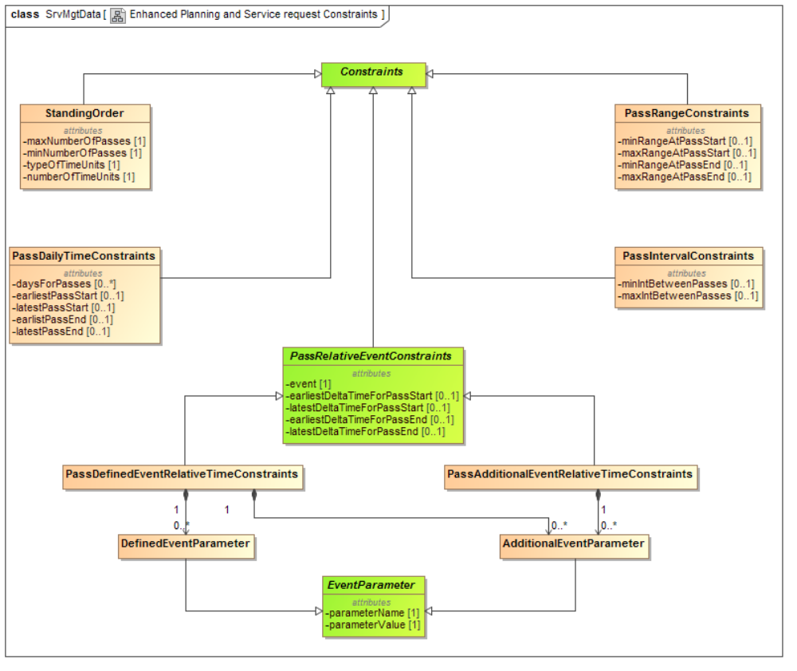
Figure 3-3: Service Management Utilization Request Formats Enhanced Constraints Class Diagram
The attributes of each class are described further in the following subsections and tables.

CLASS Constraints (Abstract)
See section 3.2.17 for the definition of this class.

CLASS StandingOrder
      - The StandingOrder class is and can be used to submit “repeat” requests. It allows the specification of the number of passes that are required within a specified time interval. A standing order will be repeated until the start time of the service(s) requested is after the endTime specified in the SrvMgtUtilReqHeader class.
      - The StandingOrder class shall include parameters specified in Table 3-33.
Table 3-33: Class StandingOrder Parameters
Parameter | Description | Data Type |  | Data Units
minNumOfPasses | The minimum number of passes required in the specified time interval. | Integer > 0 | n/a
maxNumOfPasses | The maximum number of passes required in the specified time interval. | Integer ≥ minNumOfPasses | n/a
typeOfTimeUnits | The type of time unit within which the minimum and maximum number of passes shall occur. | Enumeration  - DAY(S)  indicates that the required number of passes shall occur within the specified number of days.  - WEEK(S)  indicates that the required number of passes shall occur within the specified number of days.  - ORBIT(S)  indicates that the required number of passes shall occur within the specified number of orbits. | n/a
numberOfTimeUnits | This parameter is used to specify the required number of days, weeks or orbits. | Integer >0 | n/a

Class PassIntervalConstraints

The PassIntervalConstraints class is optional and can be used to permit the specification of the minimum and/or maximum intervals between passes.

The parameters of the PassIntervalConstraints class are specified in Table 3-34 below.
Table 3-34: Class PassIntervalConstraints Parameters
Parameter | Description | Data Type | Data Units
minIntBetweenPasses | Optional parameter.  This is used to specify the minimum interval required between passes. | Integer ≥ 0  Default value if omitted is 0 | Seconds
maxIntBetweenPasses | Optional parameter.  This is used to specify the maximum interval required between passes.  NOTE: If both minimumIntervalBetweenPasses and maximumIntervalBetweenPasses  are specified then maximumIntervalBetweenPasses ≥ minimumIntervalBetweenPasses | Integer ≥ 0  Default value if omitted is ∞ | Seconds

Class PassDailyTimeConstraints

The PassDailyTimeConstraints class is optional and can be used to permit the specification of the earliest and/or latest absolute (UTC) times for passes. The use of these constraints could be used for example to limit passes to being only during normal working hours etc..

The parameters of the PassDailyTimeConstraints class are specified in Table 3-35.

There shall be zero or one instances of the PassDailyTimeConstraints class for each instance of the PlanningRequest class.
Table 3-35: Class PassDailyTimeConstraints Parameters
Parameter | Description | Data Type | Data Units
daysForPasses | Optional parameter.  Used to specify the day(s) on which a pass can be accepted. | Enumeration  - MONDAY  - TUESDAY  - WEDNESDAY  - THURSDAY  - FRIDAY  - SATDAY  - SUNDAY | n/a
earliestPassStart | Optional parameter.  Used to specify (in UTC) the earliest time during the day at which a pass can start. | String8 of format hh:mm:ss  Where  - hh = Hour in two-character subfield with values 00-23  - mm = Minute in two-character subfield with values 00-59  - ss = Second in two-character subfield with values 00-59  (-58 or -60 during leap seconds) | n/a
latestPassStart | Optional parameter.  Used to specify (in UTC) the latest time during the day at which a pass can start.  NOTE: If both earliestPassStart and latestPassStart are specified then latestPassStart ≥ earliestPassStart | String8 of format hh:mm:ss  Where  - hh = Hour in two-character subfield with values 00-23  - mm = Minute in two-character subfield with values 00-59  - ss = Second in two-character subfield with values 00-59  (-58 or -60 during leap seconds) | n/a
earliestPassEnd | Optional parameter.  Used to specify (in UTC) the earliest time during the day at which a pass can end. | String8 of format hh:mm:ss  Where  - hh = Hour in two-character subfield with values 00-23  - mm = Minute in two-character subfield with values 00-59  - ss = Second in two-character subfield with values 00-59  (-58 or -60 during leap seconds) | n/a
latestPassEnd | Optional parameter.  Used to specify (in UTC) the latest time during the day at which a pass can end.  NOTE: If both earliestPassEnd and latestPassEnd are specified then latestPassEnd ≥ earliestPassEnd | String8 of format hh:mm:ss  Where  - hh = Hour in two-character subfield with values 00-23  - mm = Minute in two-character subfield with values 00-59  - ss = Second in two-character subfield with values 00-59  (-58 or -60 during leap seconds) | n/a

Class PassRangeConstraints

The PassRangeConstraints class is optional and can be used to permit the specification of the minimum and/or maximum range between the spacecraft and groundstation for the start and/or end of a pass.

The parameters of the PassRangeConstraints class are specified in Table 3-36 below.

There shall be zero or one instances of the PassRangeConstraints class for each instance of the PlanningRequest class.
Table 3-36: Class PassRangeConstraints Parameters
Parameter | Description | Data Type | Data Units
minRangeAtPassStart | Optional parameter.  Used to specify the minimum range required at the pass start. | Integer ≥ 0 | Kilometres
maxRangeAtPassStart | Optional parameter.  Used to specify the maximum range required at the pass start.  NOTE: If both minRangeAtPassStart and maxRangeAtPassStart are specified then maxRangeAtPassStart ≥ minRangeAtPassStart | Integer ≥ 0 | Kilometres
minRangeAtPassEnd | Optional parameter.  Used to specify the minimum range required at the pass end. | Integer ≥ 0 | Kilometres
maxRangeAtPassEnd | Optional parameter.  Used to specify the maximum range required at the pass start.  NOTE: If both minRangeAtPassEnd and maxRangeAtPassEnd are specified then maxRangeAtPassEnd ≥ minRangeAtPassEnd | Integer ≥ 0 | Kilometres

CLASS PassDefinedEventRelativeTimeConstraints

The PassDefinedEventRelativeTimeConstraints class is optional and may be used to specify pass start/end timing constraints with respect to Events that are defined in reference [7].
NOTE – The PassDefinedEventRelativeTimeConstraints class is a specialization of class PassRelativeTimeConstraints described in section below, and the description of the parameters is given in that subsection.

CLASS PassAdditionalEventRelativeTimeConstraints

The PassAdditionalEventRelativeTimeConstraints class is optional and may be used to specify pass start/end timing constraints with respect to Events that are not defined in reference [7]. The need for this may arise if it is found that in certain cases (or missions) the Events defined in reference [7] are not sufficient and additional Events are required. See reference [7] for further information on the definition of Additional Events.
NOTE – The PassAdditionalEventRelativeTimeConstraints class is a specialization of class PassRelativeTimeConstraints described in section below, and the description of the parameters is given in that subsection.

The usage of additional Events is not within the scope of this document and should be specified in an ICD between the relevant parties.

CLASS PassRelativeTimeConstraints (Abstract)

The PassRelativeTimeConstraints class is mandatory and shall be used to specify pass start/end timing constraints with respect to Events.

The PassRelativeTimeConstraints class parameters specified in Table 3-37 below.
Table 3-37: Class PassRelativeTimeConstraints Parameters
Parameter | Description | Data Type | Data Units
event | The event - the various different events defined are described in reference [7]. | Enumeration. | See reference [7]
earliestDeltaTimeForPassStart | Optional parameter. If this is specified it is added to the time at which the event occurs and this time is taken to be the earliest the pass can start relative to the event. | Integer ≥ 0 | Seconds
latestDeltaTimeForPassStart | Optional parameter. If this is specified it is added to the time at which the event occurs and this time is taken to be the latest the pass can start relative to the event.  NOTE: If values for both earliestDeltaTimeForPassStart and latestDeltaTimeForPassStart are specified they must be such that the latest time the pass can start is after the earliest time it can start | Integer ≥ 0 | Seconds
earliestDeltaTimeForPassEnd | Optional parameter. If this is specified it is added to the time at which the event occurs and this time is taken to be the earliest the pass can end relative to the event. | Integer ≥ 0 | Seconds
latestDeltaTimeForPassEnd | Optional parameter. If this is specified it is added to the time at which the event occurs and this time is taken to be the latest the pass can end relative to the event.  NOTE: If values for both earliestDeltaTimeForPassEnd and latestDeltaTimeForPassEnd are specified they must be such that the latest time the pass can end is after the earliest time it can end. | Integer ≥ 0 | Seconds

CLASS DefinedEventParameter

The DefinedEventParameter class is optional and may be used to permit the instantiation of parameters for an Event that is defined in this recommendation..
NOTE – The DefinedEventParameter class is a specialization of class EventParameter described in below, and the description of the parameters is given in that subsection.

There shall be zero or more instances of the DefinedEventParameter class for each instance of the DefinedEvent class.

The parameters that are expected to be associated with the various defined events are specified in in reference [7].

CLASS AdditionalEventParameter

The AdditionalEventParameter class is optional and may be used to permit the instantiation of additional parameters for an Event. The need for this may arise if it is found that in certain cases (or missions) the parameters defined in this recommendation are not sufficient and additional information is required.
NOTE – The AdditionalEventParameter class is a specialization of class Parameter described in below, and the description of the parameters is given in that subsection.

There shall be zero or more instances of the AdditionalEventParameter class for each instance of the DefinedEvent class.

There shall be zero or more instances of the AdditionalEventParameter class for each instance of the AdditionalEvent class.

The usage of these additional parameters is not within the scope of this document and should be specified in an ICD between the relevant parties.

CLASS EventParameter (ABSTRACT)

The EventParameter class shall be used to permit the instantiation of parameters for an Event by allowing the specification of parameter name/value pairs using the parameters specified in Table 3-38.
Table 3-38: Class EventParameter Parameters
Parameter | Description | Data Type | Data Units
parameterName | Name of the parameter. | String1024 | n/a
parameterValue | The value of the required parameter. | As required by the additional parameter | As required by the additional parameter

Submission Request

Overview
Figure 3-4 shows the UML Class diagram for the Service Management Utilization Request Formats Submission request.
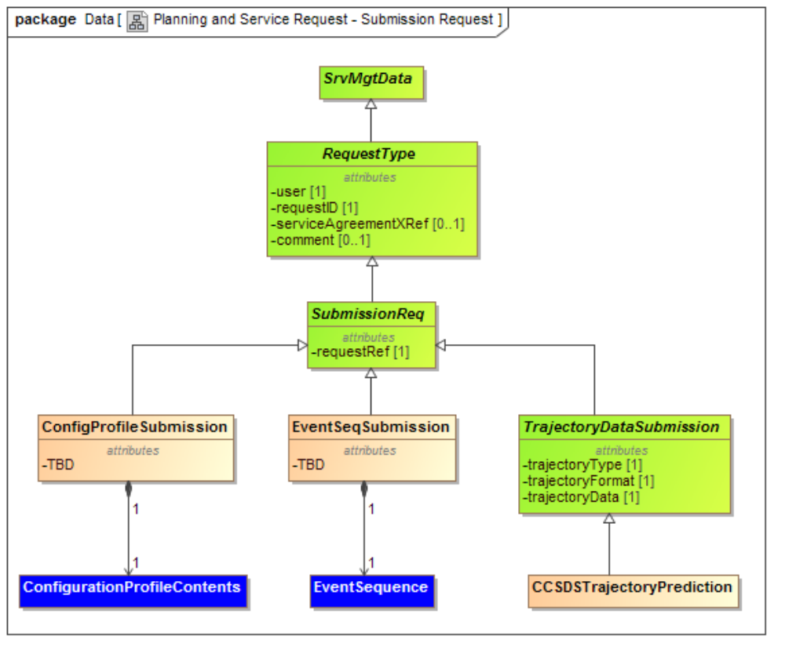
Figure 3-4: Service Management Utilization Request Formats - Submission Request Class Diagram
The attributes of each class are described further in the following subsections and tables.

CLASS SrvMgtData
See reference [6], Annex A for the definition of this class.

CLASS RequestType
See section 3.2.4 for the definition of this class.

CLASS SubmissionReq
See section 3.2.20 for the definition of this class.

CLASS ConfigProfileSubmission
See section 3.2.23 for the definition of this class.

CLASS ConfigurationProfileContents
See section 3.2.24 for the definition of this class.

CLASS EventSeqSubmission
See section 3.2.25 for the definition of this class.

CLASS EventSequence
See section 3.2.26 for the definition of this class.

CLASS TrajectoryDataSubmission
See section 3.2.21 for the definition of this class.

CLASS CCSDSTrajectoryPrediction
See section 3.2.22 for the definition of this class.

Basic Service Management Utilization Request Formats – Service Package - New Request

Overview
Figure 3-5 shows the UML Class diagram for the Basic Service Management Utilization Request Formats Service Package New Request.
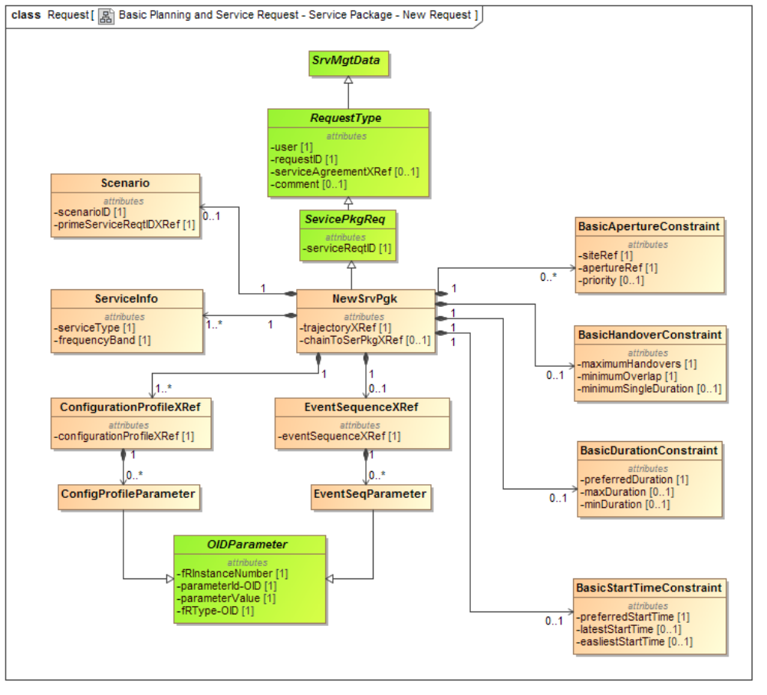
Figure 3-5: Basic Service Management Utilization Request Formats Service Package New Request Class Diagram
The attributes of each class are described further in the following subsections and tables.

CLASS SrvMgtData
See reference [6], Annex A for the definition of this class.

CLASS RequestType
See section 3.2.4 for the definition of this class.

CLASS ServicePkgReq
See section 3.2.5 for the definition of this class.

CLASS NewSrvPkg
See section 3.2.6 for the definition of this class.

CLASS Scenario
See section 3.2.13 for the definition of this class.

CLASS ServiceInfo
See section 3.2.14 for the definition of this class.

CLASS ConfigurationProfileXRef
See section 3.2.15 for the definition of this class.

CLASS ConfigProfileParameter
See section 3.2.16 for the definition of this class.

CLASS EventSequenceXRef
See section 3.2.17 for the definition of this class.

CLASS EventSeqParameter
See section 3.2.18 for the definition of this class.

CLASS OIDParameter
See section 3.2.19 for the definition of this class.

CLASS BasicStartTimeConstraint
See section 3.3.3 for the definition of this class.

CLASS BasicDurationConstraint
See section 3.3.4 for the definition of this class.

CLASS BasicHandoverConstraint
See section 3.3.5 for the definition of this class.

CLASS BasicApertureConstraint.
See section 3.3.6 for the definition of this class.

Basic Service Management Utilization Request Formats – Service Package - Update Request

Overview
Figure 3-6 shows the UML Class diagram for the Basic Service Management Utilization Request Formats Service Package Update Request.
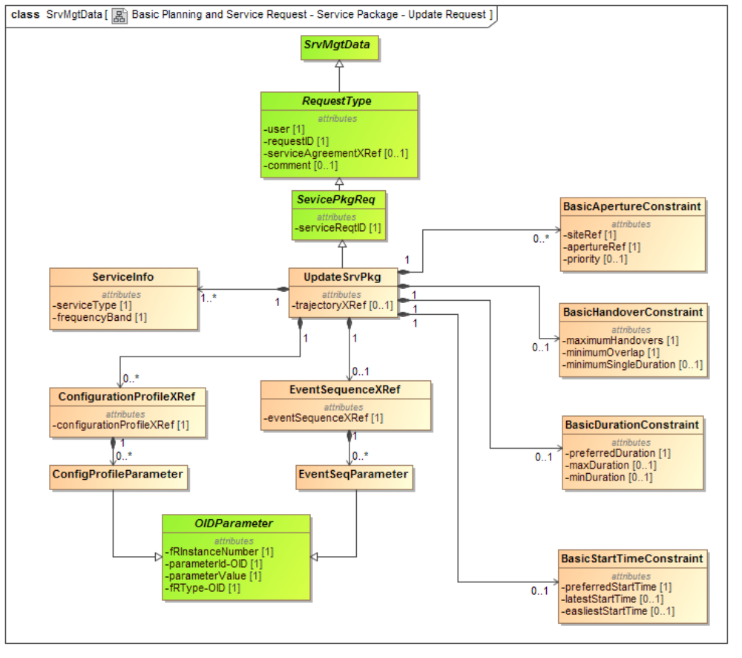
Figure 3-6: Basic Service Management Utilization Request Formats Service Package Update Request Class Diagram
The attributes of each class are described further in the following subsections and tables.

CLASS SrvMgtData
See reference [6], Annex A for the definition of this class.

CLASS RequestType
See section 3.2.4 for the definition of this class.

CLASS ServicePkgReq
See section 3.2.5 for the definition of this class.

CLASS NewSrvPkg
See section 3.2.6 for the definition of this class.

CLASS Scenario
See section 3.2.13 for the definition of this class.

CLASS ServiceInfo
See section 3.2.14 for the definition of this class.

CLASS ConfigurationProfileXRef
See section 3.2.15 for the definition of this class.

CLASS ConfigProfileParameters
See section 3.2.16 for the definition of this class.

CLASS EventSequenceXRef
See section 3.2.17 for the definition of this class.

CLASS EventSeqParameters
See section 3.2.18 for the definition of this class.

CLASS OIDParameter
See section 3.2.19 for the definition of this class.

CLASS BasicStartTimeConstraint
See section 3.3.3 for the definition of this class.

CLASS BasicDurationConstraint
See section 3.3.4 for the definition of this class.

CLASS BasicHandoverConstraint
See section 3.3.5 for the definition of this class.

CLASS BasicApertureConstraint.
See section 3.3.6 for the definition of this class.

Basic Service Management Utilization Request Formats – Planning Info Request

Overview
Figure 3-7 shows the UML Class diagram for the Basic Service Management Utilization Request Formats Planning Info Request.
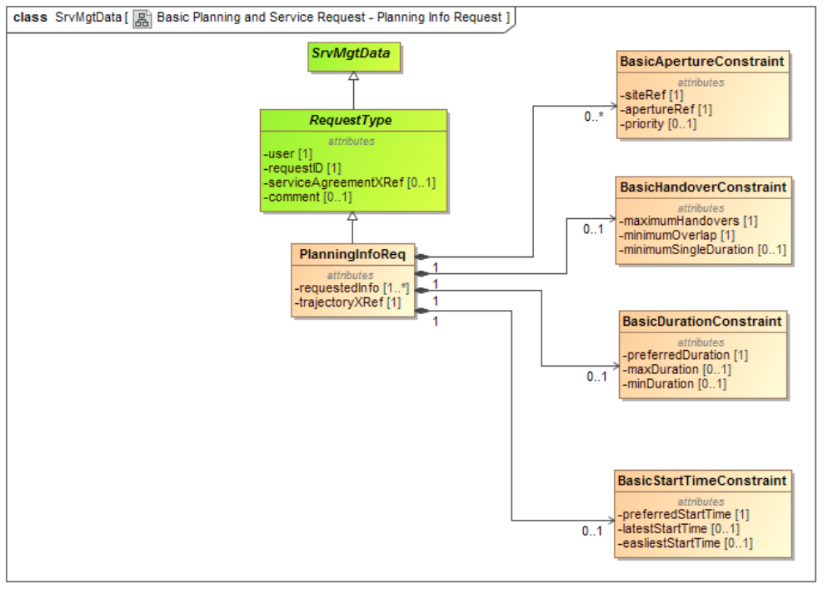
Figure 3-7: Basic Service Management Utilization Request Formats Planning Info Request Class Diagram
The attributes of each class are described further in the following subsections and tables.

CLASS SrvMgtData
See reference [6], Annex A for the definition of this class.

CLASS RequestType
See section 3.2.4 for the definition of this class.

CLASS PlanningInfoReq
See section 3.2.10 for the definition of this class.

CLASS BasicStartTimeConstraint
See section 3.3.3 for the definition of this class.

CLASS BasicDurationConstraint
See section 3.3.4 for the definition of this class.

CLASS BasicHandoverConstraint
See section 3.3.5 for the definition of this class.

CLASS BasicApertureConstraint.
See section 3.3.6 for the definition of this class.

Service Management Utilization Request Formats – Service Package - Delete Request

Overview
Figure 3-8 shows the UML Class diagram for the Service Management Utilization Request Formats Service Package Delete Request.
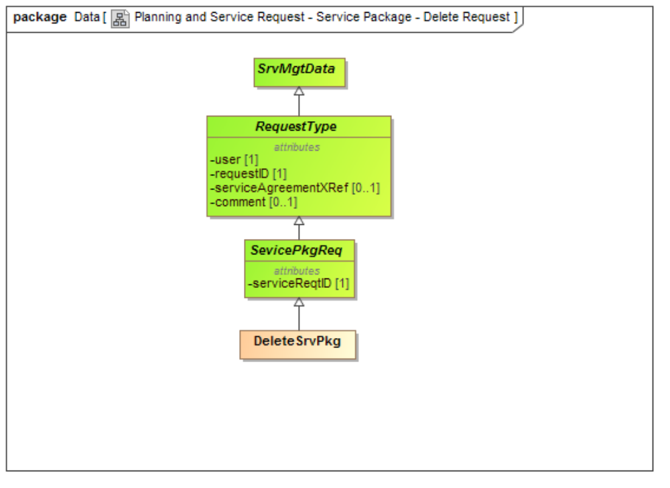
Figure 3-8: Service Management Utilization Request Formats Service Package Delete Request Class Diagram
The attributes of each class are described further in the following subsections and tables.

CLASS SrvMgtData
See reference [6], Annex A for the definition of this class.

CLASS RequestType
See section 3.2.4 for the definition of this class.

CLASS ServicePkgReq
See section 3.2.5 for the definition of this class.

CLASS DeleteSrvPkg
See section 3.2.8 for the definition of this class.

Service Management Utilization Request Formats – Service Package – Select Alternate Request

Overview
Figure 3-9 shows the UML Class diagram for the Service Management Utilization Request Formats Service Package Delete Request.
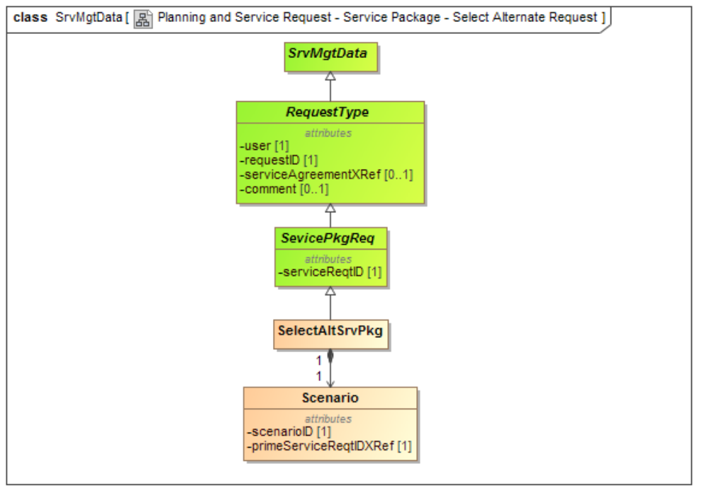
Figure 3-9: Service Management Utilization Request Formats Service Package Select Alternate Request Class Diagram
The attributes of each class are described further in the following subsections and tables.

CLASS SrvMgtData
See reference [6], Annex A for the definition of this class.

CLASS RequestType
See section 3.2.4 for the definition of this class.

CLASS ServicePkgReq
See section 3.2.5 for the definition of this class.

CLASS SelectAltSrvPkg
See section 3.2.9 for the definition of this class.

CLASS Scenario
See section 3.2.12 for the definition of this class.

Service Management Utilization Request Formats – Report Request

Overview
Figure 3-10 shows the UML Class diagram for the Service Management Utilization Request Formats Report Request.
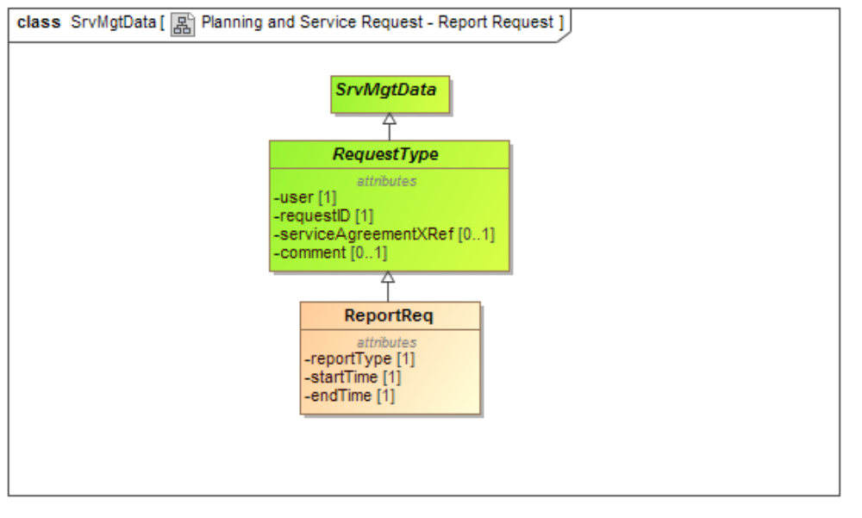
Figure 3-10: Service Management Utilization Request Formats Report Request Class Diagram
The attributes of each class are described further in the following subsections and tables.

CLASS SrvMgtData
See reference [6], Annex A for the definition of this class.

CLASS RequestType
See section 3.2.4 for the definition of this class.

CLASS ReportReq
See section 3.2.11 for the definition of this class.

Service Management Utilization Request Formats – Information Request

Overview
Figure 3-11 shows the UML Class diagram for the Service Management Utilization Request Formats Information Request.
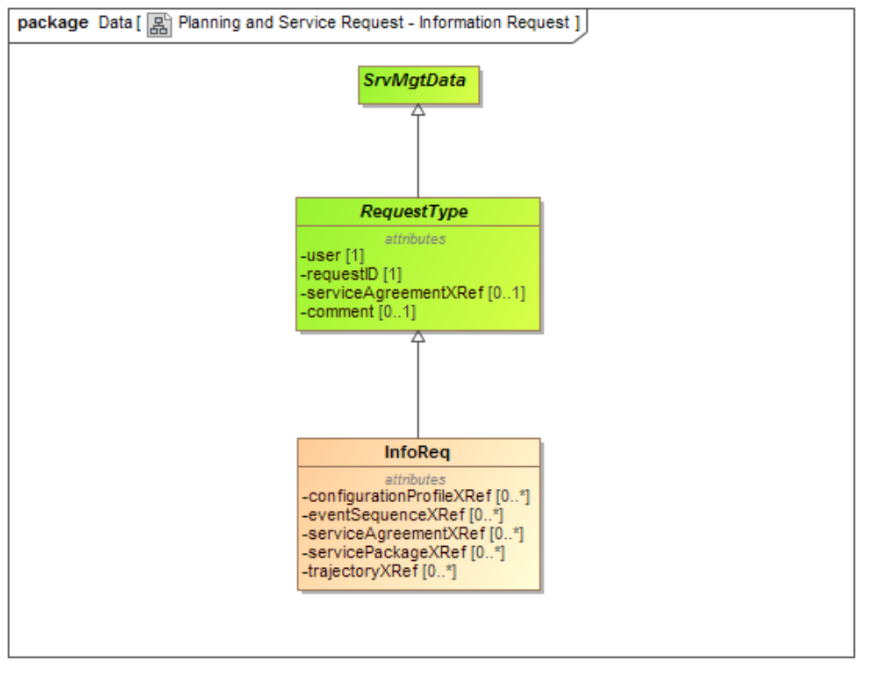
Figure 3-11: Service Management Utilization Request Formats Information Request Class Diagram
The attributes of each class are described further in the following subsections and tables.

CLASS SrvMgtData
See reference [6], Annex A for the definition of this class.

CLASS RequestType
See section 3.2.4 for the definition of this class.

CLASS InfoReq
See section 3.2.12 for the definition of this class.

Enhanced Service Management Utilization Request Formats – Service Package - New Request

Overview
Figure 3-12 shows the UML Class diagram for the Enhanced Service Management Utilization Request Formats Service Package New Request.
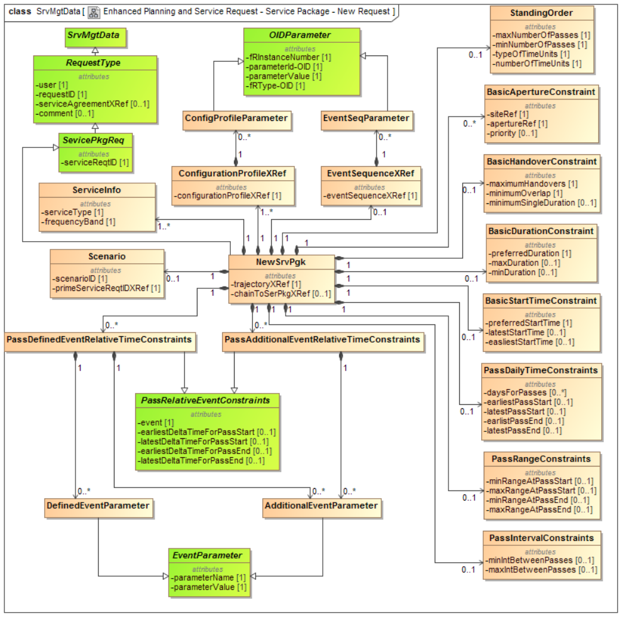
Figure 3-12: Enhanced Service Management Utilization Request Formats Service Package New Request Class Diagram
The attributes of each class are described further in the following subsections and tables.

CLASS SrvMgtData
See reference [6], Annex A for the definition of this class.

CLASS RequestType
See section 3.2.4 for the definition of this class.

CLASS ServicePkgReq
See section 3.2.5 for the definition of this class.

CLASS NewSrvPkg
See section 3.2.6 for the definition of this class.

CLASS Scenario
See section 3.2.13 for the definition of this class.

CLASS ServiceInfo
See section 3.2.14 for the definition of this class.

CLASS ConfigurationProfileXRef
See section 3.2.15 for the definition of this class.

CLASS ConfigProfileParameters
See section 3.2.16 for the definition of this class.

CLASS EventSequenceXRef
See section 3.2.17 for the definition of this class.

CLASS EventSeqParameters
See section 3.2.18 for the definition of this class.

CLASS OIDParameter
See section 3.2.19 for the definition of this class.

CLASS BasicStartTimeConstraint
See section 3.3.3 for the definition of this class.

CLASS BasicDurationConstraint
See section 3.3.4 for the definition of this class.

CLASS BasicHandoverConstraint
See section 3.3.5 for the definition of this class.

CLASS BasicApertureConstraint.
See section 3.3.6 for the definition of this class.

CLASS StandingOrder
See section 3.4.3 for the definition of this class.

CLASS PassIntervalConstraints
See section 3.4.4 for the definition of this class.

CLASS PassDailyTimeConstraints
See section 3.4.5 for the definition of this class.

CLASS PassRangeConstraints
See section 3.4.5 for the definition of this class.

CLASS PassDefinedEventRelativeTimeConstraints
See section 3.4.7 for the definition of this class.

CLASS PassAdditionalEventRelativeTimeConstraints
See section 3.4.8 for the definition of this class.

CLASS PassRelativeTimeConstraints (Abstract)
See section 3.4.9 for the definition of this class.

CLASS DefinedEventParameter
See section 3.4.10 for the definition of this class.

CLASS AdditionalEventParameter
See section 3.4.11 for the definition of this class.

CLASS EventParameter (Abstract)
See section 3.4.12 for the definition of this class.

Enhanced Service Management Utilization Request Formats – Service Package - Update Request

Overview
Figure 3-13 shows the UML Class diagram for the Enhanced Service Management Utilization Request Formats Service Package Update Request.
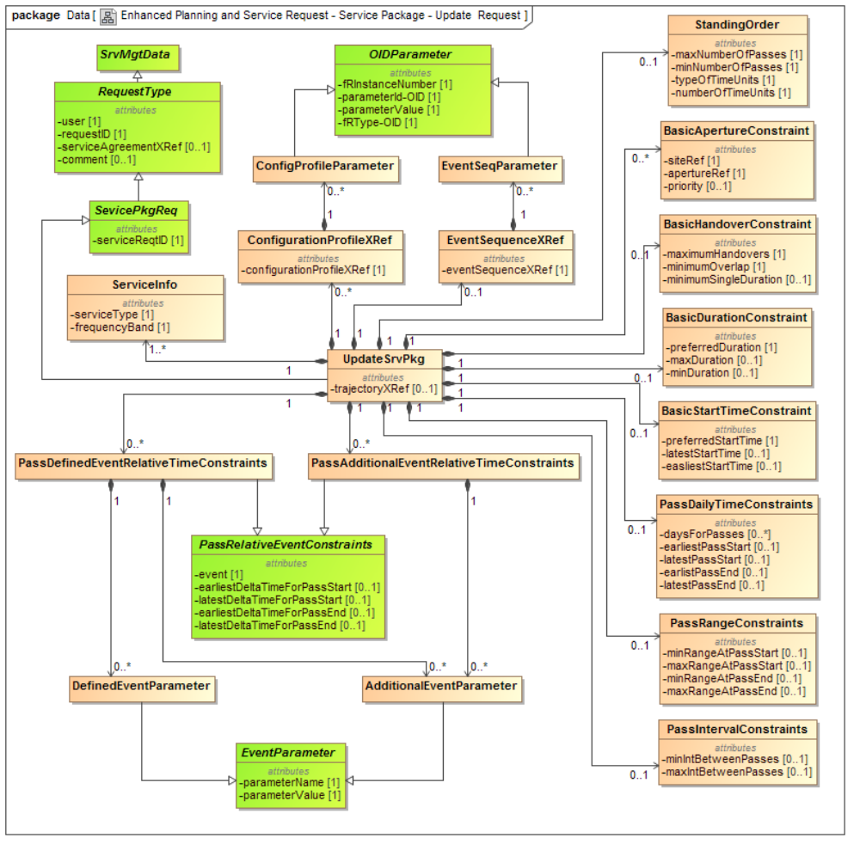
Figure 3-13: Enhanced Service Management Utilization Request Formats Service Package Update Request Class Diagram
The attributes of each class are described further in the following subsections and tables.

CLASS SrvMgtData
See reference [6], Annex A for the definition of this class.

CLASS RequestType
See section 3.2.4 for the definition of this class.

CLASS ServicePkgReq
See section 3.2.5 for the definition of this class.

CLASS NewSrvPkg
See section 3.2.6 for the definition of this class.

CLASS ServiceInfo
See section 3.2.14 for the definition of this class.

CLASS ConfigurationProfileXRef
See section 3.2.15 for the definition of this class.

CLASS ConfigProfileParameters
See section 3.2.16 for the definition of this class.

CLASS EventSequenceXRef
See section 3.2.17 for the definition of this class.

CLASS EventSeqParameters
See section 3.2.18 for the definition of this class.

CLASS OIDParameter
See section 3.2.19 for the definition of this class.

CLASS BasicStartTimeConstraint
See section 3.3.3 for the definition of this class.

CLASS BasicDurationConstraint
See section 3.3.4 for the definition of this class.

CLASS BasicHandoverConstraint
See section 3.3.5 for the definition of this class.

CLASS BasicApertureConstraint.
See section 3.3.6 for the definition of this class.

CLASS StandingOrder
See section 3.4.3 for the definition of this class.

CLASS PassIntervalConstraints
See section 3.4.4 for the definition of this class.

CLASS PassDailyTimeConstraints
See section 3.4.5 for the definition of this class.

CLASS PassRangeConstraints
See section 3.4.5 for the definition of this class.

CLASS PassDefinedEventRelativeTimeConstraints
See section 3.4.7 for the definition of this class.

CLASS PassAdditionalEventRelativeTimeConstraints
See section 3.4.8 for the definition of this class.

CLASS PassRelativeTimeConstraints (Abstract)
See section 3.4.9 for the definition of this class.

CLASS DefinedEventParameter
See section 3.4.10 for the definition of this class.

CLASS AdditionalEventParameter
See section 3.4.11 for the definition of this class.

CLASS EventParameter (Abstract)
See section 3.4.12 for the definition of this class.

Enhanced Service Management Utilization Request Formats – Planning Info Request

Overview
Figure 3-14 shows the UML Class diagram for the Enhanced Service Management Utilization Request Formats Planning Info Request.
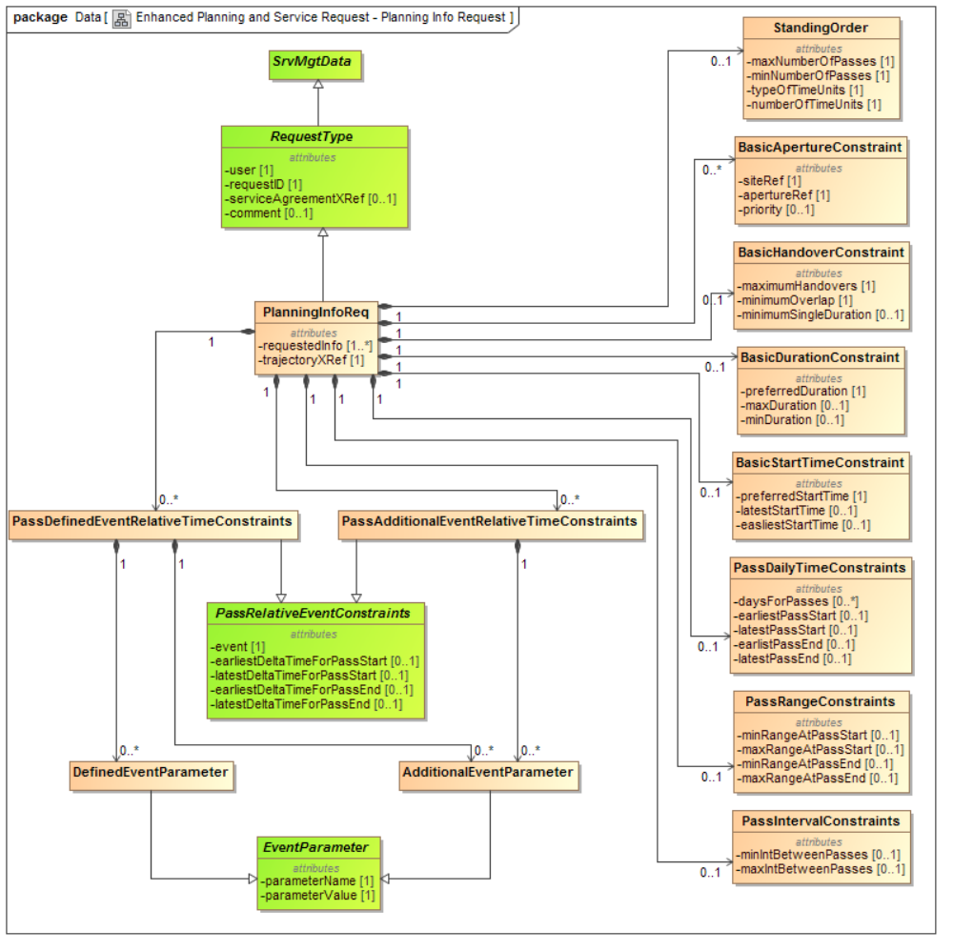
Figure 3-14: Enhanced Service Management Utilization Request Formats Planning Info Request Class Diagram
The attributes of each class are described further in the following subsections and tables.

CLASS SrvMgtData
See reference [6], Annex A for the definition of this class.

CLASS RequestType
See section 3.2.4 for the definition of this class.

CLASS PlanningInfoReq
See section 3.2.12 for the definition of this class.

CLASS BasicStartTimeConstraint
See section 3.3.3 for the definition of this class.

CLASS BasicDurationConstraint
See section 3.3.4 for the definition of this class.

CLASS BasicHandoverConstraint
See section 3.3.5 for the definition of this class.

CLASS BasicApertureConstraint.
See section 3.3.6 for the definition of this class.

CLASS StandingOrder
See section 3.4.3 for the definition of this class.

CLASS PassIntervalConstraints
See section 3.4.4 for the definition of this class.

CLASS PassDailyTimeConstraints
See section 3.4.5 for the definition of this class.

CLASS PassRangeConstraints
See section 3.4.5 for the definition of this class.

CLASS PassDefinedEventRelativeTimeConstraints
See section 3.4.7 for the definition of this class.

CLASS PassAdditionalEventRelativeTimeConstraints
See section 3.4.8 for the definition of this class.

CLASS PassRelativeTimeConstraints (Abstract)
See section 3.4.9 for the definition of this class.

CLASS DefinedEventParameter
See section 3.4.10 for the definition of this class.

CLASS AdditionalEventParameter
See section 3.4.11 for the definition of this class.

CLASS EventParameter (Abstract)
See section 3.4.12 for the definition of this class.

Informative References
(INFormative)
[A7] Space Communication Cross Support—Service Management—Operations Concept. Issue 1. Report Concerning Space Data System Standards (Green Book), CCSDS 910.14-G-1. Washington, D.C.: CCSDS, May 2011.
[A8] Extensible Space Communication Cross Support—Service Management—Concept. Report Concerning Space Data System Standards (Green Book). Washington, D.C.: CCSDS, forthcoming.

