CCSM Telecon/Webex, 27 October 2015

Attendees
E. Barkley, J. Chamoun, A. Crowson, M. Gnat, C. Haddow, H. Kelliher, P. Pechkam, T. Pham, J. Pietras, J. Reinert, K. Tuttle

Agenda and Notes
- Action Item Review
  - Several actions set with new dates of the fall meetings
- Abstract service request walk through and implications
  - C. Haddow, A. Crowson, J. Pietras have updated the abstract model re configuration profile
    - Configuration profile, in-line is now essentially the payload of the configuration profile book (for service commitment type requests)
  - Tentative plan of creating a request book as its own deliverable discussed
  - Please see presentation attached below
- Potential future work re schedule of services
  - No general objection to the notion of adding associations for scheduled packages (see diagram below)
  - To be considered for a future version of the schedule book
    - Likely that the “Simple Schedule” will become just the “Schedule” book
  - General notion of a more robust meta-data facility discussed as technique for CSSM recommendations across the board
    - E.g, to record, for example, that the schedule has been filtered
      - May help with moving toward management service eventually
- Fall meetings planning
  - Joint session on SLS-SLP
  - Consideration of concept updates to be added to fall meeting agenda
    - Potential creation of request book
    - Potential next version of schedule recommendation
- AOB
  - None

Next Telecon
The next telecon date will be determined at the Fall meetings
[end notes]

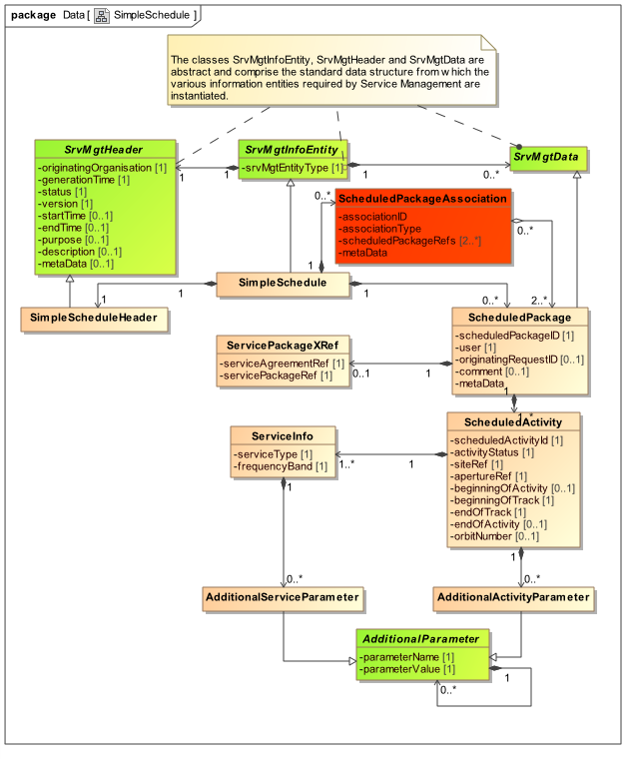

Figure 1 – Potential modification to Schedule Recommendation

