# CCSM Telecon, 13 October 2015

# Attendees

E. Barkley, JP Chamoun, K. Costello, A. Crowson, M. Gnat, C. Haddow, P. Pechkam, T. Pham, J. Pietras, J. Reinert, K. Tuttle

# Agenda and Notes

1. Action Item Review
2. Brief update on prototype and project definitions (TGFT and TP)
   1. CNSA delegate to support prototyping
   2. Book development dates are okay, assuming that E. Barkley corrects TP project definition dates
3. Trajectory segment action item review/close out (see email from J. Reinert)
   1. Orbit hybrid message appears to allow for “parent-child” relationship; expression of trajectory to another arbitrary body (not necessarily earth)
   2. OHM is currently proposed in NAV WG
   3. Agree to not state end time (from SM header) in TP book
   4. Note that there is now a dependency for TP book on definition in the OEM/NAVWG
   5. Action E. Barkley to contact D. Berry to note dependency
4. Status update re abstract service request
   1. See charts below; no comments questions at this time
   2. Full result to be presented at fall meetings
5. Status update re event sequencing vs SC-CSTS
   1. No comments questions at this time
   2. Next steps are to harmonize the functional resources vs state models and look at priority of SC-CSTS vs Event Sequence (in the execution environment)
6. Fall meetings planning
   1. No comments at the moment
   2. General request for everyone to look at the draft CSSM (see below) and check re time allocations, etc.
7. AOB - None.

# Next Telecon

Our next telecon is scheduled for 27 October.

[end notes]

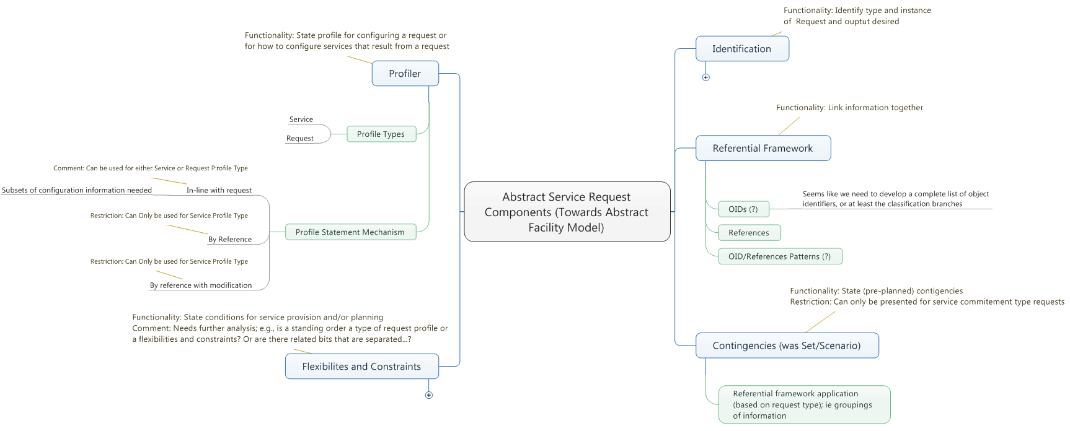

Fig 1 – Very abstract service request components (full model not shown)



Fig 2 – Abstract request model

Table 1 – Draft CSSM Fall 2015 Agenda