28 July 2015 Teleconference Notes

Attendees:

E. Barkley
J. Chamoun
A. Crowson
M. Gnatt
C. Haddow
H. Kelliher
J. Pietras
P. Pechkam
T. Pham
K. Tuttle

Agenda

1) Action item review
2) Schedule of services finalization
3) Forward frame management considerations
4) Brief status update re abstract request engineering
5) Projected delivery updates (work plan review)
6) AOB

Discussion Summary:

- Action items review:
  - Re 2015-0414-2 (Schema registry); agreed that ancillary concern registering namespaces is better addressed in more global context such as XSG

- Final SoS finalization
  - Agreed to finalize with respect to creation/use of Site and Apertures registry

- Forward frame management considerations
  - for the most part it appears that the management considerations are essentially configuration profile concerns
  - the enterprise type model is essentially a “fan-in” where each service user has a bound context to the FF server and that the information for all of these connections is indicated in the service package; essentially the inverse of a service package with multiple RAF/RCF outputs.

- Brief re abstract service request engineering
  - Still in progress, no definitive model yet; J. Pietras added as member of splinter group

- Projected delivery updates (work plan review)
  - Reviewed the work plan from the spring meetings
  - Adjusted key dates for work items
  - Net assessment is that no work items are significantly threated at the moment, but planning book and service request/service package book may become so if the abstract service request slips significantly
  - Updated work plan with changed items is shown below

- AOB
  - None

Our next telecon/WebEx is scheduled for August 11, 2015

Updated work plan
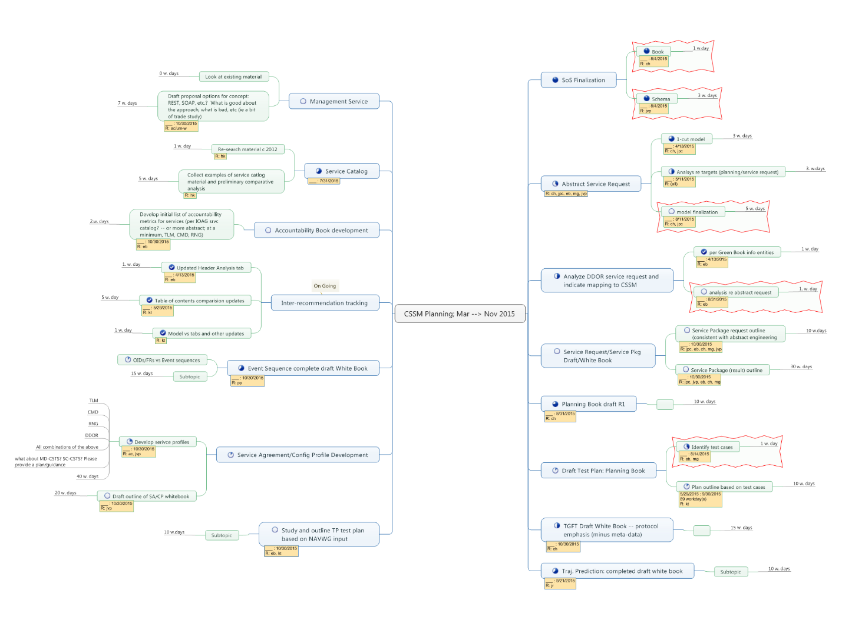
[end notes]

