CSSM Abstract Service Request Engineering Splinter Session Telecon; 30 Jun 2015

Attendees:
E. Barkley
H. Driehahn
J. Chamoun
C. Haddow

Agenda/Notes:
- Review/discuss abstract service request; plan course forward
  - Agreed that the configuration functional component essentially supports three options
    - All of the configuration parameters supporting the request are found via the profile reference
    - All of the configuration parameters are contained “in-line” with the request
      - Implies that configuration profile ref is null-able which means that the abstract class diagram needs updating
    - Just some configuration parameters are being supplied in the “re-specification” case
  - Walked through updates/mapping exercise for DDOR service request (J. Chamoun)
    - See Fig 1 and Fig 2 diagrams below
    - Main conclusion is that fig 2 diagram can be viewed as an “application” of the fig 1 diagram if in the fig 1 diagram:
      - The various constraints are given identifiers
      - An new functional component is added that ties between the referential framework component (class) and the service component (class) thereby allowing expression of various constraints for a particular service or for the service package request in general
        - Noted that in general, composition may not quite be the proper UML association to use for this
    - Detailed mapping information from J. Chamoun’s exercise is on the CWE (http://cwe.ccsds.org/css/docs/CSS-SM/CWE%20Private/Service%20Package%20Request%20and%20Service%20Package%20Book/CSSSM_DDOR_Request_MapV2.xlsx)
  - Action to C. Haddow to revise the abstract service request class diagram per discussion, conclusions
    - This is essentially updates to Figure 1
  - agreed that at next teleconference it would be good to see the same type of exercise that was done for the Delta door service request to be done for the planning request
    - Action C. Haddow for next CSSM telecon in late July

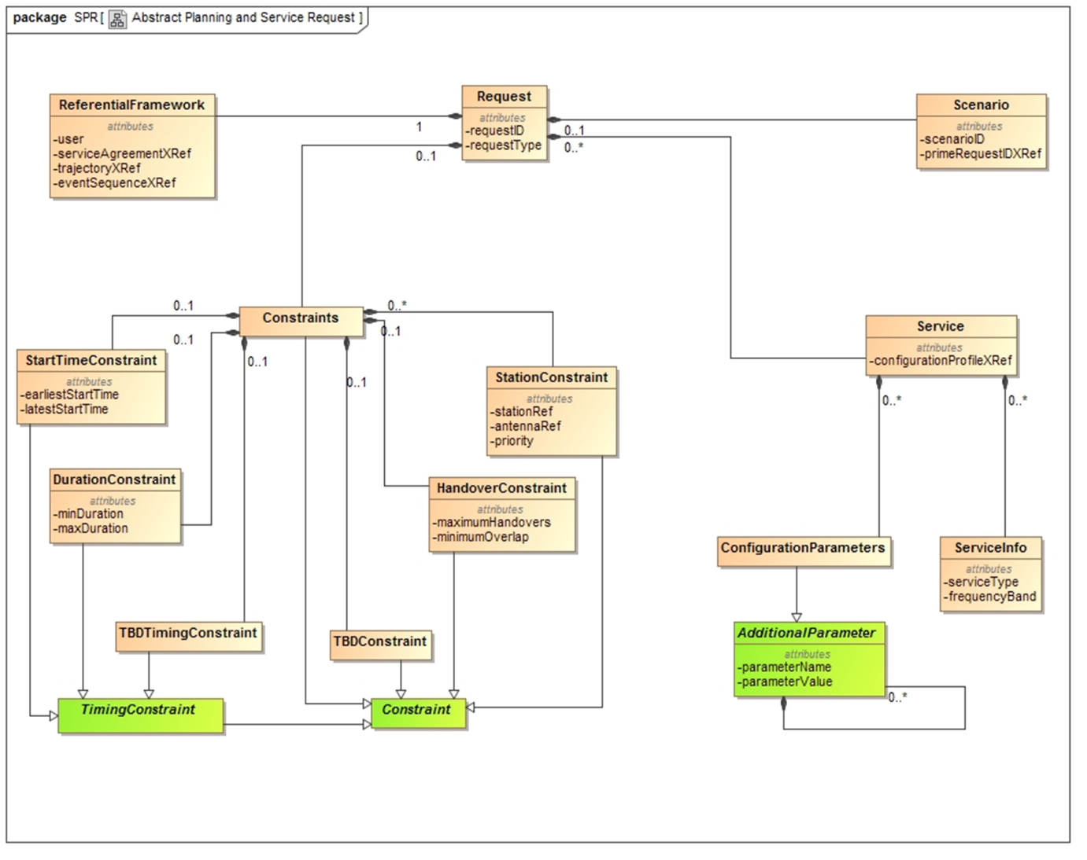
Figure 1: Abstract Svc Request at close of Spring 2015 meetings

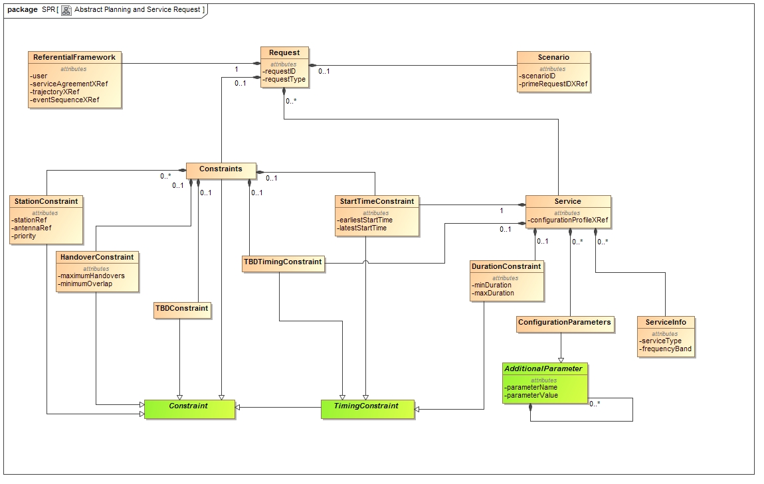

Figure 2: Abstract Svc Request, “effective” trial mapping/”application” of Fig 1 to accommodate DDOR

