Preliminary Draft:

Service Package Request Components
V 0.0; 09-Mar-2015; eb

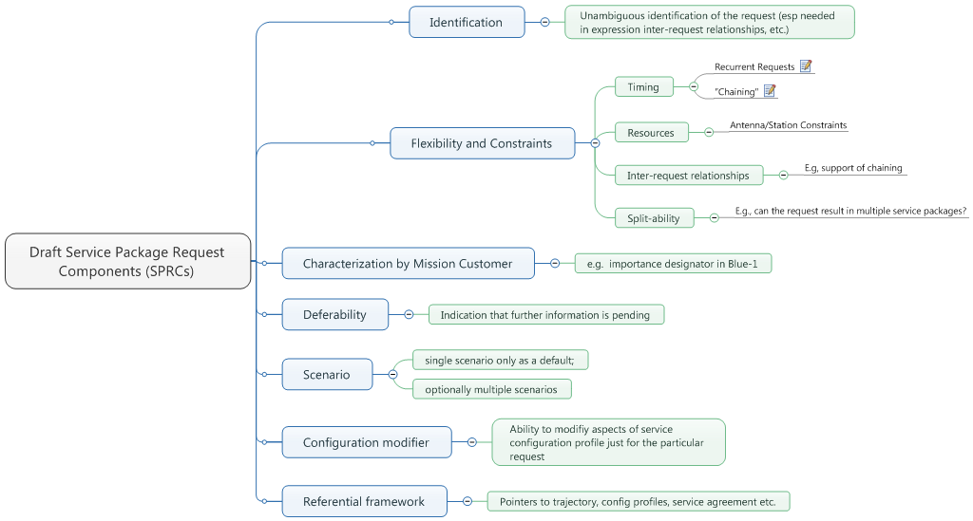
Figure 1: Service Request Components as of London Meetings (Nov 2014)

Components

Identification

Purpose: Allow the request to be uniquely identified.
- May support ability to refer to the request from another request
  - Allow inter-request relationships to be built re Flexibilities and Constratins
  - Potentially DDOR tracking
- May support ability to trace multiple service packages back to (single) request

Extensibility
- a minimum core identification will always be required
- if the request represents “standing orders” perhaps version or revision information may be included?

Flexibilities and Constraints

Purpose: Allow for negotiation “envelope” to be stated
- What time range or ranges are needed
- Statement as to request being of a “standing” nature or for just a particular time
- statement of relationship (if any) of this request to other requests
- statement of resources to be allowed and or excluded (cf. blue-1)
- indication as to suitability for splitting of resultant service packages among multiple service package instances

Extensibility
- Basic time relationships (start window, minimum/preferred duration of service part of “core” definition)
- Timing, Resources, Inter-request relationships (incl “split-ability”) are extension points

Mission (UM) Characterization of Request

Purpose: Allow level of support needed to be indicated; may affect pricing
- Statement of relative importance of the request to the mission; e.g., support is critical at time indicated for proper tracking during entry/descent and landing
- Indication that request is of an emergency nature (cf. “urgent” flag in blue-1)

Extensibility
- Urgency (as in emergency) is part of core definition
- Assume that everything else is extensible (perhaps as generic string definitions)

Deferability

Purpose: allow the request to indicate that further details are pending
- e.g, event sequence; terrestrial data transfer mappings (cf blue-1)

Extensibility
- Assume definition of what is extensible exists for the minimal service package request definition
- extensibility here tracks extensibility in other components of the service request to the extent the other components introduce a need for extensibility
  - e.g., if there is some extension provided for a more sophisticated flexibility and constraints statement but then some of that flexibility/constraints statements can be deferred, then the defer ability component is, by definition, extended

Scenario

Purpose: to allow preplanned contingencies to be calculated and ready for changes in execution at very short notice during execution time
- for example, a trajectory correction maneuver is planned during the particular time window of the request and significantly different trajectories may result and so it contingency is to provide tracking in reference to trajectory a versus trajectory b (cf scenarios in blue-1)
- provide identification of the default scenario that will be used in initiating the set of tracking services

Extensibility
- assumed that a single scenario is the default
- extensibility is only in terms of cardinality (i.e. number of contingency scenarios to be accommodated)

Configuration Modifier

Purpose: Allow changes to service configuration on a per request basis.
- allow modification of selected parameters of referenced service configuration profile (cf. blue-1)
  - Note: this will need to tie into functional resource model and/or pre-defined “cookie cutter” profile definitions
  - Note: if configuration modifiers are for request that is a of standing order nature, it is in effect then a type of configuration profile
  - Note: if a configuration profile is submitted, it will be up to an ICD determination (until management service is defined) as to precedence relative to standing order type request

Referential Framework

Purpose: Allow supporting information entities to be referenced (and thereby be “re-used”)
- May need to be more than just a simple reference. This may need some sort of ability to indicate temporal updates – e.g, trajectory prediction consistent with the Flexibility/Constraints: time range data

Extensibility
- assumed to be largely covered by initial definition of the service request
- May be similar to the deferability component -- i.e., if other components of the service request and subsequent references then presumably the referential framework also requires extensibility

Notes
- Depending upon the level of sophistication needed for stating flexibilities, constraints etc. it’s not inconceivable that a blue book just for stating these kinds of things could be created
- For the moment, it is assumed that there will be at least some minimum set of flexibilities, constraints that satisfy the interoperation needs for the CCSDS member agencies
- further study may be warranted to consider restrictions rather than extensibility for scenarios; for example, perhaps the different configuration profiles that may be referred to by different scenarios have restrictions in terms of the variability for rapid real-time implementation (for example, perhaps an S band uplink scenario is not allowed as an alternate for the service provider resources schedule)

