Draft CCSDS Event Sequence Extensibility/Components

Purpose
The purpose of this document is to describe the process of refactoring Blue 1 Event Sequence Profiles of the SCCS SM specification to address extensibility concepts that are key to the development of the Blue 2 standard. The artifacts of this process include a conceptual design of the restructured Event Sequence Profile that focuses on describing new extension points and major components of the restructure.

Background
An Event Sequence provides the capability to describe spacecraft events that are expected to occur within a specific period of time. The sequence of events can be used for comparison to actual events as they occur in real time. In addition, they can be used for all mission types but are primarily intended for deep space tracking. Spacecraft actions (such as to communicate to earth) are pre-planned or executed via spacecraft autonomy, and due to the length of time (ie round trip light time (RTLT)) between actions executed by the spacecraft and the observation of the event on the ground, ground planning and preparation is required. For example, ground operations use event sequences to plan for command uplinks reaching the spacecraft at a specific time or when the spacecraft is in a specific state.

There are two event sequences: a mission/user sequence, which captures events from a spacecraft’s point of view and a ground sequence, which captures events from a ground point of view and takes into account a provider’s ability to perform managed services with respect to the mission events. In the basic example, a user submits an event sequence for a spacecraft in near earth orbit with a return carrier enabled for a specific time and duration. The provider generates an event sequence that “echoes” the specified return carrier times and duration. In another example, a user may specify its Mars orbiting spacecraft to keep its transmitter “on” for a duration of time, but due to the various geometries tracked by a specific provider, that provider determines that it can only provide managed service for the spacecraft for portions at a time (as the spacecraft goes in and out of view) and will generate an event sequence that accounts for these occultations by only sequencing events when service provision can be provided.

An Event Sequence Profile Invocation is a means for a mission user to submit a mission sequence to a CSSS Provider. The CSSS Provider produces an Event Sequence Profile Result, which is 1) committed/scheduled by the provider and 2) account for any calculations and resultant re-rendering of events (typically for more accurate representation of events). Item (2) may be a capability of the CSSS provider, with such capability noted in the service agreement, distinguishing between Providers or agreements with varying functionality/quality levels of management services.

Use cases
From the green book, here is the set of uses cases in which a Blue 2 event sequence is to be extended:
- New service management capability – the event sequence profile structure should allow for a phased approach to defining and deployment of a management service.

- New managed service – a new managed service could entail integrating a set of Information Entities and operations to a management service. The event sequence profile should provide an extension point where logically the new entities could be added without significantly perturbing the structure and/or other information entities.
  - Example/possible use case: Delta DOR

- New space communication technology and configurations – new technologies that establish space links could also involve integrating a set of information entities and operations to a management service. Such technologies do not obsolete current technologies so the event sequence profile should allow for adding new ways of defining a space link without perturbing the existing reference implementation (of RF based space links).
  - Example/possible use case: (configuration) 3-way between different Provider CSSSes, (tech) optical space links

- Application of managed services and service management capabilities that are local to individual TT&C service provider – the functional aspects of an event sequence should be represented as logical extension points where a provider could extend the standard event sequence with localized, non-standard managed services and/or management service entities.
- Bi-lateral Service provision information between User and Provider – events in an event sequence may have additional context that is specific to the User and/or Provider. These may be tweaks to the behavior of the managed service. SCCS SM will formalize a set of these “advisories”. However, we can expect this to be an extension point since these advisories can be born from various emergent factors.

Approach
The approach to re-factoring the event sequence profile starts with revisiting the Blue-1 event sequence profile and considering new or updated use cases. The artifact of this approach should be a revised event sequence profile with extension points and any re-organization of the information and/or structure to support the new use cases. The extension points will naturally need to be defined where we expect extension of the event sequence profile is needed after Blue 2 is delivered.

Per the SCCS SM green book concepts, functional groups that are organized around space communication technologies make logical extensibility points. We will look at the current state of functional groups/resources as documented in (the function resource tech note). We will also look at the current work being performed in the Service Package Result (Abstract modeling of Service Package Result Components).

From a technical perspective, we will look at constraints and/or optimizations that come with the implementation – using XML schema as a sample technology to rate how well the extensibility structures/requirements map.

Architecture of the event sequence
The current information architecture of an event sequence profile defines a structural relationship between when a space link is available and when data services are performed over the space link. Space Link Availability is first organized into F401 and R401 based space links, such that the respective space link availability states have state parameters based on those standards. The transfer services have an associated space link in either the forward or return direction. For example, the FCLTU/commanding transfer service occurs on a forward space link, thus a forward F401 space link availability is related to the command transfer service. A common means to express behavioral changes over time is to use a state model. To define the event sequence using states, figure xx uses a protocol state model with super-states and sub-states.
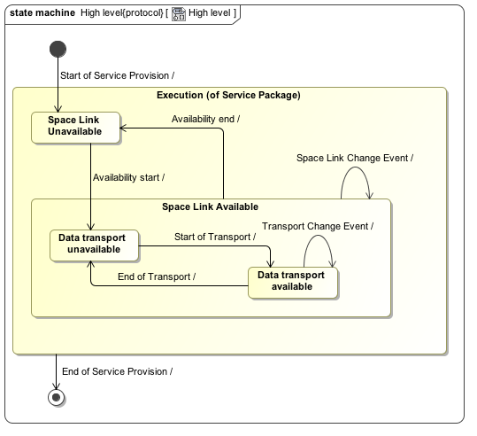
Figure 0-1, Space link and transfer services State model

Each of these states, by definition is bound by a start time, an end time, and key characteristics of that state e.g. a return space link availability being characterized by the parameters in a referenced carrier profile. The state and carrier profile reference allows for either 1) multiple, concurrent space links that have different signal characteristics (ie frequency as defined in a carrier profile), or 2) a single space link that will exhibit changes over time including becoming available-unavailable-available due to occultation(s) or the space link characteristics change as a function of time due to space craft positioning, configuration, etc.. States capture lifecycle over time and allow a user to be very explicit with regards to when or how changes occur.

Each return space link available state also contains a list of minor state changes in which some characteristics can change within the time frame but do not necessitate reacquiring the space-link (think self-state change, in state model terms).

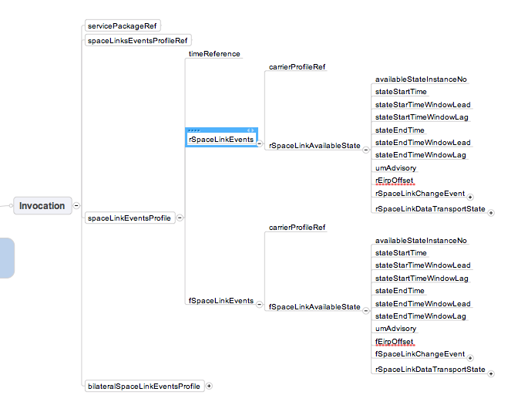
Figure 0-2, Current parameters of the space link availability state in Blue 1
Each space link availability state contains a list of space link data transport states that are similarly structured in terms of defining availability times and characteristics of the data transport.

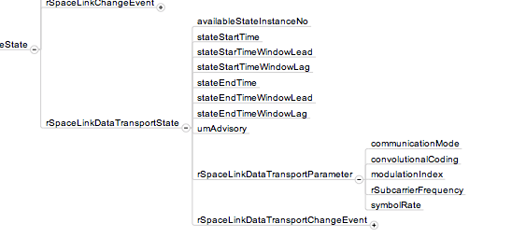

In addition, Blue 1 defined event sequence profiles based on CCSDS 401 Radio frequency and modulation system standards. Blue 1 data transport states are based on a select set of return and forward managed services including RAF, RCF, etc..

Analysis
- The state design aspect of event sequences does not need to change. All Blue 1 space link and data transport availability states are still relevant in Blue 2. The organization of return and forward space links and respective data transport availability sub-states does not change. This is based on the premise that specific implementation of functional resources is abstracted by the concept of space link services and transfer services, which the space link availability and data transport represent.

- While a space link is active, a respective data delivery transfer service can start and stop – but not while it is inactive. Hence, the super-state organization that describes a return space link owning return data transport states (and the same for forward) still applies. If a service has components in both directions, then the data transports will be split accordingly in parts with respect to their direction. If a transfer service is independent of the space link availability, then a data transport state needs to be added orthogonal to the return and forward space link availability states.

- The next order of information organization is accounting for the different data delivery transfer services. How does an event sequence, in which each event has a distinct set of parameters, properly describe the event in a way that clearly associates the parameters with the proper transfer service being specified? What is not accounted for in the above is how to manage the specific “types” of data delivery transfer services that are added as part of extension. In the Blue 1 specification, this manifested itself in specific state instances and specific parameters. How a return or forward transfer service is defined does require some change to account for extensibility. This informs the decision to either adopt the extended parameters as part of an existing state (of behavior) or create a new state to capture the behavior separately. As we add new transfer services, are we still within the realm of one data transport state? Are

additional data transport availability states needed ? The Blue 1 recommendation combined RAF and RCF data delivery transfer services into one RSpaceLinkDataTransportState. This made sense for Blue 1’s scope but does it still apply with ROCF, RUTF, return file service, etc, and does it still make sense to combine all the parameters in one data transport state? There are two approaches: 1) combine all parameters in one state or 2) have a state for each data transfer service.

- The state model should be enhanced to model new types of data transport, where the types vary from a new data delivery transfer service, an extended service or a localized service.

- Since it is expected that not all transfer services can be covered in the scope of Blue 2, the event sequence extensibility framework should address transitioning these services using the extensibility mechanisms that are designed as part of Blue 2.

- Where does monitored data service and service control fit in an event sequence? Does it need to be sequenced with respect to the states or is it just a persistent service started and stopped for the duration of the package (thinking of the monitor data service here). Service control may have more relevance and is a question of whether service control directives change or establish new states.

Key changes
The parameters for each space link availability state and each data transport availability state have been identified as areas for extension points. This is mainly to address local definitions of each state.

To handle external space link references, a separate container has been added. Because the external space link can also be composed of extended events, the external reference is also an extension point.

In the case that the functional group behind space link services is drastically different or must be localized then the space link availability state is an extension point.

Components of the event sequence

(Abstract) Return and Forward Space Link Availability Extension point. The event sequence profile structure requires a method to define what is being added in the extension point. As a general definition, a space link is defined by its carrier profile (referenced), a qualifier/type and extensions for: key parameters of the state, key parameters in a change-of-state. There are two main extension points: 1) adding a new space link availability state, or 2) extending the existing space link availability via additional parameters.

For comparison, the original Blue 1 structure for the Event Sequence Profile Result is included as figure. Note: the invocation Event Sequence Profile has the exact same structure as the result but with different state names to emphasize the invocation role; to ease discussion, changes are described for just the result profile with the expectation that the changes will also fold in to the invocation profile similarly.
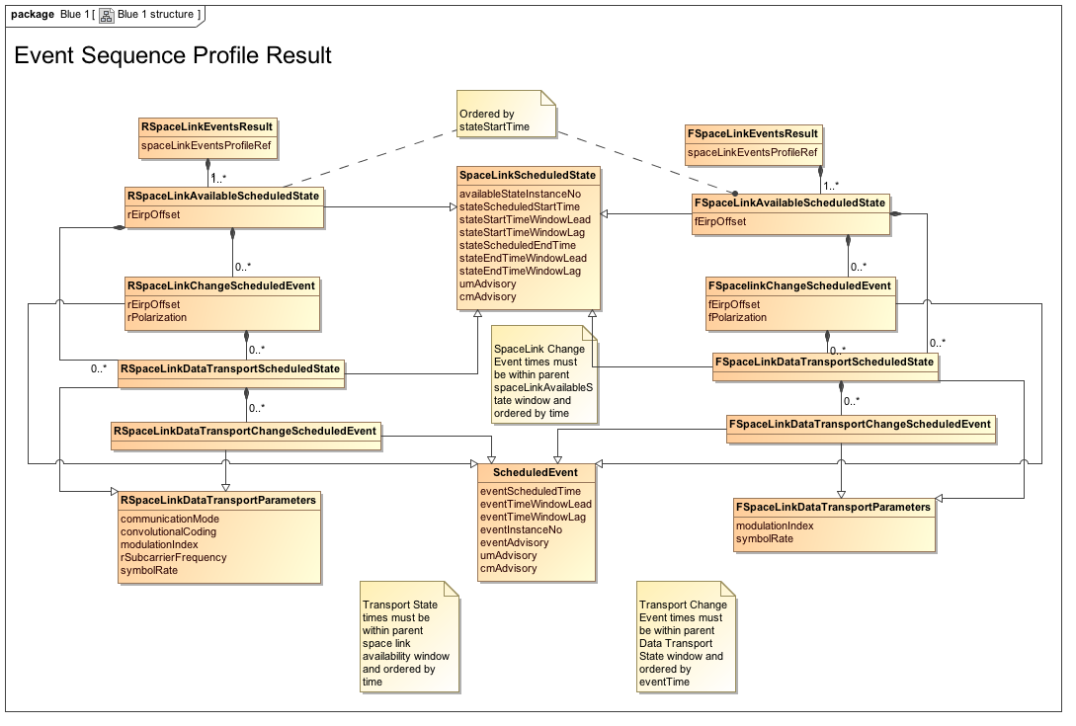
Figure 0-4, Event Sequence Profile Result from Blue 1

Approach #1:
This approach entails having one data transport state accommodate all transfer services. This implies that the extensions that need to be made include adding new parameters to the data transport availability states.
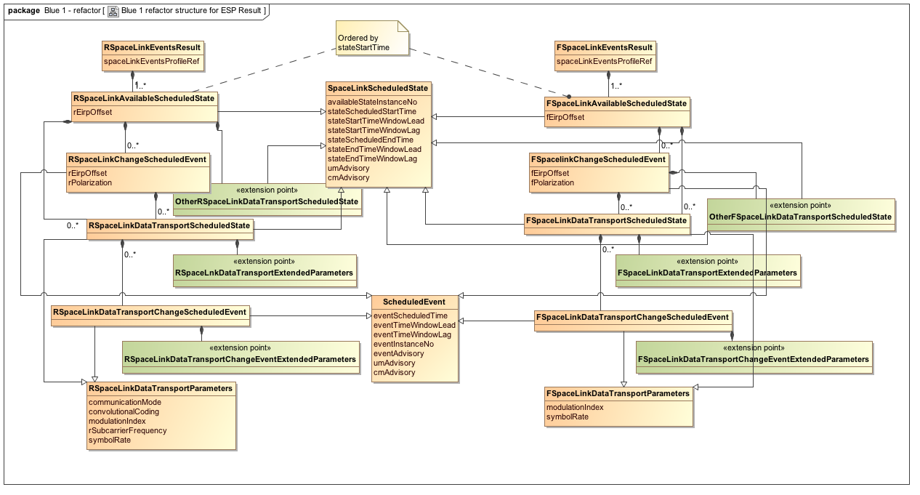
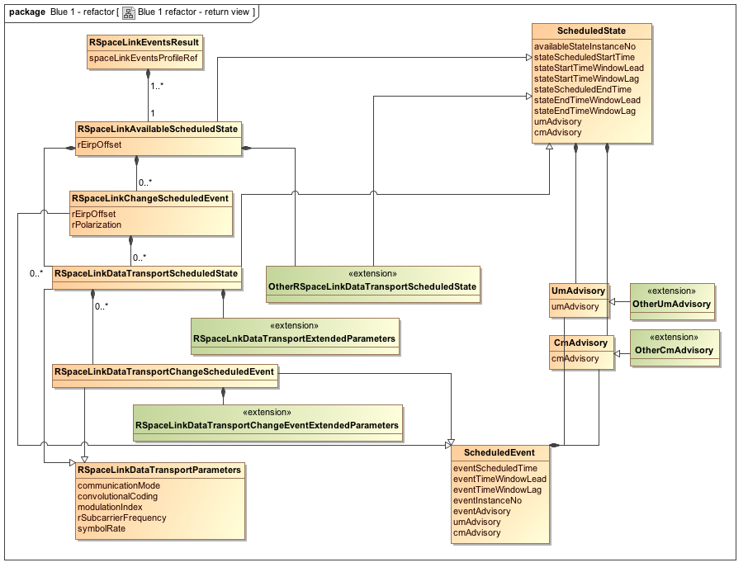
Figure 0-5, Event Sequence Profile Result re-factored with extensibility

Approach #2
This approach is more explicit in defining a state for each transfer service. This would allow 1) allocating the parameters of the state behavior to a proper set of states, 2) for states/services to execute in parallel over a space link (where applicable) . This adds an extension point at the data transport availability level such that an extension is essentially adding a new data transport availability state.

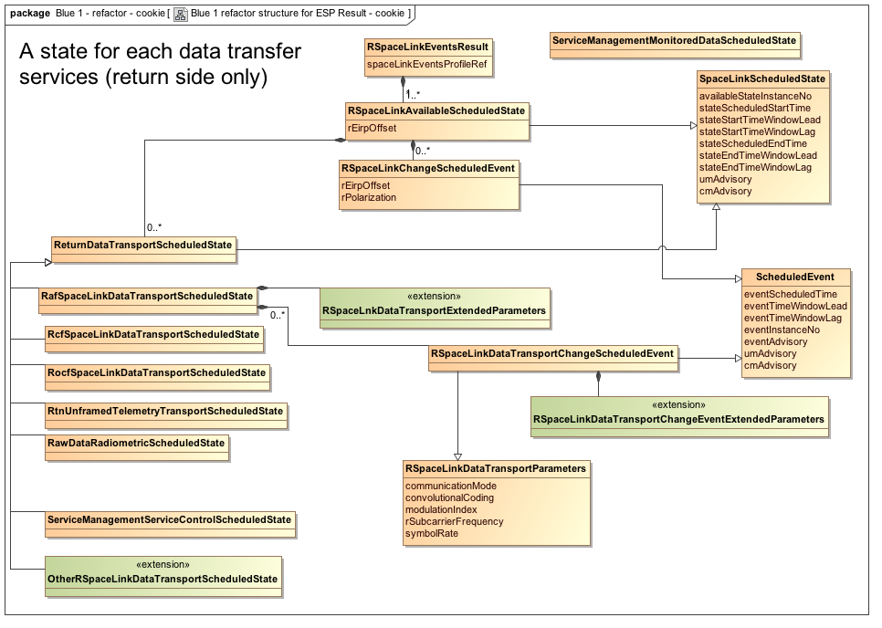

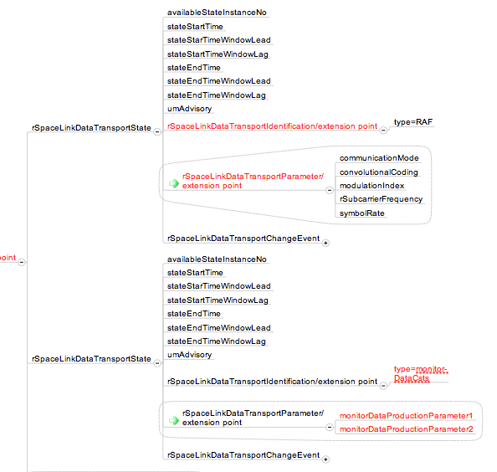
Figure 0-7, Example defining a data transport state for Monitor data CSTS
External Return and Forward Space Links – for defining characteristics of a space link provided by or provisioning another service package at a CSSS e.g. transfer of the forward space link for 3-way.
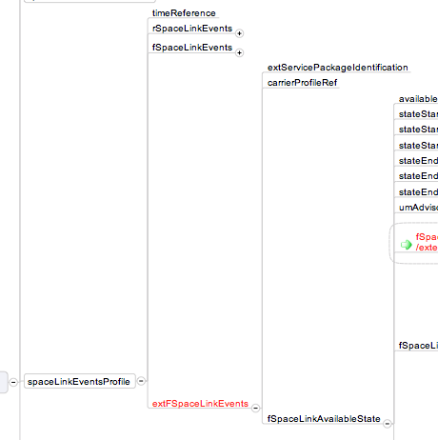

Versioning
TBD Note: based on telecon discussion, use common approach. See simple services schedule for versioning example.

