
Draft Report Concerning
Space Data System Standards
Extensible Space Communication Cross Support—Service Management—Concept
Draft Informational Report
CCSDS 902.0-G-0 Comment Response
Draft Green Book
June 2014AUTHORITY

 | Issue: | Draft Green Book, Issue 0
 | Date: | June 2014
 | Location: | Not Applicable
(WHEN THIS INFORMATIONAL REPORT IS FINALIZED, IT WILL CONTAIN THE FOLLOWING STATEMENT OF AUTHORITY:)
This document has been approved for publication by the Management Council of the Consultative Committee for Space Data Systems (CCSDS) and reflects the consensus of technical working group experts from CCSDS Member Agencies. The procedure for review and authorization of CCSDS Reports is detailed in Organization and Processes for the Consultative Committee for Space Data Systems (CCSDS A02.1-Y-4).

This document is published and maintained by:

CCSDS Secretariat
National Aeronautics and Space Administration
Washington, DC, USA
E-mail: secretariat@mailman.ccsds.org
FOREWORD
Through the process of normal evolution, it is expected that expansion, deletion, or modification of this document may occur. This Report is therefore subject to CCSDS document management and change control procedures, which are defined in Organization and Processes for the Consultative Committee for Space Data Systems (CCSDS A02.1-Y-4). Current versions of CCSDS documents are maintained at the CCSDS Web site:
http://www.ccsds.org/
Questions relating to the contents or status of this document should be sent to the CCSDS Secretariat at the e-mail address indicated on page i.
At time of publication, the active Member and Observer Agencies of the CCSDS were:
Member Agencies
- Agenzia Spaziale Italiana (ASI)/Italy.
- Canadian Space Agency (CSA)/Canada.
- Centre National d’Etudes Spatiales (CNES)/France.
- China National Space Administration (CNSA)/People’s Republic of China.
- Deutsches Zentrum für Luft- und Raumfahrt (DLR)/Germany.
- European Space Agency (ESA)/Europe.
- Federal Space Agency (FSA)/Russian Federation.
- Instituto Nacional de Pesquisas Espaciais (INPE)/Brazil.
- Japan Aerospace Exploration Agency (JAXA)/Japan.
- National Aeronautics and Space Administration (NASA)/USA.
- UK Space Agency/United Kingdom.
Observer Agencies
- Austrian Space Agency (ASA)/Austria.
- Belgian Federal Science Policy Office (BFSPO)/Belgium.
- Central Research Institute of Machine Building (TsNIIMash)/Russian Federation.
- China Satellite Launch and Tracking Control General, Beijing Institute of Tracking and Telecommunications Technology (CLTC/BITTT)/China.
- Chinese Academy of Sciences (CAS)/China.
- Chinese Academy of Space Technology (CAST)/China.
- Commonwealth Scientific and Industrial Research Organization (CSIRO)/Australia.
- Danish National Space Center (DNSC)/Denmark.
- Departamento de Ciência e Tecnologia Aeroespacial (DCTA)/Brazil.
- European Organization for the Exploitation of Meteorological Satellites (EUMETSAT)/Europe.
- European Telecommunications Satellite Organization (EUTELSAT)/Europe.
- Geo-Informatics and Space Technology Development Agency (GISTDA)/Thailand.
- Hellenic National Space Committee (HNSC)/Greece.
- Indian Space Research Organization (ISRO)/India.
- Institute of Space Research (IKI)/Russian Federation.
- KFKI Research Institute for Particle & Nuclear Physics (KFKI)/Hungary.
- Korea Aerospace Research Institute (KARI)/Korea.
- Ministry of Communications (MOC)/Israel.
- National Institute of Information and Communications Technology (NICT)/Japan.
- National Oceanic and Atmospheric Administration (NOAA)/USA.
- National Space Agency of the Republic of Kazakhstan (NSARK)/Kazakhstan.
- National Space Organization (NSPO)/Chinese Taipei.
- Naval Center for Space Technology (NCST)/USA.
- Scientific and Technological Research Council of Turkey (TUBITAK)/Turkey.
- South African National Space Agency (SANSA)/Republic of South Africa.
- Space and Upper Atmosphere Research Commission (SUPARCO)/Pakistan.
- Swedish Space Corporation (SSC)/Sweden.
- Swiss Space Office (SSO)/Switzerland.
- United States Geological Survey (USGS)/USA.

DOCUMENT CONTROL

Document | Title | Date | Status
CCSDS 902.0-G-0 Comment Response | Extensible Space Communication Cross Support—Service Management—Concept, Draft Informational Report, Issue 0 | June 2014 | Current draft

CONTENTS
Section Page
1 Introduction 1-1
1.1 Purpose OF THIS REPORT 1-1
1.2 Background 1-1
1.3 SCOPE 1-2
1.4 APPROACH 1-3
1.5 Document Organization 1-4
1.6 Definitions 1-5
1.7 References 1-8
2 Concept overview 2-1
2.1 What is The Extensible Space Communication Cross Support Service Management Concept? 2-1
2.2 SCCS Service management Enterprise Model 2-1
2.3 Information Entities 2-6
2.4 Extensibility Of SCCS SM Information Entities 2-7
2.5 Management Services 2-10
2.6 Roadmap 2-10
3 SCCS Service management Enterprise Model 3-1
3.1 General 3-1
3.2 Organizational Domains in the SCCS SM Enterprise Model 3-1
3.3 Functional View 3-2
3.4 Physical View 3-5
4 SCCS Mission Support Lifecycle 4-1
4.1 General 4-1
4.2 Service Catalog Consultation 4-1
4.3 Service Agreement Development 4-2
4.4 Service Agreement Period 4-3
5 InforMation Entities 5-1
5.1 General 5-1
5.2 Service Catalog 5-1
5.3 Planning Request 5-2
5.4 Provisional Plan 5-2
5.5 Service Agreement 5-3
5.6 Configuration Profile 5-4
5.7 Communications Geometry 5-5
5.8 Sustainable Data rates & Volume EstimateS 5-6
5.9 Radio Frequency Interference 5-7
5.10 Resource Conflicts 5-8
5.11 Cost Estimates 5-9
5.12 Space Link Event Sequence 5-10
5.13 Resource Availability Information 5-11
5.14 Trajectory Prediction Segment 5-11
5.15 Service Package Request 5-12
5.16 Service Package 5-13
5.17 Schedule of Services 5-14
5.18 Service Package Execution Event Notification 5-15
5.19 Accounting Report 5-15
5.20 Information Entity Cross-Referencing Framework 5-16
6 Extensibility Of SCCS SM Information Entities 6-1
6.1 ConceptS of Information Entity Extensibility 6-1
6.2 Extensibility of the Service Agreement and Configuration Profile INformation Entities 6-2
6.3 Extensibility of the Service Package Request and Service Package Information Entities 6-33
6.4 Extensibility of Planning Data Information Entities 6-38
7 ManageMent ServiceS 7-1
7.1 General 7-1
7.2 SCCS SM Information Entities in Provider-Specific Management Services 7-1
7.3 Extensible SCCS Management Services 7-2
8 Roadmap 8-1
8.1 Overview 8-1
8.2 Deliverables 8-1

ANNEX A Acronyms and Abbreviations A-1
ANNEX B COMPARISON of the SCCS SM Enterprise Model to the Cross Support ReferEnce Model, Part 1: SpAce Link Extension B-1
ANNEX C SysML SCCS Service Management Enterprise Model C-1
ANNEX D Solar System Internetwork Enterprise Model D-1
ANNEX E Service Units and Functional Resource Types Used by the Example AOS and Telecommand Missions E-1

Figure
2-1 Organizational Domains of the SCCS SM Enterprise Model 2-2
2-2 Summary Functional View of the SCCS SM Enterprise Model 2-3
2-3 Summary Example Physical View of an SCCS Enterprise 2-4
3-1 Functional View of the SCCS SM Enterprise 3-3
3-2 Service Management Functions—Functional View 3-5
3-3 Essential Physical View of SCCS SM Enterprise Model 3-6
3-4 Physical View of an Example SCCS Enterprise with Distributed Earth User CSSS and Provider CSSS 3-9
3-5 Example Enterprise Configuration for Executing Delta DOR 3-10
3-6 Example Enterprise Configuration for Providing Three-Way Tracking and Handover via Two Provider CSSSes 3-11
4-1 SCCS Mission Support Lifecycle 4-1
5-1 SCCS Service Management Information Entity Cross-Referencing Framework 5-17
6-1 Abstract Service Units for Earth-Space Link Terminals 6-9
6-2 Service Units for IOAG Services 6-15
6-3 Abstract Service Units Associated with SLS Service Packages 6-18
6-4 Abstract Service Units Associated with Retrieval Service Packages 6-19
6-5 Abstract Service Units Associated with a Forward Offline Service Package 6-19
6-6 Telecommand Mission Service Agreement - Service Units for SLS Service Packages 6-20
6-7 Telecommand Mission Service Agreement - Service Units for Retrieval Service Packages 6-21
6-8 AOS Mission Service Agreement—Service Units for SLS Service Packages 6-22
6-9 Notional Interfaces of the Generic Functional Resource Type 6-23
6-10 Telecommand Mission Service Agreement—Functional Resources for SLS Service Packages 6-25
6-11 Telecommand Mission Service Agreement—Retrieval Profile Functional Resources 6-26
6-12 Telecommand Mission FSP Configuration Profile—Functional Resources for SLS Service Packages 6-27
6-13 Telecommand Mission F-CLTU Configuration Profile—Functional Resources for SLS Service Packages 6-28
6-14 AOS Mission Service Agreement—Profile Functional Resources for SLS Service Packages 6-30
6-15 AOS Mission Forward Transfer Frame Configuration Profile—Functional Resources for SLS Service Packages 6-31
6-16 AOS Mission Forward CADU Configuration Profile—Functional Resources for SLS Service Packages 6-32
6-17 Notional Structure of the Extensible SLS Service Package Request 6-36
8-1 Extensible SCCS SM Products, By Lifecycle Stage and Order of Development 8-4
B-1 SCCS Service Management Environment B-2
C-1 Essential SCCS SM Enterprise Model (in SysML) C-2
C-2 SCCS SM Enterprise Model with Management and Transfer Services C-3
C-3 SCCS SM Enterprise Model—Mission Using Multiple Providers C-4
C-4 Provider Tracking Multiple Spacecraft from Different Missions C-5
D-1 Functional View of the SSI Enterprise D-3
D-2 Physical View of Example SSI Enterprise D-5
D-3 SSI Enterprise with Separate Earth-Space and Space Routing Service Providers D-7

Table
8-1 Schedule of Extensible SCCS SM Products 8-5

Introduction

Purpose OF THIS REPORT
This report documents a concept for Space Communication Cross Support Service Management that spans the space mission lifecycle and that enables the graceful evolution of Space Communication Cross Support Service Management in step with the evolution of space communication technology.

Background
For many decades, various space agencies of the world have operated Tracking, Telemetry, and Command (TT&C) systems to provide services that enable operators and users of spacecraft to communicate with and track those spacecraft. Since the early 1980s, the Consultative Committee for Space Data Systems (CCSDS) has been developing standards for a wide range of space-related data exchanges and processes, including standards for the communication and tracking services of TT&C systems. The term Space Communication Cross Support (SCCS) services refers to TT&C services that are performed in conformance with CCSDS standards.
Management information must be exchanged between space missions (hereinafter referred to as Missions) and SCCS service providers for the purposes of negotiating, configuring, and executing space link services and ground data transfer services that are provided to the Mission. SCCS Service Management (SM) is the set of processes involved in the collection and exchange of information which is required to negotiate, configure, schedule, prepare, access, and report on SCCS services. These processes are carried out cooperatively between Missions and SCCS service providers.
CCSDS developed and published a first-generation (Version-1) SCCS SM service specification (Recommended Standard, reference [1]) and accompanying concept description (Informational Report, reference [2]) that defined a standard interface for the exchange of management-related information: service requests (and the resultant request dispositions), service configuration information, trajectory prediction information, and service agreement information between Mission and SCCS service providers. The first-generation SCCS SM specification defined a standard set of SM-related information associated with the scheduling of SCCS services, and the standard interface used to exchange that management information.
There were a number of shortcomings with the Version-1 Recommended Standard, which can be summarized in two major categories: (1) the scope of the Version-1 standard focused on the subset of Service Management activities associated with requesting and scheduling SCCS services to the exclusion of other Service Management activities that occur over the lifecycle of the relationship between an SCCS Service Provider and a Mission, and (2) the structure of the standard was not designed to accommodate either the management of new space communication technologies or the impact of the evolution of service management techniques on the SM interface.
CCSDS has decided to develop a next generation of SCCS SM standards that eliminates the shortcomings of Version-1 SCCS SM. A key aspect of this next generation of SCCS SM standards is to allow the specification of both what is to be managed and the messages of the management interface to be extended to accommodate the graceful evolution of SCCS SM. The concept for this next-generation of SCCS SM Information Entities is called the extensible SCCS SM concept.
NOTE – Although extensibility is a key aspect of this concept and a key difference between this concept and the concept for Version-1 SCCS SM and this next-generation version, extensibility is not the only difference. The inclusion of ‘extensible’ in the name of the concept is primarily to differentiate it from the Version-1 SCCS SM concept.

SCOPE
SCCS SM is concerned with managing the Physical and Data Link Layer aspects of space link services that are provided in a cross-support environment. As of the early 2010s, the predominant manifestation of SCCS services occurs on space-ground links; that is, space links that have one termination on the Earth and the other termination on a platform in space (either in orbit/transit or on another celestial body). In this configuration, the SCCS service provider interfaces with Mission elements on the ground (Earth) side via a wide–area network, and interfaces with the Mission’s space platform via the space-ground link. It is this single-hop Earth-space link model that provides the context for SCCS SM in the near future.
The Space Communications Cross Support Architecture (references [16] and [17]) includes the aforementioned single-hop Earth-space link configuration (which is called the ABA configuration in the SCCS Architecture documentation as a short-hand representation for Mission ‘A’ being supported by SCCS service provider ‘B’) and then extends it by adding space-space links and space-planet links overlaid with internetworking functionality to form the so-called Solar System Internetwork (SSI). The Interagency Operations Advisory Group (IOAG) has identified two sets of space communication services, corresponding to the single-hop Earth-space link configuration and the SSI configuration, and has documented them in Service Catalogs #1 (reference [18]) and #2 (reference [19]), respectively.
In the near term the single-hop Earth-space link predominates, and the scope of SCCS SM is focused on the planning, scheduling, execution, monitoring, controlling, and accounting of Earth-space links and (as necessary) the extension of those space links to Mission elements on the ground.
In the longer term, SCCS SM will continue to focus on the planning, scheduling, execution, monitoring, controlling, and accounting of space links, but those space links will include not only Earth-space but also space-space and space-planet links.
NOTE – In accordance with the SSI architecture, the management of the internetworking functions that overlay the various space links is delegated to network management functions (see reference [16]) that are outside the scope of SCCS SM.
This extensible SCCS SM concept logically includes both the single-hop Earth-space link and SSI cases. However, there are still many details of SSI that are as yet undefined, so the development of future Recommended Standards for SCCS SM initially focuses on the management of IOAG Service Catalog #1 (reference [18]) services provided in the single-hop Earth-space link configuration.

APPROACH
The concept for SCCS SM put forth in this document:
- identifies the role of SCCS SM in the overall SCCS Enterprise;
- identifies the role of SCCS SM in the lifecycle of the Missions that are supported by SCCS service providers;
- identifies the Information Entities that are exchanged between SCCS service providers and Missions during that lifecycle for the purposes of managing those services;
- describes the concept of extensibility of Information Entities and identifies key extensibility mechanisms; and
- describes the concept of standard management services that span the Mission support lifecycle.
SCCS SM must be able to evolve as new standard space communication technologies and service management capabilities are developed, and it must also be able to apply to managed services and service management, capabilities that are local to individual SCCS service providers. To meet these requirements, the various Information Entities have extensibility built into their core structures. As new standard managed services and/or service management capabilities are developed, the affected Information Entity specifications can be updated simply by adding sections that define the new capabilities and where they ‘plug in’ to the standard extension points defined within those Information Entities. For managed services and service management capabilities that are unique to a particular Agency or SCCS service provider, Information Entity extension specifications for those managed services and capabilities can be developed in conformance with the standard Information Entity structures. Each such extension specification identifies the standard extension point into which each of the local service/capability specifications plugs, allowing the provider-unique management information to be included in addition to or in place of CCSDS-standard extensions in Information Entities.
The development of SCCS SM in its entirety will span a number of years and will be documented in a family of CCSDS Recommended Standards. The Information Entities specifications are being developed in an order that is based on priorities established by CCSDS. The Information Entities are being developed first, with the understanding that they can be exchanged using legacy or ad hoc methods until the corresponding SCCS management services are defined in later years. The management services will use the most appropriate underlying technologies available at the time that the standards are written, and the selection/specification process will take into consideration the maturity and availability of applicable CCSDS and commercial technologies at that time. In the meantime, the Information Entity specifications will be available for adoption by other CCSDS Recommended Standards, e.g., those associate with Spacecraft Monitor and Control. The phasing of these products is addressed in the Roadmap section (section 8) of this Informational Report.

Document Organization
Section 2 provides an overview of the concept for extensible SCCS SM.
Section 3 addresses the SCCS Service Management Enterprise Model, which provides the context in which SCCS SM operates.
Section 4 describes the SCCS Mission Support Lifecycle.
Section 5 identifies the Information Entities that are exchanged between parties involved in SCCS SM.
Section 6 describes how extensibility applies to SCCS SM Information Entities and discusses how extensibility is enabled in three major categories of Information Entities: Information Entities used to define the management parameters of resources used to provide SCCS services, Information Entities involved in the scheduling of SCCS services, and Information Entities used in the planning of SCCS services.
Section 7 addresses the standard SCCS Management Services that are used for the exchange of the Information Entities identified in section 5.
Section 8 is the Roadmap for the development of SCCS SM. It documents the relative sequence in which the various SCCS SM products will be developed, based on priorities established by CCSDS. It also identifies the applicability of those products with respect to the SCCS Mission Support Lifecycle described in section 4.
Annex ANNEX A lists the acronyms and abbreviations used in the Informational Report.
Annex ANNEX B identifies the differences between the concepts for SCCS SM that are described in this Informational Report and underlying concepts of the Cross Support Reference Model (CSRM) as put forth in references [14] and [15].
Annex provides Systems Modeling Language forms of the SCCS Service Management Enterprise Service Management Model presented in section 3.
Annex ANNEX C presents a preliminary Solar System Internetwork Enterprise Model.
Annex ANNEX D provides a more detailed description of the composition of the Service Components that are used in section 6 to illustrate the extensibility of the Information Entities used to define management parameters of SCCS services.

Definitions

Definitions from the Cross Support Reference Model
This Informational Report makes use of the following terms that are defined in the CSRM, reference [15].
- Space Link Extension (SLE);
- Complex Management;

- offline SLE Transfer Service;
- online SLE Transfer Service;
- Mission Operation Data System (MDOS);
- Service Management (SM);
- Service Package;
- Space Element;
- SLE Complex;
- Space Link Session (SLS);
- transfer service instance provision period;
- Utilization Management.

Definitions from the Space Communication Cross Support Service Management Service Specification
This Informational Report makes use of the following terms that are defined in the Space Communication Cross Support Service Management Service Specification, reference [1].
- Service scenario;
- Space Communication Cross Support Service Management (SCCS SM);
- SLS transfer service;
- Retrieval transfer service.

Definitions from the Space Communication Cross Support Service Management Operations Concept
This Informational Report makes use of the following terms that are defined in the Space Communication Cross Support Service Management Operations Concept, reference [2].
- specific scheduling;
- retrieval transfer service;
- rule-based scheduling.

Definitions from the Space Communications Cross SupPort Architecture Description Document
This Informational Report makes use of the following terms that are defined in the Space Communications Cross Support Architecture Description Document (ADD), reference [16].
- ABA (cross-support configuration);
- Cross Support Service System (CSSS);
- data forwarding (as a function of the SCCS Enterprise Model);
- data store (as a function of the SCCS Enterprise Model);
- Earth Space Link Terminal (ESLT);
- Earth User Node;
- functional view;
- link processing (as a function of the SCCS Enterprise Model);
- network management;
- organizational domain;
- physical view;
- Provider CSSS;
- Provision Management (PM);
- Provider Node;
- Space User Node;
- User CSSS.

Definitions from IOAG Service Catalog #1
This Informational Report makes use of the following terms that are defined in the IOAG Service Catalog #1, reference [18].
- Forward Data Delivery Services Group;
- Ground Link Interface;
- Radiometric Services Group;
- Return Data Delivery Services Group;
- Service Management Functions Group;
- Space Link Interface.

Definitions from the cross SUPPORT transfer Service specification framework
This Informational Report makes use of the following terms that are defined in the Cross Support Transfer Services (CSTS) Specification Framework, reference [21].
- complete Cross Support Transfer Service;
- Functional Resource (FR);
- Functional Resource Name;
- Functional Resource Type (FR Type);
- Published Identifier;
- real-time Cross Support Transfer Service.

Definitions from the Functional Resources for Cross Support Services
This Informational Report makes use of the following term defined in the Functional Resources for Cross Support Services technical note, reference [25].
- Abstract Service Component (ASC);
- Service Component (SC).

Terms Defined in this Informational Report
The following terms are defined in this Informational Report. The section references identify the section where the term is described or defined.
- Event Timeline (6.4)
- extension (6.1);
- extension point (6.1);
- Information Entity (section 5);
- Mission Planning (3.3);
- Service Package Set (5.16);
- Space User Management (3.3).

References
The following documents are referenced in this Report. At the time of publication, the editions indicated were valid. All documents are subject to revision, and users of this Report are encouraged to investigate the possibility of applying the most recent editions of the documents indicated below. The CCSDS Secretariat maintains a register of currently valid CCSDS documents.
[1] Space Communication Cross Support—Service Management—Service Specification. Issue 1. Recommendation for Space Data System Standards (Blue Book), CCSDS 910.11-B-1. Washington, D.C.: CCSDS, August 2009.
[2] Space Communication Cross Support—Service Management—Operations Concept. Issue 1. Report Concerning Space Data System Standards (Green Book), CCSDS 910.14-G-1. Washington, D.C.: CCSDS, May 2011.
[3] Radio Frequency and Modulation Systems—Part 1: Earth Stations and Spacecraft. Issue 23. Recommendation for Space Data System Standards (Blue Book), CCSDS 401.0-B-23. Washington, D.C.: CCSDS, December 2013.
[4] TM Synchronization and Channel Coding. Issue 2. Recommendation for Space Data System Standards (Blue Book), CCSDS 131.0-B-2. Washington, D.C.: CCSDS, August 2011.
[5] TC Synchronization and Channel Coding. Issue 2. Recommendation for Space Data System Standards (Blue Book), CCSDS 231.0-B-2. Washington, D.C.: CCSDS, September 2010.
[6] TM Space Data Link Protocol. Issue 1. Recommendation for Space Data System Standards (Blue Book), CCSDS 132.0-B-1. Washington, D.C.: CCSDS, September 2003.
[7] AOS Space Data Link Protocol. Issue 2. Recommendation for Space Data System Standards (Blue Book), CCSDS 732.0-B-2. Washington, D.C.: CCSDS, July 2006.
[8] TC Space Data Link Protocol. Issue 2. Recommendation for Space Data System Standards (Blue Book), CCSDS 232.0-B-2. Washington, D.C.: CCSDS, September 2010.
[9] Space Link Extension—Forward CLTU Service Specification. Issue 3. Recommendation for Space Data System Standards (Blue Book), CCSDS 912.1-B-3. Washington, D.C.: CCSDS, July 2010.
[10] Space Link Extension—Return All Frames Service Specification. Issue 3. Recommendation for Space Data System Standards (Blue Book), CCSDS 911.1-B-3. Washington, D.C.: CCSDS, January 2010.
[11] Space Link Extension—Return Channel Frames Service Specification. Issue 2. Recommendation for Space Data System Standards (Blue Book), CCSDS 911.2-B-2. Washington, D.C.: CCSDS, January 2010.
[12] Space Link Extension—Return Operational Control Fields Service Specification. Issue 2. Recommendation for Space Data System Standards (Blue Book), CCSDS 911.5-B-2. Washington, D.C.: CCSDS, January 2010.
[13] Space Link Extension—Forward Space Packet Service Specification. Issue 2. Recommendation for Space Data System Standards (Blue Book), CCSDS 912.3-B-2. Washington, D.C.: CCSDS, July 2010.
[14] Cross Support Concept—Part 1: Space Link Extension Services. Issue 3. Report Concerning Space Data System Standards (Green Book), CCSDS 910.3-G-3. Washington, D.C.: CCSDS, March 2006.
[15] Cross Support Reference Model—Part 1: Space Link Extension Services. Issue 2. Recommendation for Space Data System Standards (Blue Book), CCSDS 910.4-B-2. Washington, D.C.: CCSDS, October 2005.
[16] Space Communications Cross Support—Architecture Description Document. Issue 1. Report Concerning Space Data System Standards (Green Book), CCSDS 901.0-G-1. Washington, D.C.: CCSDS, November 2013.
[17] Space Communications Cross Support—Architecture Requirements Document. Forthcoming.
[18] IOAG Service Catalog #1. Issue 1 revision 4. Washington, DC: IOAG, June 2013.
[19] IOAG Service Catalog #2. Issue 1 revision 1. Washington, DC: IOAG, June 2013.
[20] Cross Support Transfer Services—Monitored Data Service. Forthcoming.
[21] Cross Support Transfer Service—Specification Framework. Issue 2. Draft Recommendation for Space Data System Standards (Red Book), CCSDS 921.1-R-2. Washington, D.C.: CCSDS, May 2014.
[22] Cross Support Transfer Services—Service Control. Proposed.
[23] OMG Systems Modeling Language (OMG SysML™). Version 1.3. Needham, Massachusetts: Object Management Group, June 2012.
[24] Solar System Internetwork (SSI) Issue Investigation and Resolution. IOAG.T.SP.001.V1. Washington, DC: IOAG, 1 August 2010.
[25] Functional Resources for Cross Support Services. Draft Technical Note, CSSA 1-TN-0.03. N.p.: n.p., March 2014.
[26] Tim Bray, et al., eds. Extensible Markup Language (XML) 1.0. 5th ed. W3C Recommendation. N.p.: W3C, November 2008.
[27] Cross Support Transfer Services—Tracking Data. Proposed.
[28] Orbit Data Messages. Issue 2. Recommendation for Space Data System Standards (Blue Book), CCSDS 502.0-B-2. Washington, D.C.: CCSDS, November 2009.
[29] XML Specification for Navigation Data Messages. Issue 1. Recommendation for Space Data System Standards (Blue Book), CCSDS 505.0-B-1. Washington, D.C.: CCSDS, December 2010.
[30] Pseudo-Noise (PN) Ranging Systems. Issue 2. Recommendation for Space Data System Standards (Blue Book), CCSDS 414.1-B-2. Washington, D.C.: CCSDS, February 2014.
[31] Data Transmission and PN Ranging for 2 GHz CDMA Link via Data Relay Satellite. Issue 1. Recommendation for Space Data System Standards (Blue Book), CCSDS 415.1-B-1. Washington, D.C.: CCSDS, September 2011.

Concept overview

What is The Extensible Space Communication Cross Support Service Management Concept?
As described in 1.2, SCCS SM facilitates the collection and exchange of all information which is required to agree, configure, schedule, prepare, access, and report on SCCS services. An earlier effort by CCSDS led to the development of a standard SCCS SM specification (reference [1]) for standardized management parameters, interaction mechanisms, and management specifications, but that specification was not structured in a way that could gracefully accommodate management of new space communication and tracking technologies.
The extensibility concept for SCCS SM refers to an approach to defining service management Information Entities and operations in a way that they can easily evolve to accommodate new space communication and tracking technologies and new service management techniques.
This section introduces principal components of the extensible SCCS SM concept.

SCCS Service management Enterprise Model
The SCCS SM Enterprise Model expands upon the SCCS enterprise model that is documented in the SCCS ADD (reference [16]). As described in that document, the SCCS SM Enterprise Model is an abstract model that describes the logical and physical structure of the cross-support systems involved in SCCS services, including the localization of both cross-support entities and cross-support interfaces. The SCCS SM Enterprise Model captures the common traits of all the various SCCS enterprises and provides the context for SCCS SM.
At the top level, the SCCS SM Enterprise Model is described in terms of organizational domains (see reference [16]). The space Mission (hereinafter referred to simply as the Mission) is the top-level organizational domain representing service user functionality, systems, and physical entities (e.g., facilities). The Mission is composed of two CSSSes (see reference [16]) organizational domains, the Earth User CSSS and the Space User CSSS. The Earth User CSSS consists of the Earth-bound collection of functions, systems, and facilities associated with a Mission. The Space User CSSS consists of the functions, systems, and platforms associated with that Mission: free-flying spacecraft, landed spacecraft, rovers, etc.
The top-level organizational domain representing service provider functionality, systems, and physical entities is the Provider CSSS. The Provider CSSS transports space Data Link Layer data units between the Earth User CSSS and the Space User CSSS and tracks physical elements of the Space User CSSS for the benefit of the Earth User CSSS. Figure 2-1 is an abstract depiction of the organizational domains that constitute the SCCS SM Enterprise Model. The Earth User CSSS interfaces with the Provider CSSS via terrestrial links for the purpose of transferring Space User CSSS-bound data to the Provider CSSS, for transferring data that originated in the Space User CSSS to the Earth User CSSS, and for transferring service data generated by the Provider CSSS (such as tracking data) to the Earth User CSSS.
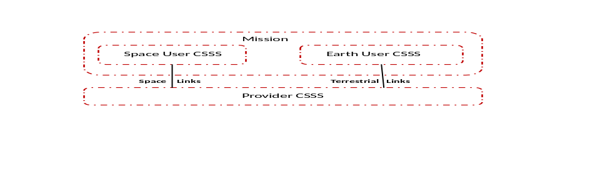
Figure 2-11: Organizational Domains of the SCCS SM Enterprise Model
The Space User CSSS interfaces with the Provider CSSS via space links for the purpose of transferring Earth User CSSS-bound data through the Provider CSSS and for transferring data generated by the Earth User CSSS through the Provider CSSS to the Space User CSSS.
The SCCS Enterprise Model has multiple views (see reference [16]). Of particular significance to the SCCS SM Enterprise Model are the functional view and the physical view. In general, the functional view of an enterprise model does not address the location in which those functions are performed. However, for SCCS enterprises, some notion of location is inherent in the overall notion of an SCCS enterprise because a key characteristic of SCCS enterprises is that some of the functions are performed on Earth and some in space. Therefore the SCCS SM Enterprise Model functional view identifies the functions that are performed in the various CSSSes of the enterprise. Figure 2-2 is a summary functional view of SCCS SM Enterprise Model. In this summary functional view, an application function in the Earth User CSSS communicates with a peer application function in the Space User CSSS by using the SCCS functions of the Earth User CSSS, Provider CSSS, and Space User CSSS.
Figure 2-2 also depicts the two functions that are involved in SCCS SM: the Utilization Management (UM) function of the Earth User CSSS, and the Provision Management (PM) function of the Provider CSSS. UM and PM exchange Service Management information related to the scheduling and allocation of the resources of the Provider CSSS to satisfy the needs of the Mission. UM and PM communicate via the Service Management interface that is represented by the dashed line. Subsection 3.3 provides a more-detailed version of the SCCS SM Enterprise Model functional view.
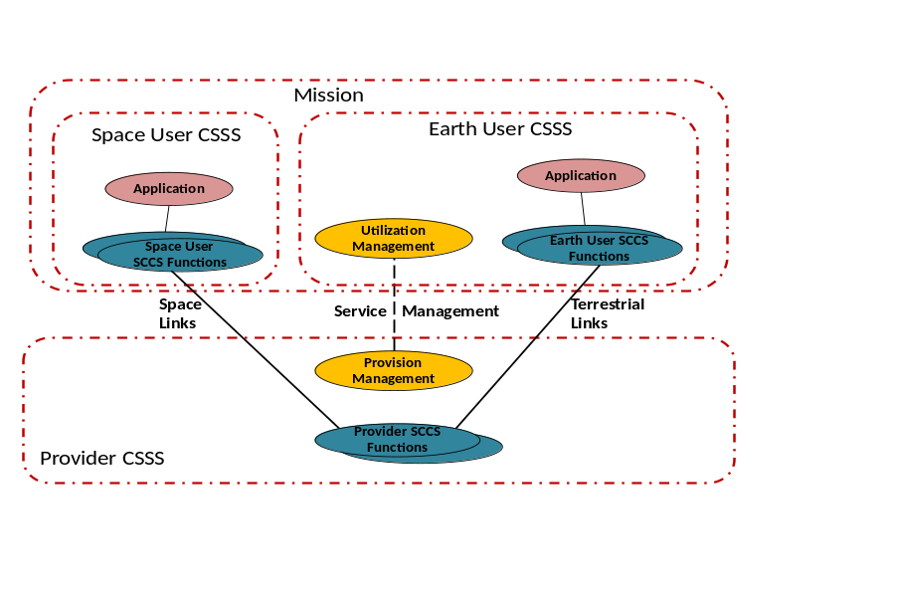
Figure 2-22: Summary Functional View of the SCCS SM Enterprise Model
Physical views in the SCCS SM Enterprise Model represent deployments of the enterprise functions to physical nodes. There is no one single physical view in the SCCS SM Enterprise Mode, only physical views of example configurations. Real Missions and real Provider CSSSes have their own specific sets of nodes. Figure 2-3 is a summary physical view of an SCCS enterprise in which the functions of each CSSS are performed in the minimal set of nodes possible, that is, one node per CSSS. In this example SCCS enterprise, the functions of the Earth User CSSS are performed in a Mission Operations Center (MOC) node, the Provider CSSS functions are performed by an Earth Space Link Terminal (ESLT), and the Space User CSSS functions are performed by the Lander node. Subsection 3.4 provides other example physical views, corresponding to situations where the functionality is distributed to multiple nodes per CSSS.
In the future, end-to-end internetworking protocols will overlay space-space, Earth-space, and planet-space links to form the SSI. From a management perspective, the SSI introduces a new CSSS type and new functions in the SCCS Enterprise Model. The new CSSS type, functions, and the services of the SSI-era SCCS Enterprise Model are outside the scope of the generation of the extensible SCCS SM concept that is addressed by this Informational Report. However, annex ANNEX C provides examples of how the functional and physical views of the SCCS SM Enterprise Model could evolve into the SSI-era SCCS Enterprise Model.
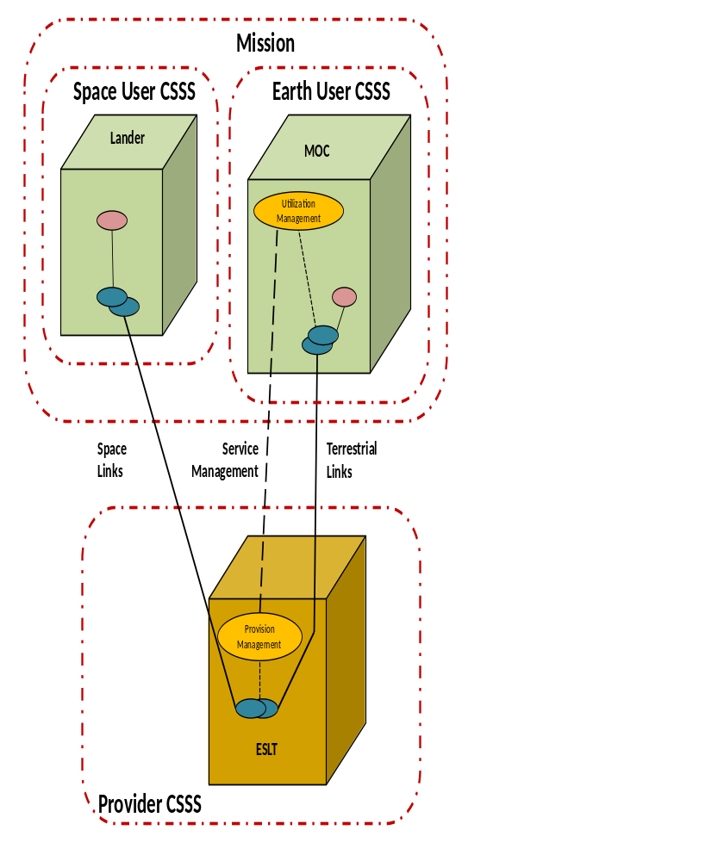
Figure 2-33: Summary Example Physical View of an SCCS Enterprise
SCCS Mission Support Lifecycle
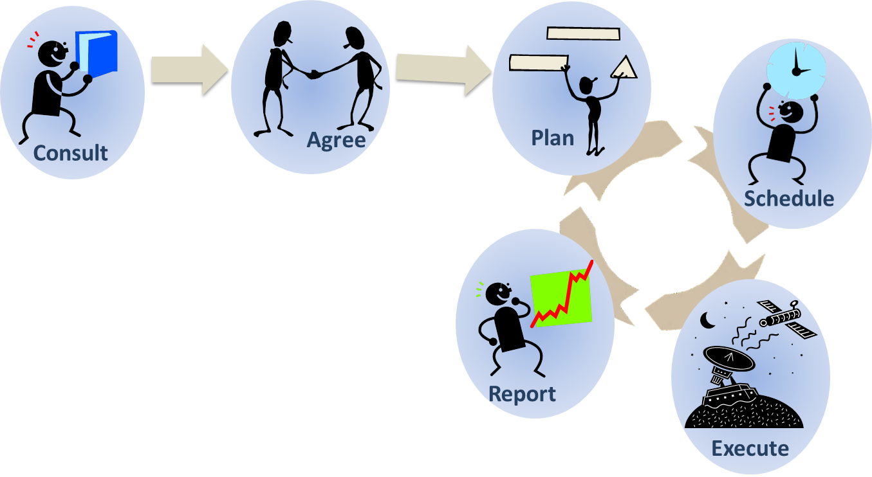
SCCS SM is involved in the entire time period from Mission design and preparation through to the end of life of the Space User CSSS. After an initial set-up phase, the main SCCS SM activities for arranging service provision are repeated throughout the Mission lifetime.

In early stages of Mission definition, Mission planners consult the Service Catalog of one or more Provider CSSSes; the Service Catalog lists details of services that the Provider CSSS offers. The Provider CSSS performs telecommunications analyses and determines whether sufficient resources are available to support the Mission.

If the consultation reveals mutually acceptable circumstances for a relationship between the Mission and the Provider CSSS, the two organizations negotiate a Service Agreement which describes technical and management characteristics of services to be provided during the lifecycle of the Mission, or during a particular phase of that lifecycle. The Service Agreement is the basis for subsequent Service Management interactions.

For some Missions, the Service Agreement may completely specify the values of service configuration parameters for the services used by the Mission. For other Missions, the Service Agreement can specify ranges or valid sets of values for the service configuration parameters, allowing the Mission to plan multiple Configuration Profiles for different operating conditions, for example, different spacecraft modes. Various forms of planning data such as communications geometry information are exchanged between the Mission and the Provider CSSS. The Mission generates Trajectory Predictions that are subsequently used by the Provider CSSS to acquire and track the Mission Spacecraft. In some cases the Mission also generates Space Link Event Sequences which describe expected changes of spacecraft state, for example, changes in bit-rate or short-term loss of contact due to occlusion.

There are two general approaches to scheduling SCCS services. The Mission may request service at specific times, possibly with a degree of flexibility about the precise timing, to increase the likelihood that the provider can accommodate the request. Alternatively, the Mission may specify rules in advance which the Provider CSSS can use to optimize resource usage and offer the Mission-specific service times. The rules may, for example, cover length, frequency, and separation of spacecraft contacts. The scheduling process involves the use of the various products generated during the planning stage to select appropriate service provision periods and to configure the Provider CSSS resources when the time to execute the scheduled services arrives.

Service execution is the provision of the agreed SCCS services. There may be support for monitoring or even control of the provided services by the Mission.


At some time after service execution, the provider may supply reports or accounting information covering one or more service provision sessions.

Section 4 describes the SCCS Mission Support Lifecycle in detail.

Information Entities
A key aspect of SCCS SM is the standardization of management information that is exchanged between the Mission and the Provider CSSS over the course of the SCCS Mission Support Lifecycle. SCCS Service Management information is organized into standard Information Entities. These Information Entities are formatted in a standard markup language that is both human and machine readable, making them usable in a range of management automation (or lack thereof) environments. SCCS SM Information Entities exist for all phases and activities of the SCCS Mission Support Lifecycle. Some of the SCCS SM Information Entities are:
- Service Catalog, which identifies and defines the space communication and tracking services that are available from a Provider CSSS.
- Service Agreement, which specifies the types, amounts, and ranges of the services that the Provider CSSS is to make available to the Mission during a specified period of time.
- Configuration Profile, which specifies a reusable set of parameter values to be applied to functional resources in order to configure space link services, ground data transfer services, or space internetworking services.
- Communications Geometry, which identifies events such as mutual visibility that can be subsequently used as constraints on the scheduling of space communication and/or tracking services.
- Space Link Events Sequence, which specifies when and how a Space User Node is planned to change the configuration of a space link.
- Trajectory Prediction Segment, which specifies the predicted position and velocity (and possibly other dynamic flight characteristics) of a platform (e.g., a spacecraft) at one or more points in the future. One or more Trajectory Prediction Segments collectively form a predicted trajectory.
- Service Package Request, which identifies a related set of space communication and tracking services that are being requested and the flexibilities and constraints that may be applied in attempting to schedule the request. The set of services is known as a Service Package (see reference [15]).
- Schedule of Services, which summarizes the space communication and tracking activities relevant to a Mission that a Provider CSSS plans to perform over a specified period of time (e.g., a week).
- Accounting Report, which summarizes the services that have been delivered by the Provider CSSS, the quality of those services, and the quantities of data processed and/or delivered by those services.
Section 5 identifies and describes the complete set of SCCS SM Information Entities.

Extensibility Of SCCS SM Information Entities

General
A key factor in the continuing development of SCCS SM standards is the ability of those standards to support the graceful evolution of SCCS services and Service Management functions and technologies. In particular, the contents of SCCS SM Information Entities must be able to accommodate new management information resulting from the introduction of new services, functions, and technologies. Individual Provider CSSSes may provide these services, functions, and technologies at varying times, for varying durations, and in different combinations. SCCS SM Information Entities must be ‘standard’ enough to be recognized and usable in cross-support situations while at the same time be flexible enough to contain subsets of parameters corresponding to different services and management capabilities. The method of accomplishing such flexibility is by including well-defined extension points in the Information Entities. Extension points are locations in the format of an Information Entity into which management information associated with specific technologies can be inserted. Each extension point is constrained to contain only a particular type or class of management information, and each defined extension is likewise constrained to conform to one of the types defined for the Information Entity. For example, the Configuration Profile Information Entity contains configuration parameters for space communication resources. Separate extension points for the space link coding algorithms and space data link protocols allow the Configuration Profile Information Entity to accommodate different combinations of coding technologies and space link protocols.
As the Information Entities are developed, each will be evaluated for the need for extensibility. Some key extensibility mechanisms have already been identified for a significant portion of the SCCS SM Information Entities.

Extensibility Of Service AGREEMENT and Configuration Profile INformation Entities
The key extensibility consideration for the Service Agreement and Configuration Profile Information Entities is robustness as space communication technologies evolve over time, and in particular the changes in the management information as those technologies evolve. The use of Abstract Components to represent the abstract functionality of space communication and tracking technology is adopted for SCCS SM. Fifteen Abstract Service Components have been defined, aligned approximately with the layered model of space communication functionality as presented in various CCSDS Recommended Standards (references [3], [30], [31], [4], [5], [6], , and -[8]).
The concept is that, as space communication and tracking technologies evolve, they will do so at the level of one of these layers (i.e., Abstract Service Components). Each of these Abstract Service Components performs a well-defined function that is invariant at its interfaces with the adjacent Abstract Service Components (e.g., ingest a stream of channel symbols and produce a stream of demultiplexed and decoded frames), but there may be multiple technologies (e.g., different decoding schemes) for doing so.
Within the Service Agreement and Configuration Profile Information Entities, extension points are defined for each of the Abstract Service Components. The extensions that are attached to these extension points are collections of management parameters for specific technologies that implement the respective Abstract Service Component. The technology-specific extensions, or specializations, of the Abstract Service Components are simply called Service Components. For example, a Service Component that conforms to the CCSDS TM Synchronization and Channel Coding standard (reference [4]) is a specialization off thepAbstract Service Component that encompassesr return link decoding that would contain the management parameters specific to configuring Reed-Solomon and/or Turbo decoders. In the future, a Service Component that conforms to a different return link decoding scheme (e.g., based on a commercial standard) would have different configuration parameters, but because both Service Components belong to the samepAbstract Service Components, either Service Component could be used in the Information Entity.
Subsection 6.2 identifies the twelve Abstract Service Components and describes in detail the role of Abstract Service Components in SCCS SM Information Entities.

Extensibility of Service Package-related INformation Entities
There are several extensibility considerations concerning Service Package-related Information Entities that need to be examined in the process of developing those Information Entities. One such consideration is the ability to accommodate different levels of flexibility and constraints in the scheduling of Service Packages, and how those different flexibilities and constraints affect the contents of the Service Package Request Information Entity. For example, a very basic Service Package Request might simply request that the Service Package begin and end at specific times, and some existing Provider CSSSes use this approach in their (proprietary) equivalents to the Service Package Request. A somewhat more flexible approach is to allow the Mission to specify in the request a preferred start time, a window about that preferred start time a preferred duration, and a minimum acceptable duration. This expanded set of start/stop-related parameters gives the Provider CSSS flexibility in scheduling a Service Package that is acceptable if not ideal.
As of this writing, a number of such flexibilities have been identified, and it is likely that more will be identified during the course of the definition of the Service Package Request Information Entity. So one of the extension points (or perhaps set of extension points) has to accommodate different kinds and levels of flexibilities and constraints.
Standard rules will be defined to cover the known flexibilities and constraints of the CCSDS member Agencies’ Provider CSSSes. These standard rules will be part of the Service Package Request Information Entity specification. If and when new flexibility/constraint mechanisms are identified as candidates for addition to the CCSDS standard set, rules corresponding to those mechanisms will be developed and added to the Service Package Request Information Entity specification.
Each Provider CSSS supports those rules that apply to the flexibility and constraint mechanisms supported by that Provider CSSS. However, there is one mandatory constraint that must be supported by all Provider CSSSes that adopt the Service Package Request Information Entity: the requested time period for a Service Package may be specified by the Mission using the fixed start time and fixed stop time for each Space Communication Service Request.
Subsection 6.3 describes the extensibility mechanism for accommodating various flexibilities and constraints in greater detail and also identifies other possible types of extension points for Service Package-related Information Entities.

Extensibility of Planning Data INformation Entities
The common characteristic of the various planning data Information Entities is that each is constructed as a time series of events, where all of the event types share the common parameters of event identification and event time but then contain information that is specific to the Information Entity to which the events belong (e.g., predicted acquisition of signal and predicted loss of signal events in a Communications Geometry Information Entity). All of the planning data Information Entities implement an Event Timeline stereotype that will be part of the SCCS SM Planning Data Formats Recommended Standard (see 8.2c)).

Management Services
SCCS Management Services are capabilities that facilitate the planning, scheduling, control, and monitoring of SCCS services. SCCS Management Services are generally grouped in alignment with the SCCS Mission Support Lifecycle.
Provider CSSSes already provide some form of management services, using Provider-specific data structures (i.e., Information Entities) and transfer mechanisms to permit Missions to schedule, monitor, and in some cases control the Provider’s SCCS services.
This SCCS SM Concept adopts a phased approach to definition and deployment of SCCS Management Services. In the near term, standard Information Entities will be integrated into Provider-specific management services. In the longer term (circa 2020), standard SCCS Management Services will be available. The concept for SCCS Management Service is further elaborated in section 7.

Roadmap
The Roadmap lays out the sequence of Informational Reports and Recommended Standards that as a whole constitute the standardization of extensible SCCS SM. The Roadmap is based on
- the set of Information Entities;
- the relative priorities expressed by the CCSDS member agencies;
- an approach of developing useful data format exchange specifications prioritized over service specifications; and
- the collection of Information Entities that have strong affinities into particular definitions in Recommended Standards.
The products that will document the results of this next-generation SCCS SM development activity have been defined and given target completion dates in section 8. Section 8 also identifies which Information Entities are allocated to these products.

SCCS Service management Enterprise Model

General
As described in 2.2, the SCCS–SM Enterprise Model expands upon the characteristics, details, and concepts of Service Management within the SCCS Enterprise model described in the Space Communications Cross Support ADD (reference [16]).
This section further describes the SCCS SM Enterprise Model, using the Reference Architecture for Space Data Systems (RASDS) graphical notation that is used in the Space Communications Cross Support ADD (reference [16]).
Annex presents the Object Management Group (OMG) System Modeling Language (SysML) SCCS SM Enterprise Model. SysML is the formal method for describing enterprise models (reference [23]).

Organizational Domains in the SCCS SM Enterprise Model
As described in 2.2, the SCCS SM Enterprise Model involves two top-level organizational domains: the Mission and the Provider CSSS, where the Mission organizational domain is in turn composed of the Earth User CSSS and the Space User CSSS operational domains.
The SCCS SM Enterprise Model depicted in summary form in figure 2-1, figure 2-2, and figure 2-3 is the model for traditional SCCS enterprises, in which a Mission directly contracts with a Provider CSSS to supply a space link by which that Mission’s Ground User CSSS can communicate with its Space User CSSS. This traditional SCCS Enterprise Model is referred to in the Space Communications Cross Support ADD (reference [16]) as the ABA configuration, where the services of Provider CSSS ‘B’ are used to connect Mission A’s Space User CSSS to its Earth User CSSS.
NOTES
- Typically, the Mission and Provider CSSS belong to different Agencies, and the ABA configuration is often described in CCSDS documentation in terms of Agency B providing service to Agency A. However, although CCSDS Recommended Standards are formally specified in the context of inter-agency cross support, the association of Mission, User CSSS, and Provider CSSS with different agencies is not a fundamental characteristic. The affiliation of Mission and Provider CSSS with Agencies is irrelevant in the extensible SCCS SM concept.
- The ‘ABA’ name implies that only a single Provider CSSS is involved in the enterprise, but multiple Provider CSSSes can in fact be used simultaneously by a Mission, as described in 3.3 and 3.4.2. The important feature of the ABA configuration is that the Provider CSSS is providing cross-support services at the Physical and Data Link Layers of the space link. The term ‘ABA’ is used in this concept document to identify this enterprise configuration to maintain consistency with the Space Communications Cross Support ADD.
- A single link Provider CSSS may use multiple Physical Layer hops internally to provide the single space link to the User CSSS, as long as the details of those internal physical hops are not exposed to the User CSSS. This is the case for ‘bent pipe’ data relay systems such as the NASA Space Network. From the perspective of a User, such a relay satellite-based Provider CSSS provides both the terrestrial interfaces to the User Earth assets and the space link to the User space assets, and the details of the link between the Space Network ground terminal and the relay satellite are invisible to the User.
A more complex enterprise configuration is the SSI configuration, which differs from the ABA configuration in that data are routed through the Provider CSSS(es) on the basis of internetwork addresses. Many aspects of the overall SSI concept are in development as of the writing of this Informational Report, and so the SSI enterprise configuration is outside the scope of this version of the extensible SCCS SM concept. However, SCCS SM will continue to play a role in the SSI Enterprise Model. Annex ANNEX C provides a brief introduction to the SSI Enterprise Model and the role of SCCS SM in it, as currently envisioned.
The SCCS services fall into two major categories: data delivery services and radiometric services. Data delivery services provide a conduit through which data from the Earth User CSSS are transferred to the Space User CSSS (and/or vice versa). Radiometric services use artifacts of the space communication process to determine position and velocity of assets in the Space User CSSS.

Functional View
As described in 2.2, the functional view identifies the functions commonly associated with each CSSS. Figure 2-2 presents a summary functional view of the ABA Enterprise Model, which groups some of the functions in order to focus on a few key points. Figure 3-4 presents a more-detailed functional view of the ABA Enterprise Model, in which the functions are named and used at the same level as in the Space Communications Cross Support ADD. In the Ground User CSSS, what were called the Earth User CSSS functions in figure 2-2 are now elaborated as Terrestrial Link Processing, Data Forwarding, and Data Store. Terrestrial Link Processing encompasses the terrestrial network protocols and the user elements of whatever transfer services are used to transfer the service data units to and from the Provider CSSS. The Data Store and Data Forwarding functions of the Earth User CSSS represent those aspects of Earth User CSSS that facilitate discontinuities in time between when forward link data are generated and when they are transferred to the Provider CSSS, and between when return link data are received from the Provider CSSS and when they are processed into usable products. The Data Forwarding and Data Store functions of the Earth User CSSS have little or no involvement with SCCS SM, but are included in the figure because they do play a role in the overall SCCS Enterprise Model. The connections among the functions that represent the flow of space data (both within the Earth User CSSS and between the Earth User CSSS and the Provider CSSS) are represented by solid lines.
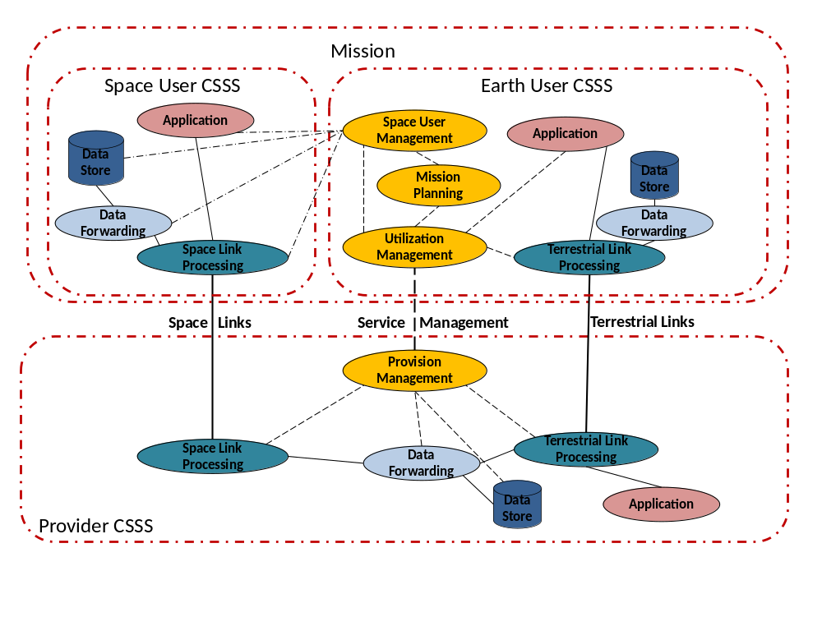
Figure 3-44: Functional View of the SCCS SM Enterprise
Figure 3-4 also introduces two additional management-related functions of the Earth User CSSS, Mission Planning and Space User Management.
The Mission Planning function encompasses the activities that address achieving the ultimate goals of the Mission. Space User Management encompasses the activities involved with monitoring and controlling the functions of the Space User CSSS. Mission Planning relies on the UM function of the Earth User CSSS to acquire and configure the Provider CSSS communications and tracking services that are necessary to fulfill the goals of the Mission, and it relies on Space User Management to configure and control the Space User CSSS to fulfill Mission goals.
NOTE – The Space Communications Cross Support ADD does not call out the Mission Planning and Space User Management functions. These are management functions that are brought out by the SCCS SM Enterprise Model.
The communication between UM and other functions within the Earth User CSSS (for the purposes of that coordination) is represented by short dashed lines, The communication between the Space User Management function and the functions of the Space User CSSS is represented by alternating dashed and dotted lines. These communications between UM and the functions of the Space User CSSS are, of course, actually accomplished over the communication links through the Provider CSSS.
The Provider CSSS comprises the functions involved in the provision of cross-support services to the Mission. The functions presented collectively as Provider SCCS Functions in figure 2-2 are expanded in figure 3-4 to be the Terrestrial Link Processing function (which provides the interfaces to the Earth User CSSS), the Space Link Processing function (which provides the space links to the Space User CSSS), the Data Forward function (which connects the Terrestrial Link Processing and Space Link Processing functions), and a Data Store function that accommodates time differences between when the space link is active and when data are transported across the terrestrial links (e.g., for playback of stored telemetry data).
The Space User CSSS comprises the functions that use the services that are presented across the space link of the Provider CSSS. The functions presented collectively as Space User SCCS Functions in figure 2-2 are expanded in figure 3-4 to be the Space Link Processing function, the Data Forward function, and a Data Store function. As described previously, these functions are not directly controlled via SCCS SM. They are configured and controlled (directly or indirectly) by the User Space Management function of the Earth User CSSS.
SCCS SM is the set of functions by which an Earth User CSSS acquires the data delivery and radiometric services offered by Provider CSSSes. The service management functions that are performed by the User CSSS are ascribed to the Utilization Management function of the Earth User CSSS, and service management functions performed by the Provider CSSS are ascribed to the PM function of that Provider CSSS. The service management functions include Service Catalog Consultation for SCCS service to be provided, performing telecom analysis, negotiating and adopting service agreements, planning and scheduling SCCS service packages, executing SCCS service packages, and accounting for SCCS service quality. Each of these functions is performed partially by UM and partially by PM. These functions are performed across the lifecycle of the Mission, and are further described in section 4. Figure 3-5 shows a decomposition of UM and PM into their component functions.
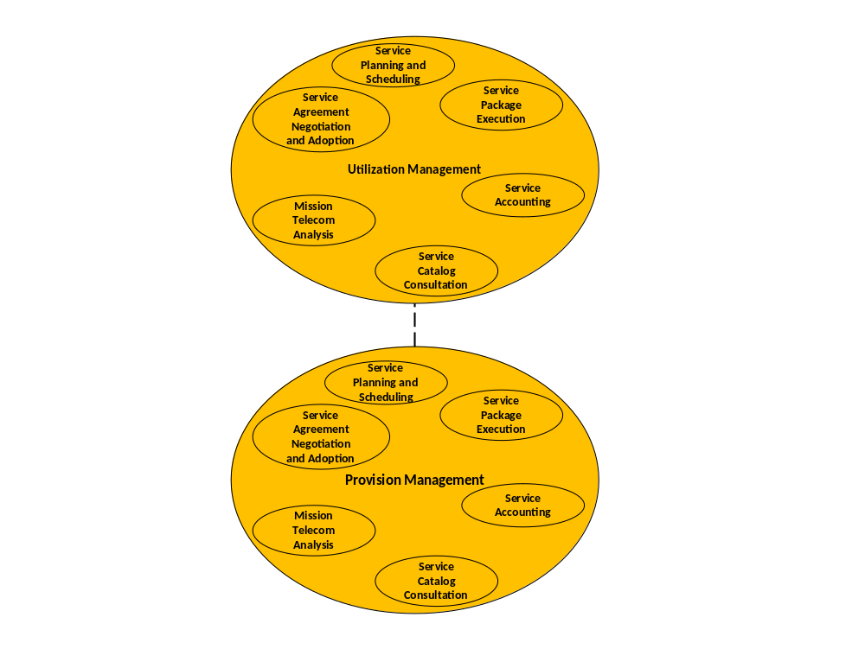
Figure 3-55: Service Management Functions—Functional View

Physical View

General
As noted in 2.2, the SCCS SM Enterprise Model includes the physical view in addition to the functional view. Whereas the functional view of the SCCS SM Enterprise Model can be represented by a single diagram, those functions can be allocated to and replicated among numerous combinations of nodes within the Earth User CSSS and Provider CSSS, and to a lesser extent within the Space User CSSS. Each real User CSSS and real Provider CSSS has its own set of nodes, so the physical view of each SCCS enterprise in unique.
Figure 3-6 depicts the essential physical view for the ABA SCCS SM Enterprise Model. The term essential refers to the fact that the enterprise contains the minimal number and types of nodes necessary to perform all of the functions of an SCCS enterprise. In this essential physical view, each CSSS consists of one node. The essential physical view corresponds to the summary physical view depicted in figure 2-3, but with a few more modeling details. The MOC node represents the general class of Earth User Nodes, the Lander node represents the general class of Space User Nodes, and the ESLT node represents the general class of Provider Nodes (see reference [16]).
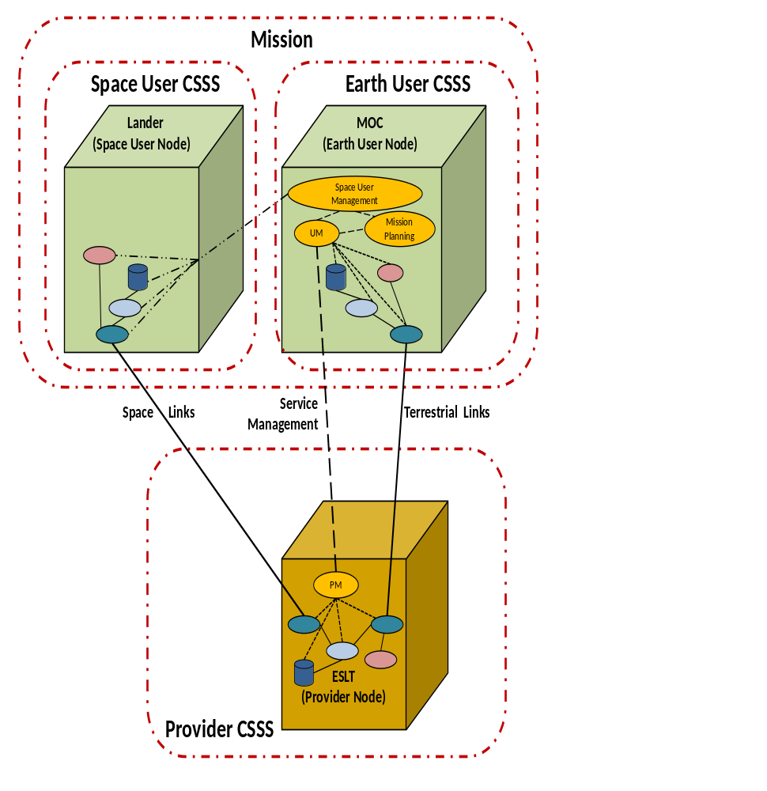
Figure 3-66: Essential Physical View of SCCS SM Enterprise Model
NOTE 1 – The MOC and Lander designations have no formal significance in the SCCS Enterprise Model. They are terms that are commonly used in spaceflight operations, and are used here to provide concrete examples of the concept of Space User Node and Earth User Node.
The MOC Earth User Node in the essential physical view contains all ground-based functionality associated with communicating with the Mission’s Space User Node: Applications, Data Store, Data Forwarding, Terrestrial Link Processing, Mission Planning, Space User Management, and UM.
The single ESLT Provider Node of the Provider CSSS in the essential physical view contains all functionality of the Provider CSSS: Terrestrial Link Processing, Data Store, Data Forwarding, Space Link Processing, and PM.
Figure 3-7 depicts the physical view for an SCCS enterprise with Earth User CSSS and Provider CSSS functions distributed across multiple nodes. The Earth User CSSS functionality is distributed between two nodes, a Mission Control Center (MCC) and a Science Center (where the principal investigator might perform work, for example). In this example Earth User CSSS, the MCC node hosts the UM, Mission Planning, and Space User Management functions and communicates with the Lander via the services provided by the Provider CSSS. The UM function coordinates the use of the Provider CSSS services by not only the MCC but also the Science Center.
The functionality of the Provider CSSS is distributed among a Provider Control Center (CC) node and two ESLT nodes. The Provider CC node serves a pure Service Management role, hosting the PM function but playing no role in the actual transfer of space data. Each of the ESLTs holds the ground resources used to create the space link to the lander and to connect the ground termination of that space link to User nodes over terrestrial links.
NOTE 2 – As with the essential physical view example (see note 1, above), the MCC, Lander, and Provider CC designations have no formal significance in the SCCS SM Enterprise model.
Figure 3-8 is the physical view of an example SCCS enterprise that supports Delta Differential One-way Ranging (DOR) operations. In this configuration, one Provider CSSS with two ESLTs (i.e., two ground antennas and sets of functional resources in different, distant locations) are used to provide Delta-DOR tracking of the Spacecraft (Space User Node of the Space User CSSS), data collection and data forwarding to the MOC Earth User Node of the Earth User CSSS, where the Delta-DOR data is correlated. A variation of this example (not shown) is a one in which the second ESLT belongs to a different Provider CSSS, in which case the enterprise would consist of two Provider CSSSes of one ESLT each.
Figure 3-9 is a physical view of an example enterprise composed of two different providers (e.g., NASA Deep Space Network and ESA European Space Tracking [ESTRACK] network) supporting three-way communication and handover. This demonstrates two Provider CSSSes, to execute three-way tracking with a forward carrier handover. In this scenario, both Provider A and B have a return carrier space link to the spacecraft, while Provider A has the forward carrier space link. In a handover, that forward link will transfer to Provider B. This type of configuration would require agreements, policies and coordination between both Providers to execute the handover. However, Service Management provides a uniform interface to both Providers, minimizing the distinction between them.

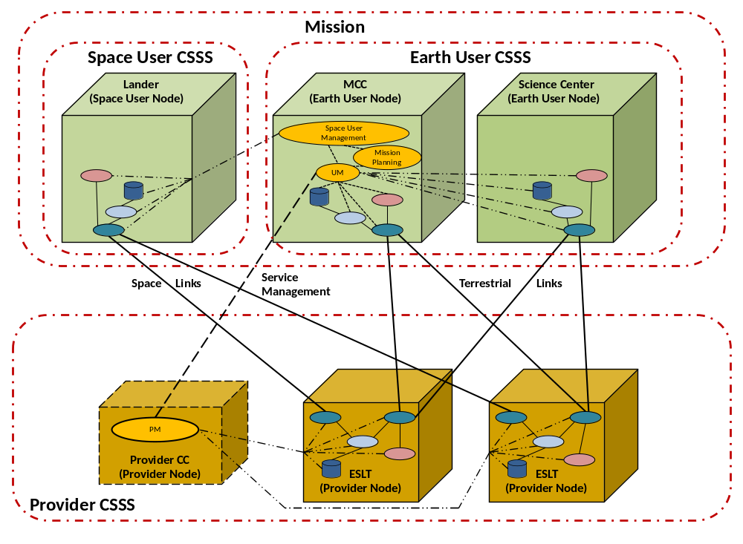
Figure 3-77: Physical View of an Example SCCS Enterprise with Distributed Earth User CSSS and Provider CSSS
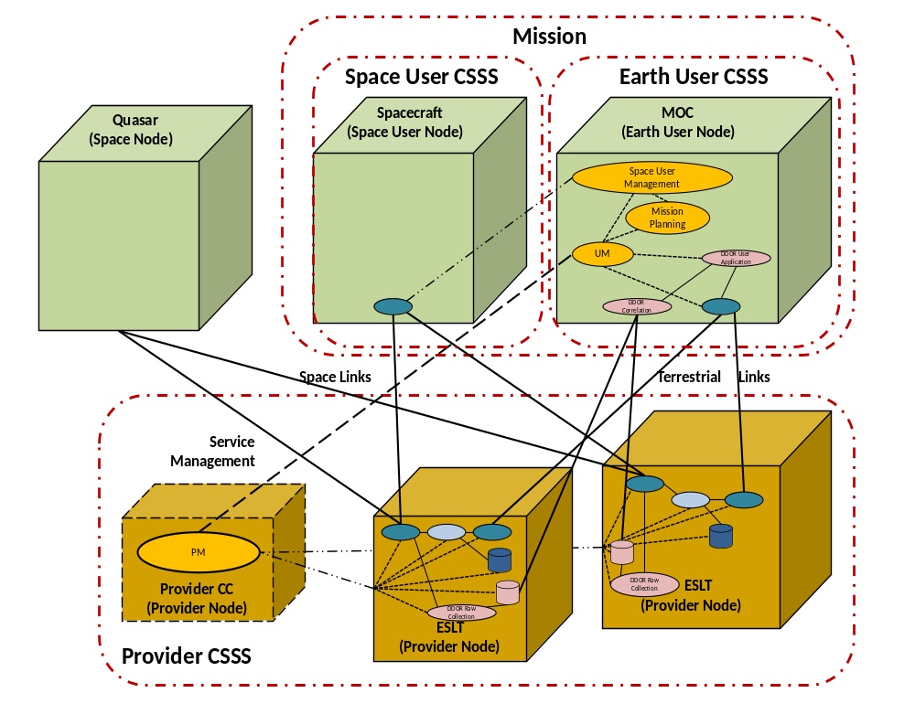
Figure 3-88: Example Enterprise Configuration for Executing Delta DOR
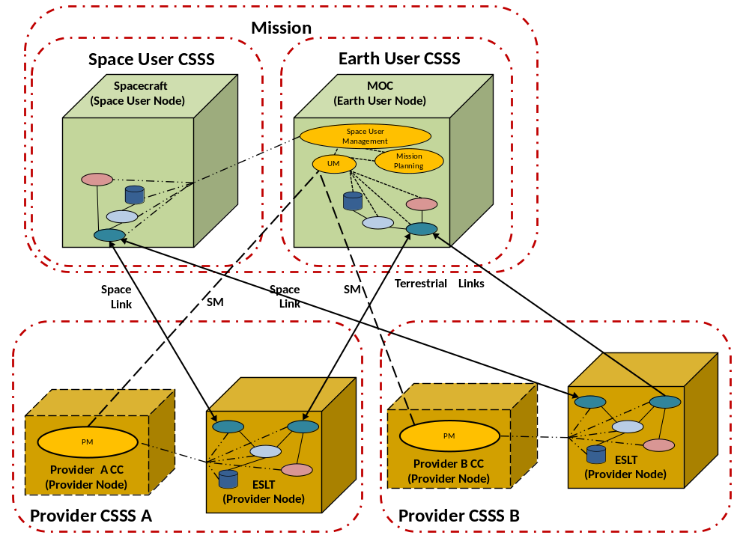
Figure 3-99: Example Enterprise Configuration for Providing Three-Way Tracking and Handover via Two Provider CSSSes

Multiplicity of Cross Support Service Systems
In terms of multiplicity and scaling, the functional view of the enterprise model presents one Provider CSSS, one Earth User CSSS, and one Space User CSSS, but this is just the minimal configuration. SCCS enterprises can involve multiple CSSSes. Indeed, it is a goal of standardization to allow the various CSSSes to use and provide common services via common interfaces so that, for example, a Mission has access to the services of many Provider CSSSes. Sometimes this use of multiple Provider CSSSes occurs serially (e.g., as the Space User Node passes through the regions of space supported by the different providers). Other times, the use of multiple Provider CSSSes occurs simultaneously, and in the examples of Delta DOR and three-way tracking using two different Provider CSSSes.
Likewise, from a Provider CSSS’s perspective, the Provider CSSS can provide SCCS services to multiple User CSSSes, which may be of different agencies. The Provider CSSS supports multiple Missions by managing separate service agreements and managing a schedule of services requested by each User CSSS.
The service management information that is standardized through extensible SCCS SM allows the Utilization Management function of the Earth User CSSS to interface with multiple Provider CSSSes essentially interchangeably. The Mission enters into a separate service agreements with each Provider CSSS, and schedules the services of those Provider CSSSes independently. To a User, managing services with Provider CSSS A will be virtually no different from managing services with Provider CSSS B. SCCS SM allows for using multiple provider CSSSes concurrently.
NOTE – Although the UM for a Mission schedules the services of different Provider CSSSes independently, there are situations in which information may need to flow among those Provider CSSSes, e.g., for the transfer of forward link carrier frequency (for the purposes of calculating round-trip Doppler shift) and raw Delta-DOR observations (to the Provider CSSS that performs the Delta-DOR processing service). In those cases, UM configures an appropriate data transfer or radiometric service provider entity on one Provider CSSS and a peer service user entity on the other Provider CSSS.

SCCS Mission Support Lifecycle

General
The Service Management relationship between a Mission and a Provider CSSS follows a lifecycle that begins when the Mission begins to identify the space communication services that it will require, and ends when the Provider CSSS closes out the accounting for the last Service Package that was executed prior to the conclusion of the last Service Agreement between the Mission and the Provider CSSS.
The SCCS Mission Support Lifecycle depicted in figure 4-10 nominally consists of three phases: Service Catalog Consultation, Service Agreement Development, and the Service Agreement Period.
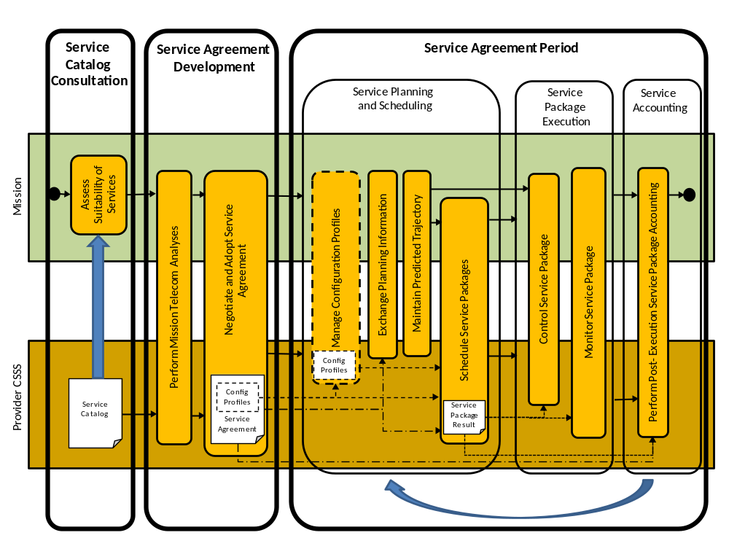
Figure 4-1010: SCCS Mission Support Lifecycle

Service Catalog Consultation
The Service Catalog Consultation phase occurs when the Mission begins to explore options for communication support from the Provider CSSS (or multiple Provider CSSSes). It is depicted in figure 4-10 as the Mission accessing the Service Catalog of the Provider CSSS in order to assess the suitability of the service provided by that Provider CSSS. This activity may be accomplished through access to/acquisition of documents on Provider CSSS capabilities and services (which is the typical approach used today), on-line access to the Provider CSSS Service Catalog, and/or interactions with Provider CSSS personnel.
The Service Catalog Consultation phase ends when the Mission reaches a decision regarding the ability of the Provider CSSS to support the Mission and the desirability of having the Provider CSSS do so. If the decision is to have the Provider CSSS provide services to the Mission, the lifecycle then transitions to the Service Agreement Development phase. Otherwise, negotiations with the Provider CSSS cease.
The Service Catalog Consultation phase typically occurs only once in the lifecycle of the relationship between a given Mission and a given Provider CSSS.
In support of the Service Catalog Consultation phase, a standard Service Catalog Information Entity (see 5.2) describes the SCCS services offered by the Provider CSSS to a level of detail sufficient to allow the Mission to determine whether or not those services are suitable for the Mission. The Service Catalog is kept current by the Provider CSSS and made available electronically so that Missions always have access to the current capabilities of the Provider CSSS.

Service Agreement Development
Once the Mission and Provider CSSS have decided to pursue a service relationship, they enter the Service Agreement Development phase. This phase has two major activities, Perform Mission Telecommunication Analyses and Negotiate and Adopt Service Agreement.
The telecommunication analyses determine the types, quality, and level of support that the Mission can expect to receive from the Provider CSSS. These analyses also determine constraints (such as windows of visibility resulting from communication geometry) that affect the ability of the Provider CSSS to be used to meet Mission requirements for communication volume and duty cycle, tracking accuracy, etc. Depending on the nature of the Mission, these analyses can be statistical (e.g., averaged over many orbits), deterministic (e.g., for a deep-space Mission where the nominal trajectory is known even in the Service Agreement Development phase), or some combination.
Based on the results of the analyses, the Mission and Provider CSSS proceed to negotiate and mutually adopt the Service Agreement(s) between them. As used in SCCS SM, the Service Agreement represents the capabilities and constraints placed on the support provided by the Provider CSSS to the Mission.
A given Service Agreement may apply to only a single phase in the Mission’s overall operational lifecycle (e.g., prelaunch testing, launch and early orbit, cruise, entry/landing, etc.). This allows the scope and constraints of the Service Agreement to be tailored to those specific Mission operational phases. Thus multiple Service Agreements may exist concurrently and even have overlapping Service Agreement Periods.
The Service Agreement Information Entities may optionally contain a set of Configuration Profile Information Entities, so that service planning and scheduling may begin as soon as the Mission enters the Service Agreement Period phase.

Service Agreement Period

General
Following mutual approval of a Service Agreement, the Mission enters the Service Agreement Period. The Service Agreement Period is the period of time during which the Mission may receive space communication services in accordance with the provisions specified in the Service Agreement. If multiple Service Agreements are approved corresponding to different phases of the Mission’s overall operational lifecycle, then there are multiple Service Agreement Periods.
Service management activities are conducted through three stages that typically repeat cyclically as a group throughout the Service Agreement Period: Service Planning and Scheduling, Service Package Execution, and Service Accounting. These service cycles can (and typically do) overlap, such that, for example, the Service Packages in one service cycle can be in the Service Package Execution stage at the same time that a later service cycle is in the Service Planning and Scheduling stage.

Service Planning and Scheduling

General
The Service Planning and Scheduling stage encompasses four groups of activities: management of Configuration Profiles, the exchange of planning information, the maintenance of Trajectory Predictions, and the scheduling of Service Packages.

Management of Configuration Profiles
The SCCS lifecycle supports the addition of new Configuration Profiles and deletion of obsolete Configuration Profiles throughout the Service Agreement Period. There are multiple kinds of Configuration Profiles, as described in 5.6.
Configuration Profiles are not expected to be added or deleted as frequently as every service cycle. They are more likely to be updated rarely (and even possibly never) during the Service Agreement Period if a stable set can be created as part of the negotiation and adoption of the Service Agreement (see 4.3).

Exchange Planning Information
Planning information that is exchanged during the Service Planning and Scheduling stage includes periods of availability of Provider CSSS resources and mutual visibility between the Space User Nodes and Provider CSSS apertures, information used to derive those periods of availability and visibility, and identification of events of interest about which space communication services are to be planned and scheduled. Subsections 5.3, 5.4, 5.7, 5.8, 5.9, 5.10 and 5.11 describe in greater detail the various categories of planning information.

Maintain Predicted Trajectory
The Provider CSSS must have an accurate prediction of the trajectory of the Space User Node in order to establish (and often maintain) communication with that Space User Node. Because the quality of Space User Node predicted trajectories normally degrades over time, it is necessary for those predicted trajectories to be periodically updated and provided to the Provider CSSS to meet the accuracy requirements for acquisition of the Space User Node.
Sometimes it is not just the Space User Node that has a time-varying trajectory, but also the Provider CSSS resource (i.e., aperture). In such cases, the Mission may need to obtain the predicted trajectory of the Provider CSSS resource (for example, for a relay satellite) in order to determine where to point the directional antenna of the Space User Node during the execution of the Service Package.
Maintenance of a common predicted trajectory between the Mission and the Provider CSSS is accomplished through the exchange of Trajectory Prediction Segments. Figure 4-10 shows the exchange of Trajectory Prediction Segments between the Mission and the Provider CSSS. While it is formally the responsibility of the Mission to provide the Trajectory Prediction Segments to the Provider CSSS, sometimes the Trajectory Prediction Segments are generated by a third party (such as a flight dynamics facility). In such cases, such a third party serves as a proxy for the Mission for the provision of Space User Node Trajectory Prediction Segments to the Provider CSSS. Similarly, such a third party can serve as a proxy for the Provider CSSS for the provision of Provider CSSS resource Trajectory Prediction Segments to the Mission.
Although figure 4-10 shows the maintenance of the predicted trajectory as occurring between the exchange of planning information and the scheduling of Service Packages, the maintenance of the predicted trajectory can be carried out in parallel with both the exchange of planning information and the scheduling of Service Packages. Trajectory Prediction Segments may even be supplied to the Provider CSSS during the execution of a Service Package if conditions require the updates in order to continue the execution of the Service Package. The only synchronization that is required between the exchange of updated Trajectory Prediction Segments and the scheduling and execution of Service Packages is that relevant acquisition-grade Trajectory Prediction information be available to the Provider CSSS in time for the Provider CSSS to be able to use it during the execution stage of each of the Service Packages to which the Trajectory Prediction information applies.
NOTE – Each Provider CSSS has constraints on how quickly and under what conditions it can convert Trajectory Prediction Segments into usable acquisition data. In some cases these constraints may limit the ability to use Trajectory Prediction Segments that are supplied during the execution of a Service Package.

Schedule Service Packages
At the most fundamental level, scheduling of Service Packages involves the requesting of space communication services by UM and the determination by PM whether, when, and how the Provider CSSS can honor the request. Two archetypical modes of requesting and scheduling services are specific-period scheduling and rule-based scheduling (see reference [2] for more discussion on these scheduling modes).
In both modes, the requested service configurations are specified in terms of configuration profiles that have been previously defined, and the requests themselves are validated against the Service Agreement.
Each successfully scheduled Service Package is documented in a Service Package Result. The Service Package Result encapsulates the information that is needed (a) by the Mission to use the Service Package, and (b) by the Provider CSSS to allocate, configure, and activate resources necessary to provide the services during the execution of the Service Package.

Service Package Execution

General
Two types of Service Management activities may occur while the Service Package is executing, control of the Service Package and monitoring of the Service Package.

Control Service Package
Provider CSSSes may allow the UM to control well-constrained service-level aspects of their Service Packages, such as changing the bit rate and/or modulation index of the forward link and initiating a frequency sweep. These controls are limited to predefined directives and/or reconfiguration of service parameter values that the Provider CSSS permits to be reconfigured. Each Provider CSSS specifies (as part of the Service Agreement development process, see 4.3) which configuration parameters it allows to be modified by the Mission during Service Package execution and which directives it will accept.
UM exercises execution-stage control of the Service Package by using the Service Control CSTS (reference [22]).

Monitor Service Package
Many Provider CSSSes monitor and report in near-real time the values of various parameters that indicate the health, progress, and status of the service being received. Reports containing such monitoring parameters are generated periodically. Provider CSSSes can also optionally generate one-time reports upon request, and generate reports upon occurrence of triggering events. UM monitors the Service Package by using the Monitored Data CSTS (MD-CSTS, reference [20]).

Service Accounting
Following the execution of the Service Package, the Provider CSSS provides accounting reports to the Mission regarding the volume and quality of the services provided, as measured against the Service Agreement and the obligated services documented in the Service Package Result. (See 5.19 for more details on these reports.)

InforMation Entities

General
SCCS SM information is organized into standard Information Entities that are exchanged between UM and PM. The concept described in this Informational Report includes a set of Information Entities that spans the SCCS Mission Support Lifecycle, from Service Catalog Consultation through Service Accounting.
A common feature of almost all of these SCCS SM Information Entities is that they are formatted using a formal markup language, specifically the World Wide Web Consortium (W3C) Extensible Markup Language (XML, reference [26]). XML documents are nominally human readable, but the great benefit of using XML is that it is well-suited for documents of arbitrary complexity, and it results in documents that are unambiguous. The high degree of adoption of XML within information technology ensures the availability of a variety of tools that can be used to develop automated systems for the rapid creation, maintenance, dissemination, and rendering of SCCS SM Information Entities.

Service Catalog
The purpose of the Service Catalog is to identify the space communication and tracking services that are available from a Provider CSSS to a degree sufficient to allow a Mission to determine what services (if any) are suitable for its needs.
The Service Catalog contains a description of every SCCS service offered by the Provider CSSS, with each description presented in terms of a standard set of attributes appropriate to that service.
The Service Catalog is the basis for development of Service Agreements and pre-Service Agreement Planning Requests.
The Service Catalog is published by the Provider CSSS. Depending on the Provider CSSS, a Service Catalog may be publically available and/or registered with the Space Assigned Numbers Authority (SANA).
The Service Catalog is used in the Service Catalog Consultation and Service Agreement Development phases of the SCCS Mission Support lifecycle.
The Service Catalog Information Entity is formally specified in the Space Communication Cross Support—Service Management—Service Catalog Recommended Standard (see 8.2h)).

Planning Request
The purpose of the Planning Request is to request identification and characterization of one or more aspects of feasible service opportunities, such as mutual visibility, events that would conflict with the provision of service, and estimated data rates and volumes.
The Planning Request contains (directly or by reference) requests for Communications Geometry information (5.7), Sustainable Data Rates & Volume Estimates (5.8), Radio Frequency Interference information (5.9) Resource Conflicts (5.10) and/or Cost Estimates (5.11). The Planning Request may allow for specific Provider CSSS resources to be requested (for example to exclude or include particular apertures).
Planning Requests may be used prior to the establishment of a Service Agreement, as part of the process of evaluating support feasibility and generation of a Service Agreement between the Mission and the Provider CSSS.
Planning Requests may be used after the establishment of a Service Agreement to allow the Mission to request evaluation against the committed schedule of services.
The Planning Request is communicated from the Mission to the Provider CSSS.
Depending on the operational procedures of the Provider CSSS, the Planning Request may be used in (a) the Perform Mission Telecommunication Analysis activity of the Service Agreement Development phase, and/or (b) the Exchange Planning Information activity of the Service Planning and Scheduling stage of the Service Agreement Period phase of the SCCS Mission Support lifecycle.
The Planning Request Information Entity is formally specified in the Space Communication Cross Support—Service Management—Planning Data Formats Recommended Standard (see 8.2c)).

Provisional Plan
The purpose of the Provisional Plan is to supply identification and characterization of feasible service opportunities in response to a Planning Request.
The Provisional Plan contains an uncommitted but technically feasible service plan suggested by the Provider CSSS. The Provisional Plan Information Entity Recommended Standard conveys the following types of planning data:
- predicted communications geometry events (see 5.7);
- sustainable data rates and volume estimate events (see 5.8);
- predicted radio frequency interference events (see 5.9);
- predicted resource conflict events (see 5.10); and
- cost estimates (see 5.11).
The specific types of planning data contained in the Provisional Plans generated by a given Provider CSSS will depend on the kinds of planning data that it is capable of generating and that its client Missions deem useful.
A Provisional Plan may be used as a basis for establishing a Service Agreement.
The Provisional Plan is communicated from the Provider CSSS to the Mission.
The Provisional Plan Information Entity is an instantiation of the Event Timeline stereotype, which is described in 6.4.
Depending on the operational procedures of the Provider CSSS, the Provisional Plan Information Entity is used in (a) the Perform Mission Telecommunication Analysis activity of the Service Agreement Development phase, and/or (b) the Exchange Planning Information activity of the Service Planning and Scheduling stage of the Service Agreement Period phase of the SCCS Mission Support lifecycle.
The Provisional Plan Information Entity is formally specified in the Space Communication Cross Support—Service Management—Planning Data Formats Recommended Standard (see 8.2c)).

Service Agreement
The purpose of the Service Agreement is to specify the types, amounts, and ranges of the services that the Provider CSSS is to make available to the Mission during the Service Agreement Period of the SCCS Mission Support Lifecycle (4.4).
The Service Agreement contains parameters that apply to SLS (see reference [15]) services, retrieval services (see reference [2]) used to transfer return space link data and tracking data from the Provider CSSS to the Mission following its acquisition during an SLS, and forward offline services used to transfer space link data from the Mission to the Provider CSSS prior to the SLS in which it is to be transmitted to the Space User CSSS. The parameters for SLS services include the frequency ranges, modulation schemes, space link protocols, coding schemes, transfer service types, duration of contacts, agreed data formats, service timeout limits, and apertures that the Mission may use. The parameters for retrieval services include the identities of the data stores available for storage of the Mission’s return link data, the storage capacity allocated to the Mission at each of those data stores, the policies for removal of data from each of the data stores, and the retrieval transfer service types that can be used. The parameters for the forward offline services include the identities of the data stores available for storage of the Mission’s forward link data, the storage capacity allocated to the Mission at each of those data stores, the policies for submission of data to each of the data stores, and the forward offline transfer service types that can be used. The information in the Service Agreement is organized by Functional Resources within Service Components that correspond to the SLS services, retrieval services, and forward offline services (see 6.2.3).
The information contained in the Service Agreement is used to validate the parameters of Service Package Requests, Configuration Profiles, and Trajectory Predictions. The Service Agreement is also used as the basis for assessment of the quality of services provided.
The Service Agreement is established through a mutual process of the Mission and the Provider CSSS, after which time an operational version is maintained by the Provider CSSS for purposes of validating Service Package Requests, Configuration Profiles and Trajectory Predictions. The Mission may query the content of the Service Agreement that is held by the Provider CSSS after it has been established.
The Service Agreement is used in the Service Agreement Development and Service Agreement Period phases of the SCCS Mission Support lifecycle.
The Service Agreement Information Entity is formally specified in the Space Communication Cross Support—Service Management—Service Agreement and Service Configuration Profile Data Formats Recommended Standard (see 8.2f)).

Configuration Profile
The purpose of a Configuration Profile is to specify a set of parameter values to be applied in order to configure SLS services, retrieval services, or space internetworking services. A Configuration Profile can be referenced by any number of Service Packages. Configuration Profiles allow the full set of configuration parameters to be defined independently of the Service Packages.
Configuration Profiles contain:
- Radio Frequency (RF) modulation, coding, and space data link protocol parameters for carriers on the space link;
- configuration information for data delivery transfer services such as SLE transfer services and CSTS;
- configuration information for radiometric data services;
- configuration information for space internetworking services that transfer Internet Protocol (IP) datagrams and Disruption-Tolerant Networking (DTN) bundles across space links; and
- configuration information for Service Management functions that operate during the execution phase of a service package.
NOTE – The scope of SCCS SM does not currently include space internetworking. The configuration parameters for space internetworking are not included in the initial Configuration Profile Information Entity specification. However, the extensibility features of the Configuration Profile Information Entity will facilitate easy addition of space internetworking-related parameters in the future.
The information in the Configuration Profile is organized by Functional Resources within Service Components that correspond to the SLS services, retrieval services, and forward offline services (see 6.2.3).
Configuration Profiles are communicated from the Mission to the Provider CSSS. The Provider CSSS validates each Configuration Profile against the applicable Service Agreement.
Depending on the complexity of the Mission spacecraft and the operational procedures of the Provider CSSS, Configuration Profiles are used in (a) the Negotiate and Adopt Service Agreement activity of the Service Agreement Development phase, and/or (b) the Exchange Planning Information activity of the Service Planning and Scheduling stage of the Service Agreement Period phase of the SCCS Mission Support lifecycle.
The Configuration Profile Information Entity is formally specified in the Space Communication Cross Support—Service Management—Service Agreement and Service Configuration Profile Data Formats Recommended Standard (see 8.2f)).

Communications Geometry
The purpose of the Communications Geometry Information Entity is to identify events that can be subsequently used as constraints on the scheduling of space communication and/or tracking services.
Communications geometry events may include (but are not limited to) predicted periods of mutual visibility between a Space User Node and Provider CSSS apertures, times and longitudes of ascending and descending nodes for each orbit, times and heights of apogee and perigee, sunlight entry and exit times.
The Communications Geometry Information Entity contains a series of communications geometry events that are predicted to occur during the specified timespan. Each type of communications geometry event conforms to a standard attribute and metadata specification for that event type.
Communications Geometry Information Entities may be used by Missions to assist in formulating their Service Package Requests or validating Proposed Service Packages that are generated by Provider CSSSes as a result of the application of recurrent scheduling rules. Communications Geometry Information Entities that are used by Missions may be generated by the Provider CSSS.
NOTE – A Mission may generate communications geometry information for its own use internally. Such generation and internal use, and whether or not the information is contained in Communications Geometry Information Entities, is outside the purview of SCCS SM.
Communications Geometry Information Entities may be used by Provider CSSSes in validating Service Package Requests or generating Proposed Service Packages as a result of the application of recurrent scheduling rules. Communications Geometry Information Entities that are used by Provider CSSSes may be generated by the Mission.
NOTE – A Provider CSSS may generate communications geometry information for its own use internally. Such generation and internal use, and whether or not the information is contained in Communications Geometry Information Entities, is outside the purview of SCCS SM.
Depending on the capabilities and operational procedures of the Provider CSSS, Communications Geometry Information Entities may be generated by the Mission or the Provider CSSS. Communications Geometry Information Entities are communicated from the source (Mission or Provider CSSS) to the destination (Provider CSSS or Mission).
The Communications Geometry Information Entity is an instantiation of the Event Timeline stereotype, which is described in 6.4.
Depending on the operational procedures of the Provider CSSS, the Communications Geometry Information Entity is used in (a) the Perform Mission Telecommunication Analysis activity of the Service Agreement Development phase, and/or (b) the Exchange Planning Information activity of the Service Planning and Scheduling stage of the Service Agreement Period phase of the SCCS Mission Support lifecycle.
The Communications Geometry Information Entity is formally specified in the Space Communication Cross Support—Service Management—Planning Data Formats Recommended Standard (see 8.2c)).

Sustainable Data rates & Volume EstimateS
The purpose of the Sustainable Data Rates & Volume Estimates Information Entity is to identify what data rates and volumes can be sustained by the space communication services.
The Sustainable Data Rates & Volume Estimates Information Entity contains predicted data rates and volumes that can be sustained during a specified time period, formulated as a time series of data rate events and data volume events. Each of these event types conforms to a standard attribute and metadata specification for that event type.
Sustainable Data Rates & Volume Estimates Information Entities may be used by Missions to assist in formulating their Service Package Requests or validating Proposed Service Packages that are generated by Provider CSSSes as a result of the application of recurrent scheduling rules. Sustainable Data Rates & Volume Estimates Information Entities that are used by Missions are generated by the Provider CSSS.
NOTE – A Provider CSSS may generate sustainable data rate and volume estimate information for its own use in validating Service Package Requests or generating Proposed Service Packages as a result of the application of recurrent scheduling rules. Such generation and internal use, and whether or not the information is contained in Sustainable Data Rates & Volume Estimates Information Entities, is outside the purview of SCCS SM.
The Sustainable Data Rates & Volume Estimates Information Entity is an instantiation of the Event Timeline stereotype, which is described in 6.4.
Depending on the operational procedures of the Provider CSSS, the Sustainable Data Rates & Volume Estimates Information Entity is used in (a) the Perform Mission Telecommunication Analysis activity of the Service Agreement Development phase, and/or (b) the Exchange Planning Information activity of the Service Planning and Scheduling stage of the Service Agreement Period phase of the SCCS Mission Support lifecycle.
The Sustainable Data Rates & Volume Estimates Information Entity is formally specified in the Space Communication Cross Support—Service Management—Planning Data Formats Recommended Standard (see 8.2c)).

Radio Frequency Interference
The purpose of the Radio Frequency Interference (RFI) Information Entity is to identify RFI events that can be subsequently used as constraints on the scheduling of space communication and/or tracking services.
RFI events are the predicted times of entry into and exit from regions of RFI, where each RFI event conforms to a standard attribute and metadata specification for that event type.
RFI Information Entities may be used by Missions to assist in formulating their Service Package Requests or validating Proposed Service Packages that are generated by Provider CSSSes as a result of the application of recurrent scheduling rules. RFI Events Information Entities that are used by Missions may be generated by the Provider CSSS.
NOTE – A Mission may generate RFI information for its own use internally. Such generation and internal use, and whether or not the information is contained in RFI Information Entities, is outside the purview of SCCS SM.
RFI information entities may be used by Provider CSSSes in validating Service Package Requests or generating Proposed Service Packages as a result of the application of recurrent scheduling rules. RFI Information Entities that are used by Provider CSSS may be generated by the Mission.
NOTE – A Provider CSSS may generate RFI information for its own use internally. Such generation and internal use, and whether or not the information is contained in Communications Geometry Information Entities, is outside the purview of SCCS SM.
Depending on the capabilities and operational procedures of the Provider CSSS, RFI Information Entities may be generated by the Mission or the Provider CSSS. RFI Information Entities are communicated from the source (Mission or Provider CSSS) to the destination (Provider CSSS or Mission).
The RFI Information Entity is an instantiation of the Event Timeline stereotype, which is described in 6.4.
Depending on the operational procedures of the Provider CSSS, the RFI Information Entity is used in (a) the Perform Mission Telecommunication Analysis activity of the Service Agreement Development phase, and/or (b) the Exchange Planning Information activity of the Service Planning and Scheduling stage of the Service Agreement Period phase of the SCCS Mission Support lifecycle.
The RFI Information Entity is formally specified in the Space Communication Cross Support—Service Management—Planning Data Formats Recommended Standard (see 8.2c)).

Resource Conflicts
The purpose of the Resource Conflicts Information Entity is to identify periods of time during which conflicts exist for Provider CSSS resources that would be needed to provide requested services.
NOTE – The Resource Conflicts Information Entity is applicable in scheduling environments in which scheduling information about multiple users of a Provider CSSS is shared among those users. It is not appropriate to scheduling environments in which security concerns prohibit such information sharing.
A resource conflict event identifies the service-related resource that is in conflict, the beginning and end times of the period of conflict, and the source of the conflict (e.g., another Mission).
The Resource Conflicts Information Entity contains a series of resource conflict events that are predicted to occur during the specified timespan. Each resource conflict event conforms to a standard attribute and metadata specification for the resource conflict event type.
Resource Conflicts Information Entities may be used by Missions to assist in formulating their Service Package Requests and/or as part of conflict resolution activities during the scheduling process.
Resource Conflicts Information Entities are generated by the Provider CSSS and communicated to the Mission.
The Resource Conflicts Information Entity is an instantiation of the Event Timeline stereotype, which is described in 6.4.
Depending on the operational procedures of the Provider CSSS, the Resource Conflicts Information Entity is used in (a) the Perform Mission Telecommunication Analysis activity of the Service Agreement Development phase, (b) the Exchange Planning Information activity of the Service Planning and Scheduling stage of the Service Agreement Period phase of the SCCS Mission Support lifecycle, and/or (c) the Schedule Service Packages activity of the Service Planning and Scheduling stage of the Service Agreement Period phase of the SCCS Mission Support lifecycle.
The Resource Conflicts Information Entity is formally specified in the Space Communication Cross Support—Service Management—Planning Data Formats Recommended Standard (see 8.2c)).

Cost Estimates
The purpose of the Cost Estimates Information Entity is to identify the costs associated with use of the space communication and/or tracking services.
A Cost Estimates Information Entity contains the predicted costs that will be incurred for use of specified SCCS services during specified time periods. These predictions are formulated as a time series cost estimate events, where each event conforms to a standard attribute and metadata specification for that event type.
Cost Estimates Information Entities are generated by the Provider CSSS.
The Cost Estimates Information Entity is an instantiation of the Event Timeline stereotype, which is described in 6.4.
Depending on the operational procedures of the Provider CSSS, the Cost Estimates Information Entity is used in (a) the Perform Mission Telecommunication Analysis activity of the Service Agreement Development phase, and/or (b) the Exchange Planning Information activity of the Service Planning and Scheduling stage of the Service Agreement Period phase of the SCCS Mission Support lifecycle.
The Cost Estimates information entity is formally specified in the Space Communication Cross Support—Service Management—Planning Data Formats Recommended Standard (see 8.2c)).

Space Link Event Sequence
The purpose of the Space Link Event Sequence Information Entity is to specify when and how a Mission spacecraft is planned to change the configuration of a space link during the execution of an SLS Service Package.
A Space Link Events Sequence Information Entity contains a time-ordered sequence of predefined space link events. These space link events include:
- The start and stop times of carrier availability. A forward carrier is available when the spacecraft is enabled to receive an unmodulated carrier signal. A return carrier is available when the spacecraft transmits an unmodulated carrier signal.
- The start and stop times of data transport availability. Data transport on a forward carrier is available when the spacecraft is enabled to receive modulated carrier signal. Data transport on a return carrier is available when the spacecraft transmits an modulated carrier signal.
- Changes to the configuration of the carrier that can be made when the carrier is available.
- Changes to the configuration of the carrier that can be made when data transport is available.
The event times in a Space Link Event Sequence may be defined using either absolute or relative times. Absolute times are used in a Space Link Event Sequence when the events documented within will (or must) occur at the specified times regardless of the availability of Provider CSSS resources to support the carrier. Relative times are used in a Space Link Event Sequence when the events documented within are relative to the time at which the Provider CSSS starts transmitting the forward carrier or receiving the return carrier.
The use of Space Link Event Sequences is optional. When Space Link Event Sequences are used, each carrier in a Service Package Request is bound to a Space Link Event Sequence.
Space Link Event Sequence Information Entities are generated by the User CSSS and communicated to PM.
The Space Link Event Sequence Information Entity is an instantiation of the Event Timeline stereotype, which is described in 6.4.
Depending on the Mission and the operational procedures of the Provider CSSS, Space Link Event Sequences may be used in the Negotiate and Adopt Service Agreement activity of the Service Agreement Development phase.
Space Link Event Sequences are exchanged as part of the Exchange Planning Information activity of the Service Planning and Scheduling stage of the Service Agreement Period phase of the SCCS Mission Support lifecycle.
Space Link Event Sequences are used by the Provider CSSS as part of (a) the Schedule Service Package activity of the Service Planning and Scheduling stage and (b) the Control Service Package activity of the Service Package Execution stage of the Service Agreement Period phase of the SCCS Mission Support lifecycle.
The Space Link Event Sequence Information Entity is formally specified in the Space Communication Cross Support—Service Management—Space Link Event Sequence Data Format Recommended Standard (see 8.2c).

Resource Availability Information
The purpose of the Resource Availability Information Entity is to identify a series of future time periods during which resources of the Provider CSSS are available to be scheduled.
The Resource Availability Information Entity contains a series of records, each of which describes a time period during which a schedulable resource is expected to be available. Typical manifestations of resource availability are antenna and space link carrier availability. The description of each type of resource availability conforms to a predefined attribute and metadata specification for that resource availability type. Some of these predefined types may be standard, but others may be added by Agencies/Provider CSSSes to accommodate resource constraints that are unique to those Agencies/Provider CSSSes.
Missions may use Resource Availability Information to develop service package requests that have a higher likelihood of being accepted.
The use of Resource Availability Information Entities is optional. Resource Availability Information Entities are generated by the Provider CSSS and communicated to the Mission.
The Resource Availability Information Entity is used in the Exchange Planning Information activity of the Service Planning and Scheduling stage of the Service Agreement Period phase of the SCCS Mission Support lifecycle.
The Resource Availability Information Entity is formally specified in the Extensible Space Communication Cross Support Service Management—Simple Schedule Format Specification Recommended Standard (see 8.2b)).

Trajectory Prediction Segment
The purpose of the Trajectory Prediction Segment Information Entity is to specify the predicted position and velocity (and possibly other dynamic flight characteristics) of a platform (e.g., a spacecraft) at one or more points in the future. One or more Trajectory Prediction Segments collectively form a predicted trajectory.
The content of the Trajectory Prediction Segment Information Entity is one or more records, each of which specifies the space trajectory characteristics of a space-borne body at a specific epoch. The format of each type of space trajectory characteristics record conforms to a standard attribute and metadata specification for that space trajectory characteristics type. The CCSDS-standard formats are the Orbit Parameter Message (OPM), Orbit Ephemeris Messages (OEM), and Orbit Mean-Elements Message (OMM). Each of these formats in turn has two standard representations, one that uses American Standard Code for Information Interchange (ASCII) text-based ‘keyword = value’ notation, the other that uses the eXtensible Markup Language (XML) schemas. The ASCII text representations are specified in the Orbit Data Messages Recommended Standard (reference [28]) and the XML schemas are specified in the XML Specification for Navigation Data Messages Recommended Standard (reference [29]).
Trajectory Prediction Segments are generated by the Mission (or by a third-party on behalf of the Mission) and communicated to the Provider CSSS. The Provider CSSS may use the Trajectory Prediction Segments for multiple purposes: in support of telecommunication analyses during the Service Agreement Development, in support of planning and scheduling of Service Packages, and for the generation of spacecraft acquisition data (e.g., pointing angles and Doppler compensation offsets).
For some Provider CSSSes, the space link apertures are not located at fixed locations (e.g., relay satellites or shipboard antennas). In such cases, Missions need to know the locations of the Provider apertures as a function of time in order to plan their Service Package Requests and (especially in the case of relay satellites) calculate pointing information to be used by the Space User Node. Trajectory Prediction Segments for the Provider apertures may be generated by the Provider CSSS and communicated to the Mission for use in such situations.
Depending on the operational procedures of the Provider CSSS, the Trajectory Prediction Segment is used in (a) the Perform Mission Telecommunication Analysis activity of the Service Agreement Development phase, (b) the Exchange Planning Information activity of the Service Planning and Scheduling stage of the Service Agreement Period phase, and/or (c) the Service Package Execution stage of the Service Agreement Period phase of the SCCS Mission Support lifecycle.
The Trajectory Prediction Segment Information Entity is formally specified in the Space Communication Cross Support Service Management—Trajectory Prediction Data Format Recommended Standard (see 8.2d)).

Service Package Request
The purpose of the Service Package Request Information Entity is to identify a related set of space communication services that are being requested and the flexibilities and constraints that may be applied in attempting to schedule the request.
The content of a Service Package Request may be an SLS Service Package Request, a Retrieval Service Package Request, or a Forward Offline Service Package Request. The SLS Service Package Request specifies the services to be provided (via references to Configuration Profiles) and parameters that control when and for how long the resulting Service Package is to be scheduled. The Retrieval Service Package Request specifies the configuration of retrieval transfer service instances (via reference to Configuration Profiles), the retrieval data store(s) with which they are associated, and the start and stop times that the retrieval transfer service instances are to be provided. The Forward Offline Service Package Request specifies the configuration of forward offline transfer service instances (via reference to Configuration Profiles), the forward data store(s) with which they are associated, and the start and stop times that the forward transfer service instances are to be provided.
The Service Package Request is communicated from the Mission to the Provider CSSS.
The Service Package Request is used in the Schedule Service Packages activity of the Service Planning and Scheduling stage of the Service Agreement Period phase of the SCCS Mission Support lifecycle.
The Service Package Request Information Entity is formally specified in the Space Communication Cross Support—Service Management—Service Request and Service Package Data Formats Recommended Standard (see 8.2d)).

Service Package
The purpose of the Service Package Information Entity is to describe the services that are scheduled as the result of a single Service Package Request. Corresponding to the Service Package Request (5.15), the contents of the Service Package Information Entity may be an SLS Service Package, a Retrieval Service Package, or a Forward Offline Service Package.
The SLS Service Package contains the start and stop times and the initial values of all configuration parameters (either explicitly in the Service Package or by reference to Configuration Profiles) of all space link carriers and SLS transfer service instances, and specifies the aperture(s) to be used. The SLS Service Package also assigns various Service Package instance-specific identifiers (such as transfer service instance identifiers and Functional Resource Names (see reference [21]) in the Service Package. The transfer service instance identifiers are used by the Earth User CSSS to connect to the correct transfer service instances during Service Package execution, and the Functional Resource Names are used to identify the instances of monitored parameters reported by the MD-CSTS (as described in reference [25]).
The Retrieval Service Package contains the start and stop times and the initial values of all configuration parameters of all retrieval transfer service instances in the Service Package, and also assigns transfer service instance identifiers. Similarly, the Forward Offline Service Package contains the start and stop times and the initial values of all configuration parameters of all forward offline transfer service instances in the Service Package, and assigns to them transfer service instance identifiers.
The Service Package is communicated from the Provider CSSS to the Mission. It is nominally sent when the source Service Package Request has been scheduled, and subsequently in response to a query from the Mission. The Service Package may also be sent to document modifications made by the Provider CSSS subsequent to the initial scheduling of the Service Package.
The Service Package is used in the Schedule Service Packages activity of the Service Planning and Scheduling stage of the Service Agreement Period phase of the SCCS Mission Support lifecycle.
One or more Service Packages may be grouped according to predefined selection criteria into a Service Package Set. One such selection criterion is timespan, which UM can use to request all Service Packages that have been scheduled between a specified first package date/time and last package stop date/time, e.g., corresponding to a given schedule week. A Service Package Set based on timespan is similar to the Schedule of Services Information Entity (5.17) in that it reports on multiple Service Packages in a defined timespan, but it differs from the Schedule of Services in that (a) it provides the values of all of the configuration parameters for the each of the contained Service Packages, and (b) it can be used to report on Retrieval Service Packages and Forward Offline Service Packages as well as SLS Service Packages.
The Service Package Information Entity is formally specified in the Space Communication Cross Support—Service Management—Service Request and Service Package Data Formats Recommended Standard (see 8.2d)).

Schedule of Services
The purpose of the Schedule of Services Information Entity is to summarize the space communication and tracking activities relevant to a Mission that a Provider CSSS plans to perform over a specified period of time (e.g., a week).
The Schedule of Services contains summary information that identifies the SLS Service Packages scheduled for each Mission, and for each Service Package the ESLT antennas and activity types involved, the start and stop times of the activities, and the start and stop times of the SLSes within those activities.
The Schedule of Services is communicated from the Provider CSSS to the Mission.
The Schedule of Services is used in the Schedule Service Packages activity of the Service Planning and Scheduling stage of the Service Agreement Period phase of the SCCS Mission Support lifecycle.
The Schedule of Services Information Entity is formally specified in the Space Communication Cross Support Service Management—Simple Schedule Format Specification Recommended Standard (see 8.2b)).

Service Package Execution Event Notification
The purpose of the Service Package Execution Event Notification is to allow the Provider CSSS to inform the Mission about events of importance regarding the execution of a Service Package.
The Service Package Execution Event Notification contains the identification of the Service Package for which the event notification is being issued, as well as the type of event that is being notified.
The Service Package Execution Event Notification is communicated from the Provider CSSS to the Mission.
The Service Package Execution Event Notification is used in (a) the dormant period between the scheduling and execution of a Service Package and (b) Service Package Execution stage of the Service Agreement Period phase of the SCCS Mission Support lifecycle. An example of a Service Package Execution Event Notification issued before the execution of a Service Package would be a warning that the Provider CSSS does not have sufficient Trajectory Prediction information to support the upcoming SLS Service Package. An example of a Service Package Execution Event Notification issued during the execution of a Service Package would be a notification that the Provider CSSS has terminated the SLS Service Package before its scheduled stop time (e.g., because of a non-recoverable failure).
The Service Package Execution Event Notification Information Entity is formally specified in the Space Communication Cross Support—Service Management—Service Request and Service Package Data Formats Recommended Standard (see 8.2d)).

Accounting Report
The purpose of the Accounting Report is to summarize the services that have been delivered by the Provider CSSS, the quality of those services, and the quantities of data processed and/or delivered by those services.
The contents of the Accounting Report have not been determined as of this version of this Information Report.
The Accounting Report is communicated from the Provider CSSS to the Mission.
The Accounting Report Information Entity is an instantiation of the Event Timeline stereotype, which is described in 6.4.
The Accounting Report is used in the Service Accounting stage of the Service Agreement Period phase of the SCCS Mission Support lifecycle.
The Accounting Report Information Entity is formally specified in the Extensible Space Communication Cross Support—Service Management—Service Accounting Recommended Standard (see 8.2i)).

Information Entity Cross-Referencing Framework
The SCCS SM Information Entities are highly interrelated; e.g., each parameter of a Configuration Profile can only contain values that are within the range permitted by the corresponding parameter of the Service Agreement, and a Service Package Request uses an already-created Configuration Profile to specify the parameter values for the Service Package being requested instead of explicitly containing those parameters. Because multiple instances of each type of Information Entity can exist between a Mission and a Provider CSSS, the Information Entities contain unique identification that is used for cross-referencing among Service Agreements, Configuration Profiles, Service Package Requests, Service Packages, Schedules of Service, Schedules of Service Packages, and Trajectory Predictions.
Figure 5-11 presents the SCCS SM Information Entity cross-referencing framework. The parameters of the Information Entities that are shown are only the parameters that are relevant to the cross-referencing framework: the full set of parameters for each Information Entity is specified in its Recommended Standard. In the figure, the dashed arrowed lines indicate the cross references among Information Entities. The relationships that are illustrated in the figure are:
- Each Service Agreement, Configuration Profile, Space Link Event Sequence, Service Package Request, Service Package, Schedule of Services, and Trajectory Prediction Segment Information Entity contains a unique identifier.
- Each Configuration Profile and Space Link Event Sequence Information Entity references the Service Agreement that sets the constraints on the configuration options and parameter values that the Configuration Profile or Space Link Event Sequence may use.
- Each Trajectory Prediction Segment Information Entity identifies itself (i.e., the individual segment), the Predicted Trajectory to which it belongs, and the controlling Service Agreement.
NOTE – The Predicted Trajectory is an internal product of the Provider CSSS that is created and maintained using the contents of one or more individual Trajectory Prediction Segment Information Entities. It is depicted in the figure using dashed lines to differentiate it from the Information Entities that are exchanged between the Mission and Provider CSSS.
- Each Service Package Request and Service Package Information Entity references the Service Agreement that provides the context for the Service Package and delimits the set of Configuration Profiles and Space Link Event Sequences that can be used.
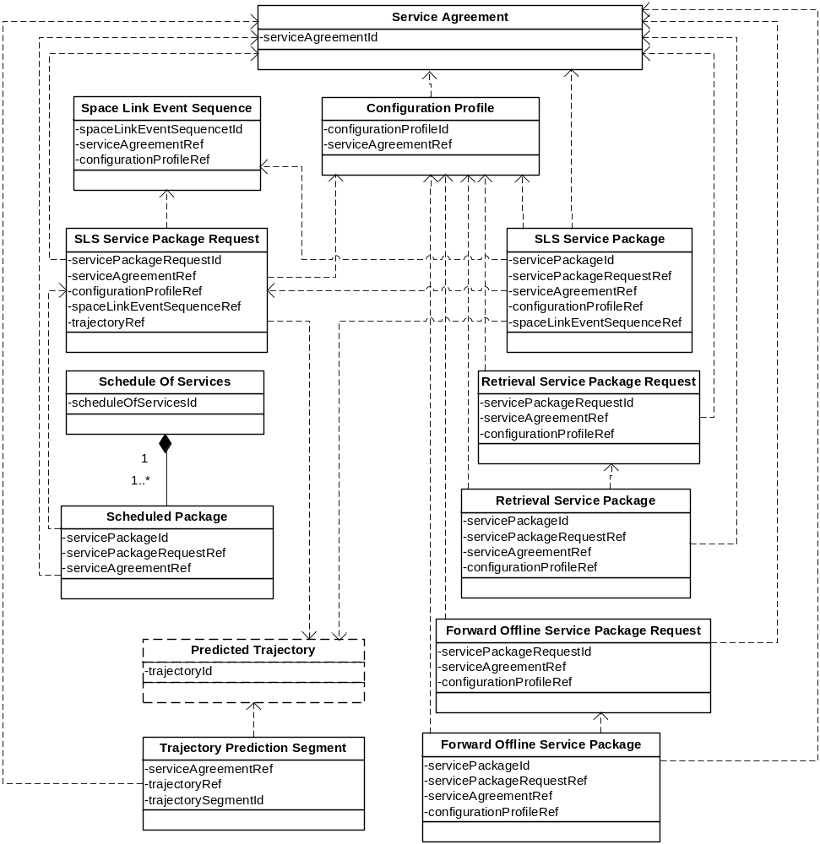
Figure 5-1111: SCCS Service Management Information Entity Cross-Referencing Framework
- For SLS Service Packages, the Service Package Request and resultant Service Package Information Entity references the Configuration Profiles and Space Link Event Sequences that specify the configuration of SCCS services to be provided and the subsequent configuration changes to be made to that configuration during the execution of the requested SLS Service Package.
- For SLS Service Packages, the Service Package Request and resultant Service Package Information Entity references the Predicted Trajectories that are required to allow the Provider CSSS to acquire the space link(s) with the target Space User Node(s) during the execution of the SLS Service Package.
- For Retrieval Service Packages, the Service Package Request and resultant Service Package Information Entity references the Configuration Profiles that specify the configuration of the transfer services to be provided during the execution of the Retrieval Service Package being requested.
- For Forward Offline Service Packages, the Service Packages Request and resultant Service Package Information Entity references the Configuration Profiles that specify the configuration of the transfer services to be provided during the execution of the Forward Offline Service Package being requested.
- Each scheduled package in a Schedule of Services Information Entity optionally references (1) the Service Agreement under which the space communication and tracking services have been scheduled and (2) the Service Package Requests that resulted in the scheduled activities. These references are optional and are not present for Service Packages that are scheduled by means other than the Service Package Request Information Entity.

Extensibility Of SCCS SM Information Entities

ConceptS of Information Entity Extensibility
A key factor in the continuing development of SCCS SM standards is the ability of those standards to support the graceful evolution of SCCS services and Service Management functions and technologies. In particular, the contents of SCCS SM Information Entities must be able to accommodate new management information resulting from the introduction of new services, functions, and technologies. Individual Provider CSSSes may provide these services, functions, and technologies at varying times, for varying durations, and in different combinations. Also, Provider CSSSes often offer combinations of Provider-unique and CCSDS-standard services and management capabilities, and the SCCS SM Information Entities must accommodate both CCSDS-standard and Provider-unique management information.
Thus the SCCS SM Information Entities must be ‘standard’ enough to be recognized and usable in cross-support situations and at the same time be flexible enough to contain subsets of parameters corresponding to different services and management capabilities (some standard, some Provider-unique). Such flexibility is accomplished by making the Information Entities extensible. The general approach to creating an extensible Information Entity is:
- identify the core parameters of the Information Entity that will not vary (e.g., parameters that uniquely identify an instance of the Information Entity);
- abstractly categorize the content of the Information Entity that is expected to vary over time or in order to accommodate Provider-unique requirements (e.g., configuration parameters that are specific to individual space link coding schemes, such that introduction of a new coding scheme will result in new configuration parameters); and
- identify or define one or more sets of CCSDS-standard parameters for each of those abstract categories of information.
The abstract categories of information are the extension points of an Information Entity, and each set of parameters that can be applied at an extension point is an extension.
The concept for extensibility of an Information Entity is that a valid Information Entity is one that has an extension for every extension point defined for that Information Entity. In the example above, the extension point is the abstract category of space link coding schemes, for which there can be multiple extensions (e.g., for Reed-Solomon and Turbo coding). As new extensions for extension points are defined (e.g., to add a new coding scheme), the new extensions can be used in place of the older ones. This extensibility mechanism also applies for Provider-unique capabilities: any Provider-unique capability that fits the abstract categorization of an extension point can be represented by an extension that contains parameters appropriate to that capability. To extend the example above, if a Provider implements a legacy coding scheme, the management parameters for that coding scheme can be contained in an extension that is applied at the corresponding extension point of the Information Entity.
As noted in section 5, the SCCS SM Information Entities are formatted using W3C XML Schema. The W3C XML Schema has features that enable the SCCS SM Information Entity extension point and extension concepts.
In addition to specifying the extension points and the standard extensions for each Information Entity, the Recommended Standard for each Information Entity will specify which of those standard extensions are mandatory and which are optional.
As the Information Entities are developed, each will be evaluated for the need for extensibility. Some key extensibility mechanisms have already been identified for a significant portion of the SCCS SM Information Entities. The following subsections describe the key extensibility mechanisms as they apply to Information Entities that focus on managed service configuration parameters (Service Agreement and Configuration Profile), Information Entities that focus on scheduling of SCCS services (Service Package Request and Service Package) and Information Entities that involve Planning Data (Provisional Plan, Communications Geometry, Sustainable Data Rates & Volume Estimates, RFI, Resource Conflicts and Cost Estimates).

Extensibility of the Service Agreement and Configuration Profile INformation Entities

General
The Service Agreement and Configuration Profile Information Entities deal with the values of configuration parameters of the resources used to provide SCCS services. The Service Agreement specifies the services that are supported under that agreement, and the range or set of values for each configuration parameter needed to perform those services. Each Configuration Profile specifies a set of services to be executed as part of a Service Package and specifies the single values of the configuration parameters for the resources corresponding to that set of services.
SCCS services are realized through different combinations of functions, each of which has service management aspects (e.g., it has configuration parameters that need to be set at initial values for the execution of the Service Package). These functions are organized into Abstract Service Components (ASCs), which are the key extension points for the Service Agreement and Configuration Profile Information Entities. ASCs are specialized in space communication technology-specific Service Component s (SCs).The management parameters of the individual functions that constitute the SCs are represented by Functional Resources (FRs). The following sections describe the ASCs, SCs, and FRs, and how they are used to construct extensible Service Agreement and Configuration Profile Information Entities.

Space Communication CRoss Support Abstract Service Components
At the highest level of abstraction, there are six basic types of configurations of functions that are used provide SCCS services in ESLTs:
- the SLS configuration, in which the ESLT delivers data to or from one or more Space User Nodes of a CSSS across one of more space links during an SLS;
- the SLS data delivery configuration, in which the ESLT provides forward and/or return data transfer services during an executing SLS so that one or more Earth User Nodes communicate with the Space User Node(s) with end-to-end connectivity in ‘real time’;
- the retrieval data delivery configuration, in which the ESLT delivers data that was received from a Space User Node to an Earth User Node, but not necessarily during the execution of the SLS by which the data was received;
- the forward offline data delivery configuration, in which the ESLT receives and stores data from an Earth User Node destined for a Space User Node, before the execution of the SLS by which the data is transmitted to the Space User Node;
- the SLS radiometric configuration, in which the ESLT extracts radiometric measurements from space links of an active SLS and delivers those measurements to the destination Earth User Node in ‘real time’; and
- the retrieval radiometric configuration, in which the ESLT delivers radiometric measurements to the Earth User Node, but not necessarily during the execution of the SLS during which the radiometric measurements were extracted.
NOTE – In the future, there will also be one or more configurations associated with the delivery of space internetworking services, but such services are outside the current scope of this concept.
The SLS configurations involve a layered space link communications model that aligns with the one presented in in various CCSDS Recommended Standards (references [3], [30], [31], [4], [5], [6], [7], and [8]). This layered model has the following abstract components:
- An aperture, which is the physical interface to the space medium. The aperture receives and/or transmits an electromagnetic signal.
- The physical channel, which transfers a stream of channel bits through the aperture across the physical medium (in this case, space). In addition to the transfer of a stream of bits, the physical channel may also carry non-binary signals, e.g., for the purpose of range measurements. The space physical channel has traditionally been provided at radio frequencies using RF modulation techniques, but the use of optical physical channels is expected to increase.
NOTE – In any realization of a space link, the technology used by the aperture must be compatible with the technology used by the physical channel. However, the possibility for multiple aperture technologies’ being applicable to the same physical channel technology (e.g., a single-feed steerable antenna, an array of geographically separated steerable antennas, an array of fixed antenna elements that ‘point’ by adjusting the phase differences among those antenna elements) justifies treating apertures separately from physical channels for the purposes of ASC definition.
- Channel synchronization and coding, which consists of the error coding, randomization, and synchronization functions that are performed to convert space data link transfer frames to the bit streams that are transferred across the space physical channel, and vice versa.
- Space data link protocols that insert/extract space-optimized Protocol Data Units (PDUs) into/from space data link transfer frames and in some cases control the flow of those transfer frames across the space link.
The SLS configurations also involve data stores that serve to buffer data between SLSes and offline terrestrial data transfer sessions:
- Retrieval space link data stores that capture return space link data.
- Retrieval radiometric data stores that hold radiometric data that has been extracted from the space link.
- Forward space link data store that holds forward offline space link data until the space link to the target Space user Node becomes active.
These data stores are typically defined in the Recommended Standards for the data transfer services that access them, e.g., the Offline Frame Buffer used by the SLE RAF (reference [10]) and SLE RCF (reference [11]) transfer services.
The SLS data delivery configuration adds to the above layered space data link model one or more SLS cross-support transfer services that allow Earth User Nodes to interface with the ESLT for the purpose of exchanging data with their respective Space User Nodes via the space links provided by the ESLT. These SLS cross-support transfer services include online SLE Transfer Services (see reference [15]) and real-time CSTS (see reference [21]).
Similarly the SLS radiometric configuration adds to the above layered space data link model data processing and radiometric data transfer services that allow Earth User Nodes to interface with the ESLT for the purpose of receiving radiometric measurements as they are being extracted from the space link by the ESLT.
The retrieval data delivery and retrieval radiometric configurations do not require the above space link communications stack as part of those configurations, because the data being retrieved has been already stored by the prior (or in some cases, concurrent) execution of an SLS configuration (which by definition does include the space link communications stack). The minimal retrieval data delivery configuration is composed of a retrieval data store and a retrieval cross-support transfer service. The retrieval cross-support transfer services include offline SLE Transfer Services (see reference [15]) and complete CSTS (see reference [21]).
Similarly, the forward offline data delivery configuration does not involve the space link communications stack because its purpose is to deposit data in the ESLT for subsequent transmission during the execution of an SLS configuration. The forward offline data delivery configuration is composed of a forward offline cross-support transfer service and a forward space link data store.
For the IOAG Service Catalog #1 (reference [18]) services performed by an ESLT (which is the current scope of SCCS SM), the composite functionality of these abstract layers conforms to the specifications provided by CCSDS Recommended Standards for space link modulation (references [3], [30], and [31]), synchronization and channel coding (references [4] and [5]), space data link protocols (references [6], [7], and [8]), and terrestrial cross-support transfer services (references [9], [10], [11], [12], and [13]). Over time, these Recommended Standards will be augmented to accommodate new space communications and tracking technologies (e.g., radio frequency vs. optical technologies at the aperture and physical channel layers). Each space communications technology may have its own set of management parameters that must be used when that technology is employed in the configuration of an ESLT. In SCCS SM, these abstract communication layers are resented by FGsASCs.

Organizing the ASCs around space communication technology-related groupings that can be substituted or added allows the ASCs to become extension points for those SCCS SM Information Entities that deal with the management parameters of space communications and tracking functionality, namely, the Service Agreement and Configuration Profile Information Entities. How this is done is addressed in greater detail in 6.2.3.
Figure 6-12 depicts the set ofsASCs for the ESLT, and the possible data flows through them. As illustrated in the figure, many combinations of ASCs are possible, although most services will each use only a single flow through thesASCs.
In figure 6-12, an arrow (that is, a line ending in an arrowhead) identifies a relatiohsinp between the two ASCs connected by the arrow, where the direction of the arrow indicates the direction of the principal data type that is exchanged between the ASCs. For example, and arrow connects the Aperture ASC to the Return Physical Channel Reception ASC for the purposes of supplying an (unnamed on the diagram) modulated waveform. A dashed lines crossing an ASC in the figure indicates that the ASC is not involved in the connection but is instead bypassed. For example, the relationship between the SLS Radiometric Data Production ASC and the Offline Data Storage ASC bypasses the SLS Data Delivery Production ASC, as indocated by the dashed line across the SLS Data Delivery Production ASC.
NOTES
- Some (but not all) of the Service Catalog #1 and Service Catalog #2 services represented by the ASCs in the figures in this subsection (6.2) are used to illustrate various aspects of extensibility as they apply to Service Agreements and Configuration Profiles. The complete set of services and the ASCs and SCs that support them are addressed in the Functional Resources for Cross Support Services Technical Note (reference [25]).
- The possible flows shown in figure 6-12 are the space communications and tracking service data flows through thesesASCs. They do not include the flows by which these ASCs are configured and controlled in real time and by which monitored parameter values and event notifications are collected from the various ASCs for reporting to the Earth User Node. Such data flows can be considered to occur in a separate management dimension (see the paragraph describing the Service Management Functions ASC below).
- Figure 6-12 includes a Space InternetworkingGASC, even though space internetworking is an IOAG Service Catalog #2 (reference [19]) capability and outside the current scope of this Informational Report. ThiG ASC is included to illustrate how space internetworking can be accommodated within thG ASC concept.
- Although the set of ASCs identified in this Informational Report encompass all services of IOAG Service Catalogs #1 and #2 (references [18] and [19], respectively), in the future new SCCS services that do not easily fit into ths ASCs defined herein may be introduced. If that happens, neFGASCs will be defined in a way that provides the same kinds of extensibility as ths ASCs described in this Informational Report.

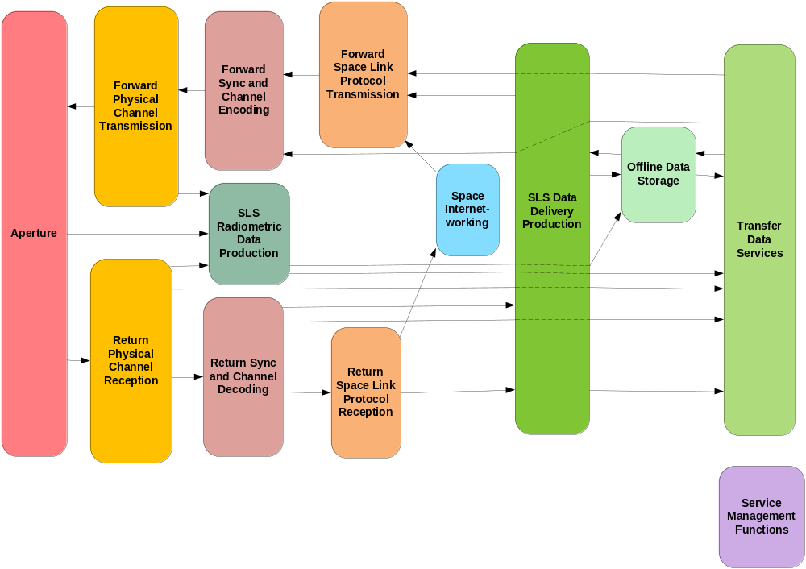
Figure 6-1212: Abstract Service Components for Earth-Space Link Terminals
The SCCS SM Enterprise Model presented in section 3 is depicted in terms of a set of ‘functions’ that provided a broad-brush abstraction of the functions performed by the Provider CSSS, Earth User CSSS, and Space User CSSS. The functions of the SCCS SM Enterprise Model have been taken from the Space Communications Cross Support ADD (reference [16]) for purposes that are somewhat different from those of derivingsASCs. As a result, while there is some general alignment between the Space Communications Cross Support ADD functions (as they appear in section 3) and thesASCs, there is not a strict relationship between the two sets. The following paragraphs describing the ASCs provide a rough mapping between ASCs and the functions of the Space Communications Cross Support ADD, but such mappings are not precise or comprehensive.
The IOAG services are distributed across multiple ASCs to align with the IOAG service categories defined in Service Catalogs #1 and #2 (references [18] and [19], respectively). IOAG services are categorized into data delivery services (forward and return), radiometric services, and service management functions. The data delivery and radiometric service groups are further divided into the space link interfaces and ground link interfaces of which they are composed.
The set of ASCs that correspond to the Space Link Interface Standards are the Aperture, Forward Physical Channel Transmission, Forward Synchronization and Channel Encoding, Forward Space Link Protocol Transmission, Return Physical Channel Reception, Return Synchronization and Channel Decoding, and/or Return Space Link Protocol Reception ASCs. By definition, these ASCs are present only in SLS configurations.
- The Aperture ASC represents the general class of apertures through which forward space link signals are transmitted and return space link signals are received as part of SLS Service Packages. Some apertures can be used by multiple forward and/or return space links simultaneously, although specific types may be limited in directionality and/or number of simultaneous links. With respect to the SCCS SM Enterprise Model functions, the Aperture ASC maps to the Space Link Processing function of the Provider CSSS.
- The Forward Physical Channel Transmission and Return Physical Channel Reception ASCs represent the RF modulation, (future) optical modulation, and radiometric measurement functions that are performed as part of SLS Service Packages. With respect to the SCCS SM Enterprise Model functions, the Forward Physical Channel Transmission and Return Physical Channel Reception ASCs are part of the Space Link Processing function of the Provider CSSS.
- The Forward Synchronization and Channel Encoding and Return Synchronization and Channel Decoding ASCs represent the coding/decoding and synchronization functions that are performed as part of SLS Service Packages. With respect to the SCCS SM Enterprise Model functions, the Forward Synchronization and Channel Encoding and Return Synchronization and Channel Decoding ASCs map to the Space Link Processing function of the Provider CSSS.
- The Forward Space link Protocol Transmission and Return Space Link Reception ASCs represent the space link protocol processing functions that are performed as part of SLS Service Packages. With respect to the SCCS SM Enterprise Model functions, the Forward Space link Protocol Transmission and Return Space Link Reception ASCs map to the Space Link Processing function of the Provider CSSS.

The set of ASCs that correspond to the ground link interfaces of the IOAG data delivery and radiometric services are the SLS Data Delivery Production ASC, the SLS Radiometric Data Production ASC, the Offline Data Delivery Production ASC, the Data Delivery Transfer Services ASC, and the Space Internetworking ASC.
- The SLS Data Delivery Production ASC represents the additional production functions beyond those provided by the Aperture, Physical Channel, Synchronization and Channel Coding, and/or Space Link Protocol ASCs that are performed as part of SLS Service Packages. For forward link data, the SLS Data Delivery Production ASC functions provide the additional processing needed to transmit data that is either transferred in real time via a Data Delivery transfer service or extracted from intermediate storage. For return link data, the SLS Data Delivery Production ASC functions provide the additional processing needed to prepare the data for either intermediate storage and/or real-time delivery via a Data Transfer service. With respect to the SCCS SM Enterprise Model functions, the SLS Data Delivery Production ASC maps to the Data Forwarding function of the Provider CSSS.
- The SLS Radiometric Data Production ASC represents the additional production functions (beyond the Aperture and Physical Channel ASC radiometric measurement functions) that are performed as part of SLS Service Packages in order to prepare radiometric data for intermediate storage and/or real-time delivery via a Radiometric Data transfer service. With respect to the SCCS SM Enterprise Model functions, the SLS Radiometric Data Production ASC maps to the Application Service function of the Provider CSSS.
- The Offline Data Storage ASC represents the production functions that are performed as part of Retrieval Service Packages (for return link communication and radiometric data) or a Store and Forward Service Package (for forward link communication data). For return link data, these functions include (but are not necessarily limited to) the data stores and recording buffers that hold data awaiting subsequent retrieval. For forward link data, these functions include (but are not necessarily limited to) the data stores that hold data awaiting subsequent transmission during a space link session. With respect to the SCCS Enterprise Model functions, the Offline Data Delivery Production ASC maps to the Data Store and the Data Forwarding functions of the Provider CSSS.
- The Data Transfer Services ASC represents the various cross-support transfer services that are used to transfer space link communication data and radiometric data across terrestrial networks between a spaceflight Mission ground facility and an ESLT. These services include the SLE transfer services, CSTS that transfer communication data to be sent or that has been received through the space link, services that transfer radiometric data from the ESLT to the Mission ground facility, as well as services that transfer files of communication data that is to be sent or that has been received through the space link. With respect to the SCCS SM Enterprise Model functions, the Data Transfer Services ASC maps to the Data Forwarding function of the Provider CSSS.
- The Space Internetworking ASC represents functions performed to transfer internetwork data across the space link as part of an end-to-end internetwork data transfer. IOAG Service Catalog #1 (reference [18]) does not include internetwork services; those are covered by Service Catalog #2 (reference [19]). Thess ASCs are included in the set of ESLs ASCs for completeness. With respect to the SSI Enterprise Model functions (see annex ANNEX C), the Space InternetworkinG ASC maps to the Data Forwarding function of the Provider CSSS.

- The Service Management Functions ASC corresponds to the IOAG service management functions. There are two transfer services that belong to the Service Management Functions ASC: the MD-CSTS and the future SC-CSTS. As noted above, the Service Management Functions interface with all of the other ASCs via connections that exist in a management dimension that is not illustrated in figure 6-12. With respect to the SCCS SM Enterprise Model functions, the Service Management Functions ASC maps to the Application Service function of the Provider CSSS.
The ASCs do not have specific management parameters, monitored parameters, notifiable events and real-time control parameters. An ASC must be specialized to a concrete Service Component for a given technology before an appropriate set of parameters and notifiable events can be defined. A set of FR Types is defined for each SC. The SC also defines the relationships among the component FR Types, and which of those FR Types implement the extension point interfaces of the ASC.
Figure 6-13 depicts thesSCstthat support the service configurations in IOAG Service Catalogs #1 (reference [18]) and #2 (reference [19]). Each of these specializations corresponds to a CCSDS Recommended Standard. Within the rounded box for ea FGASC, tns SCs of thFG ASC are depicted as dashed-border rounded boxes. In two cases (SLS Radiometric Data Production aricOffline Data Storage) tFG ASC boxes are not large enough for tonsSCs. In these cases tns SCs are shown in separate boxes at the bottom of the diagram. TonsSCs shown in figure 6-13 are further described in the Functional Resources for Cross Support Services Technical Note (referenc

NOTES
1 In figure 6-13 and subsequent figures that depict the SCs that specialze the ASCs, the placement of the SC icons within the ASC icons is not related to the postion of the arrows entering and leaving the containing parent icons. The figures merely indicate that the SCs belong to their parent ASCs. However, for those ASCs that have both forward and return SCs, the forward SCs are shown in the upper part of the ASC icons, and the return SCs are shown in the lower part of the ASC icons.
2 The functionalities of the CCSDS 401 SC specializations of the Forward Physical Channel Transmission and Return Physical Channel Reception ASCs conform to the CCSDS 401 Recommended Standards for radio frequency and modulation (reference [3]) and optionally to the CCSDS Recommended Standard for pseudo-noise (PN) ranging (reference [30]) where Code Division Multiple Access (CDMA) is not employed. These are the two physical channel-layer Recommended Standards that are explicitly called out in IOAG Service Catalogs #1 (reference [18]) and #2 (reference [19]). IOAG services could also be performed over links that use CDMA in accordance with reference [31], for which different SC specializations of Forward Physical Channel Transmission and Return Physical Channel Reception ASCs will exist.

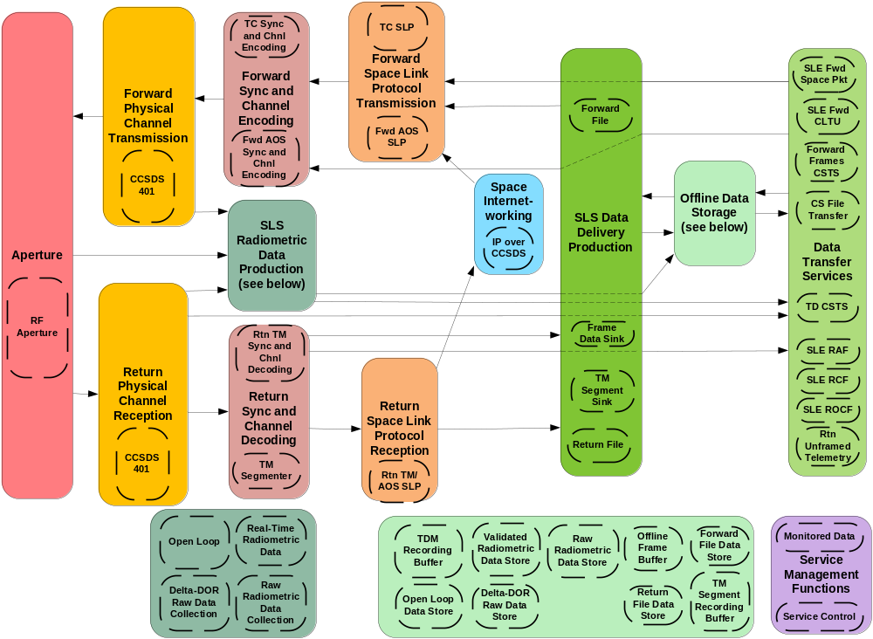
Figure 6-1313: Service Components for IOAG Services

Abstract Service Component extension points for Service Agreement and Configuration Profile Information Entities

General
The Service Agreement represents agreements between the Mission and the Service Provider that cover SCCS services that are to be provided as part of SLS Service Packages, Retrieval Service Packages, and Forward Offline Service Packages.
Figure 6-14 illustrates the SCs that represent the functions that may be performed as part of SLS Service Packages. The part of the Service Agreement Information Entity that addresses what may be scheduled as part of an SLS Service Package includes extension points for each of the SCs in the figure. The figure is almost identical to figure 6-2; the only differences are the lack of connectons between the Data Transfer Services ASC and the Offline Data Storage ASC, and the absence of the Validated Radiometric Data Store SC. The Data Transfer Services ASC and the Offline Data Storage ASC are connected only in Retrieval and Offline Forward Service Packages, and the Validated Radiometric Data Store SC is used only in Retrieval Service Packages.
Figure 6-15 depicts the ASCs that represent the functions that may be performed as part of a Retrieval Service Package. As shown in the figure, there are no space link communication functions involved in Retrieval Service Packages. The SC specializations of the Offline DatanStorage ASC serve as the repositories of previously extracted radiometric data or received return space link dat . The SC specializations of the Data transfer Services ASC consist of the terrestrial data transfer services that deliver the stored radiometric or space communication datasto the Mission ground facility.
Similarly, figure 6-16 illustrates the SCs that represent the functions that may be performed as part of a Forward Offline Service Package.
The Recommend Standard for the Service Agreement Information Entity defines extension points for the ASCs as they apply to each of the Service Package types. An individual Service Agreement between a Mission and a Provider CSSS is documented by including the extensions for the technology-specific SCs that apply to that Service Agreement.
Similar to the case of the Service Agreement, the Recommended Standard for the Configuration Profile Information Entity contains extension points for the ASCs as they apply to each of the Service Package types, and each instance of the Configuration Profile Information Entity contains the technology-specific SCs that apply to a desired configuration. The SCs used in any Configuration Profile Information Entity must correspond to the same SCs that are used in the Service Agreement.
.
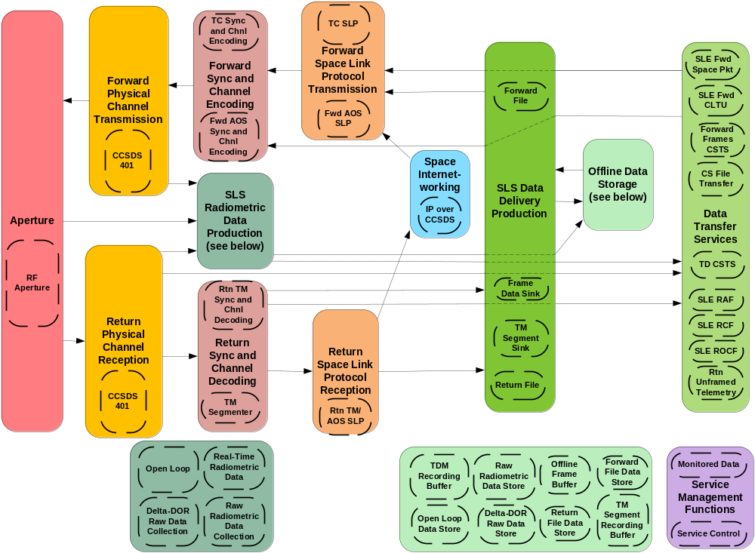
Figure 6-1414: Service Components Associated with SLS Service Packages
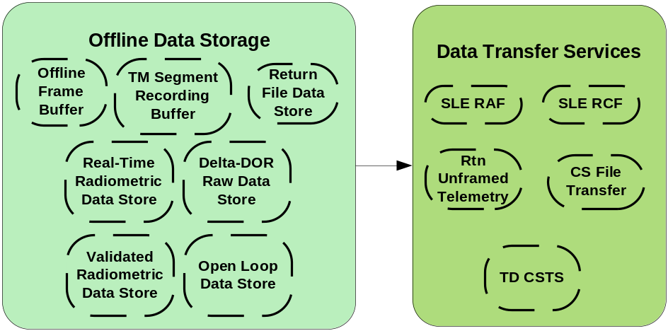
Figure 6-1515: Service Components Associated with Retrieval Service Packages
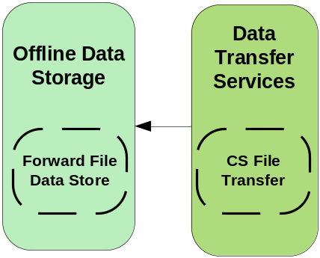
Figure 6-1616: Service Components Associated with a Forward Offline Service Package
Subsections 6.2.3.2 and 6.2.3.3 present two examples of the use of ASCs in Service Agreements and Configuration Profiles. The first example is a Mission that uses telecommand (TC) protocols on the forward link. The second example is a Mission that uses Advanced Orbiting System (AOS) protocols (see reference [7]) on the forward link. The two examples serve to illustrate the extensibility concepts as they apply to managed services, in which the one set of SCs can be substituted for another, all within the ASC framework.

Telecommand Mission Example
The Telecommand Mission in this example uses CCSDS TC coding and protocols on the forward link, CCSDS Telemetry (TM) synchronization and channel coding and TM space link protocols on the return link. The Service Agreement with the Provider CSSS allows SLS Service Packages to contain instances of the SLE Forward Space Packet (FSP) service, SLE Forward CLTU (F-CLTU) service, SLE Return All Frames (RAF) service, SLE Return Channel Frames (RCF) service, SLE Return Operational Control Fields (ROCF) service, Tracking Data CSTS (TD-CSTS), and MD-CSTS. Sometimes the Earth User Node sends Forward Space Packets to the ESLT, and sometimes it sends Telecommand Communications Link Transmission Units (CLTUs, see reference [5]) to the ESLT, but it operates in only one of these modes in any given Service Package. The Service Agreement supports both modes.
Figure 6-17 depicts thesSCs that are used in the SLS Service Package component of the Service Agreement for the Telecommand Mission.
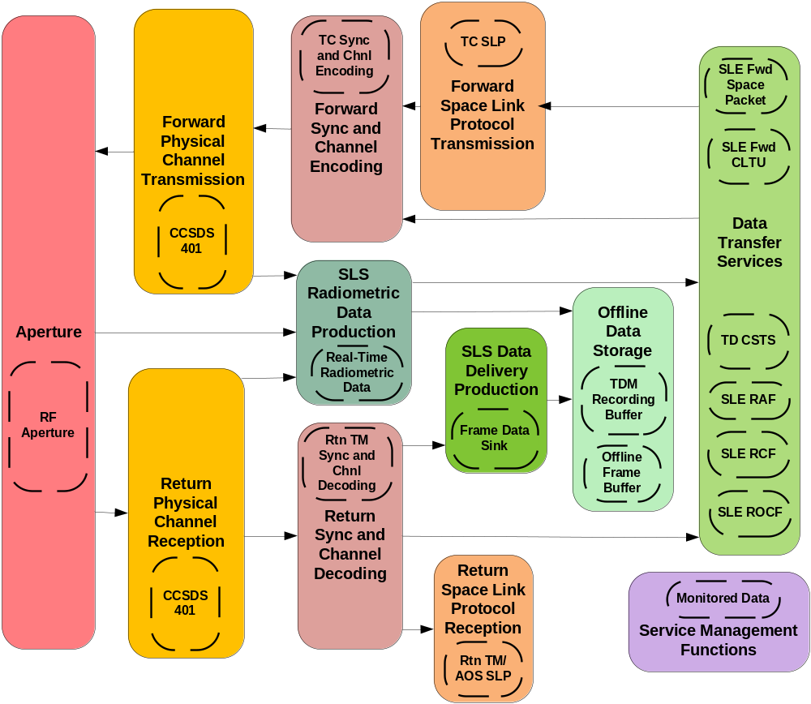
Figure 6-1717: Telecommand Mission Service Agreement - Service Components for SLS Service Packages
The Service Agreement allows Retrieval Service Packages to contain one instance of SLE RAF service, three instances of SLE RCF service, and one instance of TD-CSTS. Figure 6-18 depicts thesSCs that are used in the Retrieval Service Package component of the Service Agreement for the Telecommand Mission.
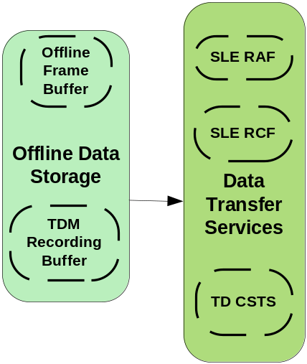
Figure 6-1818: Telecommand Mission Service Agreement - Service Components for Retrieval Service Packages
The SCs used in Configuration Profiles are the same ones that are used in Service Agreements, but any one Configuration Profile may use only a subset of the ones used in the Service Agreement. For example, for the Telecommand Mission, use of FSP or F-CLTU service is mutually exclusive in the same SLS Service Package, so the Telecommand Mission would need to create at least two Configuration Profiles, one that includes the SCs associated with Forward Space Packet and another that includes the SCs for F-CLTU.
Service Agreements and Configuration Profiles specify not only the types of functionality, but also the cardinality of each of those types. The cardinality of functionality in SCs is specified using the FRs that are defined for a given SC. The concept of FRs is addressed in 6.2.4.

AOS Mission Example
The AOS Mission in this example uses CCSDS AOS coding and protocols on the forward link and CCSDS TM synchronization and channel coding on the return link. The Service Agreement with the Provider CSSS allows SLS Service Packages to contain up to two instances of the Forward Frames CSTS (FF-CSTS), one instance of SLE RAF service, three instances of SLE RCF service, one instance of TD-CSTS, and one instance of MD-CSTS.
Figure 6-19 depicts thesSCs that are used in SLS Service Package component of the Service Agreement for the Telecommand Mission.
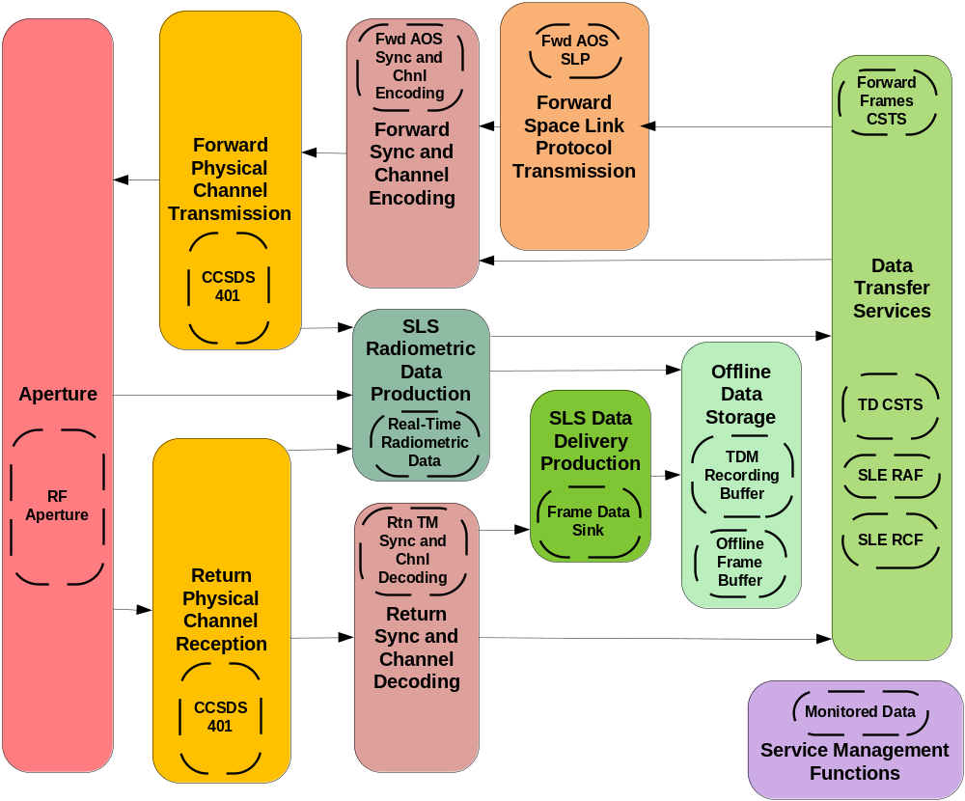
Figure 6-1919: AOS Mission Service Agreement—Service Components Groups for SLS Service Packages
Because the AOS Mission uses the same retrieval services as the Telecommand Mission, the SCs that are used in the Retrieval Service Package component of the AOS Mission Service Agreement are the same ones that are depicted by figure 6-18.

Functional Resources within Service Components

General
The functionality of an SC is defined through one or more FR Types that belong to that SC.
FR Types are the abstract representations of the functionality needed to provide space communication and tracking services. FR Types are defined at a level of granularity that is sufficient to specify the configuration parameters, monitored parameters, and notifiable events that are exposed on cross-support service interfaces. Figure 6-20 depicts a generic FR Type and its notional interfaces.
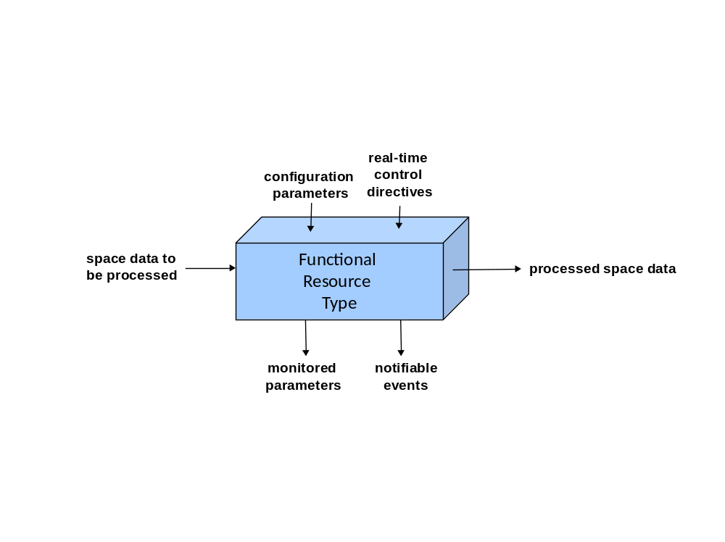
Figure 6-2020: Notional Interfaces of the Generic Functional Resource Type
The horizontal interfaces represent the flow of data or a signal through an instance of the FR Type; the ‘function’ of the FR Type is the process that it performs on this signal/data. Such processing can involve converting one type of signal to another type of signal, manipulating data to produce another type of data, generating signals from data, or extracting data from signals (e.g., space communication data modulated onto an electromagnetic signal, or Doppler data derived from an electromagnetic signal).
An FR instance (that is, an instance of an FR Type) is configured via the setting of the configuration parameters for its FR Type. When the FR instance is active, it reports measurements of whatever monitored parameters are defined for that FR Type. The FR instance also emits event notifications if any of the notifiable events that are defined for its FR Type occur. Finally, the behavior of an FR instance may be modified via the real-time control directives that are defined for its FR Type (if any).
A set of FR Types is defined for each SC. The SC also defines the relationships among its component FR Types.
Each FR Type is assigned a published identifier as defined in reference [21]. The FR Type published identifier is used to construct unique identifiers for FR instances and for the monitored parameters, configuration parameters, notifiable events, and real-time control directives that those FR instances expose for Service Management purposes. An FR instance is identified by a Functional Resource Name, which is the combination of an FR Type with a Functional Resource Instance Number (see reference [25] for additional details).
The Functional Resources for Cross Support Services Technical Note (reference [25]) provides background on the genesis of the FR concept, describes each of the FR Types used to represent IOAG Service Catalog #1 (reference [18]) services, and describes the FR Types that constitute each of the ESLnsSCs. Subsections 6.2.4.2 and 6.2.4.3 revisit the Telecommand Mission Example and AOS Mission Example of 6.2.3.2 and 6.2.3.3, respectively, to illustrate the use of FRs in Service Agreements and Configuration Profiles.

Telecommand Mission Example
The Service Agreement for the Telecommand Mission allows SLS Service Packages to contain up to five instances of the SLE FSP service or one instance of SLE F-CLTU service, one instance of SLE RAF service, three instances of SLE RCF service, one instance of SLE ROCF service, one instance of TD-CSTS, and one instance of MD-CSTS.
Figure 6-21 shows the FR Types for thesSCs that are used in the SLS Service Package component of the Telecommand Mission Service Agreement. The connections among the FR Types indicate the relationships among the FR Types, and the cardinality of FR instances is indicated at the ends of the connections. For example, the figure shows that zero to five instances of the FSP Transfer Service (TS) Provider FR Type provides Virtual Channel (VC) Packet requests to a single instance of the TC Encoding, VC Packet Processing, and VC Generation FR Type. In this and the following figures, the FR Types are color-coded for their respectivesASCs.
Figure 6-22 shows the FR Types for thesSCs that are used in the Retrieval Service Package component of the Telecommand Mission Service Agreement.
Configuration Profiles specify instantiations of the Service Agreements, which basically consist of down-selections of the capabilities represented by the Service Agreement. This down-selection takes place in several ways. First, if the Service Agreement allows multiple options of instances of FR Type, a Configuration Profile sets the exact numbers of instances that are to be enabled when that Configuration Profile is applied in a Service Package. In some cases, a Service Agreement may support service options that are supported over the operational lifecycle of the Mission but that are mutually exclusive in any given Service Package, such as the use of Space Packet service or F-CLTU service on the same forward stream of physical channel bits. In such cases the Configuration Profile supports only one of the allowed options and excludes any FR Types associated with the excluded option. Also, a Service Agreement may allow a range or set of values to be assigned to the managed parameters of FR Types, but each managed parameter can have only one value when the FR instance begins executing as part of a Service Package. The Configuration Profile sets the initial configuration values for all managed parameters.
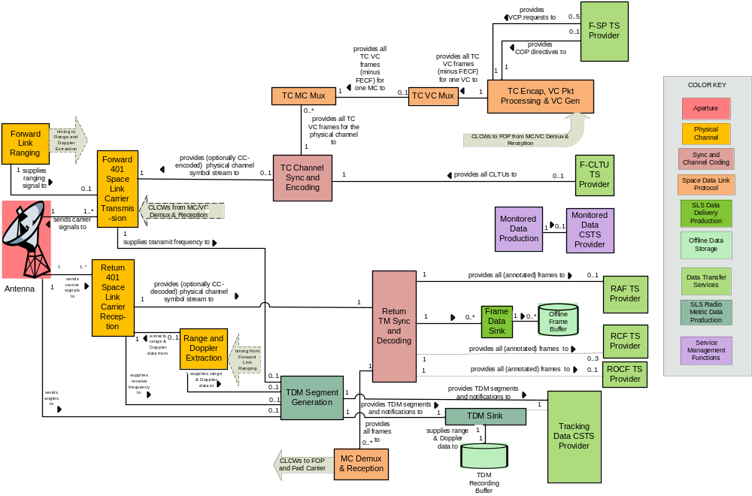
Figure 6-2121: Telecommand Mission Service Agreement—Functional Resources for SLS Service Packages
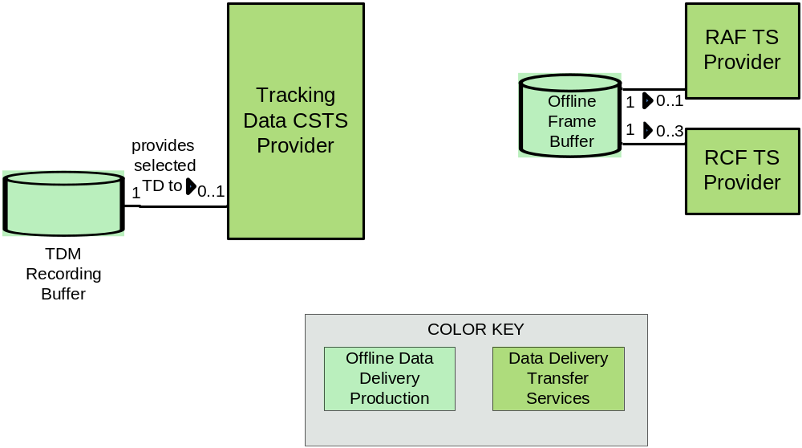
Figure 6-2222: Telecommand Mission Service Agreement—Retrieval Profile Functional Resources
In general, Configuration Profiles are used in SLS Service Packages, Retrieval Service Packages, and Forward Offline Service Packages. For the Telecommand Mission, only SLS Service Package Configuration Profiles and Retrieval Service Package Configuration Profiles are applicable.
Figure 6-23 represents an SLS Service Package Configuration Profile in which there are three SLE FSP instances, one RAF instance, two RCF instances, one TD-CSTS instance, and one MD-CSTS instance.
NOTE – These diagrams do not depict the individual managed parameters of the FR Types, so they do not illustrate the selection of a single parameter value from a range or set of possible values.
Figure 6-24 represents an SLS Service Package Configuration Profile in which there is one SLE F-CLTU instance, one RAF instance, one ROCF instance, one TD-CSTS instance, and one MD-CSTS instance.
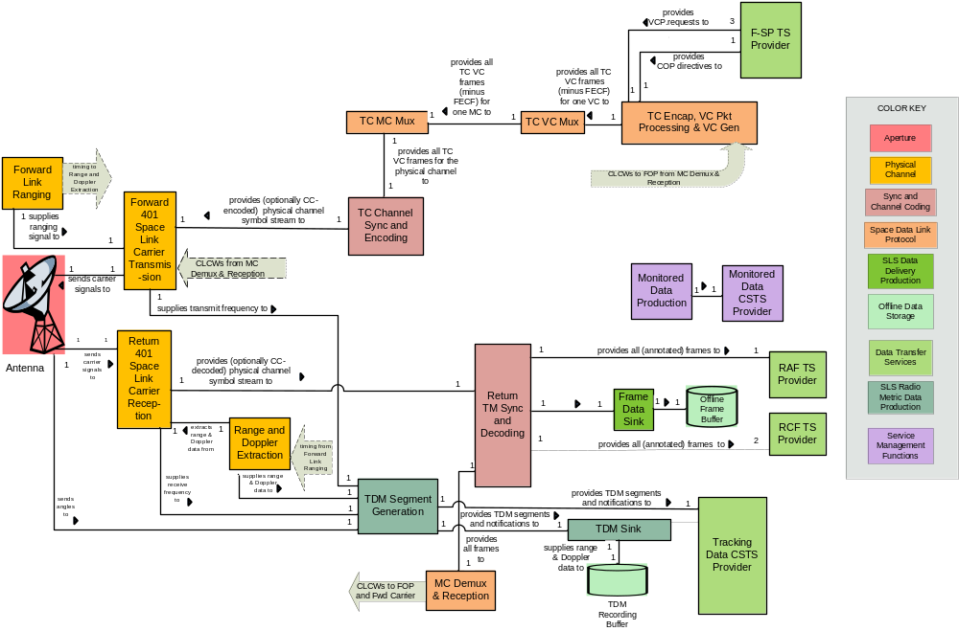
Figure 6-2323: Telecommand Mission FSP Configuration Profile—Functional Resources for SLS Service Packages
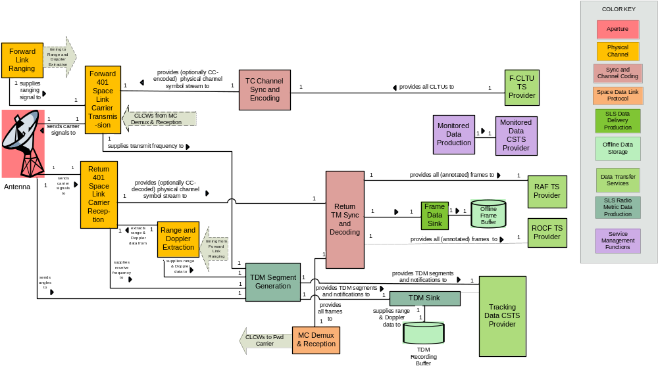
Figure 6-2424: Telecommand Mission F-CLTU Configuration Profile—Functional Resources for SLS Service Packages

AOS Mission Example
The Service Agreement for the AOS Mission allows SLS Service Packages to contain up to two instances of the FF-CSTS, one instance of SLE RAF service, three instances of SLE RCF service, one instance of TD-CSTS, and one instance of MD-CSTS. Sometimes the Earth User Node sends AOS transfer frames to the ESLT, and sometimes it sends AOS Channel Access Data Units (CADUs) to the ESLT, but it operates in only one of these modes in any given Service Package. The Service Agreement supports both modes.
The Service Agreement for the AOS Mission allows Retrieval Service Packages to contain one instance of SLE RAF service, three instances of SLE RCF service, and one instance of TD-CSTS, the same as for the Telecommand Mission.
Figure 6-25 shows the FR Types for thesSCs that are used in the SLS Service Package component of the AOS Mission Service Agreement. It is similar to thesSCs used in the SLS Service Package component of the Service Agreement for the Telecommand Mission, except that it uses the Forward AOS Synchronization and Channel Encoding and Forward AOS Space Link Protocol specializations instead of the TC ones for the forward services, and it does not need to include the Return Space Link Protocol Reception ASC because the SLE services (RAF and RCF) perform whatever space link protocol functions are required.
Because the AOS Mission uses the same retrieval services as the Telecommand Mission, the FR Types that constitute the AOS Mission Service Agreement retrieval profile are also depicted by figure 6-22.
Figure 6-26 represents an SLS Service Package Configuration Profile in which two FF-CSTS instances are configured to transfer AOS transfer frames. In the return direction there is one RAF instance, two RCF instances, one TD-CSTS instance, and one MD-CSTS instance.
Figure 6-27 represents an SLS Service Package Configuration Profile in which one FF-CSTS instance is configured to transfer AOS CADUs. In the return direction there is one RAF instance, two RCF instances, one TD-CSTS instance, and one MD-CSTS instance. This Configuration Profile is almost identical to the one for the transfer frame mode, the only difference being in the number of FF-CSTS instances and the configuration of that single instance to transfer CADUs instead of transfer frames.

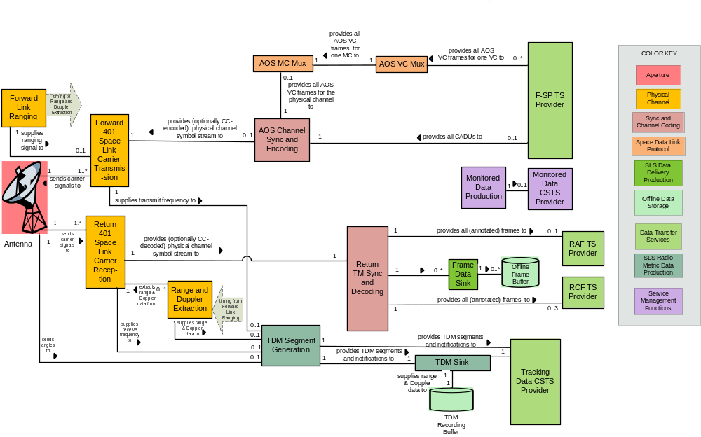
Figure 6-2525: AOS Mission Service Agreement—Functional Resources for SLS Service Packages
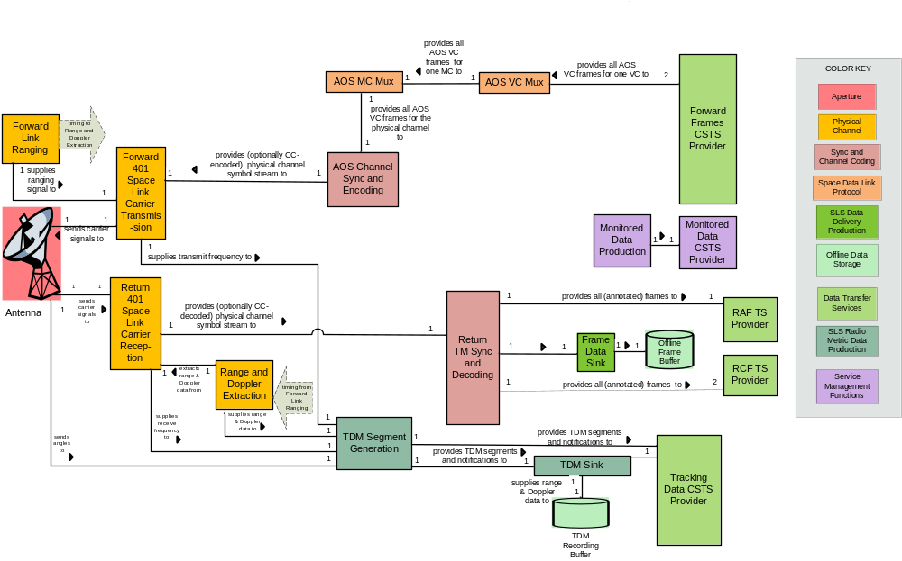
Figure 6-2626: AOS Mission Forward Transfer Frame Configuration Profile—Functional Resources for SLS Service Packages
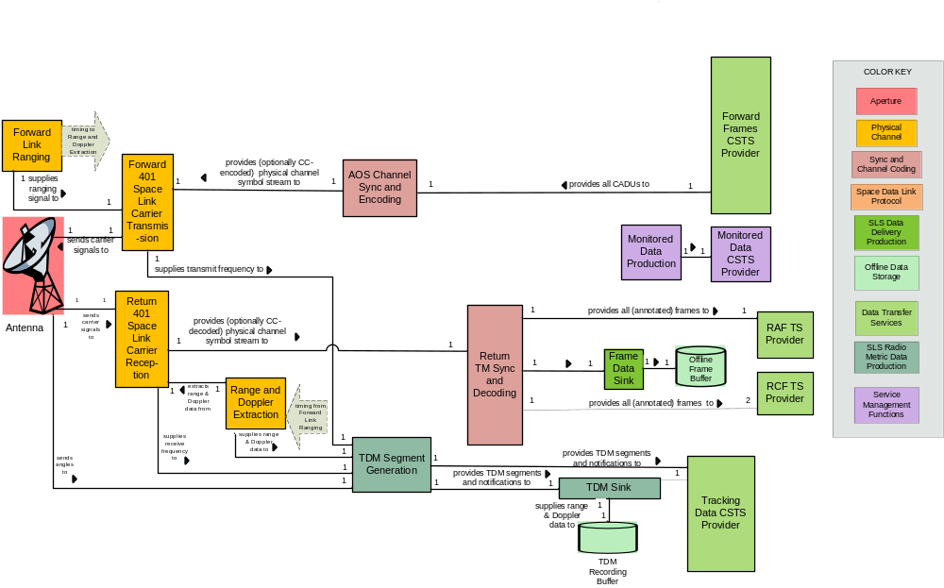
Figure 6-2727: AOS Mission Forward CADU Configuration Profile—Functional Resources for SLS Service Packages

Extensibility of the Service Package Request and Service Package Information Entities

General
As described in 5.15 and 5.16, there are three kinds of Service Packages: SLS Service Packages (for the scheduling of services that involve active space links between the Provider CSSS and the Space User CSSS), Retrieval Service Packages (for the scheduling of services that transfer return link data from the Provider CSSS to a Mission’s Earth User CSSS whether or not SLSes are executing for that Mission), and Forward Offline Service Packages (for the scheduling of services for the transfer of forward link data to the Provider CSSS before the SLS that will eventually carry that data to the Space User CSSS is active).
As defined in the first generation of SCCS SM (see reference [1]), the Retrieval Service Package is used to specify when an offline SLE transfer service instance would be permitted to bind to a data store containing return link data received and recorded by an ESLT during an SLS. The extensibility of the first-generation Retrieval Service Package is limited to being able to substitute CSTS and Provider-specific terrestrial transfer services for the SLE transfer service types named in the Recommended Standard. In the future, new SCCS services for the delayed transfer of return link may be developed based on a file transfer paradigm rather than the streaming playback model currently used in offline SLE transfer services and CSTS. The new Return File service (see reference [18]) is one such file-transfer-based service. Later will come the Return Internetworking for DTN service (see reference [19]). Configuration of an ESLT to support Return File and Space Internetworking services will likely need to be accommodated by the Retrieval Service Package and so appropriate extension points must be established.
There is no equivalent to the Forward Offline Service Package in the first generation of SCCS SM. The introduction of the Forward File service (see reference [18]) and later the Forward Space Internetworking for DTN (see reference [19]) service will require some configuration of ESLT resources to receive and store forward link data prior to, and independent of, the execution of SLSes. The core Forward Offline Service Package is defined to document the configuration information associated with the Forward File service, with extension points defined to accommodate the Forward Space Internetworking for DTN service.
The SLS Service Package has the greatest need for flexibility and extensibility of the three kinds of Service Packages. A key driver for this needed flexibility and extensibility is the variety of scheduling approaches used by Provider CSSSes to maximize the utility and utilization of their resources by their client Missions. Not only do these scheduling mechanisms differ among Provider CSSSes, but they also continue to evolve. The SCCS SM Service Package Request Information Entity (5.15) must be able both to accommodate the existing scheduling approaches and to provide extensibility mechanisms to support the evolution of scheduling approaches. Subsection 6.3.2 provides a summary of the scheduling approaches that are currently in use or are in the development stages. Subsection 6.3.3 describes the concept for ensuring that the Service Package Request Information Entity is not only capable of supporting the currently known scheduling mechanisms, but also capable of evolving.

Current and In-Development Scheduling Approaches

General
The scheduling of individual SLS Service Packages involves: (a) the Mission identifying the SCCS services that are required and the desired or acceptable times for space link sessions during which those services are to be provided, and (b) the Provider CSSS attempting to identify resources that can be made available to provide those services within the designated timeframes. Two scheduling patterns are in use today, and they are referred to in SCCS SM as specific-period scheduling and rule-based scheduling.

Specific-Period Scheduling
In specific-period scheduling, the Mission determines exactly or approximately when space link sessions are desired and uses the Provider CSSS’s equivalent of the Service Package Request to request that the Provider CSSS schedule SLSes at or around those specific times.
There are several existing variations of this approach. In the simplest one, the Mission specifies the exact start time and stop time (or, alternatively, duration) for the SLS, and the Provider CSSS attempts to schedule that exact SLS.
However, it is often the case that a particular start time may be preferred but not required, and/or that a particular duration is desired but a shorter duration would be acceptable if that is all that is available. Some Provider CSSSes support flexibility in specifying the start time and duration. In the Service Package Requests that support this capability, the specified start time becomes a preferred start time, and additional start-time lead and start-time lag parameters are provided to allow the Mission to specify how much before or how much after the preferred start time the scheduled SLS can start and still be usable by the Mission. Similarly, the stop time or duration parameter becomes a pair of parameters: a preferred duration and a minimum duration. The Mission uses these parameters to express the desired duration and the minimum useful duration. By allowing the lead and lag times to increase and reducing the minimum duration in the Service Package Request, the Mission effectively delegates to the Provider CSSS more flexibility in deciding when the SLS will actually occur, increasing the probability that the Service Package will be scheduled.
Another dimension of flexibility in Service Package Requests is the specification of the relative timing of space link carriers in the Service Package. Some Providers require that all related carriers have the same start and stop times (e.g., all carriers through the same aperture). Other Providers allow the Mission to request carrier start/stop times in terms of constraints on the start times of reference carriers. For example, a Service Package request may specify the start time preferred and offset values and the minimum and preferred duration values for a return link carrier, and simply specify that the associated forward link carrier be scheduled to occur for at least a specified minimum duration sometime during the active period of that return link carrier.
The scheduling flexibility mechanisms identified above are intended to maximize the degree to which the Mission can specify what is mandatory and what is flexible in the SCCS services that are scheduled as a result of the Service Package Request. Some Provider CSSSes also support flexibility and constraints that deal with the scheduling process itself. One such scheduling process flexibility is waitlisting, in which the Provider CSSS attempts to reschedule the Service Package Request even though it could not be scheduled initially. The rescheduling attempts continue until the Service Package is scheduled or the waitlist period for that Service Package Request (as specified by the Mission in the Service Package Request) expires.
Some Provider CSSSes continue to try to improve the Service Package even after it has been scheduled, if the Mission permits it in the Service Package Request. For example, the Service Package might be moved closer to the preferred start time, or the duration may be increased to be closer to the preferred duration. The attempted improvement continues until either no improvements are possible or the freeze interval specified in the Service Package Request is reached.
Finally, the CCSDS Space Communication Cross Support Service Management Service Specification (reference [1]) introduced the concept of the service scenario, a collection of SCCS services associated with the nominal service configurations or one or more contingency service configurations. A Provider CSSS that supports multiple scenarios allows the resources needed for the nominal and contingency configuration to be scheduled and reserved. The scenario is intended to support periods of critical activity such as launch and early operations, where it may be necessary to transition from the nominal scenario to a contingency scenario in minimal time. The scenario method of specifying alternate configurations will continue to be supported in SCCS SM.

Rule-Based Scheduling
Rule-based scheduling is a mode of scheduling in which the Mission and the Provider CSSS are able to define a generic set of scheduling rules that PM uses routinely to schedule tentative SLS Service Packages on behalf of the Mission. Rule-based scheduling is a viable approach when a Mission’s requirements can be generically stated (e.g., 6 return carriers per week, between 15 and 30 minutes each, no less than 6 hours and no more than 30 hours apart) and PM is able to perform rule-based scheduling. Rule-based scheduling extends the concept of delegating to the Complex the responsibility for determining when the SLS will occur. When used appropriately, rule-based scheduling can result in higher efficiency in the utilization of a Provider CSSS’s resources by allowing PM to fit the most contacts into a given schedule period. Rule-based scheduling, sometimes known as generic scheduling or standing order scheduling, is the primary scheduling mode for several existing Provider CSSSes, including the NASA Near Earth Network and ESTRACK.
In the existing Provider CSSSes that support rule-based scheduling, the rules are typically established by procedural means and remain in effect until changed procedurally (if ever). The rules are often based on events found in the Communications Geometry Information Entity (5.7), such as mutual visibility between the Space User Node and Provider CSSS apertures, periods of sunlight illumination, etc. PM generates a set of Service Packages that meet the rules, and sends those Service Packages to the Mission’s UM function. UM has the option to delete some or all of the Service Packages.
The concept of the Recurrent Service Package Request combines aspects of the specific-period Service Package Request with rule-based scheduling by containing a set of rules to be applied for a scheduling horizon that is specified in the request. For example, a Recurrent Service Package Request could request 6 return carriers per week, between 15 and 30 minutes each, no less than 6 hours and no more than 30 hours apart, to be scheduled between March 1 and December 31, 2017. The Recurrent Schedule Request optionally includes a set of time windows that further constrain when services can be scheduled and when they are explicitly forbidden.

EXTENSIBILITY of the Service PAckage Request
The SCCS Service Package Request Information Entity must be capable of accommodating all of the scheduling flexibility and constraint mechanisms identified in 6.3.2, and be capable of evolving to include new flexibility and constraint mechanisms in the future. The key concept for accommodating all of these mechanisms is to keep what is being scheduled (the space communication services) separated from the information that guides how those services are to be scheduled (i.e., the flexibilities and constraints to be applied) with a cross-referencing mechanism that specifies which flexibility/constraint applies to which set (or sets) of services. Figure 6-28 depicts the notional structure of the SLS Service Package Request, in which the space communications specification component is separated from the from the Flexibilities and Constraints specification component.
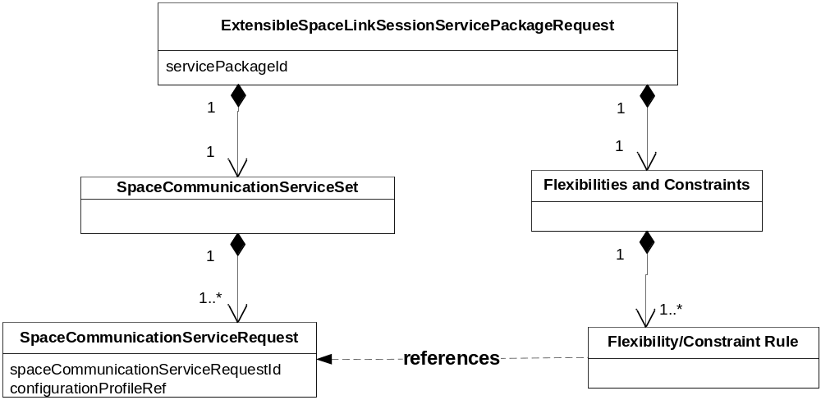
Figure 6-2828: Notional Structure of the Extensible SLS Service Package Request
Figure 6-28 is notional in that it ignores other aspects and details of the SLS Service Package Request structure in order to emphasize the points of interest here.
As shown in the diagram, the Space Communication Service Set is the collection of all of the individual Space Communication Services being requested for this Service Package. Each Space Communication Service Request is a request for all services specified in a single Configuration Profile. The Configuration Profiles are not themselves contained in the Service Package Requests, but are established separately (via the exchange of Configuration Profile Information Entities from UM to PM) and individually referenced by the Space Communication Service Requests components of the Service Package Request.
The Flexibilities and Constraints component contains the set of Flexibility and Constraint Rules that are to be applied in the scheduling of the Space Communication Requests. Each rule references the Space Communication Service Request(s) to which it applies. For example, the simplest constraint on a Space Communication Service Request is the declaration of a specific start time and a specific stop time. A fixed-time constraint rule has three parameters: start time, stop time, and the reference to the Space Communication Service Request to which the constraint applies. Other rules apply to the relationships among Space Communication Service Requests, such as one that specifies that the start time of Space Communication Service X must occur at or no later than 1 minute after the start of Space Communication Service Y.
The Flexibilities and Constraints component is a key extension point of the SLS Service Package Request. Standard flexibility/constraint rules will be defined to cover the known flexibilities and constraints of the CCSDS Member Agencies’ Provider CSSSes. These standard rules will be part of the Service Package Request Information Entity specification. If and when new flexibility/constraint mechanisms are identified as candidates for addition to the CCSDS standard set, rules corresponding to those mechanisms will be developed and added to the Service Package Request Information Entity specification.
Alternatively, an individual Provider CSSS may support a flexibility/constraint mechanism that is unique to the operating conditions of that Provider CSSS. In such a case, where standardization of the mechanism would be of no use to the rest of the international community, the Provider CSSS could develop corresponding rules that can plug into the Flexibilities and Constraints extension point.
Not all Provider CSSSes are expected to support all flexibility and constraint mechanisms covered by the Service Package Request Information Entity specification. Each Provider CSSS supports those rules that apply to the flexibility and constraint mechanisms supported by that Provider CSSS. However, all Provider CSSSes that adopt the Service Package Request Information Entity must support the minimal rule: specification of a start time and stop time for each Space Communication Service Request.
While the Flexibilities and Constraints extension point is a key extension point for the Service Package Request, it is not likely to be the only extension point. Another possible extension point is the specification of trajectory information as it applies to the Service Package: some Provider CSSSes decouple the Service Package Request from Space User Node trajectory information, other Provider CSSSes link each Service Package to a specific predicted trajectory, and yet other Provider CSSSes must link Service Packages to multiple predicted trajectories (e.g., in the case of deep space operations, where the trajectory of the target Space User Node is defined in relationship to another celestial body, the predicted trajectories of both the Space User Node and the celestial body are needed). The extension point allows each of these trajectory prediction constructions (and other future ones) to be supported.

Extensibility of Planning Data Information Entities
As described in their respective sections, the Provisional Plan (5.4), Communications Geometry (5.7), Sustainable Data Rates & Volumes (5.8), RFI (5.9), Resource Conflicts (5.10), and Cost Estimates (5.11) Information Entities are all instantiations of the Event Timeline stereotype, which is the key extensibility mechanism for Planning Data Information Entities. The Space Link Event Sequence (5.12) and Accounting Report ( 5.19) Information Entities also instantiate the Event Time stereotype.
The Event Timeline stereotype is a time-ordered series of events that are derived from and abstract Event class that has two core parameters:
- the event identifier, which uniquely identifies the event with respect to all events that can occur in the context of the Service Agreement between the Provider CSSS and the Mission; and
- the event time, which specifies when the event is predicted to occur (or has occurred). The event time has several components:
- Whether the event has a duration or is instantaneous. If it has a duration, the event time has start/stop timestamp components. If the event is instantaneous, the event time has a single timestamp component.
- An uncertainty window, which allows the event time to reflect prediction uncertainties.
- Whether the event time is specified in absolute time or relative to something that for which the time has not been fixed as of the specification of the event instance.
The Event class also includes an extension point for the addition of event type-specific information. For example, one extension type identifies the aperture in a mutual visibility communications geometry event, and a different extension type identifies the data rate that is sustainable for the duration of a data rate event.
The Provisional Plan is extensible in that its Event Timeline extension point can be populated with Information Entities of any of the type listed above, and furthermore with Planning Data Information Entities of new types that might be defined in the future, as long as those new Information Entities conform to the Event Time stereotype.
The Event Timeline stereotype itself has an extension point in that it can contain any series of events that conform to the Event class specification. This allows the Provisional Plan to contain multiple Event Timelines (one or more for each of various Information Entity types) or a single Event Timeline that mixes different event types in a single time series.
The Event Timeline stereotype and Event class definitions are logically consistent with the CCSDS Timeline Data Exchange activity. However, as of the writing of this Informational Report, the Timeline Data Exchange activity is still in the formative stages and no Recommended Standard is expected to exist to be used as a normative basis for the initial Provisional Plan and Communications Geometry Information Entity specifications. As Timeline Data Exchange Recommend Standards are published, the Planning Data Information Entities will evolve to use those standards.
The Space Link Event Sequence (5.12) and Accounting Report ( 5.19) Information Entities also use the Event Timeline stereotype.

ManageMent ServiceS

General
SCCS Management Services facilitate the SCCS SM activities that occur across the SCCS Mission Support Lifecycle (see section 4). Specifically, SCCS Management Services provide the robust, reliable, and controlled exchange of Information Entities and management messages associated with the use and applicability of those Information Entities between the UM function of the Mission and the PM function of the Provider CSSS.
The core SCCS SM Management Services deal with the routine SCCS SM activities during the course of the Mission Support Lifecycle, such as the nominal process for requesting Service Packages and scheduling them in accordance with a Provider CSSS’s policies and scheduling algorithms. Many Provider CSSSes also offer spacecraft emergency services that essentially expedite activities of the Mission Support Lifecycle in order to allow a minimal set of SCCS services to be provided on short notice and with little negotiation. The SCCS Management Services will address both routine and spacecraft emergency services.
Provider CSSSes already provide their own management services in support of most if not all of the management activities across the Mission Support Lifecycle, using Provider-specific data structures (i.e., the equivalent of the SCCS SM Information Entities) and transfer mechanisms. The Provider-specific management services are not interoperable and require that a Mission implement a different management interface for each Provider CSSS that it uses. Adoption of standard SCCS Management Services by Missions and Provider CSSSes will allow Missions to use the services of multiple Provider CSSSes while implementing a single Service Management interface.
The SCCS SM concept adopts a phased approach to definition and deployment of Management Services. In the near term, standard Information Entities will be defined and made available to be integrated into Provider-specific Management Services. In the longer term (circa 2020), standard SCCS Management Services will be available. The following subsections describe these phases in more detail.

SCCS SM Information Entities in Provider-Specific Management Services
Some Provider CSSSes will be able to use SCCS SM Information Entities in their existing management services, or they may choose to develop new management services built around some or all of the SCCS SM Information Entities. Such new management services could leverage parts of the Version 1 SCCS SM Service Specification (reference [1]). Version 1 SCCS SM provides a set of management services and associated management operations that are of general applicability, at least for the subset of management services that are covered by Version 1 SCCS SM: Service Package, Trajectory Prediction, Configuration Profile, and Service Agreement. Although the operations defined for these services use Version-1 Information Entities as their payloads, they could be adapted to use SCCS SM Information Entities instead.
Some Provider CSSSes could modify their existing management services to use the standard Information Entities directly, while other Provider CSSSes could develop translators that transform the Provider CSSS’s native management message content into standard Information Entity content and format, and vice versa. Performing such transformations would be facilitated by the XML composition of the SCCS SM Information Entities. Many tools are readily available to convert XML documents to and from other data representations.
The SCCS SM Information Entities each contain all of the information necessary to represent not only the information of interest but also the state of the Information Entity itself. This makes the Information Entity independent of the underlying transfer service used to exchange the Information Entities between UM and PM.

Extensible SCCS Management Services
The ultimate goal for SCCS Management Services is to provide Management Services that (a) address activities in all phases of the SCCS Mission Lifecycle for which standard services are appropriate, (b) will be robust as Service Management technologies and capabilities evolve, and (c) use the most appropriate underlying technology (or technologies) for the task.
With regard to the selection of appropriate underlying technologies, there are two patterns of transfer of management-related information. The first pattern is the transfer of possibly large Information Entities at relatively infrequent intervals. These Information Entities may have complex structures, but the latency requirement for processing them ranges from a large fraction of minutes to hours. Submission of multiple Configuration Profiles at the beginning of the Service Agreement Period, followed by the submission of a few optimized Configuration Profiles several months following launch, is an example of this exchange pattern. Another is the weekly submission of a batch of Service Package Requests during the first hour of a new scheduling week. Several data exchange technologies and protocols exist that are nominally suited to support this pattern, and new standards continue to emerge. Selection of the specific technologies for support of this pattern in the SCCS Management Services will be based on the availability and maturity of the candidate technologies that are available at the time that the Management Service Recommended Standards are developed.
The second transfer pattern is characterized by a streaming flow of possibly high-volume data that must be processed in near real-time (i.e., on the order of seconds). The volume and latency requirements for such data transfers lead to selection of data transfer technologies with simpler data structures and more-compact transfer syntaxes than those that could be employed for the other transfer pattern. The current concept is that the Management Services that follow this low-latency, streaming pattern of management information transfer will be built on the CCSDS CSTS Specification Framework (reference [21]).
Message transfer technologies will continue to evolve and improve after the initial versions of the SCCS Management Services Recommended Standards are published. In order to maximize the opportunity to take advantage of that evolution, the SCCS Management Service will be defined in a layered fashion such that the Management Services are cleanly decoupled from the underlying data transfer technologies by a well-defined set of service primitives. This layered approach will permit underlying technologies to be replaced over time with no effect on the functionality of the Management Services.

Roadmap

Overview
The Roadmap lays out the sequence of Informational Reports and Recommended Standards that are to be developed in the course of standardization of SCCS SM. The Roadmap is based on
- the set of Information Entities identified in section 5;
- the relative priorities expressed by the CCSDS Member Agencies;
- an approach of developing useful data format exchange specifications prioritized over service specifications; and
- the collection of Information Entities that have strong affinities into particular Blue Book definitions.

Deliverables
Following is the order for developing the deliverables to satisfy the Cross Support Service Management Working Group charter.
- Extensible Space Communication Cross Support Service Management—Concept Informational Report (Green Book) (this document): this is necessarily the first deliverable as it defines the concept for the set of following service management recommendations.
- Space Communication Cross Support Service Management—Simple Schedule Format Specification Recommended Standard (Blue Book): this Blue Book defines the details of the Schedule of Services (5.17) and Resource Availability (5.13) Information Entities. The Schedule of Services Information Entity is used in the Schedule Service Packages activity of the Service Planning and Scheduling stage of the Service Agreement Period phase of the SCCS Mission Support lifecycle. The Resource Availability Information Entity is used in the Exchange Planning Information activity of the Service Planning and Scheduling stage of the Service Agreement Period phase of the SCCS Mission Support Lifecycle.
- Space Communication Cross Support Service Management—Planning Data Formats Recommended Standard (Blue Book): this Blue Book defines the details for the Planning Request (5.3), Provisional Plan (5.4), Communications Geometry (5.7), Sustainable Data Rate & Volume Estimates (5.8), RFI (5.9), Resource Conflicts (5.10), and Cost Estimates (5.11) Information Entities. The first issue of this Blue Book will contain the Planning Request and Communications Geometry Information Entities, where the Planning Request will be limited to Communications Geometry information requests. The second issue of the Blue Book will add the remaining Information Entities and expand the Planning Request to be able to be used to request the other Information Entity types. Depending on the operational procedures of the Provider CSSS, the Information Entities specified in this Blue Book may be used in (a) the Perform Mission Telecommunication Analysis activity of the Service Agreement Development phase, and/or (b) the Exchange Planning Information activity of the Service Planning and Scheduling stage of the Service Agreement Period phase of the SCCS Mission Support Lifecycle. The Resource Conflicts Information Entity may also be used in the Schedule Service Packages activity of the Service Planning and Scheduling stage of the Service Agreement Period phase.
- Space Communication Cross Support Service Management—Trajectory Prediction Data Format Recommended Standard (Blue Book): this Blue Book defines the details for the Trajectory Prediction Segment (5.14) Information Entity. Depending on the operational procedures of the Provider CSSS, the Trajectory Prediction Segment is used in (a) the Perform Mission Telecommunication Analysis activity of the Service Agreement Development phase, (b) the Exchange Planning Information activity of the Service Planning and Scheduling stage of the Service Agreement Period phase, and/or (c) the Service Package Execution stage of the Service Agreement Period phase of the SCCS Mission Support Lifecycle.
- Space Communication Cross Support Service Management—Service Request and Service Package Data Formats Recommended Standard (Blue Book): this Blue Book defines the details of the Service Package Request (5.15), Service Package (5.16), and Service Package Execution Event Notification (5.18) Information Entities. The Service Package Request and Service Package Information Entities are used in the Schedule Service Packages activity of the Service Planning and Scheduling stage of the Service Agreement Period phase of the SCCS Mission Support lifecycle. The Service Execution Event Notification is used in (a) the dormant period between the scheduling and execution of a Service Package and (b) Service Package Execution stage of the Service Agreement Period phase of the SCCS Mission Support Lifecycle.
- Space Communication Cross Support Service Management—Service Agreement and Service Configuration Profile Data Formats Recommended Standard (Blue Book): this Blue Book defines the details of the Service Agreement (5.5) and Configuration Profile (5.6) Information Entities. Depending on the complexity of the Mission spacecraft and the operational procedures of the Provider CSSS, Configuration Profiles are used in (a) the Negotiate and Adopt Service Agreement activity of the Service Agreement Development phase, and/or (b) the Exchange Planning Information activity of the Service Planning and Scheduling stage of the Service Agreement Period phase of the SCCS Mission Support lifecycle. The Service Agreement Information Entity is used in the Service Agreement Development and Service Agreement Period phases of the SCCS Mission Support Lifecycle.
- Space Communication Cross Support Service Management—Space Link Event Sequence Data Format Recommended Standard (Blue Book): this Blue Book defines the details of the Space Link Event Sequence (5.12) Information Entity. Depending on the Mission and the operational procedures of the Provider CSSS, Space Link Event Sequences may be used in the Negotiate and Adopt Service Agreement activity of the Service Agreement Development phase. Space Link Event Sequences are exchanged as part of the Exchange Planning Information activity of the Service Planning and Scheduling stage of the Service Agreement Period phase of the SCCS Mission Support lifecycle. Space Link Event Sequences are used by the Provider CSSS as part of (a) the Schedule Service Package activity of the Service Planning and Scheduling stage and (b) the Control Service Package activity of the Service Package Execution stage of the Service Agreement Period phase of the SCCS Mission Support Lifecycle.
- Space Communication Cross Support Service Management—Service Catalog Recommended Standard (Blue Book): this Blue Book defines the details of the Service Catalog (5.2) Information Entity. The Service Catalog is used in the Service Catalog Consultation and Service Agreement Development phases of the SCCS Mission Support lifecycle.
- Space Communication Cross Support Service Management—Service Accounting Recommended Standard (Blue Book): this Blue Book defines the details of the Accounting Report (5.19) Information Entity. The Accounting Report is used in the Service Accounting stage of the Service Agreement Period phase of the SCCS Mission Support lifecycle.
- Space Communication Cross Support Service Management: Management Services (Automation) Recommended Standard (Blue Book): this Blue Book defines the management service behavior for automated exchange of Service Management Information Entities.
- Space Communication Cross Support Service Management: Best Practices Recommended Practice (Magenta Book): this Magenta Book addresses stereotypical operational procedures related to the various SM Information Entities. Topics to be addressed will include prerequisite ordering in the use of Information Entities (e.g., a Configuration Profile should be in place before a Service Package Request is submitted, and a predicted trajectory must be in place at the start of execution of the Service Package), and stereotypical combinations of (and associated constraints on) individual space communication and tracking service types as they appear in Service Agreements, Configuration Profiles, and Service Package Requests.
Figure 8-29 illustrates the products listed above, the span of the SCCS Mission Support Lifecycle phases to which each is applicable, and the relative ordering (top to bottom) in which they will be developed. The colors of the icons indicate the CCSDS book color of the deliverable.
NOTE – The product spans shown in figure 8-29 indicate the earliest and latest phases, stages, and activities that are spanned by their products, but the products do not necessarily apply to the intermediate phases, stages, or activities.
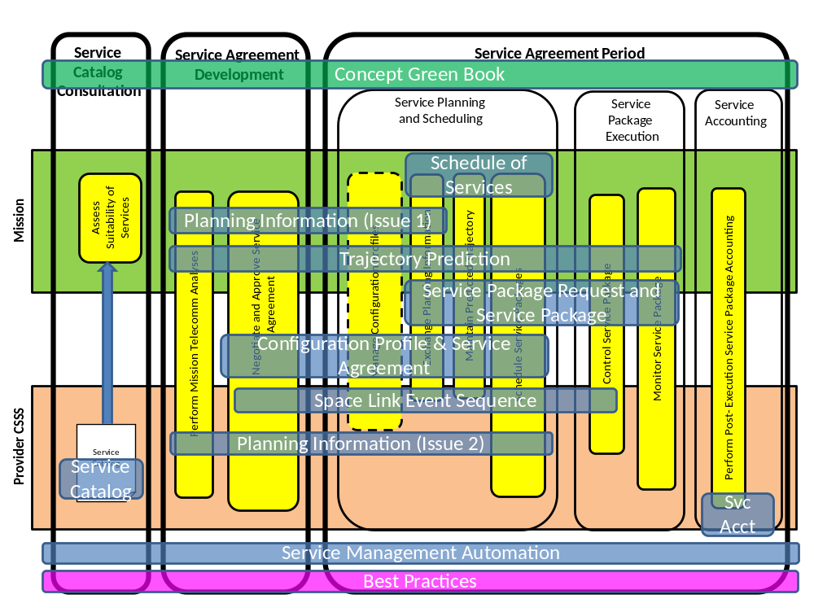
Figure 8-2929: Extensible SCCS SM Products, By Lifecycle Stage and Order of Development
Table 8-1 lists the estimated completion timeframes of the Extensible SCCS SM products.
Table 8-11: Schedule of Extensible SCCS SM Products
Product | Book Type | Estimated Date (Given Anticipated Resources)
Extensible SCCS SM Concept | Informational Report (Green) | Early 2014
Simple Schedule Format Specification | Recommended Standard (Blue) | Late 2014
Planning Data Formats (Issue 1) | Recommended Standard (Blue) | Early 2016
Trajectory Prediction Data Format | Recommended Standard (Blue) | Early 2016
Service Request and Service Package Data Formats | Recommended Standard (Blue) | Early 2017
Service Agreement and Configuration Profile Data Formats | Recommended Standard (Blue) | Early 2017
Space Link Event Sequence Data Format | Recommended Standard (Blue) | Early 2018
Planning Data Formats (Issue 2) | Recommended Standard (Blue) | Mid 2019
Service Catalog | Recommended Standard (Blue) | Late 2019
Service Accounting | Recommended Standard (Blue) | Mid 2020
Management Services (Automation) | Recommended Standard (Blue) | Late 2020
Best Practices | Recommended Practice (Magenta) | To Be Negotiated

Acronyms and Abbreviations
The following acronyms and abbreviations are used in this Informational Report. For acronyms that are originally defined in one of the reference documents in 1.7, the reference number is also included.
ABA | Cross-support configuration in which elements of organization A use elements of organization B to communicate with each other (see reference [16])
AOS | Advanced Orbiting System (see reference [7])
ADD | Architecture Description Document (reference [16])
ASCII | American Standard Code for Information Interchange
ASC | Abstract Service Component
CADU | channel access data unit (see reference [7])
CDMA | Coode Division Multiple Access
CLTU | communications link transmission unit (see reference [5])
CC | control center
CSRM | Cross Support Reference Model (reference [15])
CSSS | Cross Support Service System (see reference [16])
CSTS | Cross Support Transfer Services (see reference [21])
Delta DOR | delta differential one-way ranging
DDOR | delta differential one-way ranging
DTN | Disruption Tolerant Networking (see reference [19])
ESA | European Space Agency
ESLT | Earth space link terminal (see reference [16])
ESTRACK | European Space Tracking network
F-CLTU | Forward CLTU (see reference [9])
FF-CSTS | Forward Frames CSTS
 | [25]
FR | Functional Resource (see reference [21])
FSP | Forward Space Packet (see reference [13])
IOAG | Interagency Operations Advisory Group
IP | Internet Protocol
MAP | multiplexer access point (see reference [8])
MC | master channel
MCC | mission control center
MDOS | mission data operation system
MD-CSTS | Monitored Data CSTS (see reference [20])
MUX | multiplexing
NASA | National Aeronautics and Space Administration
OMG | Object Management Group
PDU | protocol data unit
PM | Provision Management (see reference [16])
PN | pseudo-noise
RAF | Return All Frames (see reference [10])
RASDS | Reference Architecture for Space Data Systems
RCF | Return Channel Frames (see reference [11])
RF | radio frequency
RFI | radio frequency interference
ROCF | Return Operational Control Fields (see reference [12])
SC | Service Component
SCCS | Space Communications Cross Support
SLE | Space Link Extension (see reference [15])
SLS | space link session (see reference [15])
SM | Service Management
SSI | Solar System Internetwork
sync | synchronization
SysML | Systems Modeling Language (see reference [23])
SSI-ISP | SSI Internetwork Service Provider (see reference [24])
TC | telecommand
TD-CSTS | Tracking Data CSTS (see reference [27])
TDM | Tracking Data Message
TM | telemetry
TT&C | tracking, telemetry, and command
UM | Utilization Management (see reference [15])
VC | virtual channel
WAN | wide area network
W3C | World Wide Web Consortium
XML | Extensible Markup Language

COMPARISON of the SCCS SM Enterprise Model to the Cross Support ReferEnce Model, Part 1: SpAce Link Extension

- The extensible SCCS SM concept represents an evolution of Service Management concepts that began in the early 1990s under the name Space Link Extension Service Management in the Cross Support Concept (reference [14]) and CSRM (reference [15]) for SLE Services before assuming the name SCCS SM in the Version-1 SCCS SM Service Specification (reference [1]) and SCCS SM Operations Concept (reference [2]). Many of the concepts and terms from the CSRM and Version-1 SCCS SM documents are still applicable to the extensible SCCS SM concept presented in this Informational Report. There are, however, a few departures from the previous concept that may be confusing to readers that are familiar with those previous documents. Specifically, the SCCS SM Enterprise Model introduces a different set of terminology for the components of the SM environCSRM. The followons paragraphs summarize the similarities and differenreasbetween these two models.

- The CSRM put forth a top-level Data Exchange model consisting of a Space Element, a Space Link Extension System, and a Mission Data Operation System (MDOS), where the Space Link Extension System comprised one or more SLE Complexes. This model was subsequently refined for SCCS SM into the SCCS Service Management Environment in references [1] and [2], in which the SLE Complex was renamed SCCS Complex to emphasize that the scope of Service Management was much larger than just SLE services. Figure B-30 is a reproduction of the SCCS Service Management Environment diagram from reference [1].
The SCCS SM Enterprise Model (section 3) is very similar to the CSRM and SCCS Service Management Environment diagram.
In the CSRM and SCCS Service Management Environment, the Space Element is a single spacecraft (rover, etc.), which is equivalent to a single Space User Node in the physical view of the SCCS SM Enterprise Model (see figure 3-6). However, the SCCS SM Enterprise Model is more general in that the Space User CSSS may include multiple Space user Nodes.
The Earth User CSSS is essentially equivalent to the MDOS of the CSRM and SCCS Service Management Environment. However, the MDOS only represents the functional view of the Earth User CSSS, whereas the SCCS SM Enterprise Model allows for physical views that can be used to allocate the functions to different Earth User Nodes. The SLE-specific Transfer Service User functions of the SCCS Service Management Environment are also replaced by the abstract Terrestrial Link Processing, Data Forwarding, Data Store, and Application functions in the SCCS SM Enterprise Model. The Utilization Management function of the Earth User CSSS is essentially the same as the UM function of the MDOS.

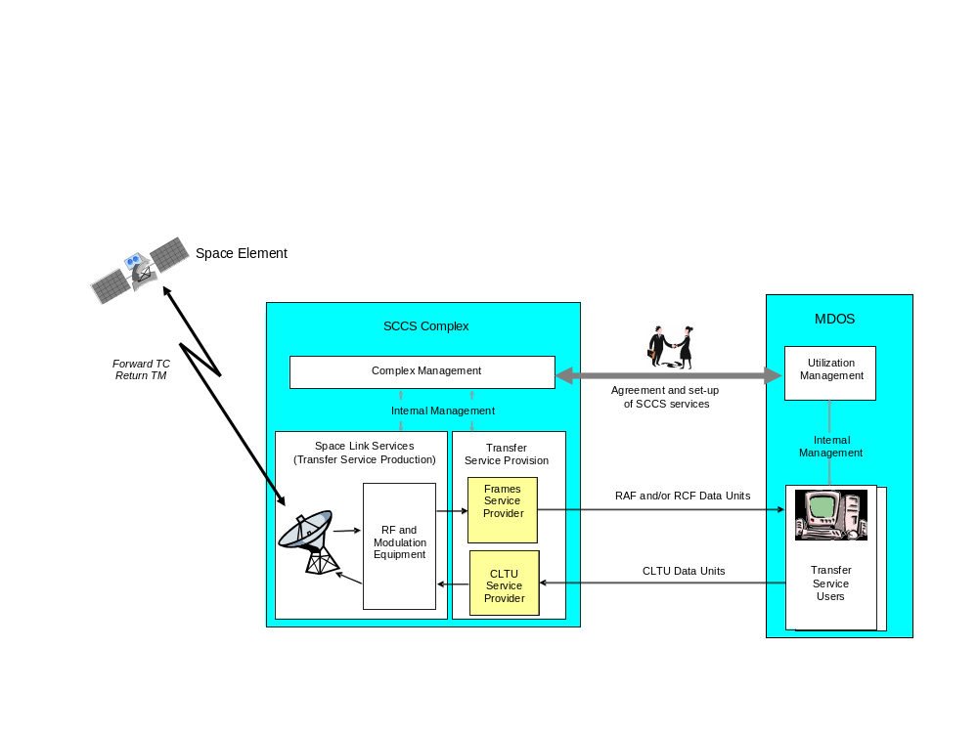
Figure B-3030: SCCS Service Management Environment

One top-level difference between the two models is that the SCCS SM Enterprise Model explicitly joins the Space User CSSS and Earth User CSSS in the Mission organizational domain. In the CSRM, the Mission relationship between the MDOS and Space Element is not explicit in the graphical model.
The Provider CSSS is essentially the same as the SCCS Complex of the SCCS Service Management Environment with the generalization of the services offered to go beyond space communication and SLE transfer services to include all radiometric services. The Provider Management functions of the Provider CSSS is essentially the same as the Complex Management function of the CSRM’s SLE Complex.

SysML SCCS Service Management Enterprise Model
  - Essential SysML SCCS SM Enterprise Model
The concepts of the SCCS Service Management Enterprise Model are introduced in section 3. Many of the concepts are visually conceptualized using the RASDS notation. This annex captures the same concepts in a formal modeling technique, OMG’s SysML. The benefits of capturing the SCCS SM Enterprise Model in SysML include (but are not limited to) using a common modeling language for sharing and collaborating, using a rich language for formally capturing components and element relationships in greater detail and scope, and providing a set of tools to manage the size and complexity of the model.
Figure C-32 is a SysML block diagram representation of the essential SCCS SM Enterprise Model. The block diagram is the preferred method of describing the SysML SCCS SM Enterprise Model because of its focus on a physical perspective. The essential model contains the minimal set of components to perform all of the functions associated with Service Management in the SCCS Enterprise and is comparable in scope and purpose to the essential physical view of the SCCS SM Enterprise Model depicted in RASDS form in figure 3-6. The block diagram best describes the physical ownership of enterprise components (i.e., a system if composed of parts), the communication types/paths, and interfaces provided/used.
The management activities identified in the SCCS Mission Support Lifecycle are represented within the UM node and the PM node. These nodes further qualify what is a User CSSS and a Provider CSSS but more importantly they provide a means to contain SM functions and to relate this containment to the organizations of the user or provider, respectively.
The Enterprise Model associates management services to their respective nodes. Figure C-33 shows the Enterprise Model with both the SM functions and SCCS services localized to their respective nodes.
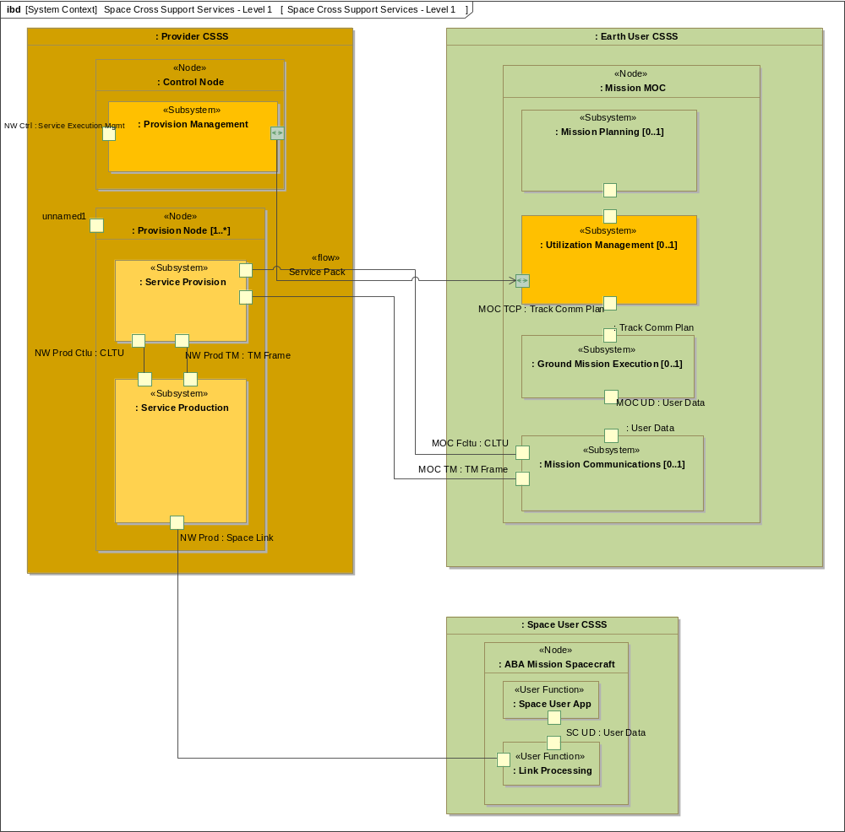
Figure C-3232: Essential SCCS SM Enterprise Model (in SysML)
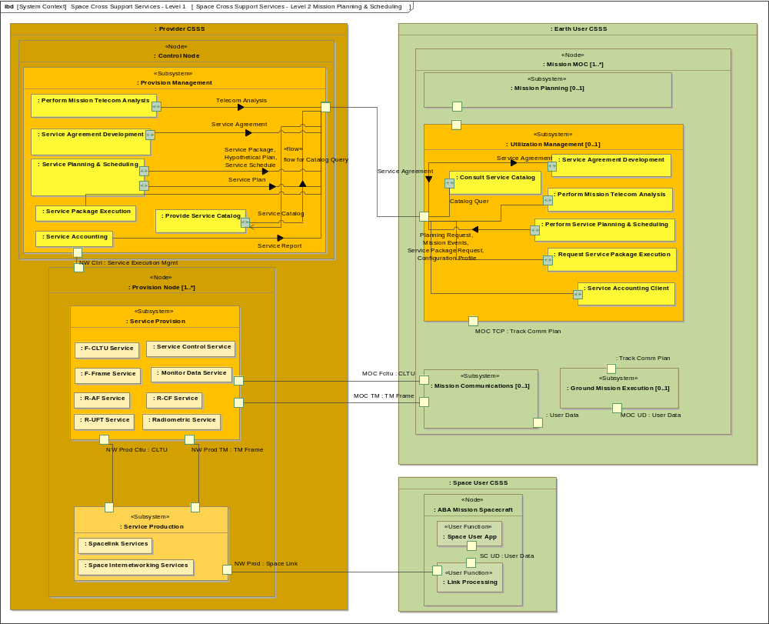
Figure C-3333: SCCS SM Enterprise Model with Management and Transfer Services
The following subsections describe various instantiations of the enterprise model in representing SCCS enterprises from two different perspectives: the User CSSS and the Provider CSSS.
  - User Perspective of the SCCS SM Enterprise
The cross-support information managed through SCCS SM allows a single UM element to interface with multiple Provider CSSSes. The Earth User CSSS of the Mission produces separate Service Agreements with each Provider CSSS. To a Mission, managing services with Provider CSSS A is no different from managing services with Provider CSSS B. SCCS SM allows for using multiple Provider CSSSes concurrently. To the Mission, a simple schedule of all services for that Mission can be obtained and managed with each Provider CSSS. Figure C-34 illustrates the Mission perspective.
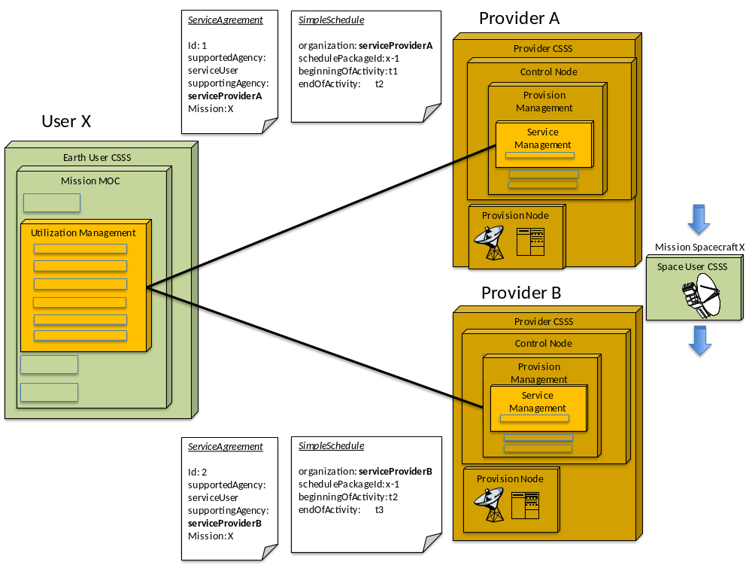
Figure C-3434: SCCS SM Enterprise Model—Mission Using Multiple Providers
  - Provider Perspective of the SCCS SM Enterprise
Figure C-35 illustrates the Provider CSSS perspective of the SCCS SM Enterprise. Because the Provider CSSS offers standard space communication services and uses a standard service management interface, it supports a number of Missions. The Provider CSSS has one or more Service Agreements for each Mission. The Provider CSSS manages its overall schedule of its resources with all Missions while providing to each Mission a simple schedule that contains information that is pertinent to that Mission.
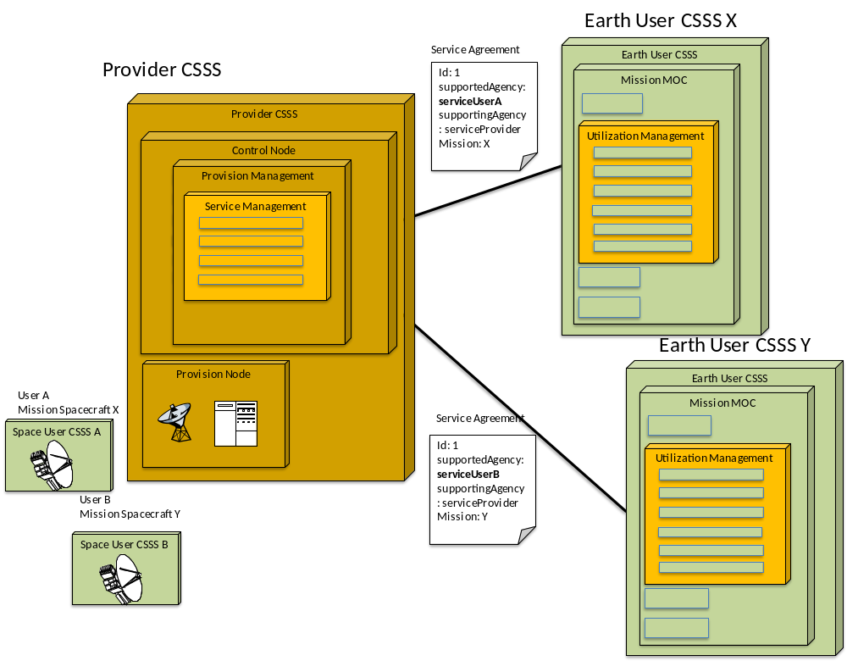
Figure C-3535: Provider Tracking Multiple Spacecraft from Different Missions

Solar System Internetwork Enterprise Model
  - General
The current scope of the concept for Extensible SCCS SM is focused on the IOAG Service Catalog #1 (reference [18]) services, which do not include space internetworking services. The enterprise model that includes space internetworking services is referred to in this concept as the SSI Enterprise Model. This annex presents a high-level introduction to the SSI Enterprise Model and explores the role of SCCS SM in the SSI Enterprise Model. SSI concepts in general are still being developed, and therefore the role of SCCS SM may change. This annex provides a snapshot of current notions.
The fundamental new concept as introduced by the SSI Enterprise Model is that all communications are cross-supported at the Network Layer. As a result, the number of data links that can be traversed is essentially unlimited: links across Earth Wide Area Networks (WANs), Earth-space links, space-space links, space-planet links, and planetary WANs can all serve as the underlying fabric of the SSI.
As with the SCCS SM Enterprise Model, the SSI Enterprise Model has both a functional view and a physical view. Subsections C2 and C3 present the functional view and physical view of the SSI Enterprise Model using RASDS graphical notation. Subsection C4 presents the SysML SSI Enterprise Model. SysML is the formal modelling language for enterprise models. This annex concludes with a summary of the role of SCCS SM in the SSI Enterprise in C5.
  - Functional View
Figure D-36 is the functional view of the SSI Enterprise. Within each CSSS, Network Processing and Routing functions process the Network Layer PDUs that originate in and/or pass through that CSSS. The SSI Enterprise introduces a new organizational domain, the agency-level SSI Internetwork Service Provider (SSI-ISP). Under current SSI concepts as defined by the IOAG (see reference [24]), the SSI-ISP coordinates internetworking activities across the SSI Enterprise. The Network Management function of the SSI-ISP has a strategic planning role in which it coordinates with all of the Missions and Provider CSSSes of the SSI-ISP’s agency to ensure that a fabric of space links is available over which the internetworking services may operate. Tactically, the Network Management function of the SSI-ISP will also coordinate the internetworking functions across the SSI through local Network Management functions. The SSI-ISPs of the various agencies will also coordinate among themselves to integrate the internetworking capabilities across the resources of all SSI member agencies. In the early days of SSI operation, this coordination will be performed indirectly, with the SSI-ISP identifying space link opportunities which will then be scheduled by the Missions via the Service Planning and Scheduling functions of Service Management, which is provided by a Network Management function that is separate from Service Management. Service Management will remain focused on the domain of space data links and the physical links that underlie them.
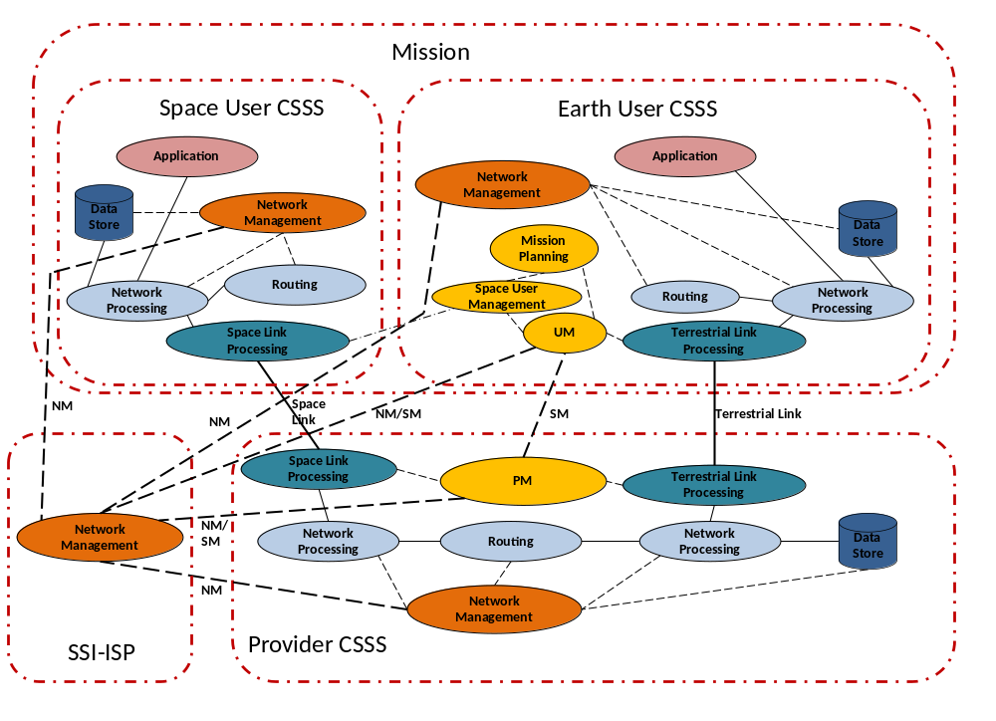
Figure D-3636: Functional View of the SSI Enterprise
Under the IOAG SSI concept, Network Management functions of the SSI-ISPs, Missions, and Provider CSSSes will remain separate from Service Management, which focuses on the domain of space data links and the physical links that underlie them. Although there has to be some coordination and synchronization between Network Management and Service Management, such coordination is outside the scope of this version of the extensible SCCS SM concept.
NOTE – The depiction of the relationships among the Network Management functions is notional. As the SSI Network Management concepts mature, these functions may be refined and their interrelationships redefined. However, since SSI network management is and will remain outside the scope of SCCS Service Management, this notional representation is sufficient for this extensible SCCS SM Concept.
The functional view identifies the functions that are present in the SSI Enterprise and the SSI-ISP and CSSSes that perform those functions. The most interesting (and useful) realizations of the SSI Enterprise replicate many of these functions within CSSSes and/or in multiple CSSSes in which the Network Processing, Routing, and Data Store functions are hosted by different types and multiplicities of nodes. The following subsection presents the physical views of two example SSI enterprises.
  - Physical View
Figure D-37 is the physical view of an example SSI-based Enterprise. In this example enterprise, the Mission (the ultimate user of SSI services in this example) and the Routing Satellite Mission belong to Agency Y. The ESLT Provider CSSS (a collection of ESLTs, of which one is shown in the figure) and the Earth Wide Area Network (WAN) Provider CSSS belong to Agency X.
In this example enterprise, the Mission has a Service Agreement with the Routing Satellite Mission to provide internetwork communications to its Spacecraft. In this relationship, the Routing Satellite Mission acts as a Provider CSSS for the Mission. In turn, the Routing Satellite Mission has a Service Agreement with the ESLT Provider CSSS to provide internetworking-over-space-link services via its collection of ESLTs. In this relationship, the Routing Satellite Mission acts as a user Mission. When the Mission wants to communicate with its Spacecraft, the Mission’s UM attempts to schedule a space link between the Spacecraft and the Routing Satellite (a Space Routing Node) with the Routing Satellite’s PM. The schedule request gets combined with requests from other Missions (not shown) and translated into an aggregate request to the ESLT Provider CSSS for space link services to/from the Routing Satellite. When the ESLT Provider CSSS schedules the space links in response to the request, the Routing Satellite Mission’s PM uses those times to determine the schedule for the space-space links between the Mission Spacecraft and the Routing Satellite.
The Agency X SSI-ISP coordinates the internetworking routing tables and other Network Layer information among the Network Management functions of the ESLT Provider CSSS, the Earth WAN Provider CSSS, and any SSI Missions that Agency X might own (not shown).
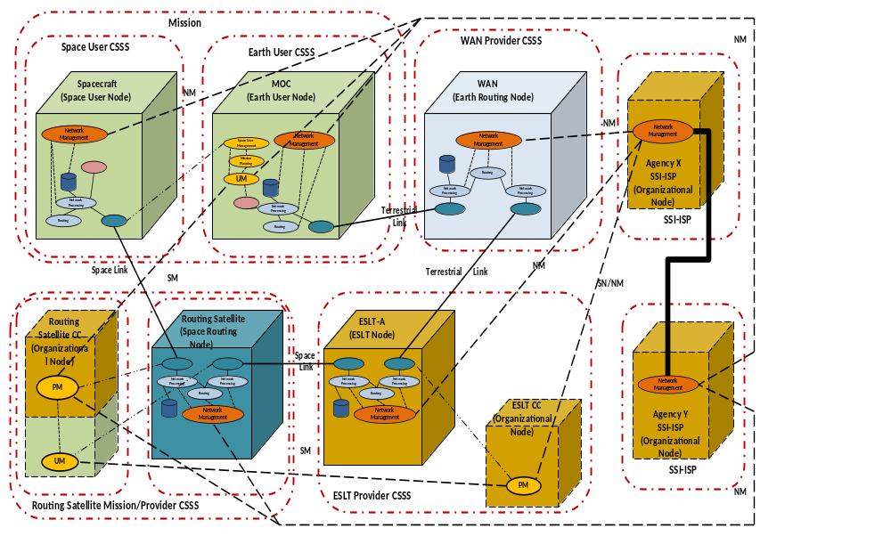
Figure D-3737: Physical View of Example SSI Enterprise
Because the Mission and the Routing Satellite Mission belong to Agency Y, they must coordinate their use of Agency X’s internetworking services through the Agency Y SSI-ISP. The SSI-ISPs negotiate and coordinate the internetworking traffic load that is expected to flow across the resource of the SSI-member Agencies. Part of this negotiation and coordination involves ensuring that adequate space link connectivity through the SSI will exist.
The Mission uses the services of the Earth WAN Provider CSSS to send and receive network PDUs (IP datagrams or DTN bundles) to/from the ESLT through which the path to the Mission Spacecraft will be established. The ESLT encapsulates the network PDUs from the MOC into the Earth-space data link PDUs and sends them to the Routing Satellite, which in turn extracts them from the Earth-space data link PDUs, determines that they are destined for the space-space data link to the Mission Spacecraft, and re-encapsulates them into the space-space data link PDUs of that link. The functions are performed in reverse for network PDUs travelling from the Mission Spacecraft to the MOC.
  - SysML SSI Enterprise Model
Figure D-38 is the SysML model for the SSI Enterprise Model, comprising a Mission, a Provider CSSS for Earth-space link services, a Provider CSSS for space routing services, and an SSI-ISP CSSS for coordinating internetworking activities. As conceived, there will be service management interfaces to the ISP to support network management of multiple providers to allow for routing services. Figure D-38 presents a sample configuration of an SSI Enterprise. This configuration corresponds to the SSI Enterprise illustrated in figure D-37 (without the Earth WAN Provider CSSS).
In this configuration, service management performs a level of management between the Provider CSSSes, which would include the planning, scheduling, and execution of spacecraft tracking services needed to perform the space relaying on behalf of the Mission. From an enterprise model perspective, the space routing node is modeled as a separate Provider CSSS in which it has service agreements developed between the two Provider CSSSes.
  - Role of SCCS SM in the SSI
The SSI Enterprise Model in figure D-37 goes beyond the current scope of SCCS SM in two ways. First, as previously stated, the current scope of SCCS SM is limited to IOAG Service Catalog #1 (reference [18]) services, which do not include space internetworking. Thus all of the Network Management functions and the interactions among them depicted in the figure are outside the scope of SCCS SM.
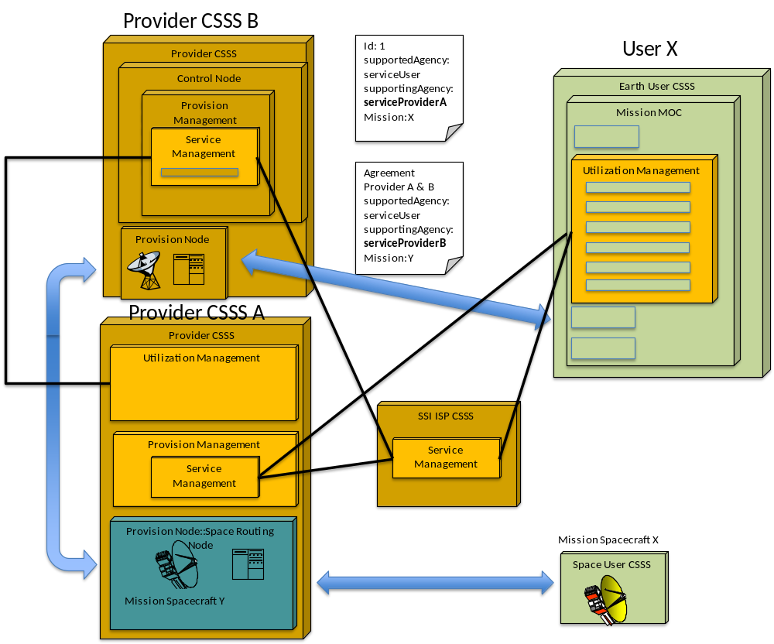
Figure D-3838: SSI Enterprise with Separate Earth-Space and Space Routing Service Providers
Second, the scope of SCCS SM is also limited to Provider CSSSes that provide Earth-space link services. In the context of the SSI Enterprise Model depicted in figure D-37, that corresponds to the ESLT Provider CSSS. In particular, it does not include:
- Any management of the Earth WAN Provider CSSS, which only provides terrestrial internetworking services. Any management coordination of Earth WAN services is in the purview of the Network Management functions of the SSI-ISP and the Earth WAN CSSS.
- The Service Management of the services provided by a space routing service provider (the Routing Satellite Mission in the example enterprise model). Future versions of the extensible SCCS SM concept, and the SCCS SM standards themselves, may address SCCS SM as it applies in this context.
As mentioned earlier, there will be some coordination and synchronization between the SSI-ISP and Service Management for the purposes of strategic planning of space links, but this is outside the scope of this version of the extensible SCCS SM concept. Any such capabilities will be addressed in future concepts for SCCS SM.
Finally, the SCCS SM Information Entities are available for use by SSI Network Management. For example, the Trajectory Prediction and Communications Geometry Information Entities may be used to exchange information among SSI-ISPs for the purpose of developing SSI routing tables.

Service Components and Functional Resource Types Used by the Example AOS and Telecommand Missions
  - Introduction
Subsection 6.2 identifies the SCCS ASCs and describes how SCs (which are specializations of the ASCs) comprise specific sets of FR Types. This annex describes the SCs that are associated with the services used in the Telecommand Mission and AOS Mission examples in 6.2 and identifies the FR Types that constitute those SCs.
NOTE – The Functional Resources for Cross Support Services Technical Note (reference [25]) describes all of thesSCs that are associated with IOAG Service Catalog #1 (references [18]) services and identifies the FR Types that constitute thosnsSCs.
  - RF Aperture SC Specialization of the Aperture ASC
The RF Aperture SC specialization of the Aperture ASC consists of the Antenna FR Type. One antenna can be used by multiple forward and/or return space links simultaneously. The Antenna FR Type also encompasses the tracking receiver used to lock onto the RF signal for the purposes of autotracking.
  - CCSDS 401 Forward Physical Channel Transmission SC Specialization of the Forward Physical Channel Transmission ASC
The FR Types that compose the CCSDS 401 Forward Physical Channel Transmission SC specialization of the Forward Physical Channel Transmission ASC are:
- Forward Space Link Carrier Transmission;

- Forward Link Ranging
- .
  - Forward Synchronization and Channel EnCoding ASC
    - TC Sync and Channel Encoding SC
The TC Sync and Channel Encoding SC specialization of the Forward Sync and Channel Encoding ASC consists of the TC Channel Synchronization and Encoding FR Type.
    - AOS Forward Sync and Channel Encoding SC
The AOS Forward Sync and Channel Encoding SC specialization of the Forward Sync and Channel Encoding ASC consists of the Forward AOS Channel Synchronization and Encoding FR Type.
  - Forward Space Link Protocol ASC
    - TC Space Link Protocol SC
The FR Types that compose the TC Space Link Protocol SC specialization of the Forward Space Link Protocol ASC are:
- TC MC Multiplexing;
- TC VC Multiplexing;
- TC Encapsulation, VC Packet Processing, and VC Generation;
- Multiplexer Access Point (MAP) Multiplexing; and
- Encapsulation and MAP Packet Processing.
NOTE – The Encapsulation and MAP Packet Processing FR Type is not used by the example Telecommand Mission in 6.2.
    - Forward AOS Space Link Protocol SC
The FR Types that compose the Forward AOS Space Link Protocol SC specialization of the Forward Space Link Protocol ASC are:
- AOS MC Multiplexing;
- AOS VC Multiplexing; and
- AOS Encapsulation, Packet Processing, and VC Generation.
NOTE – This FR Type is not used by the example AOS Mission in 6.2.
  - CCSDS 401 Return Physical Channel Reception SC SPECIALIZATION OF the Return Physical Channel Reception ASC
The FR Types that compose the CCSDS 401 Return Physical Channel Reception SC specialization of the Return Physical Channel Reception ASC are:
- Return Space Link Carrier Reception; and

- Range and Doppler Extraction.
  - Return TM Synchronization and Channel DeCoding SC Specialization of the Return Synchronization and Channel DeCoding ASC

    - The Return TM Synchronization and Channel Decoding SC specialization of the Return Synchronization and Channel Decoding ASC consists of the Return TM Synchronization and Decoding FR Type.
  - Return TM/AOS Space Link Protocol SC Specialization of the Return Space Link Protocol Reception ASC
The FR Types that compose the Return TM/AOS Space Link Protocol SC specialization of the Return Space Link Protocol Reception ASC are:
- MC Demultiplexing and Reception;
- VC Demultiplexing and Reception; and
- Packet Extraction and De-encapsulation.
NOTE – Of these FR Types, only the MC Demultiplexing and Reception FR Type is use in the example Telecommand Mission in 6.2.
  - Transfer Frame Data Sink SC Specialization of the SLS Data Delivery Production ASC
The Transfer Frame Data Sink SC specialization of the SLS Data Delivery Production ASC consists of the Frame Data Sink FR Type.
  - Real-Time Radiometric Data SC specialization of the SLS Radiometric Data Production ASC
The FR Types that compose the Real-Time Radiometric Data SC specialization of the SLS Radiometric Data Production ASC are:
- Tracking Data Message (TDM) Segment Generation; and
- TDM Sink.

  - Offline Data Storage ASC
    - Offline Frame Buffer SC
The Offline Frame Buffer SC specialization of the Offline Data Storage ASC consists of the Offline Frame Buffer FR Type.
    - TDM Recording Buffer SC
The TDM Recording Buffer SC specialization of the Offline Data Storage ASC consists of the TDM Recording Buffer FR Type.

  - Data Transfer ServiceS ASC
    - SLE FSP SC
The SLE FSP SC specialization of the Data Transfer Service ASC consists of the FSP Transfer Service Provider FR Type.
    - SLE F-CLTU SC
The SLE F-CLTU SC specialization of the Data Transfer Services ASC consists of the F-CLTU Transfer Service Provider FR Type.
    - SLE RAF SC
The SLE RAF SC specialization of the Data Transfer Service ASC consists of the RAF TS Provider FR Type.
    - SLE RCF SC
The SLE RCF SC specialization of the Data Transfer Services ASC consists of the RCF TS Provider TS Type.
    - SLE ROCF SC
The SLE ROCF SC specialization of the Data Transfer Services ASC consists of the ROCF TS Provider TS Type.

    - TD-CSTS SC

The TD-CSTS Data SC specialization of the Data Transfer Services ASC consists of the Tracking Data CSTS Provider FR Type.
  - Monitored Data SC specialization of the Service Management FUNCTIONS ASC
The FR Types that compose the Monitored Data SC specialization of the Service Management Functions ASC are:
- Monitored Data CSTS Provider;
- Monitored Data Production.

