CCSDS RID System – Pre-Requirements
Overview:
The following Requirements below should be qualified as “Pre-Requirements” or “Wish List Requirements” that have been, compiled by numerous CCSDS suggestions over the past several years. It is assumed that both the CESG and CMC will formalize which requirements are necessary in order to develop a new CCSDS RID System. In summary, these requirements address these key needs for the next CCSDS RID system upgrade:
- Support RID submission approval through center-level and agency-level.
- Allow more visibility and accountability into RID dispositions for documents that are being submitted for CCSDS reviews
Product Selection:
The new CCSDS RID System will be developed using the SharePoint 2013 Platform.
Assumptions:
In these scenarios, it is assumed that CCSDS supporters and review team members can “in good faith” be trusted to enter correct and valid data, for example, statements of RID authors disagreement or revisions to “approved” and “not reviewed” check boxes. This system should make a reasonable effort to prevent accidental mistakes, but it cannot prevent an attempt to subvert an honest review process.
PRE-REQ-001: RID Input Form:
The RID system will provide an online RID entry form like the current online RID entry form.
Example (see also figure): http://public.ccsds.org/sites/cwe/rids/Lists/CCSDS%2091011R2/NewForm.aspx?Source=http%3A%2F%2Fpublic%2Eccsds%2Eorg%2Fsites%2Fcwe%2Frids%2FLists%2FCCSDS%252091011R2%2FNASAUSOverview%2Easpx)
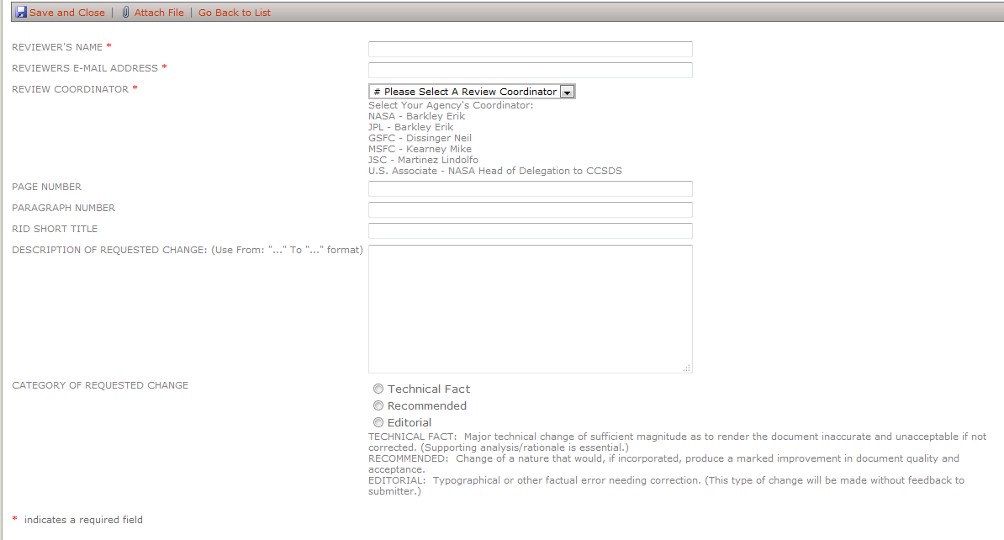

a) The RID form will have pull down boxes for which agency/center the RID Author works for.
- Add field “Why the change is being requested”
- Add rationale box “Rationale for the requested change”
- Requires “Reviewer registration”
  - Consider listing registration info so that if it’s wrong the reviewer will notice and fix it
- Review coordinator becomes “agency-center” (NASA-MSFC, NASA-JSC, ESA-ESOC, JAXA, etc.)

b) Before or during RID entry, the RID Author can see RIDs, which have already been, submitted (note – only from their organization?). This will allow the RID Author to avoid submitting duplicate entries. The RID Author should have access to a tabular listing of RIDs sortable by any header, a search capability for RIDs with keywords, and a full-screen display of any RID selected.

PRE-REQ-002: RID Submission Review Capabilities
a) There will be three levels of “submission approval”. This is the approval to submit the RID, not related to actually disposition the RID itself. Approval to submit occurs in sequence:
- Center level (e.g. JSC, JPL, ESOC, ESTEC, etc.)
- Agency level (e.g. NASA, ESA, INPE, etc.)
- International Review Coordinator (the RID coordinator gathering all the RIDS to start the review).

b) To support agency and center reviews, these dates will be established:
- RID Closure date – after this date no additional RIDs are accepted from the teams
- Center and agency reviews are allowed one week each before the international review date.
- Desirable: Coordinators can set the due dates for their organization. Starts with a default, but coordinators can change them (one week two weeks, etc.).

c) At each level, an approved reviewer will be able to log on to the CCSDS RID system (using CWE ID or RID Reviewer ID) and check a box to indicate approval or non-approval of that RID to be submitted to the next level.
C2) There will be a checkbox (etc.) for “approved to submit to next level,” “disapproved,” and “not reviewed at center level”. The default will be the latter. There will be a disposition (in effect, rationale or supporting analysis) required for any rejection.

d) RID writer should be able to save a RID without forwarding to a coordinator. “Save for later” or “Submit”. Each writer (CWE ID) would need to be able to see a list of his RIDs (saved or submitted), open them, and revise them if they are not yet submitted.
D2) Alternatively, he could withdraw it. In this case, the author withdraw amounts to an author rejection similar to center rejection or agency rejection, etc. However rationale is needed, but only for center, agency and international rejections.

e) Coordinators start with a default status of “not yet reviewed” which they can change to “approved” (to go to next level), “Rejected”, or “returned to originator” (for revision and resubmission by originator). “Rejected” or “returned to originator” require a rationale that asks for changes or revisions.

f) Immediately after the RID closure date (within a week after RID closure), a center level submission reviewer goes over the RIDs at his center and he checks one of the first two boxes (approved or disapproved). This must be done by two weeks before the RID closure date. He will be able to select between a full-screen view of each RID individually, and a tabular listing with cut-off descriptions. On the tabular listing, the user will be able to “approve all”, “clear all” (revert to not reviewed), sort by any header (date, title, RID Author, etc.). He will also be able to export the tabular listing to Excel (but not import it… selection boxes must be made online). He cannot revise the originator’s RID; he can only return it to the originator and ask for changes.

g) Immediately after the Center Submission Review is complete (from one week to two weeks after RID closure), an agency level reviewer goes over the RIDs from his agency, and he sees a similar display (approved/disapproved/not reviewed) and has similar capabilities. He also sees a column that displays the result of the center level reviewer. He also has buttons for “approve all”, “disapprove all”, “clear all”.

h) Throughout their particular review period, center and agency level, users can change only their status on forwarding/rejected. Coordination between center and agency activities is procedural on the one-week increments (email/phone). After the review period, center and agency approvals/rejection are “locked in”, and they must call the overall RID coordinator to make any changes in submission approval after that.

i) Immediately after the Agency Submission Review is complete, the Overall RID coordinator goes over the RIDs from all agencies and “other”. The user performs a similar function (approved/disapprove, not reviewed). Procedurally, if the user gets something from “other” that has not been approved for submission by an agency but looks like it should have, the user will contact the agency lead.

- Observer agencies submit directly to the CCSDS Coordinator.
- Associates submit to the agency review coordinator with which they are associated.
  - Associates that are NASA contractors may be best handled as NASA center authors. We need guidelines to explain to the rid writer how to figure out his “chain of command” for RID reviews. These guidelines should probably happen when they submit their info for their profile, which they can update at any time (from one review to the next)
- Liaisons and “Others” submit to the Secretariat.
- All of these are determined by what’s in the RID originator’s profile.

j) Any RID that does not have the RID Coordinator “disapproved for submission” box checked is not forwarded to the next level (just like the current system). The RID stays in the database, but is not forwarded. There should be some way to flag this status of “un-reviewed” when the review is over so someone will take action.

k) Coordinators do not have the ability to change most of the author’s original RID text, but they do have the capability to change between Technical and Editorial.

PRE-REQ-003: RID Disposition Capabilities
a) The Overall RID Coordinator enters proposed dispositions and coordinates their proposed dispositions with the RID Authors. The RID Authors can also see the dispositions on the website.

b) Beneath the disposition text, there are these check boxes:
- RID Author agrees with disposition
- RID Author disagrees with disposition
- RID Author allows closure with registered disagreement
And this text field: “RID author statement about disagreement”.

c) After the RID disposition process is over, the database is “locked” into display mode only. Procedurally the RID database will be locked by the secretariat when (A) requested by the Overall RID coordinator, (B) directed by the CESG, or (C) the document is submitted for a CESG or CMC poll which is based on completion of the RID process.

d) If some additional changes are to be made to the database, the Secretariat, with approval from one of the CESG co-chairs, can “unlock” the RID database and allow modifications (for example, from “RID Author allows closure with registered disagreement” to “RID Author agrees with disposition”).

PRE-REQ-002: Post-RID Review Capabilities
a) All of the “read-only” capabilities described in earlier phases are available to any CWE user. Any CWE user should be able to log onto the RID database for any document at any time and see the full-page listing of any RID, or the tabular listing. In the process, he should be able to search for a RID by the content of any of the fields.

b) From the tabular listing sorted by any header, or from a tabular listing resulting from a search query, a user should be able to click “export” and get an Excel Spreadsheet download of that listing.

c) In the tabular listing displays, any RID with “disapprove” in any column gets a red or other distinctively colored background.

