- DRAFT
VARIABLE-LENGTH SUPERVISORY
PROTOCOL DATA FIELD FORMATS
(NORMATIVE)
  - Overview
These directives are fixed length SPDUs, currently documented in CCSDS 211.0 in 3.2.4.3 Fixed Length SPDU.
- a ‘1’ in the SPDU Format ID field and a 0’ in the SPDU Type Identifier field identifies the SPDU as a 16 bit PLCW. Note: Currently used in proximity operations at Mars.
- a ‘1’ in the SPDU Format ID field and a 1’ in the SPDU Type Identifier field identifies the SPDU as a 32 bit PLCW.

The 32 bit PLCW including the SPDU header shall consist of seven fields positioned contiguously in the following sequence (described from least significant bit, Bit 15, to most significant bit, Bit 0—see figure 3-5):
- Report Value (16 bits);
- Expedited Frame Counter (3 bits);
- PCID (1 bit);
- Retransmit Flag (1 bit);
- Reserved Spares (9 bits);
- SPDU Type Identifier (1 bit);
- SPDU Format ID (1 bit).
NOTE – This PLCW shall be transmitted using the Expedited QoS.
Table B-1 : Variable-Length Supervisory Protocol Data Unit
Variable-Length SPDU | SPDU Header  (1 octet, fixed) |  |  | SPDU Data Field  (0-15 octets)
 | Format ID  (Bit 0) | SPDU Type Identifier  (Bits 1,2,3) | Length of SPDU Data Field  (Bits 4,5,6,7) | (Contains 1 or more protocol objects, i.e., directives, reports)
Type 1 | ‘0’ | ‘000’ | Length in Octets | Directives/Reports for UHF operations
Type 2 | ‘0’ | ‘001’ | " | Time Distribution PDU
Type 3 | ‘0’ | ‘010’ | " | Status Reports
Type 4 | ‘0’ | ‘011’ | " | First Generation Lunar Use
Type 5 | ‘0’ | ‘100’ | " | Second Generation Lunar Use
Type 6 | ‘0’ | ‘101’ | " | Reserved for CCSDS Use
Type 7 | ‘0’ | ‘110’ | " | Reserved for CCSDS Use
Type 8 | ‘0’ | ‘111’ | " | Reserved for CCSDS Use
NOTE – Directives and Reports can be multiplexed within the SPDU Data Field.
  - Variable-Length SPDU
    - General
A ‘0’ in the SPDU Format ID field shall identify a variable-length SPDU data field, which may contain from 0 to 15 octets of supervisory data.
NOTE – This form of SPDU uses bits 1 through 3 of the SPDU header to identify one of eight possible SPDU types, summarized in table B-1. Reference source not found. Currently three of these eight types are defined in the following two subsections. The remainder are reserved for future CCSDS specification.
    - Type 1 SPDU: 1st Generation: UHF band communication directives used at Mars
An SPDU Type Identifier equal to ‘000’ shall identify a Type 1 SPDU with a data field containing from 0 to 15 octets containing 1st generation UHF directives.
NOTE – Variable-length SPDU Types are shown in table B-1. Formats of variable-length SPDU data fields are defined in annex B.
    - Type 2 SPDU: Time Distribution directives
An SPDU Type Identifier equal to ‘001’ shall identify a Type 2 SPDU with a data field containing from 1 to 15 octets of Time Distribution supervisory data.
Octet 0 of the data field shall contain the time distribution directive type, followed by the actual time field value (1 to 14 octets).
NOTE – Variable-length SPDU Types are shown in table B-1. Formats of variable-length SPDU data fields are defined in annex B.
    - Type 3 SPDU: Status Report directives
An SPDU Type Identifier equal to ‘010’ shall identify a Type 3 SPDU with a data field containing from 0 to 15 octets of Status Report information.
NOTES
- The format of these reports is enterprise specific and is left up to the implementation.
- Provision is made in the protocol to identify when a status report is required (NEED_STATUS_REPORT) and when a status report is requested (see Type 1 SPDU Report Request, B1.6).
    - Type 4 SPDU: First Generation Lunar Use
An SPDU Type Identifier equal to ‘011’ shall identify a Type 4 SPDU with a data field containing from 0 to 15 octets which is assigned to the first generation of Lunar missions.
    - Type 5 SPDU: Second Generation Lunar Use
An SPDU Type Identifier equal to ‘100’ shall identify a Type 5 SPDU with a data field containing from 0 to 15 octets containing the second generation Lunar directives.
    - Type 6 through 8 SPDUs: Reserved for CCSDS Use
An SPDU Type Identifier equal to ‘101’, ‘110’, and ‘111’ shall identify a Type 6 through Type 8 SPDU with a data field containing from 0 to 15 octets which are reserved for CCSDS Use.
  - SPDU Type 4: First Generation Lunar Use
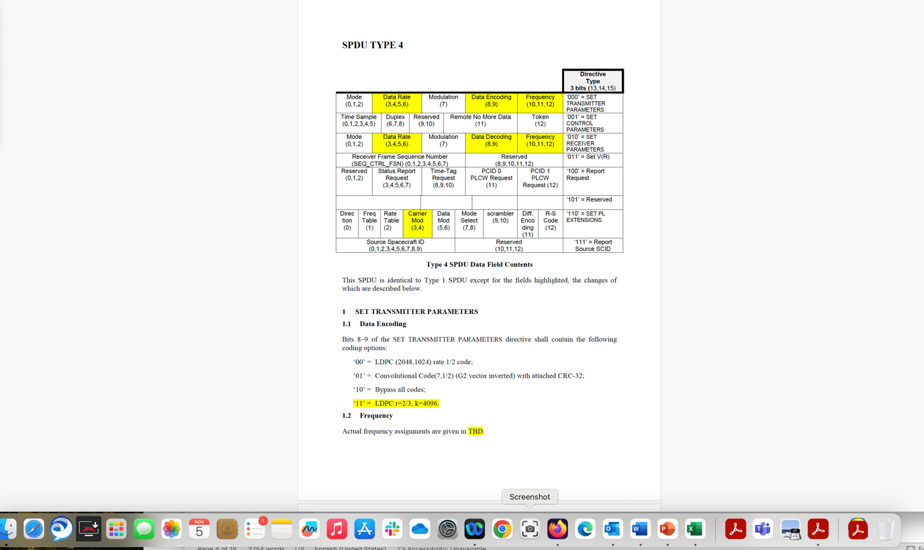
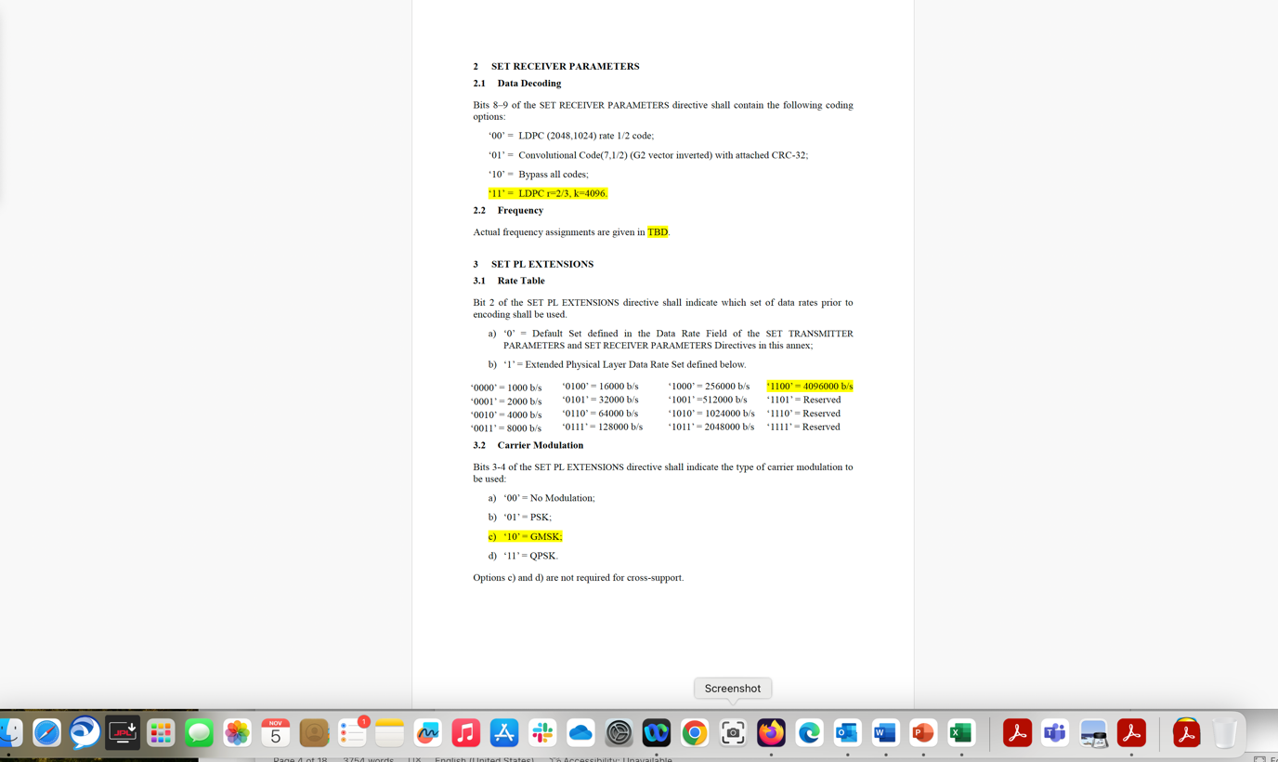
  - SPDU type 5: Second Generation Lunar Use
    - General
These directives shall be used for space link supervisory configuration and control of the transceiver and its operation at S-band.
The SPDU data field (see table B-1) shall contain between 0 to 15 octets of supervisory data.
Each directive shall perform a specific function;
- each directive shall not exceed 120 bits (15 octets times 8 bits) in length and shall be self-identified by the value in the directive name field (contained in bits 0 through 2 of the directive);
- concatenation of the directives shall be allowed without intervening bits within the data field of the SPDU Type 5 as long as the total SPDU data field length does not exceed 120 bits.
NOTE – Figure B-1 shows the SPDU Type 5 directive contents. The size of each field is given below in bits.
Directive Name
‘000’ = Link Establishment & Control  (3)  Size = 96 bits | Spare  (1) | Link Direction  (1) |  | Demand/  Query  (1) |  |  | Query Response  (1) |  |  | RNMD  (1) |  | Token  (1 | Duplex/ Simplex  (3 | Polarization  (1) | Coherent/Non-coherent  (1) | Spares  (2 | Modulation  (4 | Mod  Index  (3 | Spare (1 | Coding  (6) |  | Transceiver  Mode  (2) | Instantaneous Link SNR  (8) | Spares  (8) | Symbol Rate  (16) | Freq  uency  (32)
‘001’ = Report Request  (3)  Size = 16 bits | PCID 0  PLCW Request  (1) |  |  |  | PCID 1  PLCW Request  (1) |  |  |  | Time Tag  Sample Request  (6) |  |  |  |  |  |  |  |  | Status  Report  Request  (5)
‘010’ = Set V(R)  (3)  Size = 16 bits | Reserved  (5) |  |  |  |  |  |  |  |  |  |  |  |  |  |  |  |  | Frame Seq. Number  (8)
‘011’ = Report Source Spacecraft ID  (3)  Size = 32 bits | Reserved  (13) |  |  |  |  |  |  |  |  |  |  |  |  |  |  |  |  | Source SCID  (16)
‘100’ = Reserved
‘101’ = Reserved
‘110’ = Reserved
‘111’ = Reserved
Figure B-1 : Type 5 SPDU Data Field Contents
    - LINK ESTABLISHMENT & CONTROL DIRECTIVE
      - General
The LINK ESTABLISHMENT & CONTROL directive is used to initiate communication via hailing, then move on to a working channel, and allow for follow on link control changes between partnered transceivers. A caller transceiver is the initiator of the link establishment process and manager of negotiation (if required) of the link session. A responder transceiver typically receives link establishment parameters from the caller. The caller initiates communication between itself and a responder on a prearranged communications (hailing) channel with predefined controlling parameters. As necessary, the caller and responder may negotiate the controlling parameters for the session at some level between fully controlled (demand) and completely adaptive (negotiated by query). These roles are invariant throughout the link session.
To accomplish hailing, this directive is transmitted back-to-back within the same transfer frame to establish both the forward and return link initial communication conditions. Similarly, once the link is established, the same approach is used to move onto the selected working channel. This directive is equivalent to the SET TRANSMITTER PARAMETERS and SET RECEIVER PARAMETERS or SET PL EXTENSIONS directives for SPDU Type 1 applications. It consists of 20 fields, positioned contiguously in the following sequence (described from the most significant bit, Bit 0, to least significant bit 95):
- Directive Name (3 bits);
- Spare (1 bit);
- Link Direction (1 bit);
- Demand/Query (1 bit);
- Query Response (1 bit);
- Remote No More Data (RNMD) (1 bit);
- Token (1 bit);
- Duplex/Simplex (3 bits);

- Polarization (1 bit);
- Coherent/Non-coherent (1 bit);
- Spares (2 bits);
- Modulation (4 bits);
- Modulation Index (3 bits);

- Spare (1 bit);
- Coding (6 bits);
- Transceiver Mode (2 bits);
- Instantaneous Link SNR (8 bits);
- Spares (8 bits);
- Symbol Rate (16 bits);
- Frequency (32 bits);

NOTE – The structural components of the directive LINK ESTABLISHMENT & CONTROL directive are shown in figure B-2.
 |  | Bit 0 |  |  |  |  |  |  |  |  |  |  |  |  |  | Bit 47
 | Directive Name |  | Spare | Link Direction | Demand/ Queryt |  | Query Response | RNMD | Token | Duplex/ Simplex |  | Polarization |  | Coherent/Non-Coherent | Spares |  | Modulation | Mod Index | Spare | Coding |  | Transceiver Mode | Inst. Link SNR | Spares |  | Symbol Rate |  | Frequency
 | 3 bits |  | 1 bit | 1 bit | 1 bit |  | 1 bit | 1 bit | 1 bit | 3 bits |  | 1 bit |  | 1 bit | 2 bits |  | 4 bits | 3 bits | 1 bit | 6 bits |  | 2 bits | 8 bits | 8 bits |  | 16 bits |  | 32 bits
 | 0-2 |  | 3 | 4 | 5 |  | 6 | 7 | 8 | 9-11 |  | 12 |  | 13 | 14-15 |  | 16-19 | 20-22 | 23 | 24-29 |  | 30-31 | 32-39 | 40-47 |  | 48-63 |  | 64-95
Figure B-2 : LINK ESTABLISHMENT & CONTROL DIRECTIVE
      - Directive Name
Bits 0–2 of the LINK ESTABLISHMENT & CONTROL directive shall contain the Directive Name.
The 3-bit Directive Name field identifies the name of SPDU Type 5 protocol control directive and shall contain the binary value ‘000’ for the LINK ESTABLISHMENT & CONTROL directive.
      - Spare
Bit 3 of the LINK ESTABLISHMENT & CONTROL directive shall contain 1 spare bit reserved by the CCSDS.
      - Link Direction
Bit 4 of the LINK ESTABLISHMENT & CONTROL directive shall indicate the link direction (Forward or Return link).
- ‘0’ = Return Link;
Return is the link direction in which the responder transmits and the caller receives (e.g., typically a telemetry link). This directive sets the responder’s transmitter parameters.
- ‘1’ = Forward Link.
Forward is the link direction in which the caller transmits and the responder receives (e.g., typically a command link). The caller (i.e., link initiator) is the node that transmits the Hail Directives. This directive sets the responder’s receiver parameters.
      - Demand/Query
Bit 5 of the LINK ESTABLISHMENT & CONTROL directive shall contain either a Demand (caller expects the responder to accept the parameters in this directive ‘as is’) or as a Query to negotiate these link parameters specified in this directive between the caller and the responder. Used in hailing, moving onto a working channel, link control, and link termination.
- ‘0’ = Demand (Command);
- ‘1’ = Query (Link Negotiation).
      - Query Response
Bit 6 of the LINK ESTABLISHMENT & CONTROL directive shall indicate whether the demand or the query was accepted or rejected by the responder.
- ‘0’ = ACK;
- ‘1’ = NACK.
      - Remote No More Data (RNMD)
Bit 7 of the LINK ESTABLISHMENT & CONTROL directive shall contain the Remote No More Data (RNMD) field as follows:
- ‘0’ = No Change;
- ‘1’ = Remote Node has No More Data to Send (RNMD).
NOTE – This field plays a role in link termination. This field either notifies the caller that either there is no change in the responder’s data state (i.e., ignore this field) or notifies the caller that the responder has no more data to send, in which case, the link may be terminated when the responder locally has no more data to send.
      - Token
Bit 8 of the LINK ESTABLISHMENT & CONTROL directive shall contain the value of the Token field as follows:
- ‘0’ = No Change;
- ‘1’ = Transmit.
NOTE – This field either notifies the responder that there is no change in who has permission to transmit (i.e., ignore this field) or commands the responder to the transmit state.
      - Duplex/Simplex
Bits 9-11 of the LINK ESTABLISHMENT & CONTROL directive shall contain the Duplex/Simplex field as follows:
- ‘000’ = No Change;
- ‘001’ = Full Duplex;
- ‘010’ = Half Duplex;
- ‘011’ = Simplex Transmit;
- ‘100’ = Simplex Receive;
- ‘101’ = Reserved;
- ‘110’ = Reserved;
- ‘111’ = Reserved.
NOTE – This field either notifies the responder that there is no change in the responder’s Duplex state (i.e., ignore this field) or notifies the responder to change the directionality of communication accordingly.

      - Polarization
Bit 12 of the LINK ESTABLISHMENT & CONTROL directive shall contain the Polarization field as follows:
- ‘0’ = Left Hand Circular Polarization;
- ‘1’ = Right Hand Circular Polarization.
      - Coherent/Non-coherent
Bit 13 of the LINK ESTABLISHMENT & CONTROL directive shall contain the transceiver coherent or non-coherent option as per below:
- ‘0’ = Coherent;
- ‘1’ = Non-coherent.

      - Spare
Bits 14-15 of the LINK ESTABLISHMENT & CONTROL directive shall contain 2 spare bits reserved by the CCSDS.
      - Modulation
Bits 16-19 of the LINK ESTABLISHMENT & CONTROL directive shall contain the modulation options based upon the values below.
- ‘0000’ = PCM/PM/Bi-phase-L (filtered);
- ‘0001’ = GMSK;
- ‘0010’ = RESERVED BY CCSDS;
- ‘0011’ = RESERVED BY CCSDS;
- ‘0100’ = RESERVED BY CCSDS;
- ‘0101’ = RESERVED BY CCSDS;
- ‘0110’ = RESERVED BY CCSDS;
- ‘0111’ = RESERVED BY CCSDS;
- ‘1000’ = RESERVED BY CCSDS;
- ‘1001’ = RESERVED BY CCSDS;
- ‘1010’ = RESERVED BY CCSDS;
- ‘1011’ = RESERVED BY CCSDS;
- ‘1100’ = RESERVED BY CCSDS;
- ‘1101’ = RESERVED BY CCSDS;
- ‘1110’ = RESERVED BY CCSDS;
- ‘1111’ = RESERVED BY CCSDS.

      - Modulation Index
Bits 20-22 of the LINK ESTABLISHMENT & CONTROL directive shall set the modulation index based upon the values below.
- ‘000’ = 0 rad/pk (No Modulation);
- ‘001’ = 0.4 rad/pk;
- ‘010’ = 0.6 rad/pk ;
- ‘011’ = 0.8 rad/pk;
- ‘100’ = π/3 rad/pk (60 degrees);
- ‘101’ = 1.15 rad/pk ;
- ‘110’ = 1.3 rad/pk ;
- ‘111’ = 1.4 rad/pk.

      - Spare
Bit 23 of the LINK ESTABLISHMENT & CONTROL directive shall contain 1 spare bit reserved by the CCSDS.
      - Coding
Bits 24-29 of the LINK ESTABLISHMENT & CONTROL directive shall contain the following coding options:
- ‘000000’ = Uncoded;
- ‘000001’ = LDPC(2048,1024);
- ‘000010’ = Reserved by CCSDS;
- ‘000011’ = Reserved by CCSDS;
- ‘000100’ = Reserved by CCSDS;
- ‘000101’= LDPC(6144,4096);
- ‘000110’= Reserved by CCSDS;
- ‘000111’= Reserved by CCSDS;
- ‘001000’= Reserved by CCSDS;
- ‘001001’= Reserved by CCSDS;
- ‘001010’ = LDPC(8160,7136);
- ‘001011’ through ‘111111’ = Reserved by CCSDS.

      - Transceiver Mode
Bits 30-31 of the LINK ESTABLISHMENT & CONTROL directive shall contain the Transceiver Mode options. This field identifies the data link layer protocol operating in the transceiver:
a) ‘00’ = Proximity-1;
b) ‘01’ = USLP;
c) ‘10’ = AOS;
d) ‘11’ = Reserved by CCSDS.
      - Instantaneous Link SNR
Bits 32-39 of the LINK ESTABLISHMENT & CONTROL directive shall contain the link Signal-to-Noise (SNR) ratio Es/N0 in dB. Valid values range from -31.75 to 31.75 in quarter dB steps. A value of -32 indicates that the value is unavailable or invalid. This value is a signed fixed point number.
      - Spare
Bits 40-47 of the LINK ESTABLISHMENT & CONTROL directive shall contain 8 spare bits reserved by the CCSDS.
      - Symbol Rate

Bits 48-63 of the LINK ESTABLISHMENT & CONTROL directive shall indicate the symbol rate in symbols per second. This value is a binary16-bit whose format is specified by the IEEE 754 standard for half-precision floating point numbers i.e., 1 sign bit (always set positive), 5 bits exponent, and 10 bits mantissa/significand.

To derive the value of this field, the symbol rate in symbols per second shall be divided by 2^16 and then converted to IEEE 754 half-precision floating point.
To derive the symbol rate value from the field value, the opposite operation shall be done, i.e. the floating point value shall be multiplied by 2^16.
The minimum symbol rate allowable is 1,000 symbols/s.
In S-band, the maximum symbol rate value allowable is 4,096,000 symbols/s.
The sign bit is always transmitted as a positive value and the ‘all ones’ that is, ‘11111’ exponent value is excluded.
NOTE: Symbol Rate assignment must take into consideration the actual spectrum available.
NOTE: The default hailing symbol rate is 2,000 sps, which is LDPC (2048,1024) encoded.
NOTE: Symbol rate values in the range from 1,000 symbol/s to 4,096,000 symbols/s are represented with a precision of 0.1%.
      - Frequency
Bits 64-95 of the LINK ESTABLISHMENT & CONTROL directive shall be used to set the frequency of the partnered transceiver to the desired value (either receive or transmit frequency based upon the value of the Link Direction field defined in B3.2.4). The format of this value is a binary32-bit specified by the IEEE 754 standard for single precision floating point numbers i.e., 1 sign bit (always set positive), 8 bits exponent, and 24 bits mantissa/significand.
NOTE – Frequency channel assignments including hailing channels are defined in the Proximity-1 Physical Layer Blue Book reference [X].

    - REPORT REQUEST DIRECTIVE
      - General
The REPORT REQUEST directive is the mechanism by which either (1) a status report, (2) time-tag sample collection, or (3) a PLCW per PCID can be requested of a Proximity-1 node. It shall consist of five fields, positioned contiguously in the following sequence (described from the most significant bit, Bit 0, to the least significant bit, Bit 15):
- Directive Name (3 bits);
- PCID 0 PLCW Request (1 bit);
- PCID 1 PLCW Request (1 bit);
- Time-Tag Sample Request (6 bits);
- Status Report Request (5 bits).
NOTE – The structural components of the REPORT REQUEST directive are shown in figure B-3.
Bit 0 |  |  |  |  |  | Bit 15
Directive Name  3 bits | PCID 0  PLCW Request  1 bit | PCID 1  PLCW Request  1 bit |  | Time-Tag Sample Request  6 bits | Status Report  Request  5 bits
0-2 | 3 | 4 |  | 5-10 | 11-15
Figure B-3 : Report Request Directive
      - Directive Name
Bits 0-2 of the REPORT REQUEST directive shall contain the Directive Type.
The 3-bit Directive Type field identifies the type of protocol control directive and shall contain the binary value ‘001’.
      - Physical Channel ID 0 PLCW Report Request Field
Bit 3 of the REPORT REQUEST directive shall indicate whether a PLCW report for PCID 0 is required:
- ‘1’ = PLCW report is needed for PCID 0; transmit this report on the same PCID that the report request arrived on.
- ‘0’ = PLCW report is not required.
      - Physical Channel ID 1 PLCW Report Request Field
Bit 4 of the REPORT REQUEST directive shall indicate whether a PLCW report for PCID 1 is required:
- ‘1’ = PLCW report is needed for PCID 1; transmit this report on the same PCID that the report request arrived on.
- ‘0’ = PLCW report is not required.
      - Time-Tag Sample Request Field
Bits 5-10 of this directive shall contain the Time-tag Sample Request field. When this field is non-zero, it notifies the recipient to capture the time and frame sequence number (associated with the Proximity timing service; see section 5) for the next n frames received, where n is the number of Proximity Transfer Frames contained within the Time Sample Field.
      - Status Report Request
The value contained in bits 11–15 of the REPORT REQUEST directive shall indicate the type of status report desired.
If set to ‘00000’, a status report is not required.
The types of status reports are reserved for CCSDS use as SPDU Type 3 directives.
    - SET V(R) DIRECTIVE
      - General
The SET V(R) directive used in the COP-1 (Reference X) and COP-P (Reference Y) procedures shall consist of three fields, positioned contiguously in the following sequence (described from most significant bit, Bit 0 to the least significant bit, Bit 15):
- Directive Name (3 bits);
- Spare (5 bits);
- Receiver Frame Sequence Number (SEQ_CTRL_FSN) (8 bits).
NOTE – The structural components of the SET V(R) directive are shown in figure B-4.
Bit 0 |  |  |  |  |  | Bit 15
Directive Name  3 bits |  |  | Spare  5 bits |  |  |  | Receiver Frame Sequence Number SEQ_CTRL_FSN  8 bits
0-2 |  |  | 3-7 |  |  |  | 8-15
Figure B-4 : SET V(R) Directive
      - Directive Name
Bits 0-2 of the SET V(R) directive shall contain the Directive Name.
The 3-bit Directive Type field identifies the type of protocol control directive and shall contain the binary value ‘010’ to identify the SET V(R) directive.
      - Spare
Bits 3–7 of the SET V(R) directive shall contain spare bits, set to ‘all zero’.
      - Receiver Frame Sequence Number
Bits 8–15 of the SET V(R) directive shall contain the value of the Frame Sequence Number (SEQ_CTRL_FSN) to which the receiving unit of the partnered transceiver is to be set.
    - REPORT SOURCE SPACECRAFT ID DIRECTIVE
      - Overview
The report Source spacecraft id is the mechanism by which the local transceiver can provide status of its source spacecraft ID to the remote transceiver across the Proximity link. This directive is provided, because the verification test of the spacecraft ID performed by the protocol is by default based upon the destination spacecraft ID. There is however an option to include a test of the source spacecraft ID in the protocol as well. This directive allows the caller to query the responder for its Source Spacecraft ID.
      - General
The report Source spacecraft id directive shall consist of three fields, positioned contiguously in the following sequence (described from the most significant bit, Bit 0, to the least significant bit, Bit 31):
- Directive Name (3 bits);
- Reserved (13 bits);
- Source Spacecraft ID (16 bits).
NOTE – The structural components of the REPORT SOURCE SPACECRAFT ID are shown in figure B-5.
Bit 0 |  |  |  |  |  | Bit 31
Directive Name  3 bits |  |  |  | Reserved  13 bits |  |  | Source Spacecraft ID  16 bits
0-2 |  |  |  | 3-15 |  |  | 16-31
Figure B-5 : Report Source Spacecraft ID
      - Directive Name
Bits 0-2 of the REPORT Source Spacecraft Id status report shall contain the Directive Name.
The 3-bit Directive Name field identifies the name of the Report Source Spacecraft ID directive and shall contain the binary value ‘011’.
      - Reserved
Bits 3–15 of the REPORT Source Spacecraft Id status report shall contain reserved bits, set to ‘all zero’.
      - Source Spacecraft ID
Bits 16-31 of the REPORT Source Spacecraft Id directive shall contain the SCID of the source of the Transfer Frame. The version 3 SCID for Proximity-1 transfer frames is 10 bits long and the version 4 SCID for USLP transfer frames is 16 bits long.

