REVIEW ITEM DISPOSITION (RID):
RED BOOK RID INITIATION FORM

AGENCY RID NUMBER: ESA-FF-01
SUBMITTING ORGANIZATION (Agency, Center): ESA, ESOC
------------------------------------------------------------------
REVIEWER'S NAME: Felix Flentge
CODE: OPS-GSB
E-MAIL ADDRESS: felix.flentge@esa.int
TELEPHONE:
------------------------------------------------------------------
DOCUMENT NUMBER: CCSDS 732.0-B-4 (ommission in pink sheets)
DOCUMENT NAME: AOS Space Data Link Protocol
DATE ISSUED: October 2021
PAGE NUMBER: 4-6 / 4-8 PARAGRAPH NUMBER: 4.1.2.6.1 / 4.1.2.6.5
RID SHORT TITLE:
------------------------------------------------------------------
DESCRIPTION OF REQUESTED CHANGE:

The following notes in the Blue Book should be changed:

FROM:
4.1.2.6.1 [...]

NOTE – The 10-bit Master Channel Identifier, the 6-bit Virtual Channel Identifier, and the 8-bit Signaling Field may all be protected by an optional error detecting and correcting code, whose check symbols are contained within this 16-bit field

TO:
4.1.2.6.1 [...]

NOTE – The Master Channel Identifier, the 6-bit Virtual Channel Identifier, and the 8-bit Signaling Field may all be protected by an optional error detecting and correcting code, whose check symbols are contained within this 16-bit field

FROM:
4.1.2.6.5 [...]

NOTE - The purpose of this field is to provide a capability for protecting some key elements in the Transfer Frame Primary Header.

TO:
4.1.2.6.5 [...]

NOTE - The purpose of this field is to provide a capability for protecting some key elements in the Transfer Frame Primary Header. Note that the Virtual Channel Frame Count in Bit 16 to Bit 39 is not protected.

------------------------------------------------------------------
CATEGORY OF REQUESTED CHANGE:
Technical Fact _X__ Recommended ___ Editorial _X_
NOTES:
TECHNICAL FACT: Major technical change of sufficient magnitude as to
render the Recommendation inaccurate and unacceptable if not
corrected. (Supporting analysis/rationale is essential.)
RECOMMENDED: Change of a nature that would, if incorporated, produce
a marked improvement in document quality and acceptance.
EDITORIAL: Typographical or other factual error needing correction.
(This type of change will be made without feedback to submitter.)
------------------------------------------------------------------
SUPPORTING ANALYSIS:
- Technical Fact - The first note states that the MCID is 10 bits. However, with extended SCID it may be 12 bits. Since the 12-bit MCID spans over more than one field, omitting the bit indication looks the best choice.
- Editorial – The suggested addition reiterates that the protection is not complete. Moreover, highlights that the 3 octets of the CV Count are not considered by the RS encoder as this can be easily overlooked.

------------------------------------------------------------------
DISPOSITION: Accepted with modification.

There are really 2 parts to Felix’s RID (I’ve shown this with the dividing line above).

Part 1: reformulation of the 12 bit MCID for AOS Version 5 and greater versions:

MCID now equals TFVN + Lower 8 bits of the existing SCID (least significant bits) + 2 spare bits of Signaling Field (which become the 2 most significant bits of SCID). Figure 4-2 has been adjusted (see below) to show this.

Part 2: Redefine the signaling field.
Remove the virtual channel frame count cycle field as well from the “signaling field”, since it is not a signal.

TRANSFER FRAME PRIMARY HEADER

General
The Transfer Frame Primary Header is mandatory and shall consist of five fields, positioned contiguously, in the following sequence:
- Master Channel Identifier (12 bits; mandatory);
- Virtual Channel Identifier (6 bits; mandatory);
- Virtual Channel Frame Count (3 octets; mandatory);
- Signaling Field (2 bits; mandatory);
- Virtual Channel Frame Count Cycle (4 bits; mandatory);
- Frame Header Error Control (2 octets, optional).

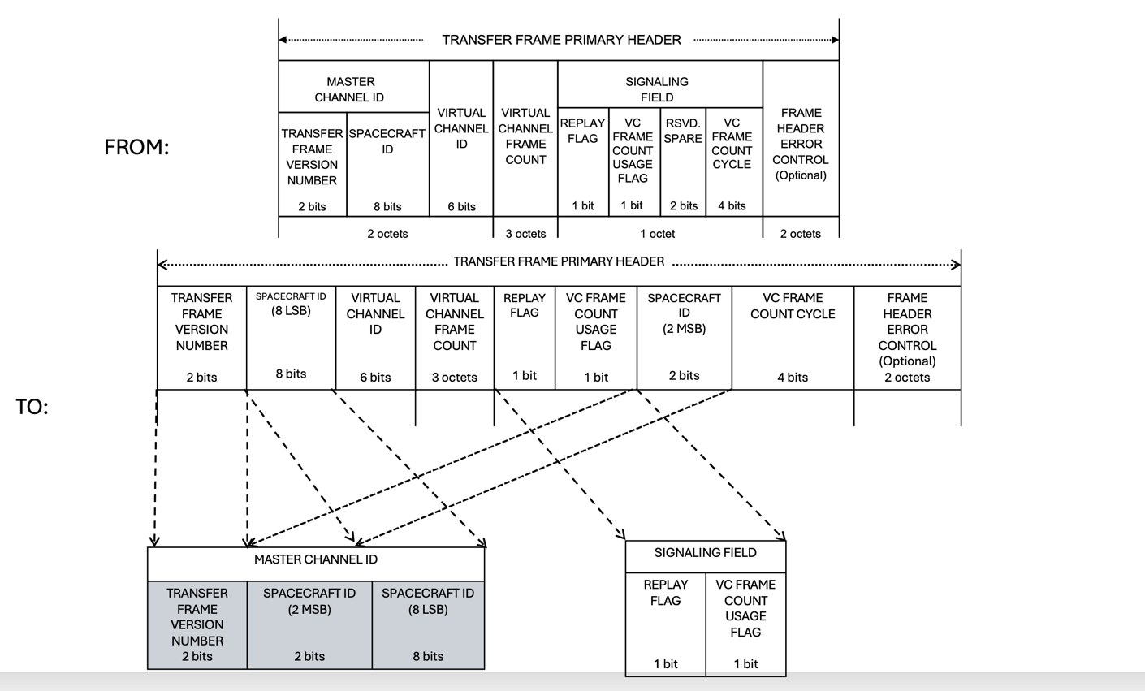
New Figure 4-2 (above)

Part 2 – Updated Signaling Field definition
Signaling Field
General
Bits 40–41 of the Transfer Frame Primary Header shall contain the Signaling Field.
The Signaling Field shall be used to alert the receiver of the Transfer Frames with respect to functions that: (a) may change more rapidly than can be handled by management, or; (b) provide a significant cross-check against manual or automated setups for fault detection and isolation purposes.
This 2-bit field shall be subdivided into two sub-fields as follows:
- Replay Flag (1 bit, mandatory);
- Virtual Channel (VC) Frame Count Cycle Use Flag (1 bit, mandatory);
** End of Signaling Field **
Spacecraft ID (MSB)
Bits 42-43 of the Transfer Frame Primary Header shall contain the 2 MSB of the Spacecraft ID, mandatory.
NOTE – Missions implementing CCSDS 732.0-B (AOS) version 4 or earlier versions have this field set to ‘00’.

Virtual Channel (VC) Frame Count Cycle
If used, bits 44-47 of the Transfer Frame Primary Header shall contain the Virtual Channel Frame Count Cycle field.
Each time the Virtual Channel Frame Count returns to zero, the VC Frame Count Cycle shall be incremented.
NOTE – The VC Frame Count Cycle effectively extends the Virtual Channel Frame Count from 24 to 28 bits.
If not used, bits 44 through 47 of the Transfer Frame Primary Header shall be set to ‘all zeros’.

Frame Header Error Control
If implemented, Bits 48-63 of the Transfer Frame Primary Header shall contain the Frame Header Error Control.
NOTE – The 12-bit Master Channel Identifier, the 6-bit Virtual Channel Identifier, the 2-bit Signaling Field, and the 4-bit VC Frame Count Cycle may all be protected by an optional error detecting and correcting code, whose check symbols are contained within this 16-bit field.

NOTE - The Virtual Channel Frame Count from Bit 16 to Bit 39 is not protected.

