CCSDS Order of processing for Telecommand using SDLS_2021_05_12.docx
5/12/21
G. Kazz

CCSDS Order of processing for Telecommand User Data Frames using SDLS (Sequential with Figure 6-3):

On the Ground: (sending side)
1. Virtual Channel Generation Function with SDLS | 232.0-B-3 | 6.4.2.1
Frame Initialization Procedure  The Frame Initialization Procedure generates a (partial) TC Transfer Frame for the Frame Data Unit. The (partial) frame includes Transfer Frame Primary Header, provision for the Security Header, Transfer Frame Data Field and for optional Security Trailer. | Future 232.0-B-3 | 6.4.2.1
2. SDLS ApplySecurity Function | 232.0-B-3 | - (b)
Encrypt only the Transfer Frame Data Field | 355.0-B-1 | 4.2.3.3
Populate the optional Security Trailer with the computed MAC*(Authentication only) | 355.0-B-1 | 4.2.3.4
3. FOP-1 (Frame Operation Procedure) | 232.0-B-3 | 4.3.5.3
Frame Finalization Procedure (within VC Generation Function) | 232.0-B-3 | 4.3.5.4
4. Virtual Channel Multiplexing Function | 232.0-B-3 | 4.3.6
5. Master Channel Multiplexing Function | 232.0-B-3 | 4.3.7
6. All Frames Generation Function | 232.0-B-3 | 4.3.8
Compute and add CRC to FECF | 232.0-B-3 | 4.3.8.2
7. Encode & Randomize the Transfer Frame (When BCH encoding, Randomization is done first; the opposite for LDPC) | 231.0-B-3 | 3 (BCH) or 4 (LDPC); 6
8. Modulate onto Subcarrier/Carrier and transmit | 401.0-B-31 | 2.2

Notes: * MAC (authentication) is computed over Masked TF Header, Complete Security Header, Complete Frame Data Field.

-Space Link –

On the Spacecraft: (receiving side)
9. Receive and Demodulate | 401.0-B-31 | 2.2
10. Decode & Derandomize the Transfer Frame (Note the order is dependent uopn the coding scheme) | 231.0-B-3 | 6.3,3.5 or 4.5
11. All Frames Reception Function with SDLS | 232.0-B-3 | - (c)
Frame Delimiting and Fill Removal Procedure (invalid code blocks reported by C&S sublayer + fill removal ) | 232.0-B-3 | 4.4.8.2
Frame Validation Check Procedure (includes optional CRC) | 232.0-B-3 | 4.4.8.3
12. Master Channel Demultiplexing Function | 232.0-B-3 | 4.4.7
13. Virtual Channel Demultiplexing Function | 232.0-B-3 | 4.4.6
14. Virtual Channel Reception Function | 232.0-B-3 | 4.4.5
15. FARM-1 (Frame Acceptance and Reporting Mechanism, subprocedure of the COP-1) | 232.0-B-3 | 4.4.5.2
16. CLCW (Command Link Control Word) appears within either TM, AOS, or USLP OCF Field | 232.0-B-3 | 4.4.5.2
17. SDLS ProcessSecurity Function | 232.0-B-3 | 6.5.2.1 (b)
Optional: Validate the MAC, if invalid, report security error in Frame Status Report into the OCF in telemetry frame | 355.0-B-1 | 4.2.4.4
Decrypt the Transfer Frame Data Field | 355.0-B-1 | 4.2.4.5
18. SDLS FSR (Frame Status Report) appears within either TM, AOS, or USLP OCF Field | 132.0-B-3  732.0-B-3  732.1-B-2 | 4.1.5.5  4.1.5.5  4.1.5.2.2
Thereafter, Frame Data Units provided to on-board processing (i.e., perform VC Packet Extraction function or MAP Demultiplexing function or VCA Service User)

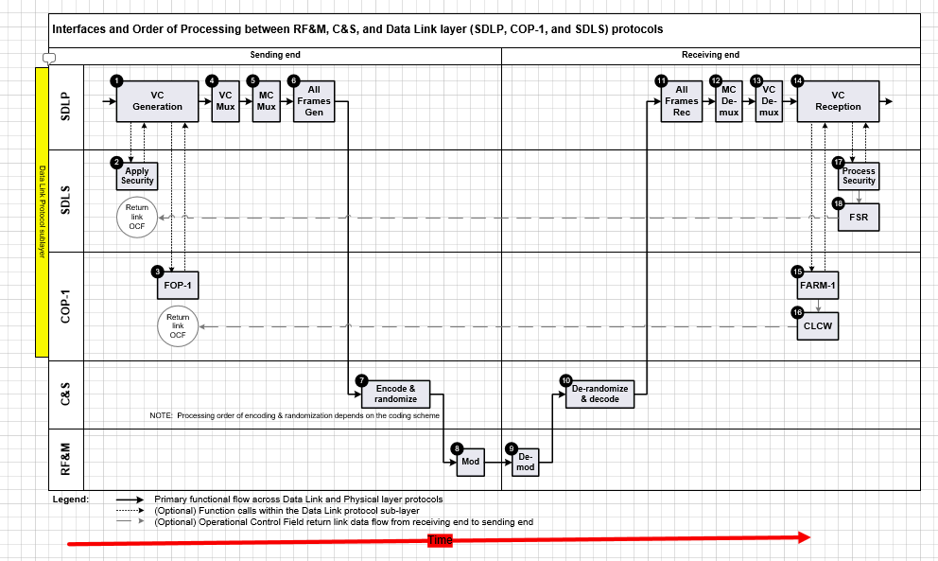
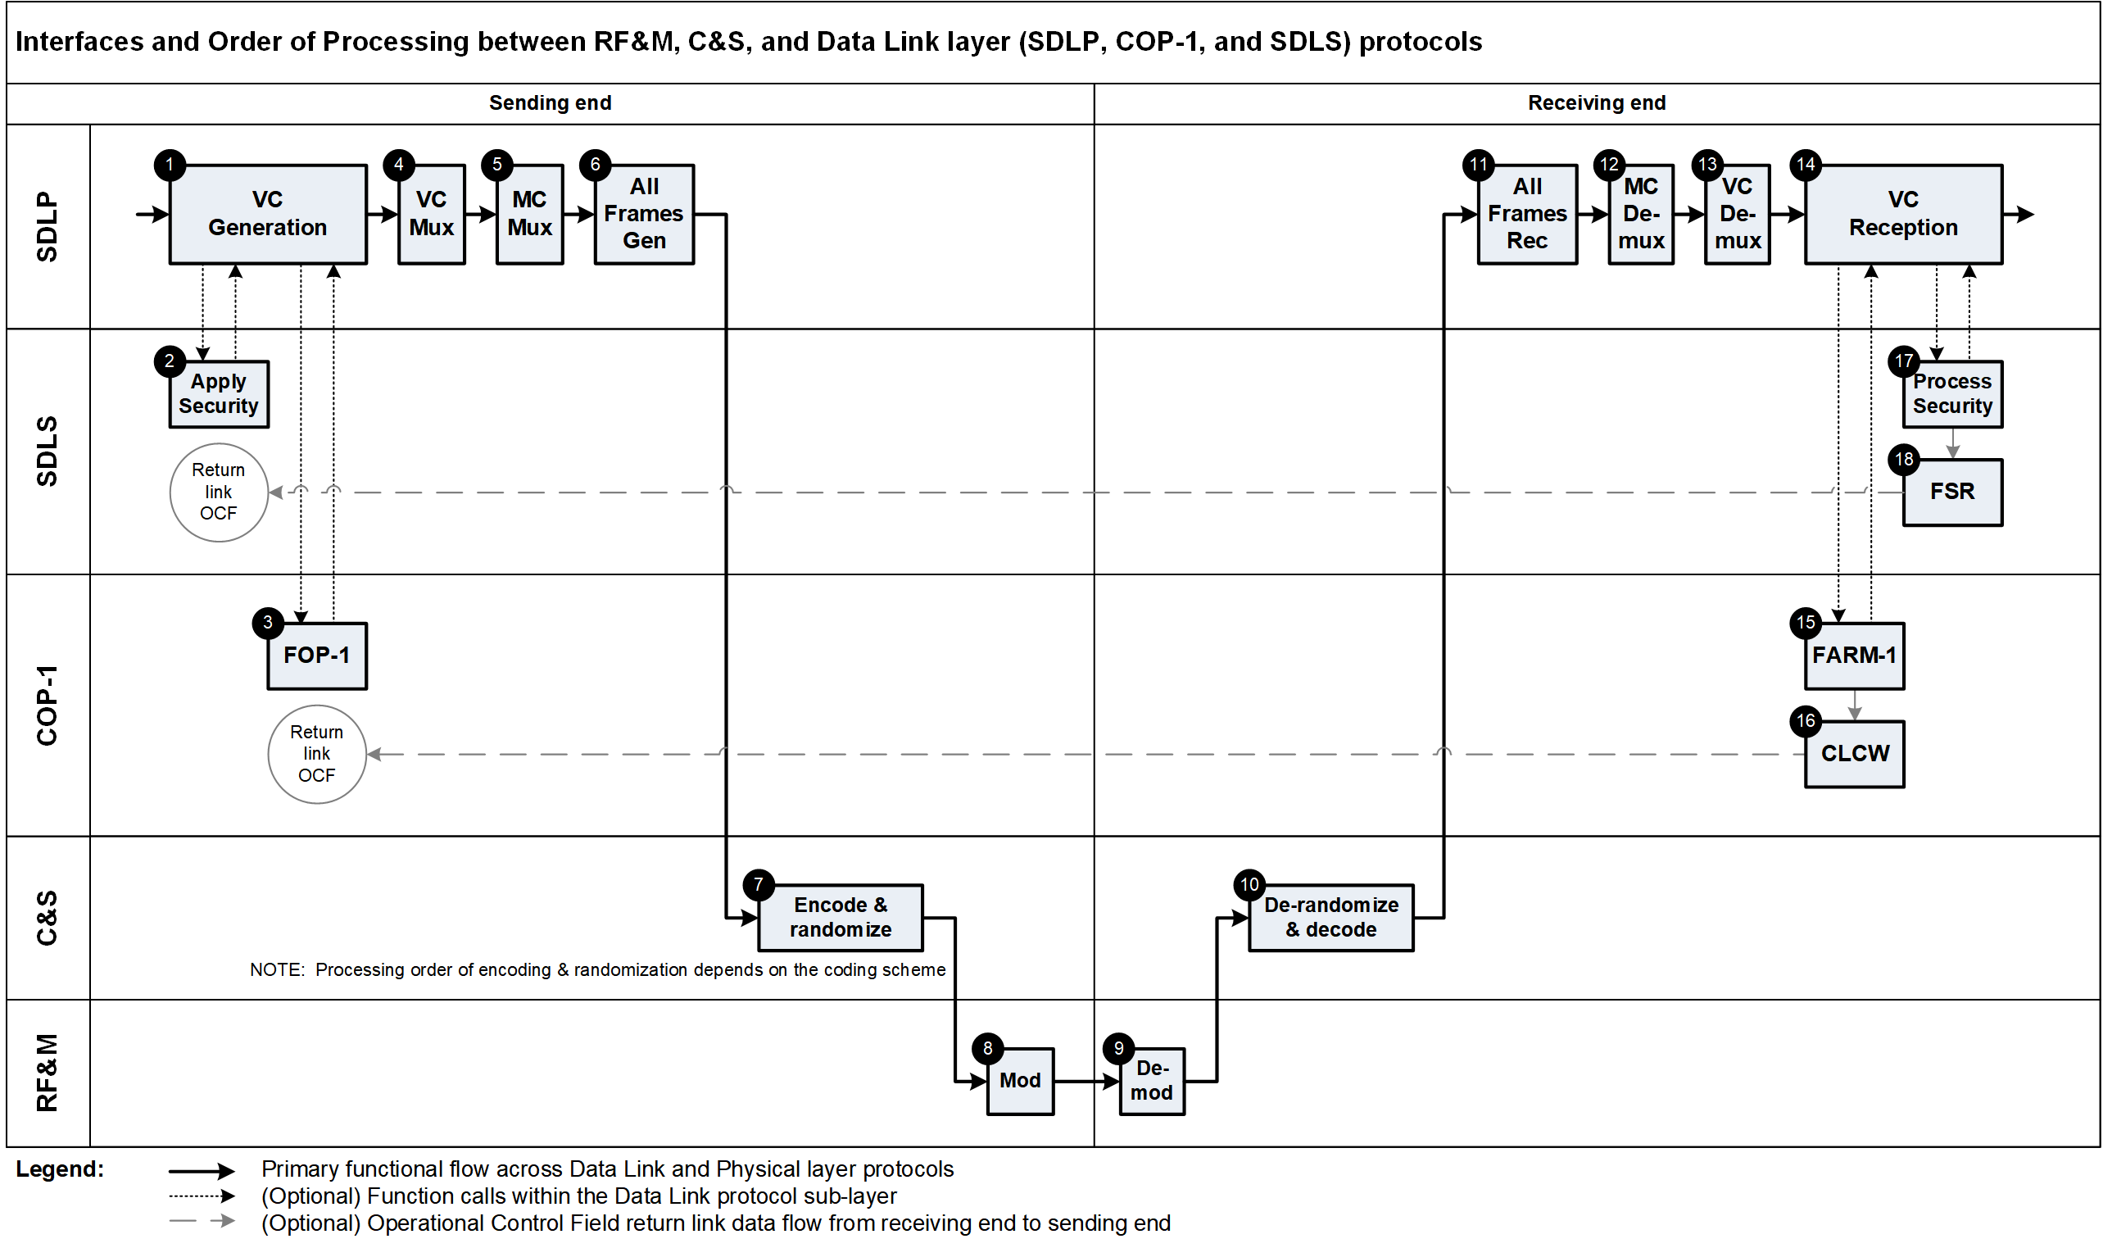

Temporary Note to be removed before publication: This is a Procedure required only by SDLP to accommodate the different processing required. It is not mentioned in 4.3.5.2 but it shall be mentioned in the revised 6.4.2.1. Unless the reference to 4.3.5.2 has to be intended as new addition in 355.0-B.

