CCSDS Fall 2019 SLP WG Meeting Minutes - Draft

Darmstadium --Darmstadt, Germany

October 21 PM – October 22 AM, 2019 – Greg Kazz/Chairman

Major Accomplishments at this Meeting:

- WG Consensus achieved to publish CCSDS 133.1 Encapsulation Packet Protocol Issue 3 once the RID resolutions which the WG approved are reviewed by the WG in document form.
- WG Consensus achieved to publish CCSDS 133.0 Space Packet Protocol (SPP) Issue 2 once the RID resolutions which the WG approved are reviewed by the WG in document form.
- WG Consensus achieved to publish CCSDS 700.1-G-1 USLP Green Book Issue 1. Document delivered to SLS Area Director.
- WG Consensus reached to send CCSDS 211.0 Proximity-1 Space Data Link Protocol for Agency Review to add the USLP frame PDU to it. Document delivered to SLS Area Director.
- Presentation on GFP associated with enabling variable length frames and rates for optical communication
- SLP WG interactions with other CCSDS WGs
  - C&S WG for recommending an OID frame pattern and alignment of 231.0 and 232.0 concerning ‘systematic retransmission’ of TC frames.
  - CSTS WG for assessing impact of USLP upon SLE services
- Action Items
- Next Meeting
- Acknowledgment
- Attendance Lists

- Publish CCSDS 133.1 Encapsulation Packet Protocol Issue 3

There were 4 ESA RIDs resolved at the meeting concerning CCSDS 133.1-P-2.1 pink sheets. The first three RIDs were quite straight-forward and removed information no longer relevant or clarified a statement made. The 4th RID involved refomulating the services section 2.2 “Features of the Protocol”, because the focus of this book has changed from the ‘Encapsulation Service’ to the ‘Encapsulation Packet Protocol’. Greg Kazz generated a draft proposal containing a reformulation of the ‘services’ part of that section that was emailed to the SLP WG during the meeting week with a deadline of a response back to him within one week i.e., by Oct. 30, 2019. The final document containing the agreed to RID resolutions will be placed into the CWE with the word, “_post” appended to the filename, to give the WG the final opportunity to review the document before publication.
See this URL: https://tinyurl.com/yyhvug9d

- Publish CCSDS 133.0 Space Packet Protocol Issue 2

We spent most of the first afternoon session on Monday, Oct. 21 resolving the RIDs against the SPP revisions document. The three NASA RIDs were resolved first. The most notable of those RIDs was RID 2 to make the Packet 2nd Header a dynamic field. During the meeting, the WG did some checking in the document and made two findings. First, the 2nd Header Flag is required to be static over a mission phase. Moreover, the content of the 2nd Header itself, is required to be static over all mission phases. So even though, theoretically one could make both the flag and the contents dynamic, none of the agencies present could define a real use case to change from static to dynamic at this time. There is simply no requirement to do so. So this RID was rejected. The text of the resolution of all 3 NASA RIDs is available in the CWE. Seach for the filename that contains the word, “_post” for the NASA RIDs. The URL is at the bottom of this section.

We resolved two DLR RIDs as well. DLR-1 asked to add MO-MAL (reference 524.1) to Figure 2-1 to the left on the CFDP box. There will be a line added from MO-MAL to the EPP/SPP shim protocol box below. The WG was surprised that this interface was missed by review. Therefore, we will send a message to the MOIMs area to make them aware of it. DLR-2 requested the addition of the minimal space packet length be added to the document. But since the minimal length is not as critical to be know as the maximum length (which is defined in the document), there wasn’t a driving reason to add it and this RID was rejected. The text of the resolution of all DLR RIDs is available in the CWE under X with the word “_post” included in the filename. The URL is at the bottom of this section.

We resolved all of the ESA RIDs as well. The first group of RIDs were from Michele Zundo who pointed out the need to keep Fig. 2-1 very clear to the user. We need to mention the reason in the text of the diagram why SPP appears twice in the diagram. Moreover, we need to highlight the each (perhaps by font and color) appearance differently so that the distinction between the two (application vs shim protocols) is apparently clear. Another theme of Michele’s RID focused on ensuring that fields like the Source Packet Sequence Count (SPSC) are specified in the text so that the user clearly understands that each SPSC applies per APID. The text of the resolution of all ESA RIDs is available in the CWE under X with the word, “_Post” in the filenames. All of Michele Zundo’s RIDs were accepted, as well as all of Ignacio Clerigo’s. In addition, Gian Paolo submitted 24 ESA RIDs that were also resolved during the meeting. In particular, we looked back into several silver SLS books to determine the path forward with the terms: “sequence flags” and “segment” whose usage in the context of SPP was questionable. It turns out that 2 silver books used “sequence flags” and only the Packet Telemetry silver book used “grouping flags”. Therefore, we choose to keep the term, “sequence flags”. Also the term, “segment” is overloaded in 4.1.2.4.2. Based upon the historical usage and further discussion, we came up with replacing the term “segment” in that requirement with “portion”. The text of the resolution of Michele’s and Ignacio’s ESA RIDs is available in the CWE with the word, “_Post” in the filenames. The final resolution of Gian Paolo’s ESA RIDs is in the CWE with the date “Oct 23” in the filename.

Once the RIDs were disposed, we had a discussion about the newly proposed SANA annex. This proposal came about due to additional requirements from two area directors: Peter Shames (SEA) and Jonathan Wilmot (SOIS). The new proposal contains more detail including OIDs (Object Identifiers) and additional details that they feel are required for the SANA operator to generate new registries that are identified in this SANA annex. Matt Cosby raised an objection that he felt the previous SANA registry in the existing pink sheets is sufficient and adding a more complicated one would only complicate the mission’s job of populating it. Matt’s reasoning was that if all the SANA information goes into a database, why put any of this information into a blue book which has a very long update cycle (every 5 years).
See this URL for all SPP RID resolutions: https://tinyurl.com/y2edbdd3

- Publish CCSDS 700.1-G-1 USLP Green Book Issue 1
The action from the Spring 2019 meeting was completed by the interoperability testers, when they provided the Chairman with their final comments on this book. This resulted in a few comments that were straight-forward and appreciated. This was the last action on the document. Based upon the resolution of the WG to publish the document after those comments were integrated, the Chairman provided this copy of the document to the AD, DAD and secretariat to prepare the book for publication post meeting.

- Send CCSDS 211.0 Proximity-1 Space Data Link Protocol for Agency Review

The reason for requesting Agency Review of 211.0 is to add the USLP frame as an additional PDU to the book along with the existing Proximity-1 frame. This task is more than an simple cut and paste of referencing the USLP frame PDU to the document. Careful editing has been done to ensure that Section 3 Proximity-1 frame PDU remains “as is”, so as not to confuse the reader and add a new section to reference the USLP frame PDU. The WG came to consensus that sufficient review has been completed by the WG to sent the document next to agency review.

- Presentation repeated from the Optical Comm WG on a proposal to add variable length CCSDS transfer frames (USLP) to use the Generic Framing Procedure (GFP)

Greg Kazz presented this material to the SLP WG so that the WG would be informed about the options that the optical comm WG are considering in using GFP for delimiting CCSDS transfer frames used for optical communication. GFP enables the use of both variable length frames as well as variable data rates. Note that this approach is technically not limited to just optical communication and could also apply to RF. See this URL for a copy of the presentation:

https://tinyurl.com/yxjydsow

- SLP WG interactions with other CCSDS WGs

  - There are two separate interactions of the SLP WG with external WGs. First, the C&S WG plans on defining a recommended pattern for the data content of the Only Idle Data (OID) frame. Second, there is a need to align sections of both 231.0 and 232.0 concerning the topic of ‘systematic retransmission’ of TC frames. Indeed the term, “systematic” may be renamed to “repeated”. Please note that the SLP WG went ahead and approved the editorial corrigendum in 232.0 because it was purely editorial. However, we will defer it’s publication until the 5-year review cycle occurs which is scheduled for next year. Third, SLP WG will request that the C&S WG assess the impact of adding the USLP SDLP to 131.0, 231.0, and 131.2 (note that pink sheets for agency review have already been approved for 131.3).
  - The second interaction was with the CSTS WG for assessing impact of USLP upon SLE services. It appears the only impact of USLP upon SLE is on RCF and ROCF services. There is work to be done within the CSTS WG to capture the various USLP frame headers fields and sizes in USLP and integrate that information into their models. An estimate of 1 MM was given.

- Summary of Action Items

Action items assigned during this meeting are:

- Action 1: Greg Kazz – Provide the AD and DAD with the updated 133.1 document with the RID resolutions integrated into the text by Nov 11. Thereafter, Request a resolution to publish the Version 3.
- Action 2: Greg Kazz – Provide the AD and DAD with the updated 133.0 document with the RID resolutions integrated into the text by Nov. 20. Thereafter, Request a resolution to publish the Version 2, once SANA registry issue is resolved.
- Action 3:Greg Kazz – Correspond with the C&S WG on the three requests identified in paragraph 6a above. Before end of November.

- Next SLP WG Meeting

To be held at the Westin Hotel and Conference Center during the week of May 4 – 8, 2020 (note 5 day meeting). Exact days of the SLP WG meetings are TBD but most likely will occur on Monday and Tuesday of that week.

- Acknowledgment

Many thanks to the wonderful accommodations and hospitality of ESA for use of the Darmstadium in Darmstadt, Germany.

- List of Attendees (Oct 21-22, 2019)

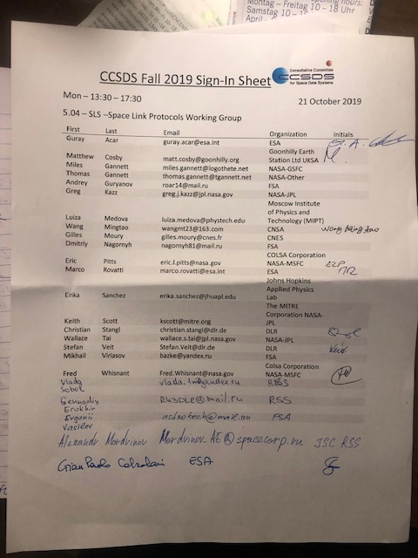

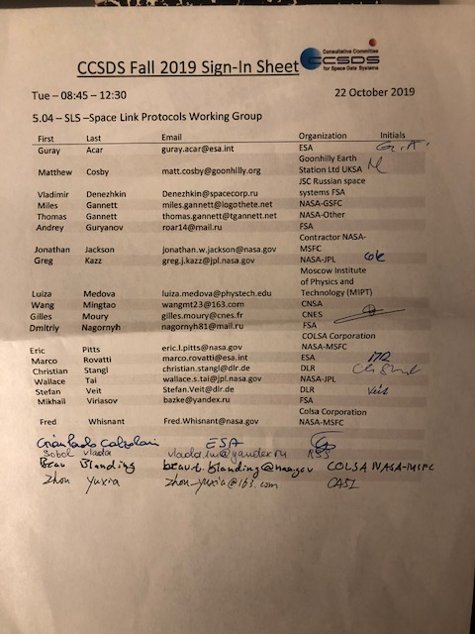
End of Report

