CCSDS Spring 2019 SLP WG Meeting Minutes - Draft

NASA Ames – MT. View, CA USA

May 6 AM-May 7 PM, 2019 – Greg Kazz/Chairman

Major Accomplishments at this Meeting:

- WG Consensus achieved to craft Resolution for Publication of CCSDS 700.1G USLP Green Book Issue 1 once testers complete their review by Sept.20
- Resolution adopted to send the revised Space Packet Protocol (SPP) to Agency Review once WG completes clean copy check by May 20.
- Resolution adopted to send the revised Encapsulation Service reformulated into the Encapsulation Packet Protocol to Agency Review once WG completes clean copy check by May 20.
- Consensus reached on establishing the SPP/EPP Green Book Project
- Plan identified on way forward with SLS Glossary of Terms Project
- Resolution adopted to request that CCSDS General Secretary recommend to the Gateway Program the use of USLP as the Data Link Layer Protocol.
- SLP WG interactions with other CCSDS WGs
  - C&S WG
  - SDLS WG
- Action Items
- Next Meeting
- Acknowledgment
- Attendance Lists

- Publish CCSDS 700.1 USLP GB as an Issue 1

We reviewed the residual comments of which there weren’t many left at the meeting. Final agreement was to have the interoperability testers take a final look at this Green Book to ensure it is complete and if they have any changes they think would help implementers understand it better. Sept. 20, 2019 was the deadline for them to provide their feedback to the SLP WG chairman. See Action Item 2. The current USLP GB version (contains Ames_May7 in the filename) is at this URL: https://tinyurl.com/y5habz6e

- Send revised SPP to Secretariat by May 20, 2019 for Agency Review

We spent most of the first afternoon session on Monday, May 6 discussion the remaining comments that required WG discussion on the SPP revision document. Most of time we focused on removing additional remnants of “networking” from the document. For example, whenever possible we removed the term, “sub-networks” with “underlying layers”. There were also several consistency checks applied as well and in the action item list (see action item 1). The term “data path” was also replace wherever possible.

- Send revised EPP to Secretariat for Agency Review
We had a much easier time in the review of the Encapsulation Packet Protocol on Tuesday AM. We resolved the issue about where EPP belongs in the protocol stack i.e., NOT within the data link layer but rather as a “shim protocol” above the data link layer. Tom Gannett recommended that we release the entire EPP document for agency review instead of generating pink sheets for ease of editing, due to the scope of changes involved. Other changes involved: replacing Service User with Protocol User throughout. Gilles Moury has already provided text for the Security Annex to reference both SDLS and Bundle Security Protocols.

- Consensus reached on starting the SPP/EPP Green Book Project

We discussed the pros and cons of revising the existing draft SPP Green Book of 2008. We agreed that the FAQ format was useful because of the emerging development of the various formats of the SPP secondary header (PUS, DEM, Core FSW) being defined in SANA as well as ensuring that how SPP is carried by Bundle Protocol is well defined. Action on Greg Kazz to generate a one-page Concept Paper. Guray will ask DTN WG if they can provide short explanation on how to transfer SPP or EPP over DTN. It made more sense for this green book to cover both the EPP and the SPP, since both are relatively small blue books and are related as “shim protocols”.

- Plan identified on way forward with SLS Glossary of Terms Project

The goal of this project is to come up with one definition for each SLS area term. These terms are to be defined in a glossary for SLS terms. The glossary would be entered into SANA and each book would also contain a glossary specific to that book.

At this meeting, Tom Gannett showed his excel spreadsheet of SLS terms including multiple definitions based upon the books where the definitions occurred. Greg Kazz’s Word file contains a list of occurrences where these terms show up in the CCSDS SLS blue books.

Next steps are to prepare a list for the SLP WG to review, which would contain the candidate definitions for each term. A merged column will be created in Tom’s spreadsheet to show the candidate definition and to note any additional actions to take on the related books. Note that it may be legitimate to have more than one definition per term per layer (e.g., data link layer vs Physical layer). We will also prioritize the list of terms to be changed.

Several additional questions came up during this discussion. They are: 1) How comprehensive is this list ? (any terms missing?); 2) Should our list be checked with other lists in CCSDS from different areas or WGs ?; 3) Tom Gannett will ask other WGs if they want to take on this task in their areas as well. The glossary of terms documents (Greg’s Word document and Tom Gannett’s spreadsheet) are at this URL: https://tinyurl.com/y336p4qe

- Resolution adopted to request that CCSDS General Secretary recommend to the Gateway Program the use of USLP as the Data Link Layer Protocol.

The SLP WG came to consensus on a resolution from the WG to ask the CCSDS General Secretary to recommend the use of USLP as the Data Link Layer Protocol for the Gateway (LEOP) Program. This request is in direct response to the call by Phil Liebrecht during the opening CCSDS plenary for the use of international data system standards at the Moon and beyond.

- SLP WG Interactions with other WGs

  - C&S WG – Already mentioned the pink sheets generated with help from the C&S WG to add the USLP transfer frame to the Proximity link.
  - SDLS WG – the SDLS WG added the Frame Status Report (FSR) to both the AOS and the TM SDLPs as pink sheets (for action during the next 5 year review anticipated in 2020). These pink sheets use the same formulation for the FSR as exists in Issue 1 of the USLP Blue Book.

- Summary of Action Items

Action items assigned during this meeting are:

- Action 1: Matt Cosby – Make sure Figure 2-1 (shows all the protocols in the stack) in SPP is consistent with the other protocol stack diagrams in the SLP purview of link layer documents. Current Clean Version of SPP is at this URL: https://tinyurl.com/y3w2zjfo
- Action 2: Stefan Veit, Kevan Moore, Paul Thomson to provide feedback on the USLP Green Book – with file name of USLP_Green_20190321c-AMES_May7.docx. See CWE URL: https://tinyurl.com/y5habz6e
Due date: Sept. 20, 2019.
- Action 3:SLP WG in general. Review the clean versions of both the SPP and EPP at the following URL and respond back to the SLP WG Chair if any changes are required to the clean versions of these documents by May 20. Both the EPP and SPP clean versions are at this URL: https://tinyurl.com/y3w2zjfo

- Next SLP WG Meeting

To be held at Darmstadium in Darmstadt, Germany during the week of Oct 21 – 24, 2019 (note 4 day meeting). Exact days of the SLP WG meetings are TBD but most likely will occur on Monday and Tuesday of that week.

- Acknowledgment

Many thanks to NASA-Ames for their hospitality in Mt. View, CA. USA.

- List of Attendees (May 6-7, 2019)

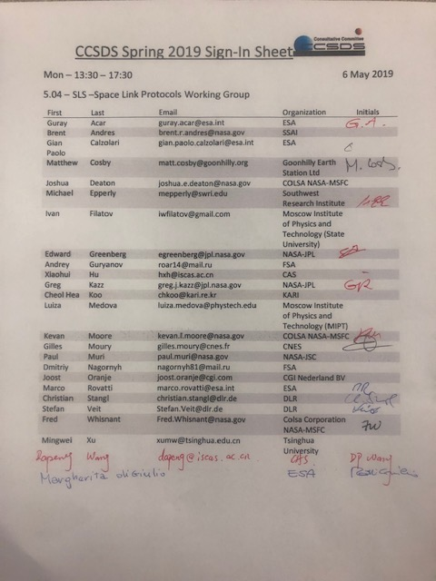

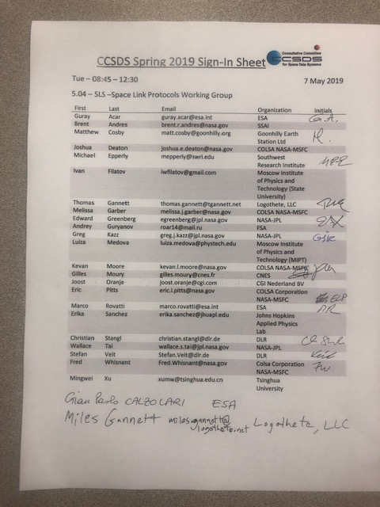

End of Report

