CCSDS Fall 2018 SLP WG Meeting Minutes - Final

DIN, Berlin, Germany

October 18, 2018 – Greg Kazz/Chairman

Major Accomplishments at this Meeting:

- During this meeting, the CCSDS 732.1 USLP became an issue 1 Blue Book due to a successful CMC poll.
- Achieved WG Consensus for USLP Green Book 700.1 to become an Issue 1 Green Book contingent upon cross-checks with USLP Blue Book (Pre-CMC copy)
- Discussed the status of USLP Interoperability Testing (DLR & NASA MSFC)
- Discussed the pink sheets to CCSDS 211.0-B-2 Proximity-1 Coding & Sync Blue Book generated in cooperation with the C&S WG to add the USLP Transfer Frame
- Glossary Issues for SLP – Global Virtual Channel Identifier (Gian Paolo Calzolari)
- Returning the Reserved APIDs (2040-2046) back to the APID Pool (Gain Paolo Calzolari)
- NASA Proposal for revising the SPP (Greg Kazz)
- SLP WG interactions with other CCSDS WGs
  - C&S WG
  - SDLS WG
- Action Items
- Next Meeting
- Acknowledgment
- Attendance Lists

- CCSDS 732.1 USLP becomes an Issue 1 Blue Book

Congratulations to the SLP WG due to the approval by the CMC of the first issue of the USLP Blue Book! This concludes the USLP blue book project started in Oct 2014.

- WG consensus achieved (post condition) to publish Issue 1 USLP GB

We reviewed CCSDS 700.1 (USLP GB) at this meeting. In general, the WG found the content of the current GB to be quite comprehensive and informative. The suggestions for final review that were made are: 1) Compare the high level abstract diagrams in Section 4 of the USLP Green Book with the frame generation details in Figure 4-6 of the GB to see if it makes sense to put them side by side. 2) An action was taken by the WG to review this GB with respect to the CMC pre-publication copy of the USLP BB to ensure consistency between the two document. See Action Item 5 in Section 8 below. The current version of the USLP GB can be found at: https://tinyurl.com/ybwlzjg6

- Final USLP Testing Results (Lee Pitts)

Lee Pitts (NASA MSFC) summarized the interoperability testing completed between NASA MSFC, DLR, and UKSA for the USLP Blue Book. Great cooperation between the agencies enabled this testing to uncover errors and deficiencies in the specification which was of great value.

Lee pointed out that it would have helped him had CCSDS would have provided a Yellow book Test Template. Instead he reviewed various other CCSDS yellow books in order to construct the yellow book.

Lee’s report is on the CWE under the URL: https://tinyurl.com/y8dfbct3

- Pink sheets generated to CCSDS 211.0-B-2 Proximity-1 Coding & Sync Blue Book to add USLP Transfer Frame

Greg Kazz presented the results of the pink sheets that were generated as a result of the C&S WG meeting held on Tuesday, Oct 16, 2018 with the C&S WG. A simpiler formulation of the original concept paper containing a draft of the changes was achieved. The term “transfer frame” was formally defined in the pink sheets to be either a Version 3 Proximity-1 frame or a USLP Version 4 frame. In addition, the Maximum transfer frame length parameters in both Proximity-1 SDLP and USLP were referenced in the pink sheets. The pink sheets are located under the URL: https://tinyurl.com/y74fcjv3

- Glossary Issues for SLP – Global Virtual Channel Identifier (Gian Paolo Calzolari)

Gian Paolo Calzolari presented an approach for the SLP WG to modify the TM SDLP as the definitive source for the definition of the Global Virtual Channel Identifier (GVCID). It turns out that there are several terms in CCSDS that are not officially defined up front in the definition section (1.6) but are often first defined later in line in the documents. Also there is inconsistencies between the terms e.g., Identifier vs Identification etc. The WG decided on having Tom Gannett first identify the inconsistencies and then work with SANA to ensure they are correctly defined in the SANA registries.

Gian Paolo’s presentation is found under the URL: https://tinyurl.com/y8ad4d83

- Returning the Reserved APIDs (2040-2046) back to the APID Pool (Gian Paolo Calzolari)

Gian Paolo presented the approach of releasing the currently reserved APIDs 2040 to 2046 inclusive back to the APID pool. The Idle packet would remain reserved by CCSDS (2047) and encapsulation of “upper layer protocols” becomes managed by the individual missions. Space Packet becomes decoupled from the Encapsulation Service. Therefore, the Space Packet needs to be removed from the Encapsulation Service Blue Book. See Action 2 in Section 8 below. Note that no prototype required for interoperability testing, because no new feature will be added. By removing the Space Packet from the Encapsulation Service, we 1) decouple the SPP from the Encapsulation Service, 2) the Encapsulation Packet is not an application layer PDU (unlike the Space Packet), 3) simplify the interfaces between the Space Packet and the other CCSDS protocols, 4) we create instead a type of encapsulation shim protocol. In addition, no agency could identify a use for the “Packet Name” (used instead of Packet Sequence number) defined in SPP. Therefore, Action 3 was composed. See Section 8 for it.

- NASA Proposal for revising the SPP (Greg Kazz)

Approach 2 was chosen by the WG as a way forward on revising SPP. Eliminate these terms from SPP: LDP, Path, Path ID, subnetworks, APID Qualifier, QoS and redefine the Packet and Octet String services in SPP to use APID and eliminate APID_Qualifier and QoS in these primitives.

At this point, it is unclear if we need or don’t need the companion SPP GB. Once we are closer to publishing the revised SPP blue book, then we will know if it makes sense to include the SPP use cases, etc discussed at this meeting.

See the following URL for the NASA presentation on the way forward on SPP: https://tinyurl.com/ycny2r8z

- SLP WG Interactions with other WGs

  - C&S WG – Already mentioned the pink sheets generated with help from the C&S WG to add the USLP transfer frame to the Proximity link
  - SDLS WG – the SDLS WG added the Frame Status Report (FSR) to both the AOS and the TM SDLPs as pink sheets (for action during the next 5 year review anticipated in 2020). These pink sheets use the same formulation for the FSR as exists in Issue 1 of the USLP Blue Book.

- Summary of Action Items

Action items assigned during this meeting are:

- Action 1: Within 1 Month (by Nov 18, 2018) report back to SLP WG Chair on the proposal to remove the reserved APIDs # 2040 – 2046 from SANA and the SLP Blue books e.g., SPP and SDLP books.
- Action 2: If Action 1 agreed to, remove Space Packet from the Encapsulation Service BB. Thereafter, SLP WG to create new project to remove Space Packet from Encapsulation Service BB. Note that no prototype required for interoperability testing, because no new feature will be added.
- Action 3: Remove the term, “Packet Name” in SPP – within 1 month time to report back to SLP WG chair to agencies. An instance of Packet Name occurs on page 5-4 in CCSDS 203.0-B-2.
- Action 4: Agreed to Approach 2: Eliminate these terms from SPP: LDP, Path, Path ID, subnetworks, APID Qualifier, QoS and redefine the Packet and Octet String services in SPP to use APID only. Ensure that if there are any other terms associated with the list above that these are reviewed as well. Goal: Whatever terms we keep, they must be completely defined i.e., not be abstract terms.
- Action 5: Each Agency to cross-check USLP Blue Book (CMC copy pre publication) with USLP Green book to ensure USLP GB is up to date with the blue book. Due date: Jan 15, 2019.

- Next SLP WG Meeting

To be held at NASA AMES in Buildings 3 & 152 in Mountain View, California, USA during the week of May 6 – 9, 2019 (note 4 day meeting). Exact days of the SLP WG meetings are TBD.

- Acknowledgment

Many thanks to DLR for their outstanding hospitality at the DIN in Berlin, Germany.

- List of Attendees (October 18, 2018)

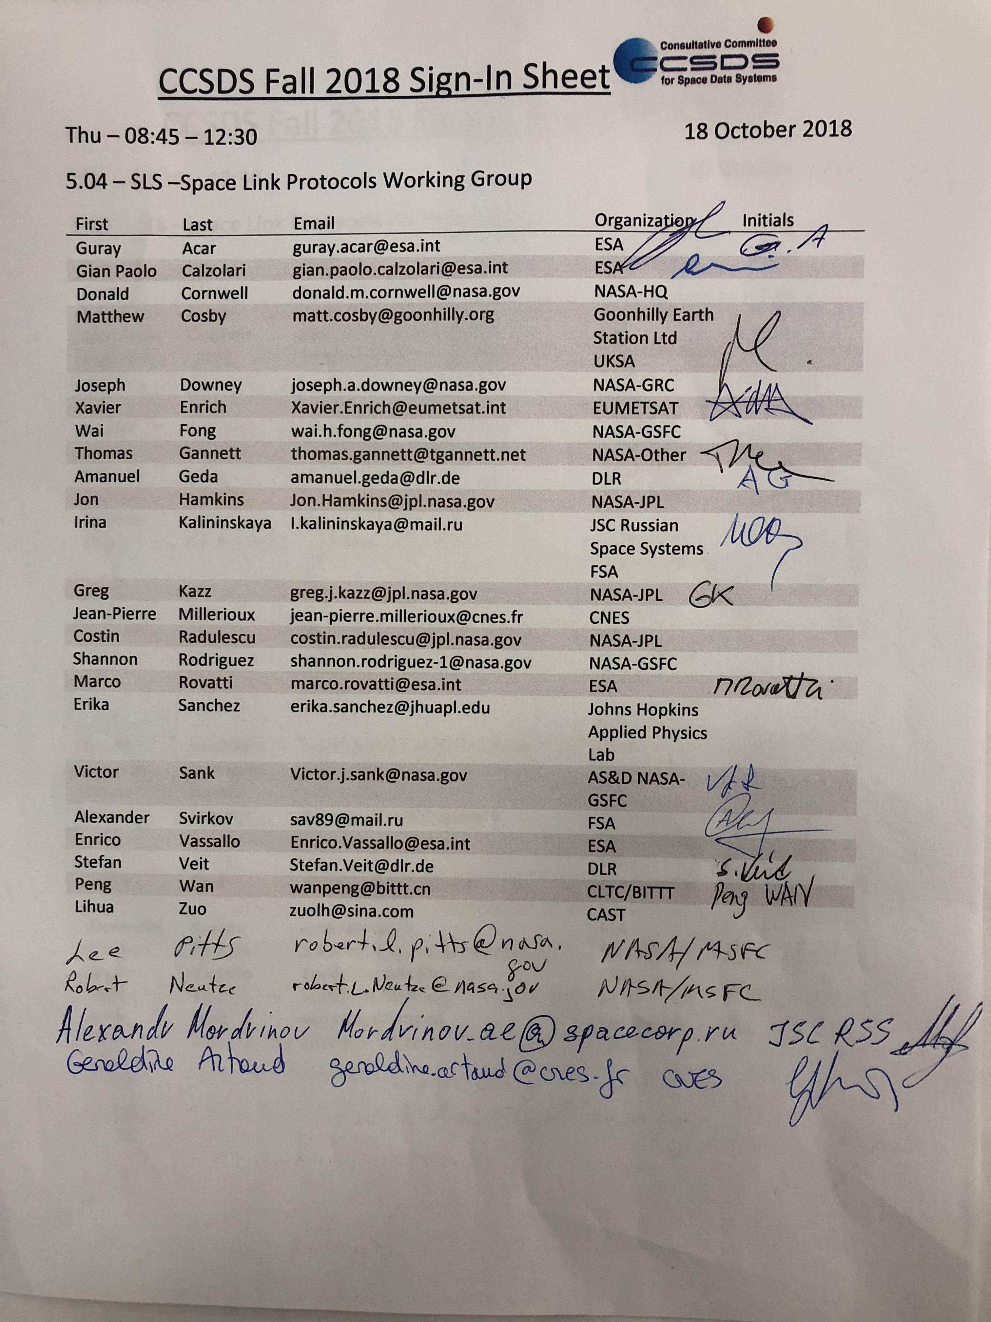

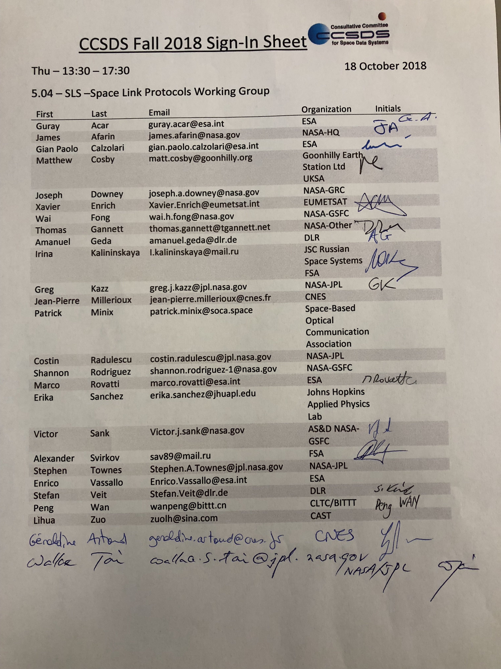

End of Report

