CCSDS Spring 2018 SLP WG Meeting Minutes - Draft

NIST, Gaithersburg, MD, USA

April. 12-13, 2018 – Greg Kazz/Chairman

Major Accomplishments at this Meeting:

- Achieved WG Consensus for USLP RED-3.1+ to become a Blue Book (All)
- Discussed the status of USLP Interoperability Testing (DLR & NASA MSFC)
- Impact on other CCSDS documents due to the issuance of USLP (Matthew Cosby)
- Additional improvements to USLP (Gian Paolo Calzolari)
- Proposed Revisions to SDLP books other than USLP (Gain Paolo Calzolari)
- Plan forward on SPP Revisions project (Greg Kazz/Gian Paolo Calzolari)
- SLP WG interactions with other CCSDS WGs
  - C&S WG
  - SDLS WG
  - SOIS WG
- Action Items
- Next Meeting
- Acknowledgment
- Attendance Lists

- Forward Progress towards making USLP an Issue 1 Blue Book - All

Consensus was reached at this SLP WG meeting to progress the Red 3.1 plus version into an issue 1 Blue Book once interoperability testing has been completed and the USLP yellow book is released. The estimate given by Lee Pitts (NASA/MSFC) for competing these remaining tasks is approximately 4 to 6 weeks.

- Status of USLP Interoperability testing – Lee Pitts MSFC

Lee Pitts reported on the status of interoperability testing taking place between DLR (Stefan Veit), NASA/MSFC(Kevan Moore) and NASA/JPL (Josh Schoolcraft). Lee reported that 100% of the USLP PICs had been tested. No physical limitations had been encountered during the testing to date. Only functional testing of SDLS emphasizing the SDLS header and trailer interface was done, which is adequate. Since testing was accomplished using UDP, frame dropouts do occur, which helped test a link with dropouts. A good metric that bodes well of nearing completion of the testing is that no fundamental mistakes have been found in “a long while”. Actions remaining are to 1) complete the interoperability testing with DLR, 2) Initiate the testing with QinetiQ, and 3) finalize the USLP yellow book. Lee’s presentation is found on the CWE under the URL: https://tinyurl.com/ycrzu2se

- Impact on other CCSDS documents due to the issuance of USLP (Matthew Cosby)

Matt generated a report that examines the frequency of occurrence of the CCSDS SDLPs (TM, TC, AOS, Proximity-1) in all of the CCSDS books. The purpose of this search was to get a handle on how extensive changes to CCSDS books will be, once USLP Issue 1 Blue book is added. Tom Gannett pointed out that the report gave one the impression that adding USLP would be a daunting task. However, he suggested CCSDS prioritize the list of documents that require change due to the addition of USLP. Tom suggested that the highest priority changes should occur in the link layer protocols and Coding & Synchronization books as well.
The result of this discussion resulted in the following actions:
- Internal to SLS Area: Address the list of SLS area books that are affected by issuance of USLP Blue 1 and prioritize the order of update of those books. This is to be accomplished in a short joint session to be held before the next SLS plenary at the Fall 2018 meeting in Berlin.
- External to SLS area: SLP WG (using Matt’s updated report) will ask the WGs outside of the SLS area to judge the impact of adding USLP to the books they are cognizant of. Target is to have an interchange with those groups affected at the Fall 2018 meeting in Berlin.

Matt’s updated report (version 2) of the Impact Assessment organized by CCSDS area is on the CWE under the URL: https://tinyurl.com/yaw62du6

- Additional Improvements proposed to USLP (Gian Paolo Calzolari as AD)

Gian Paolo presented a series of additional improvements to the USLP draft Blue book as follows: (See URL: https://tinyurl.com/ycqkz5nr )

- File: USLP.ImprovementVCF-MCF.v1.0.docx PROPOSED CORRIGENDUM FOR USLP Section 2.2.3.6 Virtual Channel Frame (VCF) Service and Section 2.2.3.7 Master Channel Frame (MCF) Service

The updates to this text which are new (yellow highlight) have now been added to the draft USLP Blue book after the meeting.

- File: USLP.OCTETstreamNotify.v2.0.pdf

On Thursday, April 12, SLP WG reverted the original decision as documented in version 1.0 on this topic, and instead choose to add an OCTET_STREAM_Notify.indication
Primitive to Section 3.5 MAP Octet Stream Service. This change also requires that the QOS and SDU ID parameter be added to the request primitive as well as editing section Update to 2.2.3.4 MAP Octet Stream Service also required to document that this service can also guarantee completeness of each portion of an Octet Stream sent over sequence-controlled QoS.

After this meeting, these new changes have been added and are now in the current version of the draft USLP Blue Book.

- File: Improvement for USLP Frame Restrictions – Section 3.2.6

The following note #4 has now been added to USLP Section 4.1.5, which states:

“It is up to the spacecraft designer to ensure that Virtual Channels carrying OCFs are transmitted frequently enough to not disrupt the intended behavior of the COP in use that may time out if OCFs are not delivered in a timely fashion.”

- Proposed Revisions to SDLP books other than USLP

Gian Paolo Calzolari presented a series of proposed changes to several CCSDS documents under the purview of the SLP WG. Among them were: AOS, TM, TC, Proximity-1 SDLPs, and the Encapsulation Service. All of the proposed changes for the SDLPs were discussed and can be viewed in the CWE under the URL: https://tinyurl.com/yd2xgoyb

The proposed changes to the Encapsulation Service can be found at this URL: https://tinyurl.com/y7nlzn34 … note that a version two of this presentation was created during the meeting and is stored along with the first version at that URL.

At this meeting, it is noted that there was no opposition to these proposed changes. Members are encouraged to revisit these proposals on the CWE before the Fall 2018 meeting in Berlin if they have any comment on them.

Therefore, we did not decide at this meeting exactly when these changes need to be made because they are not urgent. However, Tom Gannett noted that the changes proposed for both TM SDLP and AOS SDLP were very minor and could most likely be made by a future Corrigenda but they should be held for the 5-year review time. Also due to the large amount of changes to TC SDLP, it makes more sense to go for a pink sheet revision of that document instead.

The Encapsulation service change (adding the missing QoS parameter to the .request primitive) is also a minor change. Matt Cosby pointed out that the higher layer protocols above the Encap service e.g., CFDP, DTN, LTP do not require the link to be reliable. In those cases, the QoS could always be set to Expedited. (Note: TC, AOS, TM use the term Service Type instead of QoS). The question put forth was: Can we assume that all of these higher layer protocols never require Sequence-Controlled QoS from the SDLPs? If the answer is yes, then the Encap service would only need to state that the required QoS parameter is always expedited.

The action was taken by Matt Cosby before the Berlin Fall meeting to ask the SIS area for their position on this matter: should the QoS be added or not added to the Encap Service and does the SIS area require the sequence-controlled service from the SDLPs ? At the Berlin Fall meeting the item will be discussed.

If the Encap Service was modified to include the QoS parameter, then the data unit would also require an SDU ID and a notify.indication primitive as well.

- Plan forward on SPP Revisions Project

A joint presentation was given by Greg Kazz and Gian Paolo Calzolari on a way forward toward a revision of the Space Packet Protocol (SPP). See https://tinyurl.com/y7tmtz9h for both version 1 (pre meeting version) and version 2 (post meeting version) of this presentation.

The intent of this presentation was to lay out a plan on how the SLP WG could revise the SPP. We reached some agreement at this meeting with respect to wording certain portions of the document. However, I will note below where we do not yet have full consensus.

Major take away points from this discussion were:

- Space Packet Protocol’s purpose is a point to point interface. Currently in the Purpose section of the document it says” “The purpose of this Recommendation is to specify the Space Packet Protocol. Space missions will use this protocol to transfer space application data over a single ground-to-space or space to ground or space-to-space communications link.”
- All were in agreement to expunge “Routing” and any Routing functions from SPP. The term “transfer” was suggested to replace the term “routing”. We need to try it on for size throughout the document to see if that makes sense or not. The term “Space Link or SDLP” was suggested to replace “subnetwork”. Although that may work for the “shim” function that SPP provides, tying the SPP only to SDLP may break multiple agencies current uses of SPP for managing packets on-board and on the ground. We need to do further diligence on this topic between now and the Berlin Fall meeting.
- The term, Logical Data Path (LDP) was discussed. The proposal was to expunge it from the document but leave a historical note about its previous existence. On the other hand, LDP is conceptual and abstract i.e., it is not a real data path so in that sense does it really need to be expunged ? We need to do further diligence on this topic between now and the Berlin Fall meeting.
- The term, Path ID was discussed. The proposal is to define it as “APID + SDLP_Channel”, where SDLP_Channel is defined for each SDLP in the Encapsulation Service. So, the currently nebulously defined APID Qualifier would be defined as SDLP_Channel. We need to do further diligence on this topic between now and the Berlin Fall meeting.
- Gian Paolo pointed out in VG #3 (location of SPP/EPP) that only Encap Service provides qualified APIDs between 2040 to 2047 to send across the SDLPs. On the other hand, the user can choose APIDs from between 0 to 2039. There are other APIDs whose use is restricted and cannot be used except for CFDP or for Idle packets. The SPP Revision needs to explain this clearly maybe as a note in the future revised document.
- Guray pointed out on p. 13 that in the Packet Assembly Function should the APID Qualifier be optional or not? If we defined APID Qualifier to be the SDLP_Channel parameter, then it would simply this primitive to remove the optional part and make it mandatory. However, this decision really depends upon what we finally decide to do with the APID Qualifier field.

- SLP WG interactions with other WGs

  - Interface with C&S WG
External to this meeting during the Monday AM C&S WG session, Greg Kazz provided status to the C&S WG on the Interoperability testing of the capability to run USLP frames over the Proximity-1 CCSDS C&S Sublayer. See the C&S WG meeting minutes for this activity.

  - Interface with SDLS WG

Internal to this meeting during the Thursday PM SLP WG session, Gilles Moury, CNES addressed two issues that intersect both SDLS and SLP WGs regarding USLP.

Item 1 concerned the definition of a USLP Protocol ID (UPID) as proposed in the USLP draft Blue book for SDLS control commands. Item 2 addressed validation of the wording in the USLP draft Blue book for OCF insertion of the SDLS Frame Status Report (FSR).

The first item provides SDLS with the ability to send SDLS control commands within the frame layer. This capability looks attractive, because the local standalone security processor would be able to extract the commands directly from the TFDZ of the USLP frame without having to deal with the data structure of a packet. After some discussion on the pros and cons of this approach, the argument for local processing without having to involve packet structures won. SDLS decided to adopt this method and therefore USLP will have a SANA registry dedicating a UPID associated to SDLS control commands.

The second topic discussion was the wording of the OCF insertion text due to the inclusion of the SDLS FSR. The relationship expressed in this paragraph is in the draft USLP Blue book in Section 3.6.1 Overview of the MC OCF Service description. The terminology used must be consistent with the way SDLS describes who does the security actions or functions on board vs on the ground. This relationship is expressed in SDLS in terms of a master/slave i.e., Initiator/Recipient relationship. The change to section 3.6.1 proposed and accepted at this meeting was:

FROM:

SDLS secured TC Uplink Recipient

TO:

SDLS secured link Recipient

FROM:

SDLS secured TC Uplink Initiator

TO:

SDLS secured link Initiator

Rationale for the change was to more generalize to space to space and also space to ground links, so telecommand and uplink was too specific a case and was modified.

This new change has now been made to the draft USLP blue book.

Note also that SDLS WG (Gilles Moury) took an action to review the authentication mask with respect to the USLP primary transfer frame header, since this structure differs from TM, TC, AOS SDLPs. Pink sheets will be needed against SDLS for this change which is an SDLS matter.

Gilles Moury took the action to include the Frame Status Report (FSR) into both AOS and TM SDLP similar to how it is specified in USLP. These changes to the OCF section of TM and AOS SDLP would be part of the 5-year Review clean-up of those documents.

  - Interface with SOIS WG

During the Friday, April 13 session, Jonathan Wilmot, the SOIS AD, presented an on-board perspective of defining an SPP secondary header to solve some of the real problems he is encountering with the Deep Space Gateway and the use of Core Flight Software on International missions. Jonathan’s presentation is on the CWE in this URL: https://tinyurl.com/y9sd7osm

One of the first questions to ask is do we want to define a Space Packet that is useful for local on-board communications, broadcast, publish and subscribe in addition to inter-entity communications per the original Packet Telemetry blue book? It was mentioned that what could be needed is a “spacecraft packet” as opposed to the current “space packet” which could be implemented in CCSDS as a new version number 1 of the SPP as compared to the existing version 0 of the SPP. Note that currently the Packet Version Number (PVN) is an 8 bit field. There are two IDs used to date: SPP and Encap Packet. That leaves 6 PVNs available for future definition.

But the intent was not to start from scratch, but to use as much commonality in the SPP as possible. For example, the primary SPP header could still be used again in a new packet format. So, the focus of this talk was on creating a “standard secondary SPP header”.

We can’t change ESA Packet Utilization Standard (PUS) nor any of the NASA implementations that utilize SPP. So, although Ed Greenberg mentioned that if you could keep the existing version 0 SPP and use the first octet after the primary header to be a kind of version number for secondary headers, then one could define many future secondary headers without having to “waste” an SPP version number. However, that won’t work without breaking the previously mentioned implementations across multiple agencies. He also pointed out that there is dejure a “standard secondary header” there is “defacto” no such thing as a standard secondary header because each Agency has defined its own.

An important finding at least so far it seems is that the software from agencies that reads the PVN rejects the packet if the PVN does not equal Version 0. That kind of software behavior is essential, if in the future multiple PVNs are utilized in ground and/or flight software.

Action was on Jonathan Wilmot to provide a concept paper for this activity that includes the use cases for this “spacecraft packet”. Note that this is outside the current scope of the SPP revisions project.

- Summary of Action Items

Action items assigned during this meeting are:

- Lee Pitts, Kevan Moore, Stefan Veit - 1) complete the USLP interoperability testing with DLR, 2) Initiate the testing with QinetiQ, and 3) finalize the USLP yellow book
- Greg Kazz, Tom Gannett - Internal to SLS Area: Address the list of SLS area books that are affected by issuance of USLP Blue 1 and prioritize the order of update of those books. This is to be accomplished in a short joint session to be held before the next SLS plenary at the Fall 2018 meeting in Berlin.
- Greg Kazz, Tom Gannett - External to SLS area: SLP WG (using Matt’s updated report) will ask the WGs outside of the SLS area to judge the impact of adding USLP to the books they are cognizant of. Target is to have an interchange with those groups affected at the Fall 2018 meeting in Berlin.
- Matt Cosby – Before the Berlin Fall meeting to ask the SIS area for their position on this matter: should the QoS be added or not added to the Encap Service and does the SIS area require the sequence controlled service from the SDLPs ? At the Berlin Fall meeting the item will be discussed.
- Gilles Moury took the action to include the Frame Status Report (FSR) into both AOS and TM SDLP similar to how it is specified in USLP. These changes to the OCF section of TM and AOS SDLP would be part of the 5-year Review clean-up of those documents.
- Action was on Jonathan Wilmot to provide a concept paper for the proposed “spacecraft packet” secondary header activity that includes the use cases for this “spacecraft packet”. Note that this is outside the current scope of the SPP revisions project.

- Next SLP WG Meeting

To be held at DIN in Berlin, Germany during the week of October 15 – 19, 2018 (note 5 day meeting). Exact days of the SLP WG meetings are TBD.

- Acknowledgment

Many thanks to NASA for providing the meeting rooms and facilities at the NIST in Gaithersburg, MD.

- List of Attendees (April 12-13, 2018)

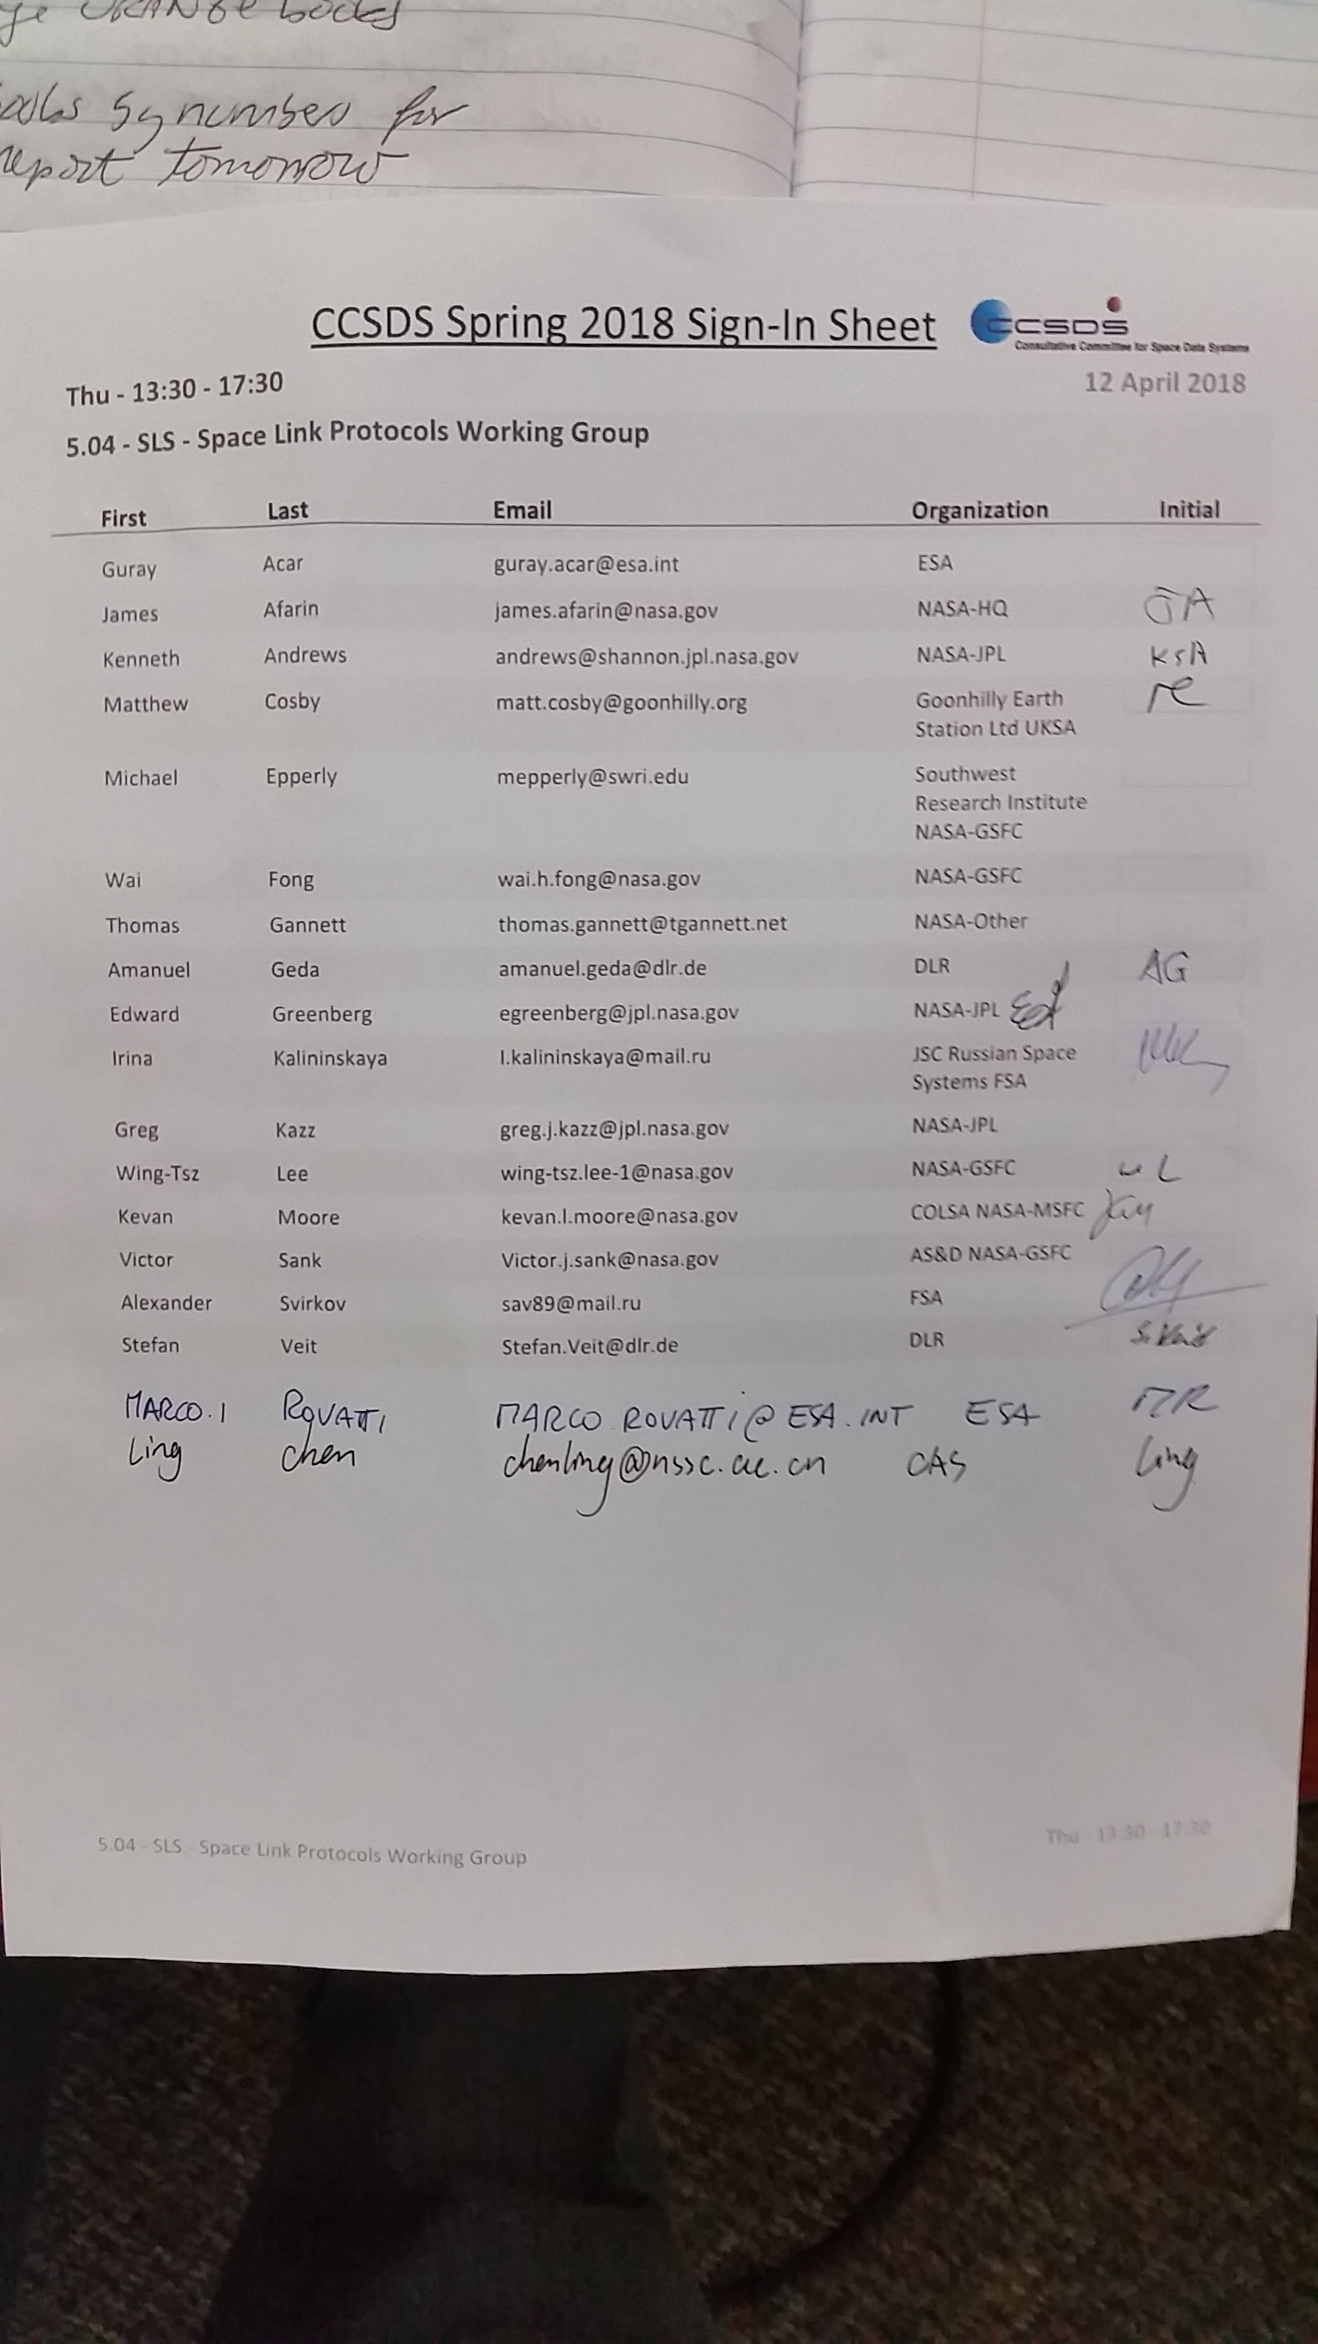

End of Report

