CCSDS Spring 2017 SLP WG Meeting Minutes - Draft

Den Haag, the Netherlands

Nov. 5-6, 2017 – Greg Kazz/Chairman

Major Accomplishments from this Meeting

- Promoted USLP RED-3 to RED-3.1
- Reconfirmed IP over CCSDS Blue Book, CCSDS 702.1-B-1
- Technical Corrigenda to enable USLP to run over CCSDS C&S Sublayer
- Space Packet Protocol Revisions Discussion
- Status of Interoperability Testing including Tests yet to be performed
- Status of USLP GB
- Action Items
- Next Meeting
- Acknowledgment
- Attendance Lists

- USLP RED-3 RID Dispositions

Our Monday PM session was largely devoted to dispositioning the USLP RED-3 RIDs submitted by UKSA, NASA, and ESA. Consensus to promote the USLP RED-3 book to RED3.1 was achieved. Tom Gannett was on-hand and concurred with naming this book, RED3.1. It is the intention of the SLP WG to keep this book “frozen” unless further interoperability testing results in additional RIDs that the SLP WG needs to disposition in the future.

All of the RID resolutions generated during this session have been transferred to the SLP CWE under the URL:
https://tinyurl.com/ydbdcrbg

A summary of the discussion involving the key RIDs follow:

The key NASA RID submitted by Tom Gannett challenged the characterization of mandatory vs optional fields in the specification. The WG came to consensus on removing the word “mandatory” that appeared after field names (because the book already defines all fields as mandatory unless they are explicitly called out to be optional). In addition, wording was added to the key fields: OCF, IZ, Transfer Frame Data Field, and FECF focusing upon the presence of those fields in the document as opposed to their use. An example of this rewording for the OCF requirements follow:

      - The presence of the Operational Control Field is signaled; its presence or absence shall be signaled by the Operational Control Field Flag for each applicable Virtual Channel.
      - If present, the Operational Control Field shall occupy the four octets following, without gap, the TFDF, if this is present, or the Insert Zone, if the TFDF is not present, or the Transfer Frame Primary Header, if the Insert Zone and the TFDF are not present.

The example above illustrates quite well the changes made in Section 4 (PDU). Those fields whose use can be optional was made explicit as well.
There was major discussion involving two similar RIDs one from ESA and one from UKSA about periodic vs synchronous Service in USLP. The UKSA concern was met by the following RID resolution: During the meeting we limited the Insert Service to be the only periodic service. All other references to periodic service was removed. A requirement was added in the Insert Zone (section 4) stating that IZ service shall be a periodic service.

ESA wrote a RID about what appeared to be the inability to mix both sequence-controlled and expedited frames over the same VC. The result of this RID was the addition a note right after 4.1.2.12.5. It clarifies that both the sequence-controlled frame counter as well as expedited frame counter can be maintained over a given VC. Also deleted NOTE 5 below since it is redundant with the new note. “5- USLP allows the user to define up to 63 VCs (VCID 63 is reserved). Constraining a VC to exclusively support either Sequence-Controlled or Expedited Service means that each VC would need only 1 VC counter”

It was also pointed out by ESA in another RID, that USLP did not explicitly state where the CRC-16 and CRC-32 definitions are. This was rectified by the following correction: The changes made are to add a new requirement in USLP to amplify the fact that the CRCs are defined in a normative annex B.
4.1.6.2.2. The FECF shall be computed using either the 16-bit coding procedure or the 32-bit coding procedure specified in Annex B.

- 5-Year Reconfirmation Review of IP over CCSDS (IPoC) CCSDS 702.1-B-1

At the Spring 2017 meeting, agencies were requested to start the formal review of the IP over CCSDS Blue Book, i.e., CCSDS 702.1-B-1 in their respective agency.

Consensus at this meeting was achieved to reconfirm IP over CCSDS for another 5 years.

There were two remarks made during the discussion at this meeting. One by Peng Wen from Tsinghua University and one by Lee Pitts, NASA-MSFC.

From Peng Wan from: 1. Insert the words "Notes" before the last paragraph in Page 2-4 of CCSDS 702.1-B-1.

The SLP WG discussed this issue and came to the conclusion that since this information is already non-normative, it would not make a difference if the word, “NOTE” was prepended to this information or not. Therefore, no change was made.

2. add the notes or suggestion about the relationship between uplink VCs and downlink VCs which might be used to apply interactive internet protocols, such as MSN or video conference. The SLP WG discussed this point and we decided to see if this information might better be made to the USLP green book for future application.

Lee Pitts suggested that a new Secondary Header be added to the Encapsulation Packet to accommodate providing the time field into the packet header. This change would actually be made to the CCSDS Encapsulation Service Blue book and not to the IPOC blue book. We asked Lee Pitts to generate a Pink Sheet to Encapsulation Service, CCSDS 133.1-B-2, October 2009 book. However, that change would not impact the reconfirmation of IPoC.

- Technical Corrigenda to enable USLP to run over CCSDS C&S Sublayer

Ken Andrews made a short presentation which he will give at the C&S WG meeting on Wed. PM, regarding the changes to the SCCC, DVBS-2, TC Sync & CC, TM Sync & CC blue books due to the addition of the Version -4 USLP Transfer Frame. This was done so that the SLP WG could be kept informed about the coordination necessary between both SLP and C&S WG, once the USLP specification becomes a blue book. Ken’s presentation is available in the SLP CWE under:

https://tinyurl.com/yacfmx93

- Space Packet Protocol (SPP) Revisions Discussion

There has been several email discussion occurring outside of the SLP WG concerning the current state of the CCSDS 133.0-B-1 Space Packet Protocol. Blue Book. Issue 1. September 2003. The SPP has become somewhat of an “orphan” within CCSDS. However since the restructuring of the CCSDS link layer documents around 2000-2003, SPP has been handled by the SLP WG.

The crux of the issues concerning SPP today boil down to the duality of the functionality of the protocol. SPP is both an application layer data structure, i.e., it defines the Space Packet which is used by many agencies as an application layer data structure. Additionally, agencies use the SPP as a packet with transport like functionality but not as a network packet which is placed into Level-2 CCSDS transfer frames. The appearance of SPP at both the application layer as well as directly above the frame layer in CCSDS causes some confusion that needs clarification in the SPP specification.

So SPP has this dual use functionality. We need to explicitly state that there is this dual use and that either use or both is valid. The application layer functionality is the one that is currently not documented and this is the point that needs to be updated. Note that Tomaso de Cola’s diagram in Orange book 131.5-O-1 (Erasure Codes) would also need to be modified to show SPP in the application layer.

An example given during the discussion about the “duality” of SPP is the following: An SPP packet (at the application layer) can be placed into a DTN Bundle which is encapsulated into a SPP packet (just above Level 2) which is placed into CCSDS frame.

At the meeting Lee Pitts, NASA-MSFC pointed out that ISS uses Logical Data Path in SPP for Point-to-Point links. This is consistent with the ABA configurations where there is no question about the packet source or destination.

Consensus was achieved at this meeting that a revision to the current SPP is in order and that this work shall best be carried out as a new project in the SLP WG, called “SPP Revisions” Project. Currently the scope of the project is to examine the network like concepts introduced within SPP such as Logical Data Path (LDP) and Application ID Qualifiers that “do routing by management” and decide best how to describe them as they are truly used today.

These points are:
- Modify the SPP Blue Book to clearly state what the SPP protocol, as specified, actually is capable of doing, and do so in a way that does not break any existing, legitimate, uses of SPP to carry application data.
  - SPP is an application layer protocol that defines the Space Packet PDU but is not a routing protocol
- Remove these fictional "routing by management" features that could never be used interoperably in any kind of SSI configuration and leave real routing to DTN.
- Update the other CCSDS blue and green books e.g., Overview of Space Comm Protocols GB, etc that are affected by changes to the SPP. Also include BP, LTP into these affected GBs as well.

For these points a clear consensus was achieved. NASA agreed to be the book editor of SPP. ESA, CNES, DLR, UKSA all agreed to participate as monitors to this work.
  - WG to request SLS AD to approve project on the above basis.
  - The presentation given by the SLP WG chair contained all of the ingredience (scope, resources, and schedule of the proposed project) necessary to start the project within SLP WG.
  - Clean up of SPP concepts concerning the LDP and APID Qualifiers will occur prior to Spring 2018 and Pink Sheets to SPP will be circulated prior to Spring 2018 meeting
  - End point Application to Application Namespace formulations will be discussed as an additional topic wrt how this content could appear in a managed or signaled Space Packet Secondary Header

In addition, it was recognized by all that additional revisions to the SPP are possible. In particular, due to the timely needs of the Deep Space Gateway (DSG) which includes international participation (NASA, ESA, JAXA, Roscomos, CSA), a solution to the namespace issues is a very timely topic that CCSDS needs to be ahead of the curve. One area that the international space agencies need to explore further within this project is expanding the Namespace.

- Additional work is to define a namespace that can optionally be included in the SPP packet secondary header to support an extended number of end user applications distributed within a system and/or between systems.

- The motivation is to provide unique (and extensible) names for single spacecraft, constellations, and any of their functional composite parts that need to be identified as communications end-points at the applications layer, such that they can be unambiguously referenced.
  - At the link layer end-points are identified using CCSDS SCIDs.
  - At the network layer end-points are identified using DTN node identifiers or IP addresses and ports.

- These identifiers are intended to be referenced for application layer message exchanges. As such they may be used with CCSDS SPP “message” exchanges, or within other application support layer protocols like AMS on on-board message buses.

What the best approach to expanding the namespace is the question? Several recommendations were made at this meeting for moving forward with this idea, so to document these approaches as an appendix in the SPP Revisions white paper. Currently there is no way to know what is contained in a packet secondary header. e.g., if it contains a PUS secondary header, or if there is a time code there or some future 2nd header content. Two options were given at the meeting for further evaluation:

- Managed approach: Keep the same Space Packet version number 1 and use management to differentiate between the various types of content within a SPP secondary header.
- Signaled approach: Create Space Packet version number 2, which would be a self-identifiable version i.e., contain some kind of ID within the packet 2nd header to describe the contents of that header. CNES was keen on this option, since it would guarantee backward compatibility of the existing SPP in packet version 1.

It was noted that the SPP must not be modified to allow the addition of routing within the protocol.

Keith Scott made the recommendation that Type Length Value (TLV) fields be used to make the new 2nd header content field Identifier field within the secondary packet header as extensible for the future as possible.

Note: This discussion was attended by the SLP, SOIS, and SIS area directors which helped ensure that the decisions made at this meeting had a wide acceptance across these CCSDS areas.

The presentation given by Greg Kazz introducing this topic of the need to revise the SPP at this meeting is found in the SLP WG portion of the CWE under the Fall 2017 den Haag meetings:

https://tinyurl.com/yb2c9y6u

- Status of Interoperability Testing including Tests yet to be performed

Lee Pitts NASA-MSFC provided a status report of the interoperability testing performed to date between DLR and NASA. That report is on the SLP CWE under:

https://tinyurl.com/yd8xf6gd

At the meeting, a splinter session occurred that focused on what additional tests need to take place.

The additional tests that were identified are:

- Run the Version-4 USLP frames over the CCSDS Prox-1 C&S Blue book and the COP-P and COP-1 protocols. Here we test the interface between the C&S sublayer and the USLP protocol sublayer. The existing USLP implementations (DLR, NASA-MSFC, NASA-JPL) supply the USLP frames to the Prox-1 C&S sublayer software (JPL will have one implementation, not sure yet who will supply the 2nd implementation), which will find the frame length in the Version-4 USLP transfer frame demonstrating that the frame can be delimited by the C&S sublayer. The C&S sublayer will pass this data onto the receiving node’s C&S sublayer and the existing USLP implementations will demonstrate that they can receive/validate Version-4 transfer frames from the C&S sublayer.
All these interface testing can be done in an uncoded mode. No coding required, because codex has already been tested before. This is testing the the new frame format interface which boils down to being able to delimit the new frame length field in the V4 transfer frame.

- USLP Annex C – Relationship between Version-3 & Version-4 frames will also need to be tested since it is normative. Essentially we will need to demonstrate at the protocol sublayer level that one can transfer both Version-4 transfer frames containing user data (I think we can already demonstrate this one) as well as Version-4 frames containing protocol data (e.g., Prox-1 control directives defined in Annex A of the Prox-1 Data Link Protocol). This would be done on implementations that can demonstrate the effects of Prox-1 directives on the receiving side e.g., data rate changes actually occur.
The rationale for that depth of testing is because both ‘some of the sizes’ as well as the locations of the fields that originated in Prox-1 Space data link protocol have different locations and in some case even different sizes in USLP.

- Need to show that USLP frames can carry the SDLS header and SDLS trailer. This level of testing should also be done at the interface between USLP and SDLS. Find the SDLS header and trailer and extract out the fake content.

- Need to demonstrate that both COP-1 and COP-P procedures can be executed using the Version-4 USLP transfer frame.

- Status of USLP GB

Due to time constraints, the USLP GB was not discussed in San Antonio. Since USLP is complex, it is very important that this book provide major insight into the USLP Blue book. This Green Book will be updated due to the resolutions associated with transitioning from RED-3 to RED-3.1

- Action Items

Action items assigned during this meeting are:

- Lee Pitts, NASA-MSFC plans to write pink sheets against the CCSDS Encapsulation Service, CCSDS 133.1-B-2 to introduce a packet secondary header into the Encapsulation Packet to carry the spacecraft clock time tag by the Spring 2018 meeting.
- NASA (Greg Kazz, Jonathan Wilmot, Peter Shames, Scott Burleigh, Keith Scott) will provide a SPP Revisions White Paper before the Spring 2018 meeting.
- Greg Kazz and Matthew Cosby will search through all the CCSDS books (including Blue, Green, Orange) to find where any modification is necessary due to the addition of the USLP Space Data Link Protocol by the Spring 2018 meeting.

- Next SLP WG Meeting

To be held at NIST in Gaithersburg, MD USA during the week of April 9 – 13, 2018 (note 5 day meeting). Exact days of the SLP WG meeting are TBD, but are most likely all day on Monday and Tuesday AM.

- Acknowledgment

Many thanks to ESA for providing the meeting rooms and facilities at the Hague Marriott in the Hague, the Netherlands.

- List of Attendees (Nov 6-7, 2017)

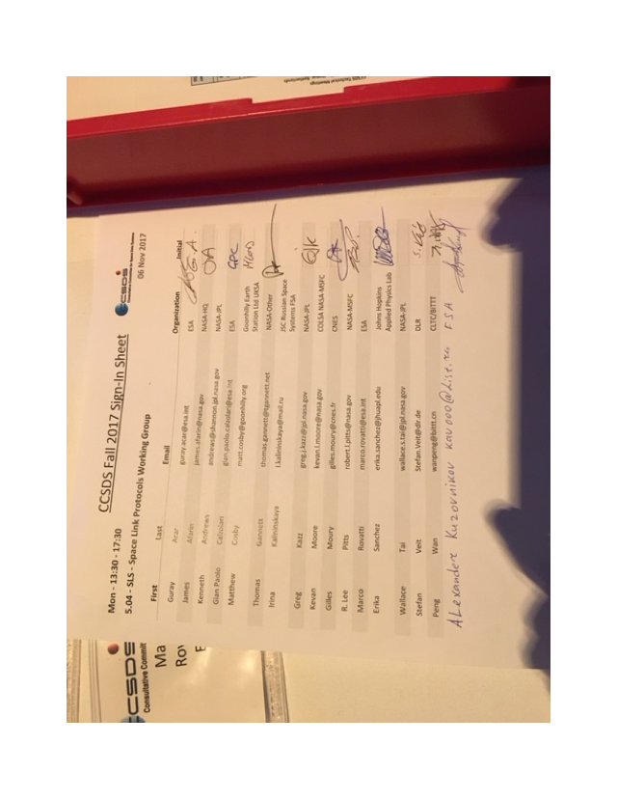

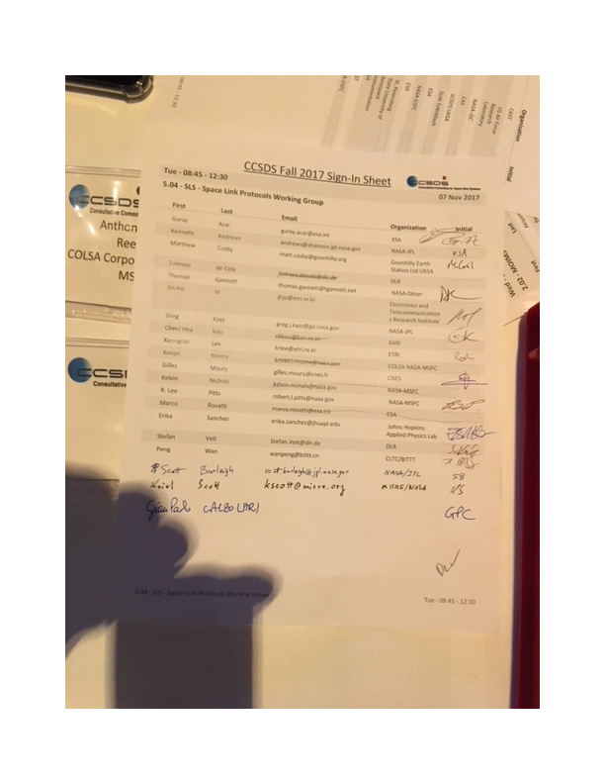

End of Report

