CCSDS Spring 2017 SLP WG Meeting Minutes
San Antonio, TX, USA
May 11-12, 2017 – Greg Kazz/Chairman

Major Accomplishments from this Meeting

- Promoted USLP RED-2to RED-3
- Start of Reconfirmation Review for IP over CCSDS
- Remaining work items for USLP Blue Book
- Nominations for SLP WG Deputy Chair
- USLP Green Book
- Joint meeting with SDLS WG
- Status of Interoperability Testing
- Next Meeting

USLP RED-2 RID Dispositions

8 RIDs were submitted by ESA. 81 RIDs were submitted by NASA. All of the RIDs categorized as “Technical Fact” and most of the “Recommended” were dispositioned at the meeting. The remaining 10 NASA Recommended RIDs that were not dispositioned at the meeting, due to a lack of time available, were resolved after the San Antonio meeting during a telecon that occurred later in May. Authors of the RIDs were informed of the dispositions after the San Antonio meeting. In addition, comments were received before the San Antonio meeting from the SLS Area Director and incorporated into the document as well as annotated in the form of Word Notes.

It is significant to note that these RIDs were addressing issues at a finer layer of granularity than in previous reviews. This result is consistent with general consensus of the SLS WG that we are coming closer to conclusion on the USLP specification and is a good sign of technical progress.

5-Year Reconfirmation Review of IP over CCSDS (IPoC) CCSDS 702.1-B-1

Agencies were requested to start the formal review of the IP over CCSDS Blue Book, i.e., CCSDS 702.1-B-1 so that if an agency recommends changes to this specification, the agency representative will send their changes onto the SLP WG Chairman so that they can be discussed during the CCSDS Fall 2017 Meeting.

Remaining work on USLP Blue Book

Both the Security Annex as well as the PICs Proforma need to be developed for USLP. The SLP WG chair took the action to complete both of these Annexes before the Fall 2017 meeting. These Annexes will be provided to the SLP WG at least 2 months before the Fall 2017 meeting to ensure an adequate review will take place.

SLP WG Deputy Chair
UKSA put forward Matt Cosby as their nominee for the position of SLP WG deputy chair. The CMC will be reviewing all the candidates for this position and will provide the results of their deliberations after the CMC meeting in June.

The USLP Green Book

Due to time constraints, the USLP GB was not discussed in San Antonio. Since USLP is complex, it is very important that this book provide major insight into the USLP Blue book. One important aspect are the utilization profiles which are to be reflected in the GB. This Green Book will be updated due to the resolutions associated with transitioning from RED-2 to RED-3.

Joint Meetings with other WGs

SLP WG had a meeting with the SDLS WG that resulted in no change to the GVCID nor to the GMAP parameters within the Space Data Link Protocol (SDLP) books. There was a proposal to modify both of these parameters in the SDLP books so that each of them would contain a bit to show “directionality” of the link (for example, a telemetry vs a telecommand link). However, the consensus was that no change was required within the SDLP books nor in the emerging USLP, since SDLS WG could contain the change within their area and books.

Discuss the status of USLP Interoperability Testing (DLR & NASA MSFC)

Lee Pitts gave a short presentation of the status of USLP interoperability testing. See the URL below:

https://tinyurl.com/ybujemfg

Next SLP WG Meeting
To be held at the Marriott Hotel in the Hague, the Netherlands during the week of Nov. 6 - 9 (5 day meeting). Exact days of the SLP WG meeting are TBD, but are most likely Monday PM and Tuesday AM.

Acknowledgment

Many thanks to SWRI for providing the meeting rooms and facilities at SWRI in San Antonio, TX USA.

List of Attendees (Thursday May 11-12, 2017)

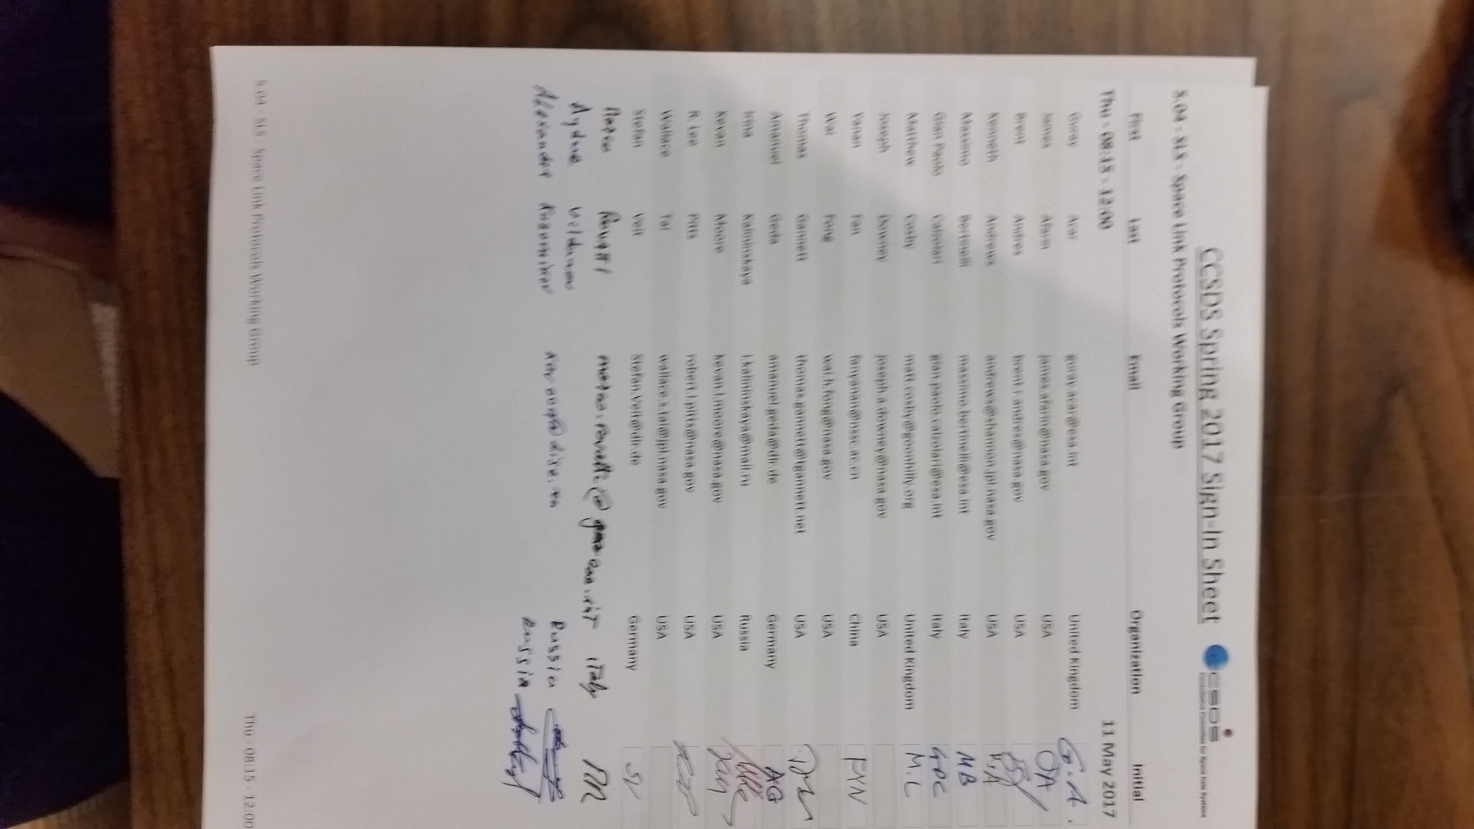

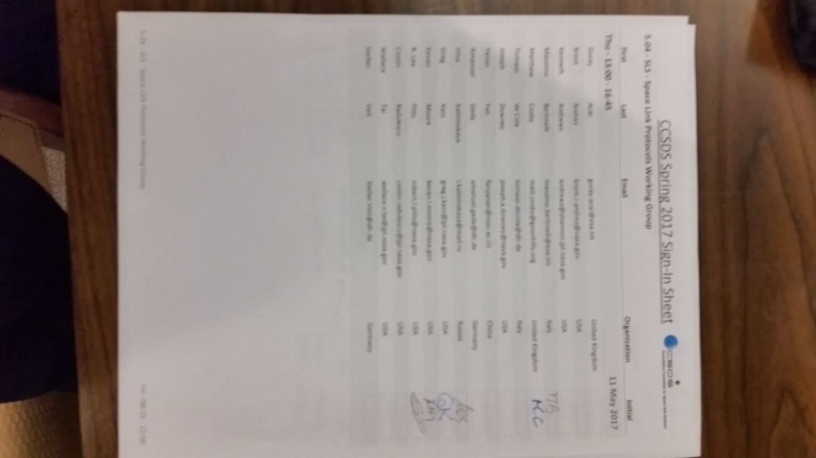

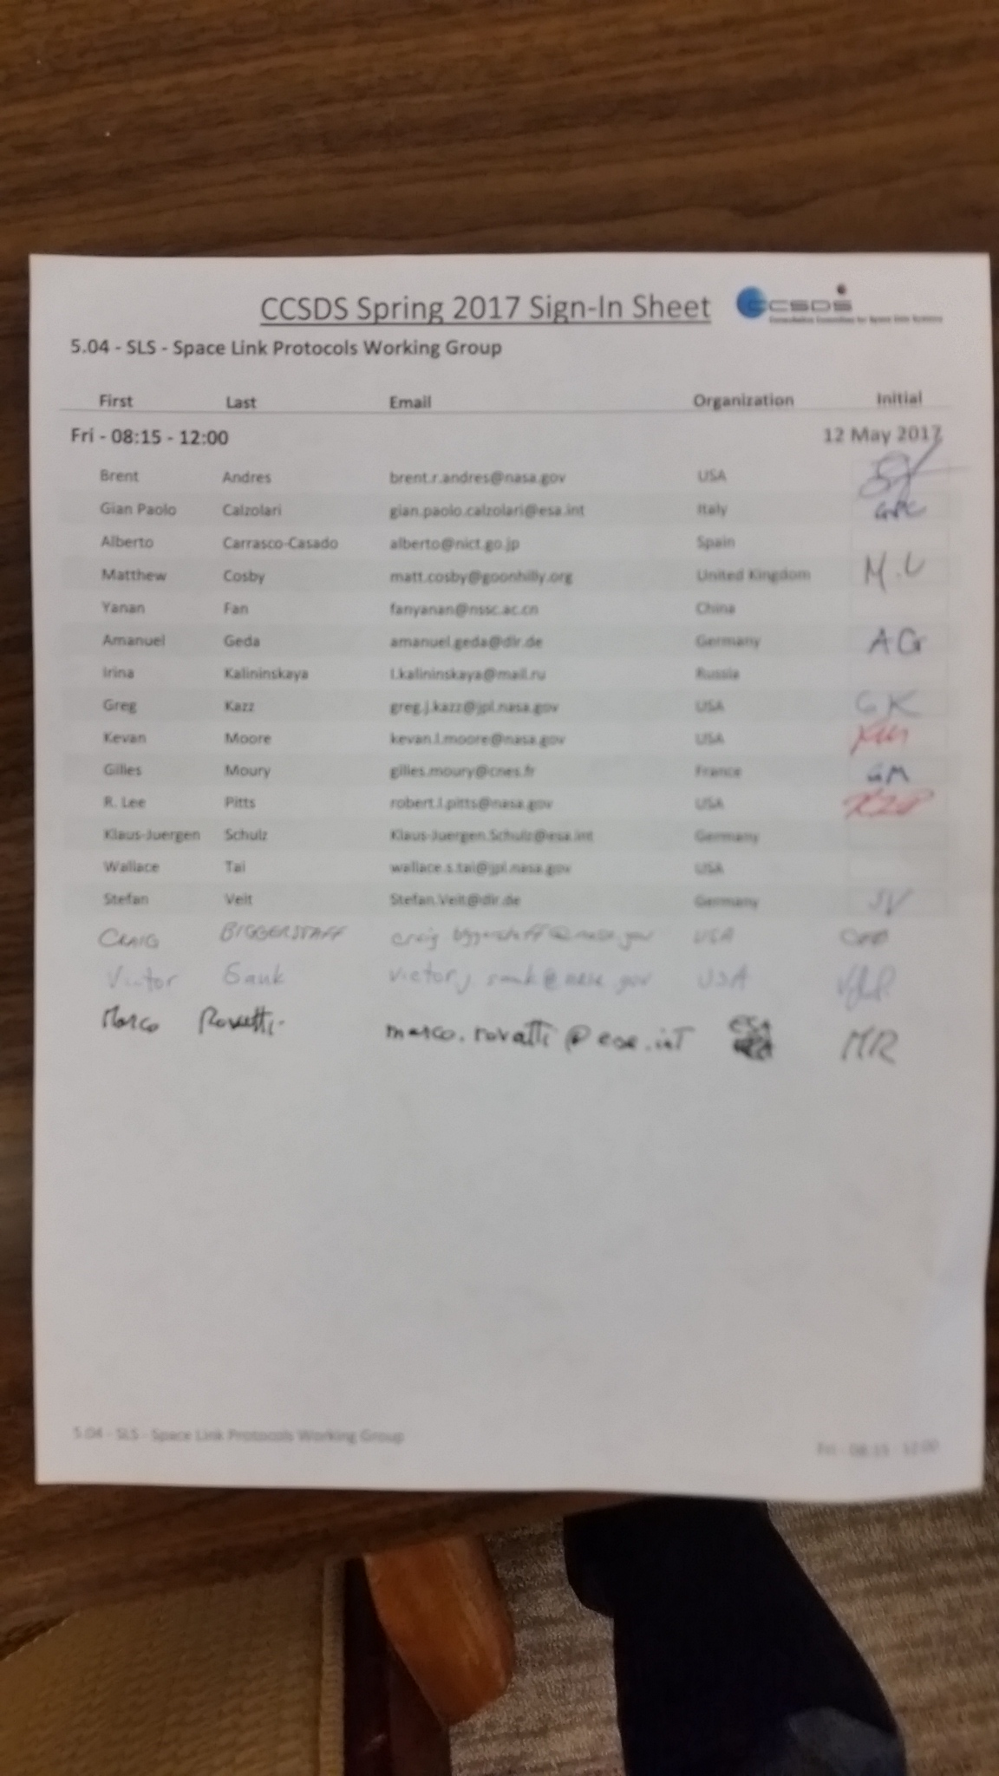

End of Report

