Draft CCSDS Fall 2016 SLP WG Meeting Minutes
Rome, Italy
Oct. 20-21, 2016 – Greg Kazz/Chairman

Major Accomplishments from this Meeting

- Promote USLP RED-1 to RED-2
- USLP draft Green Book to be updated to v0.4
- Reconfirmed CCSDS 133.1-B-2 (CCSDS Encapsulation Service) for another 5-years

USLP RED-1 RID Dispositions

107 RIDs were submitted against USLP RED-1. All of these RIDs were dispositioned at the meeting. The authors of the RIDs will be informed of the dispositions within the next 2 weeks.

Executive Summary of RID resolutions

The RIDS can be categorized into the following:

- Several RIDs came from the SIS area director, Keith Scott concerning the definition of the sequence count field, the inconsistency of naming of the MAPA service, and several editorial RIDs.
- The SDLS WG reported that in general USLP conforms quite well to the existing SDLS protocol. 4 RIDs from SDLS WG were dispositioned.
- Three RIDs came for the CSS Area director. One of which dealt with streamlining the SANA section on new SANA registries as a result of USLP.
- 7 ESA RIDS covered the topic of frame verification from a C&S point of view. The answer depends upon which C&S specification applies.
- 14 ESA RIDS covered several aspects of the protocol including the fact that packets include both the rule ‘000’ and ‘111’
- 68 NASA RIDs focused mainly on the PDU format, Services, and Managed Parameters. Clarity is needed concerning the consistent use of fill/Idle/OID data throughout the document.
- 1 CNES RID focused on the apparent contradiction with the ability to repeat a USLP frame multiple times even though this is not considered retransmission.

Joint Meeting with C&S WG

On Wednesday afternoon, the SLP WG met with the C&S WG and focused on the SLP WG proposed draft Utilization Profiles. By examining the format and content of this book during the meeting, both WGs came to consensus on these results:

- SLP WG was asked to examine the format of the TM Channel Coding Profiles Magenta Book. The matrix contained in this book could be modified to show which channel coding options work with USLP.
- NASA plans to convert the content of the Utilization Profiles book into the matrix stated above. The following agencies indicated that they are willing to review a white paper provided before the CCSDS Spring 2017 Meeting and to be presented there that shows this matrix. These agencies are: UKSA, DLR.
- The goal is to reach consensus by the Spring 2017 meeting and create a new project in SLP WG, supported by C&S WG, called “USLP Channel Coding Profiles”. There is still some debate as to whether or not this book will become a Blue or a Magenta Book. The decision most likely will come from the CESG/CMC.

Reconfirmation of Encapsulation Service (CCSDS 133.1-B-2), TC and AOS Green Books

Agencies were polled at the meeting to reconfirm the Encapsulation Service, TC and AOS Green Books for another 5 years.
No agency was against this reconfirmation and therefore after the meeting, a resolution was submitted at the SLS plenary to the SLS Area director requesting the reconfirmation.

Details of major decisions made at Rome meeting

Topic: How to document USLP Version-4 transfer frame in Proximity-1 SDLP

Greg Kazz made the viewgraph presentation entitled, “Prox-1 to USLP Conversion” found at this URL: http://tinyurl.com/zvy8gyg

The major points of the presentation were:
- Proximity-1 SDLP doesn’t fit the prototypical Space Data Link Protocol framework until TM, TC, and AOS.
- Prox-1 SDLP contains many more features e.g., session control state tables, COP-P, etc. that are not contained in the other SDLPs.
- Except for the Timing Service, Proximity-1 has no other services defined.
- Recommendation made in the SLS Plenary simply to add the Version-4 USLP transfer frame to Proximity-1 by reference to USLP in the PDU section of the Proximity-1 document. USLP would also include a short one or two page section on the mapping of the new fields in USLP to Proximity-1. In this section, the following mappings would be discussed:
- The VCID field would be a new field in Proximity-1
- PCID would be assigned to 1st bit of VCID field to accommodate the existing two PCIDs
- MAP ID would replace Port ID in Proximity-1

Topic: The USLP Green Book

On Friday AM, we reviewed the USLP Green Book v0.3. Since USLP is complex, it is very important that this book provide major insight into the USLP Blue book. Basically this Green Book will be updated due to the resolutions associated with moving RED-1 to RED-2.

Topic: Proposed Notes in TM & AOS concerning SDLS cannot be applied to OID Frames

During the development of the NASA-MSFC USLP Prototype, a question came up about the use of SDLS for OID transfer frames. We initially believed that there was a need to provide a new Note both in AOS and TM that would alert the user to requirement 4.2.2.2.3 in SDLS that prohibits the application of SDLS over OID frames. During the SLP WG meeting on Friday AM, we heard from Gilles Moury who confirmed that SDLS already contains a Note to that effect. Therefore, there is no need for additional notes neither in TM nor in AOS.

Topic: UKSA presentation on UKSA study showing similarities and differences between COP-1 and COP-P – Andrew Vo/Matt Cosby

See URL: http://tinyurl.com/h86fr3f

The conclusion reached by the UKSA study on COP-1/COP-P was that one couldn’t run COP-1 over Proximity-1 SDLP. COP-1/COP-P are significantly different enough to prohibit simply swapping one in for the other. However, both COP-1 or COP-P can run over USLP.

Topic: Discuss the status of USLP Interoperability Testing (DLR & NASA MSFC)

Lee Pitts indicated that both NASA-MSFC and DLR are planning to do an integrated test TBD in calendar year 2017.
There will be two separate CCSDS Yellow books written for USLP interoperability testing. One by DLR and One by NASA-MSFC.
Lee said he would approach Dave Israel (NASA-GSFC) to see if Dave could support USLP testing in the LADDE test bed at optical data rates. This could become part of the physical channel test.

Lee Pitts asked the SLP WG to provide performance model for the various USLP environments (DTE, DFE, proximity). This would consist of a list of performance parameters and ranges to be tested.
Next SLP WG Meeting
To be held at SWRI in San Antonio, TX, USA during the week of
May 8-12 (5 day meeting). Exact days of the SLP WG meeting are TBD.

Acknowledgment

Many thanks to ASI for providing the meeting rooms and facilities at ASI Headquarters in Rome.

List of Attendees (Monday Apr. 4, 2016)

Oct. 19 AM Joint Session SLP WG with C&S WG

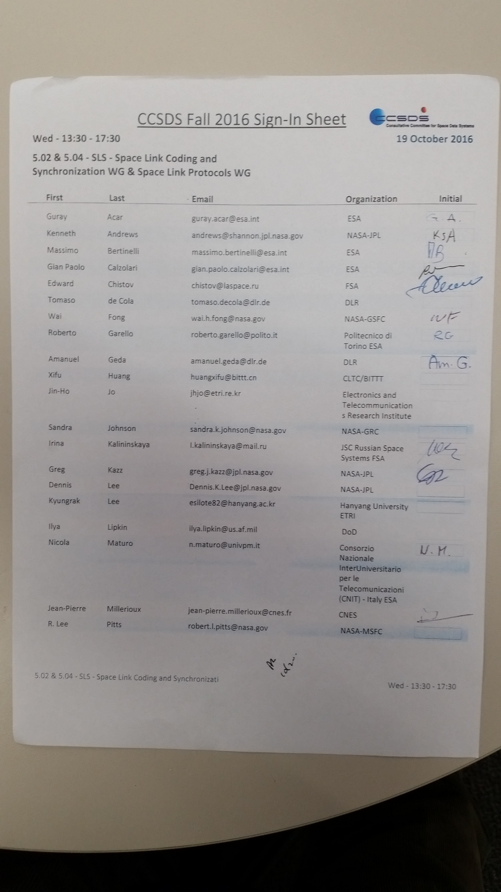

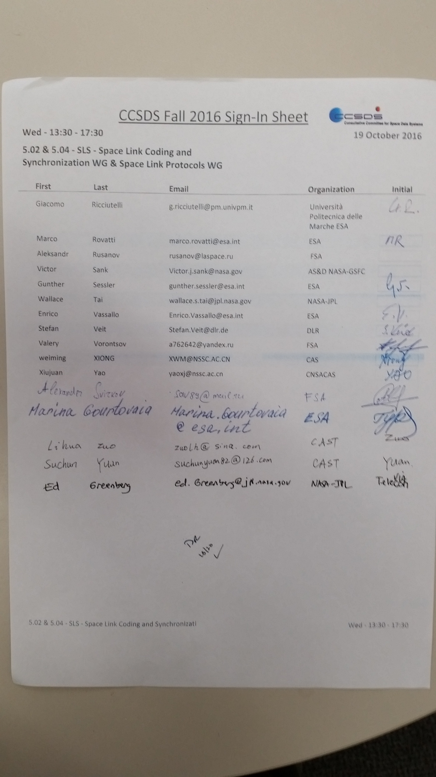

Oct. 20 AM SLP WG Session:

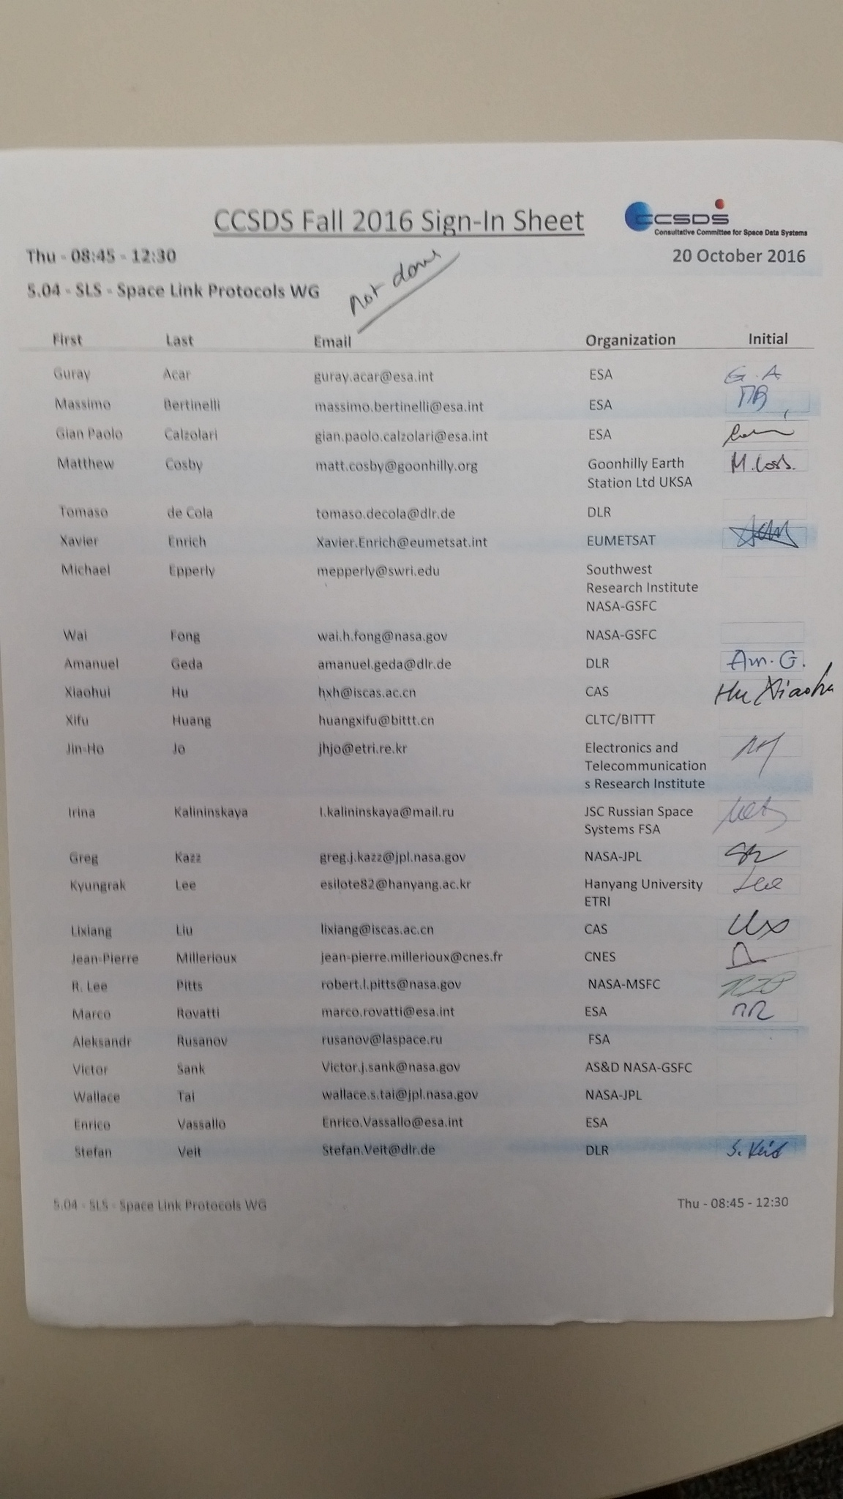

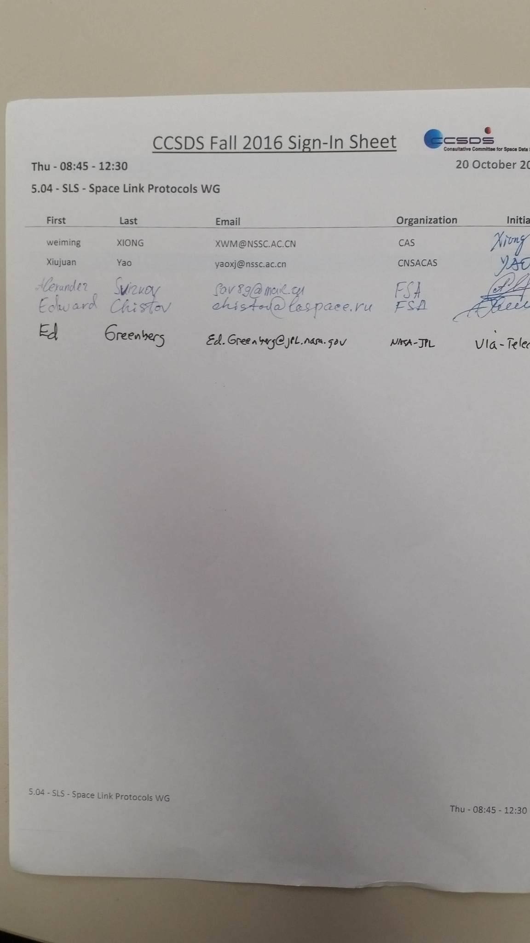

Oct. 20 SLP WG PM Session:

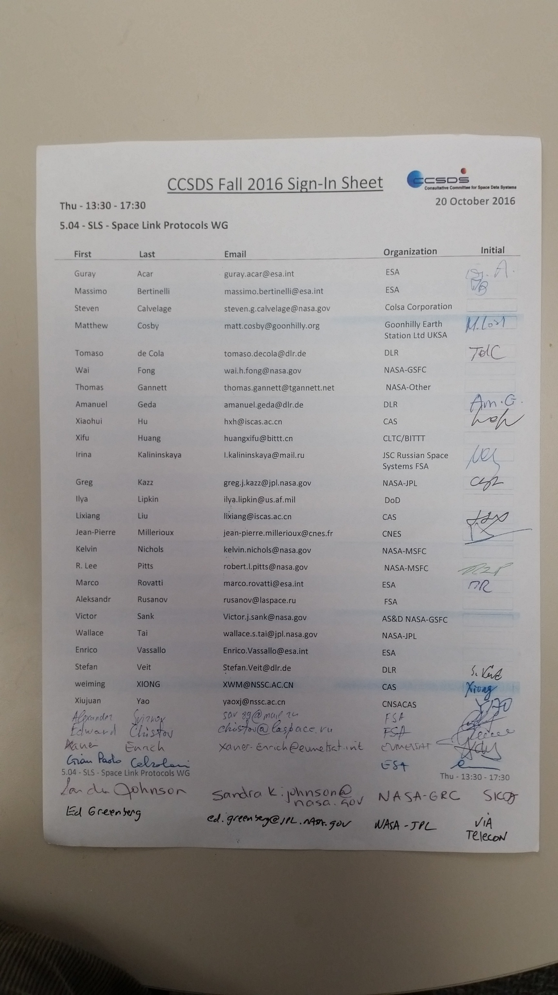

Oct. 21 SLP WG AM Session:

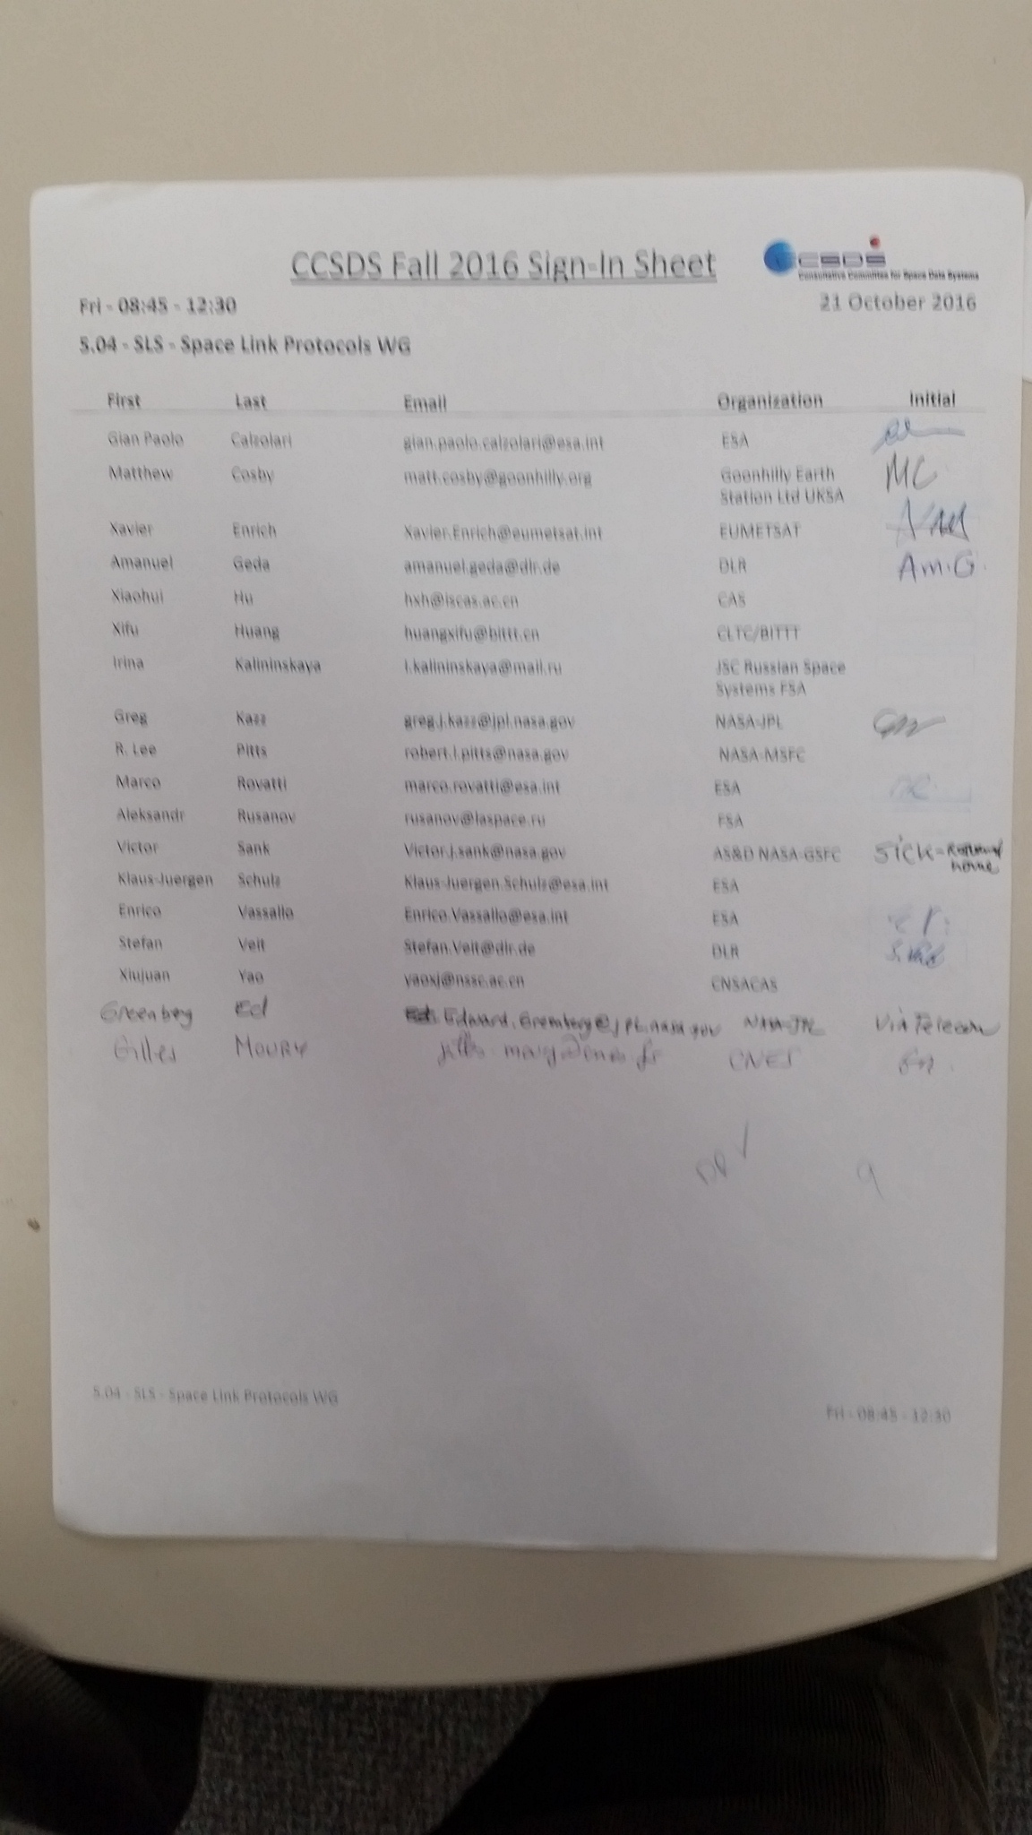
End of Report

