CCSDS Spring 2016 SLP WG Meeting Minutes
Cleveland, OH USA
Apr 4-8 2016 – Greg Kazz/Chairman

USLP White Book Discussion

The current goal of the SLP WG, is to create both a Unified Space Data Link Protocol (USLP) Blue book and Green book. The immediate goal is to obtain consensus to move the draft white USLP protocol book to red-1 status. Therefore, after this meeting, an effort will occur in which the updated draft white book will be redistributed to the WG so that members can be polled to decide whether or not the new draft white book is of sufficient maturity to become the Red-1 version. In order for this updated book to become Red-1, the new Red-1 book would have to be released by the CCSDS Secretariat by the middle of May. This is in order to give ample time for the review of Red-1 by member agencies. If the book cannot be turned around in sufficient time, then the expectation is that the Red-1 version will result from the Fall 2016 meeting in Rome.

Executive Summary

We came to consensus on several major issues concerning the development of the Unified Space Data Link Protocol (USLP).
These are:
- SLP WG will use Encap Service to support the transport of DTN (BP and LTP) across the link instead of native insertion directly into USLP. Consensus along with the SIS Area Director, Keith Scott.
- SLP WG will remove MAP_UPDU service since CCSDS recognized protocols that carry a defined length field could already be transferred using CCSDS IPoC and/or Encap Service.
- SLP WG will keep the COPs Management Service as a reference to the COPs directives sent by the protocol. SDLS Ext. Procedures Mgmt. would also need to be added. Also need PID for Ext. Procedures.
- SLP WG will remove On-demand Insert Zone since there is no consensus for it. The belief is the functionality can be accomplished using packets.
- SLP WG will fix the rqmt to relax the current limitation so to allow different users to multiplex their OCF reports on VC(s)
- Several other finer details captured in the redlines to the pre-Cleveland USLP white book. See topic discussion below.

Additional Joint Meetings

We had two joint meetings with other SLS area working groups. One joint meeting with C&S WG. Another with SDLS WG. The results of these two meetings are documented in both the C&S WG meeting minutes as well as the SDLS WG meeting minutes. A quick summary is provided below:

- With the C&S WG, we came to the consensus conclusion of the need to create a new C&S WG project to modify the Prox-1 C&S coding book to handle version 4 (USLP) transfer frames.
- With the SDLS WG, we worked out a method of transferring SDLS Extended Procedure PDUs over the space link using packets. We also concluded that we need amplification in the TM Space Data link book that Only Idle Data (OID) “fill” transfer frames cannot be secured through SDLS (higher susceptibility to cryptanalysis).

Please see the SDLS meeting minutes as well as the C&S WG meeting minutes for further details.

Call for reconfirmation of COP-1 protocol (CCSDS 232.1-B-2)

Agencies were polled at the meeting to the COP-1 protocol for another 5 years.
No agency was against the reconfirmation and therefore after the meeting, a resolution was submitted at the SLS plenary to the SLS Area director requesting the reconfirmation.

Next SLP WG Meeting
To be held at ASI Headquarters in Rome, Italy during the week of
Oct. 17-21 (5 day meeting). Exact days of the SLP WG meeting are TBD. It may be that the usual Monday full day and Tuesday half-day SLP WG meeting may occur later in the week. Stay tuned.

Acknowledgment

Many thanks to NASA for providing the meeting rooms and facilities at the Westin in Cleveland.

Details of decisions made at CLE meeting

Topic: Direct Insertion of SDU into USLP Frames vs. Use of Encapsulation Service

The pros and cons of direct insertion of SDUs into USLP frames vs. using he established Encapsulation Service was discussed. The advantages of direct insertion were: 1) packet reassembly at the receive side would be eliminated, since encapsulation packets would not be necessary. Neutral was the issue of header overhead. The USLP header fields would still need to incorporate more or less the same type of information already present in the Encapsulation Packet Header. The disadvantages of the direct insert approach was 1) the possible confusion that might be caused with the user community when given the choice of both direction insertion and the Encapsulation Service for USLP. Therefore there was no compelling reason to choose the direct insertion approach.

During the discussion of how LTP segments would be transported across the USLP space link, it was pointed out that only one LTP segment at a time would be placed into the TFDF of a USLP frame. If one had several small segments one could place them first into a CCSDS Space Packet or Encapsulation Packet before placing the packet into the USLP frame. This is the job of the Convergence layer adapter (CLA), which Keith Scott said that SIS area is willing to write. Depending upon the type of frame (variable or fixed), a different TFDF construction rule would apply. The agreement with SIS area is that SIS will provide the CLA service that puts an LTP segment or a DTN bundle into an Encapsulation Packet. Therefore Encapsulation Service becomes the universal solution.

Topic: The proposed UPDU Service

The usefulness of the Upper Layer PDU service was discussed. The key point here was that both the existing Encapsulation Service (for fixed length frames) as well as the MAPA service (for variable length frames) accomplishes the same objectives of the UPDU service. Therefore consensus was not achieved for the UPDU service.

Topic: COPs Management Service

Consensus on this topic was to keep the COPs Management service in USLP. The rationale is that SLP WG needs a way to tie the COP to USLP. This is because of the COP directives that are carried and identified by USLP. This will also be the case for the SDLS extended procedure directives as well that are being defined by SDLS.

Topic: On Demand Insert Service

The rationale behind offering an On-Demand Insert Service in addition to the Isochronous Insert Service is to provide a low latency service in one doesn’t have to wait to create a transfer frame data field to contain this data. The counter argument was that this type of behavior could be accomplished using packet service. The concern was that users could misuse a privately formatted data service and by pass the standard approaches such as packet service offered by CCSDS. There was no consensus for the On-Demand Insert Service.

Topic: How long for an implementation needs to wait before it supplies fill

This issue came up from the USLP interoperability testers at the meeting. The best option is to address these issues within the Managed Parameters. Two new VC managed parameters were added due to this need. They are:
- Maximum delay in milliseconds for a TFDF to be completed, once started, before it must be released
- Maximum delay in milliseconds between releases of transfer frames of the same VC
Both are integer values.

Topic: General Characteristics of Fixed vs. Variable Length Frames

Ed Greenberg presented on this topic at the meeting. His presentation addresses the general features of both fixed and variable length transfer frames. His idea was to help us better understand the fundamental difference so as to see when to apply a fixed length frame vs. when to apply a variable length one. Ed’s presentation as a pdf file appears in the CWE under the URL: http://tinyurl.com/jv2gpbl (the file name contains the title: variable frames)

Topic: Frame Assembly and Frame Reception procedures from an Implementation point of view – USLP GB

Ed Greenberg walked though both the send side and receive side diagrams found in the draft USLP GB. We found an error in the send side that needs to be corrected. The diagrams presented at the meeting can be found at this URL: http://tinyurl.com/jv2gpbl (the file name contains the title: frame building process 3)

Topic: Splinter Session on USLP Testing Held outside of this meeting

A splinter meeting was held on Wed. AM to discuss the test planning for future follow on USLP interoperability testing. Since this meeting was made available to all SLP WG participants but did not occur directly in the SLP meeting, I will mention the summary material available about it: A presentation summarizing the testing approach is available in the CWE under the URL:
http://tinyurl.com/jv2gpbl (the file name contains the words MSFC CCSDS report Apr_2016)

List of Attendees (Monday Apr. 4, 2016)

April 4 AM Session
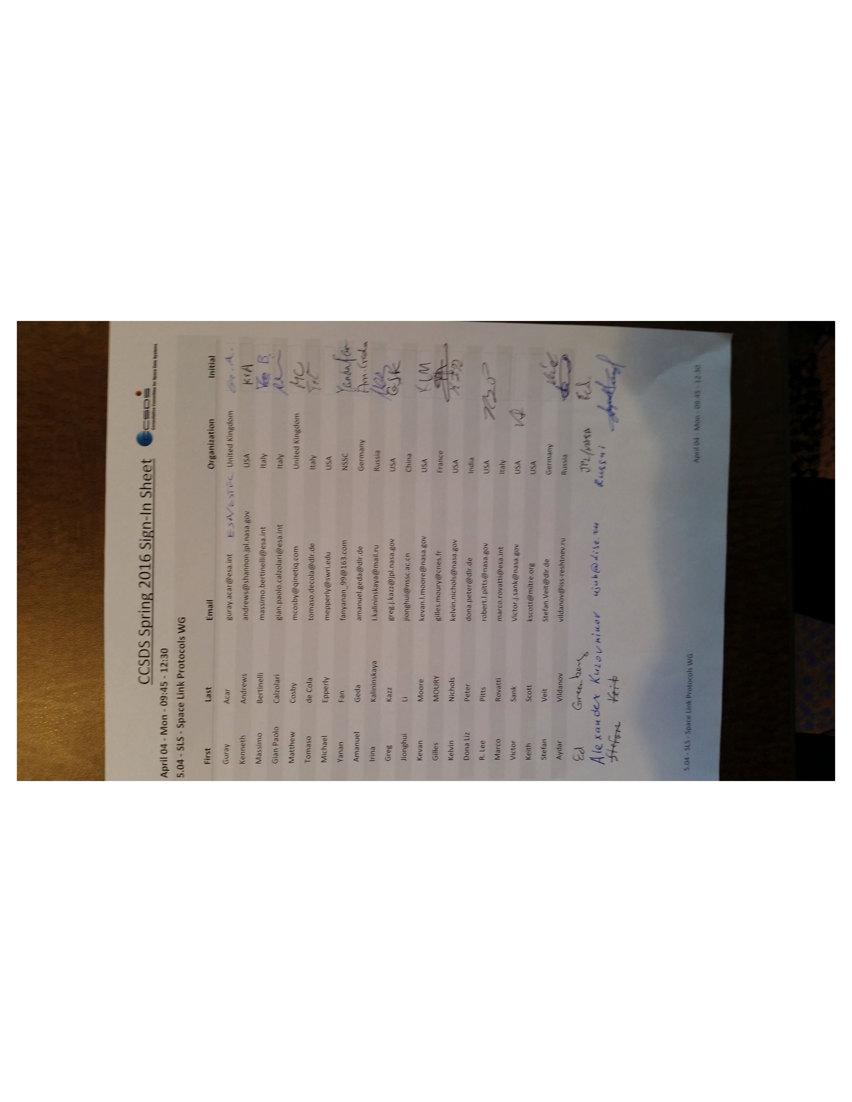

April 4 PM Session:

