From CCSDS 232.0-B-3 TC SDLP
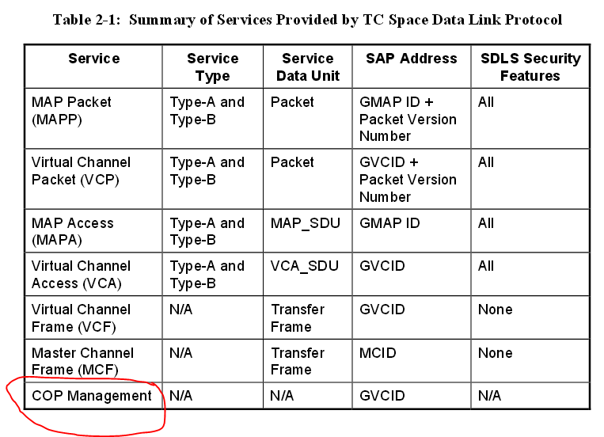

From CCSDS 232.0-B-3 TC SDLP
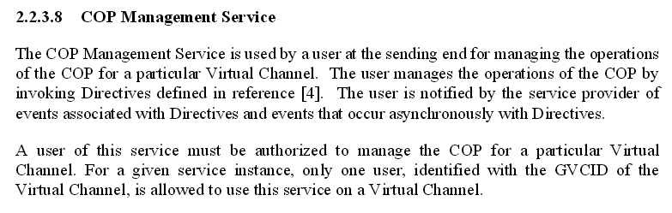

From CCSDS 232.0-B-3 TC SDLP
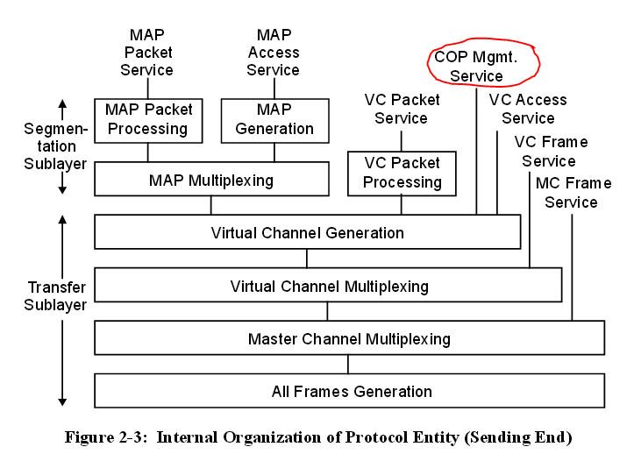

From CCSDS 232.0-B-3 TC SDLP
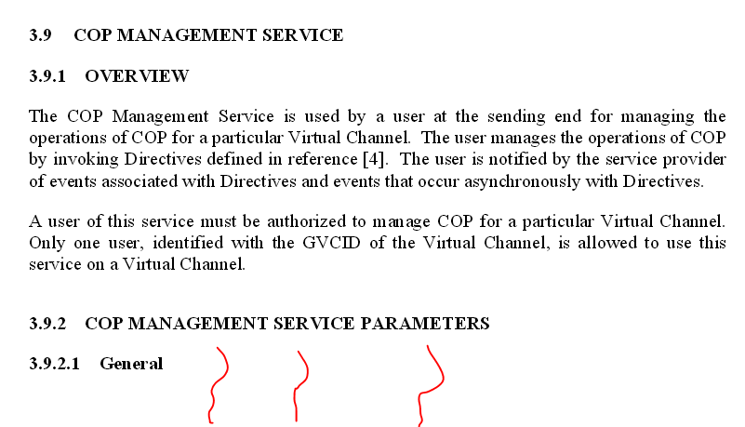
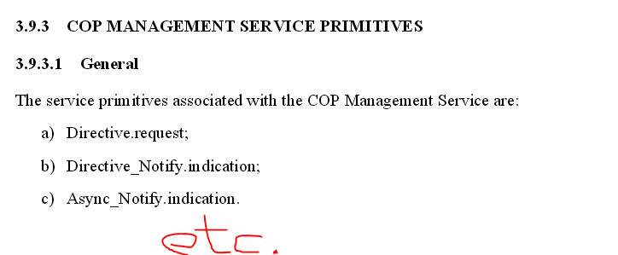

From CCSDS 232.0-B-3 TC SDLP
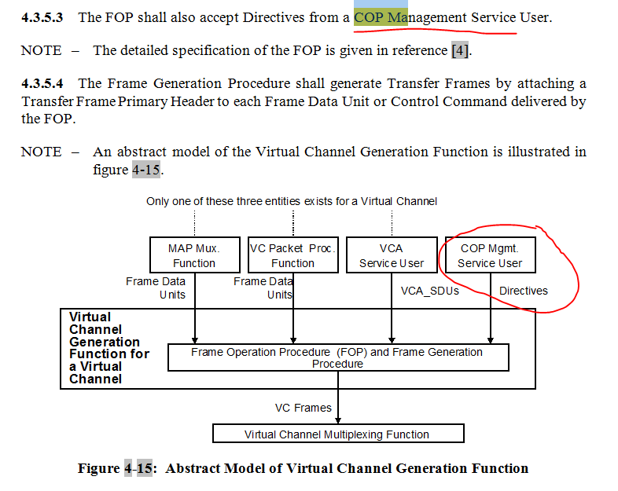
From USLP draft SDLP book
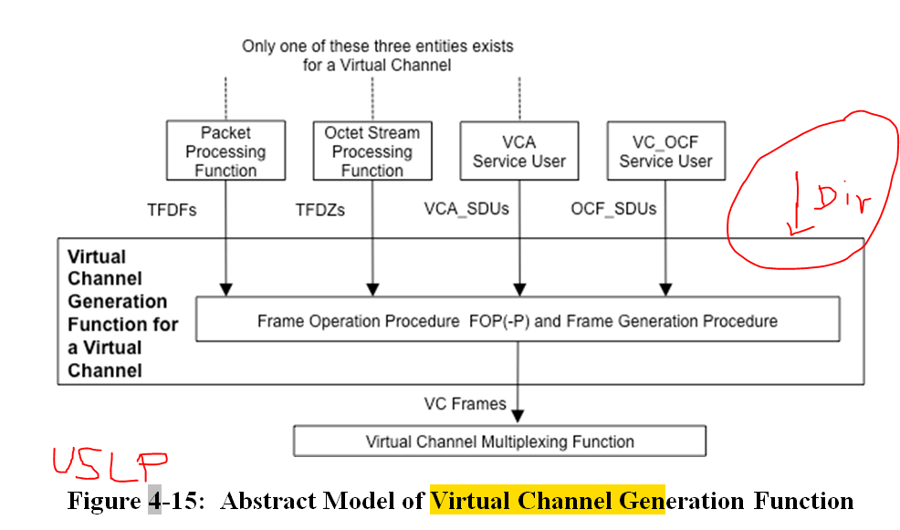

From USLP draft SDLP book
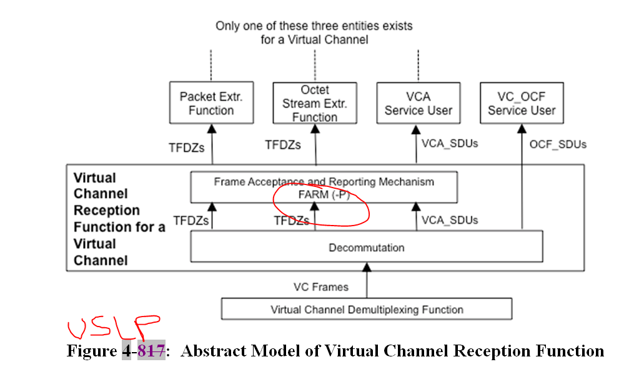
Table 2-1 : Summary of Services Provided by USLP Space Data Link Protocol
Service | Service Type | Service Data Unit | SAP Address | SDLS Security Features
MAP Packet (MAPP) | Sequence-Controlled and Expedited, Asynchronous | Packet | GMAP ID + PVN | All
MAP PDU  (“For Future Discussion“) | Sequence-Controlled and Expedited, Asynchronous | CCSDS Recognized PDUs – See SANA protocol ID registry | UPID | All
MAP Access (MAPA) | Sequence-Controlled and Expedited, Asynchronous or Periodic | MAP_SDU | GMAP ID | All
Virtual Channel Octet Stream | Asynchronous or Periodic | Octet Stream Data | GVCID | All
Virtual Channel Operational Control Field (VC_OCF) | Synchronous or Periodic | OCF_SDU | GVCID | None
Virtual Channel Frame (VCF) | Asynchronous or Periodic | Transfer Frame | GVCID | None
Master Channel Frame (MCF) | Asynchronous or Periodic | Transfer Frame | MCID | None
Isochronous Insert | Periodic | IN_SDU | Physical Channel Name | None
On-demand Insert (“For Future Discussion”) | Asynchronous | IN_SDU | GVCID | None

