PROCEDURES AT THE SENDING END
The procedures described in this subsection are defined in an abstract sense and are not intended to imply any particular implementation approach of a protocol entity.

Protocol Sublayer Procedures
The process from accepting user supplied data to delivery of a frame to the CS_SL is provided in this section. The SAPs provide the interface between the user and the frame generation function. The SAP is assigned a Global MAP ID (Master Channel ID + Virtual Channel ID + MAP ID) and can be assigned for either sequence controlled or expedited delivery service (or that information can be supplied by the data source with the delivered data). The SAP will accept the data for transfer and insert it into one or more TFDZ. The SAP computes the TFDF Header that identifies the protocol or process that the data is associated with, and identifies the construction rules followed to include the data in the TFDZ. Since management parameters can impose constraints on the TFDZ the SAP uses different construction techniques as outlined in section 4.1.5.2.1.5. The SAP initiates the process of building the frame header inserting the GMAP ID, the Bypass Flag and the numeric value of the TFDF that will be included in the frame. This immature Frame Header and the TFDF that will be included in the frame is started on its journey through the processes to complete the frame for delivery to the Coding And Synchronization Sublayer.
The Frame will eventually contain a frame header and TFDF plus it may include an Insert Zone, a security header & trailer, a OCF_SDU and a FECF. The inclusion of these fields is controlled by management parameters that are established for the link. The order of construction is controlled by the implementation therefore the order of processing presented here is only an example. This section will provide an example of how the frame pieces are built and then assembled. The process described will not include the details of the COP retransmission processing nor the SDLS processing only a statement on how they affect the created frame.
The managed parameters for the physical channel will determine if a FECF is required and which FECF algorithm is to be used. The MC Managed Parameters for the MC will determine if an isochronous insert is to be included and provides its length. The VC Managed Parameters for the VC will determine if the security fields, an OCF_SDU and an On-Demand Insert_SDU shall be allowed to be included in the frame. In this example the order of processing is as follows:

- The SAP utilizing its inherent processing capability accepts user provided data units. The data unit is processed complying with the construction rules dictated by the USLP protocol to create one or more TFDFs that will became the data fields for frame(s). In addition the SAP using the managed parameters creates a frame header for the TFDF(s) created. At this point the frame header that will carry the TFDF contains the GMAPID (Version+SCID+VCID+MAPID), the Bypass Flag value, a length field containing the size of the Isochronous Insert and the size of the FECF.
- The VC Map multiplexing process will order the delivery of its received embryonic frame to the VC Count Assignment process. The VC MAP multiplexing process must ensure that all the segments of a data unit are included in sequential VC frames.

- The VC Count Assignment process uses the COP attribute expressed in the Bypass Flag to select the VC count that is incremented and appended to the frame header. The length of the frame header is then added to the length field value in the embryonic frame header.

- The VC multiplexing process can now order the VCs to form a Master Channel.

- If the VC Managed parameters specify that the security process is to be performed on this VC then the required security process is invoked. If authentication is indicated the following information; GMAP_ID, VC Count, and TFDF are delivered to the security process. If authentication is not to be included then only the TFDF is provided. The output products of the security process are wrapped around the TFDF as required by the frame protocol. The length of the security products is added to the length field in the frame header. Note: This process follows VC Mux because the SDLS specification allows a single Security Association to apply to multiple VCs.

- At this point the COP retransmission buffer process should be included to store new emergent frames that can be reintroduced later if retransmission is required by the FOP. Note: This is required to be at this point if the latest OCF and/or On-Demand Insert value is to be included in the resent frame.

- If an On-Demand Insert_SDU is to be included and it is available then it is entered in to the frame. The length of the On-Demand Insert-SDU is required to be in the first octet of the Insert_SDU, this value is added to the length field in the header and the Insert Included Flag in the header is set true.

- If an OCF_SDU is to be included and it is available then it is placed into the frame. The value “4” is added to value in the frame length field and the OCF Included Flag in the header is set true.

- At this point fill is included into the frame that will eventually be replaced by the Isochronous Insert-SDU and FECF fields. .

- The frame can now be multiplexed with other MC frames. Note: The protocol sublayer will make available to C&S an OID frame when the managed parameters require the inclusion of an OID frame when the production process cannot provide one as required for C&S.

- The Isochronous insert can now be placed into its position in the frame

- If it is specified that an FECF is required. It is computed and inserted into its portion of the frame.

- The frame can then be delivered to the Coding and Synchronization Sublayer.
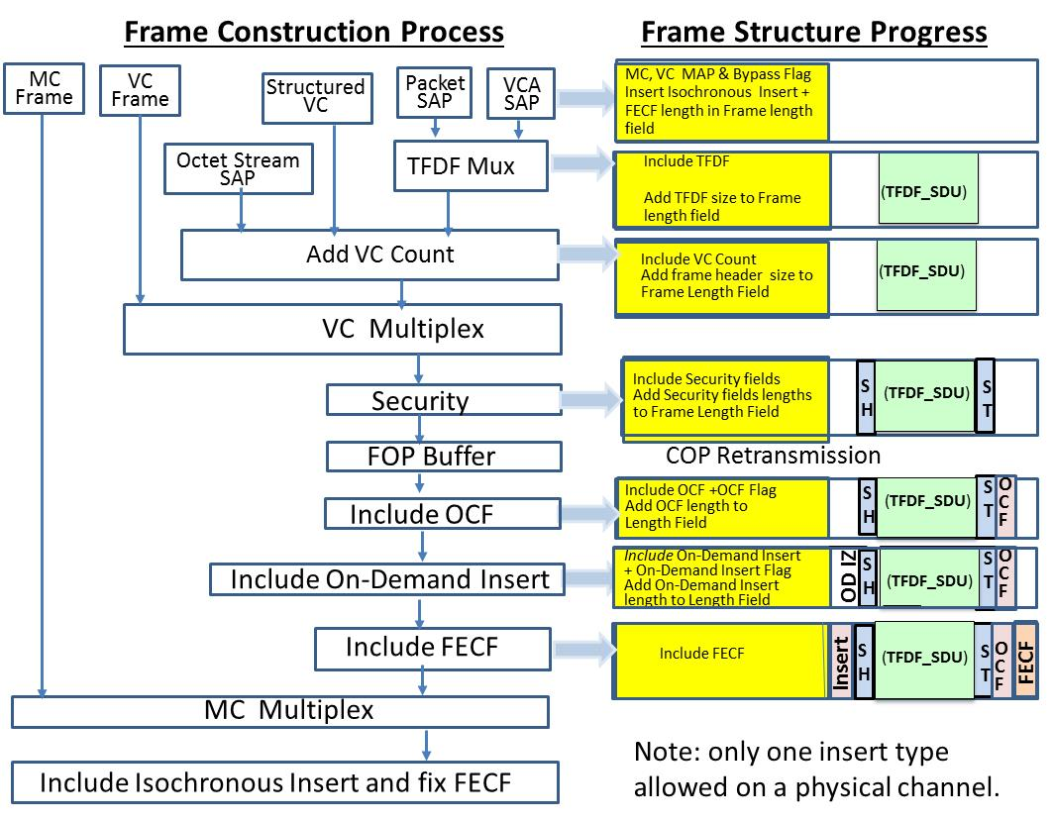
Figure 4-5 Sending Side Transfer Frame Assembly Process
4.3 PROTOCOL PROCEDURES AT THE RECEIVING END
4.3.1 OVERVIEW
This subsection describes the series of procedures at the receiving end. The order of the data-handling functions performed by the protocol entity at the receiving end logically will follow the order described in the example provided in this subsection. This example is not intended to imply any hardware or software configuration in a real system. Depending on the services actually used for a real system, not all of the functions may be present in the protocol entity. The procedures described in this subsection are defined in an abstract sense and are not intended to imply any particular implementation approach of a protocol entity.
- The delimited frame is delivered to the Data Link Protocol Sublayer by the Coding and Synchronization Sublayer. The managed parameters will provide the information relative to a few processing steps. The managed parameters will identify;
  - If an FECF is included and which CCSDS codified algorithm is used.
  - If a Isochronous Insert is included and its size
  - Which VC includes security: The Security Association Header will identify the security algorithm and the sizes of the Security Header and Trailer fields.
- If and FECF is employed the first task would be to perform the required CRC algorithm and determine if the frame has not been modified in transit.
- If an Isochronous Insert is employed then the Insert SDU will be extracted and delivered to the designated user. The start of Insert SDU will be located by using the frame header length (7 plus the VC Count length field) and the Insert Zone length is specified in the managed parameters.
- Master channel de-multiplexing is the performed delivering each Spacecraft’s frames to the designated mission’s handling facility.
- The On-demand Insert Included Flag in the Frame’s primary header will trigger the Insert extraction process. The Insert SDU will be located by using the frame header length (7 plus the VC Count length field) and its length will be equal to the value in the first octet in the Insert zone field .
- If the OCF include flag is set then the OCF service will extract the OCF SDU that will be located by subtracting the FECF length and the value 4 from the value in the frame’s primary header length field.
- The size of frame’s primary header plus the size of the Insert SDU is offset from the beginning of the frame to the next included field.
- If the managed parameters indicate the next process would be the security process. The length of the security header and trailer are contained in the managed parameters and the length of the TFDF can be calculated by subtracting the FECF’s length plus the OCF’s length plus the security header and trailer sizes plus the Security/TFDF Offset from the value in the Frame’s header length field.
- Since a single Security Association can be employed the security process is invoked at this point in the processing. If the security process is successful the unencrypted frame will be provided to the VC De-multiplexer.
- The VC De-multiplexer will deliver the VC Frame to the designated user.
- The frame process will extract the TFDF and deliver it to its specified data processing entity (MAP-SAP)
- The MAP-SAP will process the TFDF header to identify its protocol and the construction rules used to place the data in the TFDZ.

C&S procedures for each Space Link Operational mode
In order for USLP to provide services is all the space link operational fields the USLP frame must provide the required services for that link and C&S must provide the operational modes for frame delivery in all the modes.
Note: Current Operational Modes
- Direct From Earth uses Variable Length Frames that are aligned to variable length code blocks
- Direct to Earth uses Fixed Length frames aligned to fixed length code block and Fixed Length Frames unaligned to fixed length code blocks
- Proximity uses Uncoded, Convolutional Only and Variable Length Frames that are unaligned with fixed length code blocks.
Note: It is conceivable that future mission could use Fixed or Variable Length Frame unaligned to Fixed Length Code blocks for all space links.
THE C&S PROCEDURES FOR THE SENDING SIDE.

Uncoded Mode
- The Frame shall contain a FECF.
- The CS-SL shall prepend a TFSM.
- The TFSM shall be the 16 pseudorandom codeword xxxxxx.
- Randomization is recommend but not required.
- Interface with the Physical layer shall be a continuous symbol stream at a fixed rate for the session.
- Idle octets shall be used to maintain constant output data rate when no frames are available for transmission.
- This mode shall only be used when the SNR is >11 dB yielding a bit error rate of ~10⁻⁶.

Convolutional Only mode
- The Frame shall contain a FECF.
- The CS-SL shall prepend a TFSM.
- The TFSM shall be the 16 pseudorandom codeword xxxxxx
- Randomization is not required because the CCSDS Convolutional Code has a built in symbol transition, but if used it would be applied before encoding
- Interface with the Physical layer shall be a continuous symbol stream at a fixed rate for the session.
- Idle octets shall be input to the encoder to maintain constant output data rate when no frames are available for transmission.
- This mode shall only be used when the SNR is > 5 dB yielding a bit error rate of ~10⁻⁶.

variable length frame aligned to a variable length codeblock
- The Frame may contain a FECF if required by the physical link managed parameters.
- The Frame size is variable to the maximum size specified for the link.
- The codeblock shall contain as many codewords as required to encapsulate the frame.
- The CS-SL shall prepend a CSM to the codeblock as specified for the coding algorithm.
- The CS-SL shall append fill octets to the frame so that the combination of frame plus fill octets entirely fills the information portion of the codeblock starting at the first bit following the CSM.
- Randomization is recommend but not necessarily required.
- Randomization if applied shall be applied as required by the CCSDS Coding and Synchronization Recommendation.
- Interface with the Physical layer shall be a continuous symbol stream at a fixed rate for th session.
- Idle octets shall be inserted into the symbol stream from CS-SL to Physical Layer to maintain a constant output data rate when no frames are available for transmission.
- This mode shall only be used when the SNR is > 5 dB yielding a bit error rate of ~10⁻⁶.

Fixed Length Frame Aligned to Fixed Length Codeblock
- The Frame may contain a FECF if required by the physical link managed parameters
- The DLP-SL shall provide frames to CS-SL continuously, Only Idle Data (OID) Frames will be supplied when no newly created frames are available for transmission.
- The Frame shall be the same size as the fixed length of the information portion of the codeblock to be used by CS-SL.
- The encoded Frame shall be contained within the information portion of the codeblock starting at the first bit following the CSM.
- The CS-SL shall prepend a CSM to the codeblock as specified for the coding algorithm.
- Randomization is recommend but not required.
- Randomization, if applied, shall be applied as required by the CCSDS Coding Recommendation.
- Interface with the Physical layer shall be a continuous symbol stream at a fixed rate for session.
- Idle octets shall be inserted into the data stream from CS-SL to Physical Layer to maintain a constant output data rate when no frames are available for transmission.
- This mode shall only be used when the SNR is sufficient to yield a codeblock error rate of less than 10⁻⁵.

Note: For fixed length frames the use of random inclusion of signaled data can be used but the size of the TFDF must be shortened to compensate for the inclusion. Note that all frames must be the same size but how that is managed may be different in each VC.

Variable length frame unaligned to a fixed length codeblock.
- The Frame may contain a FECF if required by the Physical Layer managed parameters.
- The Physical Layer Managed Parameters will dictate whether the DLP-SL shall provide frames to CS-SL continuously. If required then Only Idle Data (OID) Frames shall be supplied when no newly created frames are available for transmission.
- The CS-SL shall prepend the received frame with the standard 32 bit TFSM.
- The Frame and TFSM shall be placed in a FIFO buffer.
- A Data Slicer shall extract a data slice from the FIFO. The required Data Slice shall contain the number of octets required to fill the information portion of a codeword. If the buffer contents are insufficient to fill that requirement, then CS-SL shall append the required number of Idle Octets to complete the slice.
- The CS-SL shall encode the data slice with the specified forward error correction algorithm specified in the Physical Layer Managed Parameters.
- The CS-SL shall assemble a codeblock (consisting of the required number of codewords specified in the Physical Layer Managed Parameters) from the encoded codewords. The codeblock shall then be randomized.
- NOTE: The order of processing when using DVB-S2 and SCCC shall be different. The codeblock will be assembled and randomized before encoding.
- The CS-SL shall prepend a CSM to the codeblock as specified for the coding algorithm.
- Interface with the Physical layer shall be a continuous symbol stream at a fixed rate for each session.
- The variable length frame unaligned to a fixed length codeblock mode shall only be used when the SNR is sufficient to yield a codeblock error rate of less than 10⁻⁵.

- When VCM is included, then the codeword size can change after each codeblock. The data slicer must receive the codeword size from the VCM control process. It must also know when a codeblock begins in order to create the correct size slice and to allow for randomization as required. The CSM will also be augmented to identify the coding and modulation algorithms used in the immediately following codeblock.

C&S RECEIVE SIDE PROCEDURES FOR EACH MODE
The C&S sublayer must receiver the symbol stream from the Physical Layer. This was a simple bit stream interface until the introduction of high performance codes. These newer codes require not simple bits but quantized symbols in order to achieve their maximum performance. In the latest adaptation call Variable Coding and Modulation the Error correction code algorithm can change every few code words along with the physical channels modulation. It is therefore necessary for VCM to use the Frame Unaligned to the Code block mode. The following are the procedures required in the C&S to service all required and projected Operational Modes.
Uncoded
- Search for TFSM discard bits until TFSM located
- Start de-randomizer when managed parameters (MP) dictates use
- Delimit frame using frame length in header. Stop de-randomizer.
  - If data loss before frame complete discard data and start TFSM search
- Perform FECF decode, if passes FECF deliver frame

CC only
- Provide input data stream to CC decoder.
- Search output of CC decoder for TFSM discard bits until TFSM located
- Start de-randomizer when MP dictates use
- Delimit frame using frame length in header. Stop de-randomizer.
  - If data loss before frame complete discard data and start TFSM search
- Perform FECF decode, if passes FECF deliver frame

Variable length aligned to variable length codeblock
- Search for CSM discard bits until CSM located
- Start de-randomizer when MP dictates use.
3 options for delimiting codeblock
- Add an uncorrectable codeword to codeblock.
- Use frame length to determine how many codewords in code block
- Continuously search for frame sync
- Delimit frame by using frame length, discard fill from last code word.
- If data loss before frame completes discard data and start TFSM search
- Perform FECF decode, if passes FECF deliver frame

Fixed length frame aligned to fixed length codeblock
- Search for CSM discard bits until CSM located
- Start de-randomizer when MP dictates use.
- Delimit codeblock using Managed parameters, stop de-randomizer
- If data loss before codeblock completes discard data and start CSM search
- Perform FECF decode, if passes FECF deliver frame. If OID frame discard frame

Fixed length frame unaligned to fixed length codeblock
- Search for CSM discard bits until CSM located
- Start de-randomizer when MP dictates use.
- Delimit codeblock using Managed parameters, stop derandomizer
- Search output data stream for TFSM, discard bits until TFSM located
- Delimit frame using frame length managed parameter
  - If data loss before frame completely delimited, discard data and start TFSM search
- Perform FECF decode, if passes FECF deliver frame. If OID frame discard frame

Variable length frame unaligned to fixed length codeblock
- Search for CSM discard bits until CSM located
- Start de-randomizer when MP dictates use.
- Delimit codeblock using Managed parameters, stop derandomizer
- Search output data stream for TFSM, discard bits until TFSM located
- Delimit frame using frame length in frame header
  - If data loss before frame completely delimited, discard data and start TFSM search
- Perform FECF decode, if passes FECF deliver frame. If OID frame discard frame

