# WHITE PAPER: The CCSDS Next Generation Spacelink Protocol (NGSLP)

**Background**

The CCSDS space link protocols [i.e., Telemetry (TM), Telecommand (TC), Advanced Operating Systems (AOS)) were developed in the early growth period of the space program. They were designed to meet the needs of the early missions, be compatible with the available technology and focused on the specific link environments. Digital technology was in its infancy and spacecraft power and mass issues enforced severe constraints on flight implementations. Therefore the Telecommand protocol was designed around a simple Bose, Hocquenghem, Chaudhuri (BCH) code that provided little coding gain and limited error detection but was relatively simple to decode on board. The infusion of the concatenated Convolutional and Reed-Solomon codes for telemetry was a major milestone and transformed telemetry applications by providing them the ability to better utilize the telemetry link and its ability to deliver user data. The ability to significantly lower the error rates on the telemetry links enabled the use of packet telemetry and data compression. The infusion of the high performance codes for telemetry was enabled by the advent of digital processing, but it was limited to earth based systems supporting telemetry.

There was also no need to provide uplink security when the original protocols were codified. There were very few nations with the required uplink capabilities to command spacecraft especially deep space vehicles But with the advance of technology that is no longer the case and thus NASA has dictated that we must provide security for national (space) assets. This requires us to redesign our uplink equipment and gives us the opportunity to change the protocol and uplink coding.

The latest CCSDS space link protocol, Proximity-1 was developed in early 2000 to meet the needs of short-range, bi-directional, fixed or mobile radio links characterized by short time delays, moderate but not weak signals, and short independent sessions. Proximity-1 has been successfully deployed on both NASA and ESA mission at Mars and is to be utilized by all Mars missions in development.

The current relationship that requires synchronization of the frame with the error correcting code blocks was codified for four reasons all of which have reduced in significance over the intervening years. The reasons for the synchronization were: 1) reduce the data link overhead, 2) to reduce the processing by limiting the synchronization process to a single instance instead of one for the code and one for the frame, 3) to maximize the forward error performance because single erred Code Block only affected a single frame, and lastly 4) to perform the encoding and decoding processing in the digital components of the bygone era. Today link data rates are substantially greater and the added overhead that is caused by adding a second synchronization code word is small especially since new codes provide improved error correction performance and higher rates can use larger frame sizes to improve the operational processing for high rate links. Additionally, transponders are now being designed using digital technology and incorporating the coding and randomization into the transponder and thus removing the constraint of frame and code block synchronizations improves the protocol layer process and testability.

A new age has arisen, one that now provides the means to perform advanced digital processing in spacecraft systems enabling the use of improved transponders, digital correlators, and high performance forward error correcting codes for all communications links. Flight transponders utilizing digital technology have emerged and can efficiently provide the means to make the next leap in performance for space link communications. Field Programmable Gate Arrays (FPGAs) provide the capability to incorporate high performance forward error correcting codes implemented within software transponders providing improved performance in data transfer, ranging, link security, and time correlation. Given these synergistic technological breakthroughs, the time has come to take advantage of them in applying them to both on going (e.g., command, telemetry) and emerging (e.g., space link security, optical communication) space link applications. However the largest prohibiting factor within the Data Link Layer in realizing these performance gains is the lack of a generic transfer frame format and common supporting services amongst the existing CCSDS link layer protocols. Currently each of the 4 CCSDS link layer protocols (TM, TC, AOS, and Proximity-1) have unique formats and services which prohibits their reuse across the totality of all space link applications of CCSDS member space agencies. For example, a Mars mission that implements their fundamental data link layer applications using the Proximity-1 frame format and services cannot be readily reused by a deep space mission without first re-implementing them using multiple deep space transfer frame services and formats i.e., TM or AOS, and TC.

**Executive Summary**

The prime purpose of this paper, is to describe a new general purpose CCSDS Data Link layer protocol, the Next Generation Space Link layer Protocol (NGSLP) that will provide the required services for all the CCSDS space links (ground to/from space and space to space links). The Protocol is targeted for the emerging missions, both manned and unmanned, that will need to have higher performance and operate with added security. A new data link layer protocol is defined that utilizes the features of the existing CCSDS protocols utilizing their proven features and adding options that can be used to tailor mission link layer needs. In addition the paper identifies new coding options and describes their optional relationships to the proposed new Link Layer’s Frame structure. These options include removing the constraint to synchronize the frame with the code block allowing frame sizes to be tailored to the missions requirements. This paper also demonstrates how a short high performance block code can be used with longer frames even when the transfer frame-code block synchronization constrain is in place.

**Overview of the Link Layer Protocol Stack**

The model for the space data link layer can be depicted as composed of three protocol sub-layers as shown in Figure 1. The Link Layer sub-layer that connects to the physical layer is the Coding and Synchronization Sub-Layer. This Sub-layer is used to provide a very low error rate data channel and to delimit the Transfer Frame. The Data Link Services Sub-layer provides the data structures to transport the data across the link and provides accountability and security. The Session Management and Reliable Delivery Protocols sub-layer connects to the network providing session control and reliable delivery services. The prime purpose of this paper, however, is to describe a new general purpose Data Link Services Sub-Layer that will provide the required services for all the CCSDS space links (ground to/from space and space to space links). This paper will also describe options that can be included for the Coding and Synchronization Sub-Layer that can be used to extend the capacities of the link and can be defined to provide an independence of the coding and services sub-layers.

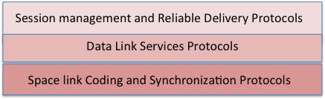

Figure 1 Space Link Layer Protocol stack

**Data Link Services Protocol Sub-layer**

A) Overview of the proposed new Transfer Frame

The proposed Data Link Services protocol Sub-Layer incorporates a flexible transfer frame structure that can be optimized for the specific needs of all space link types and constraints all using the tools provided by the frame’s flexibility. The transfer frame structure provides enough data within the frame header to enable the receive side link layer frame processing; with the ability to delimit the frame, separate and route Master and/or Virtual Channel (VC) frames without having any knowledge of the management details associated with the VC nor the security encoding incorporated within them. The tailoring of the frames functionality is accommodated within the Transfer Frame’s Data Field (TFDF). The details of the TFDF’s data structure will be explained in a subsequent section of this White Paper. An attached synchronization marker (ASM) is required that is pre-pended to the frame. The exact size and code for the marker is dependent upon the error characteristics that would be encountered when it is required to delimit the start of the frame. With the ASM attached to the frame the combination is called the Protocol Link Transmission Unit (PLTU). The ASM and the application of the FEC is discussed in a later section of this White Paper.

In order to provide special features the inclusion of Virtual Channel Sub-Channels (VCS) has been added. The Virtual Channel Sub-channel (VCS) is a multiplexing feature that allows a VC to deliver up to 32 independent sub channels one at a time over the same VC. The capability to include multiple different VCS SDUs within a Virtual Channel provides the capability to utilize a single Security Association to delivery those independent VCS SDUs that share the same VC. This capability enables a single VC to provide reliable delivery of the various VCS-SDUs sharing that VC using the “Go-Back-N” protocols for that VC as currently used in Telecommand and Proximity Links. This capability can be used, for example, for the operational control facilities to provide its unique security coding on those data streams that it controls with a single SA, while the instrument of other agency habitation unit can use its own VC and security association.

The current Telecommand Protocol relies on a segmentation process to allow large packets to be carried within small frames, while the TM and AOS protocols provide this capability by a process named in this document as “streaming”. In the “streaming” process, packets are allowed to flow across frame boundaries. The streaming process has been utilized within this proposed protocol for use on all links to provide this functionality.

B) The Proposed Transfer Frame Format

The Transfer Frame Structure is shown in Figure 2,

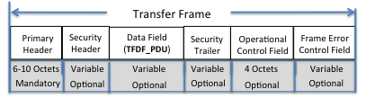

Figure 2: Transfer Frame Fields

The Transfer Frame shall have a mandatory frame header followed by up to six optional fields, positioned contiguously, in the following sequence:

* 1. Transfer Frame Primary Header (mandatory, fixed per VC, difference is signaled]
  2. Security Header (optional, managed)
  3. Transfer Frame Data Field (optional, variable)
  4. Security Trailer (optional, managed)
  5. Operational Control Field (4 octets, optional, managed by VC)
     + Required to support COP-1 and COP-P operations
  6. Frame Error Control Field (optional, managed by VC)
     + Only one FEC algorithm allow per Physical Channel and inclusion is signaled in Frame Header

*Note: Coding is managed for a link (only 1 ASM, code type and code word size per link session is allowed)*

C) The Transfer Frame Header Format

The Frame header is shown in figure 3 and where it is located within the frame.

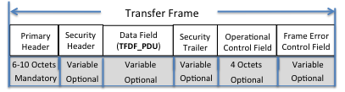

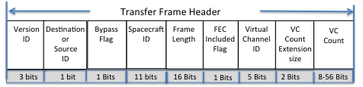

Figure 3: NGSLP Transfer Frame Header

The Transfer Frame Header Data Fields are as follows:

* Version ID- since the current CCSDS Transfer Frames use a two bit Version ID an additional bit to the Version number to allow future versions to be backward compatible. This frame version will be (110) so that an addition frame version can use (111).
* Destination/Source - Identifies the Spacecraft ID as either the source of the data or the intended recipient (destination)
* Bypass – Identifies the frame as non-sequence controlled allowing the VC Count contents to be used for special command data; Thus the frame size can be reduce to as small as 64 bits carrying 8 information bits if no security or Frame Error Control Field (FEC) are required.
* Spacecraft ID - allows for 2048 Spacecraft IDs
* Frame Length –(N+1) allows frame sizes to be as small as 6 octets to as large as 65536 octets
* Frame Error Control (FEC) Included -- signals the inclusion of the FEC (y/n)
  + Signals the receiving Master Channel process to check the Frames validity using attached FEC
* Virtual Channel ID – accommodates 32 Virtual Channels
* VC Count Extension Size –the VC counter can be from 1 to 7 octets– (N x 2) +1 octets
* VC Count – Incrementing VC counter that has a minimum size of 1 octet and a maximum size of 7 octets;
  + This counter can be used by the crypto authentication process eliminating the need to define a second sequence counter in the frame’s Security Header as long as selective retransmission is not used.

D) The Transfer Frame Data Field and Transfer Frame Data Field Header Formats

The format of the TFDF is illustrated in Figure 4 and where it is located within the frame.

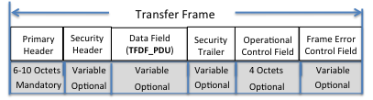

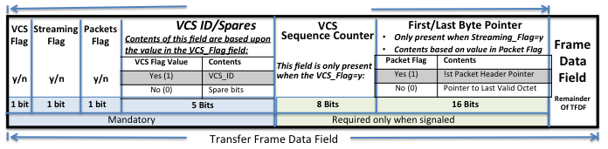

Figure 4. Transfer Frame Data Field (TFDF) Format

The versatility of the NGSLP frame is derived from the 3 construction flags in the first three bits built into the TFDF and the rules that they control.

The first flag, VCS_Flag signals whether the TFDF contains VC Sub-channels or not. The Virtual Channel Sub-channel (VCS) is a multiplexing feature that allows a VC to multiplex up to 32 independent sub channels one at a time over a VC. The selection of the order for inclusion of a VC Sub-channel’s data is managed per VC and outside the purview of this paper. The VCS-SDU for the communal service requires a TFDF header to identify the sub-channel ID, provide sequentially information via the VCS_Counter and identify the format of the data contained within the TFDF. The VCS_Counter is required for reassembly of packet segments that cross frame boundaries and/or for notification of data gaps for the octet data carried by the sub-channel. This counter is necessary in order to assure VC Sub-channel continuity when multiple VC Sub-channels are utilized on the same VC.

The second flag, the Streaming Flag identifies the boundary observing rules for the data within the TFDF. The boundary rules for a packet could constrain the TFDF to carry only an integer number of complete packets that fill the TFDF data field or can allow packets to be segmented across frame boundaries and thus be carried in a series of frames. In order to enable the receiving packet extraction process to resynchronize if an intervening frame is lost, a 2 byte first header pointer is provided to point to the first octet of the first packet header contained within the frame data field. The boundary rules that apply to VCA data can require the data to either fill the TFDF data field or to carry fewer octets than the data field could carry. To accommodate sending less octets then are needed to fill the available area within the TFDF, a 2 byte field is provided to point to the last valid octet in the Frame Data Field.

The third flag, the Data Content Flag, signals whether the TFDF carries either packet or user delivered octet data units (VCA_PDUs).

E) Transfer Frame Assembly Process

The total length of all the included fields plus the frame header will be identified in the length field in the Transfer Frame header. The size, content and presence of the remaining fields are as prescribed by the management rules for the specific VC. The order for inclusion of the data fields within the frames is as follows: 1) the optional Transfer Frame Data Field (TFDF_SDU) is received and placed in the frame, 2) the mandatory Transfer Frame header can then be composed because the length of the frame can now be calculated and placed in the header, 3) the optional Operational Control Field (OCF-SDU) that is supplied by the Frame Acceptance and Reporting Mechanism (FARM) follows, 4) the optional Security Header and Trailer that uses the assigned Security Association are inserted and the required crypto algorithm is then performed replacing, as required, the fields identified by the Security Association , and optionally lastly 5) the Frame Error Control field(FECF) is calculated based on all the fields already placed in the frame using the predefined algorithm defined for the link . Figure 5 illustrates the composition of the frame and serializes the order in which the fields are included into the frame.

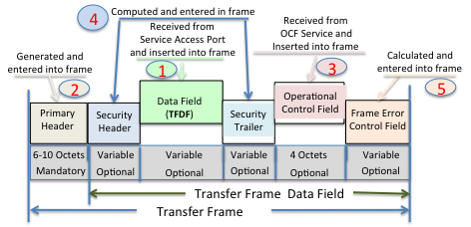

Figure 5: Order in which the Transfer Frame is composed.

F) Data Link Services

Figure 6 is an end-to-end illustration of the services that can be provided by the data link layer. Note that when a Protocol Link Transmission Unit (PLTU) is received it must be delimited before it can be processed. When the frame is not synchronized to the code block a Code Block Synchronization Marker is employed to delimit the code block and start the derandomization process. Since the code block and and frame are not synchronized in this mode a fixed length code block is required for the link. When the frame is synchronized to the code block an ASM is used to delimit the start of the frame and the length field is used to delimit its end. The FEC decoder and de-randomizer processors are started by the acquisition of the ASM. When the frame is synchronized to the FEC PLTU the content of the frame’s header is not in clear text and thus the first code word processed after ASM acquisition will need to be decoded before the contents of the frame header can be viewed and only then will the frame length become visible. The frame length will be used to determine how many code words are in the PLTU. After the last code word in the PLTU is processed, the frame synchronization process is restarted and the FEC decoder and de-randomizer are stopped. If the header indicates that a FECF is contained within the frame the FEC process will determine if there are errors in the frame. Note: Due to the cyclic nature of the LDPC code, LDPC codewords are required to be randomized i.e., encode first, then randomize.

At this point the OCF can be delivered to the OCF service and the VC frame can be forwarded to the local or remote VC processing entity. There the validated frames are provided to the security process and the verified frames are ready for delivery to the Frame Data Field content processor for extraction of the contained octets or packets delivery to the users. The services that are supported are:

1. Master Channel Frame Service
2. Virtual Channel Frame Service
3. Operational Control Field Service
4. Virtual Channel Sub-Channel Service
5. Packet Service
6. Virtual Channel Access (octet) Service

**Coding and Synchronization Sub-layer**

As noted in the opening paragraph of this White Paper the NGSLP protocol required a low error rate channel to provide its services. The forward error correction codes that can be used will be identified in the Space Link Synchronization and Coding Specification (see reference xxx). That document also includes tested synchronization markers and randomization algorithms that are required to improve physical layer operations. This paper will only discuss techniques that can be used with the recommended codes for achieving the required lower error rates. The current CCSDS specifications only allow the code blocks to be synchronized with the frame. This approach enables a single synchronization marker to be used to delimit the code block and frame but it couples the frame to be the size of the code block. The CCSDS Telecommand Specification allows for a series of code words to form the code block thus allowing the frame size to vary in length but there still must be synchronism between the frame and the code block. This White Paper recommends that a number of different techniques can be used, but only one method should be used on a link at any given time. The following approaches are proposed:

1. Synchronize the frame to the code block but allow the code block to be composed of multiple code words. An option can be included to allow Idle bits to be introduced into the link when necessary. This later option exacerbates the frame synchronization process but could reduce restrictions on other complexities.
2. Disassociate the frame from the coding, allowing the frame to be variable size even when the code block is fixed in size. Each code block would be preceded by a Code Block Synchronization Marker. The code blocks could be composed of a single code word or multiple code words that are concatenated without an intervening Marker. The last code word in a code block would always be followed by the Code Block Synchronization Marker. Since the frame and the code block are not synchronized an option to include Idle bits between data frames may be permitted, if desired. This later option exacerbates the frame synchronization process, but since frame synchronization is performed in a very low error rate environment, this extra processing requires little added complexity.

Figure 6 depicts the layering of the services, their interfaces and location of the services with respect to the functions performed within the Link Layer.

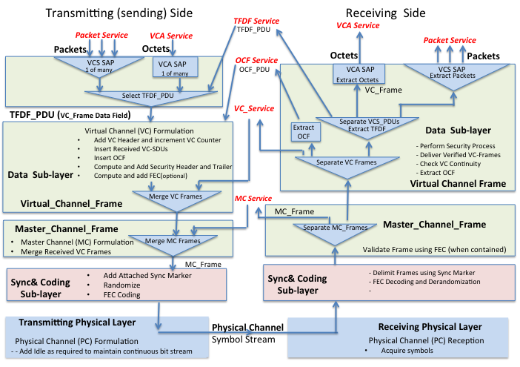



Figure 6 Link Layer Services and Service Access points

**Annex A: Selecting Frame Header Field choices.**

The designated fields and the size that have been included in the frame header are open for discussion:

1. The change to the version number. Adding one more bit to allow only a single new frame version to be added. The use of this field is questionable by itself because multiple frame formats are not typically allowed to be present on the same link at the same time, and the added bit offers only a minimal extension capability.
2. The Bypass flag is not truly required because the rules associated with a virtual channel can be used to identify a VC that is not sequence controlled. There is no reason why a VC needs to carry frames that are sequence controls and frames that are not.
3. Spacecraft ID was chosen to 11 bits; that allows for twice the number of unique Spacecraft addresses as the current capability provided by the current link layer protocols.
4. A 16 bit frame length field has been provided to allow frames to be as large as 65k octets. Including this field allows all links carry variable length frames
5. A FEC Flag was included to provide a signal to the frame validation process to enable it to be validation to be checked without other knowledge of the VC. This would desirable for SLE Return Services so the frame can be decoded and validated without any knowledge of VC rules except for routing. The question of whether a FEC is desired on some frames but not all frames is an issue.
6. The variable size of the sequence number: A 1 octet sequence number is typically satisfactory for ground to space and space to space links. A larger count is required for telemetry but the required length is variable.

Selection of FEC codes;

1. The uplink code choice is still dependent on Transponder performance capabilities and implementation considerations that tend to favor the use of short codes. We currently have the choice of rate ½ LDPC codes of 64,128,258,512 or 1024 information bits for use on the ground to space and space to space links. There currently are studies of short non-linear LDPC that offer improved performance but implementation requires substantially more complexity. The choice is dependent on latency, performance and implementation complexity.
2. The ability to concatenate code words to fit the desired frame length can be used on all links. Uplinks have favored the use of variable length frame with idle allowed between frames while telemetry links typically are transmitting stored data and have little need to add idle between frames.
3. Space to ground links could use any of the LDPC codes currently in the Telemetry Coding and Sync specification. The limited implementation complexity of encoders and the ability of Earth based receivers to operate with very low symbol power makes the selection of longer more powerful codes the prime choice. The use of variable coded modulation can improve pass throughput but may not be suitable when frame and code block is synchronized.
4. The selection of the ASM will be dependent on the operational mode (variable or fixed frame) and the performance desired. Longer ASMs are required for code block synchronization because they need to be detected when the symbol error rate is high.

Annex B: Application of this protocol to different type Space Links

In this Annex it shall be demonstrated how the NGSLP Protocol could be utilized in each of the space link environments. In general each VC is governed by its own set of management directives (e.g. a VC is specified as sequence controlled or non-sequence controlled, carrying Sub_Channels or without Sub_Channels).

1. Application to Command Uplink (Telecommand):
   * 1. Deep Space
        1. Flight Transponders today are limited both in providing hard coded output bits and their ability to synchronize to the channel symbols when the input levels are low (SSNR=4db). The upcoming transponders, because of technology advances, can provide soft symbol outputs and can synchronized to the channel symbols at much lower received power levels(SSNR=-1db). The performance of flight transponders is expected to improve dramatically but will not be up to the performance of Earth based transponders.
        2. The limited ability of flight transponders to synchronize to the channel symbols, the implementation requirements for the FEC synchronization and decoding and the requirement to receive a complete command when the spacecraft is tumbling (and the receiving window is short), favors the use of short codes. This provides for emergency commanding to a tumbling spacecraft and the use of these short LDPC codes improves the link performance such that communications can be achieved at significantly longer distances and/or can be accomplished at significantly higher data rates.
     2. Near Earth
        1. For higher data rate uplink’s, as required for the manned missions, use of short frames is burdensome and significantly increases the information processing and overhead. In these cases the use of multiple code concatenated words that would contain a command frame should be advantageous. The basic rules of the NGSLP protocol allow the use of multiple contiguous code words to contain a PLTU (the ASM and the frame).
     3. General Commanding
        1. What NGSLP formatting options would be useful for efficient commanding:
           + Since Supervisory commands are usually short they are best transported in the variable length frame mode.
           + Very short hardware commands can be transported within their own VC that is not sequence controlled. For hardware commands that are not sequence controlled the VC count field can be used to carry the “hardware command data”, thus the minimum frame size can be 64 bits to deliver an 8 bit hardware command.
           + An alternative approach, that provides an efficient approach for variable length frames, is to disassociate the code block and the frame and use the largest code size that can be used within the mission’s constraints. This eliminates the need to use fill bits to complete a code block when the frame size does not match the size of an integer number of the code words.
           + One VC, that is sequence controlled, could be designated as the COP-1 VC. The VC would transport a TFDF that could contain a VCS_SDU header that is capable of supporting up to 64 sub-channels. Each sub-channel would operate like a MAP in the current TC specification.
           + A VCS_SDU carrying packets could be defined to carry an integer number of packets or utilize a first header pointer and contain a contiguously streaming set of packets that flow across frame boundaries (as is currently done in the TM and AOS protocols).
           + The current proposed method for manned mission security , as we understand it, is to use a single SA for master channel security. This method requires each VC to provide the security fields necessary for the chosen SA including the security counter that will be applied to all VCs.. The use of sub-channels allows the various operations users to provide a complete TFDF that can be carried within a single operations VC using a single security association (SA). This methodology ensbles each VC to use their on SA as they require while allowing operational commands to use one VC.
2. Application to Space to Space Links (Proximity):
   * + 1. In proximity links, both ends of the communications path are supported by flight transponders or transceivers. These have the same limitations as discussed for transponders used for Telecommand (see 1 above).
       2. The same constraints with flight receivers that apply to Telecommand are true for Proximity and thus the selection of short LDPC codes are most desirable.
       3. Again for higher rate communications, longer transfer frames are desired. These can be obtained by having multiple code words forming the code block per frame.
       4. What NGU formatting options would be viable for efficient proximity operations:
          - Since Supervisory commands are usually short they are best transported in the variable length frame mode.
          - Currently the Proximity Specification use a single channel that can be logically selected the Physical Channel ID in the Frame header. The VC ID can serve that function.
          - One VC, that is sequence controlled, could be designated as the COP-1 VC. The VC would transport a TFDF that would contain a VCS_SDU that could carry one of the allowed 64 sub-channels. Each sub-channel would operate like a separate Port as currently provided by the Proximity -1 specification.
          - It is not anticipated that security would be used in the Proximity link but if it was a single VC carrying a set of sub-channels can utilize a single security association (SA).
       5. Another approach, that is most efficient for variable length frames, is to disassociate the code block and the frame and use the largest code size that can be used within the mission’s constraints.
3. Application to Space to Earth Links (Telemetry):
   * + 1. Earth based Transponders today can synchronize to the channel symbols when the input levels are very low (SSNR=-8db). This allows higher performance FEC codes to be used. The longer LDPC codes provide higher performance
       2. The NGSLP protocol is largely derived from the AOS protocol and provides most of its capabilities. The sequence number size has been increased to support the integration of large data sets that are collected on different passes and at different times. Note that the sequence number for telemetry is not used for retransmission but only accountability and integration of received data.
          - The current AOS protocol includes an insert zone to support isochronous data transfer. This however has never been used and the prospect of its future use is vanishing rapidly because of the advances in Internet technology and compression.
          - Both AOS and TM have an option for a frame secondary header but it has only been used by CNES to extend of the sequence counter in TM. This capability would no longer be need because the sequence counter size has been significantly expand (when required)
       3. What NGSLP formatting options would be viable for efficient telemetry support:
          - A single VC carrying a set of sub-channels can utilize a single security association (SA).
          - A single VC can carry the OCF required to support uplink COP operation
          - Another approach is to disassociate the code block from the transfer frame and use the largest code size that can be used within the mission’s constraints. This reduces the constraints on the use of variable coded modulation simplifying the process. This also moves the coding into the transmitters and receivers eliminating the need for the flight data systems to synchronize the frames with the code blocks.

Annex C List of Managed Parameters

Note: The managed parameters are required by the sending entity and not the receiving entity. The Frame has indicators that provide all the information to the receiving entity for data extraction from the frames and for assembly of packets. The only things that the receiving entities must have as managed parameters relate to the physical link [frequency, modulation, coding and synchronization word (as code block sync or ASM)], reliable delivery protocols (COP-1/P, frame retransmission) and delivery addresses for the data (either frame and/or packet).

Managed Parameters:

Physical Channel---

* + Fequency, modulation and FEC Code,

Link Layer

* + Inter-frame Idle Allowed/not allowed?
  + Fixed/variable frame length?
  + VC priorities
  + Max Frame Size allowed
  + ASM,
  + Fill type (frame or bits)

VC --- (per VC)

* + Sequence Counter size
  + Bypass Flag y/n
  + Sequence controlled Y/N
  + OCF included y/n
  + Security header & trailer sizes
  + Security SA ( include if VC Counter is used for security? Y/N
  + Assigned sub-channels
  + VCS Sub-channels included y/n

VCS ---

* + Fixed (VCS_PDU size) /variable (Max VCS_PDU Size)

Annex E: CCSDS -Forward Error Correction Code Performance

Figures provided by Ken Andrew (JPL)

Figure D-1 provides the performance of the currently used codes. while figure D-2 shows the performance of the short LDPC codes presently be examined for direct from Earth and space to space links. The gain in performance over currently used FEC codes ranges from 4 to 8 db depending on code selection. Figure B-3 shows the probabilities of Frame synchronization using a 64 symbol or 128 symbol ASM.

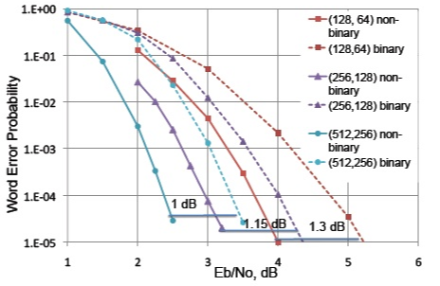

Figure D-1 Proposed LDPC short Codes

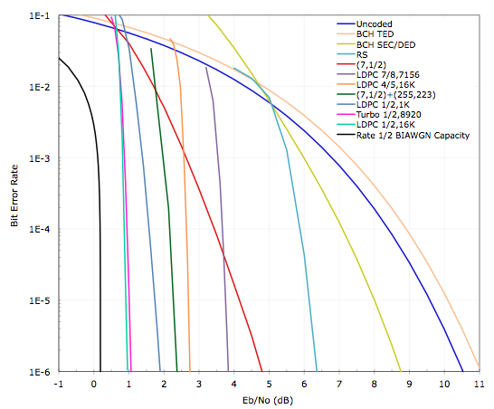

Figure D-2 Performance of long CCSDS Recommended Codes

Annex F: CCSDS –Synchronization Marker Performance

Figures provided by Ken Andrew (JPL)

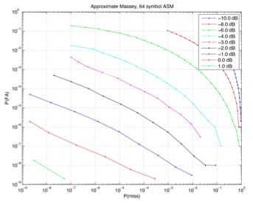

Figure D-3 64 bit ASM performance



Figure D-4 64 bit ASM performance