**WHITE PAPER: Next Generation Spacelink Protocol (NGSLP)**

The current spacelink protocols were developed in the early growth period of the space program. They were designed to meet the needs of the early missions, be compatible with the available technology and focused on the specific link environments. Digital technology was in its infancy and spacecraft power and mass issues put severe constraints on the flight implementations. Thus the uplink protocol was designed around a simple BCH code that provided little coding gain but was simple to decode. The infusion of the concatenated Convolutional and Reed-Solomon codes for telemetry was a major milestone and transformed telemetry applications and provided the ability to better utilize the telemetry link and its ability to deliver user data. The ability to significantly lower the error rates on the telemetry links opened to door to the use of packets and data compression. The infusion of the high performance codes for telemetry was enabled by the blossoming of digital processing, but it was limited to earth based systems supporting telemetry.

A new age has arisen, one that now provides the means to perform advanced digital process in spacecraft systems opening the door to the use of improved transponders, digital correlators, and high performance forward error correcting codes for all communications links. Flight transponder and digital technology have blossomed and can provide the means to make the next leap in spacelink communications. FPGAs provide the capability to incorporate high performance forward error correcting codes (see Annex A) and implement software transponders providing improved performance in data transfer, ranging and time correlation. The purpose of this paper is to initiate the development and codification of a new spacelink protocol data structure that can take advantage of these advancements and be utilized on all spacelinks (ground to space, space to ground and space to space).

The proposed protocol creates a flexible transfer frame structure that is compatible with the Forward Error Correcting (FEC) block codes currently specified within CCSDS documents [ e.g. Low Density Parity Codes (LDPC)]. The transfer frame structure provides enough data within the frame header to enable the receiving link layer frame processing; includes Frame delimiting, Forward Error Correction decoding, frame validation and Channel Services with the ability to separate and route Master and/or Virtual Channel (VC) frames without having any knowledge of the management details associated with the VC nor the security encoding incorporated within them.

The Frame Structure is shown in Figure 1,

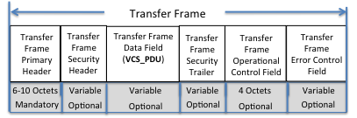

Figure 1: Transfer Frame Structural Components

The Transfer Frame shall have a mandatory frame header followed by up to six option fields, positioned contiguously, in the following sequence:

* 1. Transfer Frame Primary Header (mandatory, fixed per VC, difference is signaled]
  2. Security Header (optional, managed)
  3. Transfer Frame Data Field (optional, variable)
  4. Security Trailer (optional, managed)
  5. Operational Control Field (4 octets, optional, managed by VC)
     + Required to support COP-1 operations
  6. Frame Error Control data Field (optional, managed by VC)
     + Only one CRC algorithm allow per Physical Channel and inclusion is signaled in Frame Header

*Note: Coding is managed for a link (only 1 code type and code word size per link session)*

The transfer frame is designed to transport the data across the link. Specific rules will be imposed upon the frames carried in the link. These rules include the specification of the specific Forward Error Correcting (FEC) code employed, the specific pattern of the Attached Synchronization Marker (ASM) that is used to delimit the beginning of the frame and the algorithm for the Cyclic Redundancy Code (CRC) that can be used. The FEC will create a code word of a specific size, but a frame can occupy a series of code words (herein called a Protocol Transmission Unit – PLTU). Rules can be imposed on the formation of a PLTU allowing it to be constructed from a varying number of code words (resulting in variable sized frames) or limited to a fixed number of code words (fixed length frames structure). The rules for a link typically require that the data stream (when carrying frames) be continuous. Some links will allow idle bits to be inserted between the end of one frame and the beginning of the ASM for the next; but added rules can be applied that specify that each frame on a physical link must be separated from the adjacent frame by the ASM and only the ASM. These rules about idle bits between frames are dependent on the performance of the chosen ASM and/or the requirement to deliver isochronous data.

The Frame header is shown in figure 2.

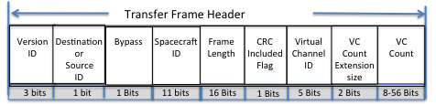

Figure 2: NGSLP Transfer Frame Header

The Header Data Fields are as follows:

* Version ID- is extended to 3 bits to accommodate one additional frame version (111) after this one (110) is codified
* Destination/Source - Identifies the Spacecraft ID as either the source of the data or the intended recipient
* Bypass – Identifies the frame as non-sequence controlled allowing the VC Count contents to be used for special command data; Thus the frame size can be reduce to as small as 64 bits carrying 8 information bits if no security or check bytes are required.
* Spacecraft ID - allows for 2048 addresses
* Frame Length –(N+1) allows for frame to be as small as 6 octets to as large as 65536 octets
* CRC Included -- signals the inclusion of the CRC (y/n)
  + Signals the receiving Master Channel process to check the Frames validity using attached CRC
* Virtual Channel ID – accommodates 32 Virtual Channels
* VC Count Extension Size –the VC counter can be from 1 to 7 octets– (size is increased by N x 2 octets)
* VC Count – Incrementing VC counter that has a minimum size of 1 octet and a maximum size of 7 octets;
  + This counter can be used by the crypto authentication process eliminating the need of a second counter

The frame data that follows the frame header of a VC can vary substantially. The data contents of a frame are contained in 4 optional data fields illustrated in figure 3. There are universal construction rules that are specified in this paper and there are Virtual Channel management rules that regulate the contents of each of these data fields individually for each Virtual Channel.

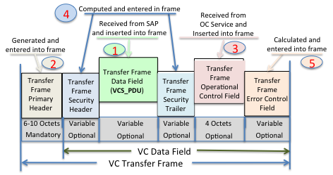

Figure 3: Order of Inclusion of the fields within the VC Frame.

The total length of all the included fields plus the frame header will be identified in the length field in the header. The size, content and presence of the remaining fields are as prescribed by the management rules for the specific VC. The order for inclusion of the data fields within the frames is as follows: 1) the optional VC data information field (VCS_SDU) is received and be placed in the frame, 2) the mandatory Frame header can then be composed because the length of the frame can now be calculated and then placed in the header, 3) the optional VC operational control field (OCF-SDU) that is supplied by the Frame Acceptance and Reporting Mechanism (FARM) is next to be placed in the frame, 4) the optional Security Header and Trailer that use the assigned Security Association are computed and then placed within the frame, and optionally lastly 5) the frames Cyclic Redundancy Check (CRC) field is calculated based on all the fields already placed in the frame using the predefined algorithm defined for the link . Figure 3 illustrates the composition of the frame and serializes the order in which the fields are included into the frame.

The versatility of the NGSLP frame is derived from the construction rules that are utilized by the VC management rules in the construction of the Transfer Frame Data Field (VCS_SDU). This field is constructed by a service access point entity (or directly supplied by a dedicated user) for inclusion into that specific Virtual Channel. The content of this field can vary greatly and can be tailored to fit the user’s needs and the link demands.

The VC can be delegated to a single user or it can be a communal resource that carries up to 64 sub-channels. When a VC is allocated to a single user and link rules allow for variable length frames then the content of the VCS_SDU can simply be either a set of octets or an integer number of concatenated CCSDS packets. This form can be used efficiently for supervisory/control data (e.g. proximity Hails or COP-1 reset).

When the VC is specified as a communal provider its function is to carry the information provided by the assigned sub-channels. The VCS-SDU field for the communal service requires a VCS-SDU header to identify the sub-channel, provide sequentially information and the type and to identify the form of the data contained within this VCS data field. The VCS-header is described in Figure 4. The VCS Header can identify 64 unique sub-channels that can be carried within the VC; one sub-channel’s data will be carried in each VC frame. The selection of the order for inclusion of a sub_channels data is a managed rule for the VC and outside the purview of this White Paper. The VCS-Header will contain an incrementing counter associated with the specific VC sub-channel to provide sequentially information for that particular VC-sub-channel. This counter is required for reassembly of packet segments that cross frame boundaries and/or for notification of data gaps for the octet data carried by the sub-channel.

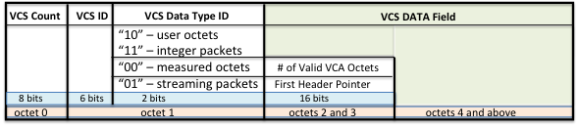

Figure 4: The Virtual Channel Sub-Channel Service Data Unit Structure

The third field in the VCS-SDU is the VCS Data Type ID (VCS-DTID). This field identifies the construction rules and type of data contained within the VCS_SDU. When its first bit is a “zero” then a two octet field (described later in this section) is extended to this header. When the second bit is a “zero” the VCS data field is carrying user octets and that sub-channel is dedicated for the exclusive use of a single user. When the second bit of this field a “one” then the VCS data field is carrying packets which can be from multiple sources. The rules governing the DTID ID are:

1. When the DTID value is “00” the contents will be octets and the value contained in octets 2 and 3 will specify the number of valid octets contained within the VCS-Data field (starting in octet 4) that are to be delivered to the user.
2. When the DTID value is “01” the contents are streaming packets that are concatenated end of one packet to the header of the next packet. The second and third octets will contain a first header pointer that points to the first header contained within the VCS Data Field. The streaming packets need not be fully contained within the VCS Data field but can flow across the frame boundaries and continue in following frames that have the same VC and sub-channel ID. If a frame does not contain a packet header the first header pointer will contain all “1”s.
3. When the DTID value is “10” the contents of VCA data field will be the octets provided by the user.
4. When the DTID value is “11” the contents will be limited to integer frames that fill the VCS Data Field

Figure 5 is an end to end illustration of the services that can be provided by the link layer. Note that when a Protocol Link Transmission Unit (PLTU) is received it must be delimited before it can be processed. The ASM is used to delimit the start of the frame and the length field is used to delimit its end. The FEC decoder and de-randomizer processors are started by the acquisition of the ASM. When the frame is synchronized to the FEC PLTU the content of the frame’s header is not in clear text and thus the first code word processed after ASM acquisition will need to be decoded before the contents the frame header can be viewed and only then will the frame length become visible. The frame length will be used to determine how many code words are in the PLTU. After the last code word in the PLTU is processed the frame synchronization process is restarted and the FEC decoder and de-randomizer are stopped. If the header indicates that a CRC is contained within the frame the CRC process will determine if there are errors in the frame.

At this point the OCF field can be delivered to the OCF service and the VC frame can be forwarded to the local or remote VC processing entity. There the validated frames are provided to the security process and the verified frames are ready for delivery to the frame information field content processor for extraction of the contained octets or packets delivery to the users.

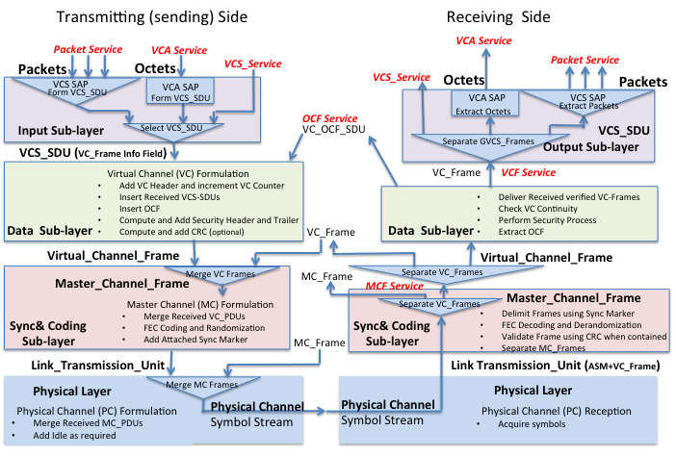



Figure 5 Frame Handling Processes and Service Access points

Annex A

The designated fields and the size that have been included in the frame header are open for discussion:

1. The change to the version number. Adding one more bit to allow only a single new frame version to be added. The use of this field is questionable by itself because multiple frame formats are not allowed to be present on the same link at the same time, and the added bit doesn’t offer much of an extension capability.
2. The Bypass flag is not truly required because the rules associated with a virtual channel can be used to identify a VC that is not sequence controlled. There is no reason why a VC needs to carry frames that are sequence controls and frames that are not.
3. Spacecraft ID was chosen to 11 bits; that is twice the size of the current capability provided by the current link layer protocols.
4. A 16 bit frame length field has been provided to all frames of up to 65k octets.
5. A CRC Flag was included to provide a signal to the frame validation process to enable it to be validation to be checked without other knowledge of the VC. This would desirable for SLE Return Services so the frame can be decoded and validated without any knowledge of VC rules except for routing. The question of whether a CRC is desired on some frames but not all frames is an issue.
6. The variable size of the sequence number: A 1 octet sequence number is typically satisfactory for ground to space and space to space links. A larger count is required for telemetry but the required length is variable.

Selection of FEC codes;

1. The ability to concatenate code words to fit the desired frame length can be used on all links. Uplinks favor the use of variable length with idle allowed between frames while telemetry links typically are transmitting stored data and have little need to add idle between frames.
2. We currently have the choice of rate ½ LDPC codes of 64,128,258,512 or 1024 information bits for use on the ground to space and space to space links. The choice is dependent on latency, performance and implementation complexity.
3. Space to ground links could use any of the LDPC codes currently in the Telemetry Coding and Sync specification.
4. The selection of the ASM will be dependent on the operational mode (variable or fixed frame) and the performance desired.

Annex B

In this Annex it shall be demonstrated how the NGSLP Protocol could be utilized. In general each VC is governed by its own set of management directives (e.g. a VC is specified as sequence controlled or non-sequence controlled, carrying Sub_Channels or without Sub_Channels).

1. Application to Command Uplink (Telecommand):
   * + 1. Flight Transponders today are limited both in providing hard coded output bits and their ability to synchronize to the channel symbols when the input levels are low (SSNR=4db). The upcoming transponders, because of technology advances, can provide soft symbol outputs and can synchronized to the channel symbols at much lower received power levels(SSNR=-1db). The performance of flight transponders is expected to improve dramatically but will not be up to the performance of Earth based transponders.
       2. The limited ability of flight transponders to synchronize to the channel symbols, the implementation requirements for the FEC synchronization and decoding and the requirement to be able to receive a complete command when the spacecraft is tumbling (and the receiving window is short), favors the use of short LDPC codes. This provides for emergency commanding to a tumbling spacecraft but the use of these short LDPC codes improves the link performance such that communications can be achieved at significantly longer distances and/or command can be accomplished a significantly higher data rates.
       3. For higher rate uplinks the use of short frames is burdensome and significantly increases the information and processing overhead. In these cases the use of multiple code words to contain a command frame is advantageous. The basic rules of the NGSLP protocol allow the use of multiple contiguous code words to form a PLTU that contains the frame.
       4. What NGSLP formatting options would be viable for efficient commanding:
          - Since Supervisory commands are usually short they are best transported in the variable length frame mode.
          - Very short hardware commands can be transported within its own VC that is not sequence controlled and where the VC count field can be used to carry the “hardware command data”. Thus the minimum frame size of 64 bits can be utilized to deliver an 8 bit hardware command.
          - One VC could be designated as the COP VC. This VC would be sequence controlled. The VC would transport a VCS_SDU that contains a VCS_SDU header that supports up to 64 sub-channels. Each sub-channel would operate like a MAP in the current TC specification. The VCS_SDU carrying packets could be defined to carry an integer number of packets or utilize a first header pointer and contain a contiguously streaming set of packets that flow across frame boundaries.
          - A single VC carrying a set of sub-channels can utilize a single security association (SA). This is the mode planned for the U.S. manned mission program where the digital control command and the voice channel would share an SA while other communications (i.e. platform controls) would use their own VC and their own SA if desired.
2. Application to Space to Space Links (Proximity):
   * + 1. In proximity links, both ends of the communications path are supported by flight transponders or transceivers. These have the same limitations as discussed for transponders used for Telecommand (see 1 above).
       2. The same arguments as applied to Telecommand hold for Proximity and thus the selection of short LDPC commands is most desirable.
       3. Again for higher rate communications, longer transfer frames are desired. The can be obtained in concert with the coding by having multiple code word per frame.
       4. What NGU formatting options would be viable for efficient proximity operations:
          - Since Supervisory commands are usually short they are best transported in the variable length frame mode.
          - Very short hardware commands can be transported within its own VC that is not sequence controlled and where the VC count field can be used to carry the “hardware command data”. Thus the minimum frame size of 64 bits can be utilized to deliver an 8 bit hardware command.
          - One VC could be designated as the COP VC. This VC would be sequence controlled. The VC would transport a VCS_SDU that contains a VCS_SDU header that supports up to 64 sub-channels. Each sub-channel would operate like a Port in the current Proximity specification. The VCS_SDU carrying packets could be defined to carry an integer number of packets or utilize a first header pointer and contain a contiguously streaming set of packets that flow across frame boundaries.
          - It is not anticipated that security would be used in the Proximity link but if it was a single VC carrying a set of sub-channels can utilize a single security association (SA).
3. Application to Space to Earth Links (Telemetry):
   * + 1. Earth based Transponders today can to synchronize to the channel symbols when the input levels are very low (SSNR=-8db). This allows higher performance FEC codes to be used. The longer LDPC codes provide higher performance
       2. The NGU protocol is largely derived from the AOS protocol and provides most of its capabilities. The sequence number size has been increased to support the integration of large data sets that are collected on different passes and at different times. Note that the sequence number for telemetry is not used for retransmission but only accountability and integration of received data.
          - The current AOS protocol includes an insert zone to support isochronous data transfer. This however has never been used and the prospect of its future use is vanishing rapidly because of the advances in Internet technology and compression.
          - Both AOS and TM have an option for a frame secondary header but it has only been used as an extension of the sequence counter in TM. This feature is not required especially for the use it was applied to.
       3. What NGU formatting options would be viable for efficient telemetry support:
          - A single VC carrying a set of sub-channels can utilize a single security association (SA).
          - A single VC can carry the OCF required to support uplink COP operation

Annex C

Managed Parameters:

Physical Channel---

* + FEC Code,
  + Inter-frame Idle Allowed/not allowed?
  + Fixed/variable frame length?
  + VC priorities
  + Max Frame Size allowed
  + ASM,
  + Fill type (frame or bits)

VC --- (per VC)

* + Sequence Counter size
  + Bypass Flag y/n
  + Sequence controlled Y/N
  + OCF included y/n
  + Security header & trailer sizes
  + Security SA to use VC Counter? Y/N
  + Assigned sub-channels
  + VCS data --- identify allowed data type

VCS ---

* + Fixed (VCS_PDU size) /variable (Max VCS_PDU Size)

Annex D

Figures provided by Ken Andrew (JPL)

Figure D-1 provides the performance of the currently used codes. while figure D-2 shows the performance of the short LDPC codes presently be examined for direct from Earth and space to space links. The gain in performance over currently used FEC codes ranges from 4 to 8 db depending on code selection. Figure B-3 shows the probabilities of Frame synchronization using a 64 symbol or 128 symbol ASM.

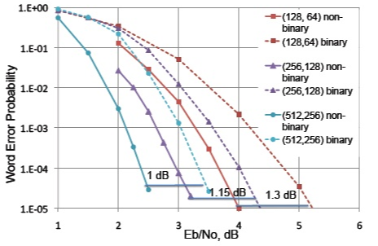

Figure D-1 Proposed LDPC short Codes

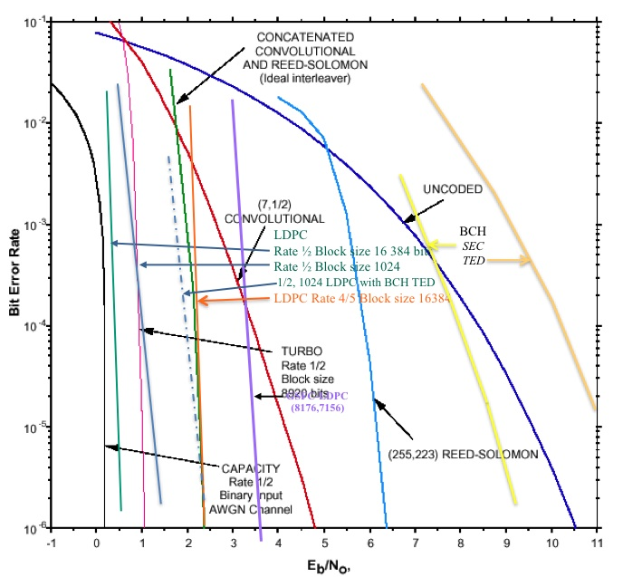

Figure D-2 Performance of CCSDS Recommended Codes

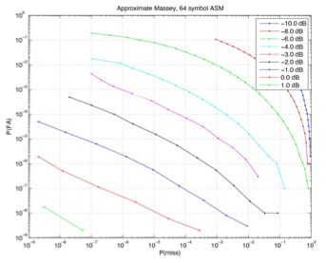

Figure D-3 64 bit ASM performance



Figure D-4 64 bit ASM performance