DRAFT


DRAFT REPORT FOR SPACE
DATA SYSTEM STANDARDS

PROXIMITY-1 SPACE LINK PROTOCOL –
Rationale, Architecture, and Scenarios

CCSDS 211.0-G-0

GREEN BOOK
[Pre-Issue Draft 03/28/05]

April 2005



AUTHORITY

 | Issue: | Green Book, pre-Issue
 | Date: | October 1, 2001
 | Location: | Not Applicable

(WHEN THIS RECOMMENDATION IS FINALIZED, IT WILL CONTAIN THE FOLLOWING STATEMENT OF AUTHORITY:)

This document has been approved for publication by the Management Council of the Consultative Committee for Space Data Systems (CCSDS) and represents the consensus technical agreement of the participating CCSDS Member Agencies. The procedure for review and authorization of CCSDS Recommendations is detailed in Procedures Manual for the Consultative Committee for Space Data Systems, and the record of Agency participation in the authorization of this document can be obtained from the CCSDS Secretariat at the address below.

This Recommendation is published and maintained by:

CCSDS Secretariat
Program Integration Division (Code MT)
National Aeronautics and Space Administration
Washington, DC 20546, USA
FOREWORD

(WHEN THIS RECOMMENDATION IS FINALIZED, IT WILL CONTAIN THE FOLLOWING FOREWORD:)
This document is a CCSDS Report which contains background and explanatory material to support the CCSDS Recommendation Proximity-1 Space Link Protocol (reference [1]).
Through the process of normal evolution, it is expected that expansion, deletion, or modification of this document may occur. This Recommendation is therefore subject to CCSDS document management and change control procedures which are defined in Procedures Manual for the Consultative Committee for Space Data Systems. Current versions of CCSDS documents are maintained at the CCSDS Web site:
http://www.ccsds.org/
Questions relating to the contents or status of this document should be addressed to the CCSDS Secretariat at the address indicated on page i.
At time of publication, the active Member and Observer Agencies of the CCSDS were:

Member Agencies

– Agenzia Spaziale Italiana (ASI)/Italy.
– British National Space Centre (BNSC)/United Kingdom.
– Canadian Space Agency (CSA)/Canada.
– Centre National d’Etudes Spatiales (CNES)/France.
– Deutsches Zentrum für Luft- und Raumfahrt e.V. (DLR)/Germany.
– European Space Agency (ESA)/Europe.
– Instituto Nacional de Pesquisas Espaciais (INPE)/Brazil.
– National Aeronautics and Space Administration (NASA)/USA.
– National Space Development Agency of Japan (NASDA)/Japan.
– Russian Space Agency (RSA)/Russian Federation.

Observer Agencies

– Austrian Space Agency (ASA)/Austria.
– Central Research Institute of Machine Building (TsNIIMash)/Russian Federation.
– Centro Tecnico Aeroespacial (CTA)/Brazil.
– Chinese Academy of Space Technology (CAST)/China.
– Commonwealth Scientific and Industrial Research Organization (CSIRO)/Australia.
– Communications Research Laboratory (CRL)/Japan.
– Danish Space Research Institute (DSRI)/Denmark.
– European Organization for the Exploitation of Meteorological Satellites (EUMETSAT)/Europe.
– European Telecommunications Satellite Organization (EUTELSAT)/Europe.
– Federal Service of Scientific, Technical & Cultural Affairs (FSST&CA)/Belgium.
– Hellenic National Space Committee (HNSC)/Greece.
– Indian Space Research Organization (ISRO)/India.
– Industry Canada/Communications Research Centre (CRC)/Canada.
– Institute of Space and Astronautical Science (ISAS)/Japan.
– Institute of Space Research (IKI)/Russian Federation.
– KFKI Research Institute for Particle & Nuclear Physics (KFKI)/Hungary.
– MIKOMTEK: CSIR (CSIR)/Republic of South Africa.
– Korea Aerospace Research Institute (KARI)/Korea.
– Ministry of Communications (MOC)/Israel.
– National Oceanic & Atmospheric Administration (NOAA)/USA.
– National Space Program Office (NSPO)/Taipei.
– Swedish Space Corporation (SSC)/Sweden.
– United States Geological Survey (USGS)/USA.
DOCUMENT CONTROL

Document | Title and Issue | Date | Status
CCSDS 211.0-G-0 | Proximity-1 Space Link Protocol, Green Book, Pre-Issue | October  2001 | Current (original) Issue

CONTENTS
Section Page
1 INTRODUCTION 1-1
1.1 PURPOSE and scope 1-1
1.2 Structure of this Document 1-1
1.3 DEFINITIONS 1-1
1.4 REFERENCES 1-4
2 overview 2-1
2.1 application domaiN of the proximity-1 protocol 2-1
2.2 FEatures of the Proxmity-1 protocol 2-4
2.3 MULTICHANNEL & MULTICONNECTIONS EXTENSIONS 2-12
3 Protocol Architecture and Services 3-1
3.1 Proximity-1 user and services 3-2
3.2 Proximity protocol components 3-7
4 protocol operations 4-1
4.1 Proximity-1 data units 4-1
4.2 Messaging between two transceiver 4-6
5 Scenarios 5-1
5.1 Assumptions 5-1
5.2 static vs. dynamic environment 5-1
5.3 Topology 5-1

ANNEX A ACRONYMS A-1

Figure
Figure 3-1: Proximity-1 Architecture & Functional Models 3-1
Figure 3-2: Control Plane Services (Timing/Ranging not included) 3-3
Figure 3-3: Transfer Frame Data Field Structure 3-11
Figure 4-1: Flow of Proximity-1 Data Unit (Spanning packets shown) 4-1
Figure 4-2: Proximity-1 Data Unit Structure 4-2
Figure 4-3: Version 3 Transfer Frame Header 4-3
Figure 4-4: Telecommand Frame Header 4-3
Figure 4-5: Fixed-Length SPDU Format 4-4
Figure 4-6: Variable-Length SPDU Format 4-5
Figure 4-7: Flow Path of Proximity-1 Data and Messages 4-6
Figure 4-8: Session Establishment onto a Working Full Duplex Channel 4-9
Figure 4-9: Reconfiguration on Full Duplex Channel (Orbiter-to-Lander Scenario) 4-10
Figure 4-10: COP-P Configurations 4-14
Figure 4-11: FOP State Diagram 4-15
Figure 4-12: FARM State Diagram 4-16
Figure 4-13: Recovery from Error Frame (Go-Back-2) 4-18
Figure 4-14: Recovery from lost PLCW 4-19
Figure 4-15: Two COP-P Flows in the same direction 4-20
Figure 4-16: Two COP-P in Balanced Configuration 4-21
Figure 4-17: Half Duplex with One COP-P 4-22
Figure 4-18: Session Termination (2-way handshake) 4-23
Figure 4-19: Transmission of User Data Across Two Sessions 4-24
Figure 5-1: One-to-One Link using dedicated channel 5-2
Figure 5-2: One-to-One Link using Separate Hailing and Working Channel 5-3
Figure 5-3: Simultaneous hailing; both landers in view of the orbiters 5-4
Figure 5-4: Simultaneous hailing; only one lander in view of both orbiters 5-4
Figure 5-5: Collision Avoidance using Carrier Sensing on Hailing Channel 5-4
Figure 5-6: Collision Avoidance on the Working Channel 5-5

Table
Table 3-1: Frame Construction Rules and Data Link Mode 3-9

INTRODUCTION

PURPOSE and scope
This document is an adjunct document to the CCSDS Draft Recommendation for Proximity-1 Space Link Protocol Data Link Layer[8], Synchronization and Channel Coding [9], and Physical Layer [10]. It contains material helpful in understanding the primary document, and which will assist decision makers and implementers in evaluating the applicability of the protocol to mission needs and in making implementation, option selection, and configuration decisions related to the protocols.
This report provides supporting descriptive and tutorial material. This document is not part of the Recommendation. In the event of conflicts between this report and the Recommendation, the Recommendation shall prevail.

Structure of this Document
This document is organized as follows.
- Section 1 defines the purpose and scope of this document, and lists the definition and convention used throughout this document.
- Section 2 gives an overview of the application context and concept and rationale of the Proximity-1 protocol.
- Section 3 describes the protocol architecture and the functions and services provided by each protocol entity.
- Section 4 describes the data unit structures and discusses various aspects of the operation of the protocol.
- Section 5 provides several possible scenarios under which the Proximity-1 Link Protocol may operate.

DEFINITIONS
This Proximity-1 Protocol Recommendation makes use of a number of terms defined in the OSI Reference Model and the OSI Service Model [2] to describe, in a generic sense, the technology and the services provided for information exchange between two systems. These terms includes, but are not exclusive to, blocking, connection, data link layer, entity, flow control, network layer, peer entities, physical layer, protocol control information, protocol data unit (PDU), real system, segmenting, service, service access point (SAP), SAP address, service data unit (SDU), confirmation, indication, primitive, request, response, service provider, and service user.

Terms Defined in The Proximity-1 Recommendation
The following terms are defined in the recommendation. Note that new terms are added and some of the definitions are modified for clarity.
asynchronous channel: a data channel where the symbol data are modulated onto the channel only for the period of the message. The message must be preceded by an acquisition sequence to achieve symbol synchronization. Bit synchronization must be reacquired on every message. A hailing channel is an example of an asynchronous channel.
asynchronous data link: a data link consisting of a sequence of variable-length Proximity Link Transmission Units (PLTUs), which are not necessarily concatenated. Two types of asynchronous data links are:
- Asynchronous Data Link over an Asynchronous Channel
Hailing provides an example of an asynchronous data link over an asynchronous channel. An important issue is resynchronization between successive hails. Idle is provided for the reacquisition process.
- Asynchronous Data Link over a Synchronous Channel
Data service provides an example of an asynchronous data link over a synchronous channel. Once the link is established via hailing, communication transitions to a synchronous channel and maintains the link in this configuration until the session is interrupted or ends. If the physical layer does not receive data from the data link layer, it provides idle to maintain a synchronous channel.
caller and responder: A caller transceiver is the initiator of the link establishment process and manager of negotiation (if required) of the session. A responder transceiver typically receives link establishment parameters from the caller. The caller initiates communication between itself and a responder on a pre-arranged communications channel with predefined controlling parameters. As necessary, the caller and responder may negotiate the controlling parameters for the session (at some level between fully controlled and completely adaptive).
COP-P: Communication Operations Procedure for Proximity links (COP-P). The COP-P includes both the FARM-P and FOP-P of the caller and responder unit.
FARM-P: Frame Acceptance and Reporting Mechanism for Proximity links, for Sequence Controlled service carried out within the receiver in the Proximity-1 link.
FOP-P: Frame Operation Procedure for Proximity links for ordering the output frames for Sequence Controlled service carried out in the transmitter in the Proximity-1 link.
forward link: that portion of a Proximity space link in which the caller transmits and the responder receives (typically a command link).
hailing: the persistent activity used to establish a Proximity link by a caller to a responder in either full or half duplex. It does not apply to simplex operations.
hailing channel: the forward and return frequency pairs that a caller and responder use to establish physical link communications.
mission phase: a mission period during which specified communications characteristics are fixed. The transition between two consecutive mission phases may cause an interruption of the communications services.
PCID: The Physical Channel ID is used to distinguish between Proximity Link Control Words (PLCWs) received on a single receive channel in support of two independent transmitting channels.
P-frame: a Version-3 Transfer Frame that contains only self-identified and self-delimited supervisory protocol data units; compare U-frame.
physical channel: The RF channel upon which the stream of bits is transferred over a space link in a single direction.
PLCW: Proximity Link Control Word. The PLCW is the protocol data unit for reporting Sequence Controlled service status via the return link from the responder back to the caller.
PLTU: The Proximity Link Transmission Unit is the data unit composed of the Attached Synchronization Marker, the Version-3 Transfer Frame, and the attached Cyclic Redundancy Check (CRC)-32.
Protocol object: directives, PLCWs, or status reports contained within an SPDU.
Proximity link: short-range, bi-directional, fixed or mobile radio links, generally used to communicate among probes, landers, rovers, orbiting constellations, and orbiting relays. These links are characterized by short time delays, moderate (not weak) signals, and short, independent sessions.
pseudo packet ID: the temporary packet ID assigned by the protocol to a user’s packet within the segmentation process.
resynchronization (COP-P): process in which sender and receiver nodes readjust their sequence controlled frame numbers via the SET V(R) activity.
return link: that portion of a Proximity space link in which the responder transmits and the caller receives (typically a telemetry link).
Routing ID: identifier that uniquely identifies a user’s packet through the segmentation process. It consists of a PCID, Port ID, and pseudo packet ID.
Sent queue (Sent Frame queue): contains sequence controlled frames that have been sent but not yet acknowledged by the receiver.
session: a continuous dialog between two communicating Proximity link transceivers. It consists of three distinct operational phases: session establishment, data services, and session termination.
space link: a communications link between transmitting and receiving entities, at least one of which is in space.
SPDU: Supervisory Protocol Data Unit. Used by the local transceiver to either control or report status to the remote partnered transceiver. Consists of one or more directives, reports, or PLCWs.
synchronous channel: a data channel where the symbol data are continuously modulated onto the channel at a fixed data rate. If the data link fails to provide frames (data or fill), it is the responsibility of the physical layer to provide the continuous bit stream.
U-frame: a Version-3 Transfer Frame that contains user data information; compare P-frame.
vehicle controller: the entity (e.g., spacecraft control computer) which receives the notifications defined in annex E and potentially acts upon them.
Version-3 Transfer Frame: a Proximity-1 transfer frame.

REFERENCES
[1] Information Technology—Open Systems Interconnection—Basic Reference Model: The Basic Model. International Standard, ISO/IEC 7498-1. 2nd ed. Geneva: ISO, 1994.
[2] Information Technology—Open Systems Interconnection—Basic Reference Model—Conventions for the definition of OSI services. International Standard, ISO/IEC 10731:1994. Geneva: ISO, 1994.
[3] Telecommand Part 2.1—Command Operation Procedures. Recommendation for Space Data System Standards, CCSDS 202.1-B-1. Blue Book. Issue 1. Washington, D.C.: CCSDS, October 1991.
[4] Telecommand Part 2—Data Routing Service. Recommendation for Space Data Systems Standards, CCSDS 202.0-B-2. Blue Book. Issue 2. Washington, D.C.: CCSDS, November 1992.
[5] Packet Telemetry. Recommendation for Space Data System Standards, CCSDS 102.0-B-5. Blue Book. Issue 5. Washington, D.C.: CCSDS, November 2000.
[6] Telemetry Channel Coding. Recommendation for Space Data System Standards, CCSDS 101.0-B-4. Blue Book. Issue 4. Washington, D.C.: CCSDS, May 1999.
[7] CCSDS Global Spacecraft Identification Field Code Assignment Control Procedures. Recommendation for Space Data System Standards, CCSDS 320.0-B-2. Blue Book. Issue 2. Washington, D.C.: CCSDS, October 1998.
[8] Proximity-1 Space Link Protocol – Data Link Layer. Recommendation for Space Data System Standards, CCSDS 211.0-B-3. Blue Book. Issue 3. St. Hubert, Canada.: May, 2004.
[9] Proximity-1 Space Link Protocol—Coding and Synchronization Sublayer. Recommendation for Space Data System Standards, CCSDS 211.2-B-1. Blue Book. Issue 1. April 2003.
[10] Proximity-1 Space Link Protocol—Physical Layer. Recommendation for Space Data System Standards, CCSDS 211.1-B-2. Blue Book. Issue 2. May 2004.
[11] AOS Space Data Link Protocol. Blue Book. Issue 1. September 2003. Recommendation for Space Data System Standards, CCSDS 732.0-B-1. Blue Book. Issue 1. September 2003.

overview
The Proximity-1 protocol is identified as the proximate “Space Link Protocol” designed for the purpose of communications among “probes, landers, rovers, orbiting constellations, and orbiting relays.”[8] It defines the Physical Layer [10], the Coding and Synchronization Sublayer [9] and the Data Link Layer [8], which is subdivided into four sub-layers: frame, data services, input/output, and the medium access control. This section of the document addresses the question of what functions/services are provided by Proximity-1 as distinct from the many different existing and emerging wireless data link/physica layer protocols, and why they are required in the particular context of applications for which Proximity-1 is intended.

application domaiN of the proximity-1 protocol
The application profile for the development of Proximity-1 has been wireless communication among space assets that are in a near earth or deep space environment whose inter-spacecraft distances are modest in comparison to the very long links between deep space assets and Earth. Thus the term “proximity” refers to distances as large as e.g., between a surface asset on Mars and an Areostationary orbiter, or even larger distances between planetary assets and a spacecraft approaching the planet. Therefore, these distances may be as large as 100,000 kilometers. Currently, data rates of up to 2,048 kilo-bits/sec are defined, thus modest to low delay-bandwidth products are involved. At the same time, Proximity-1 is intended for use in a context similar to a micro-rover-to-lander scenario, involving ranges as short as e.g., 1 meter.
Distance alone however was not intended to be the only distinguishing feature addressed by Promixity-1; its explicit mention was due to the legacy of being developed in a similar context as Earth-deep space links having extremely long distances, i.e., “proximity” contrasts it to the CCSDS Packet Telemetry/ AOS/Telecommand protocols.[3][4][5][11].
It is worthwhile to narrow the target application domain for Proximity-1 in order to better identify the requirements driving its definition. This also serves to identify applications that are well served by Proximity-1 although not associated with (deep) space missions. There is a specific, near-term need for an efficient protocol that on the one end resides on an asset on the surface of a planet (e.g., Mars) and on the other end resides on an orbiter. The orbiter also has the capability to communicate directly with Earth over the very long “DTE” (direct-to-Earth) link. There are likely to be multiple surface assets having the capability to communicate with the orbiter. They may or may not be located simultaneously in the common “footprint” of the orbiter. The orbiter acts as a relay on behalf of the surface asset(s). This communications “network” architecture has been well studied and provides clear advantages in cost-effectiveness, owing, among other things, to the large reduction in communications resources required by the surface asset(s). The orbiter-lander link will serve as a prototypical use of Proximity-1.
While this relay orbiter application is identified as particularly suitable for Proxmity-1, it is emphasized that the relay functions of forwarding data acquired from one link to another is not part of Proximity-1 itself (this represents a higher-layer function). Relaying is not a required use for Proximity-1, and in particular the data exchanged across the data link could be consumed (in the “final destination” sense) by application entities at both endpoints.
What are the requirements for the prototypical orbiter-surface asset communications system? First, numerous specific drivers arise as a result of the deep space context. The following aspects arise for deep space scenarios:
- Predictably Episodic Connectivity – There is a dynamic but nonetheless highly predictable connectivity, i.e., times when the physical link will be available are deterministic. This is different from conventional mobile communication systems where the protocol has to operate based on the assumption that the user’s position (hence connectivity) is unpredictable. Note that when no link is available, transceiver resources may be conserved (see item 5 below).
- Limited Number of Surface Assets – Although it is possible that multiple surface assets will be in view of the orbiter simultaneously, this will not be common and when it occurs there will not be a large number in view at once (at least for the foreseeable future). This is due to the very high cost of placing assets in deep space. The result is that most often, the need is for point-to-point communication. When there are multiple assets in view at once, concerns for providing low latency access among them do not apply as they do in conventional systems. Commonplace protocols allocate short time-slices of the shared radio medium among users so that rapid access is perceived by each user (although bandwidth per user is reduced accordingly). The nature of the traffic in Proximity-1 applications typically is such that a user can wait until acquiring access, provided adequate bandwidth is provided. Thus a series of time sequenced point-to-point connections is preferable to multiaccess protocols due to the greater efficiencies in throughput.
- Traffic Characteristics of Space Science Communications - Because the application domain involves solar system exploration, the science data being returned from surface assets have traffic characteristics that are not typical of conventional wireless networks.
- Each surface asset will generally have enough data to continuously feed to a communications link for as long as it is made available. Missions will be designed with sensors capable of generating as much data as the available communication capacity, which is especially limited on the DTE link(s) that the orbiter uses to relay the data acquired from the Proximity-1 link(s) back to Earth.
- Latency requirements are more relaxed and more related to memory capacity than to control loops. In particular, control by human users inherently involves large delay feedback, since Earth is far away hence the propagation delays are large.
- On the other hand, there is a very stringent requirement for reliable communications. Any opportunity for science data return that is lost is costly.
- Generally, there is much greater volume of data returned to Earth than there is sent from Earth, and this is reflected in the proximity links as well. The protocol is designed to accommodate this anticipated traffic asymmetry. An example is a full duplex session with different data rates on the forward and return links.
- Asymmetry of Communications Resources (Receiver-driven operation) – Relay architectures have proven their cost-effectiveness, greatly reducing the communications resources needs of surface-deployed assets. Furthermore, a single relay node may provide service to many such surface elements. This is particularly true of an orbiter, which covers large areas, albeit with episodic links, and has greater visibility with Earth. This relay architecture naturally leads to designs where an orbiting asset will have significantly more communication resources, and sophistication than the surface elements. Because the orbiter has greater capabilities, it is natural for it to be responsible for controlling the communication. However, generally the primary traffic flow is telemetry from the landed asset as the source. Therefore this is unconventional in that the “receiver” will initiate communications.
- Heterogeneous Environment - Because of the costliness of deep space missions, it is advantageous to leverage the relay capability over as many missions as possible. These missions will be diverse, with a wide range of resources inherently available for communications (including radio, processing and storage capabilities). Examples span from a simple probe to a sophisticated rover or robotic outpost base station. The relay orbiter and its protocol must have the ability to accommodate these heterogeneous surface assets.
- Efficient Use of Resources – Placing resources in remote space is expensive. In particular, energy reserves will be precious for deep space assets, especially small probes (“scouts”) that are particularly dependent on relay support. Thus the protocol should be designed to minimize energy consumption. Similarly, storage (buffer) and processing resources required for communications should be utilized efficiently.
- Proper Balance of Manually Determined versus Autonomous Operation – Some degree of autonomous operation is necessary since manual interaction is made difficult by the very large propagation delays between Earth and deep space. While adaptivity is an essential element of virtually all such protocols, the inability for rapid manual intervention can be particularly constraining for deep space applications. It is desirable to maintain careful deterministic control of the mission. Predictable events, such as epochs where lander-orbiter communication is possible, are programmed and this “application” drives the connection management process. On the other hand, occasional transient errors in communications will occur randomly, and should be recovered from in-situ to avoid inefficiencies of using the long delay expensive DTE links for such purposes. Experience has proven that unpredictable fault conditions may occur after launch, but that clever “workarounds” can be developed to enable at least partial functionality through remotely commanded changes. However, substantial flexibility is needed in the system design. For this reason, Proximity-1 allows the user to control and configure the system across many interfaces at different sublayers. This adds complexity in comparison to conventional systems, but is warranted.
While there are additional aspects of deep space exploration that impact communications system designs, the aspects identified above pinpoint the compelling requirements served by the unique features of the Proximity-1 protocol. These are elaborated further below.
We will refer to the layer that interfaces above Proximity-1 as the “user”. Of course, this generally will be a process in a remote spacecraft that resides within the local vehicle controller or spacecraft Command and Data Handling (C&DH) system.

FEatures of the Proxmity-1 protocol
The prototypical scenario for Proximity-1 operation is point-to-point communication between a single orbiter and a single surface element, where the orbiter is the caller and the receiver of the vast majority of data. Although simplex operations are possible, the primary benefits of Proximity-1 arise with two-way operations - full duplex or half duplex. In continuing with the orbiter-lander scenario to aid description of Proximity-1, we assume a two-way operation using either full duplex or half duplex.
In the following section we will give an overview of the features of Proximity-1; they are divided into two categories: (1) session control and (2) data transmission.

link Session Control – Establishment, re-configuration, and termination

Concept of a Link Session
The Proximity-1 protocol operates by forming a combined link and physical layer session between two entities, A and B. The identities of these entities are defined for each session. For full or half duplex operation, two-way communications occurs during each session. However, an important feature of Proximity-1 is that the characteristics (selected parameters) corresponding to the two different directions of communications (A to B versus B to A) can be chosen to be very different, such as modulation type, data rate, or whether channel encoding (uncoded or convolutional) is used. These may be different even for half-duplex operation (i.e., when each endpoint uses the same RF center frequency). Physical and data link parameters may be changed dynamically during a session.

Connection-Oriented Data Link Layer
The Proximity-1 protocol is built on the concept of a link session. The protocol is connection-oriented and point-to-point and creates a single physical channel between two communication partners. The time scale of a link session is typically on the order of the duration of time that the orbiter and surface asset are in geometric view of one another. Data exchanges may occur continuously during this data link session. If multiple surface assets are simultaneously in view of the link initiator, and transceiver resources must be shared, then separate sessions will generally be made for each surface asset. This protocol differs from conventional systems, where latency/fairness quality of service needs typically call for rapid intermixing of different source link layer PDUs in the course of sharing the radio medium, which can significantly reduce the capacity of the link.
Each Proximity-1 session can be operated in a demand or negotiated communication style. A demand request to establish, change configuration and terminate the link can be made by either communication partner. Link establishment, data transfer operations, and termination can also occur by negotiation. For link establishment, status reports can be exchanged between nodes to determine communication capabilities. For link termination, each node can inform the other when it has no more data to send (remote no more data field in the SET Control Parameters directive) in order to terminate the link at a known data transmission state. Currently a demand hail is used to configure the partnered transceiver’s receive and transmit sides.
Circuit-Switched Physical Layer
Many conventional, particularly wireless, data link protocols are designed to share the PHY medium among many users, and operate such that the act of offering a data link SDU implicitly also triggers the actions needed to activate the PHY layer. Correspondingly, the PHY layer activation persists only as long as needed to attempt transmission of the PDU(s) comprising the data link SDU.
Proximity-1, instead, operates with a circuit-switched PHY layer, so that PHY activation (connection) precedes the ability to convey data link SDU, and is not done automatically – it must be independently initiated. Also the PHY layer actions persist by continuously maintaining IDLE data whether or not data link SDUs are offered – this is the idea behind a “synchronous channel.” The rationale for using a circuit switched physical layer include:
- Proximity-1 is point-to-point on the return (telemetry) link; Data from several landed assets in the field of view of the orbiter can be acquired by time sharing the overflight and dedicating specific intervals of time to each asset. There is no time-sharing of the channel.
- Proximity-1 can support one to many communication on the forward (command) link. An orbiter can transmit command data to multiple landed assets simultaneously and each landed asset can be individually addressed based upon it’s spacecraft ID.
- Reduction of synchronization overhead between successive transmissions of data link SDUs.
- For full duplex operation, physical layer carrier detection may serve as a clear-to-send (CTS) signal, so that the surface asset (sender) is assured of the receiver’s presence.
- There are typically enough data to continuously fill the transmission channel throughout the session, thus the need to use fill frames or idle bits to maintain synchronization is infrequent.
In fact, real time interaction between applications in different spacecraft is supported by link layer messaging in Proximity-1. Messages intended for consumption on-board the partnered spacecraft is identified by using a dedicated port-ID. Proximity-1 supports full duplex communication, although the half duplex case is also supported. Of course, half duplex operation alters the capability of maintaining continuous physical layer synchronization. In this case, the next best possibility is achieved, wherein as long as the communications partner holds access to the channel, continuous physical layer modulation is maintained. Reacquisition of the channel is needed upon each link turnaround.

Session Establishment – The Hailing Process
While most medium access protocols deal with operations at the time slot level - seconds or milliseconds -, Proximity-1 medium access control, instead, operates at a much larger time scale – connection epochs that last for minutes or hours. At the highest level, Proximity-1 provides a connection initiation service to the user. The Local Spacecraft Controller (i.e., user) issues directives to the Proximity-1 protocol to initiate link establishments via hailing procedures. The activations at this level of operation allow the spacecraft to conserve energy except when communications are known to be possible as a result of geometric relationships dynamically driven by orbital mechanics. When there are relatively few surface assets, the frequency of such opportunities makes this process appropriately performed in a fashion scheduled external to Proximity-1 itself.
Upon reception of a directive from the spacecraft controller, the Proximity-1 MAC sub-layer will initiate the hailing process by issuing a hailing signal on a predetermined frequency channel (i.e., hailing channel) between the caller and the responder. It is the responsibility of the caller to use the correctly pre-determined coding, modulation and data rate in this process. The hail contains at a minimum the destination spacecraft ID, and two directives – SET TRANSMITTER PARAMETERS and SET RECEIVER PARAMETERS – that specify the working forward and return frequencies, coding, modulation, and data rate for the session. It is also assumed that the intended recipient spacecraft must have been in listening mode with the appropriate configured default PHY parameters ready to receive the hail.
Once the communication partner receives the hail, it will respond to the caller by identifying itself to the caller and then switch to the working frequency in the hailing message, if it is different from the hailing channel. After both the caller and the responder established a physical layer circuit (i.e., bit level synchronization), the data services phase of the link session begins. The hailing channel and working channel can be the same or different; the hailing procedure can be carried out in full duplex mode or half duplex mode. See section 4.1.1.1 in this document for a detailed description of the handshaking procedure in each case.
Using separate hailing and working channels can facilitate operations in an environment involving more than two communicating entities at the same time. Having a common hailing channel allows any two spacecraft to establish a connection. Once connected, by switching to a separate working channel, another two entities may establish another connection (and so on), even though they may be spatially overlapping. Thus interference between simultaneous communications links is avoided.
Full duplex channels may be established which have widely different data rates in the opposite direction of data transfer, matched to the asymmetric needs of the traffic flows. Half duplex operation may also be used, and Proximity-1 allows each spacecraft to use explicit turn-around control (using an “End of Data” indicators) or set different transmit/receive timeout times to accommodate asymmetric traffic flows.

Dynamic Run-Time Configuration
All configuration changes are user commanded. Changes may be made during the data link session to operate on the most efficient set of data rate, coding, frequency band and modulation scheme by issuing directives to the local and remote Proximity-1 configuration control entities during the data service phase. The protocol allows either communication partner to initiate the link reconfiguration.
The need for run-time physical layer reconfiguration can arise when channel re-assignment is taking place to accommodate other Proximity-1 sessions or the channel condition may have changed significantly during the session. An example would be when signal-to-noise ratio is raised significantly higher than at the beginning of the session such that a higher data rate can be supported. A user may decide to initiate a reconfiguration process by issuing directives to local and remote Proximity-1 configuration control entities. After receiving the directives, Proximity-1 will suspend all processes and services supporting the transmission of upper layer SDUs until the appropriate responses are observed. Such responses include the loss of bit synchronization, as the receiver of the directive adopts the new channel, modulation and/or data rate. Then the initiator of the reconfiguration process will make the corresponding changes needed to re-establish a synchronous channel. At this point, data services can resume. The process of changing link layer protocol parameters, such as Go-back-N window size, ARQ timeout value, half duplex turn around timer, etc., is initiated in similar fashion, by issuing directives to local and/or remote Proximity-1 entities; however since such changes will take place in the data link layer, a synchronous channel can be maintained throughout the process.
Common to both the hailing and the run-time reconfiguration processes is the concept of a “persistence” activity, which is a handshaking process that requires each action, to be followed by the timely observation of a set of expected responses before taking the next action.

Session Termination
Session termination can occur in one of two ways: 1) by setting mode to inactive and aborting the session, or 2) by sending notification of ’no more data’ to the other node. Either node involved in a Proximity-1 session may terminate the session by setting Proximity-1 in the inactive mode without explicit notification to the other node. In effect, this turns the protocol off for the session. The other node will, as a natural result of the other’s action, lose carrier signal on the physical channel and time out, a condition that will terminate the session by default. For full duplex operation, the carrier loss timer controls how long a spacecraft will wait before terminating the session; for half duplex, both the turn-around timer and the carrier loss timer control the wait time. The shortcoming of such abrupt termination is that there can be ambiguities as to the reason for the termination – which may cause the remote spacecraft controller to decide to re-establish the session. A graceful method of termination, however, is by reception of a local (LNMD directive) and a remote (Set_Control_Parameters) ’no more data’ directive. Either the local or the remote vehicle controller can initiate the termination process. In either case, when a session is terminated, the local vehicle controller will be notified and when sequence controlled service is used be provided with information on which SDU(s) were received and acknowledged by the other node. If insufficient time is allocated at the end of the session to receive the needed acknowledgements to determine the status of all transmitted frames, follow on Proximity-1 sessions may result in possible duplication or loss of SDU(s). Elimination of this problem is left to the controlling data system.

Data transmission
Proximity-1 provides message-oriented services. That is, variable-sized SDUs are provided to Proximity-1 by the user, which are transported such that the SDU boundaries are recognized at the receiving end. This may be contrasted with a byte-oriented service (e.g., TCP), where a byte queue is identified at the sender, and bytes that the user places in the queue are transported over the link as they are available but no structure above the byte level is recognized.

Use of Synchronous Channel and Asynchronous Data Link

Once a link has been established, the RF medium resource is dedicated to the communicating entities until explicit termination or ungraceful closure. The data link layer is connection-oriented and the physical layer operates in circuit switched fashion – bit level synchronization is maintained continuously during the session except during very brief periods within a communications change. In Proximity-1 this is what is ment by a synchronous physical channel. In Proximity-1, after link establishment has occurred, an asynchronous data link is run over a synchronous physical channel. When data is available for transmission, it is carried over the data link in variable length frames. The use of variable length frames simplifies the transmission of variable length SDUs. When there is no data to transmit, IDLE data is sent across the link to keep the physical channel occupied.

Addressing: Spacecraft ID, Port ID, and Physical Channels
Proximity-1 uses three addressing labels: (1) spacecraft ID, (2) physical channel ID, and (3) port ID. The spacecraft ID field identifies either the source or destination ID of a Proximity-1 PDU by using a source/destination flag. This flag allows Proximity-1 to designate the “destination” of a command message, as in Telecommand, or designate the “source” of a data message, as in Telemetry. In the prototypical orbiter-landed asset scenario, the destination ID allows multiple landers to discriminate their content on a shared forward link, while the source ID allows the orbiter to distinguish data received from multiple landers. (See section Error: Reference source not found for a comparison of Proximity-1 header to Telecommand header.)
The Port ID provides the means to route user data internally (at the transceiver’s output interface) to specific logical ports, such as applications or transport processes, or to physical ports, such as on-board buses or physical connections (including hardware command decoders). Proximity-1 provides two independently multiplexed physical channels, each capable of supporting both the Sequence Controlled and Expedited services. In addition, Proximity-1 supports requests for PLCWs based upon the physical channel in use. However operations involving the simultaneous use of both Physical Channels is not part of the recommendation.

Proximity-1 Service Data Unit
Once data service begins, the protocol can accept three kinds of service data units (SDUs) from the upper layer: (1) Packets (CCSDS source packets, SCPS-NP datagrams, IPV4 packets, CCSDS Encapsulation packets, etc.), (2) user defined data units of unknown format, and (3) Proximity-1 protocol directives pre-formatted by the user as a supervisory protocol data unit (SPDU). The first two categories are considered user data to Proximity-1, and the third is considered a supervisory data related to Proximity-1 operation.
Proximity-1 provides the ability to fit several SDUs into a single frame, spanning SDUs across multiple frames, or segmenting a single SDU into multiple frames. There are conditions that govern whether two SDUs can share a single frame; (See sections 3.2.4 through 3.2.8on data field construction rules for packets, segments, user defined data, and SPDUs.)
If the SDU contains a packet, the upper layer application which receives this SDU can determine which protocol to route this
SDU to by evaluating the version ID (which specifies the protocol) within the packet header. This functionality is important when multiple upper layer protocols are sharing the same data link protocol, i.e., Proximity-1.
Two Grades of Link Layer Service
On any given physical channel, Proximity-1 can provide two grades of services: (1) Expedited and (2) Sequence Controlled. Both expedited and sequence controlled frames can be multipled onto the same physical channel. User data can be transported using either grade of service, while protocol directives use the expedited service.

Expedited Services
Expedited service delivers SDUs in the order they are received from the upper layer because Proximity-1 operates as a point-to-point link and delivers each SDU in a first-in-first-out (FIFO) fashion. The delivery mechanism converts each SDU (packet or user-defined data) into PDU(s) (Proximity-1 frames) and applies error detection on each PDU to ensure data integrity. A PDU will not be accepted if any error is detected. Since a 32-bit CRC is used to detect errors in the frame, the undetected bit error rate is approximately 10**-11. [Provide Reference]. Thus with high probability, any SDU extracted from accepted PDUs will be error-free. However, since dropped PDU will not be retransmitted, SDU losses may occur.
It is worthwhile to note that Proximity-1 will only deliver complete SDUs to the user; if an expedited SDU is broken into multiple PDUs, and any one of these PDUs is lost, then the entire SDU is not delivered. Expedited service does not deliver partial SDUs with errors or “holes.” Therefore, if one wants, e.g., to allow partial delivery of an image, it is better to submit the image data to Proximity-1 as a collection of smaller SDUs, rather than one large SDU.
Expedited service maintains separate sequence numbers for each SDU stream based on the physical channel ID. All expedited SDUs (and associated PDUs) receive priority transmission over all sequence controlled SDUs/PDUs for a given physical channel.

Sequence-controlled Service
Sequence controlled service may be selected for SDUs that carry user data. It differs from expedited service in the sense that retransmission of PDUs are possible. Using a Go-Back-N Automatic Repeat reQuest (ARQ) algorithm, Proximity-1 guarantees loss-free, acknowledged, duplicate-free, and high integrity delivery of SDU(s) in the order they are received within each Proximity-1 session in which there are no COP-P resynchronizations . If a COP-P resynchronization has occurred, missing or duplicate data may occur during the session due to factors outside of the control of the protocol. The use of the relatively simple Go-Back-N mechanism is appropriate since efficiencies are not impacted in the relatively short propagation delay links intended for Proximity-1, and so that complexity is minimized, relative to selective repeat ARQ, for implementation of limited resource assets. Since PDUs are queued separately based on their grade of service, and the expedited SDUs (and associated PDUs) receive priority transmission over all sequence controlled SDUs/PDUs for a given physical channel. This makes it possible for SDUs that use expedited service to arrive earlier than sequence-controlled SDUs even if they are submitted later.

Delivery Acknowledgement to Proximity-1 User
The Proximity-1 recommendation requires that the sending user must be informed of the status of each SDU delivery. For expedited service, when all PDUs associated with a SDU have been transmitted, the sending user is notified. For sequence-controlled service, the sending user is notified when all frames associated with the SDU has been correctly received and acknowledged. This feature is essential to the seamless data delivery across multiple Proximity-1 link sessions. It is important to note that duplicate-free and/or gapless delivery cannot be guaranteed across multiple Proximity-1 link sessions in the event that any link session is terminated ungracefully. In this case there can be ambiguity about the delivery status of outstanding frames and the associated SDU(s). Note that the delivery acknowledgement feature of Proximity-1 requires that the PDU (frame) sequence numbers are associated with the SDU from which they were created. For more details, see discussion in section 4.1.1.4 in this document.

Ranging and Timing Services
Proximity-1 also provides ranging and timing services to users. By time stamping the departure and arrival time of Proximity-1 transfer frames exchanged between the two spacecraft, during a commanded interval, the round trip time between two proximity spacecraft can be derived accurately. The accuracy of such calculation depends on the stability of the clock on each spacecraft, the radio’s ability to determine the trailing edge of a designated bit within the frame used for time tagging, and also the ability to accurately determine the delays incurred during transmit/receive processing of the transfer frames that are time tagged. Proximity-1 provides both a mechanism for proximity time correlation as well as exchanging time between spacecraft. Measuring the round trip time also provides a means to estimate range between spacecraft based on the propagation delay of the speed of light.

MULTICHANNEL & MULTICONNECTION EXTENSIONS
Proximity-1 provides a very efficient means for an orbiter to act as a relay on behalf of a wide-ranging set of possible assets. The protocol is designed to provide a single link session at a time between one or more spacecraft on the forward link and only one spacecraft on the return link when a single physical channel is available. Multiple transmitters/receivers are required on the return link to enable one entity to simultaneously communicate with two or more other entities. However, as was indicated in section 2.2.1.2, Proximity-1 will allow multiple links to operate simultaneously even though there is spatial overlap, by providing the means to establish separate, noninterfering “working channels.”
Also, as was indicated in section 2.2.1.1.1, if an entity needs to communicate with two other entities that simultaneously fall within its RF footprint, it may do so in a time sequenced fashion. This is done by establishing a link session with one, perform the communications, close that session, and then establish a second session with the second entity to perform the remaining communications. The entity that is not part of the individual session will either ignore hails and frames received not having the proper SCID, or will be turned off by a higher-layer scheduler knowledgeable of the sequential nature of the procedure.
It is conceivable that we may wish to design a relay orbiter with resources that would allow multiple links to operate concurrently. Extensions to the protocol toward achieving this goal are discussed in Section 5.3.2.
More generally, there is no requirement that the relay element is a satellite; it may be a base station that communicates with a collection of mobile or fixed assets in a star topology. In fact, as noted earlier, the master controller need not provide any relay function; it may simply be engaged in a two-way conversation. Many other applications scenarios may be considered, not limited to space environments. The flexibility of the interface to the user offers the potential to extend the baseline protocol for more sophisticated data link control in its operation.

Protocol Architecture and Services
The Proximity-1 protocol specifies the data link layer, coding and synchronization sublayer and the physical layer of the OSI reference model as well as their associated control/management functionalities. The data link layer functionalities are implemented by four components, or sub-layers:
- I/O Sub-layer
- Data Services Sub-layer
- Frame Sub-layer
- Link Connection/Configuration Control (called “MAC” sub-layer in the recommendation)

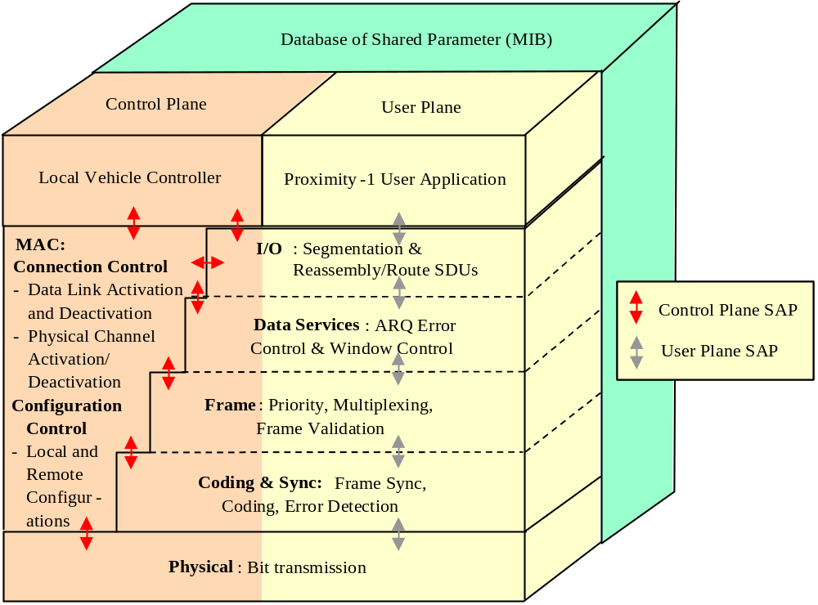
Figure 3-1: Proximity-1 Architecture & Functional Models
Figure 3-1 depicts the Proximity-1 protocol layers, sub-layers, and their functional relationships in both the user and control planes, and the Services Access Points between the user and the sub-layers. In the following section, we will give a service-based, functional description for each protocol component in the control plane and the user plane.

Proximity-1 user and services
Proximity-1 protocol operates at the request of a “user.” A possible user of Proximity-1 includes CFDP, SCPS-NP, SCPS-SP, IPv4, etc. Proximity-1 provides two basic classes of service: management/control and application. Management/control services allow the user to direct and monitor the establishment, configuration, and termination process of Proximity-1 sessions; application services accept data units from the user and transfer them to their designated recipient using different grades of services. If we consider the functional relationship between these two classes of services to the Proximity-1 protocol stack, it is clear that the user plane enables the application services, and the control plane enables the management/control services. For this reason, we shall refer to the management/control services as “control plane services” and application services as “user plane services.”
A unique feature about the Proximity-1 recommendation is the extensiveness of control plane services. Proximity-1 users are given a great deal of control over its internal operation. This is accomplished by increasing inter-layer coupling, thus making direct, manual control of lower layer parameters possible. This is typically not the case in terrestrial network system where strict layer transparency is considered a virtue. The ability for a user to explicitly control lower layer parameters is desirable for space-based operations, since the potential for manual intervention to rectify unforeseen faults or conditions counter-balances the additional complexity. Therefore the Proximity-1 user, rather than just providing the data and letting the lower layer handle all of the operational complexity, retains control of the physical layer and the activation, deactivation, and configuration of both the physical and data link connections.

control plane services
Control plane services includes the ability for the user to establish, configure, and terminate a session, regardless of whether there is data to send or not. The user has the ability to control a remote Proximity-1 entity, request and receive status reports about the on-going session, and request a Proximity-1 time tag interchange.
Figure 3-2 shows conceptually how the internal structure of Proximity-1 looks.. The building blocks of all control plane services are a set of primitives – control points within Proximity-1 that directly effect the operation of each user plane sub-layers. Some of these primitives control points are accessible to the user. Some are in turn controlled by various state variables and their associated sequential logic to perform basic control functions for the user. The “half-duplex transmission control” and “physical layer comm change” are both examples of basic functions described in the recommendation. The set of accessible primitives and basic control functions make up the core of Proximity-1 control plane services, and they can be invoked locally or remote by a set of directives.
In order to provide the maximum degree of manual control and flexibility, control plane services are not highly automated “single-button” functions; control procedures, such as hailing and run-time re-configuration, that require sequential or simultaneous execution of multiple local and remote directives may require interaction with the local spacecraft controller. See Annex D in Proximity-1 for the protocol notifications to the vehicle controller.
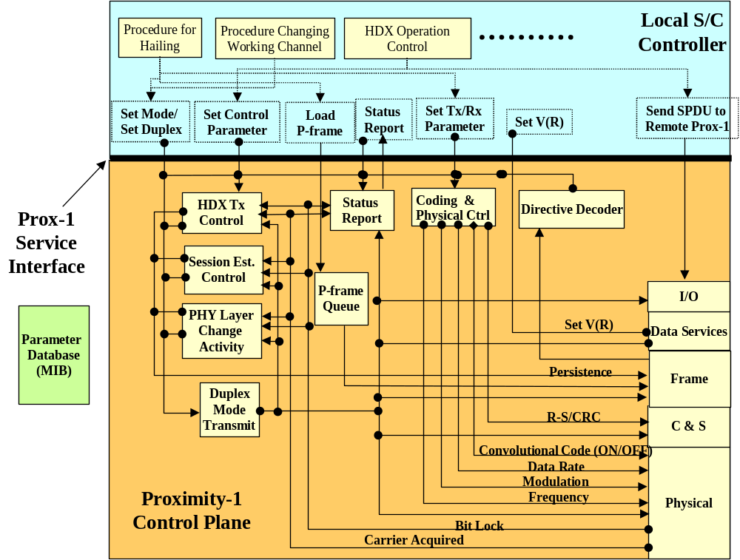
Figure 3-2: Control Plane Services (Timing/Ranging not included)
In the following section, we will describe two types of control plane services:
- Services invoked by directives
  - Issued to a local Proximity-1 entity at the user-MAC sub-layer interface, or
  - Issued to a remote Proximity-1 entity by sending a Supervisory PDU, which contains protocol directive(s) at the user-I/O sub-layer interface.
- Status report triggered by Proximity-1 events
Note that although many SPDUs are issued by the MAC sub-layer, they can also be issued by the user manually, thus having an extensive set of control capabilities on Proximity-1 operation. In the follow sections, we provide a brief summary of the control plane services provided by the Proximity-1 directives and those trigger by Proximity-1 events.

Services Invoked by Proximity-1 Directives
- SET TRANSMITTER PARAMETERS directive
Set transmission mode, data rate, encoding, modulation, and frequency. This directive is used in link establishment, and physical layer changes (e.g., data rate, frequency) during data services.
- SET RECEIVER PARAMETERS directive
Set receiver mode, data rate, encoding, modulation, and frequency. This directive is used in link establishment, and physical layer changes (e.g., data rate, frequency) during data services.
- SET MODE directive
  - Turn off transceiver (inactive)
  - Enable transmitter in asynchronous channel mode (bit synchronization not maintained) and receiver (connecting-T)
  - Enable receiver only (connecting-L)
  - Enable both transmitter in synchronous channel and receiver (active)
- SET DUPLEX directive
Set full-duplex, half-duplex, or simplex-receive, simplex-transmit operation
- SET CONTROL PARAMETERS directive
  - Request N time tags taken
  - Set link directionality (e.g., full, half duplex, simplex)
  - Inform the remote node that there is no more data available to send (link termination process)
  - Switch transmit/receive role in half duplex operation by means of token pass
- REPORT REQUEST directive
  - Request various status reports – options to be specified
  - Time tagging - request time tagging of proximity frames upon ingress and egress by both transceivers
  - Request PLCW - request a PLCW from the partnered node per physical channel ID
- TIME DISTRIBUTION – this directive category includes several specific directives and services needed for the user to perform timing computations:
  - TIME TRANSFER
  - BROADCAST SPACECRAFT CLOCK TIME
There are other types of directives that can be issued by the upper layer user but are only designed to facilitate protocol interaction between internal Proximity-1 processes. Directives such as the SET V(R) directive is intended for use by the COP-P to force resynchronization with its communication partner. The REPORT REQUEST directive has options for requesting a status report about the status of data delivery per physical channel, such as sequence numbers. This directive is intended for use by the data services sub-layer to prompt a remote Proximity-1 entity to generate an acknowledgement for out-standing frames.

Report Triggered by Proximity-1 Events
When certain events occur, Proximity-1 will automatically notify the user. The following are some of the events that will trigger automatic notification:
- Success or failure of a persistent activity (hailing; reconfiguration of frequency, data rate, modulation, etc.)
- Termination of session either due to explicit notification or prolonged loss of carrier signal.
See Annex D in Proximity-1 for a complete list of protocol notifications to the vehicle controller.

User plane Services
The basic user plane service is the delivery of SDUs between Proximity-1 users between two spacecraft. The delivery services can be described and distinguished based on the following four features: (1) grades of service, (2) number of connections, (3) SDU routing and “protocol identification,” and (4) delivery notification.

Qualities of Service
There are two qualities of service for SDUs delivered over the proximity-1 link:
- Sequence Controlled – Provides in order, without gaps, without errors, or duplicates delivery of complete SDUs within a session. SDU reliability is achieved by running the Go-Back-N ARQ algorithm on the Proximity-1 PDU (frame.)
- Expedited – Ensures error free delivery of complete SDUs within a Proximity-1 session with the possibility of SDU loss. However, expedited PDUs (frames) are given higher transmission priority than sequence-controlled PDUs (frames).
For both qualities of service, corrupted or incomplete SDUs are not delivered to the user, nor will their loss be directly indicated. Their loss can be indirectly inferred by the discontinuity in packet sequence count. For any application using the Proximity-1 protocol, the SDU size defines the granularity of data loss.. A mismatch between the application’s tolerance for data loss and the Proximity-1 SDU size may cause unnecessary data loss when using expedited service.
For example, if the Proximity-1 user sends an image of the Mars landscape using the entire image as a single SDU, then the unit of loss would be the entire image. The loss of any Proximity-1 PDU(s) (frames) associated with a SDU, will cause that entire SDU, therefore the entire image, to be discarded. On the other hand, if the image is divided into multiple SDUs each containing independently decodable segments of the image, then it is possible to deliver this image with gaps in it using the expedited service.

Multiplexing of Frames within a Connection
The notion of SDU “order” is preserved within each physical connection using independently incremented frame sequence numbers for each quality of service. For both sequence-controlled and expedited services, the physical channel ID specifies the physical connection to which a SDU belongs. SDU Routing & Protocol Identification
Proximity-1 delivers each SDU to the receiver user through a output specified port. The port ID provides a kind of “hard-wired” on-board routing functionality so that an SDU can be directed to a particular processor, memory buffer, or storage device. However, besides serving as an on-board routing address, the port ID field can also be used for protocol identification purposes by uniquely associating a port to an upper layer protocol. Delivery Notification to the Data SupplierThe I/O sublayer is required to provide delivery status for each SDU to the data supplier. If a SDU is delivered using expedited service, then the data supplier will be notified about which Proximity-1 frames containing the SDU were transmitted; there is no guarantee, however, that the SDU will be received successfully. If a SDU is delivered using sequence-controlled service, then Proximity-1 will keep track of the frame sequence numbers which span the SDU and notify the user when all frames associated with a particular SDU have been received correctly and positively acknowledged.
This feature is an important part of the session termination process because it tells the data supplier which SDUs have been transmitted and acknowledged. This enables the seamless resumption of SDU transfer from the point of interruption to when the next session begins. For delivery notification to work properly, both ends of the communication link must allow sufficient time at the end of a session to generate and receive the needed feedback information before terminating the connection. Abrupt termination of a session may create ambiguity about the delivery status and therefore cause loss or duplicated delivery of SDUs when the Proximity-1 link is re-established.

Proximity protocol components

I/O Sub-Layer
The I/O sub-layer performs the following send functions:
- Provides the interface to accept all the information necessary (e.g., port ID, PCID, QoS) to transfer service data units (SDU) from the sender-user .
- Packages an SDU into Proximity-1 transfer frame(s) and labels each frame with the appropriate sequence number.
- Delivers Proximity-1 transfer frames to the lower layers through separate FIFO queues maintained for each quality of service.
- Parses large SDUs into segments compatible with the maximum transfer unit size over the link.
- Provides reports to the sender-user on the status of SDU delivery.
  - Expedited Mode – notify sender-user when transmission of all PLTUs associated with a SDU over the physical channel has been completed.
  - Sequence Controlled Mode – notify sender-user when all frames associated with a complete SDU has been received and positively acknowledged by the receiver.
The I/O sub-layer performs the following receive functions:
- Receives Proximity-1 transfer frames from lower layers and reconstructs the original SDUs for delivery to the receiver-user through the output port ID specified by the sender-user.
- Reassembles SDUs that were segmented.

Receiving SDUs from the User
The I/O sub-layer provides the service access point (SAP) through which the user can supply service data units (SDU) to the proximity-1 link layer. Acceptable SDU formats include CCSDS source packets, CCSDS Encapsulation packet, SCPS-NP packets, IPv4 packets, etc., as well as other user defined formats unknown to the protocol. The I/O sub-layer interface also allows the user to specify, along with each SDU, the quality of service (Expedited or Sequence-controlled delivery), the output port ID through which the SDU is to be delivered on the other side, the physical channel, the PDU type (whether data or protocol directives are contained) and the construction rule by which the SDU is constructed within proximity-1 transfer frame(s).

SDU Delivery (Sending Side)
For the sender of a SDU, the I/O sub-layer will receive information from the Data Services sub-layer about which expedited frames are sent and which sequence-controlled frames are both sent and positively acknowledged. The I/O sub-layer will translate these frames received into their equivalent in terms of SDUs and update the user on the delivery status for each SDU. By keeping track of the number of the frame which contained the last part of an SDU, the sender can track when an SDU is reliably transferred by knowing if that last frame is acknowledged. On the receiving side of the link, U-frames will be delivered from the lower layer (Data Services sub-layer) to the I/O sub-layer. The I/O sub-layer will unwrapped the U-frame headers and rebuild the original SDU for delivery to the user through the user-specified port ID. Only complete SDUs will be delivered to the user. In Proximity-1, P-frames that originated from the sender-user will only be delivered to the MAC sub-layer on the receiving side. The I/O sub-layer does not process any P-frames on the receiving side.

Data services sub-layer
The data services sub-layer’s primary functions are:
- Execute the necessary sequential logic and buffer management tasks to deliver Proximity-1 frames using: (a) go-back-n ARQ and (2) Expedited QoS.
- Provide information on the sequence numbers of the frames that are transmitted and also those that are acknowledged to the I/O sub-layer.

COP-P Process
The data services sub-layer implements the go-back-n algorithm using a Command Operations Procedure-Proximity (COP-P) process. The COP-P process consists of a sender process called Frame Operations Procedures Proximity (FOP-P) and a receiver process called Frame Acceptance and Reporting Mechanism Proximity (FARM-P).

Frame Acceptance and Reporting Mechanism Proximity (FARM-P)
Since the lower layer and sub-layers (physical, coding & synchronization, and frame) will eliminate frames received with an error or invalid format and contents, all frames submitted to the FARM-P process are error free. Therefore the responsibility of the FARM-P process is to check whether a frame arrives in or out of order. Frames that arrived in order are accepted; Those that arrive out of order are rejected. The FARM-P reports to the sender the value of the next sequenced controlled frame it is expecting i.e., the sequence number of the latest frame that has been accepted plus one. The report value is sent in the PLCW.

Frame Operations Procedure Proximity (FOP-P)
The FOP-P process is in charge of sending either new frames or previously sent frames based on the feedback from the FARM-P process on the receiver side. This means that frames that are sent but not yet positively acknowledged must be stored in a temporary buffer in case retransmission is necessary, i.e., the sent queue. The FOP-P process must also throttle back transmissions of frames when the number of out-standing frames reaches the window size (N). For full duplex operation, the choice of N depends on the round trip time, the frame sizes and the data rates on the forward and return links; for half duplex operation, channel error rate plays a more important role due to the additional time required to change sender and receiver rolls.

frame sub-layer
The framing sub-layer performs the following functions:
- Multiplex P/U-frames supplied by the data services layer, P-frames from the MAC sub-layer, and P-frames (PLCW) into a single stream for transmission over the physical channel. The following priority is applied during multiplexing:
  - P-frames from MAC sub-layers
  - PLCW/status report
  - Expedited frames
  - Sequence controlled frames (first from the Sent_Queue and then new frames)
- Create PLCW (feedback frames that carry FARM-P state information needed for the go-back-n ARQ algorithm) by constructing a separate P-frame.
  - 3. Validate received frames, invalid SPDUs are dropped.
- Route U-frames and PLCW SPDUs to the Data Services sub-layer; other SPDUs are sent to the MAC sub-layer.

Asynchronous Data Link
For an asynchronous data link, the frames have variable lengths. When these frames are not generated fast enough to fill the physical channel with bits, the physical layer inserts the idle pattern, defined in the physical layer. The frame size is variable as long as it is smaller than the maximum allowed on the link. There are three possible frame construction rules: segmented, un-segmented, and user-defined data (octets).

Segmented Packets
- For segmented packets, each frame can only contain one segment from one packet therefore each segment is aligned with a frame.
- Each frame containing a segmented packet has an identifier (‘sequence flag’ in the Segment Header) that specifies whether the segment is the first, one of the middle, or the last segment of a packet. Combined with the frame length information, the length of a packet can be computed, if all of the segments are provided. Therefore, segmented packets should only be used while using the sequence controlled service, since all of the segments are guaranteed to be delivered and Proximity-1 only delivers complete packets to the user. Note that the loss of any intermediate segments would be undetectable in Expedited service unless a check sum was calculated over the entire packet before transmission.
- A segmented packet is reassembled from frames containing the same routing ID, i.e., the same physical channel ID, port ID, and ‘pseudo packet ID’ (in the Segment Header).
- Segments from other packets can be multiplexed into the stream of frames as long as they contain a different PCID or port ID.

Un-segmented Packets

When a packet can fit within a single frame, segmentation is unnecessary. Since the frame size is variable, there is also no need to include filler data within the packet. If multiple integral packets can fit within the data field of a single frame, they must share the same physical channel ID, port ID, QOS, PDU type, and DFC ID, which are all fields within the transfer frame header. User Defined Data
User defined data is fitted into a single frame without fill; it is up to the user to provide user-defined SDUs that are no larger than the maximum data field size, if it is intended for the frame and the SDU to allign

Sequence Number Assignment
In Proximity-1, sequence numbers are essential for tracking the order of frame delivery, detecting gaps, and making re-transmission requests. The frame sequence number is an 8-bit field in the frame header; Sequence number is assigned to each frame based on the quality of service requested:
- Sequence Controlled frame – Distinct sequence numbers (SEQ_CTRL_FSN) are incremented monotonically for each physical channel.
- Expedited frame – Distinct sequence numbers (EXP_SEQ) are incremented monotonically for each physical channel.
Note that both of these sequence numbers increment independently of Port ID. The SEQ_CTRL_FSN enables the Sequence Controlled process to number sequentially and then check the sequence of incoming Sequence Controlled transfer frames. The EXP_FSN is not used in the frame validation process but is required for correlations associated with Proximity-1 timing services.

Delivery of Proximity-1 Frames to Lower Sub-layer
Proximity-1 frames, whether they are U-frames or P-frames, are delivered to the lower sub-layer via two FIFO queues: (1) Expedited queue and (2) Sequence-controlled, based on the QOS selected. Frames are queued in the order they are generated from the SDUs and their position in the queues are completely independent of physical channel ID and port ID.

Coding & synchronization SUBlayer
The coding & synchronization sublayer has two basic functions:
- Frame de-limiting:
  - On the transmitting side, mark the beginning of a frame with an Attached Synchronization Marker (ASM) on transmission, and
  - On the receiving side, search the bit stream supplied by the physical layer for the ASM, and retrieve the frame using the value of the frame length in the frame header.
- Error detection:
  - On the transmitting side, compute CRC and attach to the end of the Proximity-1 frame, and
  - On the receiving side, apply error detection. If one or more errors are detected, the frame is rejected; otherwise the frame is extracted and submitted to the frame sub-layer.
This sub-layer performs the conversion between a Proximity-1 frame and a Proximity Link Transmission Unit (PLTU), which consists of an ASM, a frame, and CRC.

MAC sub-layer
The MAC sub-layer is quite different from the traditional medium access control in two aspects:
- The traditional MAC function is, in connection-less and operates in the user plane; it is only concerned with scheduling individual PDUs for transmissions on a shared physical medium. While the “MAC” sub-layer in Proximity-1 operates in connection-oriented fashion, and it is primarily a control/management plane function concerned with establishing a “link session.”
- Most MAC protocols are implemented with a strict layer separation so that its operation is transparent to the user and very lightly coupled with the physical layer through a physical convergence layer. In Proximity-1, due to the need for manual intervention during fault recovery, the MAC entity is tightly coupled with both the user as well as the physical layer.
The Proximity-1 MAC sub-layer has two functional components:
- Connection control – activation and deactivation of a Proximity-1 session and token pass for half-duplex operations.
- Configuration control – setting configuration such as frequency channel, data rate, modulation, encoding, and duplex mode.
The MAC sub-layer has an extensive set of connection and configuration control functionalities that are not traditionally associated with the MAC layer concept. Many of these functionality are directly offered to the Proximity-1 user as a service. Please refer to section 3.1.1 (“Control Plane Services”) for more detail.

Connection Control
The most important connection control function of the MAC sub-layer is the hailing procedure by which two spacecraft can establish both data link and physical level connections. Another connection control function is the token passing process used in half-duplex mode. The MAC sub-layer performs the necessary control function of regulating data flow and toggling the transceivers between transmit and receive.

Configuration Control (Comm Change)
Configuration control allows Proximity-1 to change both physical layer parameters such as frequency, coding, data rate, modulation, as well as data link layer parameters such as link layer protocol, and duplex mode from the default configuration used during hailing. Changing duplex mode however requires the initiator to change to the new duplex state before the directive is transmitted across the proximity link. In summary, reconfiguration is a key component in operating efficiently and optimizing operations in a heterogeneous environment where there is a wide variety of spacecraft with different communication capabilities.

State Variables
The MAC sub-layer maintains and updates several state variables that relate to the status and configuration of a proximity-1 session. The MODE variable controls whether the Proximity-1 connection is inactive, within the transmitting or listening phase of the hailing procedure (connecting-T, connecting-L), or ready to provide data services (active). The TRANSMIT variable controls whether the transmitter is turned on and ready to send out Proximity-1 frames. The DUPLEX parameter selects full, half, simplex-transmit, or simplex-receive operations.

Persistence Activity
A persistent activity is a process for ensuring reliable communication between a caller and a responder using the expedited QOS while transmitting exclusively from the MAC queue. Because of the potential for frame loss due to corruption across the space link, these MAC control activities require a persistence process to ensure that supervisory protocol directives are received and acted upon correctly. Persistence activities may be linked in series to accomplish a task, but persistence applies to only a single activity at a time. Proximity-1 currently defines three persistent activities: Hailing, i.e., Session Establishment (see 6.2.4 and tables 6-8 and 6-11); Comm_Change (see 6.2.4 and tables 6-9 and 6-12); and Resynchronization (see 7.1.3.2 and 7.1.3.3).

Operationally, when the persistence signal is set to true, all other data flow is suspended except for this persistent activity operated out of the MAC sub-layer until one of the following conditions occurs: 1) the expected RESPONSE to the activity is received within the allocated response time i.e., WAITING_PERIOD; 2) the expected RESPONSE is not received within the WAITING_PERIOD, but before the LIFETIME of the activity has expired, so that the persistent action can be repeated; 3) the RESPONSE is not received within the LIFETIME and the activity is terminated without success. In any case, the protocol notifies the vehicle controller about the result of the activity and resets the Persistence signal to false.

Physical layer
The primary functions of the physical layer are:
- The prime function of the physical layer is to establish a communications channel upon which the data can flow. This process includes configuration of the following physical layer parameters: frequency, data rate, modulation, and coding parameters, such that common operating characteristics exist in both spacecraft.
- Acquire bit-level synchronization using the acquisition sequence (See Physical Layer 3.3.1). Note that the Idle sequence was so chosen as to enable acquisition in the presence of data on the Proximity link.
- Provide the tail sequence for a configurable fixed period prior to terminating transmission in order for the receiving spacecraft to process the received data unit fully (required for convolutional decoding and bit lock assurances).
- Maintain a synchronous data link when data is unavailable for transmission by inserting the idle sequence onto the physical channel.
- Provide Carrier_Acquired and Bit_Inlock_Status signals to the MAC sub-layer

Note that the acquisition, idle, and tail sequences utilize the same bit pattern for all of these functions i.e., 352EF853 (in hexadecimal).

Bit Level Synchronization
Proximity-1 handles bit level synchronization in two different ways. When message exchanges are brief and there is no intention of establishing long-term communication on a channel, the physical layer operates in a message-switching fashion – acquire bit-level synchronization for each message and relinquish synchronization when there is no message to send. Since synchronization is not maintained between transmissions of messages, Proximity-1 defines this as an “asynchronous channel.” If message transmissions are sporadic and have long signal period dead times, this approach can provide significant energy savings.
However, if there is a significant amount of data to be transmitted, Proximity-1 will establish a physical channel that operates in circuit-switched fashion – once bit synchronization is achieved, it will be maintained by inserting an idle sequence when necessary. Because bit-level synchronization is maintained, Proximity-1 defines this as a “synchronous channel.” This has the advantage of reducing acquisition overhead, but may still result in higher energy consumption if there are many idle periods during the session.
From a Physical Layer point of view, traffic characteristics on Proximity-1 links after link establishment tend to be a continuous bit stream over the return link, the latter approach – establishing a circuit-switched physical layer connection – should yield better performance. This is why Proximity-1 always operates over a synchronous channel during the data service phase of a session.

Full/Half Duplex Operations
Proximity-1 supports full duplex communication, where physical channels are established for both the forward and the return links. This approach will minimize overhead associated with channel acquisition since it is nominally only done once during link establishment. However, for half duplex, the physical channel must be re-established every time the link is turned around, which may contribute to significant overhead, if there are many turn-arounds during a session.
In Proximity-1, hailing in both full and half duplex operations as well as half-duplex sender-receiver turn-arounds are regulated by four parameters: Carrier_Only_ Duration, Acquisition_Idle_Duration, Tail_Idle_Duration, and Hail_Wait_Duration. They are assigned values in the MIB to optimize the operation of the link establishment process. To overcome the uncertainty in Doppler shift and timing, the caller sends a carrier-only signal to establish carrier lock with the responder; this signal is then followed by an acquisition idle sequence to achieve bit level synchronization. After the hail directives are transmitted, the idle sequence functions as a tail sequence sent to ensure that all of the data will be processed through the receiver chain in particular the convolutional decoder. The Hail_Wait_Duration provides a period of time for the sender's receiver to listen for any responses on the return channel without interference.

Frequency Allocation/Assignment
The Proximity-1 Physical Layer has provision for proximity operations at the following frequency bands: UHF, S, X, and Ka. At the time of this document's publication, only frequency channel assignments at UHF band have been made. Assignments at the other frequency bands remain TBD until a user need is identified for them.
The UHF frequency allocation consists of 60 MHz between 390 MHz to 450 MHz. The forward frequency band is defined from 435 to 450 MHz. The return band is defined from 390 to 405 MHz. There is a 30 MHz deadband between them. There are 16 channel assignments; 8 of these channels so far have been assigned a specific frequency or frequency range.
Proximity-1 has the concept of two channel types: hailing and working channels. The hailing channel is used only for the initial link establishment. Time spent on the hailing channel should be kept to a minimum to allow other users access to it. It is recommended that after link establishment through hailing is accomplished, one transitions over to the working channel (if available) as soon as possible and continues to conduct operations on it.
The working channel is used for the bulk of proximity communication which includes any reacquisitions (due to loss of lock or half duplex turn-arounds), nominal command, telemetry, and timing data services and link termination.
The frequencies assigned for hailing are enterprise specific. This enables an enterprise to pick the forward and return frequencies for hailing to best meet the needs of the individual missions within that enterprise. Note that if the Proximity link radio equipment supports only a single channel (i.e., a single forward and return frequency pair), then the hailing channel will be the same as the working channel. This is the case for both the NASA Mars Odyssey Orbiter and the ESA Mars Express Orbiter in which channel 0 represents both the hailing and working channel. However, if interoperability amongst enterprises is required, the recommendation has reserved channel 1 (435.6 MHz Forward, 404.4 MHz Return) as the hailing channel. Note that this frequency pair was chosen to minimize the amount of bandwidth occupied by the hailing channel for two reasons: First, because hailing is done at a low data rate and therefore is a low bandwidth activity and second to maximize the use of the remaining spectrum for working channels.
For more complex configurations with one or multiple forward frequencies paired with one or multiple return frequencies, the recommendation allows for up to eight additional forward frequencies and eight additional return frequencies to be selected as long as they are distinct from all previous assignments.

Bit Error Rate
For asynchronous data link operations, the Bit Error Rate (BER) on the link should be less than or equal to 1X10⁻⁶.The physical layer also needs to meet specific Doppler tracking and acquisition requirements.

protocol operations

Messaging between two transceivers
There are several types of messages that can flow between two transceivers during a session. Figure 4-1 shows the flow through the communication protocol stack of various Proximity-1 data and control messages from one Proximity-1 node to another.
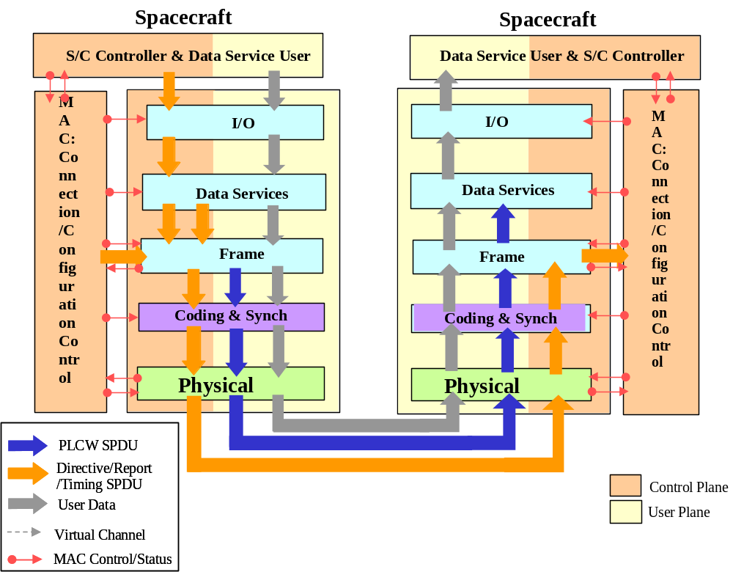
Figure 4-1: Flow of Proximity-1 Data and Messages
The user data always originates from the sender user and passes through all the sub-layers except the MAC sub-layer. In the previous section we showed how user data is submitted as a SDU, then converted to frames, PLTU, and then modulated onto the physical channel as bit stream. The receiver in order to recover the original data SDUs reverses the process.
For control messaging such as directives, both the user or the MAC sub-layer may issue an SPDU, but it will all be delivered to the remote entity’s MAC sub-layer, which will then decode the directives and perform the requested actions. Another control message exchanged between two Proximity-1 entities is the Proximity Link Control Word (PLCW). These are used for acknowledging frame reception and making retransmission requests. It flows from the data receiver’s frame sub-layer back to the data sender’s data services sub-layer.

Hailing Procedure
Hailing is an interactive process by which two Proximity-1 entities can discover each other and establish an asynchronous data link over a physical connection between them. Hailing can be accomplished by means of a demand or by negotiation. In a demand hail, a fixed set of directives are transmitted in a proximity-1 frame in order to configure the partnered transceiver. A negotiated hail allows for a more flexible link establishment process based upon requests/reports for capabilities and status. In either case, the initiator of this process is referred to as the caller, and the intended communication partner of the caller is referred to as the responder. The hailing procedure utilizes the process of a “persistence activity” to ensure reliable handshaking between the caller and the responder. The key idea behind a persistence activity is that it is transactional – an action is declared complete only when the expected response is observed with reasonable delay.
Before the hailing process begins, the caller will load a P-frame, which contains the hailing message (one or more Proximity-1 directives formatted into a frame) into the MAC sub-layer’s transmission queue. The hail frame will be addressed to the intended responder and contains directives such as the SET TRANSMITTER PARAMETER and SET RECEIVER PARAMETER directives for configuring the responder's transmitter and receiver. Then by setting the mode parameter to connecting-T, the hail frame will be radiated on the hailing channel. The responder is configured by it’s vehicle controller to be in the connecting-L mode. Once it correctly receives the hail frame or acquires bit synchronization, it responds back with a status report frame. Upon reception of this frame, the initiator resets persistence to false and begins data service.
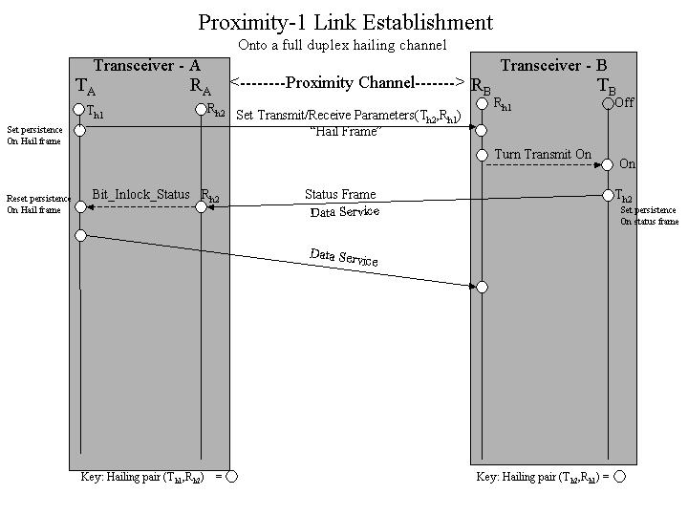
Figure 4-2: Proximity-1 Link Establishment

Full Duplex: Moving off the Hailing Channel and onto a Working Channel
Figure 4-8 shows the steps involved in moving onto a Working Channel immediately after the link is established on the Hailing Channel. In this case, the hail frame also contains parameters to change the responder's transmit and receive frequency. Upon successful receipt of the hail, the responder changes receive frequency to R_{w1} and turns on it's transmitter. It transmits a status frame back to the initiator on it's hail frequency. Upon receipt of the hail response, the initiator resets persistence on the hail activity and sets it's receiver to the new receive frequency, R _{w2} and new transmit frequency, T _{w1}. The initiator now in data services transmits frames. Upon acquiring bit synchronization or a valid frame, the responder changes it's transmitter to T _{w2} and begins data service on the working channel.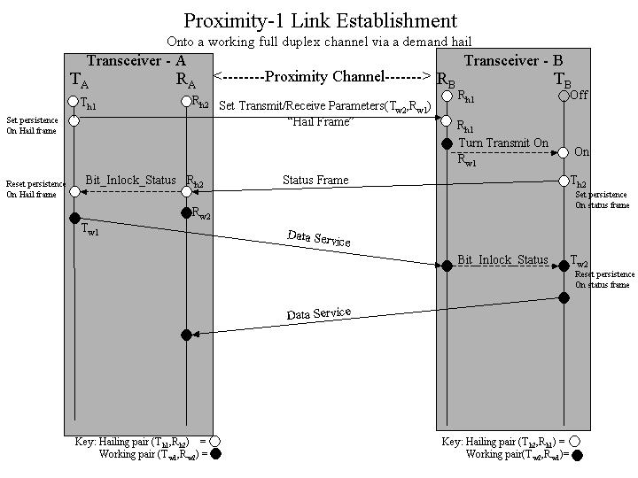
Figure 4-8: Moving onto the Working Channel in Full Duplex

Link Establishment onto a Half Duplex Channel
For half-duplex option, whether the session eventually uses a working channel or stay on the hailing channel, a three-way handshake is necessary to ensure the integrity of the hailing process. The hail frame and subsequent response frames both contain the Set Control Parameter directive that has an End of Data (EOD) indicator. This indicator basically gives the other entity control of the channel. If such EOD indication is not given at the end of each entity’s transmission, then either the loss of bit-lock or a half-duplex timer overrun will have the same effect of reversing the transmit-receive orientation.
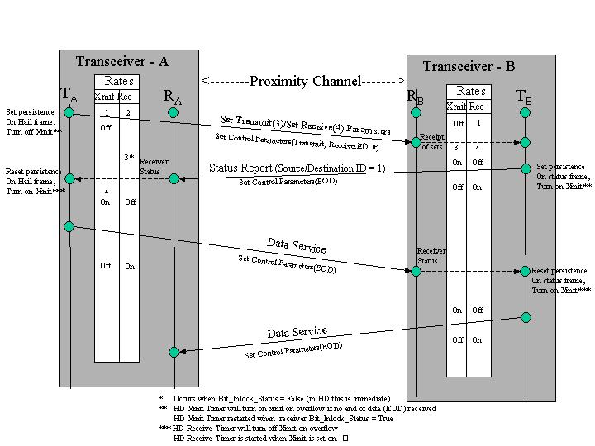
Figure 4-10: Half-Duplex Link Establishment

Communication Change During Data Services
It is possible to change physical layer parameters during a session (after link establishment) such as data rate, modulation, frequency, duplex mode, etc. Typically the decision to change communications configuration is made by the caller, but either node can initiate the change. If we consider the prototypical orbiter-to-lander scenario, we see that the orbiter, which is the caller, is the natural candidate for making configuration decisions; as the receiver of data, it will be able to assess the channel condition on the return channel (from surface to orbit) based on received SNR and other metrics derived from Proximity-1 operation.
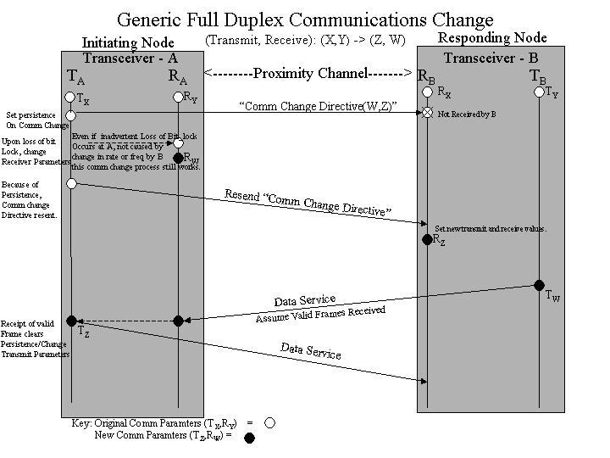
Figure 4-3: Generic Full-duplex Communications Change
- Figure 4-3 depicts a possible sequence of events for a typical communications change scenario using a full duplex channel.
One can also reconfigure communication parameters during data services on a half duplex channel as well.

Data Services Phase
The main feature of data service phase is the option to select two grades of service: Sequence-controlled or Expedited. The expedited services attempts delivery of a SDU only once without guarantee of correct reception. The sequence-controlled service uses a Go-Back-N ARQ to guarantee correct reception. The following section will describe the internal operation of Proximity-1 with more emphasis on the sequence-controlled service in more detail.

Flow of Proximity-1 Frames On the Sending Side

I/O Sub-Layer: Frame Construction
Once a session enters the data services phase, the user may supply SDUs that carries either user data or protocol directives. These are then converted to Proximity-1 transfer frames called U-frame and P-frame, respectively. The header of each frame will contain the sequence number, the QOS, physical channel, port ID, and source/destination spacecraft ID, PDU type, and other information necessary to identify and provide the appropriate grade of service to the SDUs contained in these frames. Separate sequence numbers are kept for each QoS.
Once a frame is generated, it is separately queued based on the QOS requested. The sequence-controlled queue holds frames that require the sequence-controlled service; the expedited queue holds frames that require the expedited service. Note that frames are queued strictly in the order they are generated.

Data Services Sub-Layer: ARQ Error Control
Since the data services sub-layer tracks the state of the ARQ algorithm, it maintains two queues to handle possible re-transmissions: a “New Sequence-Controlled Frame Queue” and “Sent Sequence-Controlled Frame Queue,” which stores sequence-controlled frames that are sent until they are positively acknowledged. Depending on the state of the ARQ algorithm, one frame from either queue will be loaded into a “Sequence-Controlled Frame Buffer” for delivery. For expedited service it maintains no queue, just a buffer that holds a single expedited frame extracted directly from the expedited queue in the I/O sub-layer.

Frame Sub-Layer: Prioritized Multiplexing
The frame sub-layer performs prioritized multiplexing of frames for transmission across the physical channel. Transfer frames can come from several sources, and they are give priority in the following order:
- MAC P-frame (MAC sub-layer)
- PLCW frame (generated within Frame sub-layer)
- Expedited frame (Data Services sub-layer)
- Sequence-controlled frame (Data Services sub-layer; from the sent queue)
- Sequence-controlled frame (Data Services sub-layer; a new frame)
MAC P-frame is given the highest priority because it relates directly to the time-sensitive control messages used to establish and configure Proximity-1 sessions. PLCW carries ARQ feedbacks that are also time-sensitive if the ARQ window size and timers are set very closely to the optimal value. Expedited frames coming from the user typically (but not necessarily) carries protocol directives or low latency user data. Therefore it is also given higher priority.
After the frame sub-layer selects a frame to be send, the Coding and Synchronization sub-layer pre-pends an ASM and a CRC is computed and appended to the frame, which is transmitted as a bit stream over the physical channel.

Flow of Proximity-1 Frames On the Receiving Side
On the receiving end of a Proximity-1 session, the physical layer will decode the optionally convolutionally encoded bits from the physical channel and submit them to the coding and synchronization layer as a bit stream.

Frame Delimiting and Transmission Error Detection
The decoded bit stream contains frames separated by synchronization markers and possibly idle bit inserted by the physical layer. The frame sub-layer will look for the ASM, extract the frame and decode the CRC parity check. If there is no error, then the frame is accepted. Otherwise it is rejected and the NEED_PLCW parameter is set to true.

Validate Frames, Decode P-frames and OCF
When the frame sub-layer receives frames from the C&S sub-layer, it performs another frame validation process based on the format and content of the frame. It checks that the correct frame format is used (version 3) and the destination spacecraft ID is valid for the current proximity-1 session. (Optionally tests whether the source spacecraft ID is valid when Test_Source is true).
For frames that are accepted, SPDUs are extracted from P-frames. If a SPDU is a PLCW, it is forwarded to the Data Services sub-layer so that the ARQ states can be proper updated; the other types of SPDUs are sent to the MAC sub-layer. The U-frames are forward to the Data Services sub-layer.

Frame Sequencing
The data services sub-layer, upon reception of a frame, will determine whether there is a missing frame and whether retransmission needs to be requested. For sequence-controlled services, a missing frame is detected when there is a gap between the sequence numbers between the current frame and the last received frame in the same physical channel; a request for retransmission can be done by setting the NEED_PLCW parameter to true. For expedited service, the received frame is directly passed on to the I/O sub-layer.

SDU Extraction
The data services sub-layer will deliver U-frames to the I/O sub-layer in order, but possibly with gaps when using expedited services. The I/O sub-layer will handle the task of extracting the SDUs contained in the frames, reassemble them when needed, and deliver them to the user through the designated port. The I/O sub-layer must only deliver complete SDUs to the user; therefore missing frames that contains piece(s) of one or more SDUs will cause them to be discarded.

COP-P: A Go-Back-N ARQ Algorithm
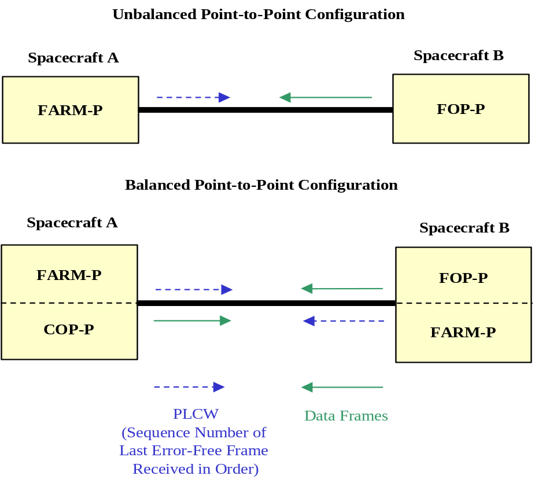
Figure 4-4: COP-P Configurations
The sequence-controlled service is an instance of a go-back-n ARQ implementation, which in Proximity-1 is called Command Operation Procedure- Proximity (COP-P) due to its similarity to the implementation in Telecommand [3]called Command Operation Procedure-1 (COP-1.) As depicted in Figure 4-4, COP-P describes the interaction between a sender-receiver pair. The procedure on the sending side is called Frame Operation Procedure (FOP), and its counterpart of the receiving side is called Frame Acceptance and Reporting Mechanism (FARM.)
Functionally, FOP controls the order of transmission of frames, and this algorithm resides in the Data Services sub-layer. The FARM process is implemented by the functionalities on the receiving side of the C&S, frame, and data services sub-layers. It checks each received sequence controlled frame for order of arrival and frame duplication. Only unique and in-order frames are accepted. The FARM process sends feedback messages called PLCWs to the FOP process regarding the sequence number of the last frame received in order. Using this information, the FOP process can decide whether retransmission is necessary and which frames can be cleared from its buffer space. The interaction between a FOP-FARM pair implements a go-back-N ARQ algorithm.

PLCW Generation
Because COP-P stored all state information such as the sequence number of the most recently sent and acknowledged frame in the Data Services sub-layer, one naturally assume the Data Services sub-layer would also create the actual feedback messages, or PLCW. However, Proximity-1 directly generates each PLCW in the Frame sub-layer using counter values provided by the FARM process. This has several benefits:
- Eliminates queuing delays by generating each PLCW right before it is sent out for coding and transmission on the physical channel,
- Make sure each PLCW carries the most updated information when it is generated – this improved half duplex operation by allow just one PLCW to be generated for each turn-around.

COP-P State Diagram
The following are two abridged state diagrams for the FOP and FARM processes. Not all counter and state variables are included, and some details are omitted and events and actions are combined for a more descriptive presentation. In the state diagrams below, we show the state transitions for sequence controlled service in a single virtual channel.
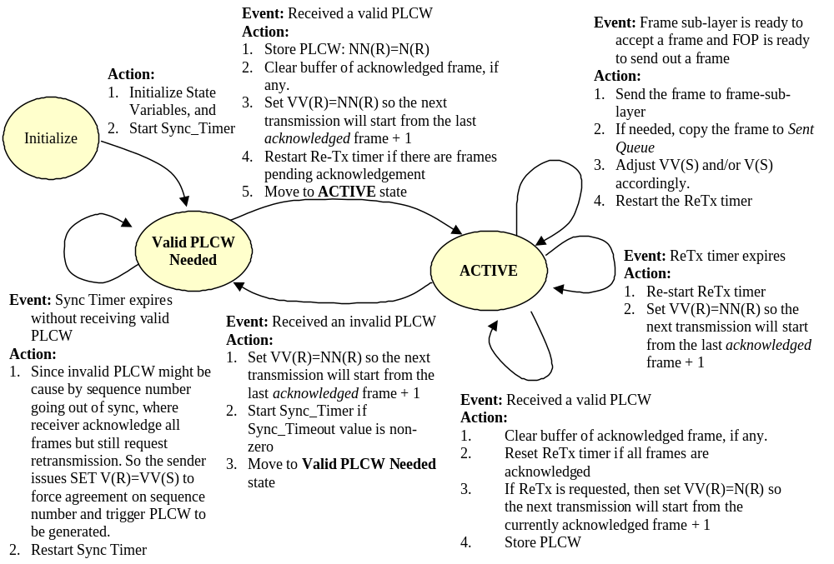
Figure 4-5: FOP State Diagram
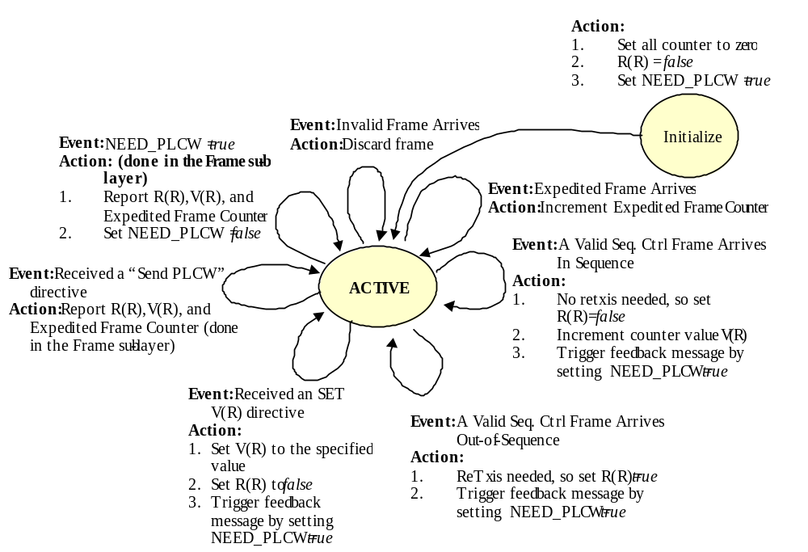
Figure 4-6: FARM State Diagram
In the recommendation, the term “pending” is used in the state table with two different meanings:
- “Pending Frame” - A frame that has already sent by the FOP but has not been positively acknowledged either explicitly or implicitly by the FARM process on the other side of the Proximity-1 link is called a “pending frame.”
- “Frame_Pending” – A binary control signal that tells the data services sub-layer that the frame sub-layer is ready to accept a frame.
In our state diagram, we use the term pending exclusively in the sense described in item 1.

Time Sequence Diagram
The FOP and FARM processes interact through the exchange of sequence controlled U-frames, directives, and PLCW, which can acknowledge one or multiple accepted frames. In time sequence diagram, we will use a shorthand notation to show the value and content of each message. A PLCW is designated by parenthesis with three fields: (VC,V(R),R(R)); directives are denoted by curly brackets: {directive}; sequence controlled U-frames are designated by a pair of brackets: [VC,N(S)]. When PLCW or directives are piggybacked on sequence controlled U-frames, we have the notation: [VC,N(S),(VC,V(R),R(R))] or [VC,N(S), {directive}].
Note that V(R) is the sequence number (plus one) of the last sequence controlled frame accepted by the receiver; R(R) is a binary flag used to request retransmission. VC is the virtual channel ID (either 0 or 1), and N(S) is the sequence number of a sequence controlled frame. Also note that the value of the Retransmission Timer is constantly adjusted in a fashion similar to a ‘sliding window’, whose size is the RETRANSMISSION_TIMEOUT parameter.
Proximity-1 allows each virtual channel to have its own COP-P processes, so for a balanced configuration, we can have actually four COP-P processes running simultaneously. For simplicity of illustration, we will provide time sequence diagrams only or configuration using up to two COP-P processes.

Full Duplex Operation
In this section, we will show examples of message exchanges under full duplex operation:
- Unbalanced configuration:
  - One COP-P Process – data frame error (loss) recovery and PLCW error (loss) recovery
  - Two COP-P Process
- Balanced configuration with Two COP-P processes.
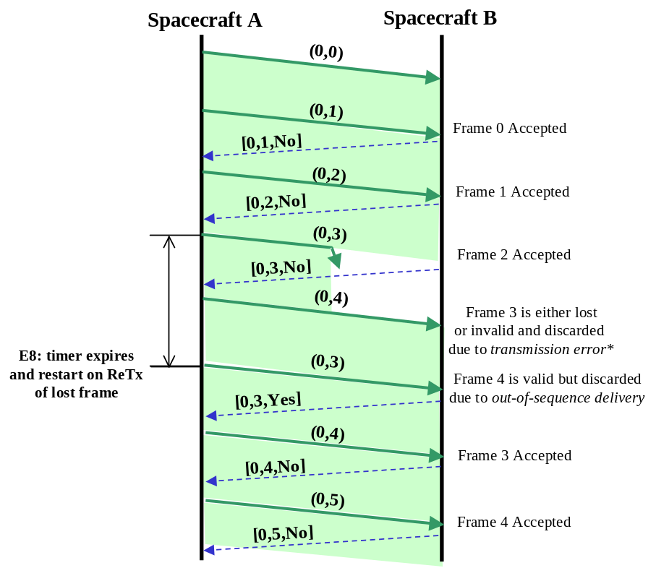
Figure 4-7: Recovery from Error Frame (Go-Back-2)
Figure 4-7 show the typical error recovery process implemented in Proximity-1. Note that when a data frame is lost or dropped due to transmission error, no PLCW is generated because there is ambiguity about the identity of the rejected frame. If a PLCW were generated to report this event, the FOP process would not be able to decide with confidence whether retransmission is necessary because it has to guess the identity of the rejected frame. Therefore, the FARM process will only generate PLCW when a valid data frame arrives out-of-sequence, which will clearly identify to the receiver, as well as the sender, which frames are missing.
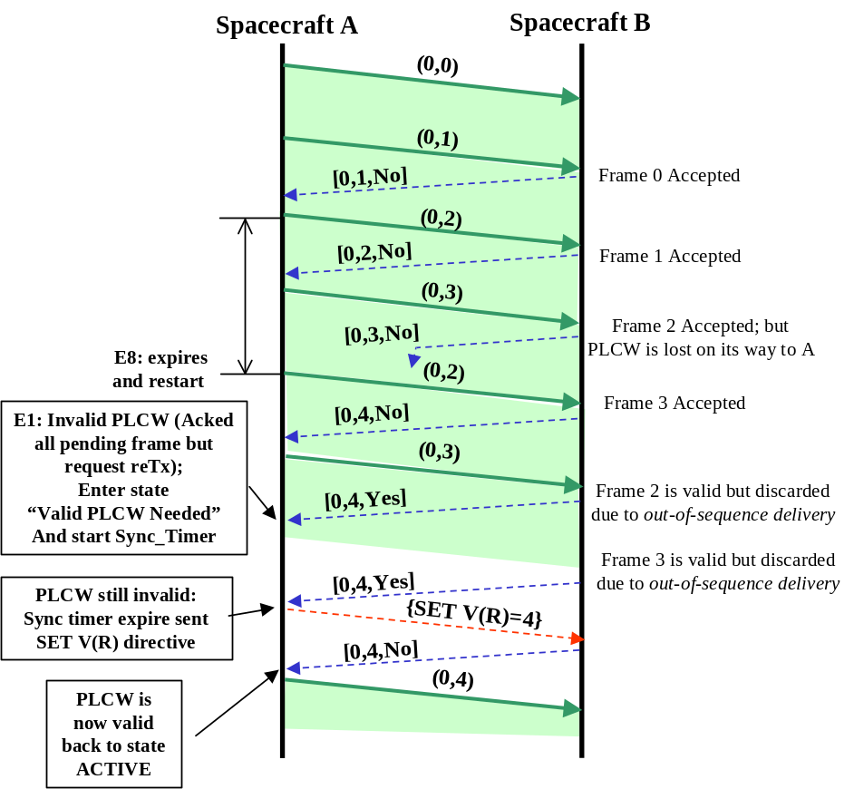
Figure 4-8: Recovery from lost PLCW
Figure 4-8 shows the recovery process when a PLCW is lost or rejected due to transmission error. From time sequence diagram, we can see that losing a PLCW will trigger a more complex recovery process than losing a data frame because the sender is waiting for acknowledgement and re-transmitting frames that the receiver thought has already been acknowledged; it takes longer for the sender to figure out the situation after receiving PLCW that does not make sense – or ‘invalid’ – and to get back on track.
Because Proximity-1 provides two virtual channels, two COP-P processes can exist at the same time under an unbalanced configuration – one spacecraft sending two independent streams of data frames to another spacecraft. Each COP-P process maintains its own state and counter information and separate Retransmission Timer.
Note in Figure 4-9, the order in which frames from the two virtual channels are intermixed is randomly chosen for illustration purposes only. In actual operations, the order in which sequence frames share the physical channel follows the order in which the user provided the original SDUs. One notable difference is that sharing the same channel creates time gaps in the flow of each COP-P process; these time gaps in turn allow the receiver time to acknowledge all pending frames, instead of constantly trying to catch with the ‘sliding window’, which allows the sender to fill the pipe with new frames. We can observe this phenomenon by noticing that the re-transmission timer is stopped more frequently. This makes each individual COP-P process operate more like a stop-and-wait process, which has lower re-transmission overhead than go-back-n; while avoiding the bandwidth inefficiency of stop-and-wait because the pipe is being filled alternately by each COP-P process.
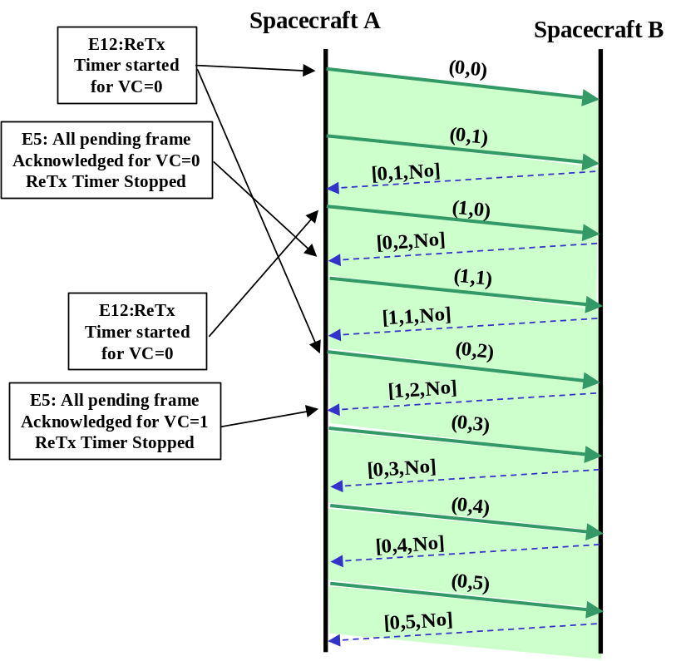
Figure 4-9: Two COP-P Flows in the same direction
In a balanced configuration (see Figure 4-4) where two COP-P processes are running in opposite directions, it is possible to take advantage of the flow symmetry by piggy-backing feedback message with data frames. Proximity-1 frame structure allows the data frame to flow continuously while carrying small payload with control information – this small payload is called the Operation Control Field (OCF) in the transfer frame structure.
In order to utilize the OCF, one needs to adjust the transfer frame size such that the resulting PLTU will not exceed the maximum allowed length. If the data link mode is synchronous (using only fixed PLTU size), the frame length, in particular the data field, must be reduced by the exact size of the OCF. Because the frames are created in the I/O sub-layer while the OCF is attached in the frame sub-layer, several issue may arise:
- The reduction in frame length must be coordinated with the use of OCF. This requires either:
  - A common control be applied to both the frame and I/O sub-layer to dynamically change frame configuration, or
  - Use a fixed configuration throughout the entire session.
- If the frame size is reduced but there is no need to use OCF in every outgoing frame, the efficiency of the system is reduced because the R-S coder uses a fixed block length that already include the OCF.
However, when properly configured, the OCF can result in improved efficiency in balanced configuration. In the figure, we assume the same data rate and PLTU size is used; note that in the case the minimum window size is 3.
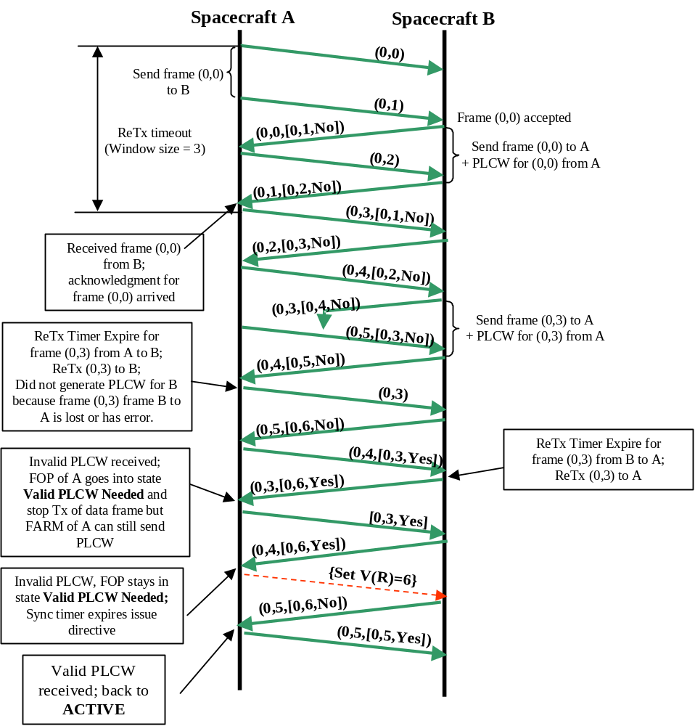
Figure 4-10: Two COP-P in Balanced Configuration
An interesting phenomenon is that when each message contains both the OCF and the data, a single message that is discarded due to transmission error has two effects: it creates a data frame loss on one side and a PLCW loss on the other. We can see the corresponding recovery process happen in opposite directions.

Half Duplex Operation
The most critical aspect of half duplex operation is the choice of window size, timeout value, and turn-around mechanism. While for full duplex operation, the optimal window size is one that just allows the sender to fill the pipe continuously, in half duplex mode the channel error rate and turn-around overhead must also be added to the equation. One can expect that under good channel condition or long turn-around time (include RTT and hardware considerations), the transmission window size should be large; for poor channel condition or situations where turn-around cost is low, the transmitter-receiver role should switch more often. Another change is the Retransmission Timeout parameter, because acknowledgement cannot occur till the receiver is allow to transmit on the channel, it must be adjusted accordingly.
In Proximity-1, the turn-around can be triggered by two methods: (1) sending SET CONTROL PARAMETERS directive with the End of Data indicator, and (2) automatically switch roles when the half duplex timer overflows. Although using the timer make the process fairly automatic and the use of directive unnecessary, one needs to use long guard band duration to avoid cutting-off transmission and/or reception in the middle of a frame. Therefore, it is suggested that the explicit use of directive should be the primary turn-around mechanism, while the timer is only used as a backup in case the directive is lost.
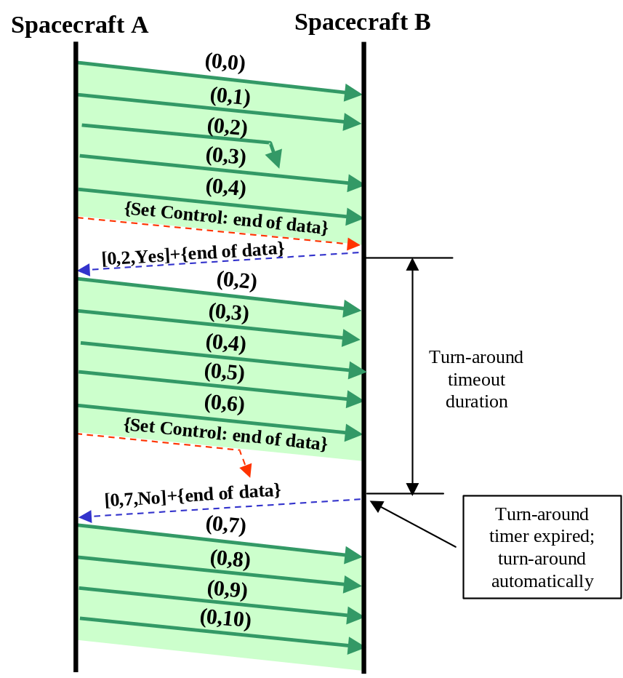
Figure 4-11: Half Duplex with One COP-P
In this time sequence diagram we illustrates how only one acknowledgement is necessary for each turn-around; also how the turn-around timer is used as a safety backup in case the turn-around directive is lost. It is also a possibility that the turn-around directive can be piggybacked with the last data frame. However, this would require the use of OCF and as we have already mentioned the frame sizing could be an issue when the PLTU size is fixed to match the Reed-Solomon coding block in synchronous data link mode.

Session Termination

Use of the END SESSION directive
A graceful termination requires that some kind of handshaking at the end of the session. In the recommendation, a two-way handshake is described. Figure 4-12 shows the general termination process between a lander and an orbiter.
The first step is that the lander’s vehicle controller has provided the last SDU that it wish to send to the Proximity-1 I/O sub-layer. At this point the vehicle controller would like to announce its intention to end the session to the orbiter using a special message. The recommendation did not specify the format of this notice. One would assume it is a data frame because it is a peer-to-peer communication between the local vehicle controllers. Once the remote spacecraft receives this notice, it can prepare for a graceful termination by having the final chance to exchange status information, request and wait for retransmissions of the last few frames, and any other end-of-session related activities. Then it will issue an END SESSION directive and then turn its transceiver off.
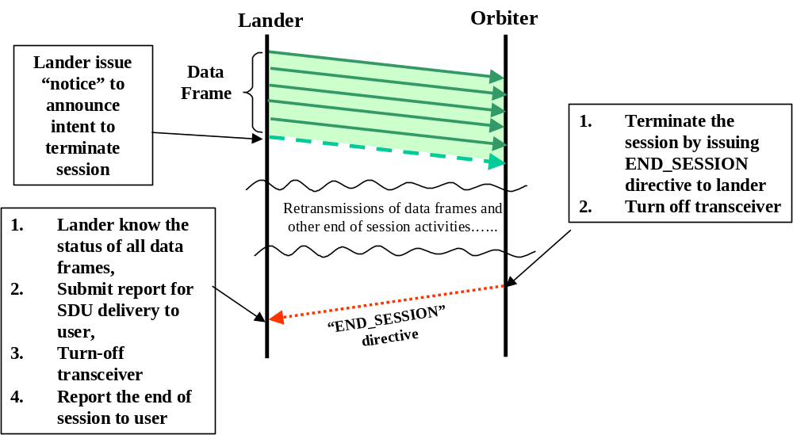
Figure 4-12: Session Termination (2-way handshake)

Carrier-Loss

Of course there is the possibility that either a graceful termination is not needed, not possible (spacecraft already went out-of-view or mal-functioning), or that the END SESSION directive is lost and corrupted. As a fail-safe measure, Proximity-1 will terminate a session when the carrier signal is lost for more than pre-specified time duration. It is up to the local vehicle controller to decide whether it is necessary to re-establish the session.

Continuity of Data Transmission
It is possible that when a session ended, data transmission is not yet complete from the user’s perspective. In such case, a graceful termination is important so that the sender has the necessary information to know which frames, and therefore which SDUs, have been received completely and correctly. This allows for a seamless resumption of SDU transfer at the beginning of the next session. Because Proximity-1 only delivery complete SDUs to the user, any SDU that are not received completely will not be delivered to the user; therefore the entire SDU must be sent again in the next session.
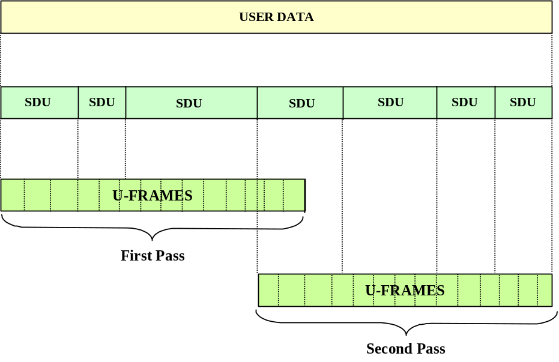
Figure 4-13: Transmission of User Data Across Two Sessions
It is possible for transmission to resume on the frame level; in such case the COP-P operation needs to be suspended between sessions. However, the recommendation explicitly prohibited the state variables and counter and timer value be stored within Proximity-1, therefore it is up to the local vehicle controller to keep all COP-P state information and re-implant these information at the beginning of the next session by issuing directive(s). However, such operation is complicated and only feasible under certain configurations.

Operational Issues
In the following section a few issues are raised only as suggestions for users or implementers of Proximity-1.

Use of Sequence Controlled Service for SPDU containing Directive
Proximity-1 recommendation allows P-frames, which contains SPDU, be sent using sequence controlled service. While sequence control service provides ARQ error control, their use should be discouraged. For SPDU carrying directives involved in handshaking process during for session establishment and reconfiguration, the use of persistence activity should be sufficient to guarantee the reliability of the process without ARQ. In fact the Proximity-1 architecture discourages the use of sequence-controlled services on P-frames because they are never submitted to the data service sub-layer on the receiving side, which makes retransmission requests on sequence controlled frames.
Problems may occur if the use sends a P-frame followed by several U-frames in the same virtual channel using sequence-controlled service. Suppose the P-frame arrives successfully, the frame sub-layer will extract the directives and forward them to the connection and configuration control algorithm. However, the data services sub-layer, which is checking the sequence number of each arriving frame, would not be aware of the successful delivery of this P-frame. When the subsequent U-frames arrive at the data services sub-layer, a ‘gap’ in sequence number would be declared and retransmission of the P-frame and all following U-frames and will be requested. Re-transmission of this P-frame may result in disruption or the creation of unintended control plane activities. Furthermore, since the P-frame will never arrive at the data services sub-layer in the receiving spacecraft, the go-back-n process will be trapped.

Terminology
In Proximity-1, the term MAC (medium access control) has been assigned very broadly to the set of connection and configuration functions in the control plane of the Proximity-1 protocol model. (Figure 3-1) Although half duplex control and the simple carrier-sensing mechanism used during hailing are typical MAC layer functions, the bulk of the functionalities implemented in the “MAC sub-layer” extends far beyond just “medium access”.
Another term used in the recommendation is “session.” This should not be associated with the session layer defined in the ISO OSI reference model. Proximity-1 is strictly a data link and physical layer protocol. The term “session” is more closely related to the notion of a “physical layer connection”. In fact a Proximity-1 session can only exist if there is a physical layer connection represented, at the very minimum, by the constant presence of carrier signal. Loss of carrier for a short amount of time is sufficient condition for session termination.

Identifier for SDU need to be specified
In order to facilitate a user level continuity in data transfer, Proximity-1 is required to provide user with delivery acknowledgement for each SDU. However, at this point, the recommendation provides no common means for identifying each SDU across the user-I/O sub-layer interface.

Large SDU Spanning More than 256 Frames
Proximity-1 tracks the delivery status each frame by its sequence number, which is assigned by the I/O sub-layer and stored in an 8-bit field in the Proximity-1 header. When the user supplies an SDU, it is converted into one or multiple frames if necessary. Therefore, Proximity-1 can track the delivery progress of each SDU by keeping record of the sequence number of all frames associated with it. Complication may arise when an SDU is so large that it occupies more than 2^8=256 frames; which can cause duplicated sequence numbers. Although not impossible, more sophisticated tracking algorithm must be used.

Window Size and Retransmission Timeout Values
The performance of Go-back-N ARQ algorithm depends strongly on the choices of window size. The overall goal is throughput efficiency but different method is applied to derive the optimal setting.
For duplex channel, throughput efficiency is independent of how often acknowledgements are sent because there is a dedicated channel for that purpose. Therefore, the optimal window size is one that just allows the sender to fill the physical channel with data frames. This can be derived from the round-trip propagation time, transmission time of a data frame, and the delay for the processing, generation, and transmission of the acknowledgement.
For half duplex operation, the process is more complicated because the data and acknowledgement will share the same channel. The turn-around frequency is determined by how good the channel is and how costly is each turn-around in terms of bandwidth. When the channel is good or when the turn-around cost is high, one would tend to increase the window size and reduce the number of turn-around; when the channel bad or when the turn-around cost is low, one would favor a smaller window size and more frequent acknowledgement.

Protocol Identification
This issue has been raised in previous section when considering a single Proximity-1 session is used to support multiple higher layer processes. The purpose of a “protocol identification” function is enable Proximity-1 to forward a SDU to the proper user level entities. The port ID designation given to each Proximity-1 SDU can be used for this purpose.

Loss of Carrier as Turn-around Signal
Besides using an end of data indicator and turn-around timer, a third condition, the loss of bit synchronization, will also cause the execution of turn-around procedure. It seems that the loss of bit lock can be used as a further backup to the use of timer, or it can be use by itself as a possible turn-around mechanism, when the channel condition is good enough such that loss of bit lock is a reliable indicator for the sender’s intent to switch the transmitter-receiver role.

Unreliable bit stream mode
Given the Proximity-1 protocol architecture allows the user directly coupling with the physical layer, the vehicle controller can directly supply the bit stream to the physical layer for transmission, thus bypassing Proximity-1 framing. Although this is not part of the protocol, it is easily implemented within the Proximity-1 architectural framework. The 2001 NASA Mars Odyssey Spacecraft has implemented such an unreliable bit stream mode.

Scenarios

Assumptions
In this section, we use the prototypical surface-element-to-orbiter scenario to illustrate how Proximity-1 operates under a wide variety of topologies. We choose this specific scenario because it is the most relevant scenario for near-term Proximity-1 operations. To understand scenarios other than surface-to-orbiter communications and those that involved balanced configuration where data flows in both directions, the reader can generalize our surface-element-to-orbiter scenario by considering the orbiter as the master, caller, and/or receiver of data; similarly one can generalize the lander as the sender of data, the slave node, and/or the responder in the hailing process. Because Proximity-1 has the flexibility such that the master is not necessarily the caller and the receiver of data, the number of possible operation configuration is large. We leave it to the reader to make the necessary extensions.

static vs. dynamic environment
Proximity-1 is designed to operate under a spectrum of scenarios and configurations. On one end of the spectrum we have a static environment where Proximity-1 will operate between a fixed pair of spacecraft that usually belong to the same mission. The caller-responder roles between these spacecraft are usually pre-defined and, even when change is allowed, are pre-scheduled. Configuration and operational parameter are limited and pre-selected to match the capability of the spacecraft. Also the frequency band are pre-defined and dedicated. Usually in such cases, the hailing channel is also used for data transmission. Static environment allows implementers to exhaustively study a given scenario and fine-tune Proximity-1 to operate under a fixed but optimize configuration.
On the other end of the spectrum, we have a dynamic environment where multiple spacecraft from different missions may communicate with each other to relay data, query information, or form cooperative teams to achieve scientific objective dynamically driven by unforeseen events and new mission objective added after launch. The operation scenario can be highly dynamic because the number of potential communication partner is high, and their corresponding configurations are less predictable. It is no longer cost effective to dedicate frequency band to each possible pairing, rather radio spectrum resource must be shared to ensure interoperability and adaptivity. In such case, there is a commonly designated hailing channel used for all possible spacecraft pairs; data transmission will typically take place on a separate pair of frequency band.

Topology
Proximity-1 one is basically a single master topology – like HDLC and other link layer protocols - because its frame header can only address either the source or the destination node, but not both. In order to operate in a multicast or many-to-many topology where each node is treated equally, both the source and destination addresses must be included.
Under a single master topology, we have two possible topological variations: (1) one-to-one and (2) one-to-many.

One to One
A one-to-one topology includes all scenarios where each spacecraft is only in communication with one other spacecraft. There can be multiple one-to-one Proximity-1 links operating at the same time. In a static environment, each one-to-one Proximity-1 link operates completely independent of others; in a dynamic environment, there will be some interaction, especially during the link establishment process.

One-to-One Link using a Dedicated Channel
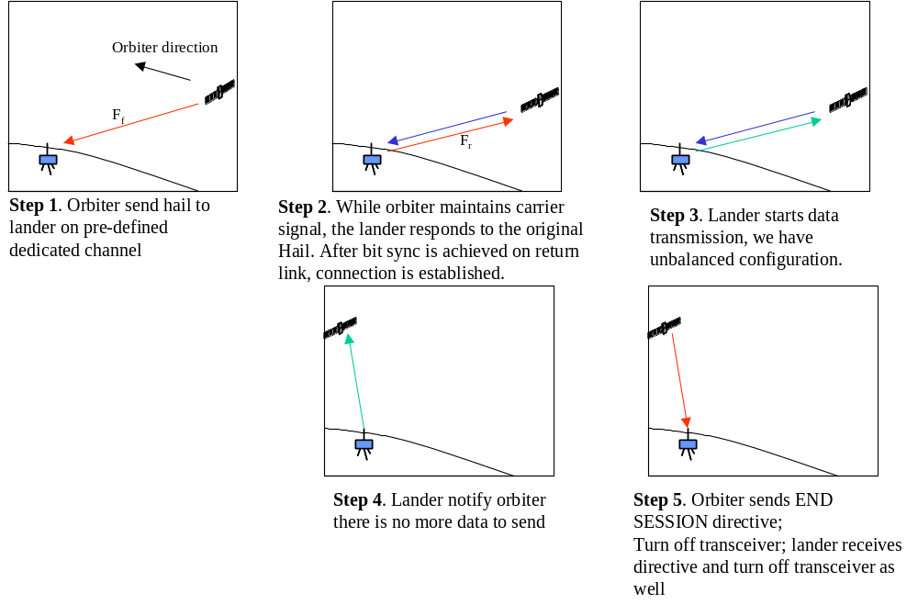
Figure 5-14: One-to-One Link using dedicated channel
When multiple one-to-one links exist, they each operate independently because each link has its own dedicated frequency band.

Single One-to-One Link using Separate Hailing and Working Channels
Typically, in a dynamic environment, Proximity-1 uses separate hailing and working channels. Sharing a common hailing channel allows any spacecraft to make contact with any other spacecraft; switching to a separate working channel is necessary because this can release the shared hailing channel for use by other spacecraft.
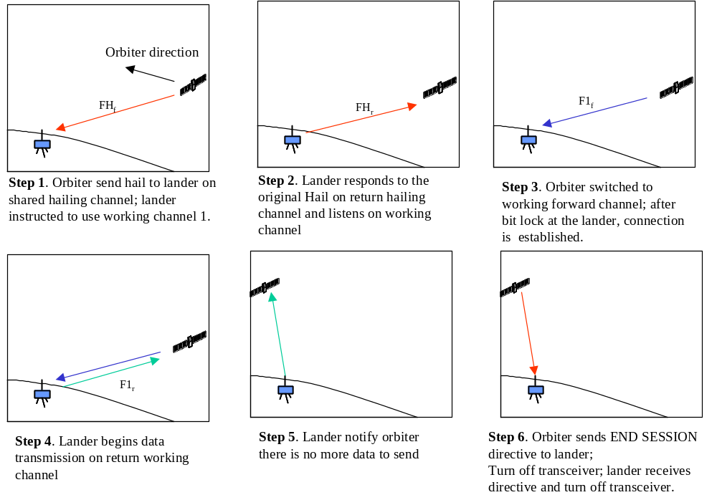
Figure 5-15: One-to-One Link using Separate Hailing and Working Channel

Multiple One-to-One Links under Dynamic Environment: Contention on the Hailing Channel
When the hailing channel is shared, then contention resolution is important. In this section we describe how contention is resolved by using random back-off and a carrier sensing mechanism.
We first assume there are two orbiters and two landers. Orbiter 1 wants to establish a one-to-link with lander 1, and orbiter 2 with lander 2. However, both orbiters decide to initiate the hailing process at almost the same time so that the carrier sensing mechanism did not detect each other’s presence. We show two scenarios: (1) both hailing messages collided and (2) only one hailing message is corrupted.
We then examine the case where one hailing process starts before the other one so that a carrier sensing mechanism allows the second caller to back-off its hailing attempt and avoid collision.
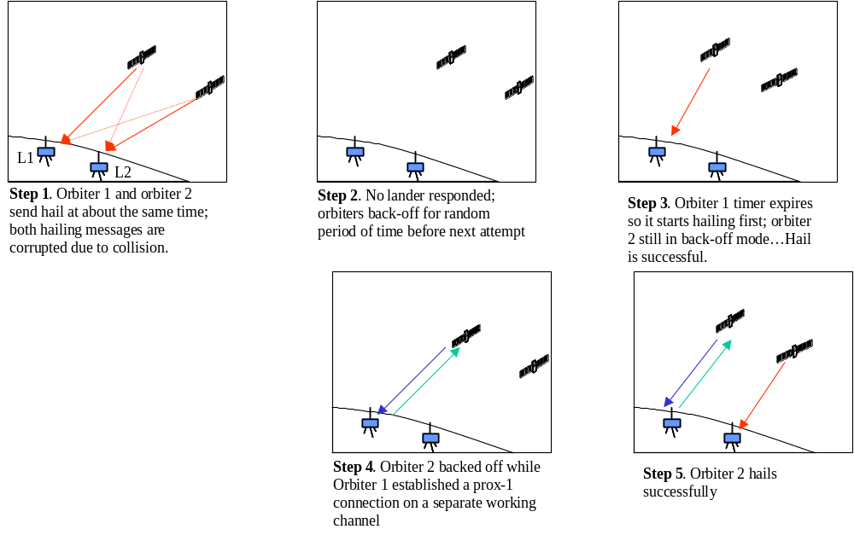
Figure 5-16: Simultaneous hailing; both landers in view of the orbiters
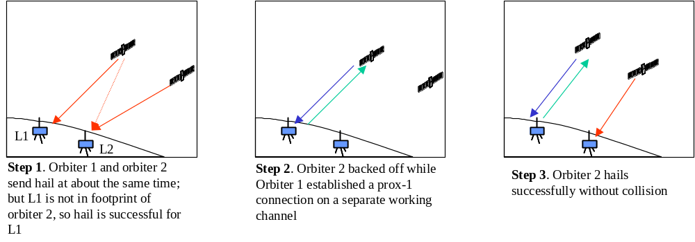
Figure 5-17: Simultaneous hailing; only one lander in view of both orbiters
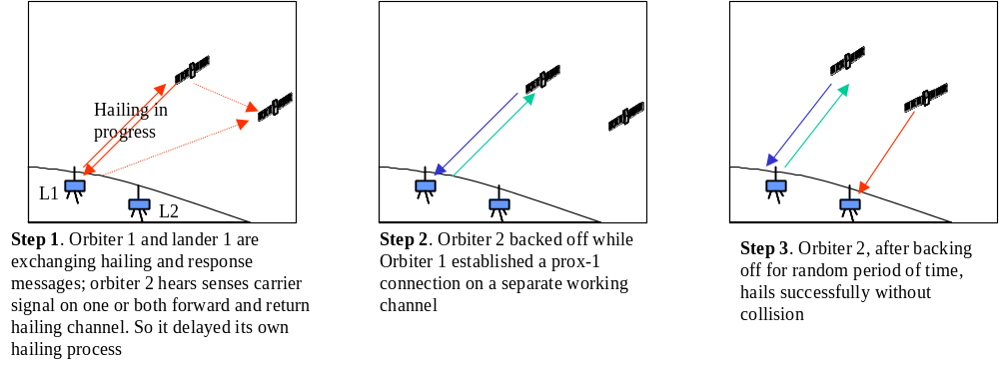
Figure 5-18: Collision Avoidance using Carrier Sensing on Hailing Channel

Multiple One-to-One Links under Dynamics Environment: Contention on the Working Channel
In all the scenarios described above, when contention on the hailing channel is resolved, the result is that one lander-to-orbiter link will be established before the second caller can start its hailing process. At this point, the second caller needs to perform additional carrier sensing in order to determine which working channel is available for use. Such a decision must be made before hailing because it is part of the hailing message.
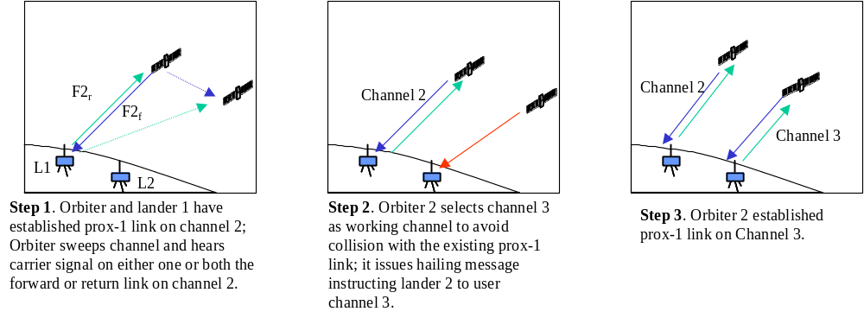
Figure 5-19: Collision Avoidance on the Working Channel

ONE to Many EXTENSIONS
For the one-to-many topology, a single orbiter can communicate with multiple landers at the same time using Proximity-1.
On the forward (command) link, an orbiter can transmit commands to multiple landers simultaneously, because a lander can discriminate the commands intended for it based upon the Spacecraft ID field in the Proximity-1 transfer frame header. In addition, broadcasting of commands to all or a group of landers within the footprint of an orbiter is also possible using the spacecraft ID as a global or group identifier.
For the return link, if the relay orbiter has only a single channel receiver available, then the orbiter can time share the link. Since the process of link establishment and moving to a working frequency takes time, we envision the orbiter overflight divided into a subset of smaller sessions each dedicated to a specific lander as opposed to a time division multiplex scheme. If the relay orbiter has multiple transceiver resources available, frequency assignments may be created that allow simultaneous accommodation of multiple surface assets. One possible configuration is to use multiple surface-to-orbit and multiple orbit-to-surface frequency pairs in FDMA/FDM fashion - running full duplex Proximity-1 protocols on each frequency pair independently. A higher-layer process would be needed to manage these links, particularly if the orbiter uses its same SCID for all of them.
A more efficient approach is to consider multiple return links using FDMA, and a single forward channel (used to multiplex PLCWs responses to the surface) . All landers would need to tune to the same receive channel. Again, several full-duplex sequence controlled Proximity-1 sessions could be supported as long as adequate margin is available in the shared forward link.

ACRONYMS
ARQ Automatic Repeat Queuing
ASM Attached Synchronization Marker
BER Bit Error Rate
CCSDS Consultative Committee for Space Data Systems
COP-P Command Operations Procedure Proximity
CW Continuous Wave
DFC ID Data Field Construction Identifier
FARM-P Frame Acceptance and Rejection Mechanism Proximity
FDU Frame Data Unit
FOP-P Frame Operations Procedure – Proximity
IPV4 Internet Protocol Version 4
ITU International Telecommunications Union
MAC Medium Access Control
MIB Management Information Base
MSB Most Significant Bit
N(R) Last acknowledged frame sequence number +1
PCM Pulse Code Modulation
PDU Protocol Data Unit
P-Frame Supervisory/Protocol Frame
PLCW Proximity Link Control Word
PLTU Proximity Link Transmission Unit
PSK Phase Shift Keyed
QOS Quality of Service
RF Radio Frequency
RHCP Right Hand Circular Polarized
R-S Reed-Solomon
Rx Receive
SAP Service Access Point
SC Spacecraft
SCID Spacecraft Identifier
SCPS-NP Space Communications Protocol Standards-Network Protocol
SDU Service Data Unit
TX Transmit
U-frame User Data Format
UHF Ultra High Frequency
V(S) Value of Sequence Number
VC Virtual Channel
VCID Virtual Channel ID

Although called “MAC” sub-layer, it functionality far exceeds the traditional role of a MAC protocol.
Assuming no resynchronization of the sequence controlled service has occurred during the session.
See the data field construction rules in Table 3-4 in the Proximity-1 Space Link Protocol Data Link Layer Specification.
Implementation choice per the Proximity-1 Recommendation.
See Section 4.3.10.6.3 for details.
The format of the END SESSION directive has not been specified in the draft recommendation.

